EXPERIMENT EE 215

TITLE
The Simple Resistive Fan Regulator

AIM
The aim of this experiment is to observe the performance of a simple resistive fan regulator and trace its circuit, and then to make simple resistance measurements to verify its performance.

OBJECTIVES
- To measure the voltage across the load and the current in the load for each setting of the fan regulator.
- To inspect the regulator, decide the function of each of its parts and draw its circuit diagram.
- To measure the resistance of each dropper stage and of the load rheostat with the Bridge Megger.
- To compare the measured resistances with the values worked out from the voltage and current readings.

APPARATUS
- Resistive fan regulator (1)
- 2 A Variac (1)
- 440 Ω rheostat (1)
- Bridge Megger (1)
- Crompton 1 A moving iron ammeter (1)
- A.C. voltmeter, 0 – 300 V (1)
Note: The A.C. voltmeter is not in the manual’s list, but it is needed to measure the voltage across the load. This experiment uses 220 V, which is a lethal voltage, so great care was taken. All connections were checked by a supervisor before power was switched on.

THEORY
The speed of an A.C. fan motor depends on the voltage applied to it. A fan regulator changes the fan speed by changing this voltage. A resistive regulator does this with a dropper resistor, which is a resistor placed in series with the fan. Part of the supply voltage is dropped across the dropper, so the fan receives less voltage and runs slower. The more resistance is put in series, the lower the voltage across the fan.
If the supply voltage is V, the load resistance is RL and the dropper resistance in circuit is Rd, the circuit is a simple voltage divider:
I = V / (RL + Rd) VL = I RL = V RL / (RL + Rd)
The dropper resistance can be found from the readings using Rd = (V − VL) / I. A typical fan regulator has a tapped wire-wound resistor with a rotary switch. The switch arm touches a row of studs, and each stud is connected to a different point on the resistor, so each setting puts a different amount of resistance in series. At the zero setting no resistance is in series, so the fan gets the full supply voltage.
In this experiment, the 440 Ω rheostat acts as the load and represents the load that a typical fan motor places on the supply (a fan taking about 110 W at 220 V has a resistance of about 220²/110 = 440 Ω). The Variac gives an adjustable supply voltage.
The power lost in the dropper is I²Rd, and it is given off as heat. This makes the resistive regulator wasteful at low speeds, but it is simple and cheap. The Bridge Megger is an instrument that measures resistance (and insulation resistance) accurately by the bridge method. It is used here to measure the resistance of each dropper stage between the studs, which are specially cleaned for this purpose.

DIAGRAM
(a) Circuit for Task A
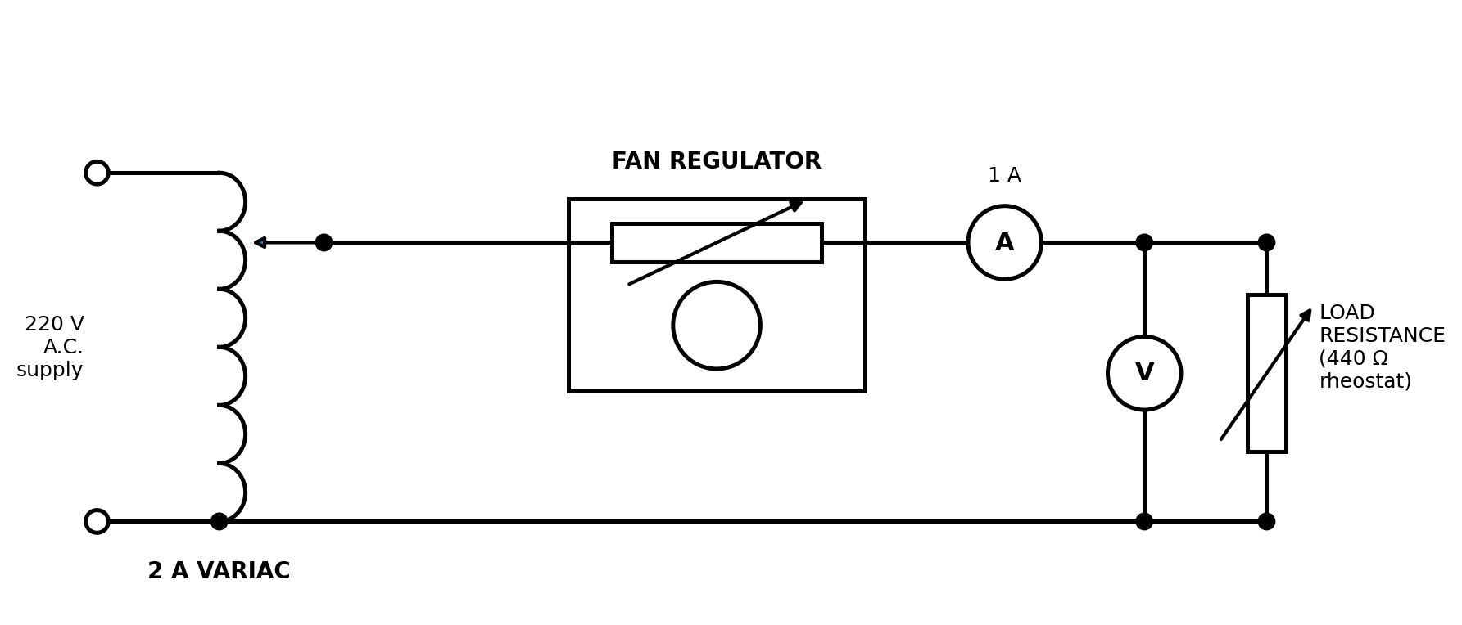
Figure 1: Circuit for Task A (an ammeter and a voltmeter are added to measure the load current and voltage)
(b) Circuit of the regulator found by inspection
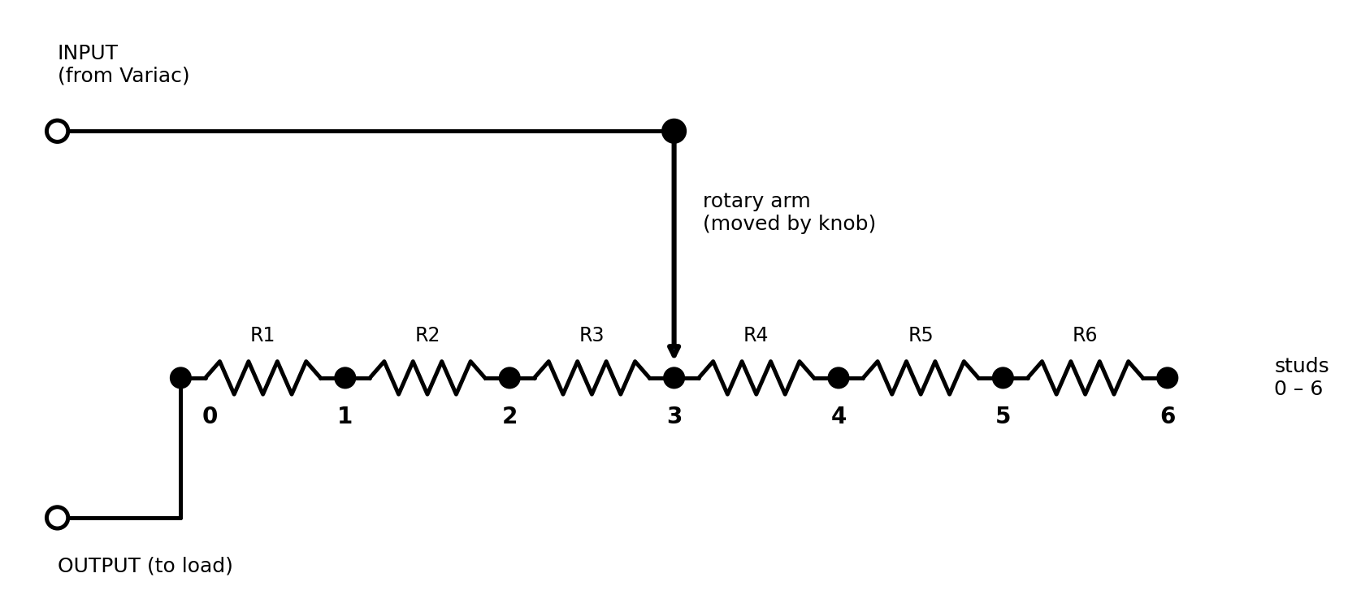
Figure 2: Internal circuit of the resistive fan regulator
(c) Resistance measurements with the Bridge Megger (Task B)
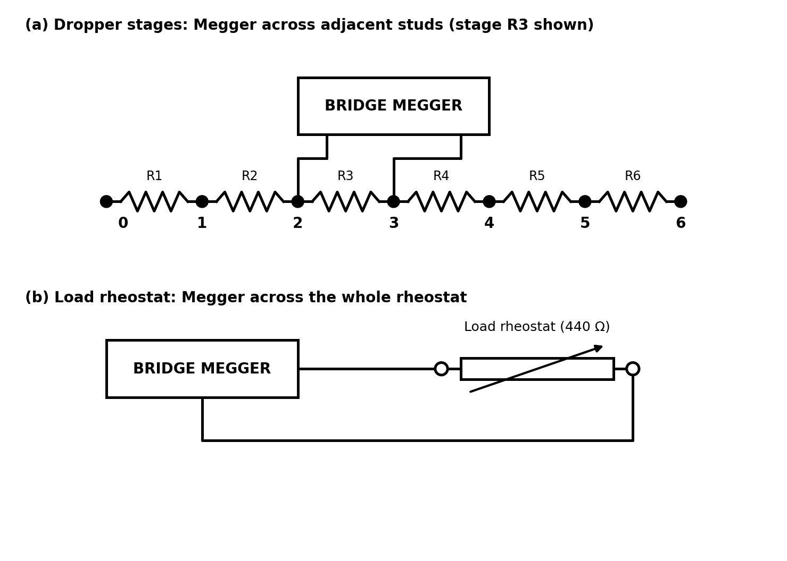
Figure 3: Connection of the Bridge Megger to the dropper stages and to the load rheostat

PROCEDURE
Task A
- Connect the circuit as shown in Figure 1. Set the 440 Ω rheostat to its full value as the load.
- With the regulator set to zero (fully anticlockwise position), switch on the Variac and adjust its output to give 220 V.
- For each of the 7 settings of the regulator (including zero), measure the voltage across the load and the current in the load. Check that the Variac output is still 220 V, and record the readings in Table 1.
- Switch off the power at the mains and disconnect the regulator. Study its construction and decide the function of each part. Reconnect the circuit for any further measurements if needed.
- From the measurements and the inspection, draw a neat circuit diagram of the regulator (Figure 2) and explain how it works.
Task B
- With the regulator disconnected from the supply, use the Bridge Megger to measure the resistance of each dropper stage between neighbouring studs (Figure 3a), following the instructions in the lid of the Megger.
- Measure the resistance of the load rheostat (Figure 3b).
- Add up the stage resistances to get the total dropper resistance for each setting, and compare with the values found from the readings in Task A.

OBSERVATION
Task A: readings
Supply voltage (Variac output) V = 220 V. Load: 440 Ω rheostat.
Table 1: Regulator settings, load voltage and load current
Regulator setting | Load voltage V (volts) | Load current I (amps) | V/I = load resistance (Ω) | Voltage drop in regulator (220 − V) (volts) | Dropper resistance (220 − V)/I (Ω) | Power lost in regulator (W)
0 | 220 | 0.500 | 440.0 | 0 | 0.0 | 0.0
1 | 206 | 0.470 | 438.3 | 14 | 29.8 | 6.6
2 | 192 | 0.435 | 441.4 | 28 | 64.4 | 12.2
3 | 178 | 0.405 | 439.5 | 42 | 103.7 | 17.0
4 | 164 | 0.375 | 437.3 | 56 | 149.3 | 21.0
5 | 150 | 0.340 | 441.2 | 70 | 205.9 | 23.8
6 | 136 | 0.310 | 438.7 | 84 | 271.0 | 26.0
Sample calculation (setting 3): V / I = 178 / 0.405 = 439.5 Ω. Voltage drop = 220 − 178 = 42 V. Dropper resistance = 42 / 0.405 = 103.7 Ω. Power lost in the regulator = 42 × 0.405 = 17.0 W.
As the setting increases, the load voltage and current fall, and the voltage drop in the regulator rises. The ratio V/I stays at about 440 Ω, which shows that the load resistance does not change.
Inspection of the regulator
When the regulator was opened, the following was observed: the rotary knob moves a metal arm over a row of seven studs, numbered 0 to 6. Between each pair of neighbouring studs there is a wire-wound resistor, so the six resistors are joined in series (R1 to R6). Stud 0 is connected straight to the output terminal, and the arm is connected to the input terminal. When the arm is on stud 0 the supply goes directly to the load, so no resistance is in series. When the arm is on stud k, the resistors R1 to Rk are in series with the load. The knob therefore selects the amount of series (dropper) resistance, and this sets the voltage and the speed of the fan. The circuit is shown in Figure 2.
Task B: Bridge Megger measurements
Table 2: Resistance of the dropper stages (Bridge Megger)
Dropper stage | Resistance of the stage (Ω) | Total resistance from stud 0 (Ω)
R1 (stud 0 to 1) | 29.8 | 29.8
R2 (stud 1 to 2) | 35.2 | 65.0
R3 (stud 2 to 3) | 40.1 | 105.1
R4 (stud 3 to 4) | 44.7 | 149.8
R5 (stud 4 to 5) | 55.3 | 205.1
R6 (stud 5 to 6) | 64.8 | 269.9
The total of the six dropper stages is 269.9 Ω. The load rheostat measured 441 Ω on the Megger.
Table 3: Comparison of Task A and Task B
Setting | Dropper resistance from Task A (Ω) | Dropper resistance from Megger (Ω) | Difference (Ω) | Measured load voltage (V) | Load voltage calculated with Megger values (V)
0 | 0.0 | 0.0 | 0.0 | 220 | 220.0
1 | 29.8 | 29.8 | 0.0 | 206 | 206.1
2 | 64.4 | 65.0 | -0.6 | 192 | 191.7
3 | 103.7 | 105.1 | -1.4 | 178 | 177.7
4 | 149.3 | 149.8 | -0.5 | 164 | 164.2
5 | 205.9 | 205.1 | +0.8 | 150 | 150.2
6 | 271.0 | 269.9 | +1.1 | 136 | 136.5
Sample calculation (setting 3): Using the Megger values, the calculated load voltage is VL = 220 × 441 / (441 + 105.1) = 177.7 V, which agrees with the measured value of 178 V.

PRECAUTIONS
- The voltages used (220 V) are lethal, so no live wiring or terminals were touched. The power was switched off at the mains before the circuit was changed or the regulator was disconnected.
- All connections were checked by a supervisor before the power supply was switched on.
- The regulator was set to zero before the Variac was switched on, and the Variac output was checked to be 220 V before each reading.
- The load current was kept below the 1 A range of the ammeter, and the meters were read with the eye directly in front of the pointer.
- The regulator was fully disconnected from the supply before the Bridge Megger was used on it.
- The studs were clean, and the instructions in the lid of the Megger were followed for the bridge tests.
- The resistors were not allowed to overheat, and the equipment was switched off after use.

CONCLUSION
This experiment showed that the simple resistive fan regulator works by putting different amounts of resistance in series with the fan. At setting 0 the load received the full 220 V and 0.500 A. At setting 6, the voltage fell to 136 V and the current to 0.310 A, so the fan would run slower. The regulator was found to have a row of seven studs, six dropper resistors in series and a rotary arm that selects how many are in the circuit.
The resistances found from the voltage and current readings in Task A (for example 271.0 Ω at setting 6) agree closely with the resistances measured with the Bridge Megger in Task B (269.9 Ω in total), to within about 1.5 Ω. The Megger readings are more accurate because they are taken directly, while the Task A values depend on reading two meters. This verifies the idea about how the regulator works. A weakness of the resistive regulator is that power is wasted as heat in the dropper. At setting 6 the load took 42.2 W while 26.0 W was lost in the regulator, so the efficiency was only about 61.8 %.
How an inductive fan regulator operates. An inductive fan regulator uses a coil with an iron core, called a choke, in place of the resistor. The choke has several tappings, and a switch selects a different number of turns for each speed. When the fan current flows in the choke, the coil drops a voltage across its reactance (X = 2πfL), and this voltage is nearly 90° out of phase with the fan voltage. So the fan receives a lower voltage, and runs slower, but very little real power is lost as heat. More turns in circuit give more reactance, so a lower fan voltage and speed. The inductive regulator is therefore more efficient and cooler than the resistive type, but it is bigger, heavier and may hum.

