LABORATORY EXPERIMENT: EEE 212

TITLE
Response of Circuits to Square Wave Voltages

AIM
The aim of this experiment is to observe experimentally the transient voltage effects in RC and RL circuits when they are driven by a square wave voltage.

OBJECTIVES
- To observe and sketch the input and output waveforms of an RC circuit for different values of capacitance.
- To observe and sketch the input and output waveforms of an RL circuit for different values of inductance.
- To measure the time t0.8 that the output voltage takes to rise to 80 % of its full value in each circuit.
- To compare the measured values of t0.8 with the values calculated from the component values.

APPARATUS
- Philip Harris Oscillator (1)
- Philip Harris Switched Capacitor (1)
- Philip Harris Switched Resistor (1)
- J.J. Instruments Switched Inductor (1)
- Oscilloscope, type D54 (1)
Note: The capacitor values in this report are in microfarads (µF). All connections were checked by a supervisor before power was switched on.

THEORY
When a sudden change of voltage (a step) is applied to a circuit that has a capacitor or an inductor, the output voltage does not change at once. It changes gradually to its final value. This gradual change is called the transient response. The theory of transient response shows that the output waveform seen across the capacitor is the sum of two parts: the complementary function, which is due to the circuit itself, and the particular integral, which is due to the shape of the input.
For an RC circuit with a step input of size Vi, the voltage across the capacitor is:
Vo = Vi (1 − e^(−t/RC))
The product RC is called the time constant of the circuit. When a square wave is applied, the simple transient analysis can be used only if the time constant is much smaller than half the period of the waveform, that is, RC << T/2. In this case the output has time to reach its final value before the input changes again. When the input falls, the capacitor discharges in the same way and the output falls as Vo = Vi e^(−t/RC).
To find the time t0.8 for the output to rise to 80 % of its full value, we put Vo = 0.8 Vi:
1 − e^(−t0.8/RC) = 0.8 so e^(−t0.8/RC) = 0.2 so t0.8 = RC ln 5 = 1.61 RC
The analysis of the RL circuit is similar. Here the output is taken across the resistor R. The inductor does not allow the current to change suddenly, so the voltage across R rises gradually:
Vo = Vi (1 − e^(−tR/L)) and t0.8 = 1.61 L/R
In the RL circuit the time constant is L/R. A larger capacitance C or a larger inductance L gives a larger time constant, so the output rises more slowly and the edges of the square wave look more rounded.

DIAGRAM
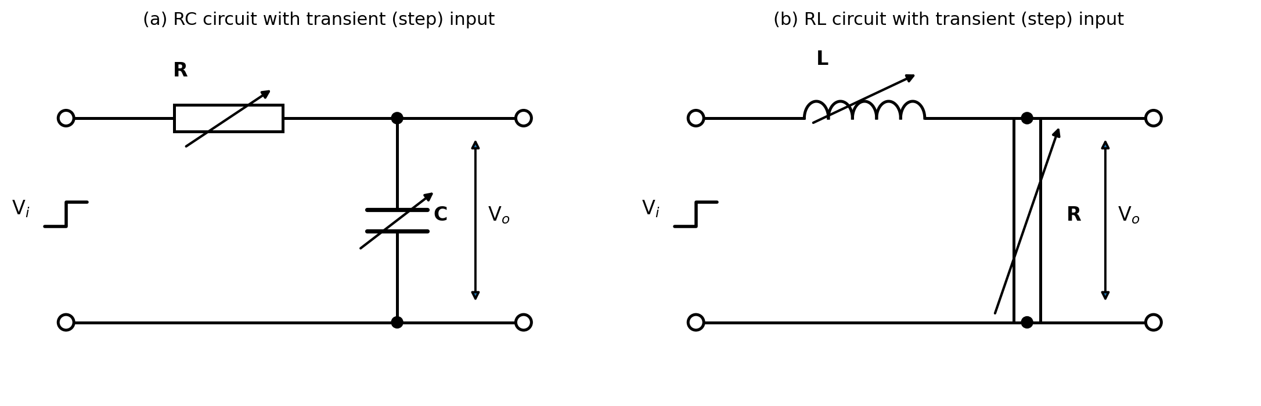
Figure 1: RC and RL circuits with a transient (step) input voltage
(a) RC circuit connected to the oscilloscope (Task A)
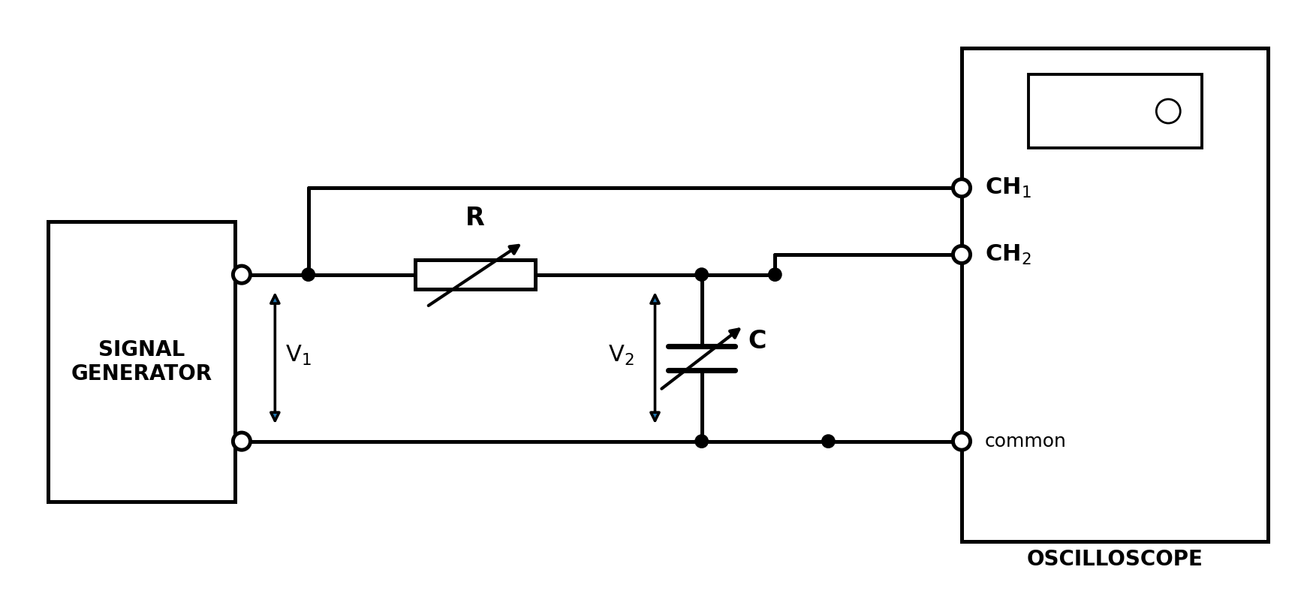
Figure 2: Connection of the RC circuit
(b) RL circuit connected to the oscilloscope (Task B)
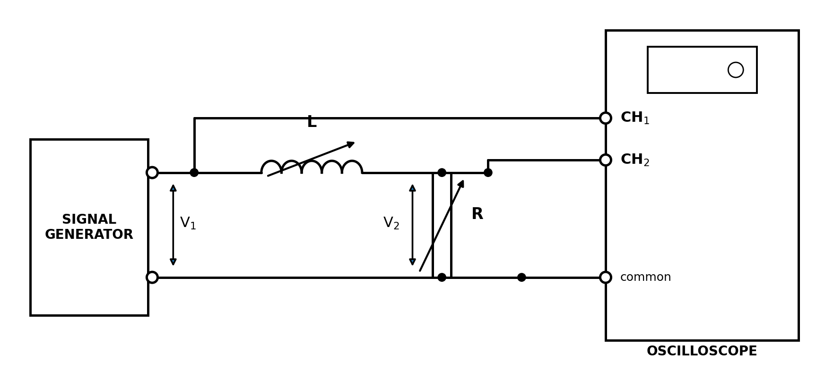
Figure 3: Connection of the RL circuit

PROCEDURE
Make the following settings on the instruments:
A. Oscilloscope
- Switch on.
- Set both channels to 1 volt/cm and CAL.
- Trigger on channel 1.
- Set the timebase to 2 ms/cm and CAL.
- Trigger internally (INT).
- Set TRIG LEVEL to AUTO.
- Set horizontal GAIN to CAL.
B. Oscillator
- Switch on.
- Switch to the range 100 Hz – 1 kHz and set 1 on the frequency dial, giving a 100 Hz output.
- Set the attenuator coarse to 10 V and the fine control to about the 6th setting.
- Switch the function switch to square wave.
C. Capacitor and resistor
- Set the resistor to 100 kΩ.
- Set the capacitor to 0.00047 µF.
Task A: RC circuit
- Connect the circuit as shown in Figure 2.
- Observe the two waveforms on the screen and adjust the STABILITY control to get a steady picture. Adjust the oscillator output so that the waves are 5 V peak to peak.
- Superimpose the two waves on the screen and sketch them accurately, labelling the timebase and the amplitude.
- Change the capacitance to 0.0010, 0.0022 and 0.0047 µF in turn, and sketch the waveforms for each value.
- Reset C to 0.00047 µF, switch off channel 1 and expand the timebase to a convenient time scale. Position the waveform so that accurate results are possible.
- Measure the distance (in cm) along the screen for the capacitor voltage to reach 80 % of its full value.
- Repeat step 6 with C = 0.0010, 0.0022 and 0.0047 µF, expanding the timebase as needed. Record the results in Table 1.
Task B: RL circuit
- Connect the circuit as shown in Figure 3 and reset the oscilloscope timebase to 2 ms/cm. Switch on channel 1.
- Set the resistance to 4.7 kΩ and the inductance to 1 H.
- Superimpose the two waveforms on the screen and sketch them accurately, labelling the timebase and amplitude as before.
- Switch off channel 1 and expand the timebase to a convenient time scale. Measure the time taken by the voltage across R to reach 80 % of its full value.
- Repeat with L = 0.8 H, 0.6 H and 0.4 H, expanding the timebase for the smaller values of inductance. Record the results in Table 2.

OBSERVATION
Input: square wave, 100 Hz (period T = 10 ms, so T/2 = 5 ms), 5 V peak to peak. The measured time t0.8 = (distance to 80 % of full voltage in cm) × (timebase setting).
Table 1: RC circuit (Task A)
R (kΩ) | C (µF) | Distance to 80 % (cm) | Timebase setting (µs/cm) | t0.8 measured (µs) | t0.8 calculated (µs)
100 | 0.00047 | 3.9 | 20 | 78 | 75.6
100 | 0.0010 | 3.3 | 50 | 165 | 160.9
100 | 0.0022 | 3.6 | 100 | 360 | 354.1
100 | 0.0047 | 3.9 | 200 | 780 | 756.4
Sample calculation (C = 0.00047 µF): Measured t0.8 = 3.9 cm × 20 µs/cm = 78 µs. Calculated t0.8 = 1.61 RC = 1.61 × 100 × 10³ × 0.00047 × 10⁻⁶ = 75.6 µs.
Table 2: RL circuit (Task B)
R (kΩ) | L (H) | Distance to 80 % (cm) | Timebase setting (µs/cm) | t0.8 measured (µs) | t0.8 calculated (µs)
4.7 | 1.0 | 3.3 | 100 | 330 | 342.4
4.7 | 0.8 | 5.4 | 50 | 270 | 273.9
4.7 | 0.6 | 4.0 | 50 | 200 | 205.5
4.7 | 0.4 | 6.6 | 20 | 132 | 137.0
Sample calculation (L = 1.0 H): Measured t0.8 = 3.3 cm × 100 µs/cm = 330 µs. Calculated t0.8 = 1.61 L/R = 1.61 × 1 / 4700 = 342.4 µs.
Table 3: Appearance of the waveforms at 2 ms/cm (T/2 = 5 ms)
Circuit | Component | Time constant (µs) | Time constant / (T/2) | Appearance of output
RC | C = 0.00047 µF | 47 | 0.9 % | Almost square, edges slightly rounded
RC | C = 0.0010 µF | 100 | 2.0 % | Slightly rounded edges
RC | C = 0.0022 µF | 220 | 4.4 % | Clearly rounded edges
RC | C = 0.0047 µF | 470 | 9.4 % | Well rounded, reaches full value before the half period ends
RL | L = 1.0 H | 213 | 4.3 % | Clearly rounded edges
RL | L = 0.8 H | 170 | 3.4 % | Rounded edges
RL | L = 0.6 H | 128 | 2.6 % | Slightly rounded edges
RL | L = 0.4 H | 85 | 1.7 % | Slightly rounded edges
The output waveform is more rounded when the time constant is larger. In every case the time constant is much smaller than T/2, so the output reaches its full value before the input changes, as the theory requires.
Table 4: Comparison of measured and calculated t0.8
Circuit | Component | Measured (µs) | Calculated (µs) | Difference (%)
RC | C = 0.00047 µF | 78 | 75.6 | +3.1
RC | C = 0.0010 µF | 165 | 160.9 | +2.5
RC | C = 0.0022 µF | 360 | 354.1 | +1.7
RC | C = 0.0047 µF | 780 | 756.4 | +3.1
RL | L = 1.0 H | 330 | 342.4 | −3.6
RL | L = 0.8 H | 270 | 273.9 | −1.4
RL | L = 0.6 H | 200 | 205.5 | −2.7
RL | L = 0.4 H | 132 | 137.0 | −3.6
Percentage difference = (measured − calculated) / calculated × 100. For example, for C = 0.00047 µF: (78 − 75.6) / 75.6 × 100 = +3.1 %.

GRAPH
Graph 1 shows the input and output waveforms of the RC circuit for the four values of capacitance, with the oscilloscope timebase at 2 ms/cm. The input is the blue square wave and the output across the capacitor is the red curve. The green dashed line marks the 80 % level.
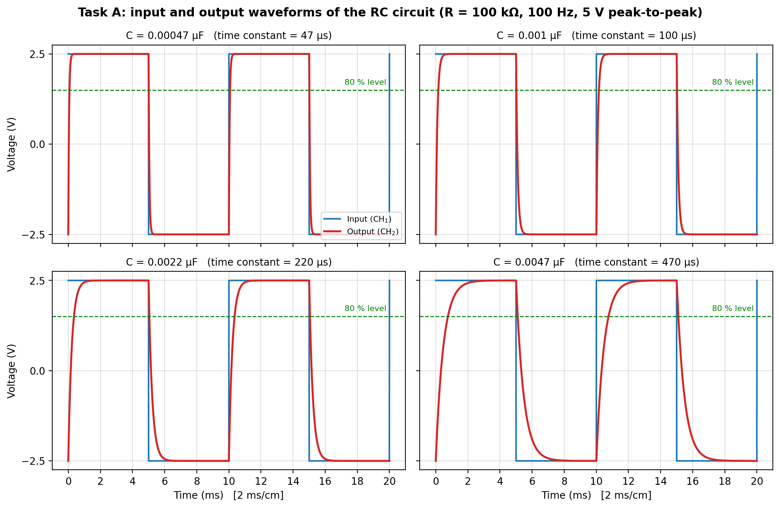
Graph 1: Waveforms of the RC circuit (Task A)
Graph 2 shows the same for the RL circuit. The output is taken across the resistor R.
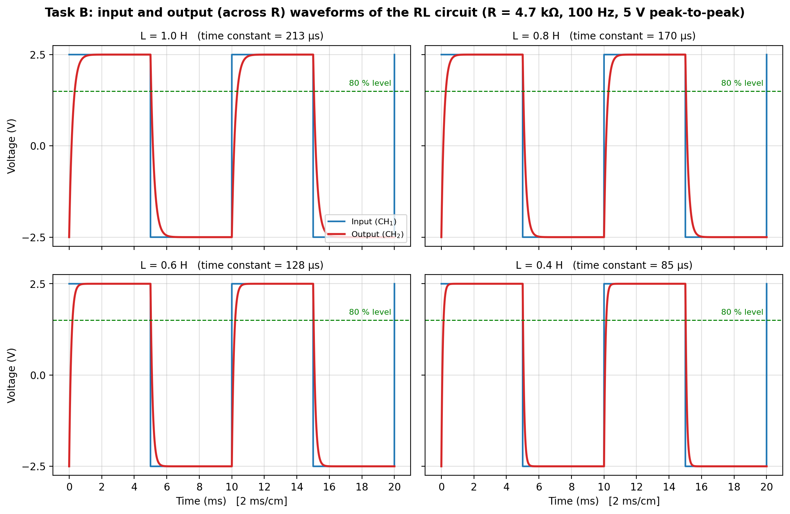
Graph 2: Waveforms of the RL circuit (Task B)
Graph 3 shows t0.8 against C and against L. The line is the calculated value and the dots are the measured values. The dots lie very close to the line, which shows that t0.8 is directly proportional to the time constant.
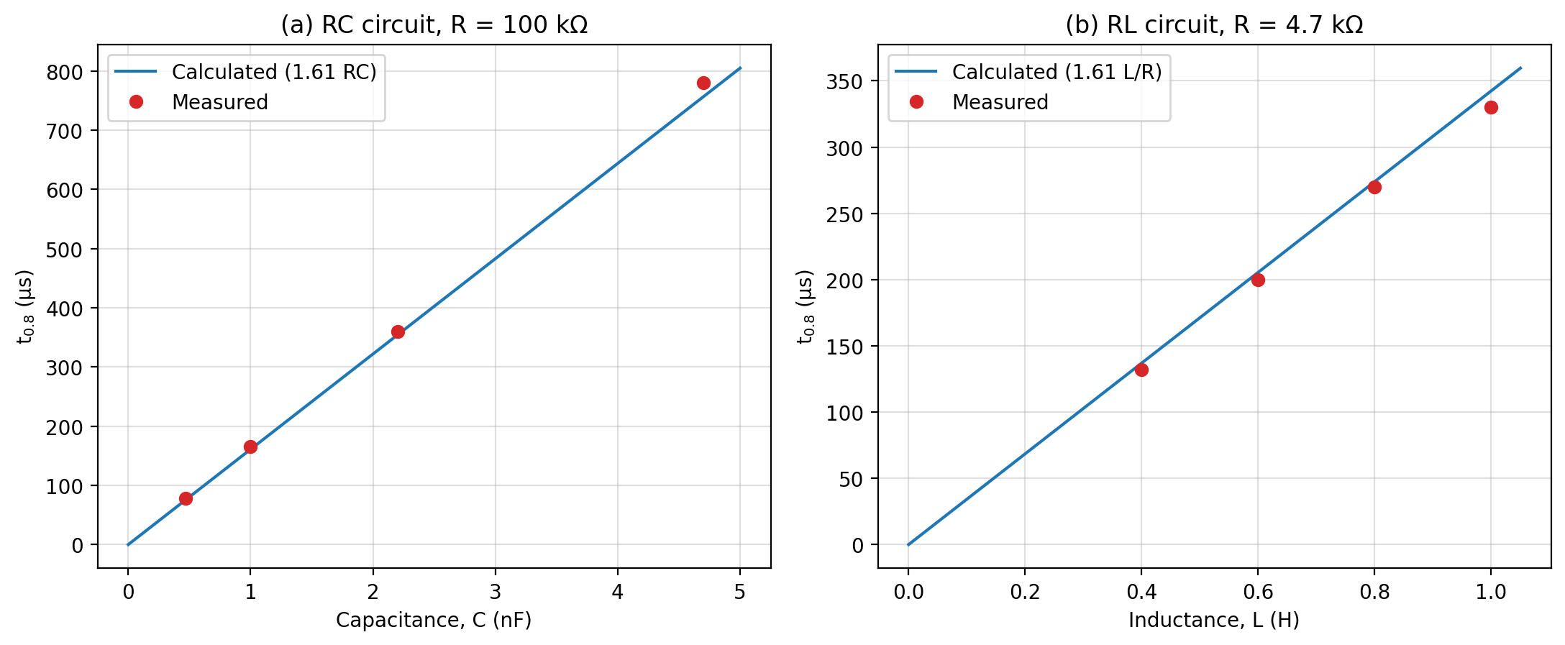
Graph 3: t0.8 against C (RC circuit) and against L (RL circuit)

PRECAUTIONS
- All connections were checked by a supervisor before the power supply was switched on.
- The oscilloscope was allowed to warm up, and the CAL positions of the voltage and time controls were used so that readings were accurate.
- The brightness of the trace was kept low and the spot was not left standing in one place.
- The common (earth) terminals of the oscillator and oscilloscope were joined correctly to avoid a wrong display.
- The waveform was positioned carefully on the graticule and the readings were taken with the eye directly in front of the screen to avoid parallax error.
- The timebase was expanded to a suitable setting before each measurement of t0.8, to reduce reading error.
- The component values were set carefully, and all equipment was switched off after the experiment.

CONCLUSION
(i) Reasons for the waveform shapes in Tasks A and B. The square wave input changes suddenly from one level to another. In the RC circuit, the capacitor voltage cannot change instantly because the capacitor must charge or discharge through the resistor. So the output rises and falls along an exponential curve with time constant RC, and the sharp corners of the square wave become rounded. In the RL circuit, the inductor opposes any sudden change of current, so the current, and therefore the voltage across R, rises gradually with time constant L/R. A larger C or L gives a larger time constant and more rounding, as seen in Graphs 1 and 2. Because the time constants used (47 µs to 470 µs) are much smaller than T/2 = 5 ms, the output reaches its full value in each half cycle.
(ii) Comparison of measured and calculated values. The calculated values of t0.8 (from 1.61 RC and 1.61 L/R) are given in Tables 1 and 2. The measured values agree with them within about 4 % (Table 4). The measured values for the RC circuit are slightly higher than the calculated ones, which can be due to the output resistance of the oscillator adding to R, and to the loading of the oscilloscope input. The measured values for the RL circuit are slightly lower, which can be due to the inductor winding having its own resistance, which reduces L/R. The component values are only accurate to their tolerances (often ±5 % or more), and the oscilloscope readings are limited by the thickness of the trace and by the difficulty of judging the 80 % point exactly. These errors explain the small differences, and the results confirm the theory of the transient response of RC and RL circuits.

