EXPERIMENT EEE 214
Maximum Power Transfer

AIM
The aim of this experiment is to verify the Maximum Power Transfer Theorem for simple D.C. and A.C. circuits.

OBJECTIVES
- To connect and test simple D.C. and A.C. circuits.
- To operate the Avometer on D.C. and A.C., on voltage and current ranges.
- To verify the Maximum Power Transfer Theorem for D.C. and A.C. circuits.

APPARATUS
A. D.C. experiment
- D.C. power supply unit (3 cells in series) (1)
- 500 Ω rheostats (2)
- Avometers (2)
B. A.C. experiment
- 2 A Variac (1)
- 500 Ω rheostats (2)
- Avometers (2)
- Harris A.C. voltmeter, 0 – 300 V (moving iron) (1)
- Inductance (1)
- Variable capacitor (1)
Note: The inductance value is not given in the manual. In this report, the inductor is taken to be 0.5 H with a coil resistance of about 15 Ω, and the capacitor is set to 60 µF. All connections were checked by a supervisor before power was switched on.

THEORY
The Maximum Power Transfer Theorem says that a source delivers the greatest possible power to a load when the load resistance is equal to the resistance of the source. A real source can be thought of as a perfect voltage source E in series with its own resistance Rs. If a load resistance R is connected to this source, the current and the power in the load are:
I = E / (Rs + R) P = I² R = E² R / (Rs + R)²
When R is very small, the current is large but the voltage across the load is small, so the power is small. When R is very large, the voltage is large but the current is small, so the power is again small. Between these two extremes there is a peak. To find it, put dP/dR = 0:
dP/dR = E² [(Rs + R)² − 2R (Rs + R)] / (Rs + R)⁴ = 0 so Rs + R = 2R so R = Rs
So the power in the load is greatest when R = Rs, and the maximum power is Pmax = E² / (4 Rs). At this point the load receives only half of the total power. The other half is lost in the source resistance, so the efficiency is 50 %. For this reason, maximum power transfer is used in small signal circuits, but not in power systems, where high efficiency is more important.
The theorem also applies to A.C. circuits. If the source has resistance Rs and a net reactance X (the inductive reactance Xₗ = 2πfL minus the capacitive reactance Xᶜ = 1 / 2πfC), the source impedance is Zs = Rs + jX. For a purely resistive load R, the power is:
P = V² R / [(Rs + R)² + X²]
Putting dP/dR = 0 shows that the power is greatest when the load resistance equals the size of the source impedance:
R = |Zs| = √(Rs² + X²)
In the A.C. experiment here, Rs = R1 + the coil resistance of the inductor, and X = 2πfL − 1/(2πfC). If the load could also have reactance, the maximum power would be delivered when the load impedance is the complex conjugate of the source impedance.
The D.C. source in this experiment is three lead-acid cells in series (about 2 V each). The A.C. source is a Variac, which is an autotransformer. It has a single winding on an iron core and a sliding contact that picks off any number of turns, so the output voltage is smoothly adjustable from zero to the input value.

DIAGRAM
(a) D.C. experiment
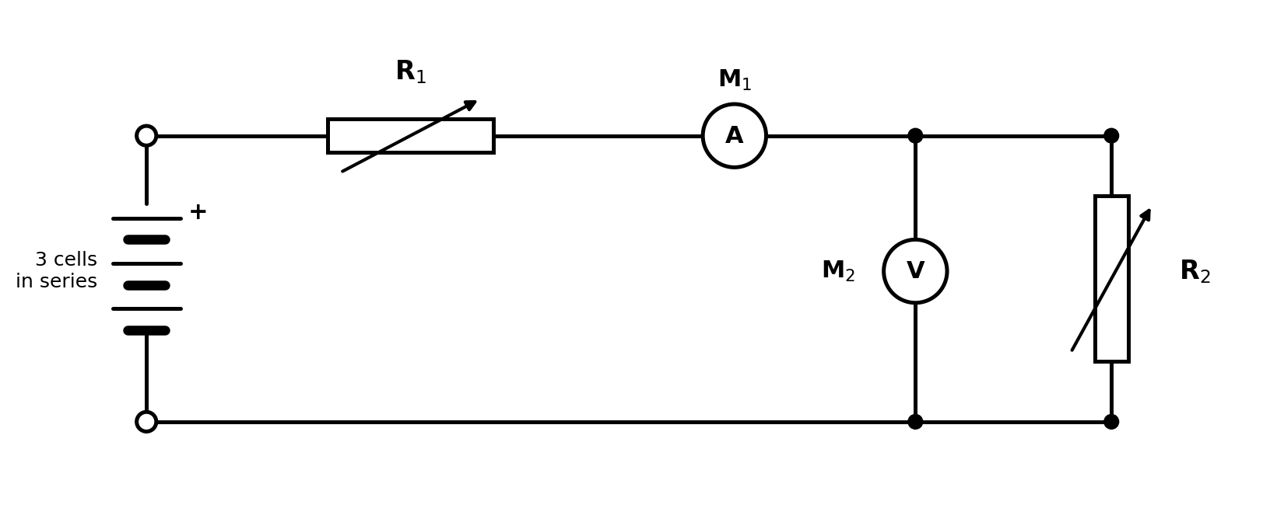
Figure 1: Circuit for the D.C. experiment
(b) A.C. experiment
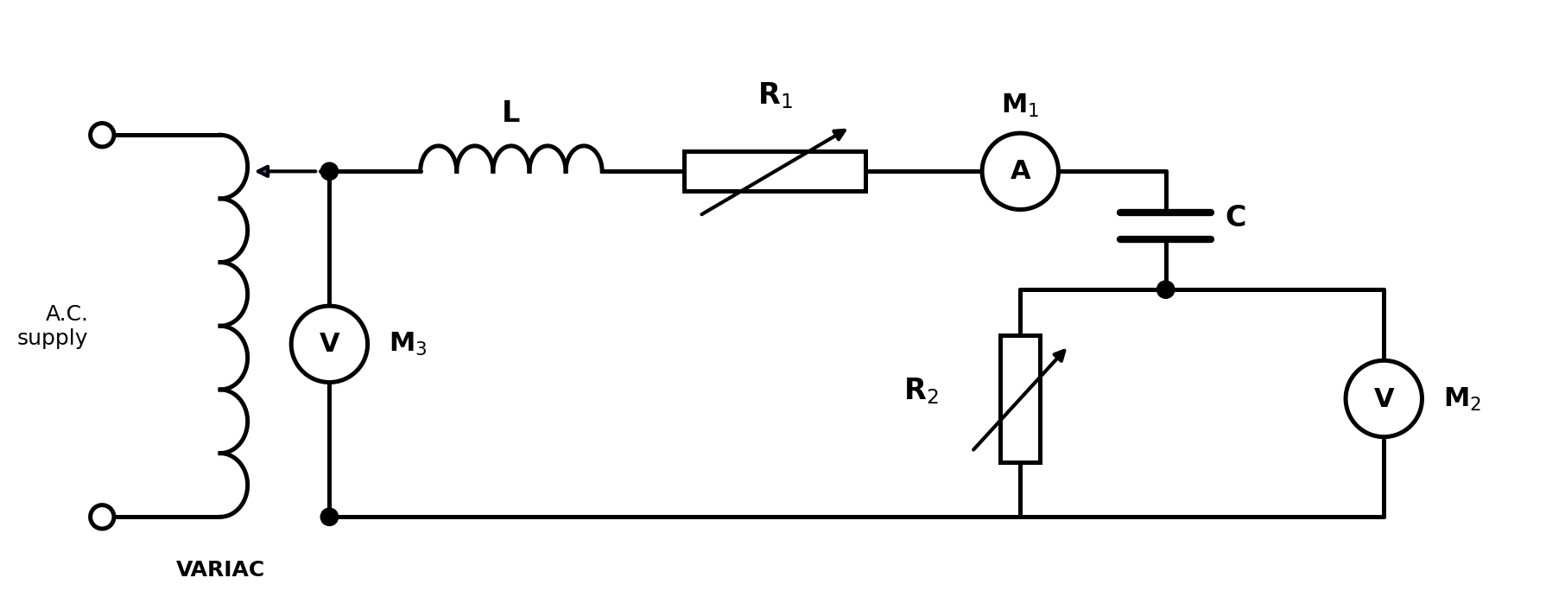
Figure 2: Circuit for the A.C. experiment

PROCEDURE
A. D.C. experiment
- Connect the 3 cells in series and use an Avometer set to D.C. voltage 0 – 10 V to check that they produce just over 6 V.
- Connect the circuit as shown in Figure 1. Check again that the cells give just over 6 V when they are connected in the circuit. If not, inform a member of the laboratory staff, as the cells need recharging.
- Set meter M1 as an Avometer to read D.C. current on the range 0 – 0.1 A, and meter M2 as an Avometer to read D.C. voltage on the range 0 – 10 V.
- Set rheostat R1 to 50 % of its full value (250 Ω) and rheostat R2 to its full value (500 Ω).
- Reduce R2 in steps. At each setting, record the voltage V from M2 and the current I from M1. Take at least ten readings, with extra readings close to the peak of the power.
- For each setting calculate V/I (the resistance of R2) and VI (the power in R2). Plot a graph of these quantities, labelling the axes.
B. A.C. experiment
- Connect the circuit as shown in Figure 2 and do not switch on until it has been checked.
- Set meter M1 as an Avometer to read A.C. current 0 – 1 A r.m.s., meter M2 as an Avometer to read A.C. voltage 0 – 100 V, and use meter M3 as a Harris moving iron voltmeter 0 – 300 V. Set the capacitor to 60 µF.
- Set rheostat R1 to 250 Ω and R2 initially to 500 Ω. Switch on the Variac and adjust it to give 100 V r.m.s. on M3. Take care not to touch exposed wiring.
- Vary R2 in steps. Before each reading, make sure M3 reads 100 V by adjusting the Variac output. Record the voltage V from M2 and the current I from M1.
- Take at least ten readings, with extra readings close to the peak. Calculate V/I and VI for each setting and plot a graph of these quantities, labelling the axes.

OBSERVATION
A. D.C. experiment
Supply: 3 lead-acid cells in series, E = 6.2 V (just over 6 V). R1 = 250 Ω. The ammeter range is 0 – 0.1 A and the voltmeter range is 0 – 10 V.
Table 1: D.C. experiment
Reading | Setting of R2 (Ω) | V (volts) | I (amps) | V/I = resistance R2 (Ω) | VI = power in R2 (mW)
1 | 500 | 4.12 | 0.0082 | 502.4 | 33.78
2 | 450 | 3.97 | 0.0088 | 451.1 | 34.94
3 | 400 | 3.80 | 0.0095 | 400.0 | 36.10
4 | 350 | 3.60 | 0.0103 | 349.5 | 37.08
5 | 300 | 3.37 | 0.0112 | 300.9 | 37.74
6 | 275 | 3.24 | 0.0118 | 274.6 | 38.23
7 | 260 | 3.15 | 0.0121 | 260.3 | 38.11
8 | 250 | 3.09 | 0.0124 | 249.2 | 38.32
9 | 240 | 3.02 | 0.0126 | 239.7 | 38.05
10 | 225 | 2.92 | 0.0130 | 224.6 | 37.96
11 | 200 | 2.74 | 0.0137 | 200.0 | 37.54
12 | 150 | 2.31 | 0.0154 | 150.0 | 35.57
13 | 100 | 1.76 | 0.0176 | 100.0 | 30.98
14 | 50 | 1.03 | 0.0205 | 50.2 | 21.12
Sample calculation (Reading 8): V / I = 3.09 / 0.0124 = 249.2 Ω. VI = 3.09 × 0.0124 = 0.0383 W = 38.3 mW.
The power in R2 rises as R2 is reduced from 500 Ω, reaches a maximum of 38.32 mW when R2 is about 249 Ω (set at 250 Ω), and then falls as R2 is reduced further. The theoretical values are: source resistance Rs = R1 + r = 250 + 2 = 252 Ω (r is the resistance of the cells, ammeter and leads), and Pmax = E² / (4Rs) = 6.2² / (4 × 252) = 38.13 mW.
B. A.C. experiment
Variac output (M3) kept at 100 V r.m.s., f = 50 Hz, R1 = 250 Ω, C = 60 µF. Ammeter 0 – 1 A, voltmeter 0 – 100 V.
Table 2: A.C. experiment
Reading | Setting of R2 (Ω) | V (volts) | I (amps) | V/I = resistance R2 (Ω) | VI = power in R2 (W)
1 | 500 | 64.8 | 0.130 | 498.5 | 8.42
2 | 450 | 62.3 | 0.138 | 451.4 | 8.60
3 | 400 | 59.4 | 0.149 | 398.7 | 8.85
4 | 350 | 56.1 | 0.160 | 350.6 | 8.98
5 | 320 | 53.9 | 0.168 | 320.8 | 9.06
6 | 300 | 52.2 | 0.174 | 300.0 | 9.08
7 | 285 | 50.9 | 0.179 | 284.4 | 9.11
8 | 270 | 49.5 | 0.183 | 270.5 | 9.06
9 | 250 | 47.6 | 0.190 | 250.5 | 9.04
10 | 200 | 42.0 | 0.210 | 200.0 | 8.82
11 | 150 | 35.1 | 0.234 | 150.0 | 8.21
12 | 100 | 26.3 | 0.263 | 100.0 | 6.92
13 | 50 | 15.1 | 0.301 | 50.2 | 4.55
Sample calculation (Reading 7): V / I = 50.9 / 0.179 = 284.4 Ω. VI = 50.9 × 0.179 = 9.11 W.
Theory: Xₗ = 2π × 50 × 0.5 = 157.1 Ω and Xᶜ = 1 / (2π × 50 × 60 × 10⁻⁶) = 53.1 Ω, so the net reactance is X = 157.1 − 53.1 = 104.0 Ω. The source resistance is Rs = 250 + 15 = 265 Ω. So |Zs| = √(265² + 104.0²) = 284.7 Ω, and the theoretical maximum power is Pmax = V² R / [(Rs + R)² + X²] = 9.10 W when R2 = 284.7 Ω. The measured maximum is 9.11 W at R2 of about 284 Ω.

GRAPH
Graph 1 shows the power in R2 (VI) against the resistance of R2 (V/I) for the D.C. experiment. The red line is drawn through the measured points and the dashed blue curve is the theoretical curve. The curve has a clear peak near R2 = 250 Ω, which is equal to the source resistance.
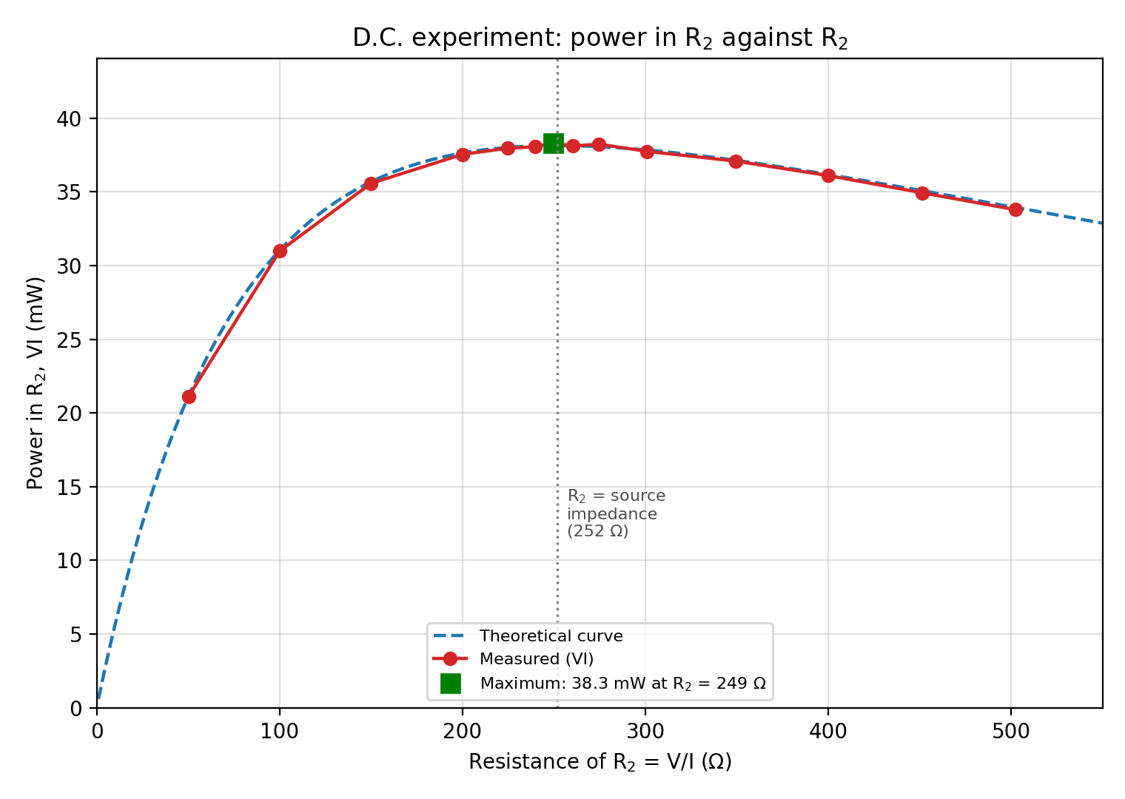
Graph 1: Power in R2 against R2, D.C. experiment
Graph 2 shows the same for the A.C. experiment. The peak is at R2 of about 285 Ω, which is equal to the size of the source impedance |Zs|.
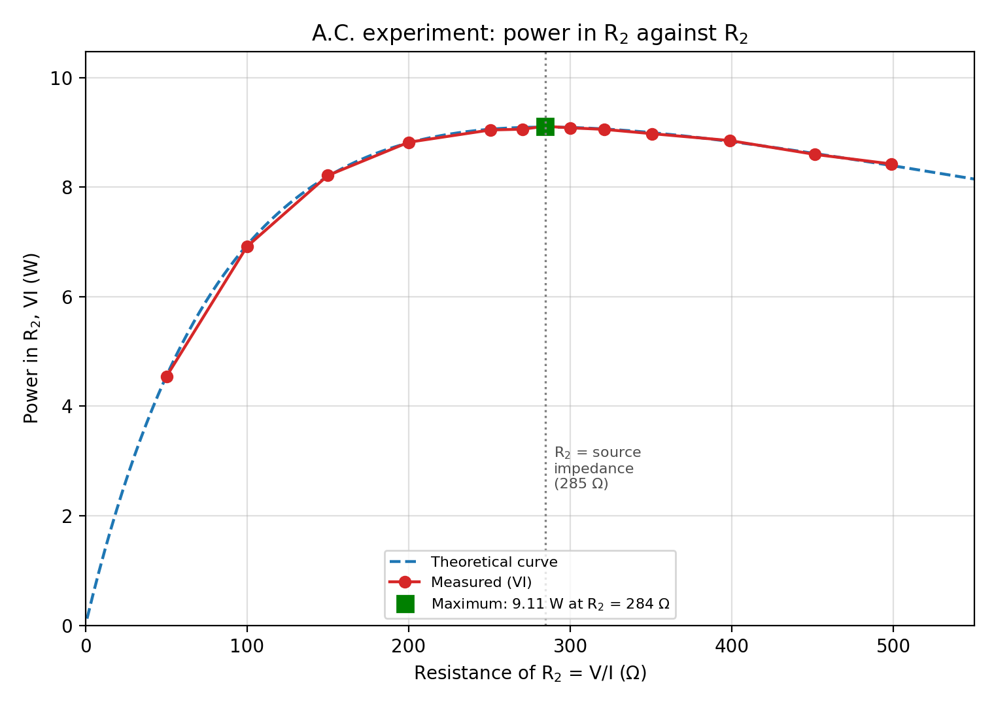
Graph 2: Power in R2 against R2, A.C. experiment

PRECAUTIONS
- All connections were checked by a supervisor before power was switched on.
- The cells were checked to be producing just over 6 V before and after connection to the circuit.
- The meter ranges were set correctly (0 – 0.1 A and 0 – 10 V for D.C.; 0 – 1 A and 0 – 100 V for A.C.) to avoid damaging the Avometers.
- The Variac output was checked before every reading to make sure M3 stayed at 100 V.
- Exposed wiring was not touched while the A.C. supply was on.
- Extra readings were taken close to the peak so that the position of the maximum could be found accurately.
- The rheostats were not overloaded, and all equipment was switched off after the experiment.

CONCLUSION
1. Proof of the Maximum Power Transfer Theorem. The power in the load is P = E² R / (Rs + R)². Setting dP/dR = 0 gives R = Rs, so the power is greatest when the load resistance equals the source resistance (the full proof is in the Theory). The experimental results support this. In the D.C. experiment the maximum power was 38.32 mW at R2 of about 249 Ω, close to the theoretical Rs of 252 Ω and Pmax of 38.13 mW.
2. Comparison of experiments A and B. In both experiments, the power in R2 was small when R2 was very large or very small, and reached a clear maximum in between. In the D.C. experiment the maximum came when R2 was equal to the source resistance (about 250 Ω). In the A.C. experiment the maximum came at about 284 Ω, which is equal to the source impedance |Zs| = 284.7 Ω, and is bigger than the resistance alone (265 Ω) because of the net reactance of 104 Ω from the inductor and capacitor. So the theorem holds for both, but for A.C. the load resistance must equal the size of the source impedance, not just its resistance. Small differences between measured and theoretical values are due to meter reading errors, rheostat tolerance and the resistance of the cells, coil and leads.
3. Type of cell used in experiment A. The cells are lead-acid cells (accumulators). Each has a lead dioxide positive plate, a spongy lead negative plate and dilute sulphuric acid as the electrolyte, and gives about 2 V. Three cells in series therefore give just over 6 V. They are secondary (rechargeable) cells, which is why the manual says that they must be recharged when the voltage falls. They have a low internal resistance and can supply steady currents.
4. Principle of the Variac supply. The Variac is an autotransformer. It has one coil wound on an iron core, with the input applied across the whole coil and a sliding carbon brush that touches different turns. By electromagnetic induction, the output voltage is proportional to the number of turns between the brush and the common end, so moving the brush gives a smoothly variable A.C. output voltage. Unlike a two-winding transformer, the output is not electrically separated from the input.

