Mechanical Engineering Laboratory ELA 301
FM311: THE STABILITY OF A FLOATING BODY
Name: [your name] Matric No: [ ] Group: [ ] Date: [ ]
Objectives: (1) To investigate the stability of a floating pontoon. (2) To establish the metacentric height of a floating pontoon.

1. Theory

Equilibrium of a floating body
A body floats at rest when two conditions are met: the weight of the water it displaces equals its own weight (Archimedes’ principle), and the two forces are in line. The weight W g acts downward through the centre of gravity G of the body, and the buoyancy force acts upward through the centre of buoyancy B, which is the centre of gravity of the displaced liquid. On an even keel, G and B lie on the same vertical line (Figure 1a).
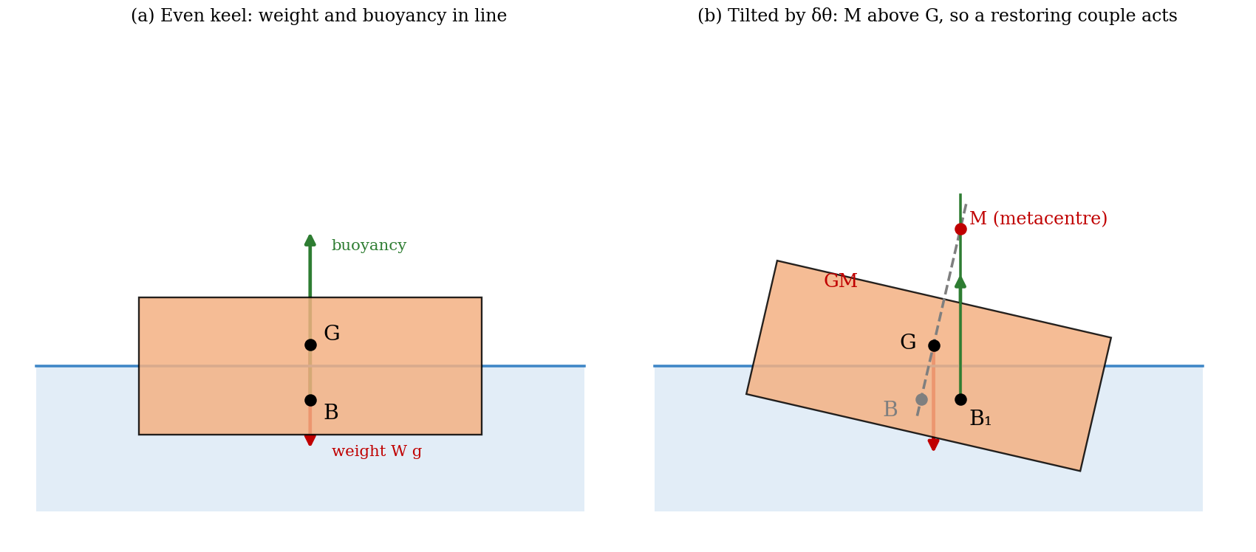
Figure 1: A rectangular pontoon (a) on an even keel and (b) tilted through a small angle δθ

Stability and the metacentre
If the body is tilted through a small angle δθ, the shape of the displaced liquid changes, so the centre of buoyancy moves from B to B₁ (Figure 1b). The vertical line of action of the buoyancy force through B₁ meets the original centre line of the body at a point M called the metacentre. The weight (through G) and the buoyancy (through B₁) now form a couple:
- If M lies above G, the couple tends to restore the body to the even keel position: the body is stable.
- If M lies below G, the couple increases the tilt: the body is unstable.
- If M coincides with G, the body is in neutral equilibrium.
The distance GM is the metacentric height, and it is the measure of stability: the larger GM, the larger the restoring moment for a given tilt, W g · GM · sin δθ.

Experimental determination of the metacentric height
Let the floating assembly have weight W (mass in kg) and let the adjustable weight w be moved through a distance δx₁ across the pontoon. The centre of gravity of the whole assembly moves parallel to the base from G to G₁, by the moment principle:
GG₁ = (w / W) δx₁
The pontoon tilts by an angle δθ until the new centre of gravity is again vertically below M. From the geometry of Figure 1b, GG₁ = GM δθ for a small angle. Eliminating GG₁:
GM = (w / W) δx₁/δθ → (w / W) dx₁/dθ
So the metacentric height is found by measuring the gradient dx₁/dθ of the graph of lateral position of the adjustable weight against the angle of list (θ in radians), for a known weight ratio w/W.

Theoretical metacentric height
When the pontoon tilts, a wedge of volume emerges on one side and an equal wedge becomes immersed on the other. The element of the immersed wedge at distance x from the axis XX, of plan area δs and height x δθ, has volume x δs δθ and weight ρ g x δs δθ, and so a moment about B of ρ g x² δs δθ. Summing over the whole waterplane gives the total restoring moment ρ g δθ ∫x² ds = ρ g I δθ, where I is the second moment of area of the waterplane about XX. The same moment is the buoyancy force ρ g V acting through the arm BB₁ = BM δθ, where V is the volume displaced. Equating:
BM = I / V
For a rectangular pontoon of length L and breadth D (both in mm), and with the water density taken as 1000 kg/m³, the quantities used in the calculation are
I = L D³ / 12 × 10⁻¹² m⁴ V = W / ρ (m³)
Depth of immersion = V / (L D) CB = V / (2 L D)
where CB is the height of the centre of buoyancy above the base. The distances are related by CM = CG + GM = CB + BM. The height of the centre of gravity CG of the assembly changes with the height y₁ of the adjustable weight above the base, according to
CG = y₁ (w / W) + A
where A is a constant for the pontoon (the contribution of the pontoon itself). Using one set of results, A can be found and then used to calculate CG for the other heights. Since GM = (w/W) dx₁/dθ and CM = CG + GM is constant, the stability line, a plot of dx₁/dθ against CG, is a straight line that falls to zero where CG = CM. This intercept is the highest position of G for which the pontoon is stable (Figure 3).

2. Apparatus
The floating-body apparatus (FM311) consists of a rectangular pontoon that floats in a water tank. A sail with five rows of V-slots, spaced 7.5 mm apart vertically, is fixed on the pontoon centre line, and an adjustable weight made of two cylinders screwed together fits in the V-slots to change the height of the centre of gravity. A jockey weight can be moved sideways along the pontoon to produce a tilt, a plumb line hangs from the top of the sail and moves over a scale to give the angle of list, and a set of magnetic weights fixes the base. Other items are a ruler, a knife edge to find the centre of gravity, and a balance.
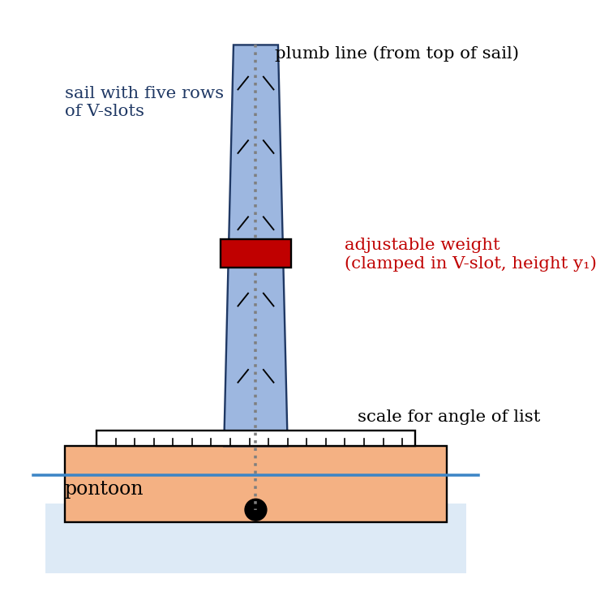
Figure 2: Arrangement of the floating pontoon apparatus
Quantity | Symbol | Value
Total weight of floating assembly (kg) | W | [ ]
Adjustable weight (kg) | w | [ ]
Length of pontoon (mm) | L | [ ]
Breadth of pontoon (mm) | D | [ ]

3. Results
Procedure followed: the length and breadth of the pontoon and the weights W and w were recorded. The height of the centre of gravity was found by balancing the assembly on a knife edge, and the height of the adjustable weight was measured from the outer surface of the pontoon (adding the sheet thickness). With the jockey weight in the central position, the pontoon was floated and the adjustable weight moved sideways until the angle of tilt was zero. The height of the centre of buoyancy and the water level were noted. The adjustable weight was then moved to the right and to the left of the centre in constant steps of 7.5 mm, and the angle of list was recorded, and this was repeated for at least five heights y₁ of the adjustable weight.
Height y₁ (mm) | −52.5 | −45 | −30 | −15 | 0 | 15 | 30 | 52.5
Angles of list (°) for lateral position x₁ (mm) of the adjustable weight; add or remove columns to match your readings, in steps of 7.5 mm.

Derived results:
y₁ (mm) | CG (mm) | dx₁/dθ (mm/°) | GM (mm) | CM = CG + GM (mm)

4. Analysis of Results
- Second moment of area: I = L D³/12 × 10⁻¹² = [ ] m⁴.
- Volume displaced: V = W/1000 = [ ] m³; BM = I/V = [ ] m.
- Depth of immersion = V/(LD) = [ ]; CB = V/(2LD) = [ ].
- From each graph of x₁ against θ, find the gradient dx₁/dθ (convert θ to radians if needed), then GM = (w/W) dx₁/dθ.
- CG = y₁ (w/W) + A, with A found from one measured CG. Then CM = CG + GM.
- Compare the experimental and calculated values of CG, GM and CM, and give the percentage difference.
As a check, with assumed values (L = 350 mm, D = 200 mm, W = 2.5 kg): I = 2.33 × 10⁻⁴ m⁴, V = 2.5 × 10⁻³ m³, BM = 0.093 m, depth of immersion = 35.7 mm and CB = 17.9 mm. If CG were 70 mm, GM = BM − BG = 93 − (70 − 18) = 41 mm, so the pontoon would be stable. This is an illustration, not experimental data.

5. Observations and Precautions
Observations
- Moving the adjustable weight to one side tilts the pontoon, and the plumb line moves over the scale.
- With the weight at a greater height, the same sideways movement produces a larger angle of list.
- At the greatest height of the weight, the pontoon tilts strongly and approaches instability.
Precautions
- Make sure the plumb line hangs free, and is not touching the scale, and wait for the water surface to settle before reading the angle.
- Use small angles of tilt only, so that the theory holds.
- Measure the heights from the outer surface of the pontoon (add the thickness of the sheet), and keep the pontoon dry on the inside.

6. Graphs
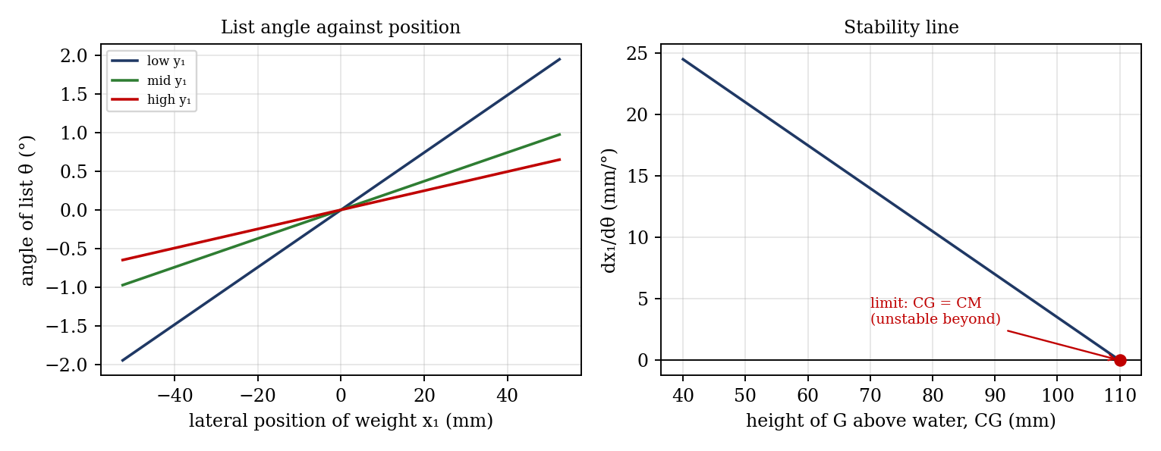
Figure 3: Expected graphs (illustrative, from the theory; not experimental data)
- Angle of list θ against position x₁ of the adjustable weight (one line for each height y₁).
- Metacentric height GM against angle of list θ.
- Gradient dx₁/dθ against height of G above the water surface CG; extrapolate to dx₁/dθ = 0 to find the limiting CG.

7. Discussion
Sources of error: the angle of list is read from the plumb line to about ±0.5°, which is a large fraction of the small angles used; the plumb line may touch the scale and stick; the water surface ripples; the CG measured by the knife edge and the heights measured from the pontoon surface carry errors of about ±1 mm; and the theory is valid only for small angles (about 10° or less), so readings at large lists lie off the straight line. GM calculated from the gradient is sensitive to these errors, because it depends on a small slope. [Compare the experimental and calculated CG, GM and CM, and give the percentage difference.]
Does looping of the plumb-bob over the scale affect the results? Yes. The plumb-bob is part of the floating assembly, and if its mass m_p = 0.604 kg is not included in W, the total weight and the position of the centre of gravity are wrong. A correction is to add it: W′ = W + m_p, and CG′ = (W · CG + m_p · y_p)/(W + m_p), where y_p is the height of the point from which it hangs, which raises G a little. Looping the cord over the scale also adds friction, which makes the plumb line lag and the angle read too small.
How would stability change on a liquid denser than water? The volume displaced is V = W/ρ, so a denser liquid gives a smaller V and a smaller depth of immersion, and BM = I/V increases in proportion to ρ. B also moves up, which reduces BG slightly, so the net result is a larger GM and a more stable pontoon, provided the pontoon still floats with the same weight.

8. Conclusion
The metacentric height of the pontoon was found experimentally from the gradient of the list-angle graph and compared with the calculated value, and the results agreed to within [ ]%. The stability line showed that the pontoon becomes unstable when the centre of gravity rises above [ ] mm, where G reaches the metacentre. The raising of the centre of gravity reduces stability, which is why ships are loaded with heavy cargo low in the hull. The results are used in the design of ships, barges, floating platforms and buoys.

Section D: Questions
- What have you gained from this experiment? [ ]
- What role did you play during the experiment? [ ]
- Could you have performed this experiment all by yourself? YES / NO. Reason: [ ]
- Comment on the experimental procedure for accuracy of results and time saving. [ ]
- Most difficult aspect and suggestions for reducing it: [ ]
- Other methods or apparatus for the same experiment: [ ]
- Parameters required: W, w, L, D, y₁, x₁ and θ.
- One measuring instrument discussed: [ ]
- Practical relevance: ship, barge and buoy design, and loading of vessels.
- Section of your course this experiment best relates: Fluid Mechanics (hydrostatics and buoyancy).
- Suggestions you made while carrying out the experiment: [ ]
- Suggestions by group members that helped the group: [ ]
- Did you put down the results at the time, or copy from group members? YES / NO. Reason: [ ]
- What interested you most during the experiment: [ ]
- Did you come to the laboratory with the laboratory manual? YES / NO. Reason: [ ]
- References: [list books/journals consulted, e.g. a fluid mechanics textbook; Laboratory Manual ELA 301]

