Mechanical Engineering Laboratory ELA 301
FM312: IMPACT OF A JET
Name: [your name] Matric No: [ ] Group: [ ] Date: [ ]
Objectives: (1) To measure the force generated by a jet of water as it strikes a flat plate and a hemispherical cup (and an inclined vane), and compare it with the momentum flow rate in the jet. (2) To determine the coefficient of impact K of the water striking a stationary vane.

1. Theory

Momentum equation for a jet
When a jet of fluid strikes a vane and is deflected, its momentum changes, and by Newton’s second law the force on the vane equals the rate of change of momentum of the fluid. Take the jet to leave the nozzle with velocity V₀ and mass flow rate ṁ = ρ Q, where Q is the volume flow rate. The jet strikes the vane and leaves with velocity V₁ at an angle β to the original direction (Figure 1). Changes in elevation and in pressure in the jet between striking and leaving are neglected. The rate at which momentum enters the system in the direction x of the jet is ṁ V₀, and the rate at which it leaves is ṁ V₁ cos β, so the force on the fluid is the change, and the force F on the vane is equal and opposite:
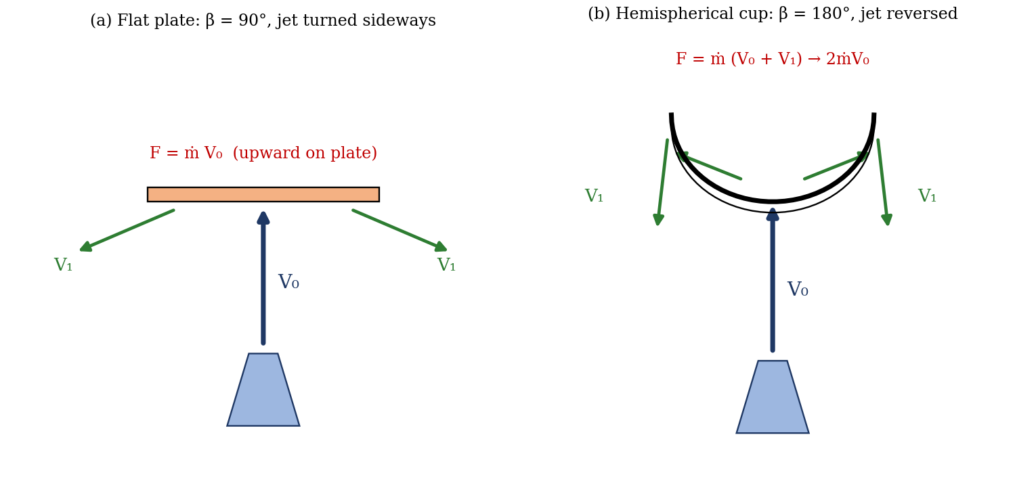
Figure 1: Jet deflected by (a) a flat plate and (b) a hemispherical cup
F = ṁ (V₀ − V₁ cos β)
The manual prints this as W(V₀ − V₁) cos β; that form appears to be garbled in the text, and the standard momentum form above is used here. The velocity of the jet is found from the flow rate and the nozzle area:
V₀ = Q / a a = π d² / 4

Flat plate
For a flat plate perpendicular to the jet, the water leaves sideways, so β = 90°, cos β = 0, and all the momentum in the jet direction is destroyed:
F_flat = ṁ V₀ = ρ Q V₀

Hemispherical cup
For a hemispherical cup the jet is turned through 180°, so β = 180° and cos β = −1, and the force is
F_cup = ṁ (V₀ + V₁)
If there are no losses, the maximum value of V₁ is V₀, giving the maximum possible force on the cup:
F_max = 2 ṁ V₀ = 2 ρ Q V₀
This is twice the force on the flat plate, because the momentum is reversed instead of being destroyed. For a curved vane whose outlet tip makes an angle φ with the direction of the jet, F = ρ Q V₀ (1 + cos φ), which becomes 2ρQV₀ when φ = 0°.

Velocity at the vane
The vane is a height s above the tip of the nozzle, so the jet slows as it rises. The velocity of the jet at the vane, by Bernoulli’s equation, is
V₁² = V₀² − 2 g s
which is a correction of less than 1% for the heights used (about 40 mm), but should be included for accuracy.

Measuring the force
The vane is carried on a lever that pivots on a bearing block and is kept horizontal by a balance weight. When the jet strikes the vane, the force acts upward on the lever. A sliding (jockey) weight W₁ is moved along the lever until the lever is balanced again. Taking moments about the pivot, where X₂ is the distance of the vane from the hinge and X₁ the distance of the sliding weight from it (measured from the zero position):
F_a = W₁ g X₁ / X₂
This is the actual force. It is compared with the theoretical force F_t calculated from the momentum equation, and the coefficient of impact is
K = F_a / F_t
K is less than 1 because of friction and losses, spray, and the fact that the water does not leave exactly at the ideal angle.

2. Apparatus
The bench supply feeds a vertical pipe ending in a tapered brass nozzle, which produces a jet of water that strikes a vane (a flat plate, a hemispherical cup or an inclined vane) inside a transparent acrylic casing, with an outlet at the base that leads the water to the weighing tank. The vane is supported by a lever that pivots on a double-bearing block and carries a balance weight and a sliding weight with a scale. A rotameter measures the flow rate, and a monoblock centrifugal pump supplies the water, with a bypass valve and drain valve (Figure 2).
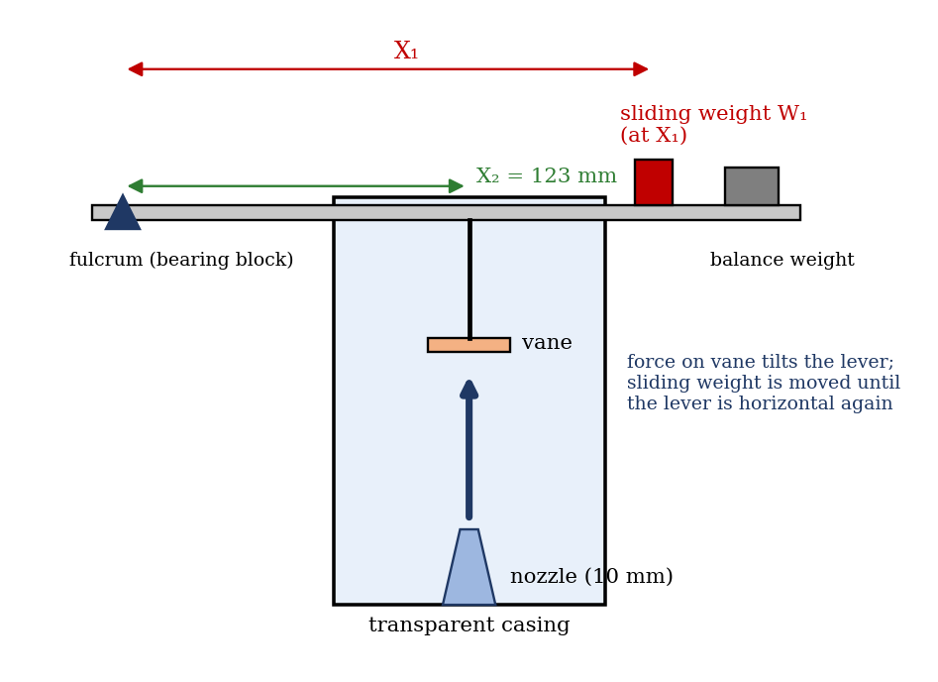
Figure 2: Impact of a jet apparatus (schematic)
Item | Specification
Nozzle diameter, d | 10 mm (a = 7.85 × 10⁻⁵ m²)
Rotameter | 0–50 litres per minute (LPM)
Distance of vane from hinge, X₂ | 123 mm
Sliding weights | 108 g and 180 g
Balance weight | 512 g
Vanes | Hemispherical (106 g), flat (60 g), inclined (60 g)
Main tank / pump | 600 × 400 × 210 mm / 0.5 hp monoblock

3. Results
Procedure followed: the apparatus was levelled by setting the lever to the balanced position (indicated by the tally) and placing the sliding weight at its zero position. A vane was fitted, the balance weight was adjusted until the lever was horizontal, and the pump was started with the supply valve open. The flow was set at a chosen value on the rotameter, and the sliding weight was moved until the lever was restored to the balanced position, and the position X₁ was noted. This was repeated for about seven flow rates, and then repeated for each of the other vanes. Optionally, the flow was also weighed by collecting water in the tank for a measured time.
Diameter of nozzle d = 10 mm; height s of the vane above the nozzle tip = [ ] mm; X₂ = 123 mm; mass of sliding weight W₁ = [ ] kg.
S/No | Vane | Rotameter Q (LPM) | Position X₁ (mm) | F_a (N) | F_t (N) | K = F_a/F_t
1
2
3
4
5
6
Repeat the table for the flat plate, the hemispherical cup and the inclined vane.

Derived quantities for each run: Q = rotameter reading × 10⁻³/60 (m³/s); ṁ = ρ Q (kg/s); V₀ = Q/a (m/s); V₁ = √(V₀² − 2gs) (m/s).

4. Analysis of Results
- Convert the rotameter reading to Q = reading × 10⁻³/60 = [ ] m³/s.
- Jet velocity: V₀ = Q/(7.85 × 10⁻⁵) = [ ] m/s; mass flow ṁ = 1000 Q = [ ] kg/s.
- Actual force: F_a = W₁ g X₁ / X₂ = [ ] N.
- Theoretical force: F_t = ρ Q V₀ for the flat plate, and F_t = ρ Q V₀ (1 + cos φ) for the curved vane (2ρQV₀ for the hemispherical cup) = [ ] N.
- Coefficient of impact: K = F_a / F_t = [ ]; take the mean over the runs.
As a check on your readings, the table below gives the theoretical values for the 10 mm nozzle (illustration from the equations, not experimental data):
Q (LPM) | V₀ (m/s) | ṁ (kg/s) | F_flat = ρQV₀ (N) | F_cup (max) (N)
10 | 2.12 | 0.167 | 0.35 | 0.71
20 | 4.24 | 0.333 | 1.41 | 2.83
30 | 6.37 | 0.500 | 3.18 | 6.37
40 | 8.49 | 0.667 | 5.66 | 11.32
50 | 10.61 | 0.833 | 8.84 | 17.68

5. Observations and Precautions
Observations
- The sliding weight has to move further out as the flow is increased.
- The hemispherical cup needs a larger balancing moment than the flat plate for the same flow.
- The water from the flat plate spreads out sideways, while the water leaves the cup nearly reversed.
Precautions
- Level the apparatus and check the zero (balanced) position of the lever before every set of readings.
- Wait for the flow and the lever to settle before reading the position of the sliding weight; keep the casing closed to avoid splashes.
- Remove air from the pipe and keep the vane height above the nozzle the same for every run; take readings with the eye level with the scale.

6. Graphs
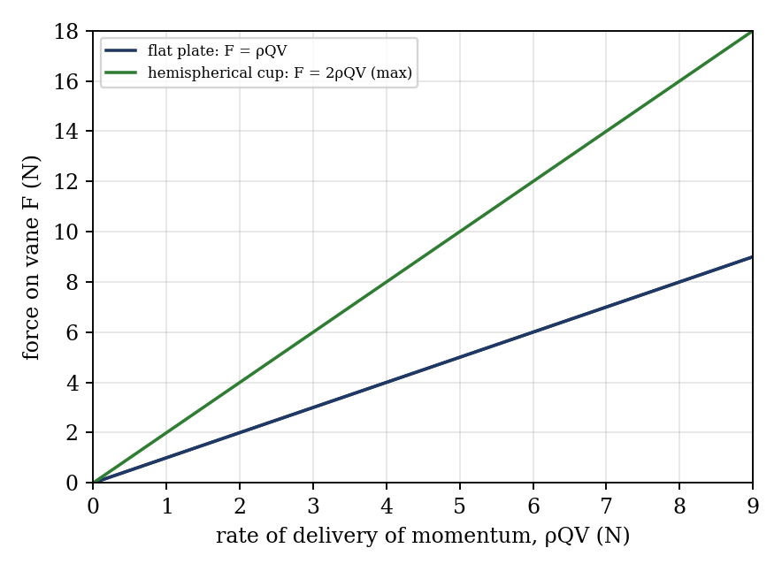
Figure 3: Expected relation between force and momentum delivery (illustrative; not experimental data)
- Force on the vane F against rate of delivery of momentum ρQV₀, for the flat plate and for the hemispherical cup on the same graph sheet (expected slopes about 1 and 2).
- [Optional] Actual force F_a against theoretical force F_t for each vane; the slope of each line is K.

7. Discussion
Compare the two graphs: the cup line should have about twice the gradient of the flat plate line, because momentum is reversed instead of being destroyed. The measured slope for the cup is usually less than 2 because the water leaves the cup at an angle less than 180°, some water is lost as spray, and the exit velocity V₁ is smaller than V₀ owing to friction on the surface. The flat plate is often close to 1, but the jet does not spread out perfectly sideways. [State your own gradients and K values.]
Sources of error: the rotameter reading has a resolution of about ±1 LPM and a few percent of full-scale error; the jet is not perfectly steady and the lever oscillates, so the balance point is uncertain by a few millimetres; friction in the pivot and the splashing of water give an extra force; the vane height and distances are measured to about ±1 mm; and the weight of the water in the jet cup acts on the vane. [Estimate the size of the errors for your data.]
Two industrial applications of high-velocity jets, where the force from deflecting the jet is useful: (1) the Pelton wheel turbine, in which jets strike curved buckets to produce power; (2) water-jet cutting and descaling, and high-pressure cleaning.

8. Conclusion
The force produced by a water jet on a flat plate and on a hemispherical cup was measured and compared with the momentum flow rate. The force on the cup was about [ ] times that on the flat plate, near the theoretical value of 2, and the mean coefficient of impact K was [ ] for the flat vane, [ ] for the hemispherical vane and [ ] for the inclined vane. The results show that curved vanes use the jet momentum better, which is why Pelton wheel buckets are cup shaped.

Section D: Questions
- What have you gained from this experiment? [ ]
- What role did you play during the experiment? [ ]
- Could you have performed this experiment all by yourself? YES / NO. Reason: [ ]
- Comment on the experimental procedure for accuracy of results and time saving. [ ]
- Most difficult aspect and suggestions for reducing it: [ ]
- Other methods or apparatus for the same experiment: [ ]
- Parameters required: nozzle diameter, flow rate, vane height, X₁, X₂, W₁ and the water density.
- One measuring instrument discussed: the rotameter. [Describe: working, range, accuracy.]
- Practical relevance: Pelton wheel turbines, water-jet cutting and cleaning, fire hoses.
- Section of your course this experiment best relates: Fluid Mechanics (momentum equation).
- Suggestions you made while carrying out the experiment: [ ]
- Suggestions by group members that helped the group: [ ]
- Did you put down the results at the time, or copy from group members? YES / NO. Reason: [ ]
- What interested you most during the experiment: [ ]
- Did you come to the laboratory with the laboratory manual? YES / NO. Reason: [ ]
- References: [list books/journals consulted, e.g. a fluid mechanics textbook; Laboratory Manual ELA 301]

