Mechanical Engineering Laboratory ELA 301
FM314: HYDROSTATIC EXPERIMENT
Part 1: Properties of Fluids (Density, Specific Gravity, Capillarity and Viscosity)
Name: [your name] Matric No: [ ] Group: [ ] Date: [ ]
Objectives: (1) To determine the density of a liquid and of a solid, and the specific gravity of a liquid. (2) To demonstrate capillary action and the dependence of the rise of water on the size of the tube or gap. (3) To determine the viscosity of liquids from the terminal velocity of a falling sphere.

1. Theory

Density, specific weight and specific gravity
The density ρ of a fluid is its mass per unit volume (kg/m³). To find the density of a liquid, the mass of a known volume is measured:
ρ = m / V
With mass measured in grams and volume in ml (cm³), ρ (kg/m³) = (mass in g / volume in ml) × 10⁶/10³. The density of pure water at 20 °C is 998.2 kg/m³, usually rounded to 1000 kg/m³. The specific weight is the weight per unit volume, w = ρ g, and has a fixed value only if g is constant. The specific gravity (relative density) is the ratio of the density of a fluid to the density of water, so it has no units:
S.G. = ρ_liquid / ρ_water
Typical values are 0.8 for paraffin, 1.6 for carbon tetrachloride and 13.6 for mercury. Specific gravity is numerically equal to density in g/cm³ and should not be confused with density. It is measured directly with a hydrometer, a hollow glass float weighted to float upright. The depth to which its stem sinks measures the density of the liquid, and a scale on the stem is calibrated to read the specific gravity. A hydrometer with a large bulb and thin stem is more sensitive (Figure 1c).
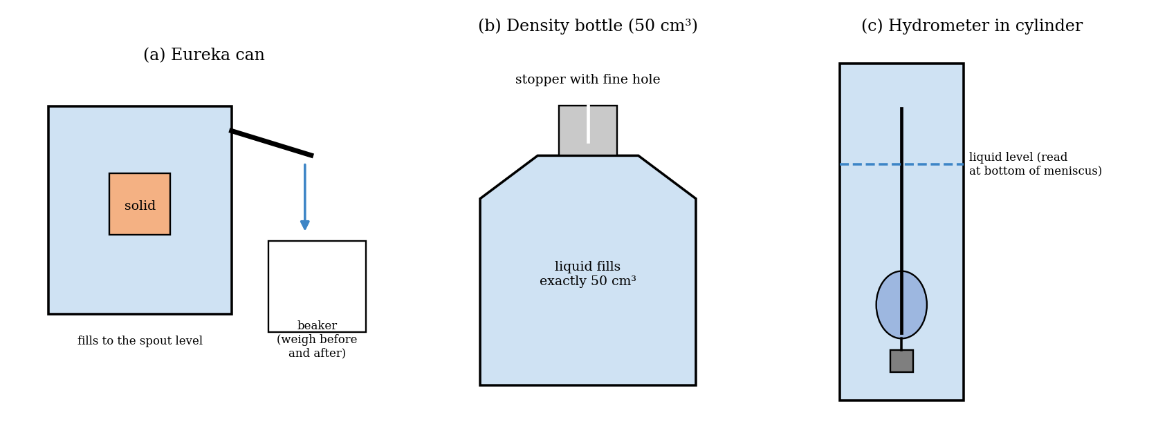
Figure 1: Methods of finding density: (a) Eureka can, (b) density bottle and (c) hydrometer
The volume is the more difficult quantity to measure. The three methods used are: (a) a measuring beaker, in which the volume is read from the graduations, which is not very precise; (b) a Eureka can, which has a fixed spout, so that a solid object put in it displaces a volume of liquid equal to its own volume, which collects in a beaker under the spout; and (c) a density bottle of fixed known volume (50 cm³) with a stopper with a fine hole, which is the most accurate, since its accuracy is limited only by the balance. The density of a solid such as sand is found by putting a known mass of it in the Eureka can in place of the solid: the volume of sand is the mass of water displaced divided by the density of water, and ρ_sand = mass of sand / volume.

Capillarity
Surface tension σ (the force per unit length along the surface) makes a liquid rise in a narrow tube if it wets the walls. For a tube of internal diameter d, the surface tension acts along the circumference, so the upward force is F = π d σ (taking the water as drawn up tangent to the wall). In equilibrium, this is balanced by the weight of the column of liquid of height h_t:
π d σ = (π d² / 4) ρ g h_t
h_t = 4σ / (ρ g d)
For two parallel plates a distance b apart, the force on a width w of the surface is 2wσ (two surfaces) and the weight of the column is w b h ρ g, so
h_p = 2σ / (ρ g b)
For constant σ and ρ, h_t d/4 and h_p b/2 should both be constant and equal to σ/(ρ g). For clean water, σ = 0.0728 N/m, and σ/(ρ g) is about 7.4 mm². The heights obtained in an experiment depend on the cleanliness of the glass and the water, and on the contact angle, so they are often much lower. The effect is significant only if the gap is small, and is generally ignored in hydrostatics for tubes with a bore larger than about 5 mm. It must be allowed for in small manometer tubes.

Viscosity
Viscosity is the property of a fluid that resists relative motion between layers. In a simple case in which a section of fluid is acted on by a shear stress τ, a velocity gradient du/dy is produced which is proportional to the shear stress. The constant is the coefficient of dynamic viscosity μ (N·s/m²):
τ = μ du / dy
This model describes laminar flow, in which layers move smoothly over one another. The kinematic viscosity is ν = μ/ρ (m²/s). Viscosity falls as temperature rises, so the temperature must be recorded.
A common method of finding μ uses the fall of a smooth sphere through the liquid. At equilibrium, the sphere falls at a constant terminal velocity u, when the weight is balanced by the buoyancy and the viscous drag (Figure 2). The drag on a small sphere is 3π μ d u, which is Stokes’ law, so
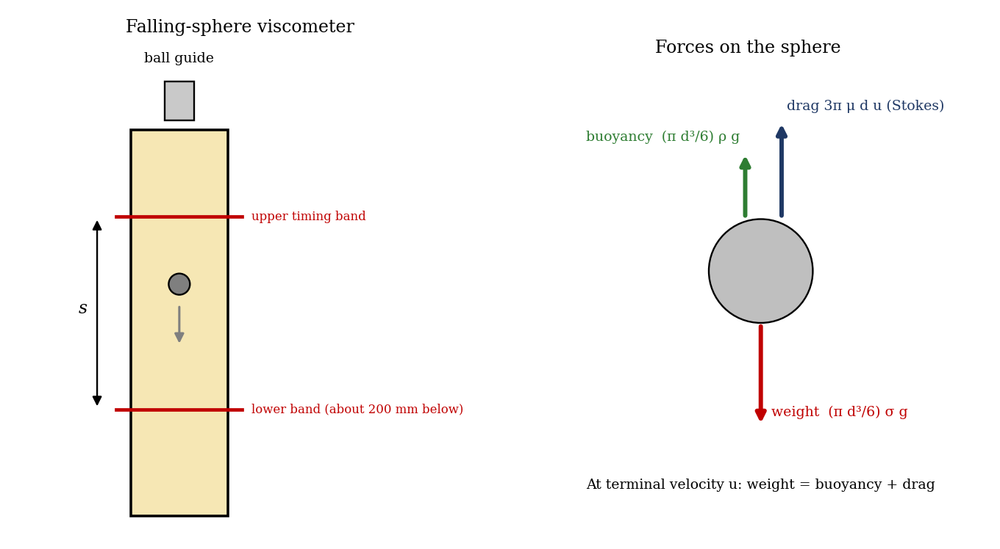
Figure 2: Falling-sphere viscometer and the forces on the sphere
(π d³/6) σ g = (π d³/6) ρ g + 3 π μ d u
u = (g d² / 18 ν) (σ/ρ − 1) so ν = (g d² / 18 u) (σ/ρ − 1)
where d is the diameter of the sphere, σ its density, ρ the density of the fluid and ν the kinematic viscosity. The equation is valid only for viscous flow, for which the Reynolds number Re = u d/ν is below about 0.2. Above this value the errors increase. The equation also shows that the fall velocity decreases as ν increases, and that for different sized balls the velocity depends on d².

2. Apparatus
The hydrostatic apparatus (FM314) with its accessories: for density, a triple-beam balance, measuring beaker, Eureka can, density bottle and a solid object (cylinder or cube); for specific gravity, hydrometers (universal, S.G. 0.7 to 2.0, and sensitive, S.G. 1.0 to 1.2) and tall glass cylinders; for capillarity, three glass capillary tubes with bores of 0.4, 0.8 and 1.6 mm, glass plates with plastic shim strips (thicknesses from 0.050 mm to 0.500 mm), the header tank and clips; for viscosity, three graduated jars filled with water, oil and glycerine, steel balls, a ball guide, movable timing band markers, a stopwatch, a thermometer and a measuring rule.

3. Results
A. Density and specific gravity
Procedure followed: (i) Beaker: the empty beaker was weighed, filled with water, read for volume and weighed again. (ii) Eureka can: the can was filled to overflowing, a solid object was lowered in, and the displaced liquid was collected in a weighed beaker and re-weighed. (iii) Density bottle: the dry bottle was weighed, filled with liquid, stoppered, dried and re-weighed. For specific gravity, the hydrometer was placed in a tall cylinder of the liquid, away from the sides, and read at the bottom of the meniscus.
Method | Mass of liquid (g) | Volume (ml) | Density ρ (kg/m³) | Difference from 1000 (%)
Measuring beaker
Eureka can
Density bottle (50 cm³) |  | 50

Specific gravity from hydrometer: [ ]; from density: [ ]. Density of the solid (sand or other): mass [ ] g, volume of water displaced [ ] ml, ρ = [ ] kg/m³.
B. Capillarity
Procedure followed: the three tubes and the plate assembly (yellow shim, about 0.5 mm gap, or another shim) were placed in the header tank, and the height of water in each was measured above the free surface (water surface at the bottom of the meniscus).
Tube or plates | Bore d or gap b (mm) | Height h (mm) | h d/4 or h b/2 (mm²) | σ = ρ g × (h d/4) (N/m)
Tube 1 | 1.6
Tube 2 | 0.8
Tube 3 | 0.4
Plates | [ ]

C. Viscosity (falling sphere)
Procedure followed: each of the graduated jars was filled with a different liquid and the ball guide inserted at the top. The upper timing marker was set about 20 mm below the base of the ball guide, and the lower marker about 200 mm below the first. A ball was dropped, and the time between the markers was measured with the stopwatch, together with the distance between the markers and the temperature of the liquid.
Liquid | Ball d (mm) | Distance s (mm) | Time t (s) | u = s/t (m/s) | Temp (°C) | ν (m²/s) | Re = u d/ν
Water
Oil
Glycerine

4. Analysis of Results
- Density: ρ = (mass in g / volume in ml) × 10³ kg/m³ for each method; compare with 998 to 1000 kg/m³ for water (the result should be within 1%).
- Specific gravity: S.G. = ρ_liquid / 1000, and compare with the hydrometer reading.
- Capillarity: calculate h d/4 and h b/2 and check that they are nearly constant; find σ = ρ g (h d/4).
- Viscosity: u = s/t, ν = (g d²/18u)(σ/ρ − 1) with σ = 7800 kg/m³ for a steel ball, then Re = u d/ν and check that it is about 0.2 or less.
Worked example for the falling sphere, using the manual’s typical results with fairly thick lubricating oil: ball diameter d = 1.59 mm, temperature 18 °C, time to fall 200 mm = 4.2 s, so u = 0.2/4.2 = 0.048 m/s. With a ball density of 7800 kg/m³ and oil density of 900 kg/m³, σ/ρ = 8.7, and
ν = 9.81 × (1.59×10⁻³)² × (8.7 − 1) / (18 × 0.048) = 2.2 × 10⁻⁴ m²/s
This is in reasonable agreement with the viscosity data for typical liquids (Table below). The Reynolds number is 0.048 × 1.59×10⁻³ / 2.2×10⁻⁴ ≈ 0.35, which is slightly above the limit of 0.2, so a smaller ball should be used for a more accurate result.
Capillarity: the manual’s typical results are shown below, with the values expected for clean water for comparison (σ = 0.0728 N/m).
Tube or plates | Typical h (mm) | h d/4 or h b/2 (mm²) | Clean-water h (mm) | Clean-water value (mm²)
1.6 mm tube | 7 | 2.8 | 18.5 | 7.4
0.8 mm tube | 12 | 2.4 | 37.1 | 7.4
0.4 mm tube | 23 | 2.3 | 74.2 | 7.4
Plates 0.35 mm apart | 14 | 2.5 | 42.4 | 7.4

Viscosity data for typical liquids (as read from the manual’s Table 2; please check the figures against the manual): kinematic viscosity ν × 10⁵ in m²/s is about 0.1 for water, 12 for medium oil, 30 for thick oil, 65 for glycerine and 100 for castor oil, and the time to fall 200 mm is about 0.02 s for water with a 1.6 mm ball, and 20 s for castor oil. Thick oils and glycerine are the most suitable, and the best accuracy is given by the smallest balls.

5. Observations and Precautions
Observations
- The measured density of water was close to 1000 kg/m³, with the density bottle giving the best result.
- Water rose higher in the narrower tubes than in the wider ones, and rose between the plates.
- The steel balls fell much more slowly in glycerine and oil than in water, and the balls fell at constant speed after the first few centimetres.
Precautions
- Keep the glassware clean and free of grease, since impurities change the capillary rise; read the meniscus at its lowest point with the eye level.
- Dry the outside of the density bottle and check that the liquid is level with the top of the stopper; place the Eureka can level, and let it stop dripping.
- Do not let the hydrometer touch the sides of the cylinder; drop each ball through the guide at the centre of the jar, record the temperature, and do not use the oil that is supplied for maintenance of the apparatus.

6. Graphs
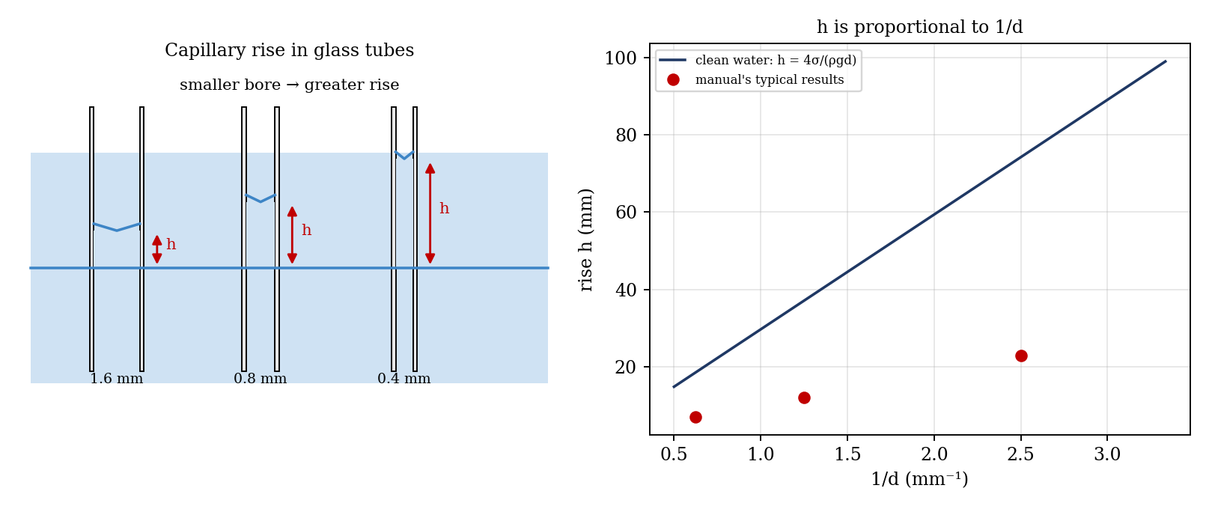
Figure 3: Capillary rise in tubes of different bore, and h against 1/d (illustrative; clean-water line and the manual’s typical results)
- Height h of rise against 1/d for the three tubes (the points should lie on a straight line through the origin, with gradient 4σ/(ρg)).
- [Optional] Terminal velocity u against d² for balls of different diameters in one liquid.

7. Discussion
Density. The density bottle should be the most accurate, because its volume is known exactly and its accuracy depends only on the balance. The measuring beaker is the least accurate, because the graduations are coarse and cannot be checked. The Eureka can is less accurate than the bottle, because of drops left on the spout and in the object, but it shows a more basic way of finding volume. Whether the best accuracy is given by a narrow deep can or a wide shallow one is a question for discussion: a narrow deep can has a smaller surface area, so a small error in the level gives a smaller error in volume.
Would the density of water be the same on the Moon, where gravity is one-sixth of that on Earth, and would you obtain the same result using the methods above? Density is mass per unit volume, and neither the mass nor the volume of water changes with gravity, so the density of water is the same. The methods used here weigh the liquid on a beam balance, which compares masses against standard masses, so they would give the same result on the Moon. A spring balance or a measurement of weight would give a reading one-sixth as large, and the specific weight (ρ g) would be one-sixth of the Earth value.
Capillarity. The results show that the rise is greater for narrow tubes, and that h d/4 is roughly constant, as the theory predicts, so σ is roughly constant. The values obtained (about 2.3 to 2.8 mm², which corresponds to σ of about 0.023 to 0.027 N/m) are well below the clean-water value of 7.4 mm² (0.073 N/m), which shows that the glass and water were contaminated or not wetted well. In most hydrostatic calculations the effect is ignored, but for manometer tubes of small bore it must be taken into account, or tubes with a bore above about 5 mm used.
Viscosity. Sources of error: the temperature changes the viscosity significantly (a few degrees changes ν by several per cent); timing by stopwatch has an uncertainty of about 0.3 s, which is large for water, where the fall time is only a fraction of a second, so only thick liquids should be used for accurate work; the ball is not in an infinite fluid, and the jar walls affect the speed; the ball may not have reached its terminal velocity by the first marker; the diameter of the ball (measured to about 0.01 mm) enters as d², which gives a 1.3% error for d = 1.6 mm; and the Reynolds number may be above 0.2. [Add your own comparison with the values in the table.]

8. Conclusion
The density of water was found as [ ] kg/m³ with the density bottle, which is within [ ]% of 1000 kg/m³, and the specific gravity of the liquid was [ ]. Water rose in the capillary tubes and between the plates to heights that increased as the bore or gap got smaller, and h d/4 was approximately constant, at [ ] mm², which corresponds to a surface tension of about [ ] N/m. The kinematic viscosity of the oil was found to be [ ] m²/s at [ ] °C, using Stokes’ law. Density and specific gravity are used in hydrometers for checking fuels, battery acid and coolants; capillarity matters in the rise of water in soil and in small bore manometers and instruments; and viscosity is important in the choice of lubricating oils and in pipe flow.

Section D: Questions
- What have you gained from this experiment? [ ]
- What role did you play during the experiment? [ ]
- Could you have performed this experiment all by yourself? YES / NO. Reason: [ ]
- Comment on the experimental procedure for accuracy of results and time saving. [ ]
- Most difficult aspect and suggestions for reducing it: [ ]
- Other methods or apparatus for the same experiment: [ ]
- Parameters required: mass, volume, tube bore or plate gap, height of rise, ball diameter, fall distance and time, and temperature.
- One measuring instrument discussed: the hydrometer (or density bottle). [Describe: principle, range, reading.]
- Practical relevance: fuel and coolant testing, lubricant selection, and small-bore manometers.
- Section of your course this experiment best relates: Fluid Mechanics (properties of fluids).
- Suggestions you made while carrying out the experiment: [ ]
- Suggestions by group members that helped the group: [ ]
- Did you put down the results at the time, or copy from group members? YES / NO. Reason: [ ]
- What interested you most during the experiment: [ ]
- Did you come to the laboratory with the laboratory manual? YES / NO. Reason: [ ]
- References: [list books/journals consulted, e.g. a fluid mechanics textbook; Laboratory Manual ELA 301]

