Mechanical Engineering Laboratory ELA 301
FM314: HYDROSTATIC EXPERIMENT
Part 2: Hydrostatic Principles, Upthrust and Centre of Pressure
Name: [your name] Matric No: [ ] Group: [ ] Date: [ ]
Objectives: (1) To demonstrate the principles of hydrostatic pressure and Pascal’s law. (2) To verify Archimedes’ principle by measuring the upthrust on a body. (3) To demonstrate buoyancy and flotation. (4) To determine the centre of pressure on a plane surface and compare the measured moment with theory.

1. Theory

Hydrostatic pressure and Pascal’s law
In the study of hydrostatics we are mainly concerned with the pressures produced on solid boundaries by static fluids. The density of a liquid does not vary much with pressure, and the variation with temperature can usually be ignored, so for water the density is taken as constant, 1000 kg/m³. Consider a vertical column of liquid of constant cross-sectional area A and height h (Figure 1a). The downward force at plane 2 is the sum of the pressure p₁ acting over the area A at plane 1 and the weight of the liquid in the column, and for equilibrium this must be balanced by the pressure p₂ acting upward over A:
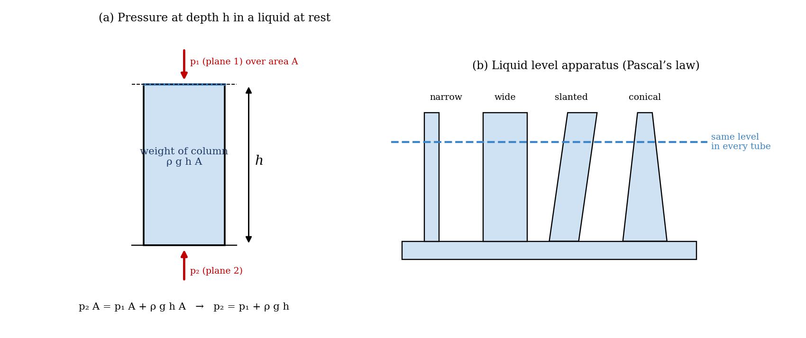
Figure 1: (a) Pressure at depth h, and (b) the liquid level apparatus
p₂ A = p₁ A + ρ g h A p₂ = p₁ + ρ g h
The area cancels and plays no part, so the pressure depends only on the depth. If the area is very small, p₂ can be taken as the pressure at a point in the liquid, and since the pressure at a point acts equally upward and downward, we deduce that pressure at a point in a liquid acts equally in all directions. This is Pascal’s law. There are two further facts that follow: (a) the pressure forces between a liquid at rest and a solid boundary always act normal to the plane of the boundary (if they did not, shear forces would be produced and the liquid would move); and (b) the pressure is the same at all points in a horizontal plane in a liquid at rest (otherwise a sideways force would act on an element, and the liquid would move).

Upthrust and Archimedes’ principle
Consider a rectangular body of plan area A floating in a liquid with its bottom a depth h below the surface. The pressure on its bottom is p₂ = p₁ + ρ g h, and equals p₁ at the top, so the net upward force, the upthrust, which balances the weight W of the body, is
W = (p₁ + ρ g h) A − p₁ A = ρ g h A
Since h × A is the volume of liquid displaced, this is the weight of the displaced liquid. This is a simple case of Archimedes’ law: the upthrust on a body is equal to the weight of the liquid it displaces. It is true for any body, irrespective of its shape, provided that the body and the liquid are at rest. In the upthrust experiment, a cylindrical body is lowered into a beaker of water on a balance. Extra water raises the level by a height h, and the balance has to carry the upthrust (which is equal to the weight of the water displaced) as well as the added water, so that
applied weight = added water weight + upthrust = 2 × (weight of water displaced)
when the extra water fills the annular space around the body, since the added water weight equals the weight of water displaced by the rise in level. So half the applied weight above the datum equals the weight of the water displaced, and the weight of displaced water is ρ g h A_w, where A_w = (area of the beaker − area of the body) is the area of the water surface that rises.

Buoyancy and flotation
The upthrust depends only on the immersed volume and not on the density or the weight of the body. Whether a body floats or sinks does depend on these. If the maximum buoyancy force, produced when the body is fully immersed, is greater than its total weight, the body floats with only part of its volume immersed, in equilibrium where the buoyancy just equals its weight; if it is less, the body sinks. The criterion for floating is therefore that the average density of the body is less than that of the liquid. Stability depends on the position of the centre of gravity relative to the centre of buoyancy (see the experiment on the stability of a floating body).

Centre of pressure on a plane surface
The centre of pressure is the point on a plane at which the total fluid thrust can be said to act, normal to that plane. A quadrant tank (Figure 3) is part of a balance. The cylindrical sides of the quadrant (radii R₁ and R₂) have their axes through the pivot O, so the fluid pressure on them, which acts normal to the surface and so passes through O, exerts no moment about O. The only moment is due to the fluid pressure on the plane surface, and this is balanced by weights W on a hanger on the opposite side. Let γ = ρ g be the weight per unit volume of water, B the breadth of the plane (75 mm), y the distance from O along the plane, h the depth of the water surface below O, and θ the angle of the plane to the vertical (here θ = 0°). An element of the plane of width dy at distance y has a depth (y cos θ − h) below the surface, so
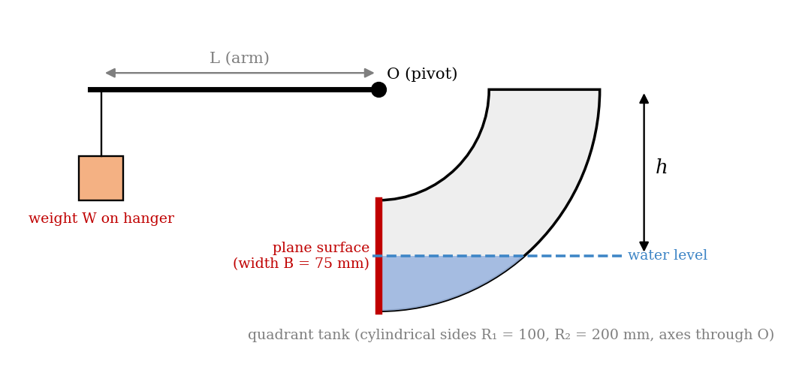
Figure 3: Quadrant tank apparatus (schematic); the plane surface is the vertical face from R₁ to R₂ below the pivot O
dF = γ (y cos θ − h) B dy dM = y dF = γ B (y² cos θ − h y) dy
Case 1: plane fully submerged (limits R₁ and R₂). Integrating the moment about O:
M = γ B [ cos θ (R₂³ − R₁³)/3 − (h/2)(R₂² − R₁²) ]
This is the equation of a straight line, y = m x + c, so a graph of M against h is a straight line with a negative gradient −(γB/2)(R₂² − R₁²), from which γ can be calculated (it should be 9810 N/m³ for water).
Case 2: plane partially submerged (limits R₂ and h sec θ). For θ = 0:
M = γ B [ R₂³/3 − h R₂²/2 + h³/6 ]
M + γ B R₂² h / 2 = γ B R₂³ / 3 + γ B h³ / 6
So a graph of h³ against M + γ B R₂² h/2 is a straight line, with gradient 6/(γB), in which γ obtained from Case 1 is used. The total thrust is F = γ B[(R₂² − h²)/2 − h(R₂ − h)] for θ = 0 and the depth of the centre of pressure along the plane is y_cp = M/F.

2. Apparatus
(a) The liquid level apparatus: vertical tubes of different sizes, shapes and cross-sections, joined by a horizontal pipe at the bottom and connected to the header tank, filled with the bilge pump and an 800 ml beaker, with the drain valve closed. (b) The fluid upthrust apparatus: a cylindrical body (diameter 70 mm) on a moulding above the three-beam balance, a beaker (internal diameter 96 mm) and weights. (c) Plastic beakers and weights for the simple buoyancy demonstrations. (d) The centre of pressure apparatus: a quadrant tank assembly on a balance, with a weight hanger and weights, a trimming tank on the same side as the hanger, a scale on the quadrant to read the water level h below the pivot, a pipette and coloured dye, and a bench with the water supply (Figures 2 and 3).
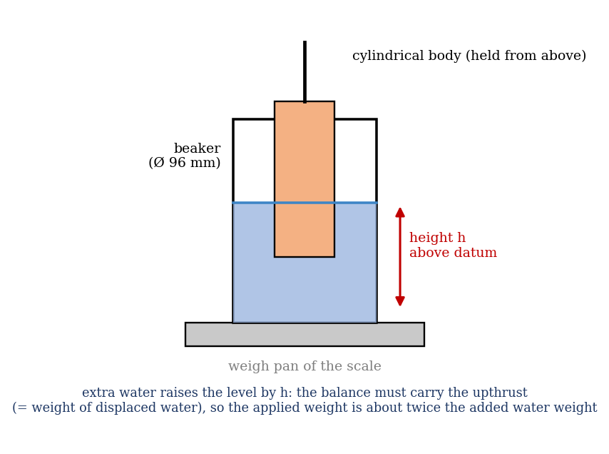
Figure 2: Fluid upthrust apparatus (schematic)

3. Results
A. Liquid level apparatus. Procedure followed: before filling the apparatus, the levels expected in each tube were predicted, and the apparatus was filled to various levels with the drain valve closed. The levels in all the tubes were compared, and any difference in the thinner tubes was noted as an effect of surface tension. Result: the levels in all tubes were [the same / differed by ___ mm].
B. Fluid upthrust. Procedure followed: the diameters of the body and the beaker were measured (areas 0.00385 m² and 0.0072 m² in the manual’s example, so the water area A_w = 0.00335 m²). The body was slid out from its parked position over the weigh pan, placed in the beaker by turning it through 90°, and the beaker was rested on the pan. The beaker was filled with water until the body was just in the water and the scale balanced; the weight for balance and the height of water were the datum values. A little water was added, the scale rebalanced, and the weight and height recorded. This was repeated for at least six steps up to near the maximum volume of the beaker. Heights were converted to metres and weights to newtons.
No. | Water height on scale (mm) | Height above datum h (m) | Applied weight for balance (g) | Weight above datum (N) | Weight of water displaced ρ g h A_w (N)
Datum |  | 0 |  | 0 | 0
1
2
3
4
5
6

C. Buoyancy and flotation (simple demonstrations). Observations: (a) a beaker floated upside down (bottom downward) tips over, depending on which way it goes, and will not float in the upright position without weights; it is ‘top heavy’. (b) A few weights placed in the centre of the bottom of the beaker, in the water, make it more stable, and it floats in a more upright position, because the centre of gravity is lowered. (c) With further weights, it floats lower in the water, and its stability further improves. (d) When enough weights are added (about 450 g for a 450 ml beaker), the beaker sinks: at this point the average density of the beaker, with its contents, equals the density of water. Record your observations: [ ]
D. Centre of pressure. Procedure followed: both tanks were empty and the assembly was trimmed to bring the submerged plane to the vertical (0° position), by gently pouring water into the trim tank until the balance reached 0° (a weight hanger and a few masses were added if needed). The first weight hanger and additional weights were then added, and water was poured into the quadrant tank until the 0° balance was restored; the additional weight (not the trim weight) and the water level h were noted. This was repeated for the full range of weights. Distance from the pivot to the weight hanger, L = [ ] mm.
No. | Mass W on hanger (g) | M = W g L/10³ (N·m) | h (mm) | h³ (m³) | M + γ B R₂² h/2 (N·m)
1
2
3
4
5
6
7
8

4. Analysis of Results
- Upthrust: calculate the water displaced for each rise, V = h A_w, and its weight ρ g V; compare it with half of the applied weight above the datum. Plot both against the height above datum.
- Manual’s typical calculation: body diameter 70 mm (A = 0.00385 m²), beaker diameter 96 mm (0.0072 m²), so A_w = 0.00335 m²; datum height 37.5 mm with balance weight 472 g (4.63 N). With water added, the height is 60 mm, so h = 0.0225 m above datum, and the weight for balance is 621 g (6.09 N), which is 1.46 N above datum. The water volume increase is 0.0225 × 0.00335 = 7.5 × 10⁻⁵ m³, weighing 1000 × 9.81 × 7.5 × 10⁻⁵ = 0.736 N. The balance weight above datum (1.46 N) is therefore roughly twice the weight of the water displaced (0.736 N), which verifies Archimedes’ principle.
- Centre of pressure: calculate M = W g L, and plot M against h for the points with h < R₁ (fully submerged); the gradient gives −(γB/2)(R₂² − R₁²), from which γ is found.
- For the partly submerged points (R₁ < h < R₂), plot h³ against M + γ B R₂² h/2; the gradient is 6/(γB); compare γ with 9810 N/m³.
As a check, with B = 75 mm, R₁ = 100 mm, R₂ = 200 mm and γ = 9810 N/m³, the equations give the following moments about the pivot (an illustration from the theory, not your data; the manual’s symbol ω for the weight density is written γ here to avoid confusion with the hanger weight).
Water level h below pivot (mm) | Moment M (N·m)
0 | 1.717
50 | 1.165
100 | 0.613
125 | 0.362
150 | 0.169
175 | 0.044
200 | 0.000

5. Observations and Precautions
Observations
- The water levels in all the tubes of different shapes and sizes were the same, apart from a small rise in the thinnest tubes due to surface tension.
- The weight needed to balance was about twice the weight of the added water.
- The moment needed to balance fell as the water level in the quadrant tank fell, becoming zero when the plane was just no longer submerged.
Precautions
- Make sure both tanks are empty and trim the assembly to the 0° position before every experiment; add water slowly, and let the balance settle before reading.
- Read water heights with the eye level, at the bottom of the meniscus; use the pipette to remove water that is added in excess; keep the beaker and the body clean and free of air bubbles.

6. Graphs
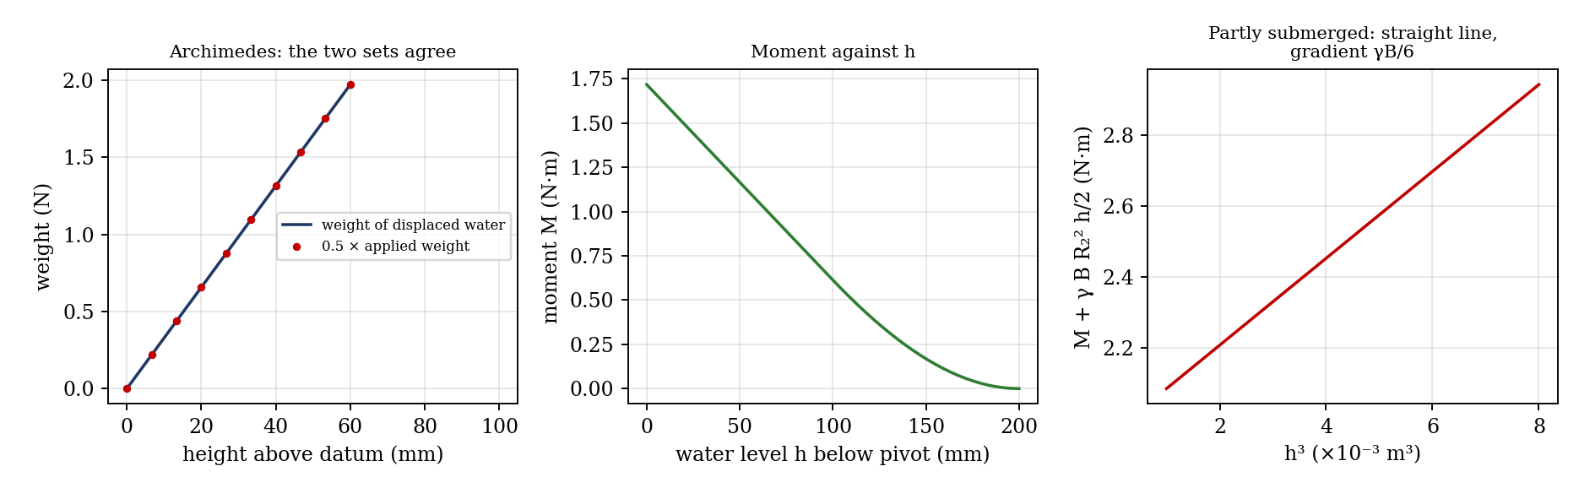
Figure 4: Expected graphs (illustrative, from the equations; not experimental data)
- Displaced weight of water and 0.5 × applied weight (vertical axis) against height of water above datum; compare the two sets of results.
- Moment M against h for the fully submerged plane (gradient −γB(R₂² − R₁²)/2).
- h³ against M + γ B R₂² h/2 for the partly submerged plane.

7. Discussion
Sources of error: in the upthrust experiment, the height of the water is read to about ±0.5 mm (which is 2% of a 25 mm rise), the beaker and body diameters are measured to ±0.2 mm (a 0.3% error in the diameter gives about 1% in the area difference A_w), air bubbles, water clinging to the sides, and the balance’s own resolution (±1 g, which is about 0.01 N). In the centre of pressure experiment: the trimming of the balance, friction at the pivot, the small amount of water left in the pipework, errors in reading h (±1 mm, a large fraction near the top of the range), the distance L, and the water entering the pivot’s cylindrical sides, which is assumed to exert no moment. The moment is zero when h = R₂, so the readings at small moments have large percentage errors. [Compare your measured and calculated values, and the γ obtained, with 9810 N/m³.]
The liquid level experiment shows that pressure depends on depth alone, so the shape and the width of a vessel do not matter (the hydrostatic paradox), and that pressure is transmitted equally in all directions. The agreement in the upthrust experiment shows that the upthrust is the weight of liquid displaced, which is why ships float, and the buoyancy demonstrations show the link between average density and floating.

8. Conclusion
The levels of water in tubes of different shapes were equal, confirming that the pressure at a given depth is independent of the shape. The weight needed to balance in the upthrust experiment was [ ] times the weight of the displaced water (theory 2), verifying Archimedes’ principle to within [ ]%. The moment on the plane surface of the quadrant tank agreed with the theoretical value, and the weight density obtained, γ = [ ] N/m³, compares with 9810 N/m³. These principles are used in the design of dams, gates, ships, submarines, hydrometers and hydraulic systems.

Section D: Questions
- What have you gained from this experiment? [ ]
- What role did you play during the experiment? [ ]
- Could you have performed this experiment all by yourself? YES / NO. Reason: [ ]
- Comment on the experimental procedure for accuracy of results and time saving. [ ]
- Most difficult aspect and suggestions for reducing it: [ ]
- Other methods or apparatus for the same experiment: [ ]
- Parameters required: water level, weights, dimensions of the body and beaker, quadrant radii R₁ and R₂, breadth B and the arm length L.
- One measuring instrument discussed: the three-beam balance (or the scale on the quadrant tank). [Describe.]
- Practical relevance: dams, sluice gates, ships and submarines, hydrometers and hydraulic systems.
- Section of your course this experiment best relates: Fluid Mechanics (hydrostatics).
- Suggestions you made while carrying out the experiment: [ ]
- Suggestions by group members that helped the group: [ ]
- Did you put down the results at the time, or copy from group members? YES / NO. Reason: [ ]
- What interested you most during the experiment: [ ]
- Did you come to the laboratory with the laboratory manual? YES / NO. Reason: [ ]
- References: [list books/journals consulted, e.g. a fluid mechanics textbook; Laboratory Manual ELA 301]

