Mechanical Engineering Laboratory ELA 302
FM321: VORTEX FLOW
Name: [your name] Matric No: [ ] Group: [ ] Date: [ ]
Objective: To obtain the important characteristics of free and forced vortices.

1. Theory

Vortices
A vortex is formed when the streamlines in a flow field are concentric circles. Vortices matter in pumps and turbines, and explain natural phenomena such as the bath-tub vortex, the whirlwind and the tornado. When the total head H increases from one streamline to the next, the flow is rotational, and when H is the same across all the streamlines, the flow is irrotational. The first type is called a forced vortex, and the second a free vortex.

Radial pressure variation
Consider a fluid element of density ρ, of radial thickness δr and angle δθ, moving in a circle of radius r at speed u (Figure 1). The pressure is p on the inner face and p + (∂p/∂r)δr on the outer face, and the net force toward the centre is (∂p/∂r) r δθ δr (the pressures on the sides give the extra term). Its mass is ρ r δθ δr, and its acceleration toward the centre is u²/r, so Newton’s law gives
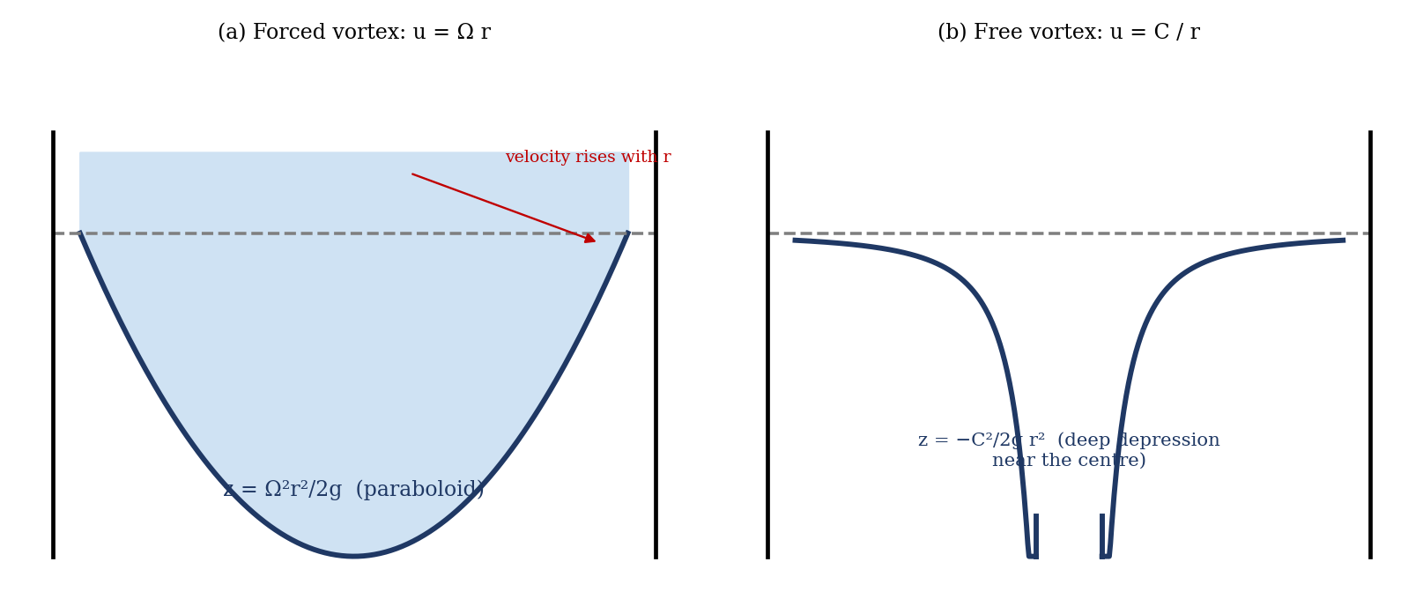
Figure 1: Surface shape of (a) a forced vortex and (b) a free vortex
dp/dr = ρ u² / r
Including gravity (z measured upward), the piezometric head p/ρg + z varies as
d/dr ( p/ρg + z ) = u² / (g r)
The total head is H = u²/2g + p/ρg + z, and differentiating it with respect to r:
dH/dr = (u/g)( du/dr + u/r )
These two equations give the variation of piezometric and total head across the streamlines of any vortex flow.

Forced vortex
In a forced vortex the fluid rotates as a solid body, u = Ω r with Ω constant. Then d/dr(p/ρg + z) = Ω² r/g, and integrating, p/ρg + z = Ω² r²/2g + k. Taking the pressure and elevation at the centre to be zero (datum), k = 0. At the free surface p = 0, so the height of the surface above the centre is
z = Ω² r² / 2g
which is a paraboloid of revolution. The total head, from dH/dr = (Ωr/g)(Ω + Ω) = 2Ω² r/g, is H = Ω² r²/g + C, and with H = 0 at r = 0:
H = Ω² r² / g
So H and z both vary with r², with gradients Ω²/g and Ω²/2g respectively, i.e. H is twice z. The head increases with radius (rotational flow).

Free vortex
For an irrotational flow dH/dr = 0, so du/dr + u/r = 0, which integrates to
u r = C (u = C / r)
The velocity increases toward the centre. With the surface elevation at a very large radius as the datum, dz/dr = u²/g r = C²/g r³, and so
z = − C² / (2 g r²)
This is a depression in the surface height as the centre is approached, becoming very deep near r = 0, and a graph of log(−z) against log r has a gradient of −2. In real fluids the viscosity prevents the velocity becoming infinite, so the centre of a real free vortex turns like a forced vortex.

2. Apparatus
The vortex apparatus (Figure 2) consists of a transparent cylindrical tank rotated by a motor, with a stopper at the base of the tank (for the forced vortex), a perforated cylinder with an annular space for water to enter (for the free vortex), a surface probe on a vertical scale and a horizontal scale (to read r), a total head probe connected to a water manometer, and a stopwatch to time 20 revolutions.
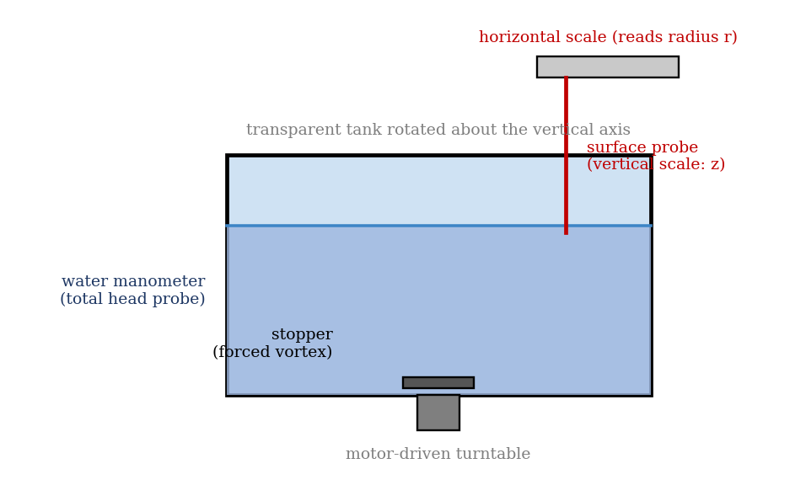
Figure 2: Vortex apparatus (schematic)

3. Results
Procedure followed. (a) Forced vortex: the stopper was placed at the base of the tank, and the surface probe was checked against the hole on top of the stopper, with the horizontal scale adjusted to read 150 mm with the probe at the centre of the hole. The base of the probe was placed on the stopper, and the vertical reading (zero, or recorded if not zero) noted. Water was poured to about half depth and the apparatus was levelled by reading the surface at the ends of a diameter. The motor was switched on, and the surface allowed to become steady (rough readings every two minutes until constant), and 20 revolutions were timed. About 36 readings of the surface along a diameter were then taken, with extra points near the centre, and 20 revolutions were timed again. The surface probe was then replaced by the total head probe, and the water manometer was read at similar positions. (b) Free vortex: the horizontal scale and stopper were removed and the perforated cylinder fitted, the scale was replaced and water was allowed to enter through the annular space, with the assembly rotating at fairly low speed. The flow was adjusted to give a steady condition with a good height at the outside. The surface profile was measured as before (about 36 readings across a diameter, with more near the centre), and repeated with the total head probe.
Time for 20 revolutions: [ ] s, so Ω = 2π × 20 / t = [ ] rad/s.
Table 1: Measurement of surface profile
Horizontal reading R (mm) | Vertical LHS (mm) | Vertical RHS (mm) | z (LHS) | z (RHS) | Average z | r (mm) | r² (mm²)

Table 2: Measurement of total head (omit for the free vortex where not required)
r¹ (cm) | r² (cm) | Vertical scale reading (cm) | Pitot tube H¹ | H² | Mean H | r (cm) | r² (cm²)

4. Analysis of Results
- From each pair of vertical readings, take the height of the surface above (or below) the centre z, and the radius r from the horizontal reading (r = reading − 150 mm for the centre); average the left and right values.
- Forced vortex: compare z (measured) with Ω² r²/2g using the measured Ω; and H with Ω² r²/g.
- Free vortex: find C = u r from the head or the velocity, and compare z with −C²/2g r².
- Calculate the gradient of z against r², and of H against r², and compare with Ω²/2g and Ω²/g.
As a check, if the forced vortex turns 20 revolutions in 20 s (Ω = 2π = 6.28 rad/s), the surface should rise above the centre by z = Ω²r²/2g = 1.3, 5.0, 11.3, 20.1 and 31.4 mm at r = 25, 50, 75, 100 and 125 mm. For a free vortex with an assumed C = 0.01 m²/s, the surface is lower than the datum by 5.7, 2.0 and 0.5 mm at r = 30, 50 and 100 mm. These are illustrations, not your data.

5. Observations and Precautions
Observations
- In the forced vortex the surface is a smooth paraboloid and rises toward the wall; in the free vortex there is a deep dimple near the centre.
- The depression in the surface grows with speed.
Precautions
- Level the apparatus, and wait until the surface is steady before reading; keep the probe tip just touching the surface.
- Take more readings near the centre, where the surface changes quickly; make sure the manometer is free of air bubbles; read the probe with the eye level.

6. Graphs
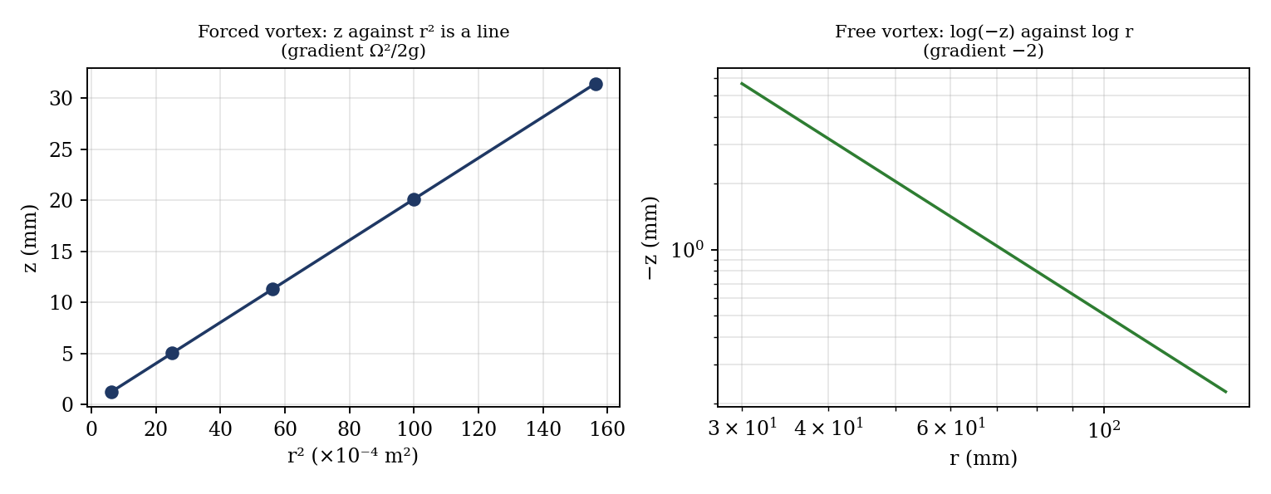
Figure 3: Expected graphs (illustrative, from the equations; not experimental data)
- Forced vortex: H and z against r (H + z are negative in the manual’s sign convention), and z and H against r² (gradients Ω²/2g and Ω²/g, lines through the origin).
- Free vortex: z against r, and log(−z) against log r; the gradient should be −2.

7. Discussion
1. Sources of error. The probe readings (±0.5 mm) are a large fraction of z near the centre, where the surface is steep; the surface fluctuates and the apparatus may not be level; the speed is not exactly constant, and is found from timing 20 revolutions (±0.3 s gives about ±1.5% on Ω, so ±3% on Ω²); the probe disturbs the surface and meniscus; the water manometer reading is affected by air bubbles; in the free vortex the viscosity of the water prevents the surface from reaching the theoretical depth near the centre. [Compare your gradients with Ω²/2g and Ω²/g.]
2. How can the forced vortex be converted into a pump? By adding a casing with an outlet at the rim, and fitting vanes (an impeller) to the rotating tank, with a feed at the centre. The fluid is thrown outward, and the pressure rise from centre to rim is Ω²R²/2g (the head), which is what a centrifugal pump produces. The outlet must be at the periphery and the inlet at the centre.
3. Whirlpool and tornado. A whirlpool in a river or sink is a free vortex: fluid drawn toward a drain keeps its angular momentum, so u r is constant and the speed rises sharply toward the centre, while the pressure and surface fall. A tornado is a similar vortex in air, with a core that rotates as a forced vortex and an outer region that behaves as a free vortex (a Rankine vortex); the very low pressure at the core (the ‘depression’) draws in air and debris, and the high wind speeds near the core cause the damage.

8. Conclusion
The surface profile of a forced vortex was found to be a paraboloid z = Ω²r²/2g, with gradient [ ] against r² compared with the theoretical [ ], and the total head was H = Ω²r²/g. In the free vortex, the surface fell toward the centre, and log(−z) against log r had a gradient of [ ] (theory −2), showing u ∝ 1/r. The results are used in the design of centrifugal pumps, turbines, cyclone separators and in the study of whirlpools and tornadoes.

Section D: Questions
- What have you gained from this experiment? [ ]
- What role did you play during the experiment? [ ]
- Could you have performed this experiment all by yourself? YES / NO. Reason: [ ]
- Comment on the experimental procedure for accuracy of results and time saving. [ ]
- Most difficult aspect and suggestions for reducing it: [ ]
- Other methods or apparatus for the same experiment: [ ]
- Parameters required: speed of rotation, radius r, surface height z, total head H and the density of water.
- One measuring instrument discussed: the surface probe and the water manometer. [Describe: how they work, accuracy.]
- Practical relevance: centrifugal pumps, turbines, cyclone separators and the study of whirlpools and tornadoes.
- Section of your course this experiment best relates: Fluid Mechanics.
- Suggestions you made while carrying out the experiment: [ ]
- Suggestions by group members that helped the group: [ ]
- Did you put down the results at the time, or copy from group members? YES / NO. Reason: [ ]
- What interested you most during the experiment: [ ]
- Did you come to the laboratory with the laboratory manual? YES / NO. Reason: [ ]
- References: [list books/journals consulted, e.g. a fluid mechanics textbook; Laboratory Manual ELA 302]

