Mechanical Engineering Laboratory ELA 302
FM322: PIPE FLOW LOSSES EXPERIMENT
Name: [your name] Matric No: [ ] Group: [ ] Date: [ ]
Objective: To measure the loss of pressure at different flow rates in a pipe, and to demonstrate the distinction between laminar and turbulent flow.

1. Theory

Head loss due to friction
When a liquid flows steadily through a pipe, there is a loss of pressure head due to friction, which depends on the velocity of the fluid, the wetted surface, and the nature of the surface. This experiment investigates the relationship between this pressure drop and the flow rate, and shows the difference between laminar and turbulent flow. Osborne Reynolds showed that there are two flow regimes, laminar and turbulent. The change between them occurs at a critical velocity for a given flow situation, and it is accompanied by a change in the law of loss of pressure (energy) with velocity. The regime is decided by the Reynolds number
Re = ρ ū d / μ
where ρ is the density of the water, ū the mean velocity, d the pipe diameter and μ the dynamic viscosity of water at the room temperature. Flow in a pipe is laminar for Re below about 2000, and turbulent for Re above about 4000, with a transitional region between.

Laminar flow in a round pipe (Hagen–Poiseuille)
Consider a cylinder of fluid of radius r and length L in steady laminar flow, with pressure drop Δp (Figure 1). The pressure force π r² Δp is balanced by the viscous shear on its surface, τ 2π r L = −μ (du/dr) 2π r L, so du/dr = −Δp r/(2 μ L). Integrating with u = 0 at the wall r = R:
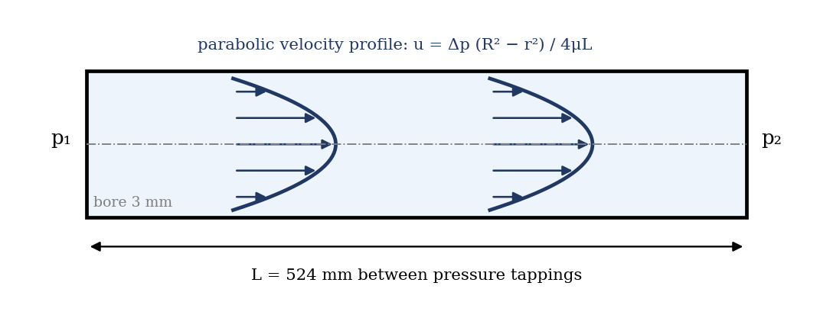
Figure 1: Laminar flow in a round pipe: parabolic velocity profile
u = Δp (R² − r²) / (4 μ L)
The velocity profile is a paraboloid of revolution. The maximum velocity at r = 0 is u_max = Δp R²/(4μL), and the mean velocity is half of it, ū = u_max/2 = Δp R²/(8 μ L). The flow rate Q = π R² ū is therefore
Q = π Δp R⁴ / (8 μ L)
which is the Hagen–Poiseuille equation. Writing the pressure drop as a head loss, Δp = ρ g h_f, and R = d/2:
h_f = 32 μ L ū / (ρ g d²)
So in laminar flow the head loss is proportional to the mean velocity (h_f ∝ ū), and depends on the viscosity but not on the roughness of the surface.

Turbulent flow: the Darcy equation
In turbulent flow the head lost to friction was found by experiment to be proportional to the square of the velocity (approximately). Consider a pipe of diameter d between sections 1 and 2, with pressure p₁ > p₂. The resultant pressure force is (p₁ − p₂) π d²/4, and it overcomes the frictional resistance, which is proportional to the wetted area π d L and to the square of the velocity: f′ (π d L) ū². Equating:
(p₁ − p₂) π d²/4 = f′ π d L ū² h_f = (p₁ − p₂)/ρ g = 4 f L ū² / (2 g d)
where f is the friction coefficient (the Fanning factor, f = f′ 2/ρ; the Darcy factor is 4f). This is the Darcy equation. Dividing by L gives the hydraulic gradient i:
i = h_f / L = k ū² k = 4 f / (2 g d)
In practice, the exponent is nearer 1.75 to 2.0, depending on the roughness, so that i = k ū^n, and a graph of log i against log ū is a straight line of slope n. In laminar flow, n = 1, and in turbulent flow n is between 1.75 and 2. The point where the extended lines intersect gives the critical velocity.

2. Apparatus
The apparatus consists of a stainless steel tube of 3 mm bore with a two-way pressure tapping at each end, the tappings being 524 mm apart. Water is fed into one end and the flow is controlled by a valve at the other end. One hole from each tapping is connected to opposite sides of a water manometer (an isolating valve is fitted, to isolate the manometer when it is not in use). The water manometer is used when the pressure drop is small, and an air chamber at the top is pressurized with a bicycle pump, to bring the water levels within the graduated scale. A mercury–water manometer is used at higher pressure drops, and bleed screws at the top of each limb of the mercury manometer enable it to be made air-free. Water is supplied from the hydraulic bench, and weighed in the weighing tank (Figure 2).
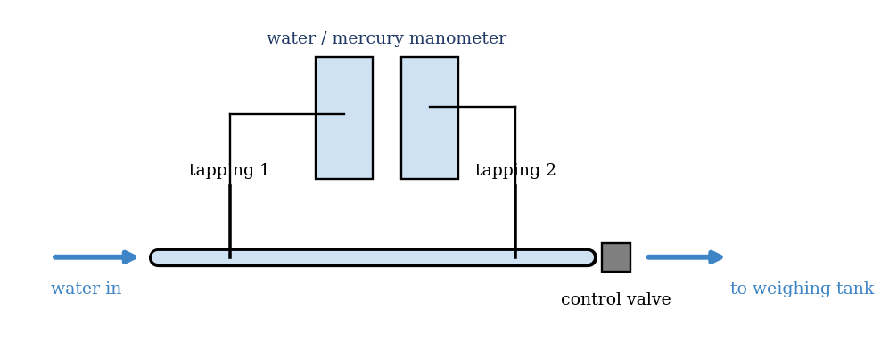
Figure 2: Pipe friction apparatus (schematic)
Quantity | Value
Diameter of tube, d | 3 mm (A = 7.07 × 10⁻⁶ m²)
Distance between tappings, L | 524 mm
Temperature of the water, and μ, ρ | [ ] °C, [ ] Pa·s, [ ] kg/m³

3. Results
Procedure followed: the valve on the hydraulic bench at the end of the pipe was closed, and the motor started. The control valve on the bench was opened wide. The manometer was rid of air bubbles by flexing the lead and tapping the columns gently. The water manometer was connected across the pipe by opening the isolating valve on the pressure tapping, and the chamber above it was pressurized with the bicycle pump until the water level was about half-way down the column. The valve at the end of the pipe was opened slowly until the manometer read about 20 cm, and the time to collect 1.5 kg of water was measured with the manometer reading. The flow was increased in increments of 10 cm on the manometer reading. When the water manometer had reached its final height, the mercury–water manometer was used (isolating the water manometer), and 4.5 kg of water was collected instead of 1.5 kg, until the maximum flow was reached. More readings were taken where the slope of the graph of manometer reading against time changed.
No. | Mass collected (kg) | Time t (s) | Manometer reading Δh (cm) | Head loss h_f (m of water) | Q (m³/s) | ū (m/s) | Re
1
2
3
4
5
6
7
8

4. Analysis of Results
- Flow rate: Q = mass/(ρ t); mean velocity ū = Q/A, with A = π d²/4 = 7.07 × 10⁻⁶ m².
- Head loss: with the water manometer, h_f = Δh (as m of water); with the mercury–water manometer, h_f = Δh (13.6 − 1) = 12.6 Δh.
- Hydraulic gradient i = h_f/L, with L = 0.524 m.
- Reynolds number Re = ρ ū d/μ, with μ and ρ for the room temperature (for example μ = 1.0 × 10⁻³ Pa·s at 20 °C).
- C_f = 2 g h_f/ū² (the manual’s loss coefficient), and log C_f.
As a check, the table below gives the head losses expected for the 3 mm tube for several Reynolds numbers, from the equations (water at 20 °C; laminar h_f = 32μLū/ρgd² and turbulent by the smooth-pipe Blasius relation f = 0.316/Re^0.25 for Re > 2300). It is an illustration, not your data. Note that the head loss rises very quickly in turbulent flow, so that the mercury manometer is needed, and that the manual’s first reading of 20 cm of water (about 200 mm) lies at the upper end of the laminar range (Re ≈ 3000 if laminar) so only the first few readings are laminar.
Re | ū (m/s) | Q (cm³/s) | h_f (mm of water) | i = h_f/L
500 | 0.167 | 1.18 | 32 | 0.128
1000 | 0.333 | 2.36 | 63 | 0.064
2000 | 0.667 | 4.71 | 127 | 0.032
5000 | 1.667 | 11.78 | 929 | 0.038
10000 | 3.333 | 23.56 | 3126 | 0.032
20000 | 6.667 | 47.12 | 10514 | 0.027

5. Observations and Precautions
Observations
- At low flows the manometer reading was steady, and rose in proportion to the flow; at higher flows it fluctuated and rose faster.
- The head loss was much larger than expected at higher flow rates, which required the mercury manometer.
Precautions
- Remove all air bubbles from the manometer and the pressure leads; check the manometer zero at no flow.
- Allow the reading to settle before timing; use a long time for small flows so that the weighing error is small; record the water temperature, since the viscosity depends on it.

6. Graphs
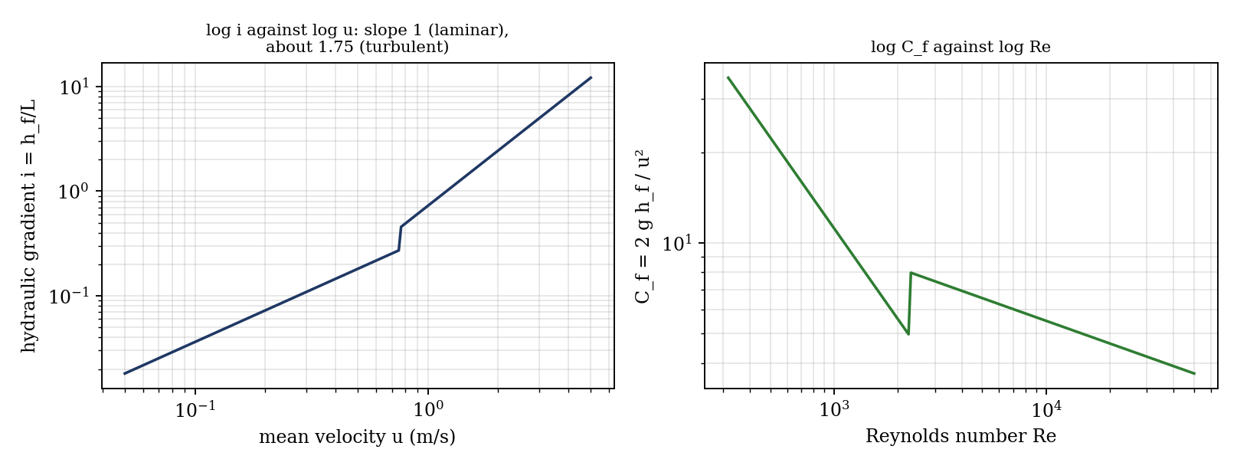
Figure 3: Expected graphs (illustrative, from the equations; not experimental data)
- h_f against ū (comment on the shape).
- log i against log ū (comment on the slope of the graphs, and on the intercepts on the y axis).
- log C_f against log Re.

7. Discussion
Is the transition from laminar to turbulent flow well defined? Not sharply. Between about Re = 2000 and 4000 there is a transitional region in which the flow switches between laminar and turbulent, and the manometer fluctuates, so the points do not lie on either line. The critical point is taken as the intersection of the laminar line (slope 1) and the line through the turbulent points (slope about 1.75 to 2) on the log i–log ū graph, which gives a critical velocity of about [ ] m/s, and the corresponding Reynolds number [ ]. This should be about 2000 to 2300. The slope in turbulent flow (about 1.75 for a smooth pipe) and the intercepts depend on the roughness and on the temperature. [Give your own values.]
How will surface roughness affect the losses? In laminar flow, the head loss does not depend on roughness, since it is controlled by the viscosity of the fluid and the flow is smooth over the roughness elements, so the losses are unchanged. In turbulent flow, roughness increases the losses (the friction factor depends on ε/d), as the eddies caused by the surface projections extract more energy, and the exponent n rises toward 2. A rough pipe may also change to turbulent flow at a slightly lower Reynolds number.
Sources of error: the weighing and timing (±0.3 s, which is significant for short times at high flows); reading the manometer (±1 mm) and air bubbles in the leads; the temperature of the water (which changes μ by about 2% per °C); the pressure tappings at the ends, where the flow is not fully developed (entry effects add to the loss); and the pipe diameter, which enters as d⁴ in the laminar formula (a 1% error in d gives about 4% in h_f).

8. Conclusion
The loss of pressure head in the 3 mm pipe was measured for flow rates giving Reynolds numbers from [ ] to [ ]. The head loss was proportional to velocity in laminar flow (log–log slope [ ]) and to ū^[ ] in turbulent flow. The critical point was found at Re ≈ [ ]. The friction loss in pipes is used to design pipelines, water supply and cooling systems, and to size pumps.

Section D: Questions
- What have you gained from this experiment? [ ]
- What role did you play during the experiment? [ ]
- Could you have performed this experiment all by yourself? YES / NO. Reason: [ ]
- Comment on the experimental procedure for accuracy of results and time saving. [ ]
- Most difficult aspect and suggestions for reducing it: [ ]
- Other methods or apparatus for the same experiment: [ ]
- Parameters required: flow rate (mass and time), manometer reading, pipe diameter and length, and the water temperature.
- One measuring instrument discussed: the manometer (water and mercury). [Describe: principle, range, accuracy.]
- Practical relevance: design of pipelines, pumps, water supply and cooling systems.
- Section of your course this experiment best relates: Fluid Mechanics.
- Suggestions you made while carrying out the experiment: [ ]
- Suggestions by group members that helped the group: [ ]
- Did you put down the results at the time, or copy from group members? YES / NO. Reason: [ ]
- What interested you most during the experiment: [ ]
- Did you come to the laboratory with the laboratory manual? YES / NO. Reason: [ ]
- References: [list books/journals consulted, e.g. a fluid mechanics textbook; Laboratory Manual ELA 302]

