Mechanical Engineering Laboratory ELA 302
FM323: DISCHARGE OVER A WEIR (GRAVIMETRIC HYDRAULIC BENCH)
Name: [your name] Matric No: [ ] Group: [ ] Date: [ ]
Objective: To observe the flow rate over a series of weirs of different geometric design (a V-notch and a rectangular weir), to verify the theoretical relationships between flow and head, and to obtain the coefficient of discharge for each profile.

1. Theory

Flow over a weir
A weir (or notch) is an opening or obstruction over which a liquid flows, and it is used to measure the flow rate in channels. The flow depends on the shape of the weir, and on the height H of the upstream water surface above the sill (or the bottom of the notch). The tests below establish the relation between these quantities and verify the theory. The theory assumes that the water particles pass through the notch like a free jet, so that a layer at depth x below the free surface has the velocity v = √(2 g x) (Torricelli’s result), the approach velocity is negligible, and the pressure in the jet is atmospheric.
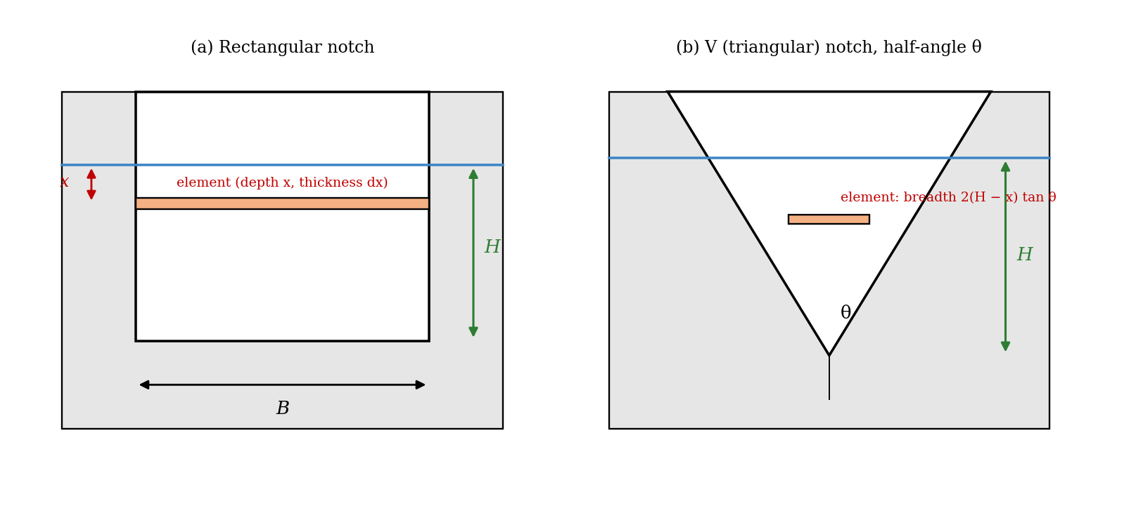
Figure 1: (a) Rectangular notch and (b) V-notch, with a thin horizontal element at depth x

Rectangular notch
Take an element of thickness dx at depth x, with the width B of the notch (Figure 1a). The area of the element is B dx, the velocity through it is √(2gx), and so the theoretical mass flow through the element is dq = ρ B √(2gx) dx. Integrating from the free surface (x = 0) to the sill (x = H):
q_th = ρ B √(2g) ∫₀ᴴ x^½ dx = (2/3) ρ B √(2g) H^(3/2) (kg/s)
The actual discharge is less than this, and the coefficient of discharge C_d corrects for it:
q = (2/3) C_d ρ B √(2g) H^(3/2)

Triangular (V) notch
For a V-notch of half-angle θ (Figure 1b), consider an element at depth x. Its breadth is 2(H − x) tan θ, so its area is 2(H − x) tan θ dx, the velocity is √(2gx), and the mass flow through the element is ρ 2(H − x) tan θ √(2gx) dx. The total discharge is therefore
q_th = 2 ρ tan θ √(2g) ∫₀ᴴ (H x^½ − x^(3/2)) dx = 2 ρ tan θ √(2g)(2/3 − 2/5) H^(5/2)
q_th = (8/15) ρ tan θ √(2g) H^(5/2) q = (8/15) C_d ρ tan θ √(2g) H^(5/2)

The relation q = K Hⁿ
In both cases the flow follows a power law in the head, q = K Hⁿ, where q is the discharge (kg/s) and H the head above the sill (m), and K and n are constants. Taking logarithms gives a straight line:
log q = log K + n log H
From the theory, n = 5/2 and K = (8/15) ρ tan θ √(2g) for the V-notch, and n = 3/2 and K = (2/3) ρ B √(2g) for the rectangular notch. The gradient and intercept of the measured log q against log H graph give n and K. If n is taken to be the same in the experiment and the theory, the coefficient of discharge is
C_d = K_measured / K_calculated
Why is C_d needed? The theory neglects several effects: the jet contracts after passing the sill (the nappe is narrower than the notch, as in an orifice, the vena contracta), so the area is smaller; the water velocity is not uniform and is not exactly √(2gx) because of viscosity and surface tension (important at small heads); there is the velocity of approach, and energy lost to friction at the edges; and the head is measured at a distance upstream, where the surface has dropped slightly. C_d accounts for all of these in one factor, and it is typically 0.6 for a sharp-edged notch.

2. Apparatus
The weir tank, made of fibreglass, is divided into three parts: the setting section at the entry, the middle gauging section, and the drainage section. Water is delivered to the tank by the pipe in the entry section, and the setting time is provided by the fact that it takes some time before the water flows over the weir, which separates the middle section from the drainage section, from where it is drained back through a pipe to the weighing tank of the hydraulic bench. Two sharp-edged weirs, one rectangular and the other triangular, made of hard plastic, fit into a groove in the weir tank, and rubber seals in the groove prevent water bypassing the weir. The height of the water just before the weir is taken with a hook gauge in a transparent setting chamber alongside the weir tank; the chamber is connected to the bottom of the middle section by a plastic tube, and the hook gauge measures to 0.1 mm. A drain is provided for the setting section (Figure 2).
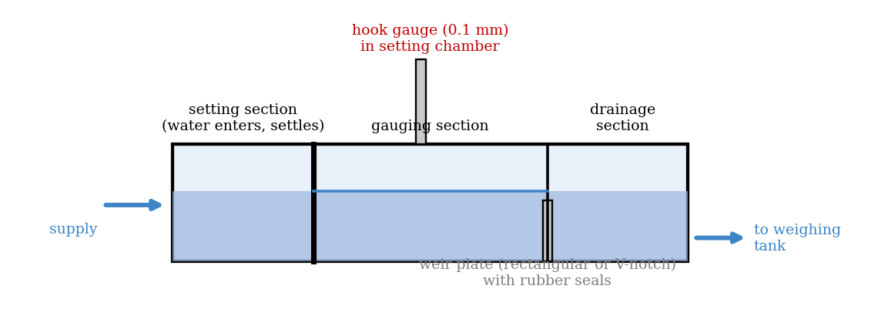
Figure 2: Weir tank and hook gauge (schematic)
Quantity | Value
Width of the rectangular notch, B | [ ] mm
Half-angle of the V-notch, θ | [ ]° (tan θ = [ ])
Hook gauge reading at the datum (water level with the sill) | [ ] mm

3. Results
Procedure followed: the V-notch weir was inserted into the groove in the weir tank, and it was checked that there was no leakage past the rubber seals. The drain taps of the setting section were closed, and the control valve of the hydraulic bench opened so that the tank filled steadily. The control was adjusted and finally closed just at the point where the surface of the water was level with the bottom of the notch; this level was read on the hook gauge and served as the datum. The control valve was then opened fully (taking care not to flood the weir). The flow was timed by collecting a mass of water in the weighing tank, and the level was measured with the hook gauge. The water level was then reduced in about six to eight even steps and the measurements repeated. The whole experiment was repeated with the rectangular weir.
V-notch weir
No. | Hook gauge reading (mm) | Head H (mm) | Mass collected (kg) | Time (s) | q (kg/s)
1
2
3
4
5
6
7
8

Rectangular weir
No. | Hook gauge reading (mm) | Head H (mm) | Mass collected (kg) | Time (s) | q (kg/s)
1
2
3
4
5
6
7
8

4. Analysis of Results
- Head: H = (hook gauge reading) − (datum reading), converted to metres; discharge q = mass collected/time (kg/s).
- Calculate log q and log H, and plot log q against log H; the gradient is n and the intercept on the log q axis is log K.
- Compare n and K with the theoretical values: V-notch n = 5/2 and K = (8/15) ρ tan θ √(2g); rectangular n = 3/2 and K = (2/3) ρ B √(2g).
- Coefficient of discharge: C_d = K_measured/K_calculated, assuming n is the same, and also C_d from each reading, q/q_th.
As a check, for assumed notches (a 90° V-notch, tan θ = 1, and a rectangular notch B = 50 mm) the theoretical constants are K = 2362 kg/s·m^2.5 for the V-notch and K = 147.6 kg/s·m^1.5 for the rectangular notch. The table gives the theoretical discharge and the discharge with an assumed C_d of 0.6 (typical for sharp-edged notches). This is an illustration, not your data.
Head H (mm) | V-notch q_th (kg/s) | V-notch, C_d = 0.6 (kg/s) | Rectangular q_th (kg/s) | Rectangular, C_d = 0.6 (kg/s)
20 | 0.13 | 0.08 | 0.42 | 0.25
40 | 0.76 | 0.45 | 1.18 | 0.71
60 | 2.08 | 1.25 | 2.17 | 1.30
80 | 4.28 | 2.57 | 3.34 | 2.00
100 | 7.47 | 4.48 | 4.67 | 2.80

5. Observations and Precautions
Observations
- The discharge increased very quickly with the head, faster for the V-notch than for the rectangular notch.
- The nappe (the sheet of water leaving the weir) contracted after passing the sill, and was narrower than the notch.
Precautions
- Check that the weir is seated in the groove without leakage, and measure the datum with the water just level with the sill.
- Wait for the level to become steady before reading, and read the hook gauge with the eye level (to 0.1 mm); do not allow the weir to flood; keep the nappe free (ventilated).

6. Graphs
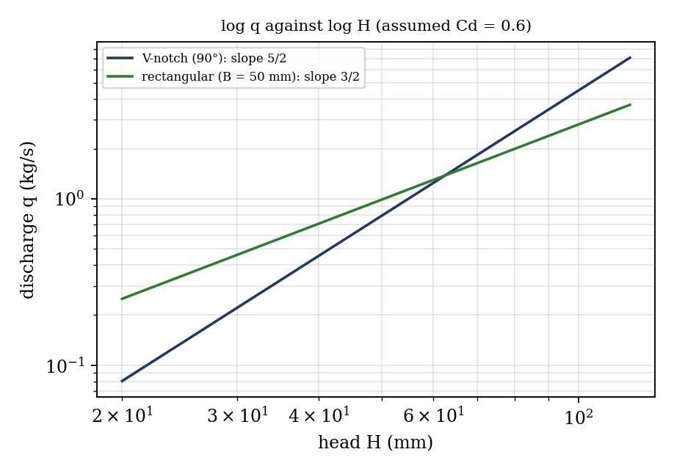
Figure 3: Expected log q against log H lines (illustrative; assumed values, not experimental data)
- log q against log H for the V-notch (gradient n, intercept log K).
- log q against log H for the rectangular weir.

7. Discussion
Compare the values obtained for K and n with the theoretical values for the two notches. The gradient is usually close to 2.5 for the V-notch and 1.5 for the rectangular weir, with the largest deviations at small heads, where surface tension and viscosity matter and the nappe may cling to the plate. A measured K smaller than the calculated one gives C_d < 1, typically about 0.58 to 0.62. Sources of error: the head is read to 0.1 mm but the datum setting is uncertain by about 0.5 mm, which is a large fraction of H at small heads (a 1 mm error in 20 mm gives 5% in H, and 12% in q for the V-notch, since q ∝ H^2.5); the timing and the weighing (±0.3 s); the water surface not being steady; leakage past the seals; the approach velocity (neglected); and a nappe that is not fully ventilated. [Give your values of n, K and C_d.]
Cause for introducing C_d. The theory ignores the contraction of the jet, friction and surface tension, and the non-uniform velocity, so the theoretical flow is always larger than the actual flow. C_d corrects the theoretical flow to the actual flow: actual flow = C_d × theoretical flow.
Practical applications. Weirs and notches are used to measure the flow of water in rivers, irrigation channels, canals and drains, in water and sewage treatment plants and in industrial processes, and in the laboratory. The V-notch is used for small flows, where its sensitivity to the head gives better accuracy, and the rectangular weir for larger flows. Weirs are also used to control water levels.

8. Conclusion
The discharge over a V-notch and a rectangular weir was measured against the head. The graph of log q against log H gave n = [ ] and K = [ ] for the V-notch (theory 2.5), and n = [ ] and K = [ ] for the rectangular weir (theory 1.5), so the coefficients of discharge were C_d = [ ] and [ ]. The discharge increases with H^2.5 for the V-notch and H^1.5 for the rectangular weir. Weirs are used for flow measurement in rivers, canals and industrial channels.

Section D: Questions
- What have you gained from this experiment? [ ]
- What role did you play during the experiment? [ ]
- Could you have performed this experiment all by yourself? YES / NO. Reason: [ ]
- Comment on the experimental procedure for accuracy of results and time saving. [ ]
- Most difficult aspect and suggestions for reducing it: [ ]
- Other methods or apparatus for the same experiment: [ ]
- Parameters required: head over the weir, mass collected and time, notch width or angle, and the water density.
- One measuring instrument discussed: the hook gauge. [Describe: principle, resolution (0.1 mm), reading.]
- Practical relevance: flow measurement in rivers, canals, irrigation and treatment plants.
- Section of your course this experiment best relates: Fluid Mechanics (flow measurement).
- Suggestions you made while carrying out the experiment: [ ]
- Suggestions by group members that helped the group: [ ]
- Did you put down the results at the time, or copy from group members? YES / NO. Reason: [ ]
- What interested you most during the experiment: [ ]
- Did you come to the laboratory with the laboratory manual? YES / NO. Reason: [ ]
- References: [list books/journals consulted, e.g. a fluid mechanics textbook; Laboratory Manual ELA 302]

