Mechanical Engineering Laboratory ELA 301
LINEAR HEAT CONDUCTION: THERMAL CONDUCTIVITY OF A METAL BAR
Name: [your name] Matric No: [ ] Group: [ ] Date: [ ]
Objectives: (1) To investigate the temperature distribution along a metal bar carrying a steady heat flow. (2) To find the thermal gradient and the thermal conductivity of the bar. (3) To investigate the effect of the thermal connection (heat transfer paste) at the joints, and (4) to record how the temperatures change with time until they stabilize (thermal log).

1. Theory

Fourier’s law of conduction
Conduction is the transfer of heat through a solid from the hotter to the colder region, as a result of the movement and collisions of atoms and free electrons. Fourier’s law states that the rate of heat flow Q through a material is proportional to the area A normal to the flow and to the temperature gradient dT/dx:
Q = − k A dT / dx
The constant k is the thermal conductivity of the material, in W/m·K, and the negative sign shows that heat flows from high to low temperature (Figure 1). Metals are good conductors because of their free electrons, so k is large (about 120 W/m·K for brass and 400 W/m·K for copper), while insulators have a small k.
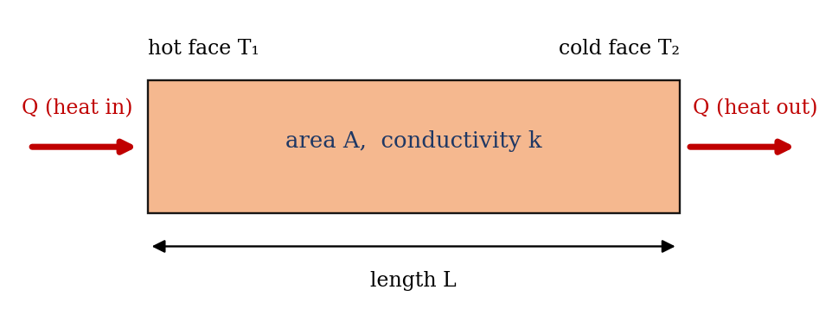
Figure 1: One-dimensional conduction through a bar

Steady one-dimensional conduction
For a uniform bar with no heat loss from its sides, in the steady state the heat flow is the same at every section, so Q, k and A are constant, and integration gives a linear temperature distribution along the bar:
T(x) = T₁ − (Q / k A) x so dT/dx = − Q / (k A)
A graph of temperature against distance is therefore a straight line, and its gradient is the thermal gradient. The thermal conductivity is obtained from the measured heat flow and the gradient:
k = Q / (A × |dT/dx|) = Q L / (A ΔT)
where A = π d²/4 for a bar of diameter d, and ΔT is the temperature difference over the length L. The heat flow Q can be taken as the electrical power supplied to the heater (V × I). Each section of the bar behaves as a thermal resistance R = L/(kA), by analogy with Ohm’s law (ΔT = Q R).

Thermal contact resistance
Where two sections of a bar are joined, the surfaces touch only at the high points of their roughness, and the gaps are filled with air, which is a poor conductor. This adds a contact resistance R_c, which produces a sudden drop in temperature ΔT_c = Q R_c at the joint, so the temperature graph has a step at the joint (Figure 3a). Heat transfer paste fills the gaps with a material that conducts much better than air, which lowers R_c and the step at the joint. With the paste removed, the step increases.

Unsteady conduction and the thermal log
After the heater is switched on, the bar takes time to warm up, because it has to store energy as its temperature rises. Temperature then depends on time and position, according to the heat conduction equation
∂T / ∂t = α ∂²T / ∂x² α = k / (ρ c)
where α is the thermal diffusivity, ρ the density and c the specific heat capacity. The temperature at each point rises roughly exponentially toward its final value, with a time constant of the order of L²/α, which for a brass bar of about 0.1 m is of the order of minutes. The readings are therefore recorded every 10 seconds until they stop changing, since only steady state readings can be used with the equations above.

2. Apparatus
The apparatus consists of a metal bar made up of a heated section with an electric cartridge heater, an interchangeable middle section (brass here) and a water-cooled section, all in line and joined end to end. Seven thermocouples T₁ to T₇ are fitted along the bar, and are read on a digital temperature display. The bar is lagged to reduce heat loss, and the heater power is set and measured with a power control and meter. A supply of cooling water, a flow control and a tube of heat transfer paste are also used (Figure 2).
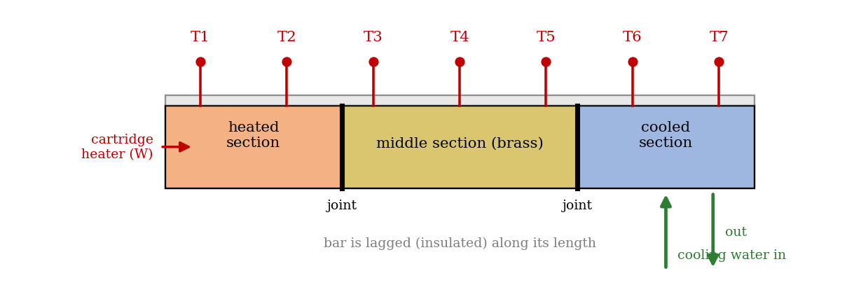
Figure 2: Linear heat conduction apparatus (schematic)
Quantity | Value
Material of middle section | Brass
Diameter of bar, d | [ ] mm
Cross-sectional area, A = π d²/4 | [ ] m²
Positions of T₁ to T₇ along the bar | [ ] (see Table 1)

3. Results
Procedure followed: with the heat transfer paste on the joints, the cooling water was turned on, the heater was set to a chosen power, and the apparatus was left until the temperatures T₁ to T₇ were steady, and then they were recorded. This was repeated for each power setting. The test was repeated with the heat transfer paste completely removed from the joints (good thermal connection comparison). Lastly, the test was repeated using the brass middle section, with a low heater setting (about 30 W) and no cooling water flowing, and the temperatures were recorded every 10 seconds until they began to stabilize (thermal log).
Table 1: Positions of thermocouples
 | T₁ | T₂ | T₃ | T₄ | T₅ | T₆ | T₇
x (mm)

Table 2: Steady-state temperatures (°C)
Condition, power Q (W) | T₁ | T₂ | T₃ | T₄ | T₅ | T₆ | T₇
With paste, [ ] W
With paste, [ ] W
With paste, [ ] W
Without paste, [ ] W

Table 3: Thermal log (brass section, about 30 W, no cooling water), temperatures in °C
Time (s) | T₁ | T₂ | T₃ | T₄ | T₅ | T₆ | T₇
0
10
20
30
40
50
60
70
80
90
100
Continue the log every 10 s until the readings stop changing (add rows as needed).

4. Analysis of Results
- Cross-sectional area: A = π d²/4 = [ ] m².
- Plot T against x for each power setting, draw the best straight line through the points on the same side of the joints, and find the thermal gradient dT/dx = ΔT/Δx = [ ] K/m (calculate it from the slope of the line).
- Thermal conductivity: k = Q / (A × |dT/dx|) = [ ] W/m·K for each power, and then the mean value.
- Contact resistance: from the step ΔT_c at the joint (the difference between the extrapolated straight lines), R_c = ΔT_c / Q = [ ] K/W, for the joint with paste and without paste.
- Percentage difference between the mean k and the handbook value (brass about 120 W/m·K): [ ]%.
- Thermal log: plot T against time and note the time taken to reach 98% of the final temperature.
As a check, for an assumed brass bar of 25 mm diameter (A = 4.91 × 10⁻⁴ m²) and k = 120 W/m·K, with no heat loss, the thermal gradient is Q/(kA), which is about 170 K/m (0.17 K/mm) at 10 W, 340 K/m at 20 W and 509 K/m (0.51 K/mm) at 30 W. This is an illustration from the equation, not experimental data; your bar and readings will differ, but the gradient should be proportional to the power.

5. Observations and Precautions
Observations
- The temperature falls along the bar from the heater end to the cooled end, and the graph is close to a straight line within each section.
- With the paste removed, a larger sudden drop in temperature appears at the joints.
- In the thermal log, the temperatures rise quickly at first and then more slowly until they level off.
Precautions
- Allow the apparatus to reach steady state before taking readings; do not use readings that are still changing.
- Do not touch the heated section; keep the cooling water flowing when the heater is on (except for the thermal log, which uses a low power), and do not exceed the maximum temperature.
- Check that the thermocouples are in good contact and read the same at the start (room temperature); apply the paste thinly and evenly, and clean it off completely for the test without paste.

6. Graphs
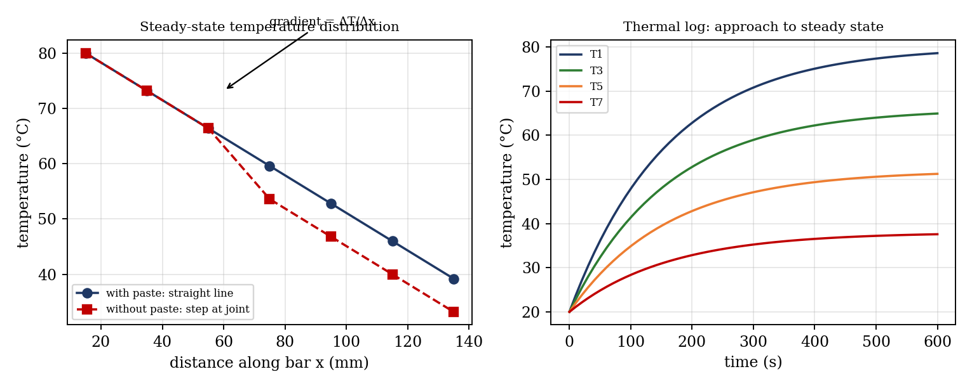
Figure 3: Expected graphs (illustrative; not experimental data): (a) steady-state profiles with and without paste, (b) thermal log
- Temperature T₁ to T₇ against distance along the bar, for each power setting (steady state), with the thermal gradient drawn.
- The same chart for the test without paste, showing the temperature step at the joints.
- Temperature against time for the thermal log.

7. Discussion
Causes of error. (1) Heat loss from the sides of the bar through the lagging, so the heat flow along the bar is less than the electrical input; using Q = V I then overestimates the heat flux, and so overestimates k, and the temperature line curves slightly. (2) Contact resistance at the joints, which is not zero even with paste, and which affects the gradient if the line is drawn through points on both sides of a joint. (3) Thermocouple errors of about ±0.5 K, and errors in their positions, which matter because the gradient is found from differences of readings. (4) Not waiting long enough for steady state. (5) Errors in measuring the heater power and the diameter of the bar (an error in d of 1% gives 2% in A). (6) Variation of k with temperature, which causes slight curvature in the line. (7) The cooling water temperature and flow varying during the test. [Add an estimate of the size of the errors for your results, and compare your k with the handbook value.]
The test without paste should show a bigger temperature step at the joints, and a higher temperature at the heater end for the same power, since the contact resistance adds to the total thermal resistance. The thermal log shows how long the apparatus takes to reach steady state, which is why readings must not be taken early.

8. Conclusion
The temperature distribution along a brass bar was measured for steady heat flow at [ ] power settings. The distribution was linear along each section, and the mean thermal conductivity was found to be [ ] W/m·K, which differs from the handbook value by [ ]%. Removing the heat transfer paste increased the temperature drop at the joints from [ ] K to [ ] K, which shows the importance of good thermal contact. The thermal log showed that the bar took about [ ] s to reach steady state. The results are used in the design of heat exchangers, insulation, electronic heat sinks and engine components.

Section D: Questions
- What have you gained from this experiment? [ ]
- What role did you play during the experiment? [ ]
- Could you have performed this experiment all by yourself? YES / NO. Reason: [ ]
- Comment on the experimental procedure for accuracy of results and time saving. [ ]
- Most difficult aspect and suggestions for reducing it: [ ]
- Other methods or apparatus for the same experiment: [ ]
- Parameters required: heater power, bar diameter, thermocouple positions and temperatures.
- One measuring instrument discussed: the thermocouple. [Describe: working, range, accuracy.]
- Practical relevance: heat exchangers, insulation, heat sinks and engine components.
- Section of your course this experiment best relates: Heat Transfer (conduction).
- Suggestions you made while carrying out the experiment: [ ]
- Suggestions by group members that helped the group: [ ]
- Did you put down the results at the time, or copy from group members? YES / NO. Reason: [ ]
- What interested you most during the experiment: [ ]
- Did you come to the laboratory with the laboratory manual? YES / NO. Reason: [ ]
- References: [list books/journals consulted, e.g. a heat transfer textbook; Laboratory Manual ELA 301]

