Mechanical Engineering Laboratory ELA 301
SM311(B): DEFLECTION OF A CANTILEVER
Name: [your name] Matric No: [ ] Group: [ ] Date: [ ]
Objective: To find experimentally the deflection of a cantilever subjected to (a) a concentrated force and (b) a uniformly distributed load, and to compare it with theory.

1. Theory

Deflection of a cantilever
A cantilever is a beam fixed rigidly at one end, with the other end free. Loads cause it to bend downward, and the deflection is greatest at the free end. For small deflections of a beam of uniform section, the bending moment M at any section is related to the curvature by
E I d²y / dx² = M(x)
where E is Young’s modulus, I the second moment of area of the cross-section (I = b t³/12 for a rectangle of width b and depth t), and y the deflection. The product EI is called the flexural rigidity.

Area-moment method
The manual uses the area-moment (Mohr) method. Its two theorems are: (1) the change in slope between two points of a beam equals the area of the M/EI diagram between them; and (2) the deflection of a point from the tangent at another point equals the moment, about the first point, of the area of the M/EI diagram between them. For a cantilever, the tangent at the fixed end stays horizontal, so the deflection of the free end is the moment of the whole M/EI area about the free end (Figure 1).
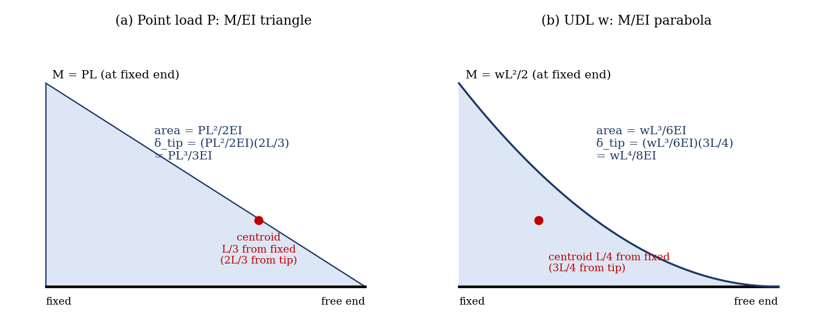
Figure 1: Area-moment method for a cantilever carrying (a) a point load at the free end and (b) a uniformly distributed load
Concentrated force P at the free end. The moment is M = P x′, where x′ is the distance from the free end. The M/EI diagram is a triangle of area PL²/(2EI) whose centroid is 2L/3 from the free end, so
δ_tip = (PL² / 2EI)(2L / 3) = P L³ / 3 E I
Uniformly distributed load w per unit length over the whole length. The moment is M = w x′²/2, and the M/EI diagram is a parabola of area wL³/(6EI), with its centroid 3L/4 from the free end, so
δ_tip = (wL³ / 6EI)(3L / 4) = w L⁴ / 8 E I

Deflection at any point
Applying the same method to a point at distance x from the fixed end gives the deflection at that point. For a point load P at the free end (x = L):
y(x) = P x² (3L − x) / (6 E I)
For a point load P at a distance a from the fixed end, the deflection at x is
y = P x² (3a − x) / (6EI) for x ≤ a y = P a² (3x − a) / (6EI) for x ≥ a
and for a uniformly distributed load w over the whole length:
y(x) = w x² (6L² − 4Lx + x²) / (24 E I)
In the experiment, L = 60 cm, with the dial gauges at x = 30 cm and x = 60 cm. The first formula for x ≥ a also shows that the deflection at x for a load at a is the same as the deflection at a for a load at x, which is the principle of reciprocity (Maxwell’s theorem) met in the previous experiment.

Superposition
For a linear elastic beam with small deflections, the deflection from several loads is the sum of the deflections from each load acting alone. The expression for more than one load acting on the cantilever is therefore found by adding the expressions above, which is verified in this experiment.

2. Apparatus
A steel beam clamped rigidly at one end and free at the other, weight hangers and slotted weights (0.5, 1, 1.5 and 2 kg), two dial gauges at 30 cm and 60 cm from the clamped end, a metre rule, and a micrometer or vernier calliper to measure the section of the beam. For the distributed load, the weights are spread along the beam (Figure 2).
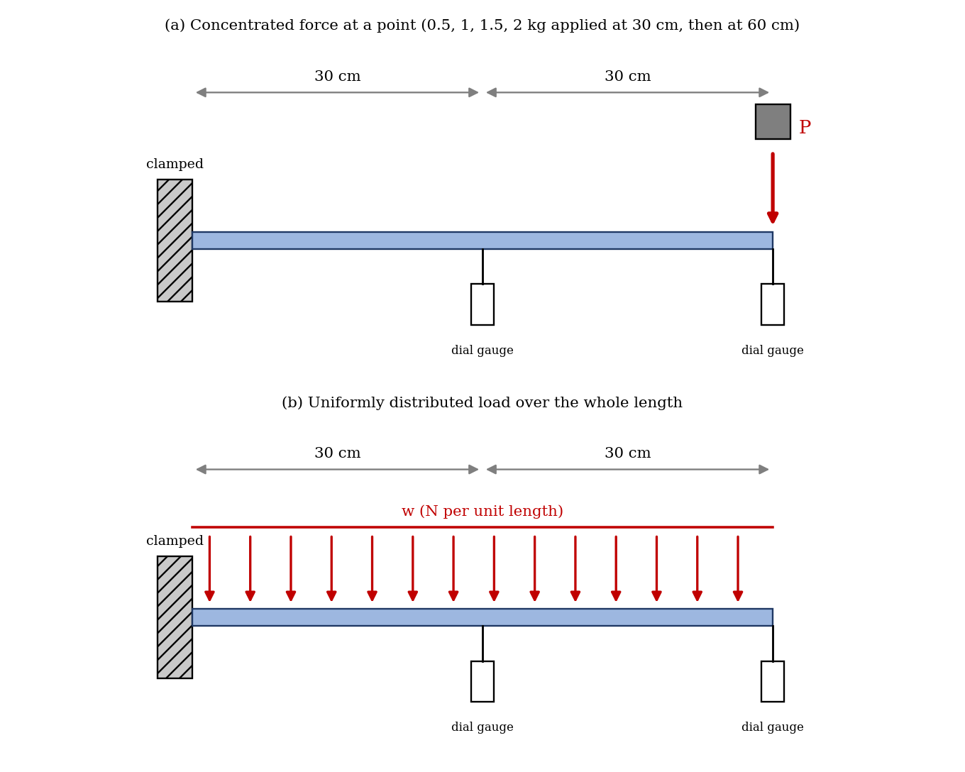
Figure 2: Cantilever with (a) a concentrated force and (b) a uniformly distributed load (schematic)
Quantity | Value
Length of cantilever, L | 60 cm
Dial gauge positions | 30 cm and 60 cm from the clamped end
Width b and depth t of the beam (mm) | [ ] × [ ]
Second moment of area I = b t³/12 | [ ] mm⁴
Young’s modulus of steel, E | 2.1 × 10⁵ N/mm²

3. Results
Procedure followed: the beam was set up as a cantilever with one end rigidly clamped and the other free. Two points 30 cm and 60 cm from the clamped end were marked. With the weight hangers in place and the dial gauges set to zero, loads of 0.5, 1, 1.5 and 2 kg were applied at each point in turn, and the deflections at both points were read. A uniformly distributed load was then applied, and the deflections read at both points.
Table 1: Concentrated force (deflections in mm)
Load (kg) | Load at 30 cm: δ at 30 cm | Load at 30 cm: δ at 60 cm | Load at 60 cm: δ at 30 cm | Load at 60 cm: δ at 60 cm
0.5
1.0
1.5
2.0

Table 2: Both loads together at 30 cm and 60 cm (superposition check, mm)
Load at each point (kg) | Measured δ at 30 cm | Measured δ at 60 cm | Sum of Table 1 values at 30 cm | Sum of Table 1 values at 60 cm
0.5
1.0

Table 3: Uniformly distributed load (mm)
Total load (kg) | w = W g / L (N/m) | Measured δ at 30 cm | Measured δ at 60 cm

4. Analysis of Results
- Second moment of area: I = b t³/12 = [ ] mm⁴, so EI = [ ] N·mm².
- Convert the loads to newtons: P = mass × 9.81 (add the weight of the hanger).
- Calculate the deflection at 30 cm and 60 cm for each case from the formulas in the theory, and compare with the measured values (percentage difference = (measured − calculated)/calculated × 100%).
- Check superposition: compare the measured deflection under both loads with the sum of the deflections from each load alone.
- Check reciprocity: compare the deflection at 60 cm for a load at 30 cm with the deflection at 30 cm for the same load at 60 cm.
- From the gradient of the deflection–load graph, EI = (formula coefficient)/gradient, and so find E.
As a check, the table below gives the deflections expected from the equations for an assumed steel beam of 25 mm × 6 mm section (EI = 94.5 N·m², L = 0.6 m). It is an illustration, not experimental data; your beam will differ, but notice that the deflection is proportional to the load, and the two cross values (load at 30 cm, reading at 60 cm and load at 60 cm, reading at 30 cm) are equal.
Load (kg) | Load at 60 cm: δ at 60 cm | Load at 60 cm: δ at 30 cm | Load at 30 cm: δ at 30 cm | Load at 30 cm: δ at 60 cm
0.5 | 1.17 | 3.74 | 0.47 | 1.17
1 | 2.34 | 7.47 | 0.93 | 2.34
1.5 | 3.50 | 11.21 | 1.40 | 3.50
2 | 4.67 | 14.95 | 1.87 | 4.67

For a 2 kg total load spread uniformly over 60 cm (w = 32.7 N/m), the same beam would deflect about 2.0 mm at 30 cm and 5.6 mm at the free end.

5. Observations and Precautions
Observations
- The deflection increases in proportion to the load, and is largest at the free end.
- The deflection at 60 cm for a load at 30 cm is equal to the deflection at 30 cm for the same load at 60 cm, within the reading error.
- The deflection with both loads together is the sum of the deflections with each alone.
Precautions
- Check that the clamped end is rigid and cannot rotate, and set the dial gauges to zero with the hangers on the beam.
- Apply the loads gently, and let the beam settle before taking a reading; take the zero reading again after unloading.
- Keep the loads small to stay within the elastic limit, and place each load exactly at the marked position.

6. Graphs
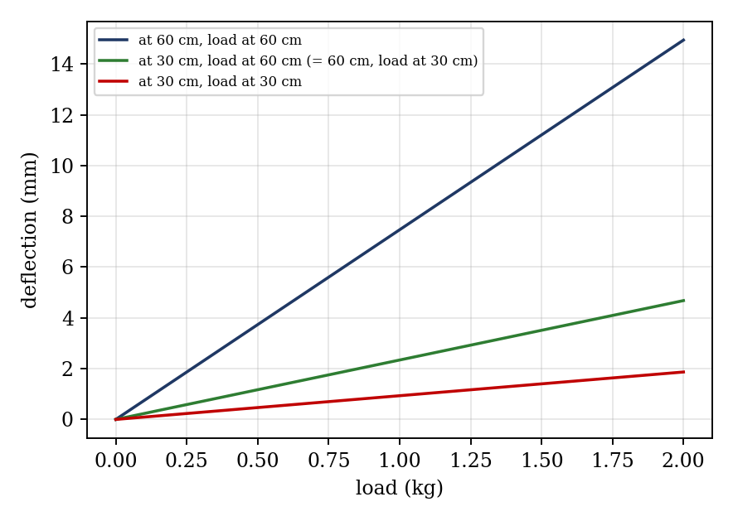
Figure 3: Expected deflection against load (illustrative; not experimental data)
- Deflection against load for a load at 30 cm (readings at both dial gauges).
- Deflection against load for a load at 60 cm (readings at both dial gauges).
- Measured against calculated deflection for the distributed load.

7. Discussion
Sources of error: the dial gauges read to about 0.01 mm, and the gauge spring presses on the beam; the clamp is not perfectly rigid, so the beam rotates slightly at the support and all deflections are slightly larger than calculated; the section dimensions are measured to a limited accuracy, and since I depends on t³ a 1% error in depth gives about 3% error in the deflection; the actual E of the beam may differ from 2.1 × 10⁵ N/mm²; the weight of the beam and of the hangers is not always included; the loads are not placed exactly at the marks; and shear deflection is neglected, which is acceptable for a long thin beam. For the distributed load, spacing the weights unevenly produces a different deflection from the ideal. [Compare your measured and calculated deflections, and comment on how far superposition and reciprocity hold.]
The concentrated force gives a larger deflection at the free end than a uniformly distributed load of the same total weight (PL³/3EI compared with WL³/8EI, so 2.7 times larger), because the load acts at the greatest distance from the support and produces a larger bending moment.

8. Conclusion
The deflection of a cantilever was measured at two points for concentrated forces and for a uniformly distributed load, and agreed with the values calculated by the area-moment method to within [ ]%. The deflection was proportional to load, and the principle of superposition and the reciprocity of the deflections were verified within the experimental error. The results are used in the design of cantilevers such as balconies, crane jibs, aircraft wings and shelf brackets, where deflection as well as stress must be limited.

Section D: Questions
- What have you gained from this experiment? [ ]
- What role did you play during the experiment? [ ]
- Could you have performed this experiment all by yourself? YES / NO. Reason: [ ]
- Comment on the experimental procedure for accuracy of results and time saving. [ ]
- Most difficult aspect and suggestions for reducing it: [ ]
- Other methods or apparatus for the same experiment: [ ]
- Parameters required: length, section dimensions, E, load, load positions and deflections.
- One measuring instrument discussed: the dial gauge. [Describe: working, resolution, zero setting.]
- Practical relevance: balconies, crane jibs, aircraft wings and brackets.
- Section of your course this experiment best relates: Strength of Materials (deflection of beams).
- Suggestions you made while carrying out the experiment: [ ]
- Suggestions by group members that helped the group: [ ]
- Did you put down the results at the time, or copy from group members? YES / NO. Reason: [ ]
- What interested you most during the experiment: [ ]
- Did you come to the laboratory with the laboratory manual? YES / NO. Reason: [ ]
- References: [list books/journals consulted, e.g. a strength of materials textbook; Laboratory Manual ELA 301]

