Mechanical Engineering Laboratory ELA 301
SM312: STRUT TEST
Name: [your name] Matric No: [ ] Group: [ ] Date: [ ]
Objective: To measure the deflections of loaded struts and investigate the validity of Euler’s formula.

1. Theory

Buckling of slender struts
A strut is a member that carries a compressive axial load. A short, stocky strut fails by crushing when the stress reaches the yield strength. A long, slender strut fails at a much lower load by buckling, which is a sudden lateral bending that appears when the load reaches a critical value. Beyond this load the straight form of equilibrium is unstable: a small sideways disturbance grows instead of dying away, and the strut collapses (it ‘cripples’). Euler’s analysis gives this critical load for an ideal strut, which is perfectly straight, of uniform section and made of a linear elastic material, with a load that is exactly axial.

Euler’s formula for a pin-ended strut
Consider a strut of length L with both ends pinned, carrying the load P, and let it be bent into a slightly curved shape with deflection y at distance x from one end. The bending moment at the section is M = −P y, so the beam equation gives
E I d²y / dx² = − P y
This is rewritten as d²y/dx² + k² y = 0, with k² = P/(EI). The solution is y = A sin kx + B cos kx. The boundary conditions are y = 0 at x = 0, giving B = 0, and y = 0 at x = L, giving A sin kL = 0. A non-zero deflection (A ≠ 0) is possible only if sin kL = 0, so kL = π, 2π, … The smallest value, kL = π, gives the Euler critical load, and the deflected shape is a half sine wave:
P_cr = π² E I / L²
Here I is the smallest second moment of area of the cross-section, because the strut buckles about the weakest axis. For a rectangular section of width b and thickness t (with t < b), I = b t³/12. The expression for the critical load shows three things: the load falls with the square of the length, it is proportional to the flexural rigidity EI, and it does not depend on the strength of the material.

Effect of end conditions
The three end conditions used in the experiment are shown in Figure 1. For other end conditions, the formula is applied with the effective length L_e, which is the length of an equivalent pin-ended strut, that is, the distance between the points of zero bending moment:
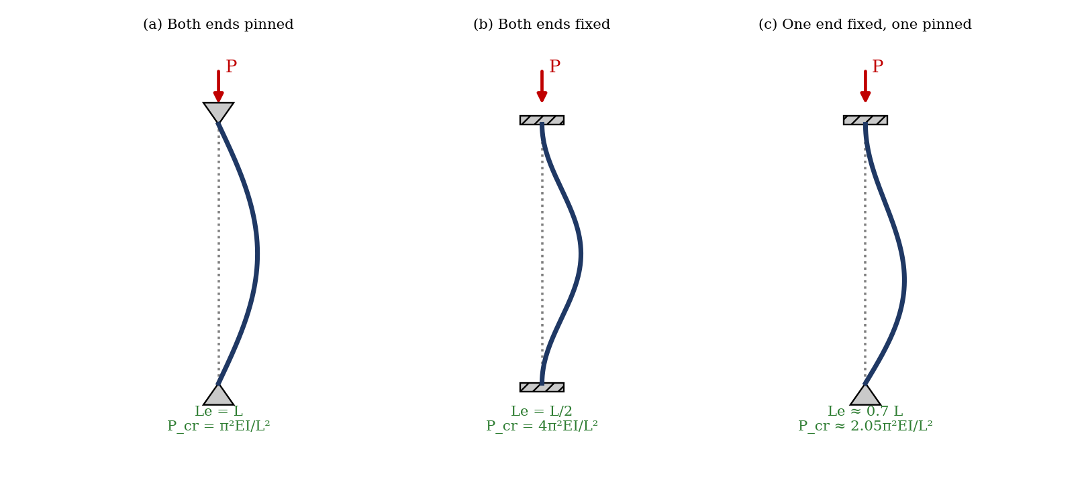
Figure 1: Buckled shapes and critical loads for the three end conditions
P_cr = π² E I / L_e²
End conditions | Effective length L_e | Critical load
(a) Both ends pinned | L | π²EI / L²
(b) Both ends fixed | L / 2 | 4π²EI / L²
(c) One end fixed, other pinned | ≈ 0.7 L | ≈ 2.05π²EI / L²

Slenderness ratio and the limit of Euler’s formula
The slenderness ratio is L_e/k, where k = √(I/A) is the least radius of gyration of the section. Dividing P_cr by the area gives the critical stress
σ_cr = π² E / (L_e / k)²
Euler’s formula holds only while σ_cr is below the proportional limit (or yield stress) of the material, since it assumes elastic behaviour. For a strut with a small slenderness ratio, σ_cr from the formula exceeds the yield stress and the strut fails by yielding before it can buckle, so the formula overestimates the load; empirical formulae of Rankine–Gordon or Johnson are used there. For the thin steel struts in this test, the slenderness ratio is large (several hundred), so Euler’s formula should apply.

Behaviour of real struts: the Southwell plot
Real struts are never perfectly straight, and the load is never perfectly axial. If the strut has an initial deflection or eccentricity e, the deflection at mid-length grows with load P as
δ = e / (P_cr / P − 1)
The deflection is small at low loads and rises without limit as P approaches P_cr, so the load–deflection graph bends over toward an asymptote at P_cr. Rearranging gives δ/P = δ/P_cr + e/P_cr, so a Southwell plot of δ/P against δ is a straight line, whose gradient is 1/P_cr. This allows P_cr to be found from readings taken at loads well below the crippling load, so that the strut is not damaged.

2. Apparatus
The strut test apparatus consists of a rigid frame with end fittings that can be arranged as pin joints or as fixed (built-in) ends, interchangeable steel struts of different lengths (45, 50 and 75 cm, and a shorter one to start with), a loading screw that applies axial compression, a spring balance that measures the load, a dial gauge at mid-length to read the deflection, and a spirit level (Figure 2).
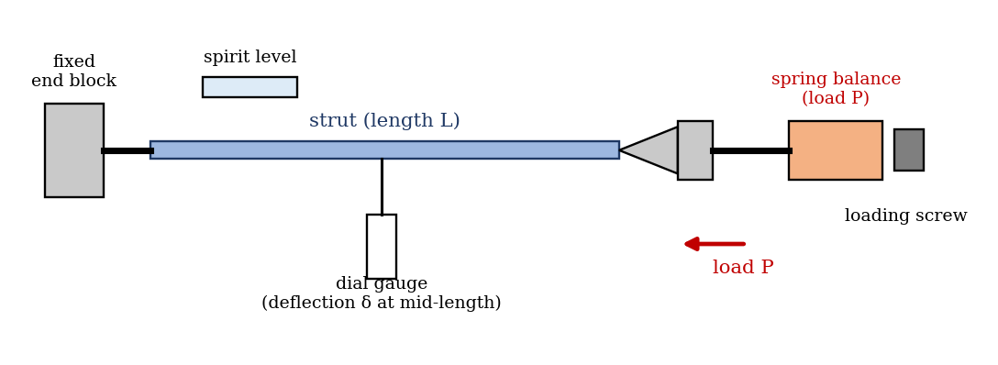
Figure 2: Strut test apparatus (schematic)
Quantity | Value
Material of strut | [ ]
Width b and thickness t of strut (mm) | [ ] × [ ]
Least second moment of area I = b t³/12 | [ ] mm⁴
Young’s modulus E | [ ] (2.1 × 10⁵ N/mm² for steel)
End condition tested | [pinned–pinned / fixed–fixed / fixed–pinned]

3. Results
Procedure followed: the experiment was set up for one of the three end conditions, starting with the shortest strut. Before each reading, the spirit level was checked to show that the apparatus was horizontal, and the dial gauge was set so that it was sensitive to a slight relaxation of the horizontal load. Loads were applied through the spring balance in increments, and the deflection at the middle of the strut was recorded for each load until the ripple point was reached; the crippling load was then noted, and the applied load was removed quickly. The procedure was repeated for struts of lengths 45, 50 and 75 cm.
Table 1: Load and deflection for each strut (repeat for each length)
Length of strut L = [ ] mm
No. | Load P (N) | Deflection δ (mm) | δ/P (mm/N)
1
2
3
4
5
6
Ripple point load: [ ] N; crippling load: [ ] N.

Table 2: Summary of results
L (mm) | L_e (mm) | Slenderness L_e/k | Experimental crippling load (N) | Euler P_cr (N) | Difference (%)
450
500
750

4. Analysis of Results
- Second moment of area: I = b t³/12 = [ ] mm⁴; EI = [ ] N·mm².
- Effective length L_e for the end condition used (Figure 1 and table in the theory).
- Euler critical load: P_cr = π² E I / L_e² for each length.
- Slenderness ratio: k = √(I/A) = t/√12; L_e/k = [ ].
- Plot δ/P against δ for each length (Southwell plot); gradient = 1/P_cr, so P_cr = [ ] N.
- Compare experimental crippling load, the Southwell P_cr and the Euler P_cr, and calculate the percentage differences.
As a check, the table below gives the Euler loads for an assumed steel strut of 25 mm × 3 mm section (EI = 11.8 N·m², E = 2.1 × 10⁵ N/mm²) for the three end conditions. It is an illustration, not experimental data; your strut section is different, so your values will differ, but the pattern (a drop with length squared, and 4 times for fixed–fixed ends) should match.
Length L (mm) | Pinned–pinned P_cr (N) | Fixed–fixed P_cr (N) | Fixed–pinned P_cr (N)
450 | 576 | 2303 | 1178
500 | 466 | 1865 | 954
750 | 207 | 829 | 424

5. Observations and Precautions
Observations
- For small loads the deflection is small, and it increases sharply as the load approaches the crippling load.
- The longer the strut, the lower the load at which it buckles.
- When the crippling load was reached, the strut bent suddenly and the load could not be increased.
Precautions
- Check that the apparatus is horizontal with the spirit level before each reading, and that the dial gauge is set properly at the centre of the strut.
- Increase the load slowly, and in small steps near the buckling load; remove the load quickly once the strut cripples so that it is not permanently bent.
- Stand clear of the strut and keep the guard in place, since a buckling strut can spring out; use the least load required and do not exceed the elastic limit of the strut more than needed.

6. Graphs
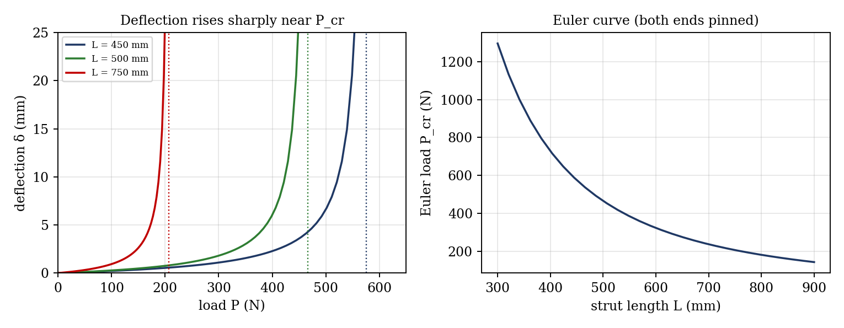
Figure 3: Expected graphs (illustrative, from the equations; not experimental data)
- Deflection against load for each length; mark the limit of elasticity (where the graph stops being a smooth rise) and the crippling load.
- Southwell plot δ/P against δ for each length, with the gradient 1/P_cr.
- Critical load against strut length, with the Euler curve P_cr = π²EI/L_e² on the same axes.

7. Discussion
The measured crippling loads are usually lower than the Euler values. Reasons: the struts are not perfectly straight and the load is not perfectly axial, so the deflection grows from the start and the strut cripples before reaching P_cr; the end fittings are not ideal pins (friction in the pins raises the load) and not ideal fixed ends (the clamp is not perfectly rigid, so the effective length is longer than L/2); the dial gauge and the spring balance have limited resolution; the cross-section dimensions are measured with limited accuracy, and since I depends on t³ a 1% error in thickness gives about 3% error in P_cr; and E may differ from the assumed value. For the shorter struts, the stress can be near the yield stress, and the deviation can become larger. [State your own percentage differences and which strut agreed best.]
Usefulness of the experiment: it confirms that the critical load decreases with L² and increases with the end fixity, and that the load–deflection curve of an imperfect strut tends to the Euler load as an asymptote, which the Southwell plot uses to find P_cr without destroying the strut. It also shows the limits of the formula: it holds only for slender struts that remain elastic, and in design a factor of safety is used, because small imperfections reduce the real strength well below P_cr.

8. Conclusion
The deflection of struts of different lengths was measured against load, and the crippling loads were compared with the Euler loads. The experimental crippling loads were [ ]% [lower/higher] than the Euler values, and the Southwell plots gave P_cr within [ ]% of the Euler loads, so Euler’s formula is [valid/approximately valid] for these slender struts. The critical load fell with the square of the length. The results are important in the design of columns, truss members, connecting rods, push rods and landing-gear struts, where the buckling load rather than the yield strength limits the load.

Section D: Questions
- What have you gained from this experiment? [ ]
- What role did you play during the experiment? [ ]
- Could you have performed this experiment all by yourself? YES / NO. Reason: [ ]
- Comment on the experimental procedure for accuracy of results and time saving. [ ]
- Most difficult aspect and suggestions for reducing it: [ ]
- Other methods or apparatus for the same experiment: [ ]
- Parameters required: strut length, section dimensions, E, end condition, load and deflection.
- One measuring instrument discussed: the dial gauge (or spring balance). [Describe: working, resolution, zero setting.]
- Practical relevance: columns, truss members, connecting rods and landing-gear struts.
- Section of your course this experiment best relates: Strength of Materials (buckling of struts).
- Suggestions you made while carrying out the experiment: [ ]
- Suggestions by group members that helped the group: [ ]
- Did you put down the results at the time, or copy from group members? YES / NO. Reason: [ ]
- What interested you most during the experiment: [ ]
- Did you come to the laboratory with the laboratory manual? YES / NO. Reason: [ ]
- References: [list books/journals consulted, e.g. a strength of materials textbook; Laboratory Manual ELA 301]

