Mechanical Engineering Laboratory ELA 301
TD311a: MARCET BOILER
Name: [your name] Matric No: [ ] Group: [ ] Date: [ ]
Objectives: (1) To determine the relationship between pressure and temperature of saturated steam. (2) To calculate the enthalpy of dry saturated steam at various pressures.

1. Theory

Saturated steam
When water is heated in a closed vessel, it boils when its vapour pressure equals the pressure above it. At that point the liquid and its vapour are in equilibrium, and the steam is called saturated. For a given pressure there is only one temperature at which this can happen, the saturation temperature T_sat, and as the pressure rises the saturation temperature rises (Figure 1). Steam at the saturation temperature with no liquid water in it is dry saturated steam. The latent heat (enthalpy of evaporation) h_fg is the heat needed to change 1 kg of saturated water into dry saturated steam at constant pressure, and the specific enthalpy of dry saturated steam is
h_g = h_f + h_fg

Clapeyron’s equation
Along the saturation line, liquid and vapour are in equilibrium, so their specific Gibbs functions are equal: g_f = g_g. For a small change dT in temperature with the corresponding dP in pressure, the change in g is the same for both phases, so −s_f dT + v_f dP = −s_g dT + v_g dP. Rearranging, with s_fg = s_g − s_f and v_fg = v_g − v_f:
dP / dT = s_fg / v_fg
During evaporation at constant temperature, s_fg = h_fg / T, so we obtain the Clausius–Clapeyron relation:
(dT / dP)_sat = T v_fg / h_fg
Here T is the absolute temperature in K, and v_fg and h_fg are the changes in specific volume and enthalpy during evaporation, which are obtained from steam tables. The equation says that the slope of the saturation curve can be calculated from steam table properties, and it also means that if the slope is found experimentally from measured pressure and temperature, then the latent heat can be found:
h_fg = T v_fg (dP / dT)
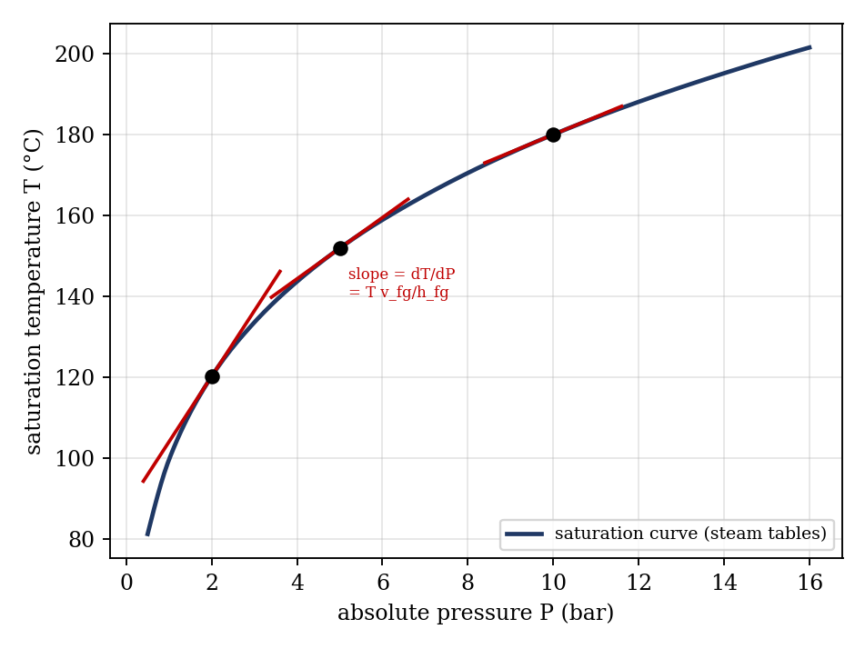
Figure 1: Saturation curve of steam and the slope dT/dP at three pressures

Simplified form
At moderate pressures, v_f is negligible beside v_g, and the vapour behaves nearly as an ideal gas, so v_fg ≈ v_g ≈ RT/P. Substituting, d ln P/dT = h_fg/(R T²), so a graph of ln P against 1/T is nearly a straight line with gradient −h_fg/R. The slope dT/dP falls as pressure rises: from about 28 K/bar at 1 bar to about 3 K/bar at 15 bar, because v_fg falls much faster than h_fg.

Absolute pressure
The pressure gauge reads gauge pressure. The absolute pressure that is used in steam tables is
P_abs = P_gauge + P_atm P_atm (bar) = barometer reading (mm Hg) × 0.001333

2. Apparatus
The Marcet boiler is a small boiler made of heavy-duty steel section, heated electrically, and lagged to allow rapid heating, arranged for bench mounting. It has a pressure gauge, a steam valve, a safety valve, a thermometer pocket with a thermometer, and a water level cock. A barometer is used to read the atmospheric pressure (Figure 2).
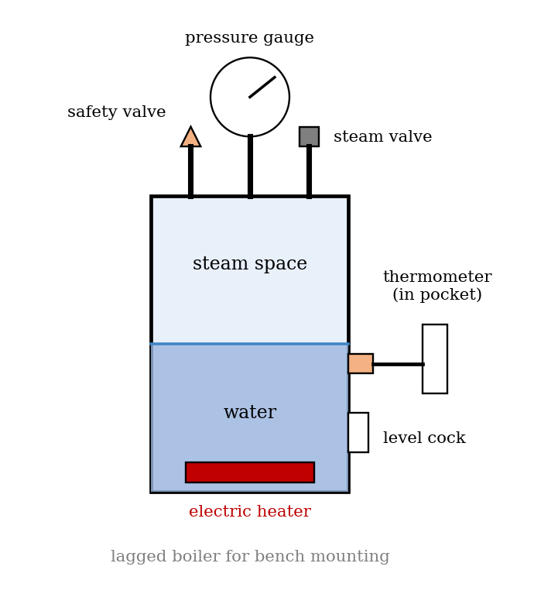
Figure 2: Marcet boiler apparatus (schematic)

3. Results
Procedure followed: the steam valve on the side of the boiler was opened, which ensured that the pressure above the water was atmospheric. The heater was switched on, and when the thermometer reading stopped rising and steam was coming out of the valve, the thermometer and barometer were read. The valve was then closed, and the pressure began to rise; the thermometer was read at every 0.5 bar up to 5 bar, and then every 1 bar up to 15 bar. The heater was switched off and the boiler allowed to cool, and the temperature was read at the same pressures during cooling.
Barometric pressure = [ ] mm Hg = [ ] bar.
Gauge pressure (bar) | Absolute pressure (bar) | Temperature, increasing (°C) | Temperature, decreasing (°C) | Mean temp. (°C) | Absolute temp. (K)
0 (atm.)
0.5
1
1.5
2
2.5
3
3.5
4
4.5
5
6
7
8
9
10
11
12
13
14
15

4. Analysis of Results
- Absolute pressure: P_abs = P_gauge + P_atm (bar).
- Mean temperature: T_mean = (T_increasing + T_decreasing)/2, and absolute temperature T = T_mean + 273.15 (K).
- Experimental slope at five pressures (for example 1, 3, 5, 10 and 15 bar absolute): (dT/dP) ≈ ΔT/ΔP, taken from the graph as the gradient of the tangent, or from points on either side.
- Calculated slope at the same pressures from the steam tables: (dT/dP) = T v_fg / h_fg (convert units: with v in m³/kg, h in kJ/kg and P in kPa, the slope is in K/kPa; multiply by 100 for K/bar).
- Enthalpy: h_fg = T v_fg/(dT/dP), and h_g = h_f + h_fg using h_f from the steam tables, at each pressure.
- Percentage difference between the experimental and calculated slopes.
As a check, the table below gives the saturation values from standard steam tables, with the slope worked out from the Clapeyron equation. It is an illustration (check the figures against your own steam table); your experimental values should lie close to these.
P (bar abs.) | T_sat (°C) | v_g (m³/kg) | h_fg (kJ/kg) | dT/dP (K/bar) | h_g (kJ/kg)
1 | 99.63 | 1.694 | 2257.5 | 27.96 | 2675.0
2 | 120.23 | 0.8857 | 2201.9 | 15.80 | 2706.6
5 | 151.86 | 0.3749 | 2108.5 | 7.53 | 2748.7
10 | 179.91 | 0.1944 | 2015.3 | 4.35 | 2778.1
15 | 198.32 | 0.1318 | 1947.3 | 3.16 | 2792.2

5. Observations and Precautions
Observations
- The temperature rose with pressure, but by less for each additional bar at high pressure.
- The temperatures read while the boiler was cooling were a little different from those read while heating at the same pressure.
- Steam came out of the valve when it was opened at atmospheric pressure, and the thermometer reading steadied near 100 °C.
Precautions
- Open the valve and boil the water at atmospheric pressure at the start, so that the air is driven out of the boiler.
- Take readings only when the temperature and pressure have settled; never exceed 15 bar, and watch the safety valve.
- Keep the barometer reading and take it at the time of the experiment; read the gauge and thermometer with the eye level with the scale; take care with the hot boiler and do not open the valve at high pressure.

6. Graphs
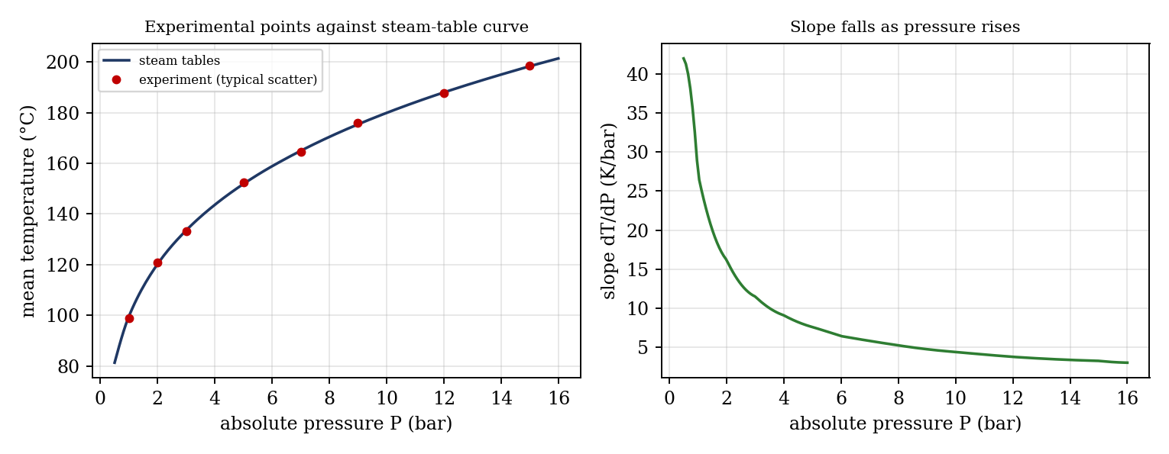
Figure 3: Expected graphs (illustrative: experimental scatter is typical, not real data)
- Mean temperature against absolute pressure, with the slope dT/dP marked at five pressures.
- The same graph again, with the points from the steam tables on the same axes.
- Slope dT/dP (experimental and from the steam tables) against pressure.

7. Discussion
Difference between experimental and calculated slopes. The experimental slope is found from small differences between readings, so it is sensitive to errors: the thermometer reads to about 0.5 to 1 °C and the Bourdon pressure gauge to about 0.1 bar (more at the low end of its range), and a 1 °C error over a 2 bar interval changes the slope by 0.5 K/bar. The tangents drawn on the graph also add scatter. The accuracy can be improved by heating slowly and allowing the readings to settle at each pressure, by using a calibrated pressure transducer and a digital thermometer, by lagging the boiler well, by taking readings at smaller steps, and by using the slope of a smooth curve fitted to the points. [State your own differences.]
1. Is there any discrepancy between the two curves on graph 2? Usually yes, a small one. The experimental curve is often slightly below the steam-table curve. The reasons are thermometer and gauge errors, thermal lag of the pocket, and the presence of air in the boiler (see question 3).
2. Is there any discrepancy between the temperature at corresponding pressures during heating and cooling? Yes. During heating, the temperature of the pocket lags behind the steam temperature, so the thermometer reads low; while cooling, it lags in the other direction, so the reading is high. The heating and cooling readings therefore bracket the true value, and the mean of the two is a better estimate. Friction in the gauge mechanism (hysteresis) adds to the difference.
3. What will be the effect of any air left in the boiler? The total pressure is the sum of the steam partial pressure and the air partial pressure (Dalton’s law). For a given gauge reading the steam pressure is therefore lower, so the temperature is lower than T_sat for that total pressure, and the experimental curve lies below the steam table curve. The error is greatest at low pressures, where the air is a larger fraction of the total. This is why the water is first boiled with the valve open, to drive out the air.

8. Conclusion
The pressure and temperature of saturated steam were measured in a Marcet boiler up to 15 bar. The saturation temperature rose with pressure, with a slope dT/dP that fell from about [ ] K/bar at low pressure to about [ ] K/bar at high pressure. The experimental slopes agreed with those from the Clapeyron equation to within [ ]%, and the enthalpy of dry saturated steam was found to be [ ] kJ/kg at [ ] bar. The results are used in boiler and steam turbine design and in the use of steam tables.

Section D: Questions
- What have you gained from this experiment? [ ]
- What role did you play during the experiment? [ ]
- Could you have performed this experiment all by yourself? YES / NO. Reason: [ ]
- Comment on the experimental procedure for accuracy of results and time saving. [ ]
- Most difficult aspect and suggestions for reducing it: [ ]
- Other methods or apparatus for the same experiment: [ ]
- Parameters required: pressure, temperature, barometric pressure and steam table data.
- One measuring instrument discussed: the Bourdon pressure gauge (or thermometer). [Describe: working, range, accuracy.]
- Practical relevance: steam boilers, turbines, and the use of steam tables in plant design.
- Section of your course this experiment best relates: Thermodynamics (properties of steam).
- Suggestions you made while carrying out the experiment: [ ]
- Suggestions by group members that helped the group: [ ]
- Did you put down the results at the time, or copy from group members? YES / NO. Reason: [ ]
- What interested you most during the experiment: [ ]
- Did you come to the laboratory with the laboratory manual? YES / NO. Reason: [ ]
- References: [list books/journals consulted, e.g. a thermodynamics textbook and steam tables; Laboratory Manual ELA 301]

