ubuntu 编译安装　openocd（支持cmsis-dap）

<https://blog.csdn.net/eastgeneral/article/details/84873061>

1. Installing libraries and tools Dependency

sudo apt-get install autotools-dev make libtool pkg-config autoconf automake texinfo libudev1 libudev-dev libusb-1.0-0-dev libfox-1.6-dev

报错：

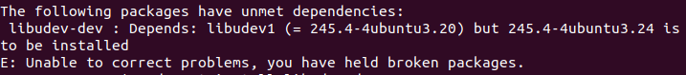

安装指定版本的依赖

sudo apt install libudev1=245.4-4ubuntu3.20

1. Installing HIDAPI

cd ~/

git clone https://github.com/signal11/hidapi.git

cd hidapi/

./bootstrap

./configure

make -j

sudo make install

nano ~/.profile （添加：PATH="$HOME/bin:/usr/local/lib:$PATH"）

sudo ldconfig

cd ~/

sudo rm -R hidapi

1. Installing OpenOCD

git clone https://github.com/SpinalHDL/openocd_riscv.git

cd ~/openocd_riscv

./bootstrap # 注意子仓库的拉取

./configure --enable-cmsis-dap

make -j

报错：

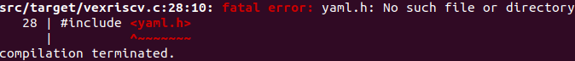

sudo apt-get update

sudo apt-get install libyaml-dev

1. Adding udev rule

lsusb

sudo nano /etc/udev/rules.d/CMSIS.rules

{

KERNEL=="hidraw*", ATTRS{idVendor}=="0d28", ATTRS{idProduct}=="0204", MODE="0666"

SUBSYSTEM=="usb", ATTRS{idVendor}=="0d28", MODE="0666"

SUBSYSTEM=="usb_device", ATTRS{idVendor}=="0d28", MODE="0666"

}

1. 重启