Practical Machine Learning

Moon jeounghoon

2017.03.24

## Introduction

### Background

Using devices such as Jawbone Up, Nike FuelBand, and Fitbit it is now possible to collect a large amount of data about personal activity relatively inexpensively. These type of devices are part of the quantified self movement - a group of enthusiasts who take measurements about themselves regularly to improve their health, to find patterns in their behavior, or because they are tech geeks. One thing that people regularly do is quantify how much of a particular activity they do, but they rarely quantify how well they do it. In this project, your goal will be to use data from accelerometers on the belt, forearm, arm, and dumbell of 6 participants. They were asked to perform barbell lifts correctly and incorrectly in 5 different ways. More information is available from the website here: <http://groupware.les.inf.puc-rio.br/har> (see the section on the Weight Lifting Exercise Dataset).

### Data

The training data for this project are available here:

<https://d396qusza40orc.cloudfront.net/predmachlearn/pml-training.csv>

The test data are available here:

<https://d396qusza40orc.cloudfront.net/predmachlearn/pml-testing.csv>

The data for this project come from this source: <http://groupware.les.inf.puc-rio.br/har>. If you use the document you create for this class for any purpose please cite them as they have been very generous in allowing their data to be used for this kind of assignment.

### What you should submit

The goal of your project is to predict the manner in which they did the exercise. This is the "classe" variable in the training set. You may use any of the other variables to predict with. You should create a report describing how you built your model, how you used cross validation, what you think the expected out of sample error is, and why you made the choices you did. You will also use your prediction model to predict 20 different test cases.

1. Your submission should consist of a link to a Github repo with your R markdown and compiled HTML file describing your analysis. Please constrain the text of the writeup to < 2000 words and the number of figures to be less than 5. It will make it easier for the graders if you submit a repo with a gh-pages branch so the HTML page can be viewed online (and you always want to make it easy on graders :-).
2. You should also apply your machine learning algorithm to the 20 test cases available in the test data above. Please submit your predictions in appropriate format to the programming assignment for automated grading. See the programming assignment for additional details.

### Reproducibility

Due to security concerns with the exchange of R code, your code will not be run during the evaluation by your classmates. Please be sure that if they download the repo, they will be able to view the compiled HTML version of your analysis.

## Analysis

### Preparing the data and R packages

#### Load packages, set caching

library(caret)  
library(corrplot)

## Warning: package 'corrplot' was built under R version 3.3.3

library(Rtsne)

## Warning: package 'Rtsne' was built under R version 3.3.3

library(xgboost)

## Warning: package 'xgboost' was built under R version 3.3.3

library(stats)  
library(knitr)  
library(ggplot2)  
  
knitr::opts_chunk$set(cache=TRUE)

#### Getting Data

# URL of the training and testing data  
train.url ="https://d396qusza40orc.cloudfront.net/predmachlearn/pml-training.csv"  
test.url = "https://d396qusza40orc.cloudfront.net/predmachlearn/pml-testing.csv"  
# file names  
train.name = "./data/pml-training.csv"  
test.name = "./data/pml-testing.csv"  
# if directory does not exist, create new  
if (!file.exists("./data")) {  
 dir.create("./data")  
}  
# if files does not exist, download the files  
if (!file.exists(train.name)) {  
 download.file(train.url, destfile=train.name, method="curl")  
}  
if (!file.exists(test.name)) {  
 download.file(test.url, destfile=test.name, method="curl")  
}  
# load the CSV files as data.frame   
train = read.csv("./data/pml-training.csv")  
test = read.csv("./data/pml-testing.csv")  
dim(train)

## [1] 19622 160

dim(test)

## [1] 20 160

names(train)

## [1] "X" "user_name"   
## [3] "raw_timestamp_part_1" "raw_timestamp_part_2"   
## [5] "cvtd_timestamp" "new_window"   
## [7] "num_window" "roll_belt"   
## [9] "pitch_belt" "yaw_belt"   
## [11] "total_accel_belt" "kurtosis_roll_belt"   
## [13] "kurtosis_picth_belt" "kurtosis_yaw_belt"   
## [15] "skewness_roll_belt" "skewness_roll_belt.1"   
## [17] "skewness_yaw_belt" "max_roll_belt"   
## [19] "max_picth_belt" "max_yaw_belt"   
## [21] "min_roll_belt" "min_pitch_belt"   
## [23] "min_yaw_belt" "amplitude_roll_belt"   
## [25] "amplitude_pitch_belt" "amplitude_yaw_belt"   
## [27] "var_total_accel_belt" "avg_roll_belt"   
## [29] "stddev_roll_belt" "var_roll_belt"   
## [31] "avg_pitch_belt" "stddev_pitch_belt"   
## [33] "var_pitch_belt" "avg_yaw_belt"   
## [35] "stddev_yaw_belt" "var_yaw_belt"   
## [37] "gyros_belt_x" "gyros_belt_y"   
## [39] "gyros_belt_z" "accel_belt_x"   
## [41] "accel_belt_y" "accel_belt_z"   
## [43] "magnet_belt_x" "magnet_belt_y"   
## [45] "magnet_belt_z" "roll_arm"   
## [47] "pitch_arm" "yaw_arm"   
## [49] "total_accel_arm" "var_accel_arm"   
## [51] "avg_roll_arm" "stddev_roll_arm"   
## [53] "var_roll_arm" "avg_pitch_arm"   
## [55] "stddev_pitch_arm" "var_pitch_arm"   
## [57] "avg_yaw_arm" "stddev_yaw_arm"   
## [59] "var_yaw_arm" "gyros_arm_x"   
## [61] "gyros_arm_y" "gyros_arm_z"   
## [63] "accel_arm_x" "accel_arm_y"   
## [65] "accel_arm_z" "magnet_arm_x"   
## [67] "magnet_arm_y" "magnet_arm_z"   
## [69] "kurtosis_roll_arm" "kurtosis_picth_arm"   
## [71] "kurtosis_yaw_arm" "skewness_roll_arm"   
## [73] "skewness_pitch_arm" "skewness_yaw_arm"   
## [75] "max_roll_arm" "max_picth_arm"   
## [77] "max_yaw_arm" "min_roll_arm"   
## [79] "min_pitch_arm" "min_yaw_arm"   
## [81] "amplitude_roll_arm" "amplitude_pitch_arm"   
## [83] "amplitude_yaw_arm" "roll_dumbbell"   
## [85] "pitch_dumbbell" "yaw_dumbbell"   
## [87] "kurtosis_roll_dumbbell" "kurtosis_picth_dumbbell"   
## [89] "kurtosis_yaw_dumbbell" "skewness_roll_dumbbell"   
## [91] "skewness_pitch_dumbbell" "skewness_yaw_dumbbell"   
## [93] "max_roll_dumbbell" "max_picth_dumbbell"   
## [95] "max_yaw_dumbbell" "min_roll_dumbbell"   
## [97] "min_pitch_dumbbell" "min_yaw_dumbbell"   
## [99] "amplitude_roll_dumbbell" "amplitude_pitch_dumbbell"  
## [101] "amplitude_yaw_dumbbell" "total_accel_dumbbell"   
## [103] "var_accel_dumbbell" "avg_roll_dumbbell"   
## [105] "stddev_roll_dumbbell" "var_roll_dumbbell"   
## [107] "avg_pitch_dumbbell" "stddev_pitch_dumbbell"   
## [109] "var_pitch_dumbbell" "avg_yaw_dumbbell"   
## [111] "stddev_yaw_dumbbell" "var_yaw_dumbbell"   
## [113] "gyros_dumbbell_x" "gyros_dumbbell_y"   
## [115] "gyros_dumbbell_z" "accel_dumbbell_x"   
## [117] "accel_dumbbell_y" "accel_dumbbell_z"   
## [119] "magnet_dumbbell_x" "magnet_dumbbell_y"   
## [121] "magnet_dumbbell_z" "roll_forearm"   
## [123] "pitch_forearm" "yaw_forearm"   
## [125] "kurtosis_roll_forearm" "kurtosis_picth_forearm"   
## [127] "kurtosis_yaw_forearm" "skewness_roll_forearm"   
## [129] "skewness_pitch_forearm" "skewness_yaw_forearm"   
## [131] "max_roll_forearm" "max_picth_forearm"   
## [133] "max_yaw_forearm" "min_roll_forearm"   
## [135] "min_pitch_forearm" "min_yaw_forearm"   
## [137] "amplitude_roll_forearm" "amplitude_pitch_forearm"   
## [139] "amplitude_yaw_forearm" "total_accel_forearm"   
## [141] "var_accel_forearm" "avg_roll_forearm"   
## [143] "stddev_roll_forearm" "var_roll_forearm"   
## [145] "avg_pitch_forearm" "stddev_pitch_forearm"   
## [147] "var_pitch_forearm" "avg_yaw_forearm"   
## [149] "stddev_yaw_forearm" "var_yaw_forearm"   
## [151] "gyros_forearm_x" "gyros_forearm_y"   
## [153] "gyros_forearm_z" "accel_forearm_x"   
## [155] "accel_forearm_y" "accel_forearm_z"   
## [157] "magnet_forearm_x" "magnet_forearm_y"   
## [159] "magnet_forearm_z" "classe"

The raw training data has 19622 rows of observations and 158 features (predictors). Column X is unusable row number. While the testing data has 20 rows and the same 158 features.

There is one column of target outcome named classe.

#### Data cleaning

First, extract target outcome (the activity quality) from training data, so now the training data contains only the predictors (the activity monitors).

# target outcome (label)  
outcome.org = train[, "classe"]  
outcome = outcome.org   
levels(outcome)

## [1] "A" "B" "C" "D" "E"

Outcome has 5 levels in character format.  
Convert the outcome to numeric, because XGBoost gradient booster only recognizes numeric data.

# convert character levels to numeric  
num.class = length(levels(outcome))  
levels(outcome) = 1:num.class  
head(outcome)

## [1] 1 1 1 1 1 1  
## Levels: 1 2 3 4 5

The outcome is removed from training data.

# remove outcome from train  
train$classe = NULL

The assignment rubric asks to use data from accelerometers on the belt, forearm, arm, and dumbell, so the features are extracted based on these keywords.

# filter columns on: belt, forearm, arm, dumbell  
filter = grepl("belt|arm|dumbell", names(train))  
train = train[, filter]  
test = test[, filter]

Instead of less-accurate imputation of missing data, remove all columns with NA values.

# remove columns with NA, use test data as referal for NA  
cols.without.na = colSums(is.na(test)) == 0  
train = train[, cols.without.na]  
test = test[, cols.without.na]

### Preprocessing

#### Check for features's variance

Based on the principal component analysis PCA, it is important that features have maximum variance for maximum uniqueness, so that each feature is as distant as possible (as orthogonal as possible) from the other features.

# check for zero variance  
zero.var = nearZeroVar(train, saveMetrics=TRUE)  
zero.var

## freqRatio percentUnique zeroVar nzv  
## roll_belt 1.101904 6.7781062 FALSE FALSE  
## pitch_belt 1.036082 9.3772296 FALSE FALSE  
## yaw_belt 1.058480 9.9734991 FALSE FALSE  
## total_accel_belt 1.063160 0.1477933 FALSE FALSE  
## gyros_belt_x 1.058651 0.7134849 FALSE FALSE  
## gyros_belt_y 1.144000 0.3516461 FALSE FALSE  
## gyros_belt_z 1.066214 0.8612782 FALSE FALSE  
## accel_belt_x 1.055412 0.8357966 FALSE FALSE  
## accel_belt_y 1.113725 0.7287738 FALSE FALSE  
## accel_belt_z 1.078767 1.5237998 FALSE FALSE  
## magnet_belt_x 1.090141 1.6664968 FALSE FALSE  
## magnet_belt_y 1.099688 1.5187035 FALSE FALSE  
## magnet_belt_z 1.006369 2.3290184 FALSE FALSE  
## roll_arm 52.338462 13.5256345 FALSE FALSE  
## pitch_arm 87.256410 15.7323412 FALSE FALSE  
## yaw_arm 33.029126 14.6570176 FALSE FALSE  
## total_accel_arm 1.024526 0.3363572 FALSE FALSE  
## gyros_arm_x 1.015504 3.2769341 FALSE FALSE  
## gyros_arm_y 1.454369 1.9162165 FALSE FALSE  
## gyros_arm_z 1.110687 1.2638875 FALSE FALSE  
## accel_arm_x 1.017341 3.9598410 FALSE FALSE  
## accel_arm_y 1.140187 2.7367241 FALSE FALSE  
## accel_arm_z 1.128000 4.0362858 FALSE FALSE  
## magnet_arm_x 1.000000 6.8239731 FALSE FALSE  
## magnet_arm_y 1.056818 4.4439914 FALSE FALSE  
## magnet_arm_z 1.036364 6.4468454 FALSE FALSE  
## roll_forearm 11.589286 11.0895933 FALSE FALSE  
## pitch_forearm 65.983051 14.8557741 FALSE FALSE  
## yaw_forearm 15.322835 10.1467740 FALSE FALSE  
## total_accel_forearm 1.128928 0.3567424 FALSE FALSE  
## gyros_forearm_x 1.059273 1.5187035 FALSE FALSE  
## gyros_forearm_y 1.036554 3.7763735 FALSE FALSE  
## gyros_forearm_z 1.122917 1.5645704 FALSE FALSE  
## accel_forearm_x 1.126437 4.0464784 FALSE FALSE  
## accel_forearm_y 1.059406 5.1116094 FALSE FALSE  
## accel_forearm_z 1.006250 2.9558659 FALSE FALSE  
## magnet_forearm_x 1.012346 7.7667924 FALSE FALSE  
## magnet_forearm_y 1.246914 9.5403119 FALSE FALSE  
## magnet_forearm_z 1.000000 8.5771073 FALSE FALSE

There is no features without variability (all has enough variance). So there is no feature to be removed further.

#### Plot of relationship between features and outcome

Plot the relationship between features and outcome. From the plot below, each features has relatively the same distribution among the 5 outcome levels (A, B, C, D, E).

featurePlot(train, outcome.org, "strip")

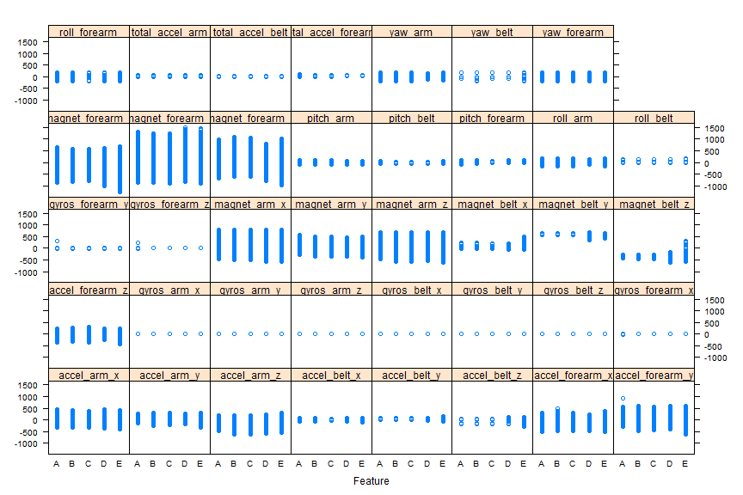

#### Plot of correlation matrix

Plot a correlation matrix between features.  
A good set of features is when they are highly uncorrelated (orthogonal) each others. The plot below shows average of correlation is not too high, so I choose to not perform further PCA preprocessing.

corrplot.mixed(cor(train), lower="circle", upper="color",   
 tl.pos="lt", diag="n", order="hclust", hclust.method="complete")

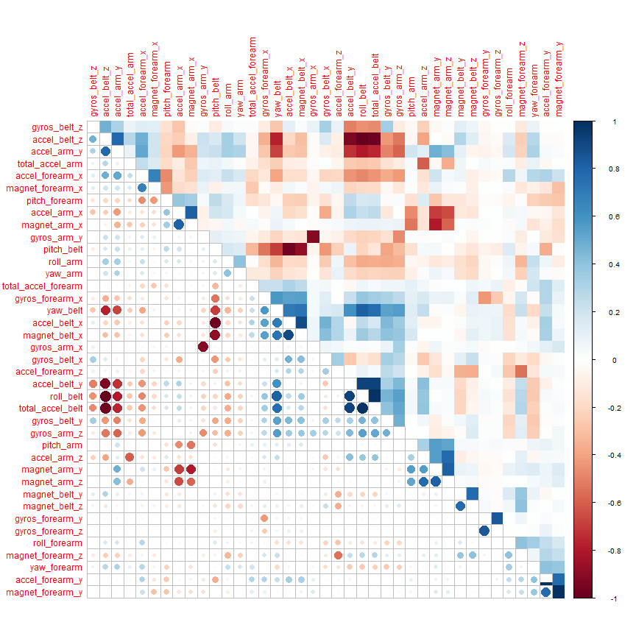

#### tSNE plot

A tSNE (t-Distributed Stochastic Neighbor Embedding) visualization is 2D plot of multidimensional features, that is multidimensional reduction into 2D plane. In the tSNE plot below there is no clear separation of clustering of the 5 levels of outcome (A, B, C, D, E). So it hardly gets conclusion for manually building any regression equation from the irregularity.

# t-Distributed Stochastic Neighbor Embedding  
tsne = Rtsne(as.matrix(train), check_duplicates=FALSE, pca=TRUE,   
 perplexity=30, theta=0.5, dims=2)  
embedding = as.data.frame(tsne$Y)  
embedding$Class = outcome.org  
p = ggplot(embedding, aes(x=V1, y=V2, color=Class)) +  
 geom_point(size=1.25) +  
 guides(colour=guide_legend(override.aes=list(size=6))) +  
 xlab("") + ylab("") +  
 ggtitle("t-SNE 2D Embedding of 'Classe' Outcome") +  
 theme_light(base_size=20) +  
 theme(axis.text.x=element_blank(),  
 axis.text.y=element_blank())  
print(p)

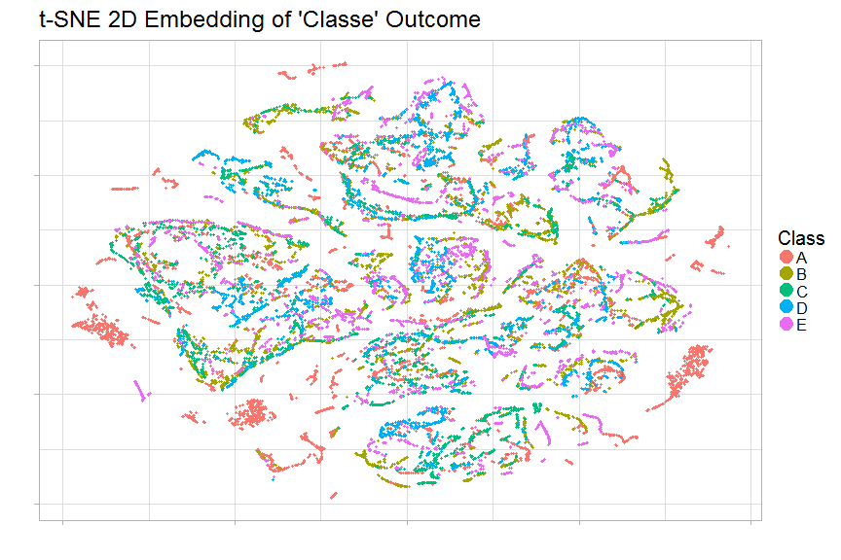

### Build machine learning model

Now build a machine learning model to predict activity quality (classe outcome) from the activity monitors (the features or predictors) by using XGBoost extreme gradient boosting algorithm.

#### XGBoost data

XGBoost supports only numeric matrix data. Converting all training, testing and outcome data to matrix.

# convert data to matrix  
train.matrix = as.matrix(train)  
mode(train.matrix) = "numeric"  
test.matrix = as.matrix(test)  
mode(test.matrix) = "numeric"  
# convert outcome from factor to numeric matrix   
# xgboost takes multi-labels in [0, numOfClass)  
y = as.matrix(as.integer(outcome)-1)

#### XGBoost parameters

Set XGBoost parameters for cross validation and training.  
Set a multiclass classification objective as the gradient boosting's learning function.  
Set evaluation metric to merror, multiclass error rate.

# xgboost parameters  
param <- list("objective" = "multi:softprob", # multiclass classification   
 "num_class" = num.class, # number of classes   
 "eval_metric" = "merror", # evaluation metric   
 "nthread" = 8, # number of threads to be used   
 "max_depth" = 16, # maximum depth of tree   
 "eta" = 0.3, # step size shrinkage   
 "gamma" = 0, # minimum loss reduction   
 "subsample" = 1, # part of data instances to grow tree   
 "colsample_bytree" = 1, # subsample ratio of columns when constructing each tree   
 "min_child_weight" = 12 # minimum sum of instance weight needed in a child   
 )

#### Expected error rate

Expected error rate is less than 1% for a good classification. Do cross validation to estimate the error rate using 4-fold cross validation, with 200 epochs to reach the expected error rate of less than 1%.

#### 4-fold cross validation

# set random seed, for reproducibility   
set.seed(12345)  
# k-fold cross validation, with timing  
nround.cv = 200  
system.time( bst.cv <- xgb.cv(param=param, data=train.matrix, label=y,   
 nfold=4, nrounds=nround.cv, prediction=TRUE, verbose=FALSE) )

## user system elapsed   
## 142.34 10.78 46.04

Elapsed time is around 150 seconds (2.5 minutes).

summary(bst.cv)

## Length Class Mode   
## call 8 -none- call   
## params 11 -none- list   
## callbacks 2 -none- list   
## evaluation_log 5 data.table list   
## niter 1 -none- numeric  
## folds 4 -none- list   
## pred 98110 -none- numeric

head(bst.cv$evaluation_log, 5)

## iter train_merror_mean train_merror_std test_merror_mean  
## 1: 1 0.06057825 0.0026705541 0.08592400  
## 2: 2 0.03645575 0.0015114940 0.06044225  
## 3: 3 0.02442825 0.0006087838 0.04754875  
## 4: 4 0.01816025 0.0005489542 0.03893600  
## 5: 5 0.01357325 0.0006661278 0.03256550  
## test_merror_std  
## 1: 0.001625581  
## 2: 0.002531370  
## 3: 0.001530331  
## 4: 0.001475538  
## 5: 0.001746778

tail(bst.cv$evaluation_log, 5)

## iter train_merror_mean train_merror_std test_merror_mean  
## 1: 196 0 0 0.00514725  
## 2: 197 0 0 0.00509625  
## 3: 198 0 0 0.00519825  
## 4: 199 0 0 0.00530025  
## 5: 200 0 0 0.00519825  
## test_merror_std  
## 1: 0.0007679116  
## 2: 0.0007627638  
## 3: 0.0006682108  
## 4: 0.0006281216  
## 5: 0.0007134646

From the cross validation, choose index with minimum multiclass error rate.  
Index will be used in the model training to fulfill expected minimum error rate of < 1%.

# index of minimum merror  
min.merror.idx = which.min(bst.cv$evaluation_log[, test_merror_mean])   
min.merror.idx

## [1] 188

# minimum merror  
bst.cv$evaluation_log[min.merror.idx,]

## iter train_merror_mean train_merror_std test_merror_mean  
## 1: 188 0 0 0.00509625  
## test_merror_std  
## 1: 0.0007206127

Best cross-validation's minimum error rate test.merror.mean is around 0.006 (0.6%), happened at 106th iteration.

#### Confusion matrix

Tabulates the cross-validation's predictions of the model against the truths.

# get CV's prediction decoding  
pred.cv = matrix(bst.cv$pred, nrow=length(bst.cv$pred)/num.class, ncol=num.class)  
pred.cv = max.col(pred.cv, "last")  
# confusion matrix  
confusionMatrix(factor(y+1), factor(pred.cv))

## Confusion Matrix and Statistics  
##   
## Reference  
## Prediction 1 2 3 4 5  
## 1 5573 5 2 0 0  
## 2 8 3775 14 0 0  
## 3 0 21 3379 22 0  
## 4 0 0 18 3196 2  
## 5 0 1 1 8 3597  
##   
## Overall Statistics  
##   
## Accuracy : 0.9948   
## 95% CI : (0.9937, 0.9958)  
## No Information Rate : 0.2844   
## P-Value [Acc > NIR] : < 2.2e-16   
##   
## Kappa : 0.9934   
## Mcnemar's Test P-Value : NA   
##   
## Statistics by Class:  
##   
## Class: 1 Class: 2 Class: 3 Class: 4 Class: 5  
## Sensitivity 0.9986 0.9929 0.9897 0.9907 0.9994  
## Specificity 0.9995 0.9986 0.9973 0.9988 0.9994  
## Pos Pred Value 0.9987 0.9942 0.9874 0.9938 0.9972  
## Neg Pred Value 0.9994 0.9983 0.9978 0.9982 0.9999  
## Prevalence 0.2844 0.1938 0.1740 0.1644 0.1834  
## Detection Rate 0.2840 0.1924 0.1722 0.1629 0.1833  
## Detection Prevalence 0.2844 0.1935 0.1744 0.1639 0.1838  
## Balanced Accuracy 0.9990 0.9958 0.9935 0.9947 0.9994

Confusion matrix shows concentration of correct predictions is on the diagonal, as expected.

The average accuracy is 99.48%, with error rate is 0.52%. So, expected error rate of less than 1% is fulfilled.

#### Model training

Fit the XGBoost gradient boosting model on all of the training data.

# real model fit training, with full data  
system.time( bst <- xgboost(param=param, data=train.matrix, label=y,   
 nrounds=min.merror.idx, verbose=0) )

## user system elapsed   
## 42.29 2.51 13.15

Time elapsed is around 40 seconds.

#### Predicting the testing data

# xgboost predict test data using the trained model  
pred <- predict(bst, test.matrix)   
head(pred, 10)

## [1] 8.172725e-04 9.968295e-01 1.817665e-03 1.547369e-04 3.809125e-04  
## [6] 9.992132e-01 5.696873e-04 1.989425e-04 4.991927e-06 1.308319e-05

#### Post-processing

Output of prediction is the predicted probability of the 5 levels (columns) of outcome.  
Decode the quantitative 5 levels of outcomes to qualitative letters (A, B, C, D, E).

# decode prediction  
pred = matrix(pred, nrow=num.class, ncol=length(pred)/num.class)  
pred = t(pred)  
pred = max.col(pred, "last")  
pred.char = toupper(letters[pred])  
print(pred.char)

## [1] "B" "A" "B" "A" "A" "E" "D" "B" "A" "A" "B" "C" "B" "A" "E" "E" "A"  
## [18] "B" "B" "B"

(*The prediction result pred.char is not displayed intentionally due to Honour Code, because it is the answer of the "project submission" part.*)

#### Feature importance

# get the trained model  
model = xgb.dump(bst, with_stats=TRUE)  
# get the feature real names  
names = dimnames(train.matrix)[[2]]  
# compute feature importance matrix  
importance_matrix = xgb.importance(names, model=bst)  
  
# plot  
xgb_var_plot = xgb.plot.importance(importance_matrix)

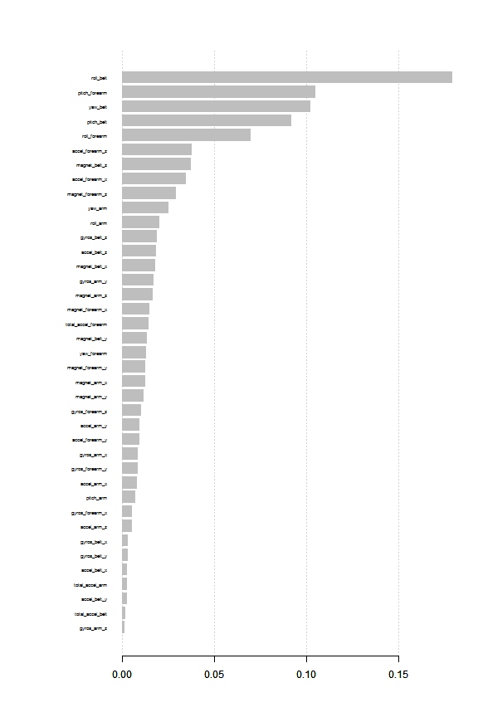

print(xgb_var_plot)

## Feature Gain Cover Frequency Importance  
## 1: roll_belt 0.179689806 0.121642898 0.057816195 0.179689806  
## 2: pitch_forearm 0.104945550 0.092375074 0.059447117 0.104945550  
## 3: yaw_belt 0.102474225 0.095227514 0.091087010 0.102474225  
## 4: pitch_belt 0.092134804 0.071293121 0.067764821 0.092134804  
## 5: roll_forearm 0.069669913 0.064874854 0.057245372 0.069669913  
## 6: accel_forearm_z 0.037745736 0.026620311 0.033107722 0.037745736  
## 7: magnet_belt_z 0.037437486 0.039299480 0.027562587 0.037437486  
## 8: accel_forearm_x 0.034443833 0.026772453 0.021446628 0.034443833  
## 9: magnet_forearm_z 0.029086007 0.025872110 0.031476800 0.029086007  
## 10: yaw_arm 0.024874759 0.020187695 0.022180543 0.024874759  
## 11: roll_arm 0.020062270 0.022160447 0.037837397 0.020062270  
## 12: gyros_belt_z 0.018613586 0.037301871 0.018674060 0.018613586  
## 13: accel_belt_z 0.018396217 0.021761736 0.025279295 0.018396217  
## 14: magnet_belt_x 0.018056413 0.021392217 0.026584033 0.018056413  
## 15: gyros_arm_y 0.017025886 0.024093553 0.024790019 0.017025886  
## 16: magnet_arm_z 0.016503736 0.025173973 0.024300742 0.016503736  
## 17: magnet_forearm_x 0.014501468 0.017769645 0.022262089 0.014501468  
## 18: total_accel_forearm 0.014454026 0.011069554 0.010274810 0.014454026  
## 19: magnet_belt_y 0.013472744 0.019110900 0.018266330 0.013472744  
## 20: yaw_forearm 0.012921233 0.011533766 0.023159096 0.012921233  
## 21: magnet_forearm_y 0.012473398 0.016745372 0.021935905 0.012473398  
## 22: magnet_arm_x 0.012335193 0.006814195 0.011824187 0.012335193  
## 23: magnet_arm_y 0.011368624 0.019494340 0.021038897 0.011368624  
## 24: gyros_forearm_z 0.010090414 0.012519103 0.014759847 0.010090414  
## 25: accel_arm_y 0.009376450 0.012755689 0.017532415 0.009376450  
## 26: accel_forearm_y 0.009330313 0.012755471 0.022098997 0.009330313  
## 27: gyros_arm_x 0.008448228 0.015911835 0.024626927 0.008448228  
## 28: gyros_forearm_y 0.008301503 0.013937546 0.025768572 0.008301503  
## 29: accel_arm_x 0.007769656 0.016218852 0.020631167 0.007769656  
## 30: pitch_arm 0.007106967 0.012056996 0.022914458 0.007106967  
## 31: gyros_forearm_x 0.005417249 0.009435025 0.015983038 0.005417249  
## 32: accel_arm_z 0.005278987 0.008405791 0.019163337 0.005278987  
## 33: gyros_belt_x 0.002990495 0.009781430 0.016880046 0.002990495  
## 34: gyros_belt_y 0.002934949 0.013798409 0.007420696 0.002934949  
## 35: accel_belt_x 0.002510205 0.008044612 0.010519449 0.002510205  
## 36: total_accel_arm 0.002334651 0.003805335 0.008888526 0.002334651  
## 37: accel_belt_y 0.002290068 0.005804877 0.004892767 0.002290068  
## 38: total_accel_belt 0.001787542 0.002313041 0.003180298 0.001787542  
## 39: gyros_arm_z 0.001345409 0.003868911 0.009377803 0.001345409  
## Feature Gain Cover Frequency Importance

Feature importance plot is useful to select only best features with highest correlation to the outcome(s). To improve model fitting performance (time or overfitting), less important features can be removed.

### Creating submission files

path = "./Project_Question"  
pml_write_files = function(x) {  
 n = length(x)  
 for(i in 1: n) {  
 filename = paste0("Answer_", i, ".txt")  
 write.table(x[i], file=file.path(path, filename),   
 quote=FALSE, row.names=FALSE, col.names=FALSE)  
 }  
}  
pml_write_files(pred.char)