БЕЛОРУССКИЙ ГОСУДАРСТВЕННЫЙ УНИВЕРСИТЕТ

Факультет прикладной математики и информатики

Кафедра технологий программирования

**Гришкин Андрей Иванович**

Отчёт по лабораторной работе №4

По курсу “Программирование мобильных и встраиваемых систем”

Базовые команды для работы с ОС LINUX для мобильных и

встраиваемых платформ

Преподаватель: Давидовская М.И.

Минск, 2020 г.

Пример makefile и работы программы 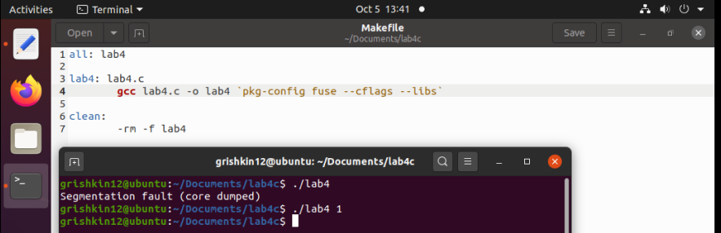

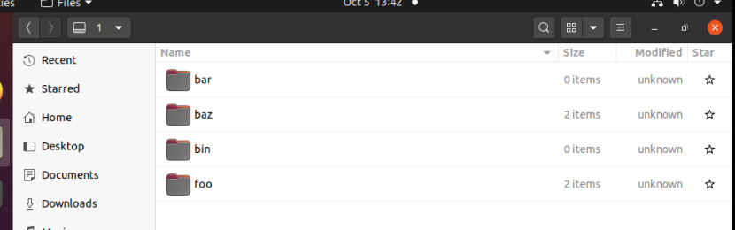

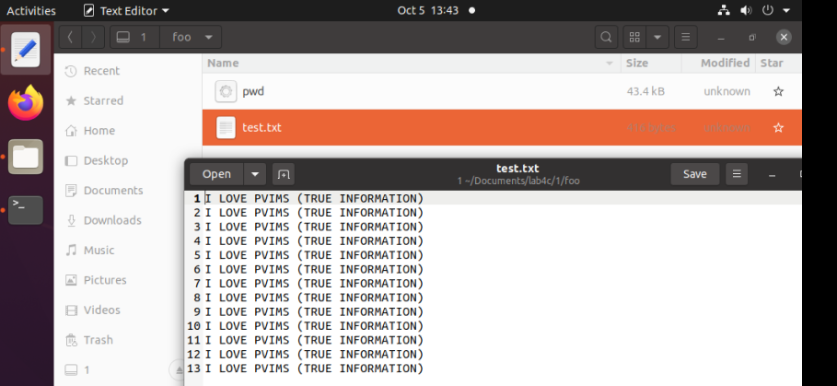

Код

#define FUSE_USE_VERSION 30

#define _FILE_OFFSET_BITS 64

#include <fuse.h>

#include <unistd.h>

#include <sys/types.h>

#include <stdio.h>

#include <string.h>

#include <errno.h>

#include <fcntl.h>

const int N=13;

char file_system_path[256] = "";

char* example_txt = "Hello world! Student Grishkin Andrei,1823113";

char test_txt[13][50];

char* readme_txt = "Student Grishkin Andrei,1823113";

static int get_attribute(const char* path, struct stat *st){

st->st_uid = getuid();

memset(st,0,sizeof(struct stat));

if(strcmp(path,"/") == 0){

st->st_mode = S_IFDIR | 0755;

}else if(strcmp(path,"/bin") == 0){

st->st_mode = S_IFDIR | 022;

}else if(strcmp(path,"/bar") == 0){

st->st_mode = S_IFDIR | 555;

}else if(strcmp(path, "/baz") == 0){

st->st_mode = S_IFDIR | 744;

}else if(strcmp(path, "/baz/readme.txt") == 0){

st->st_mode = S_IFREG | 644;

st->st_size = strlen(readme_txt);

}else if(strcmp(path, "/baz/example") == 0){

st->st_mode = S_IFREG | 222;

st->st_size = strlen(example_txt);

}else if(strcmp(path,"/foo") == 0){

st->st_mode = S_IFDIR | 711;

}else if(strcmp(path,"/foo/pwd") == 0){

st->st_mode = S_IFREG | 777;

struct stat buffer;

stat("/usr/bin/pwd",&buffer);

st->st_size = buffer.st_size;

}else if(strcmp(path,"/foo/test.txt") == 0){

st->st_mode = S_IFREG | 000;

int size = 0;

for(int i = 0;i<N;i++){

size+=strlen(test_txt[i])+1;

}

st->st_size = size;

}else{

return -ENOENT;

}

return 0;

}

static int read_directory(const char* path, void* buf, fuse_fill_dir_t filler, off_t offset, struct fuse_file_info * fi){

filler(buf,".",NULL,0);

filler(buf,"..",NULL,0);

if(strcmp(path,"/") == 0){

filler(buf,"bin",NULL,0);

filler(buf,"bar",NULL,0);

filler(buf,"baz",NULL,0);

filler(buf,"foo",NULL,0);

if(strcmp(file_system_path,"/mnt/fuse/")!=0){

filler(buf,file_system_path+1,NULL,0);

}

return 0;

}else if(strcmp(path,"/bin") == 0){

return 0;

}else if(strcmp(path,"/bar") == 0){

return 0;

}else if(strcmp(path,"/baz") == 0){

filler(buf,"example",NULL,0);

filler(buf,"readme.txt",NULL,0);

return 0;

}else if (strcmp(path,"/foo") == 0){

filler(buf,"pwd",NULL,0);

filler(buf,"test.txt",NULL,0);

return 0;

}

return -ENOENT;

}

static int read_file(const char* path, char* buf, size_t size,off_t offset, struct fuse_file_info* fi){

size_t length;

char* read_data;

if(strcmp(path,"/baz/readme.txt") == 0){

length = strlen(readme_txt);

read_data = readme_txt;

}else if(strcmp(path,"/baz/example") == 0){

length = strlen(example_txt);

read_data = example_txt;

}else if(strcmp(path,"/foo/pwd") == 0){

struct stat touch_stat;

stat("/usr/bin/pwd",&touch_stat);

length = touch_stat.st_size;

FILE* f = fopen("/usr/bin/pwd","rb");

unsigned char buffer[length];

fread(buffer,length,1,f);

read_data = buffer;

fclose(f);

}else if(strcmp(path,"/foo/test.txt") == 0){

char temp[N*50+400];

strcpy(temp,"");

for(int i = 0;i<N;i++){

strcat(temp,test_txt[i]);

strcat(temp,"\n");

}

length = strlen(temp);

read_data = temp;

}else{

return -ENOENT;

}

if(offset<length){

if(offset+size>length){

size = length-offset;

}

memcpy(buf, read_data+offset,size);

return size;

}

return 0;

}

int main(int argc, char** argv){

strcpy(file_system_path,argv[1]);

char number_line[8];

for(int i = 0;i<N;i++){

sprintf(number_line,"%d: ",i+1);

strcat(test_txt[i],"I LOVE PVIMS (TRUE INFORMATION)");

}

struct fuse_operations operations = {

.getattr = get_attribute,

.readdir = read_directory,

.read = read_file,

};

return fuse_main(argc,argv,&operations,NULL);

}