Lab 7: OLS Regression Figures
Bryan Hernandez Rodriguez
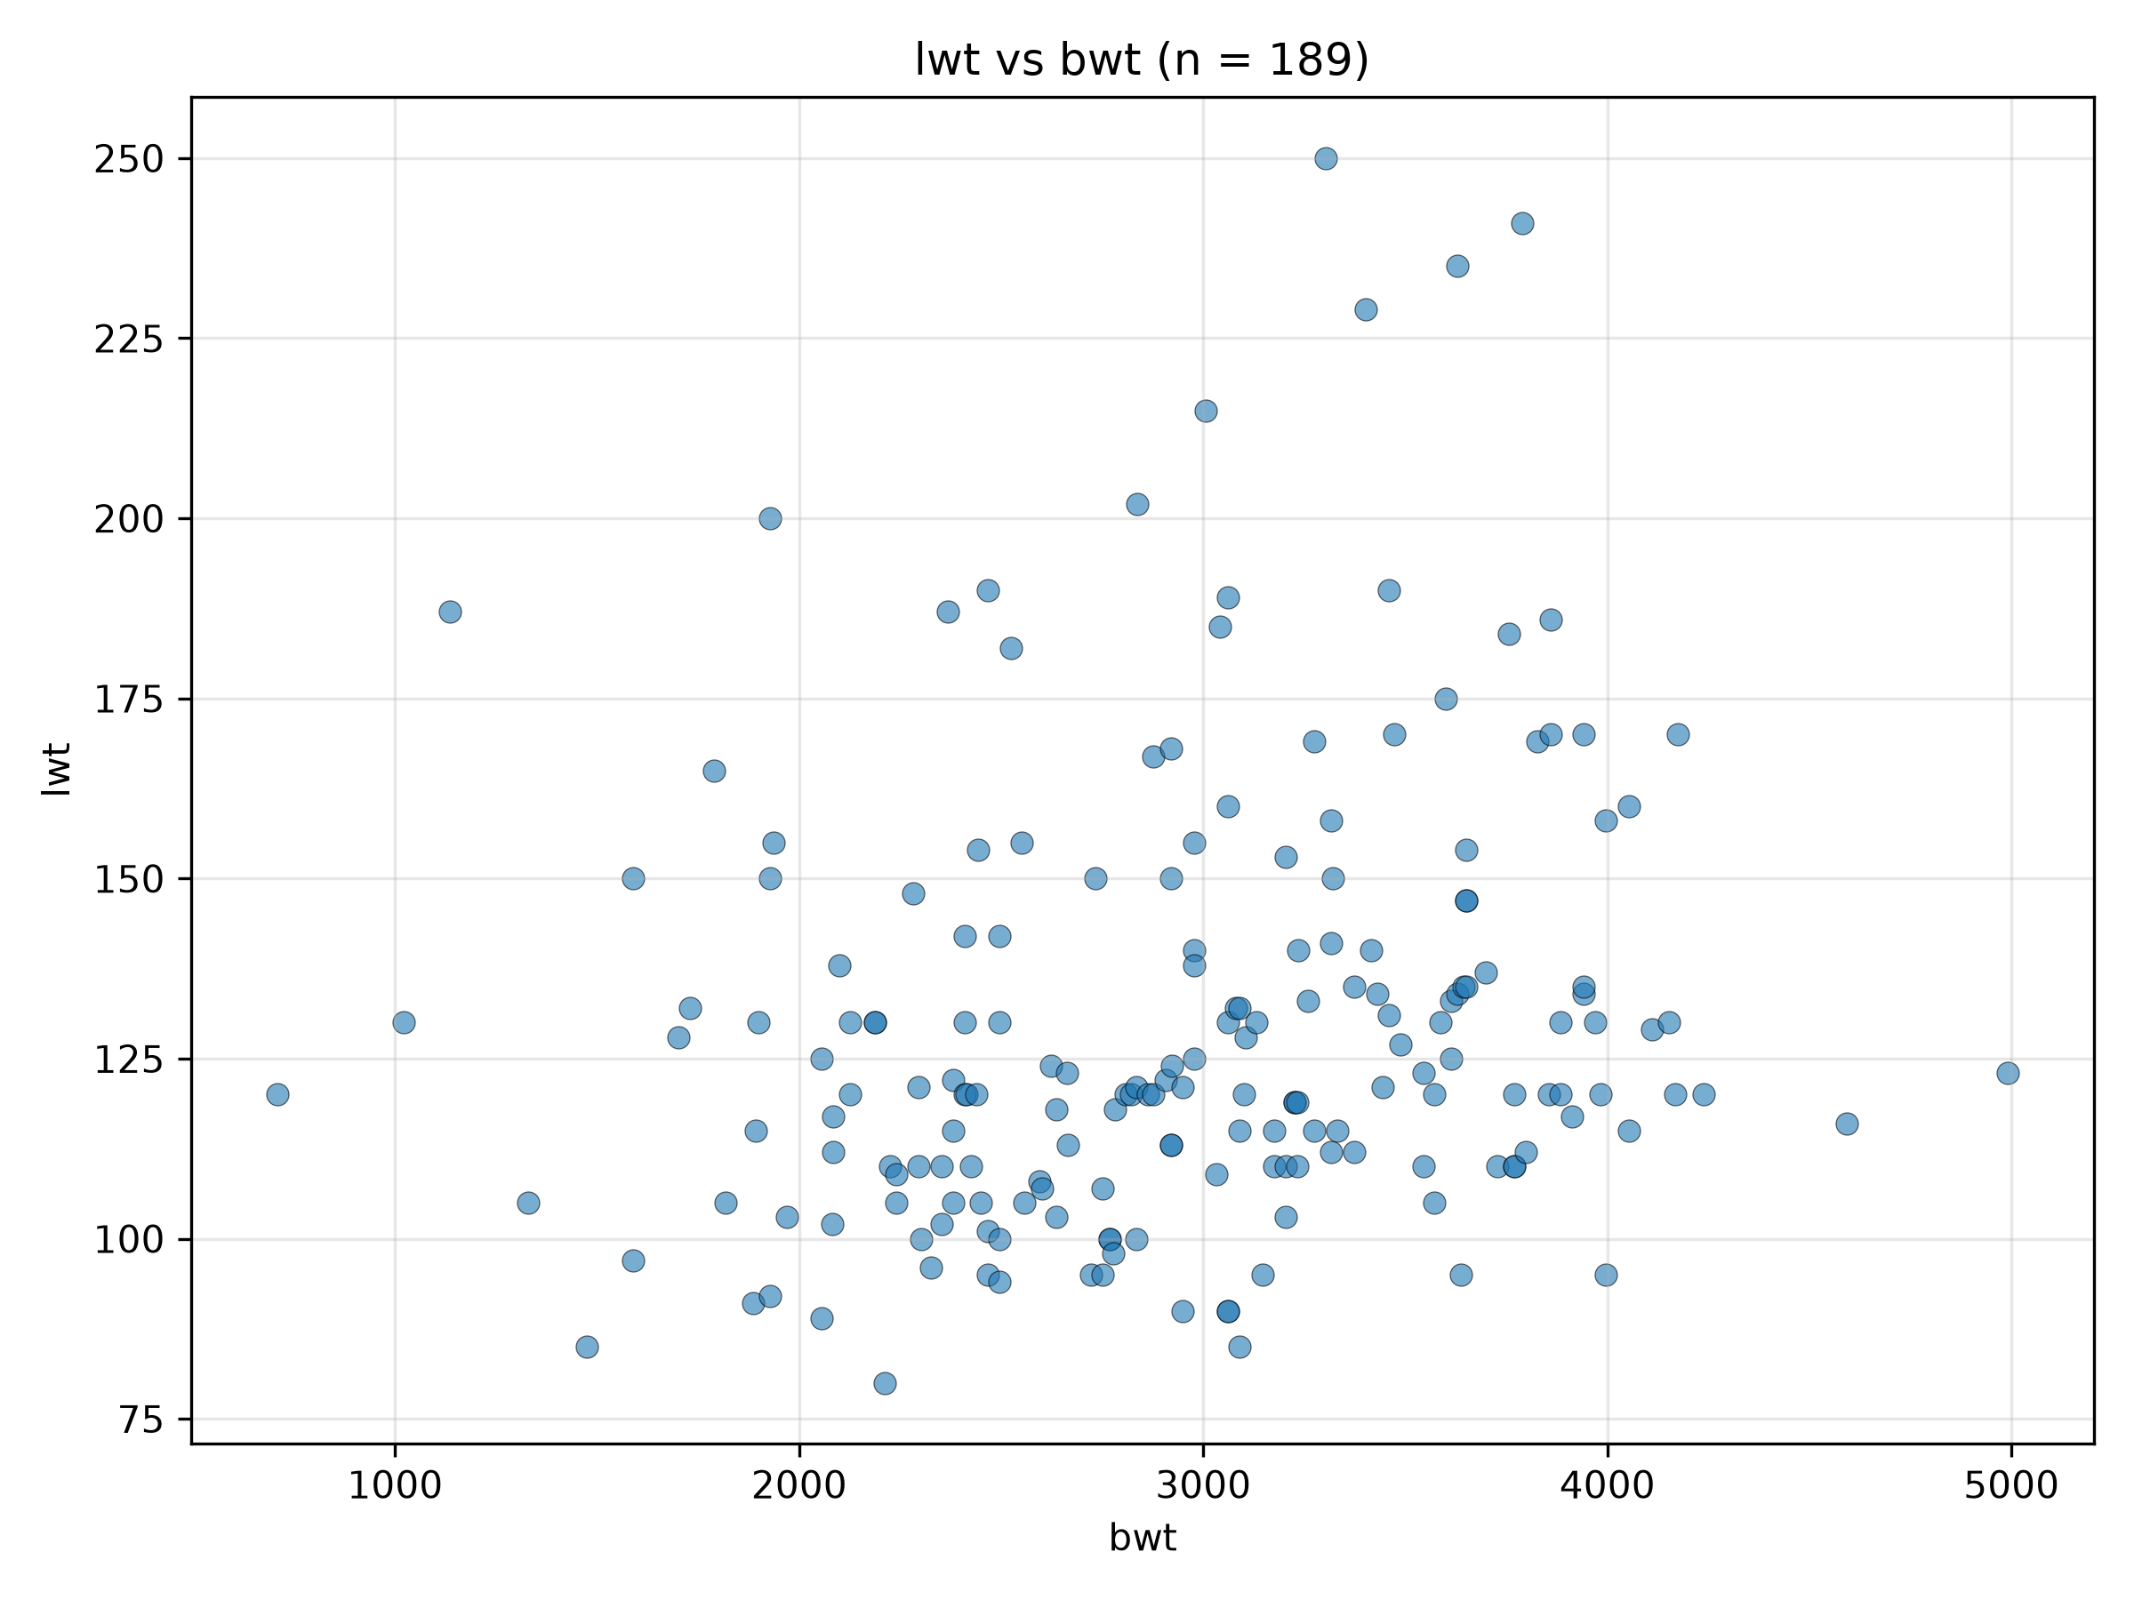
Figure 1. Scatterplot of lwt vs bwt (n = 189).
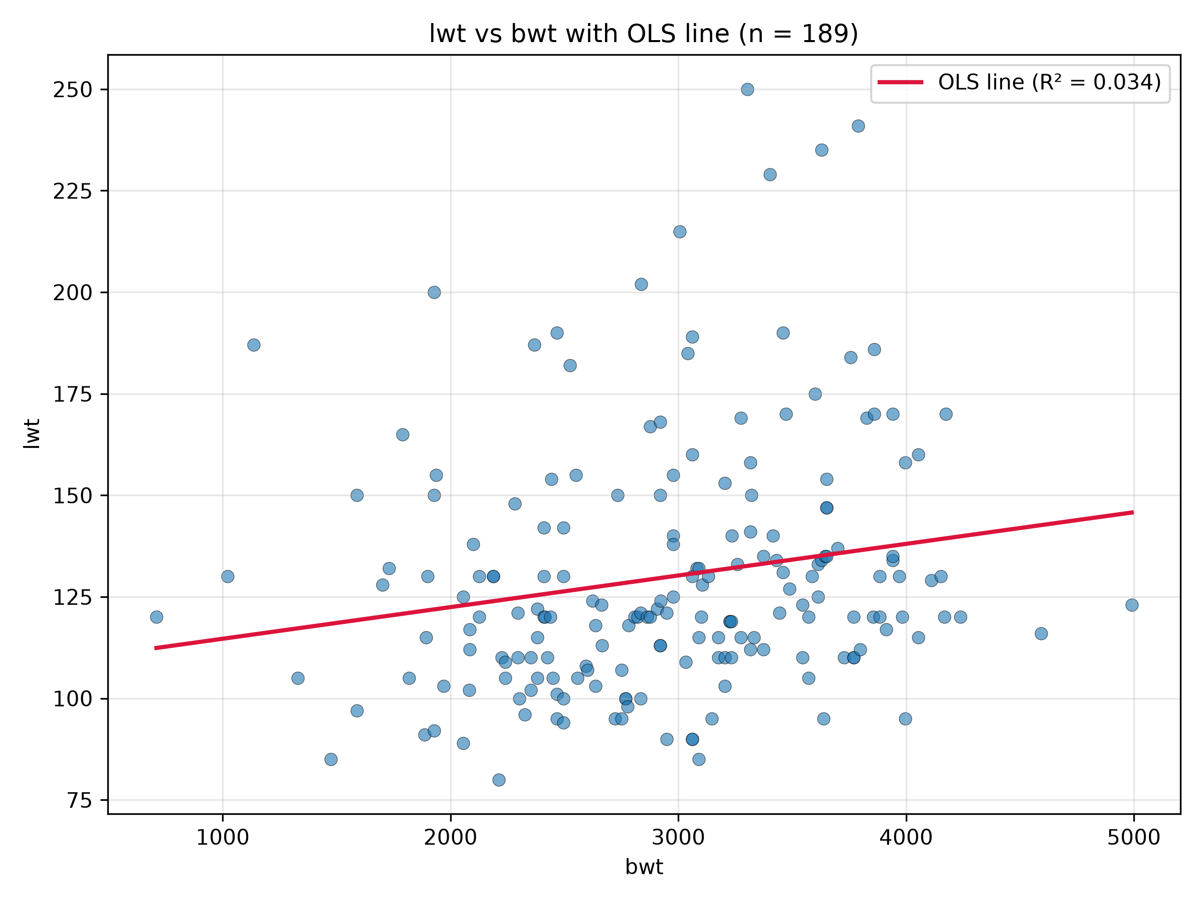
Figure 2. Scatterplot of lwt vs bwt with OLS regression line.
- Independent variable: bwt
- Dependent variable: lwt
- β0 (intercept): 106.8804
- β1 (slope coefficient): 0.0078
- R²: 0.034
- Relationship: There is a weak positive relationship between bwt and lwt: each one-unit increase in bwt is associated with an expected 0.0078-unit increase in lwt, and bwt explains only about 3.4% of the variation in lwt.

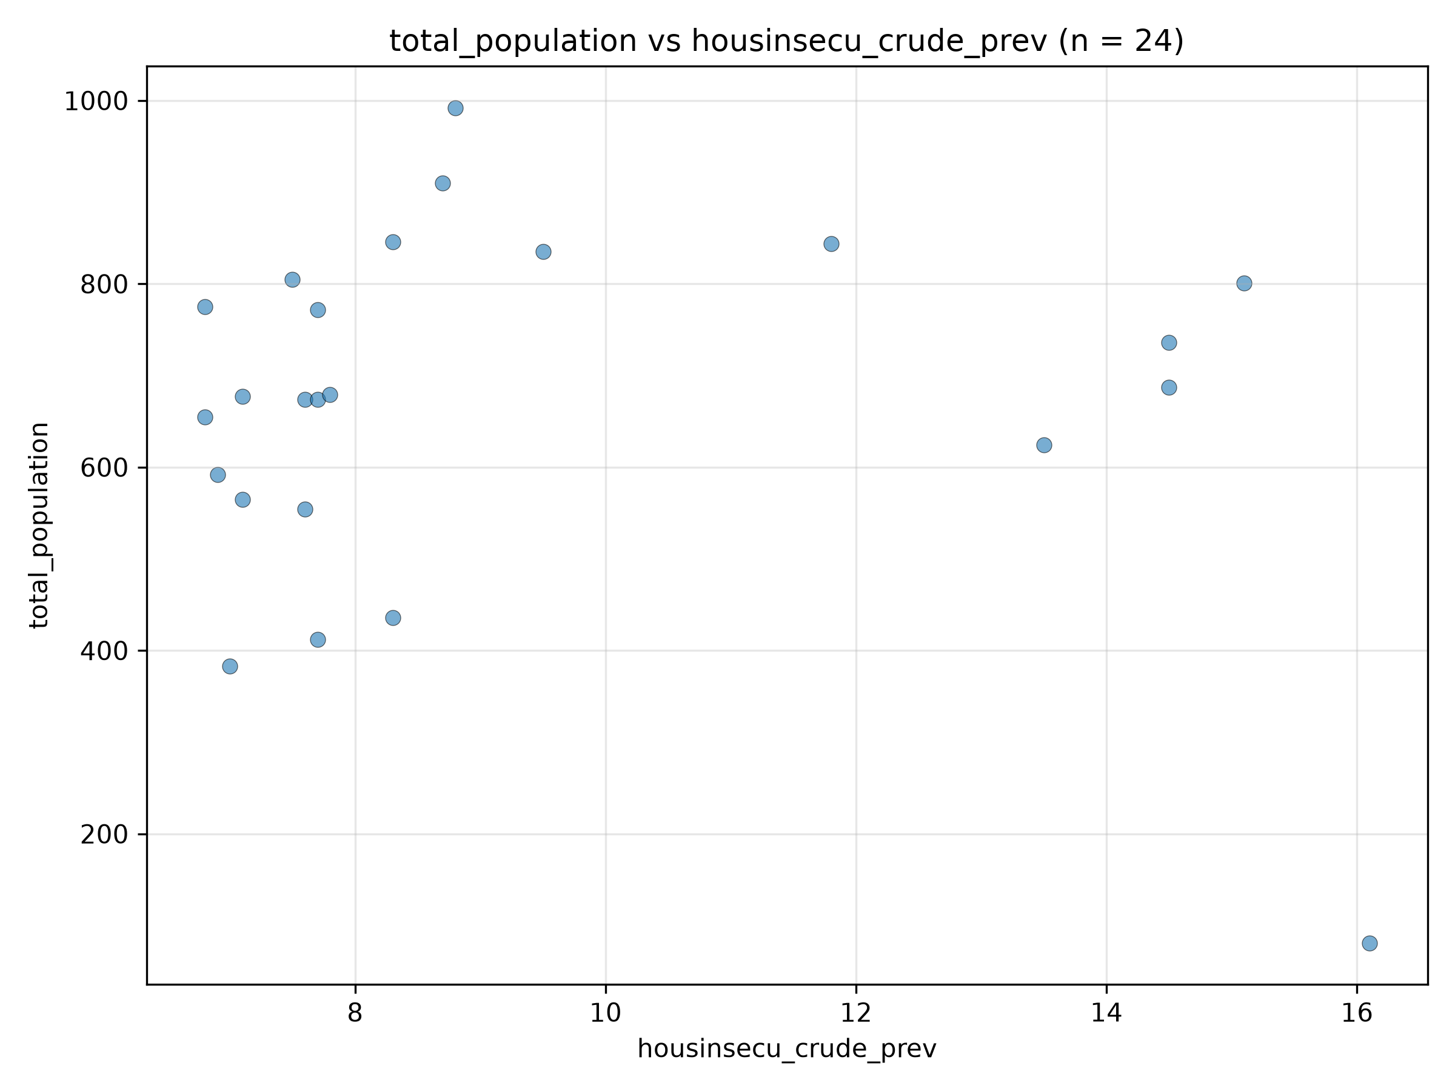
Figure 3. Scatterplot of total_population vs housinsecu_crude_prev (n = 24).
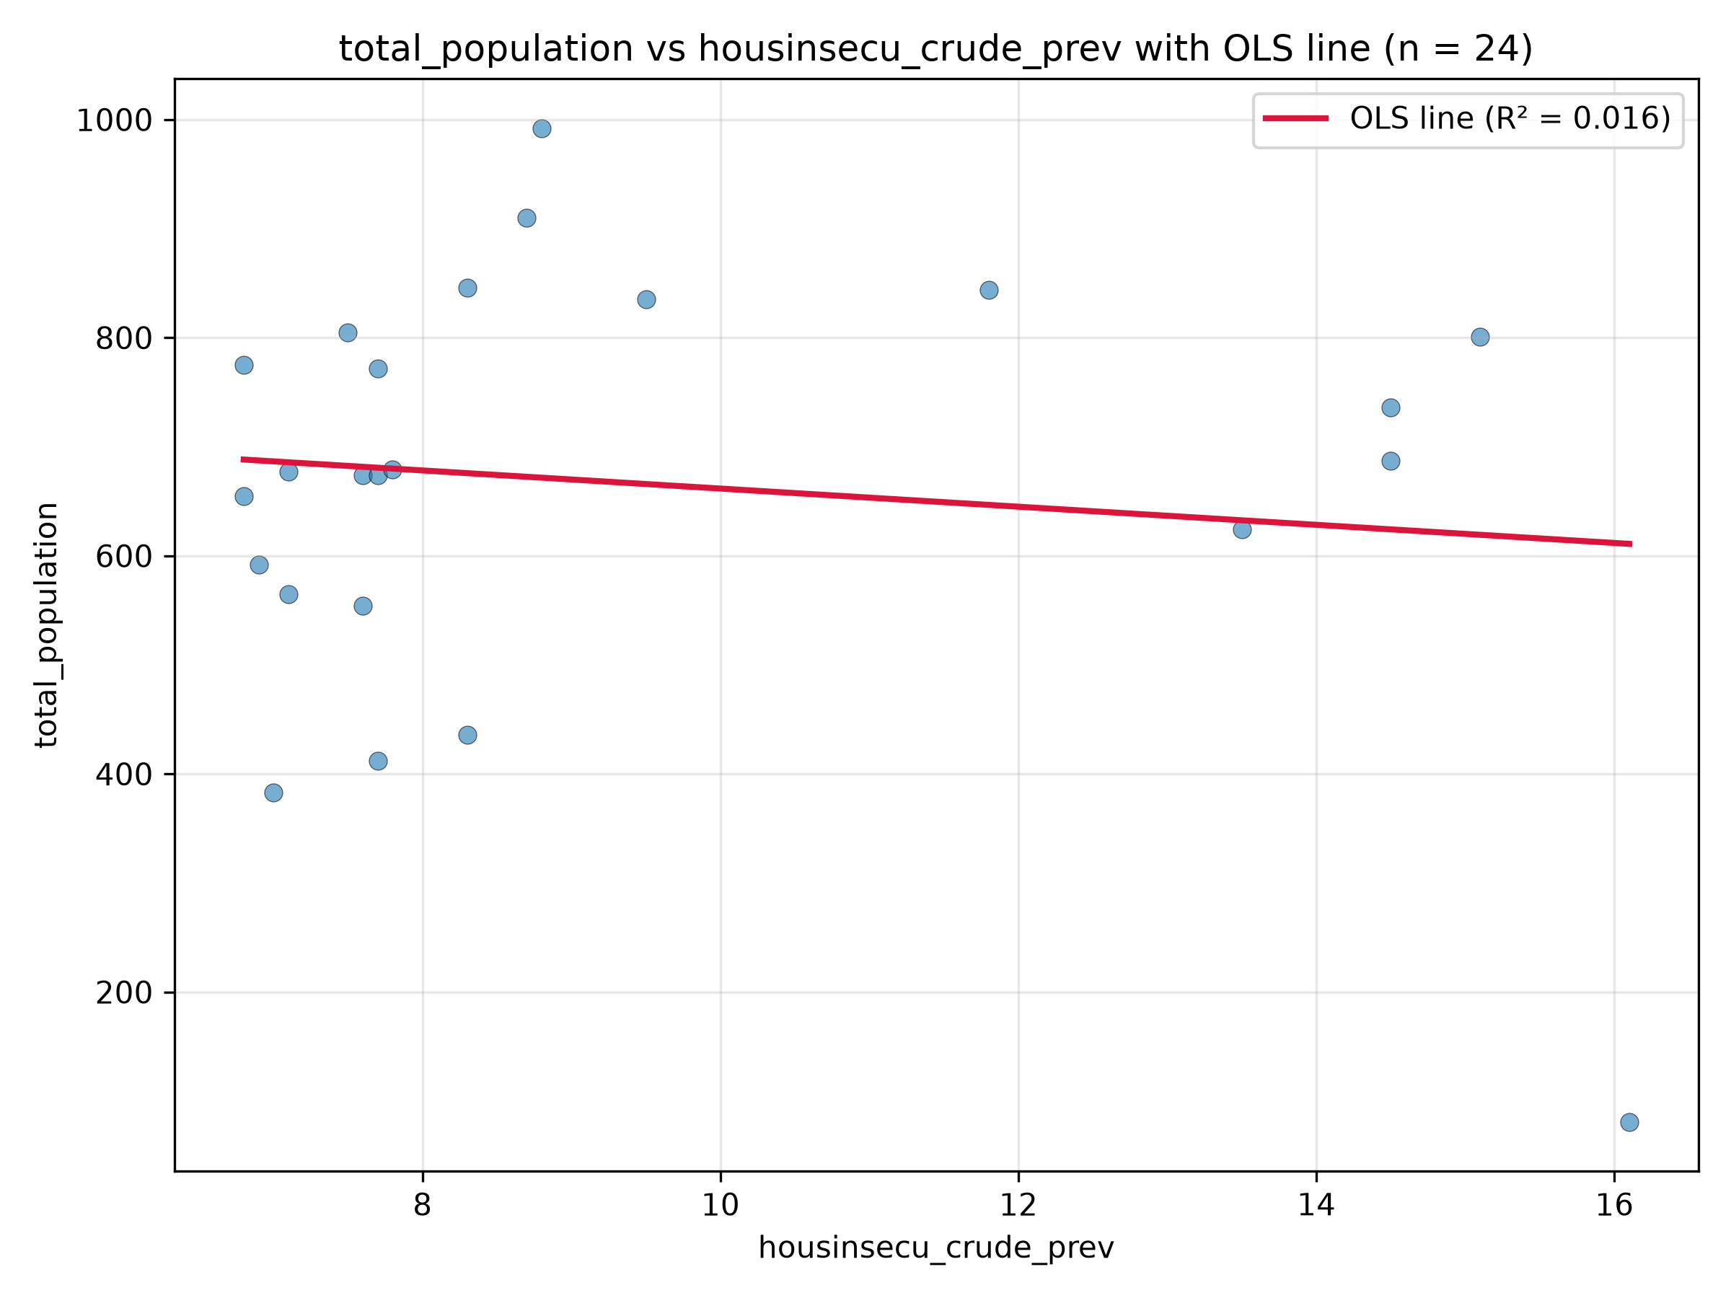
Figure 4. Scatterplot of total_population vs housinsecu_crude_prev with OLS regression line.
- Independent variable: housinsecu_crude_prev
- Dependent variable: total_population
- β0 (intercept): 744.7656
- β1 (slope coefficient): -8.3127
- R²: 0.016
- Relationship: There is a very weak negative relationship (not statistically significant, p = 0.551) between housinsecu_crude_prev and total_population: each one-unit increase in housinsecu_crude_prev is associated with an expected 8.31-unit decrease in total_population, and only about 1.6% of the variation is explained.

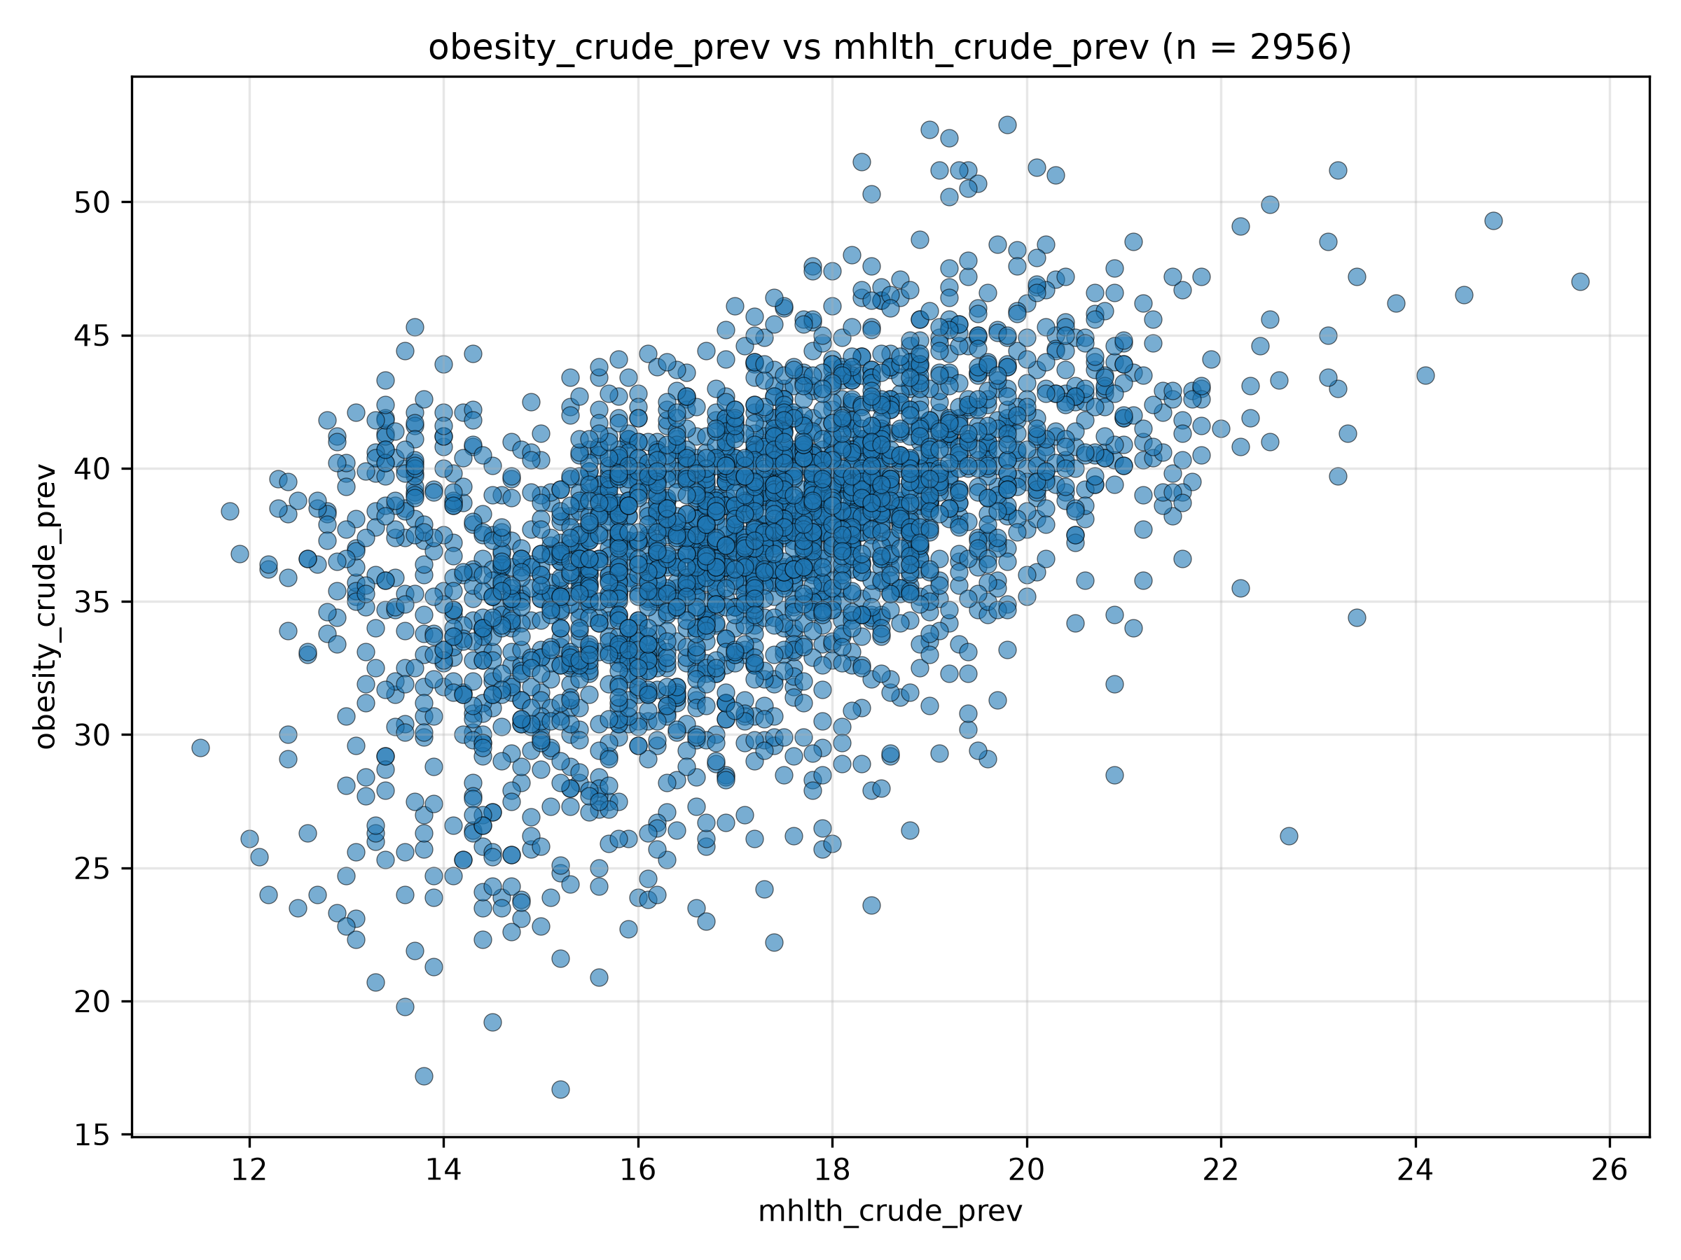
Figure 5. Scatterplot of obesity_crude_prev vs mhlth_crude_prev (n = 2956).
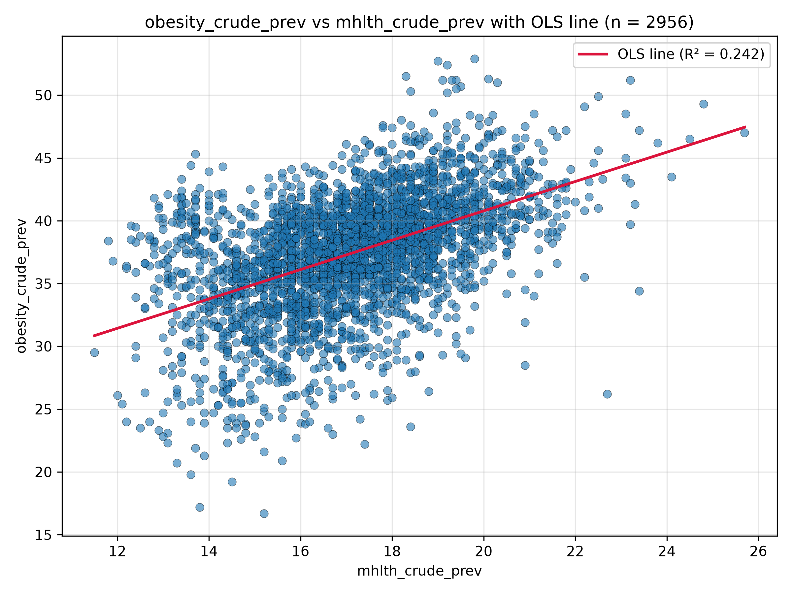
Figure 6. Scatterplot of obesity_crude_prev vs mhlth_crude_prev with OLS regression line.
- Independent variable: mhlth_crude_prev
- Dependent variable: obesity_crude_prev
- β0 (intercept): 17.4106
- β1 (slope coefficient): 1.1687
- R²: 0.242
- Relationship: There is a moderate positive relationship between mhlth_crude_prev and obesity_crude_prev: each one-unit increase in mhlth_crude_prev is associated with an expected 1.17-unit increase in obesity_crude_prev, and about 24.2% of the variation is explained.

