**WEEK-03(Assignment-3):**

**Question-1:- Implement shell scripts containing wild cards, regular expressions, escape characters, single quotes, double quotes, backticks, for loop, while loop, until loop, case statement, if , if-else, if-else-if statements.**

**1. Wild-cards:**

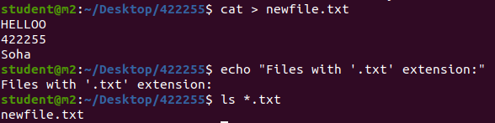

**2. Regular expressions**

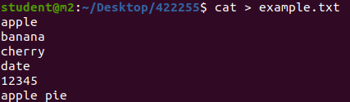

1. **Basic Matching:**
   * Match lines that contain the word "apple":
   * grep 'apple' example.txt  
     
2. **Anchors:**
   * Match lines that start with "a":
   * grep '^a' example.txt
   * Match lines that end with "y":
   * grep 'y$' example.txt
   * 
3. **Character Classes:**
   * Match lines that contain a digit:
   * grep '[0-9]' example.txt
   * 
4. **Quantifiers:**
   * Match lines containing at least two consecutive digits:
   * grep '[0-9]\{2,\}' example.txt
   * 
5. **Escape Characters:**
   * Match lines containing a period (literal dot):
   * grep '\.' example.txt
   * 
6. **Grouping and Alternation:**
   * Match lines containing either "apple" or "cherry":
   * grep -E '(apple|cherry)' example.txt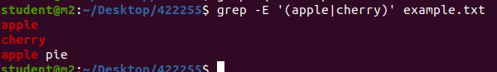

**3. Escape characters**

echo "This is a multiline message.\

It continues on the same line."



**4. Single quotes**

If you need to include variables or special characters within the string and still want to preserve the single quotes, you can use a combination of single and double quotes.





**5.Double quotes**

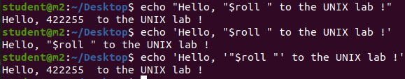

**6. Backticks**

# Backticks (Command Substitution)

current_date=`date`

echo "Current date: $current_date"



**7. For loop**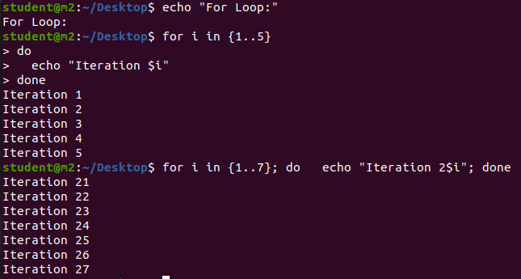

**8. While loop**

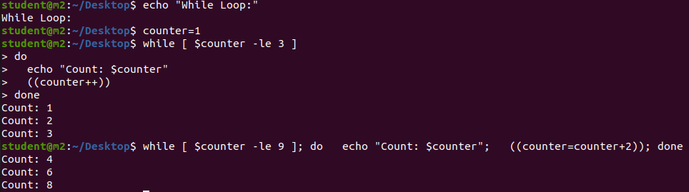

**9. Until loop**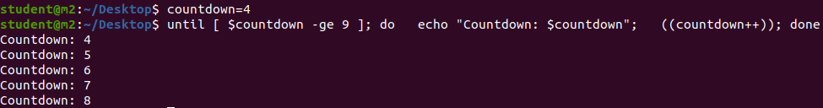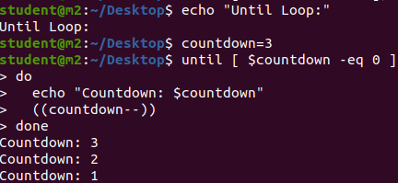

**10. Case statement** 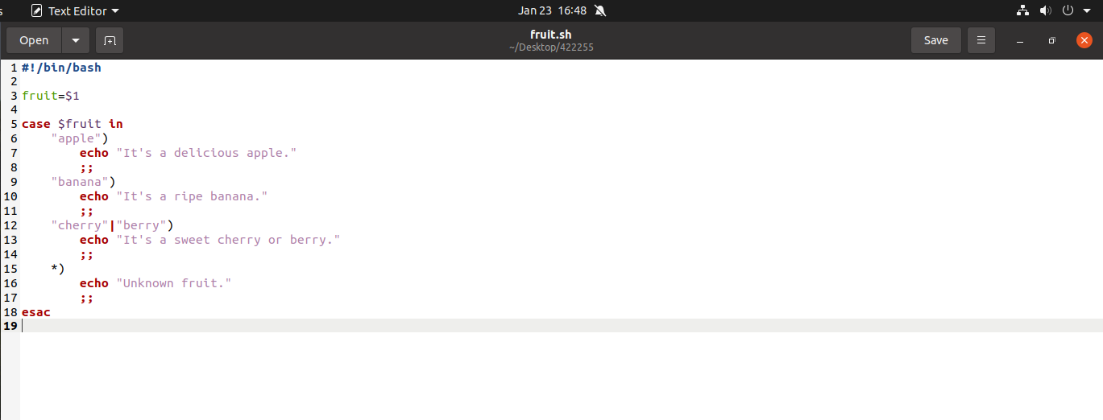

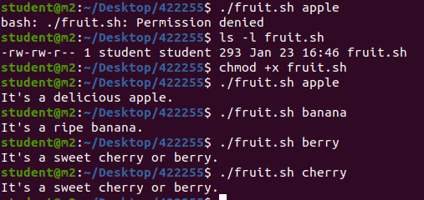

**11. If** 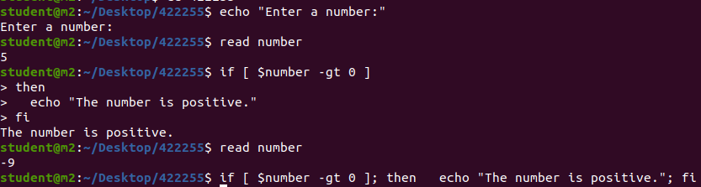

**12. If-else**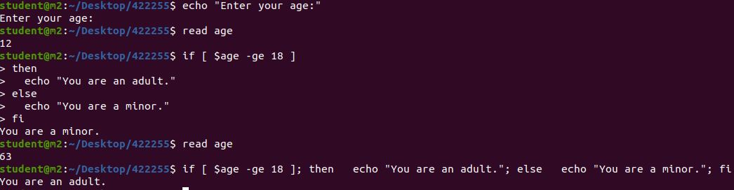

**13. If-else-if statements.**

