**WEEK-07:**

**Static linking:**

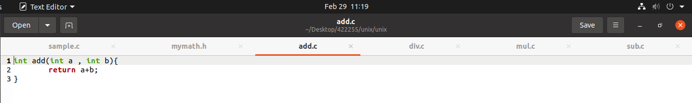

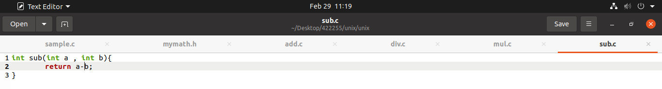

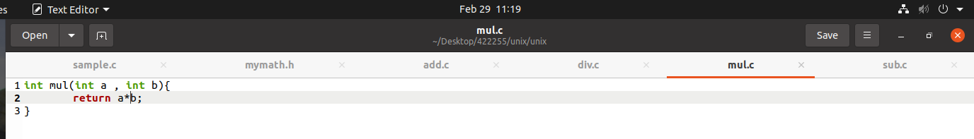

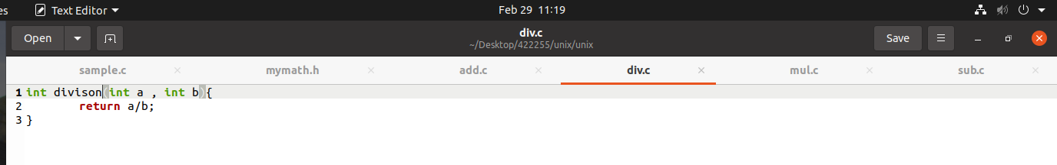

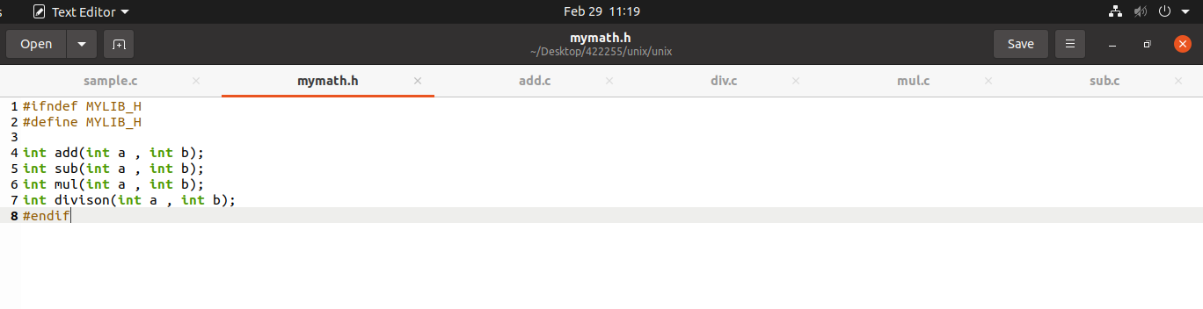

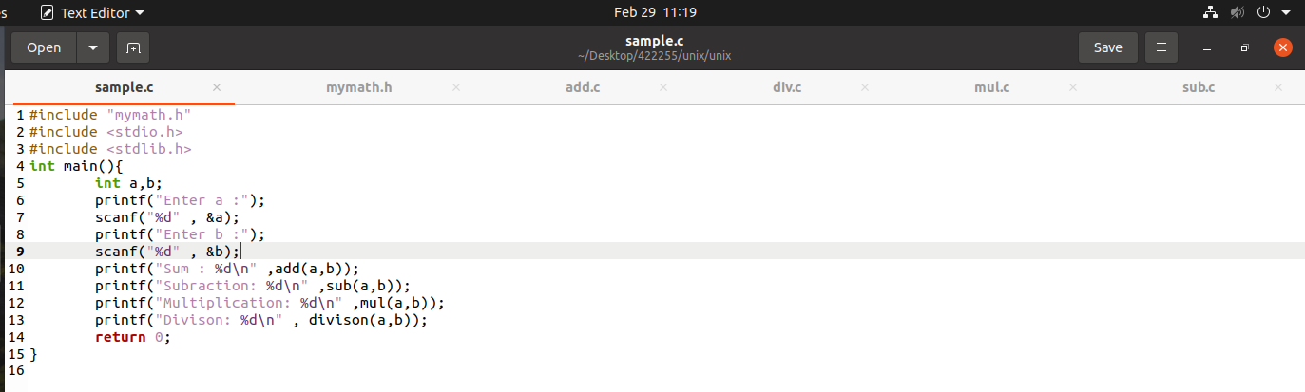

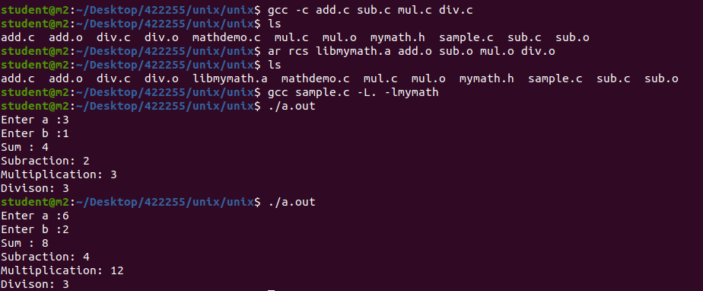

**Dynamic linking:**

