WEEK-09:

**Implement find, ping, ssh, mesg, write, talk, wall, tty and, who commands**

**These commands are used for networking purpose**

1. **find command:**

Find [path][options] filename

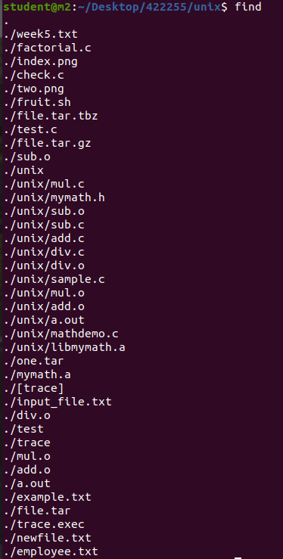

* -type: it has 2 options:

f(for files) and d(for directory)

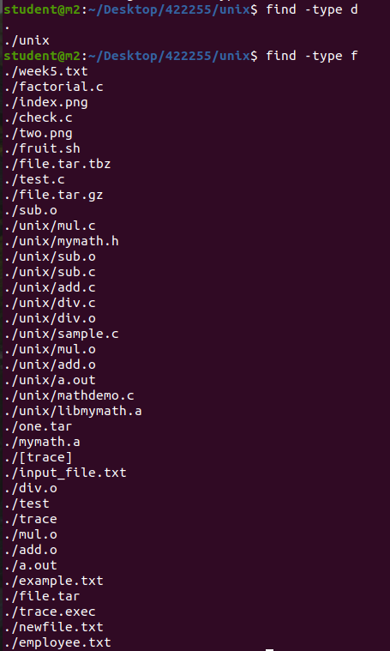

* -mtime n : number of files modified ‘n’ number of days ago



* -empty : shows empty files



* Permissions : -perm 664

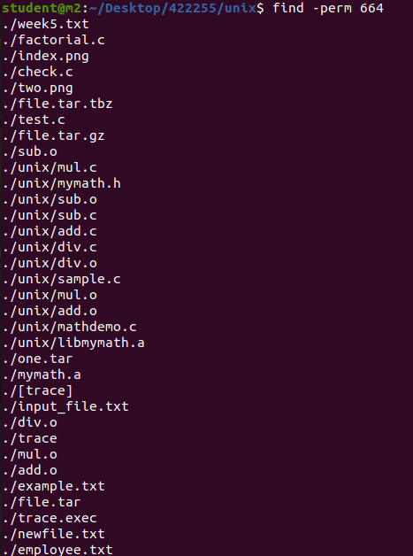

* Delete a file : -delete

All files in the current directory: find ~ -name filename

find ./gfg -name filename

1. **ping command:**

To check whether a user is connected to the network , here data is transmitted as packets.

* ping localhost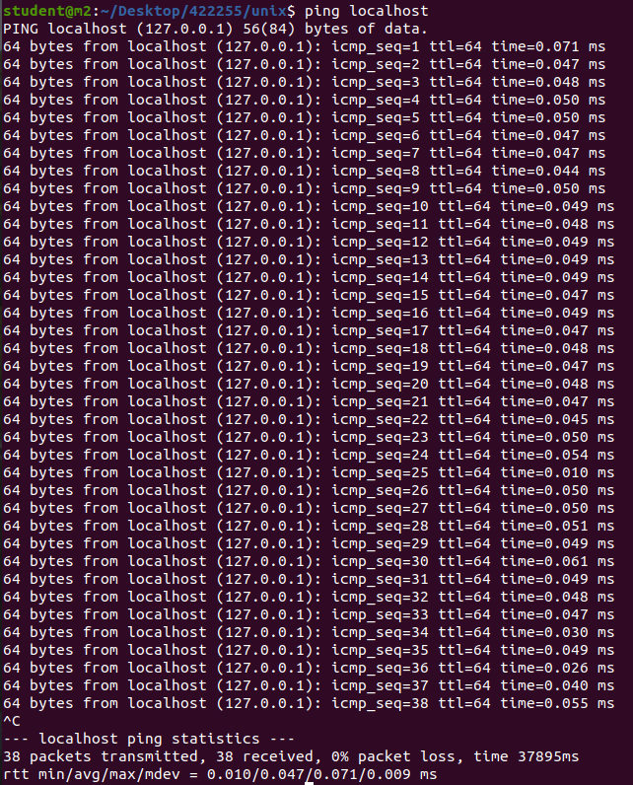
* ping -c 2 [www.google.com](http://www.google.com) :sending 2 packets to google 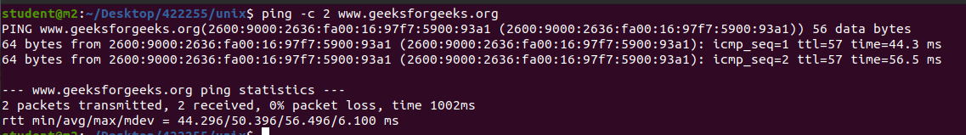
* ping -i 3 [www.google.com](http://www.google.com) : time between 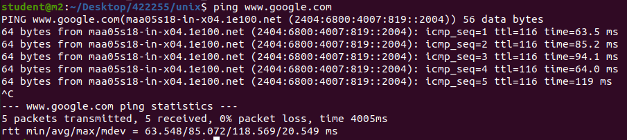
* ping -w : waiting time of the ping command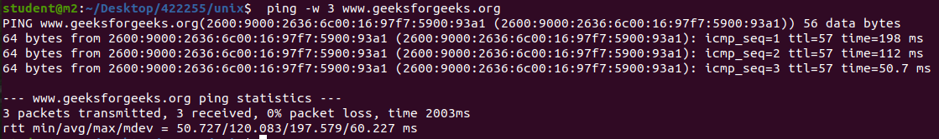
* 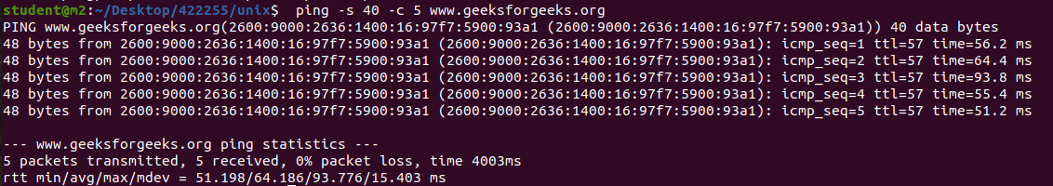
* ping -f : flooding of packets i.e sending infinite packets to a website

1. **ssh command:**

Connect one system to another system via IP address

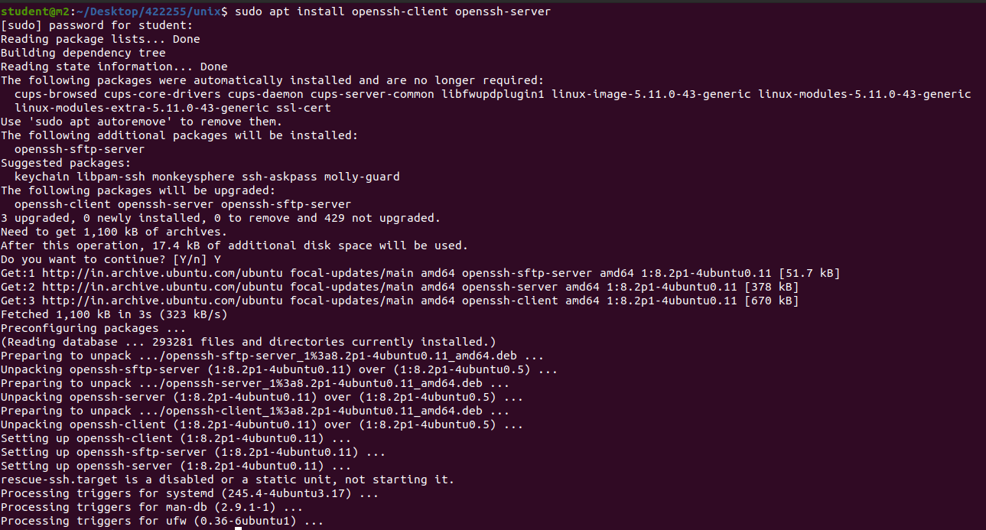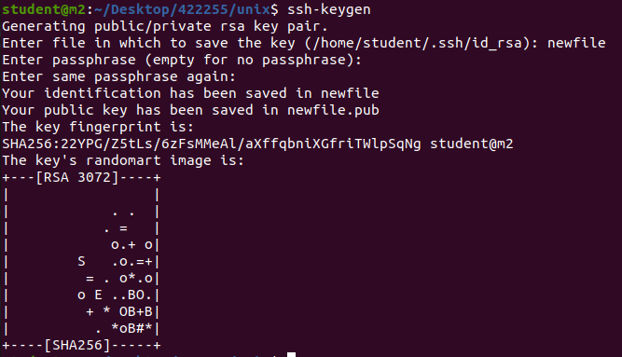Forces ssh to use protocol SSH-2 only.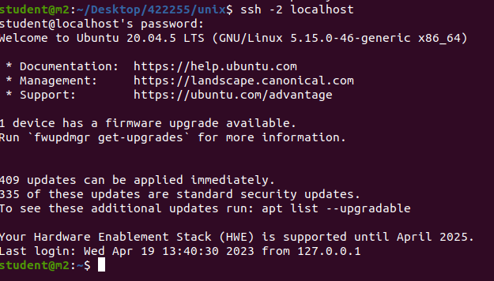

Allows IPv4 addresses only.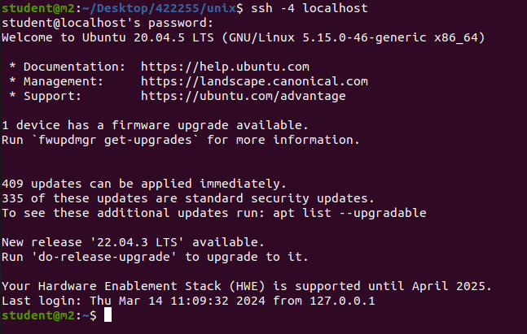Authentication agent connection forwarding is enabled.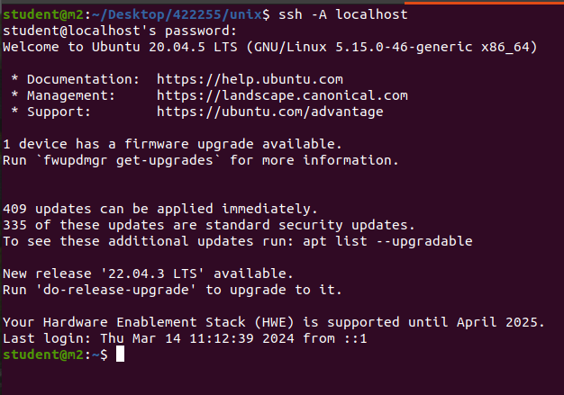

1. **mesg command:**

The mesg command controls whether other users on the system can send messages to you with either the write command or the talk command. Called without arguments, the mesg command displays the current workstation message-permission setting.

| **mesn** | Mesg n: Allows only the root user the permission to send messages to your workstation. Use this form of the command to avoid having others clutter your display with incoming messages. |
| --- | --- |
| **y** | Mesg y: Allows all workstations on the local network the permission to send messages to your workstation. |

1. **write command:**

**write** command in Linux is used to send a message to another user. The write utility allows a user to communicate with other users, by copying lines from one user’s terminal to others. When you run the write command, the user you are writing to gets a message of the form:

Message from yourname@yourhost on yourtty at hh:mm ...

**Syntax:**

write user [tty]

write metal

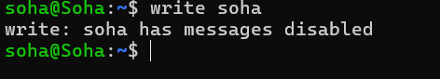

1. **talk command:** Interact with another users on the same machine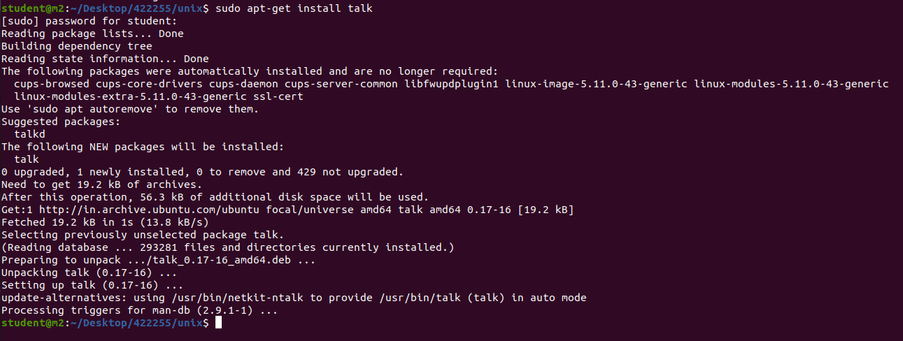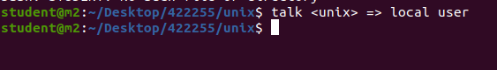
2. **Wall command:**

**wall -n:** This option will suppress the banner.

**wall -t:** This option will abandon the write attempt to the terminals after timeout seconds. This timeout needs to be a positive integer. The by default value is 300 seconds, which is a legacy from the time when peoples ran terminals over modem lines. **Example:** wall -t 30

**wall -V :** This option display version information and exit.

**wall -h :** This option will display help message and exit. 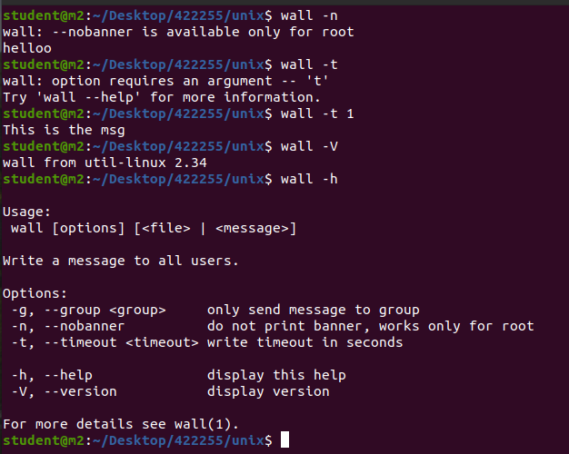

1. **tty command:**

The tty command of the terminal basically prints the file name of the terminal connected to standard input.  **-s, ––silent, ––quiet:** Prints nothing, only returns an exit status.

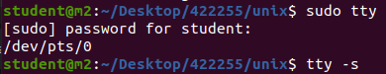

1. **who command:**

similar to finger command , it is used to display users on a system

who -u : list of users

who -b : booting of your system

