**422255(week-10)_assignment_10**

**1. Implement ssh command along with complete set of options.**

1. **Basic SSH Connection**:

ssh username@192.168.1.100

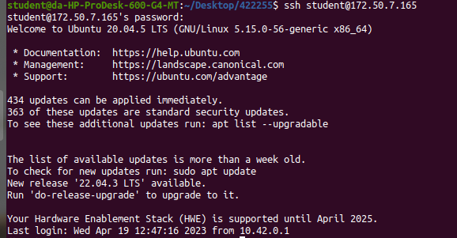

Replace username with your username on the remote machine.

1. **Specifying a Port**:

ssh -p 2222 username@192.168.1.100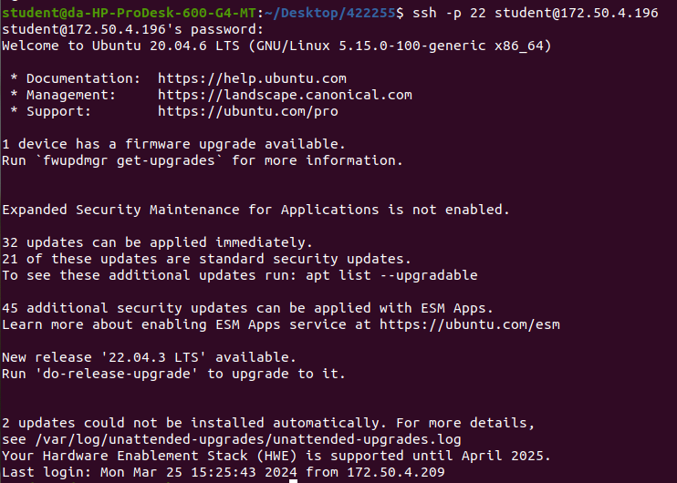

Replace 2222 with the desired port number.

**4. Verbose Mode (Debugging)**:

ssh -v username@192.168.1.100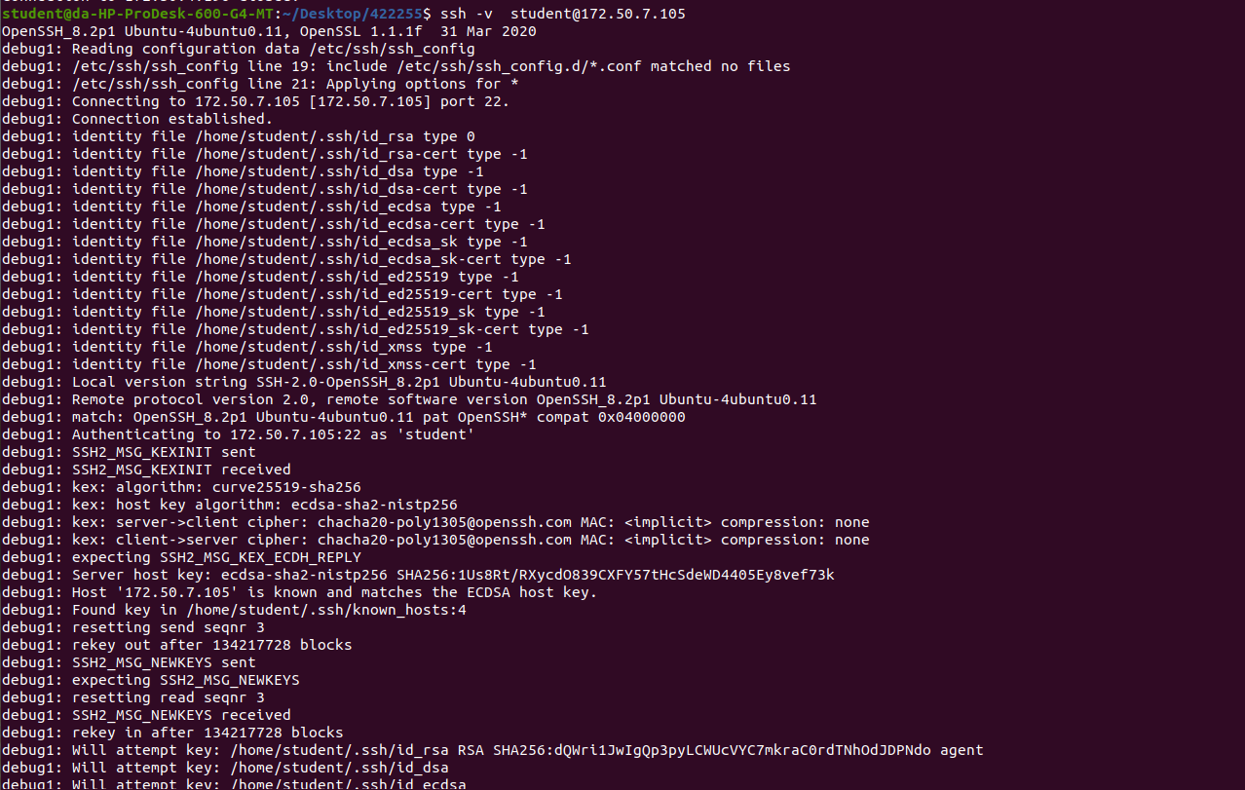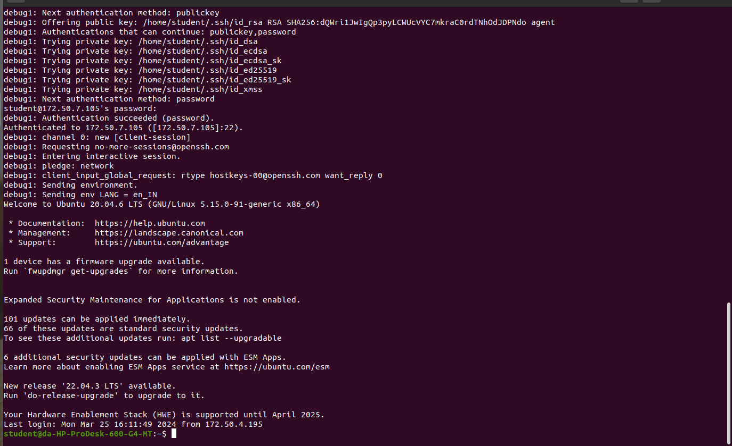

This will give verbose output for debugging purposes.

**5.X11 Forwarding**:

bash

ssh -X username@192.168.1.100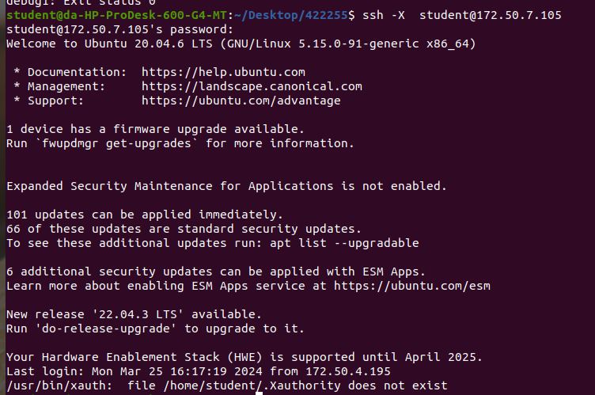

This enables X11 forwarding for GUI application.

This forwards local port 8080 to port 80 on the remote machine.

**6.Compression**:

bash

ssh -C username@192.168.1.100

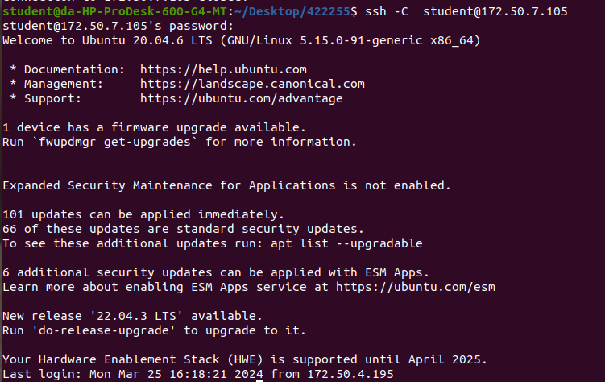

This enables compression for faster data transfer.

**2. Implement a shell script that executes finding factorial of a given number on at least three different machines using ssh.**

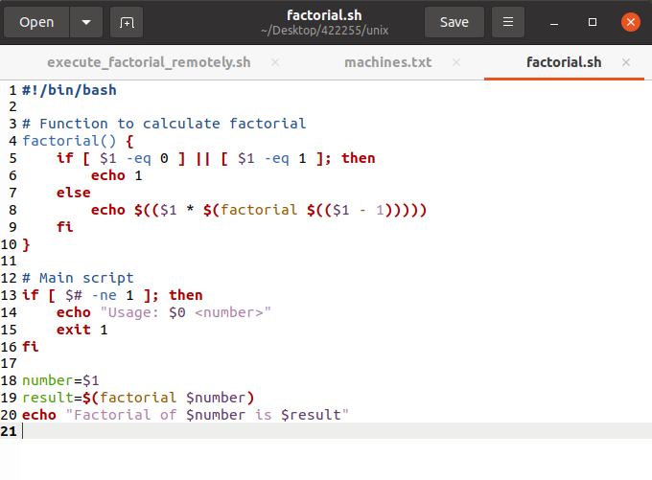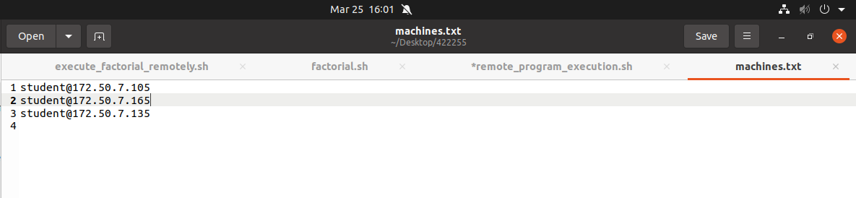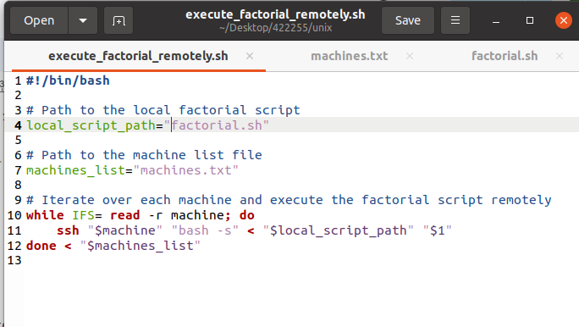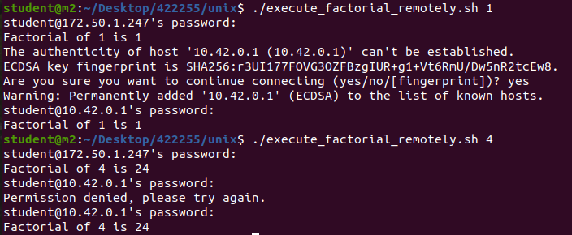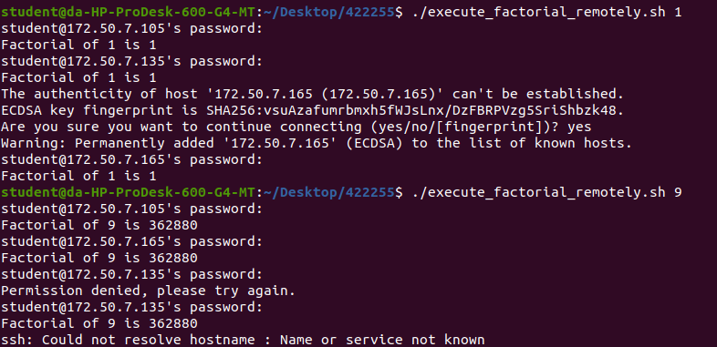

**3. Implement a shell script that executes factorial, Fibonacci and strong number programs on at least three different machines using ssh.**