**WEEK-12(ASSIGNMENT-12):**  
**Question-1:** Implement the commands mpstat, vmstat, iostat, sar and, top commands

**1.Mpstat:** **mpstat** is a command that is used to report processor related statistics. It accurately displays the statistics of the CPU usage of the system. It displays information about CPU utilization and performance. It initializes the first processor with CPU 0, the second one with CPU 1, and so on.

Mpstat: to display processor and cpu statistics

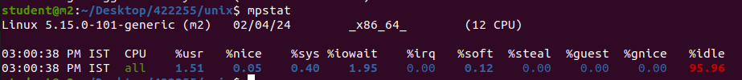Mpstat -P ALL : to display processor number of all cpu’s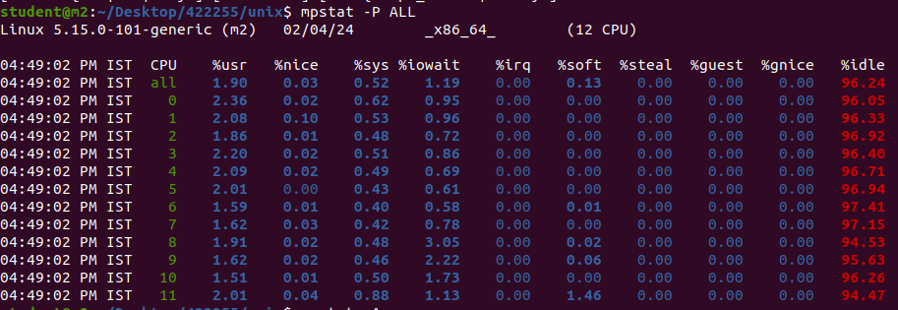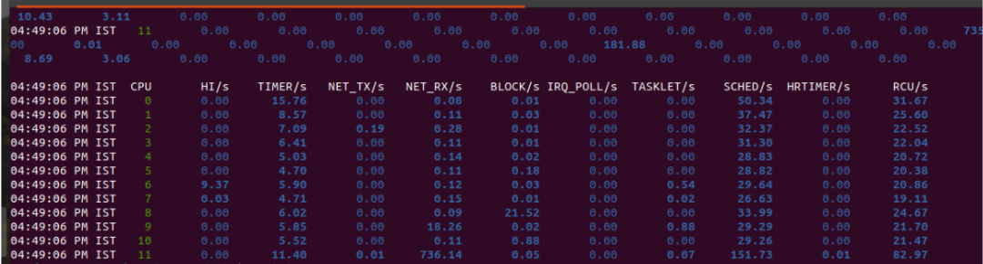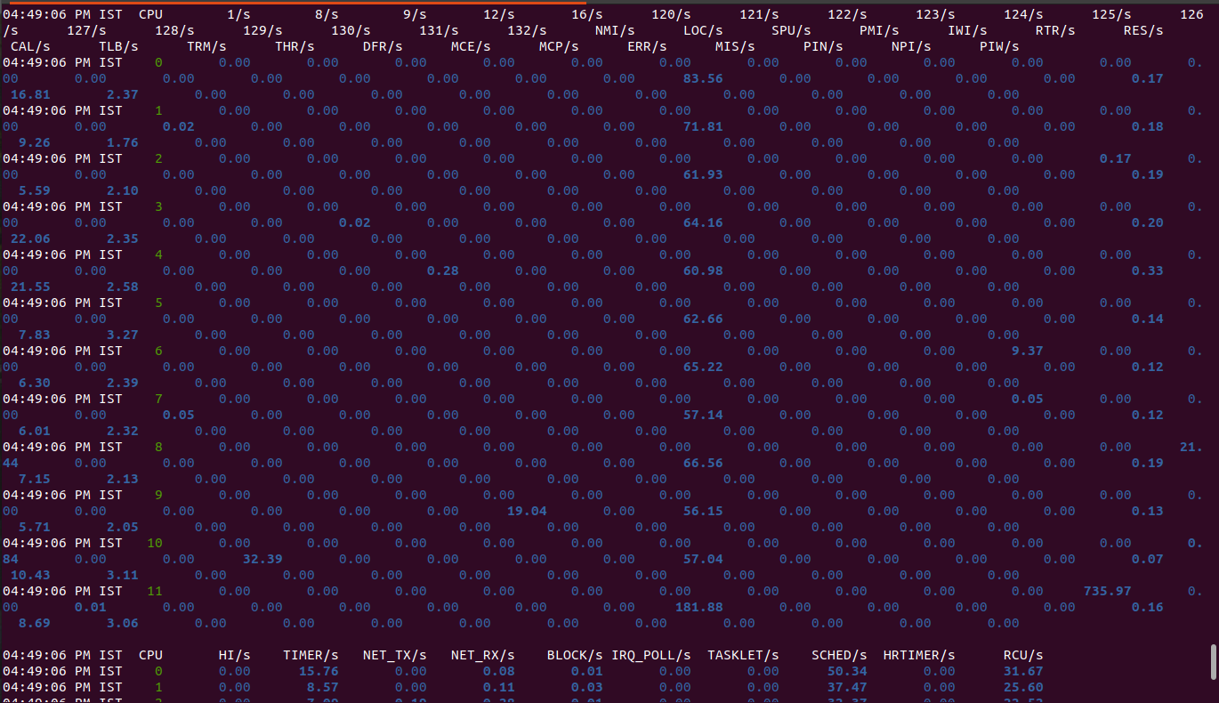

mpstat -P 0 : to display CPU utilization by a specific processor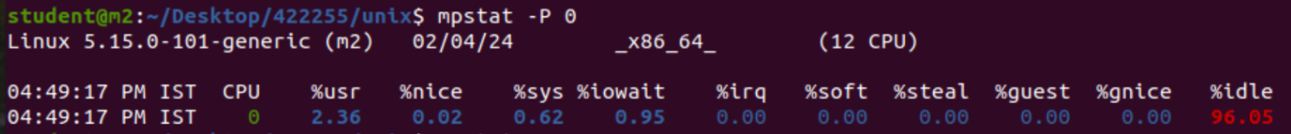mpstat 1 5: To display CPU usage with a time interval.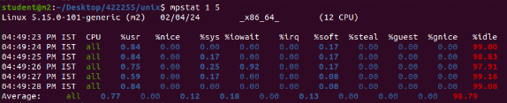mpstat -V: to display mpstat version



Mpstat -h : To display mpstat help

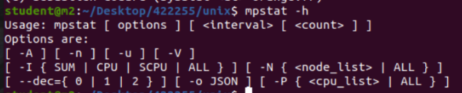mpstat -A: To get all the information which the tool may collect.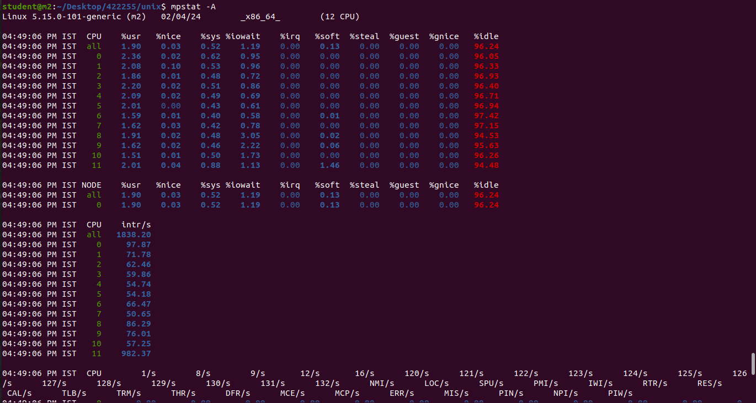

**2.Vmstat:**

*vmstat* command in Linux/Unix is a *performance monitoring command* of the system as it gives the information about processes, memory, paging, block IO, disk, and CPU scheduling. All these functionalities makes the command *vmstat* also known as *virtual memory statistic reporter*.

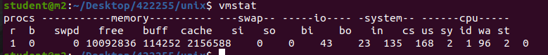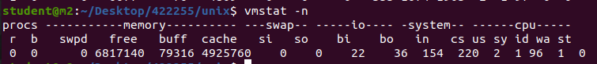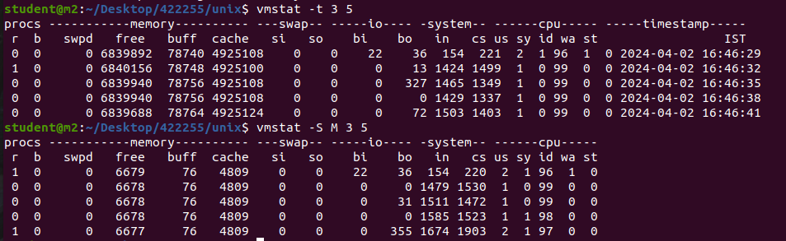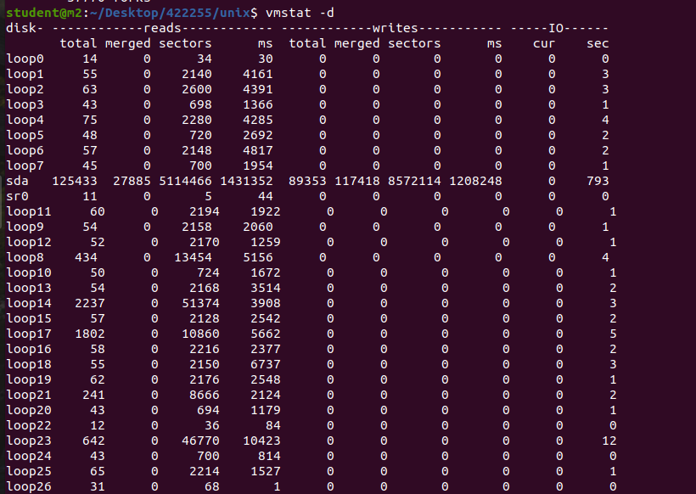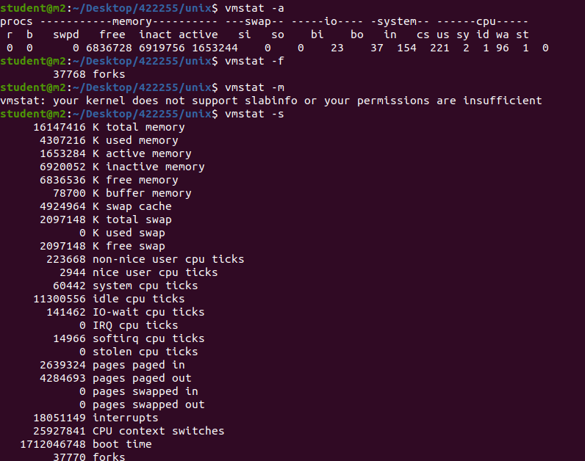

**3.Iostat:**

It monitors system input/output by observing the time the devices are active in relation to their average transfer rates. The iostat produce reports may be used to change the system configuration to raised balance the input/output between the physical disks. iostat is being included in sysstat package.

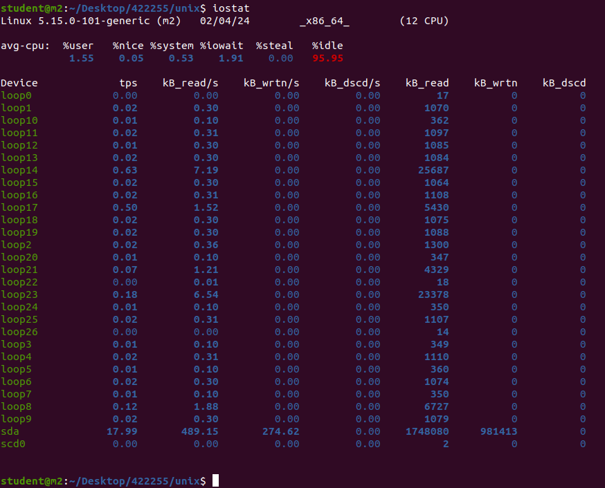

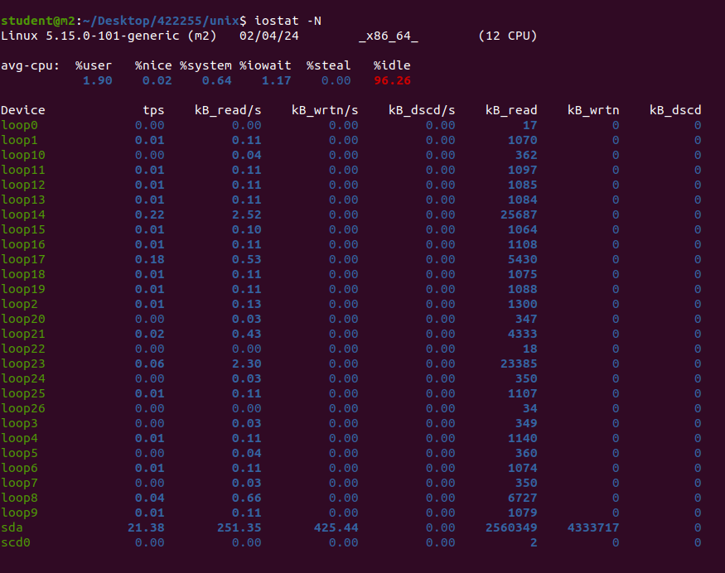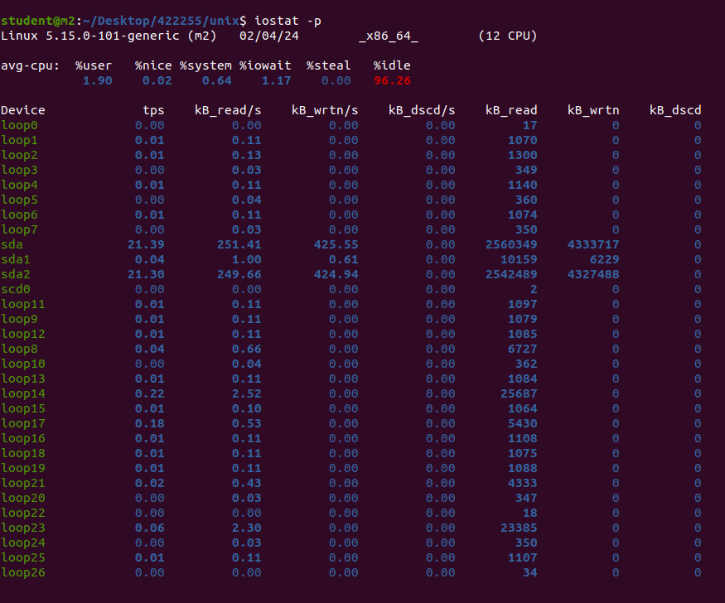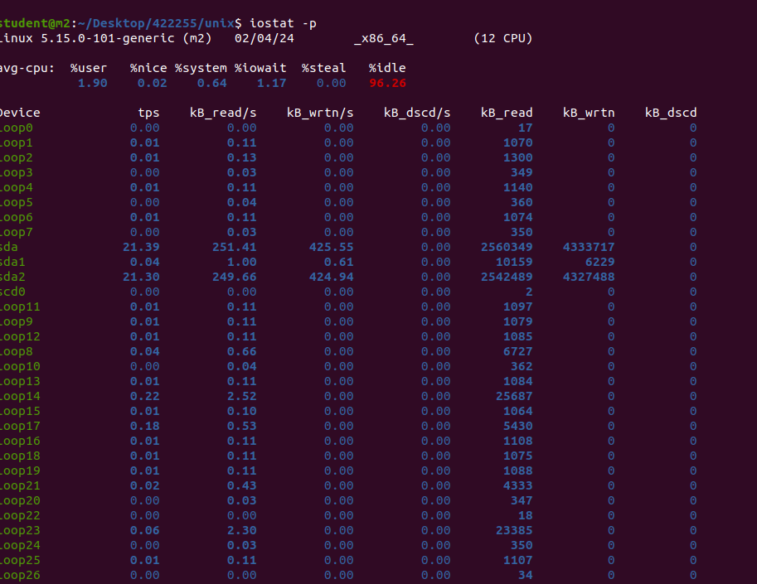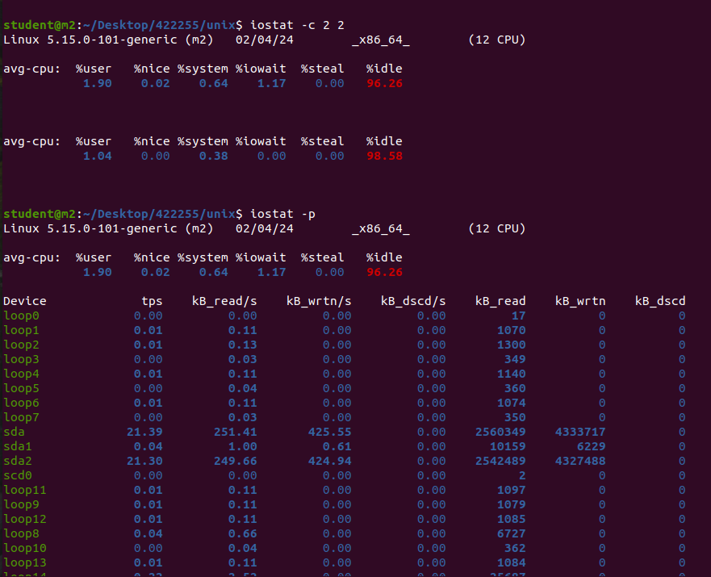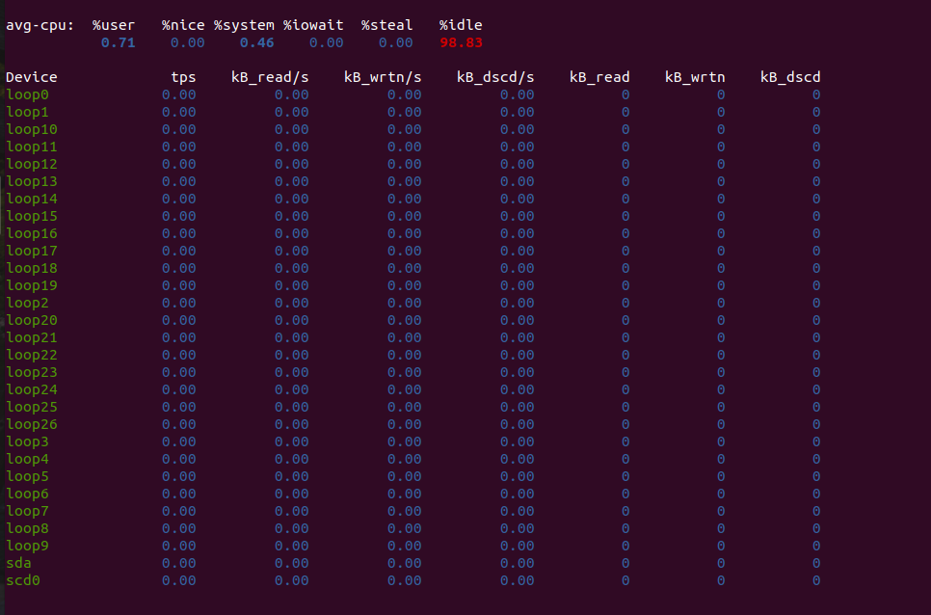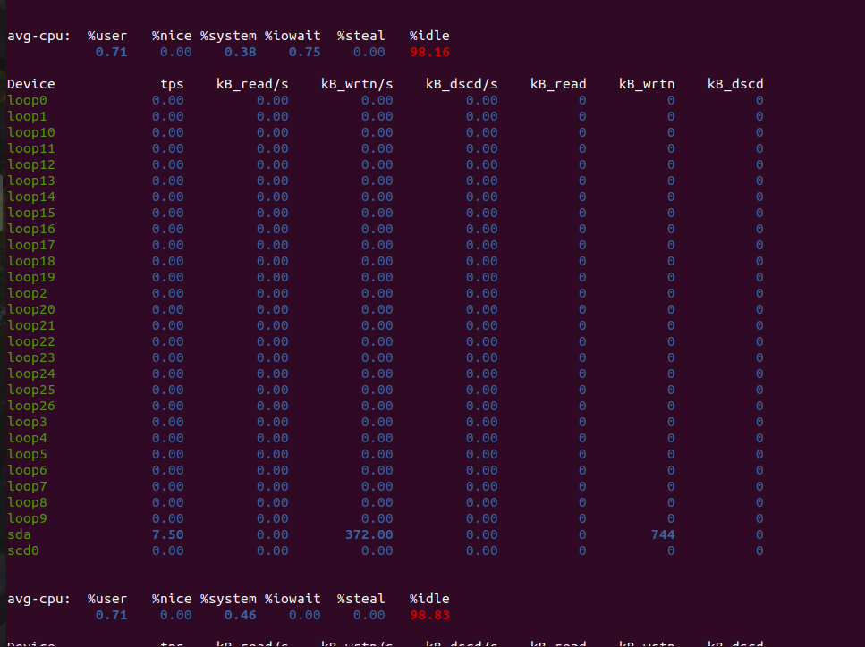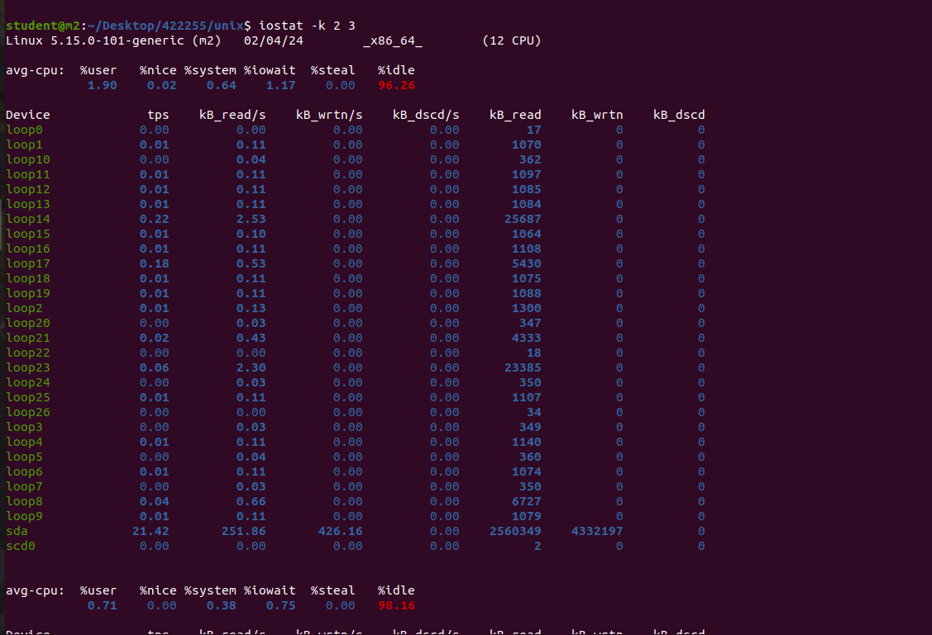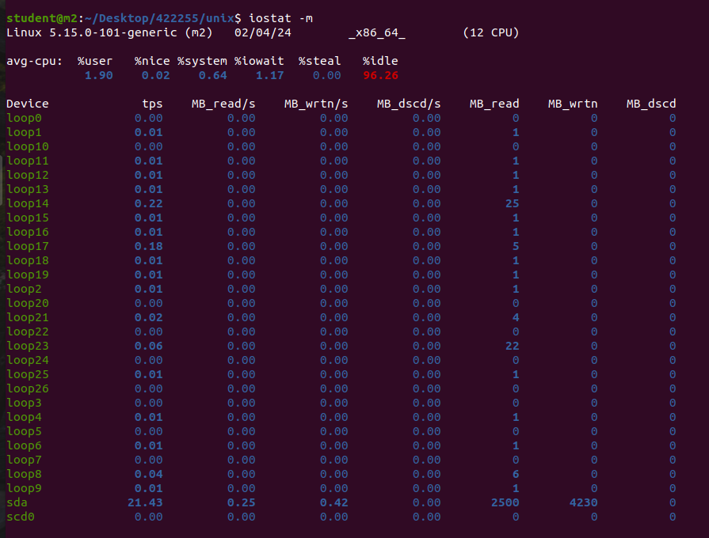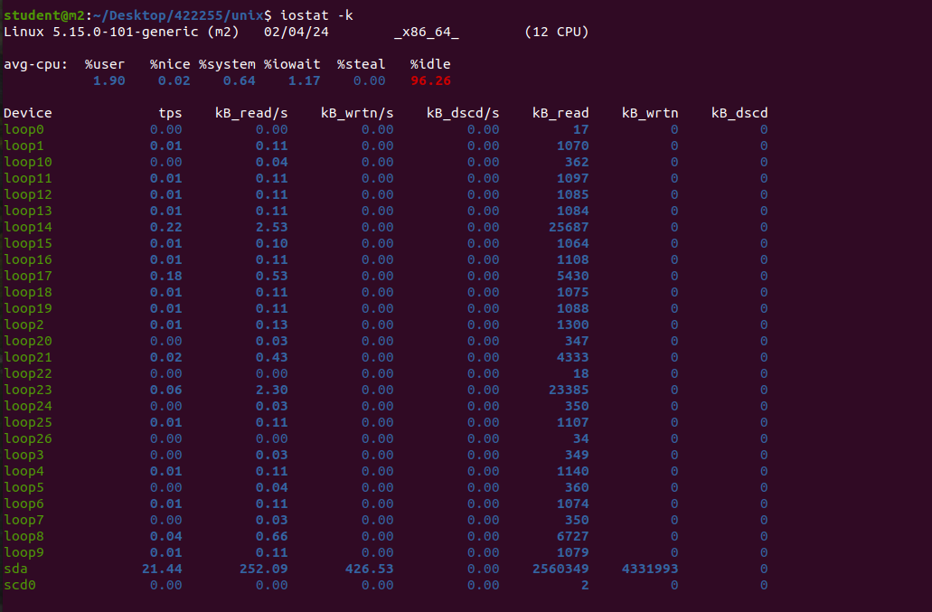

**4.Top:**

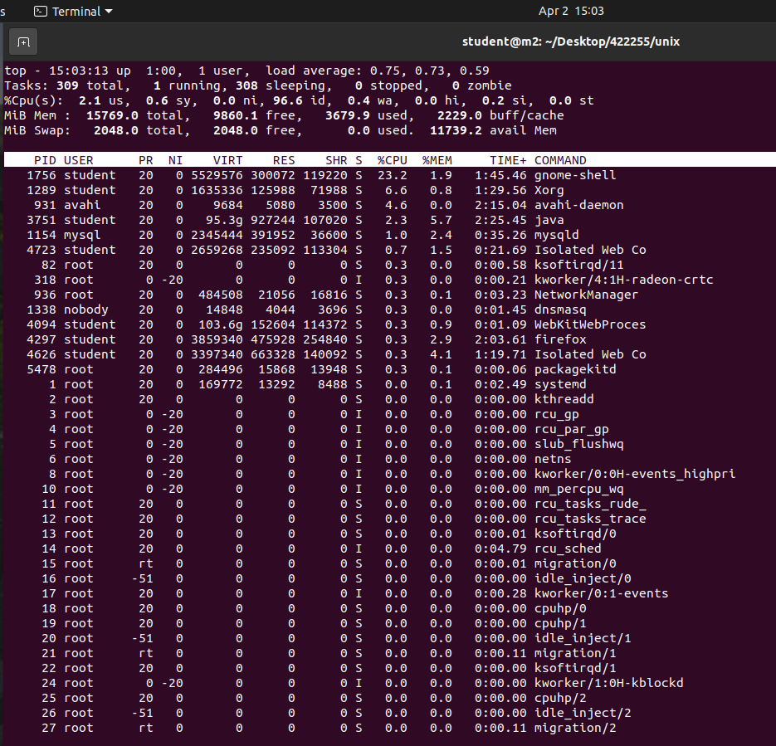

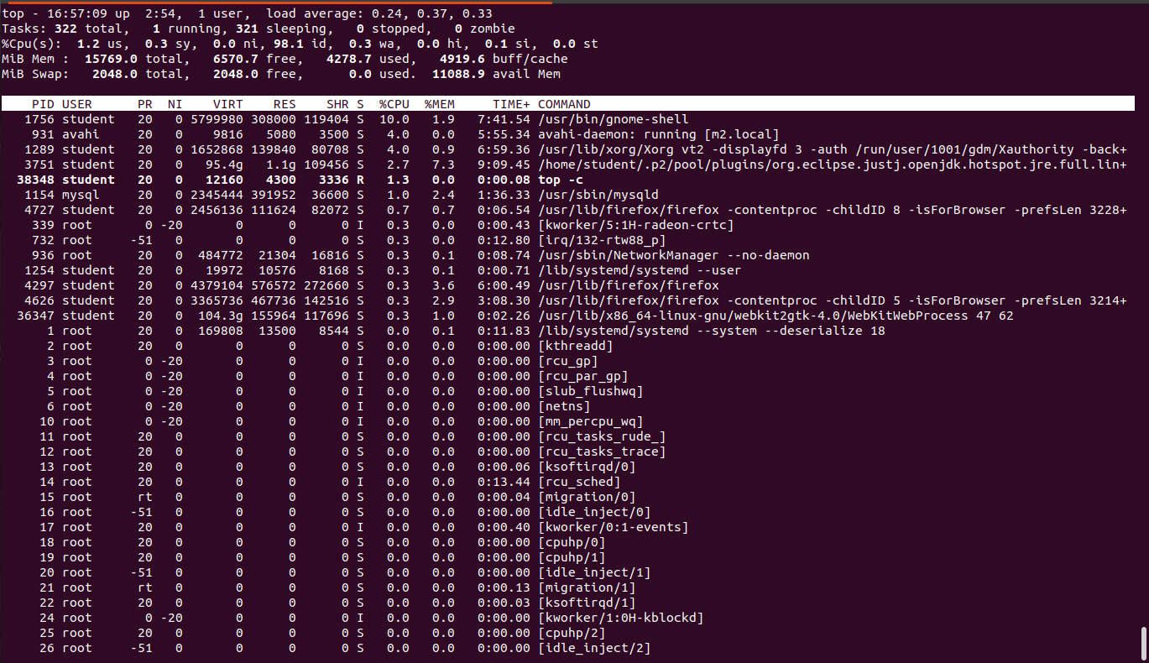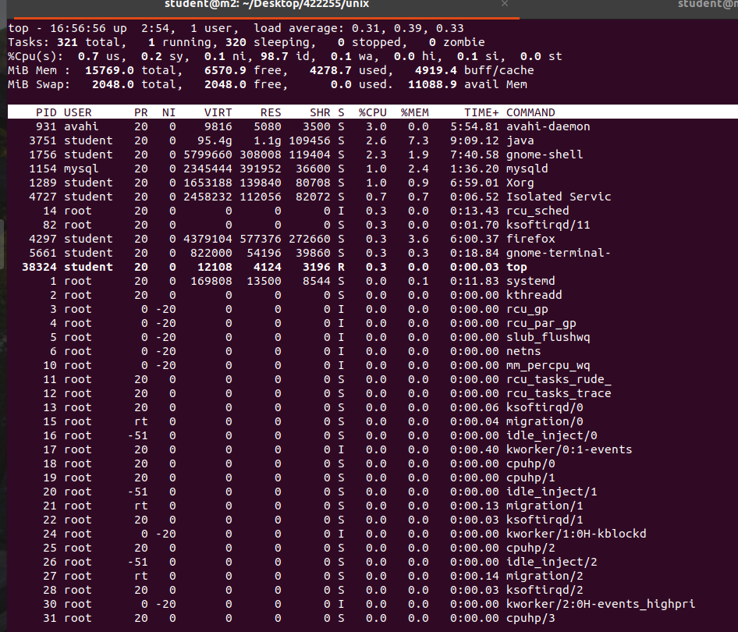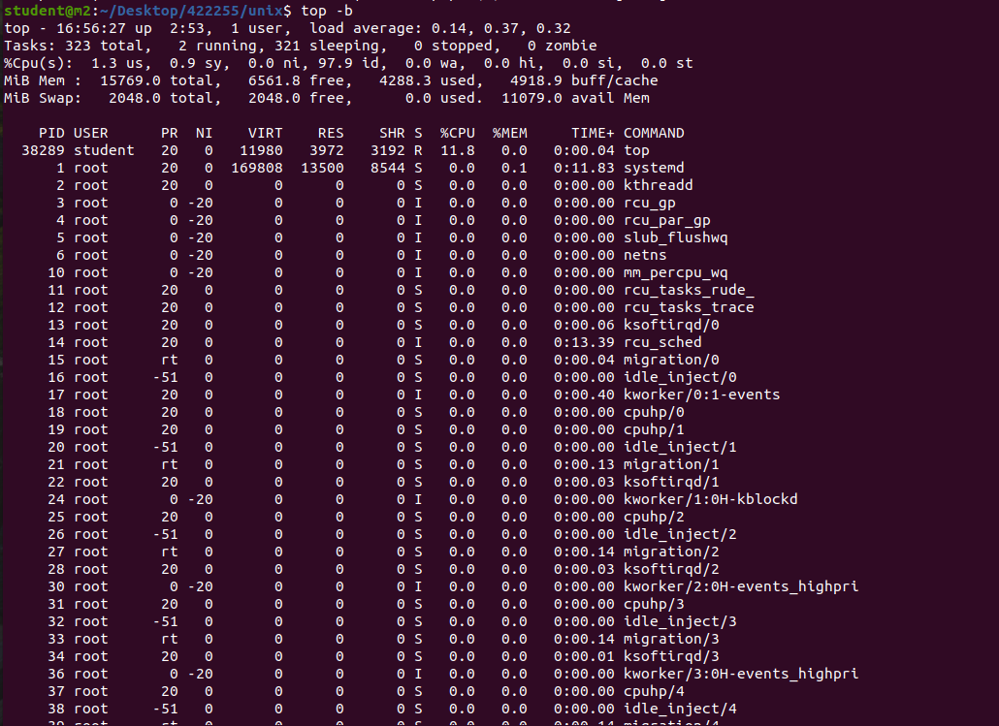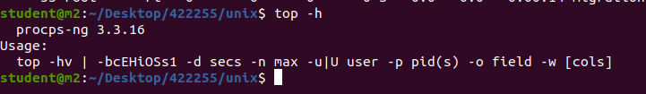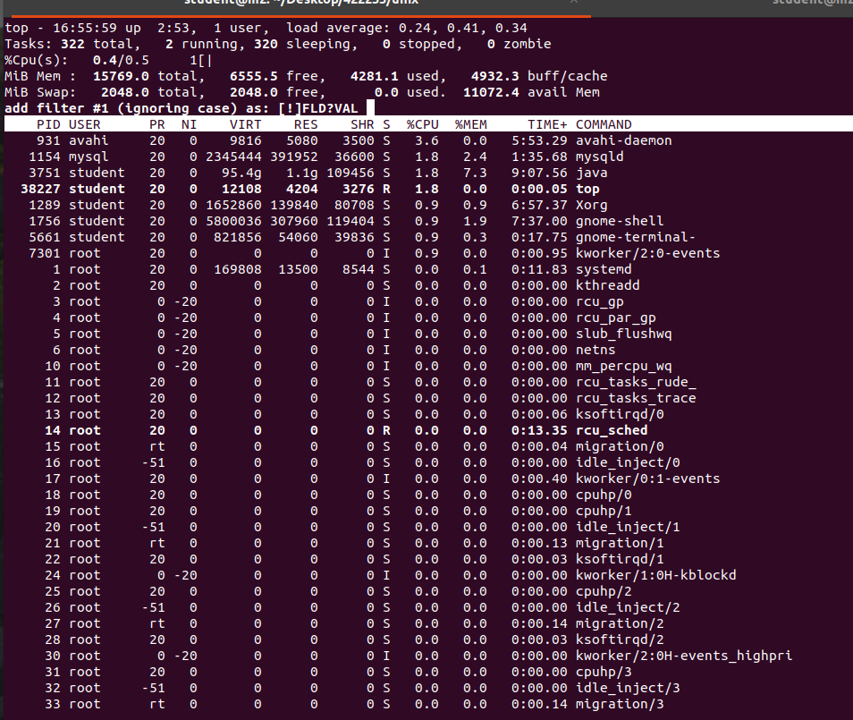

**Question-02:** Write a shell script that list the memory usage and cpu usage of multiple machines.

For 1 machine:

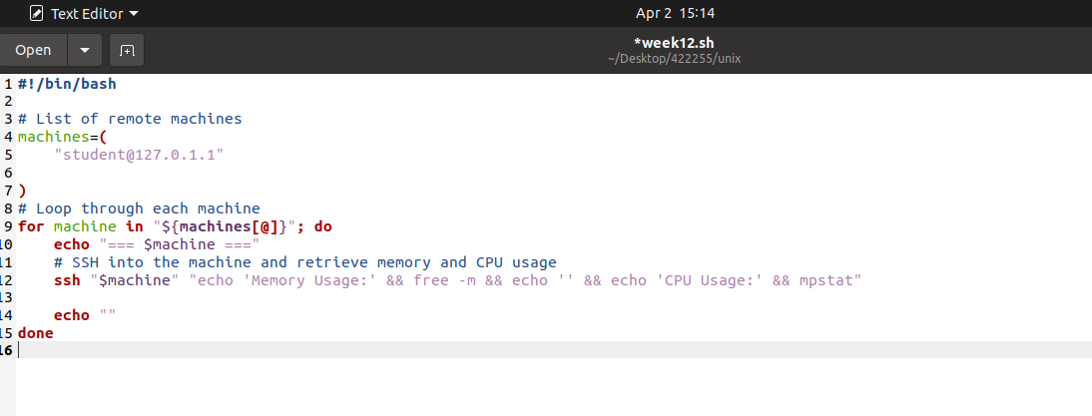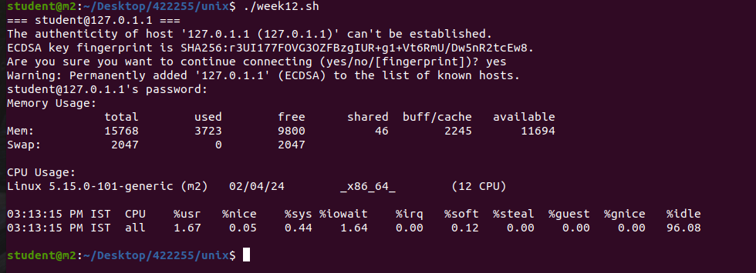

For 3 machines: