

TASK
Exploratory Data Analysis on the Wine Dataset



Introduction
This dataset consists of data from the WineEnthusiast.
The data set source for this model is collected from Sommelier reviews and ratings, the location and specific wineries. The data consists of wine reviews with variety, location, winery, price, rating and description.
The objective of this report is to perform exploratory data analysis to create visuals that allow us to highlight how different aspects of the data relate as well as create models to help predict beneficial wine making practices. It includes a selection of univariate and bivariate analysis to achieve this.

Reading the Data
Read in data set file
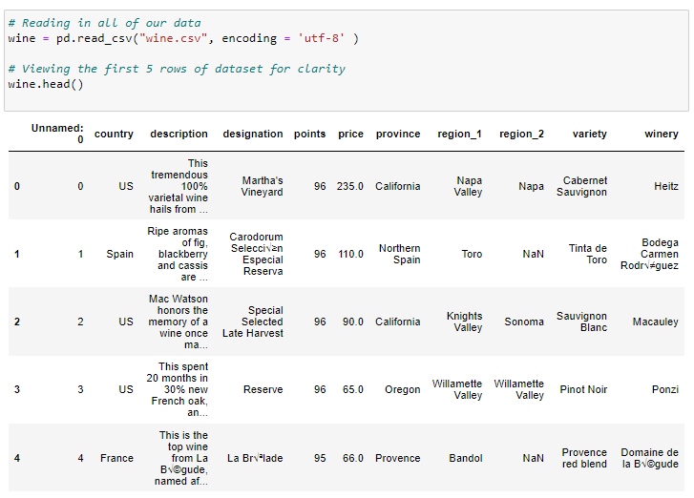

Viewing statistical overview
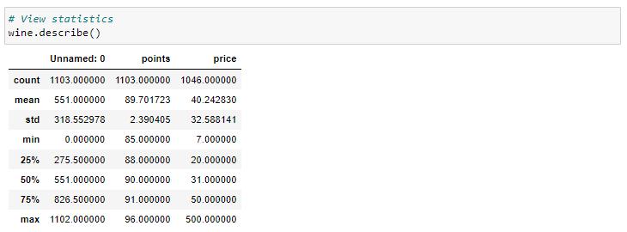

Viewing all column headings
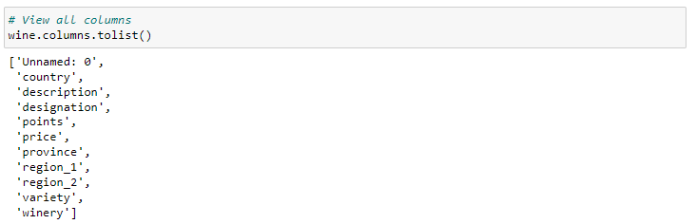

Viewing data types
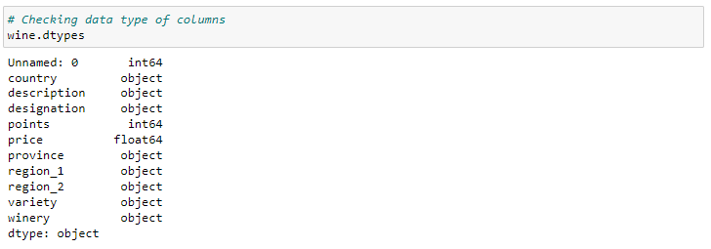
Data Summary
As we can observe, we have;
- country - The country the wine is from
- description - A description of the wine itself
- designation - Name of the wine given by owner/producer
- points - The critical rating of the wine (100 = Best)
- price - The cost of the wine
- province - The province the wine is from
- region_1 - The region the wine is from
- region_2 - The region the wine is from
- variety - The type of wine it is
- winery - The winery the wine was produced

Cleaning the Data
Dropping irrelevant columns
The 'unnamed' column repeats the numbers assigned to the rows thus is not needed so we will drop this column. The 'description' and 'winery' columns are also irrelevant to our investigation so we will also drop these.
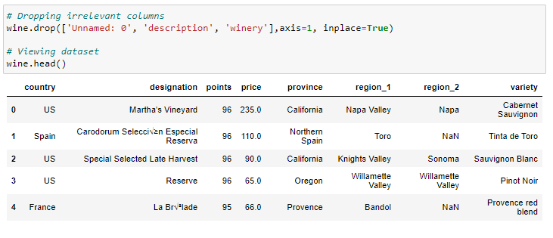
Checking for Duplicate Rows and Deleting

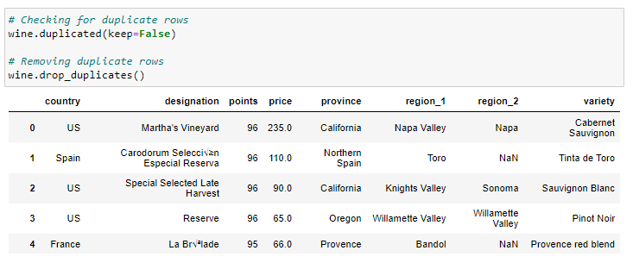

Checking for Missing Values and Cleaning Dataset Accordingly
Creating a graphic matrix to visualize whereabouts the missing data is.
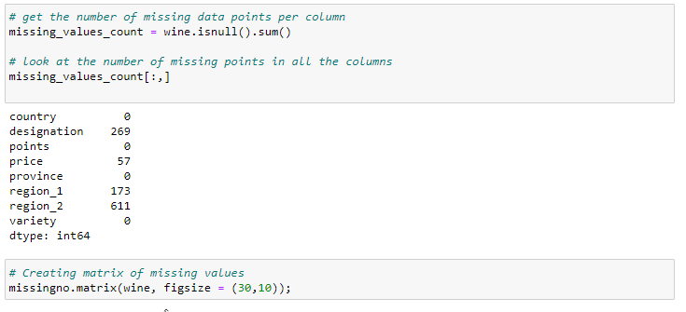
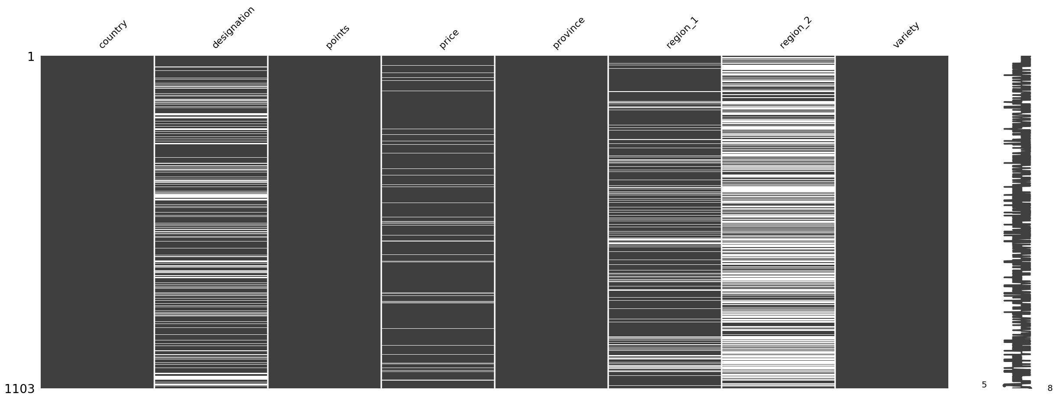

As we can see the 'Designation' of the wine has a moderate number of missing values. This is missing completely at random (MCAR). As the designated name of the wine does not affect our investigation, we can drop this column

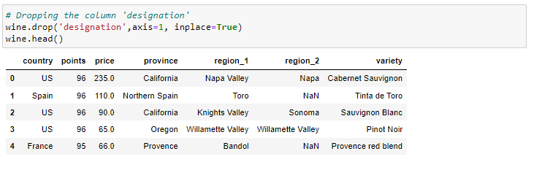
The price of the wine has a few values missing at random (MAR). The price of the wine is likely to be related to other variables such as the variety and the region it comes from. A wine is rated with 'points' taking these factors into account thus the price most likely has a positive correlation with points which can be seen in a scatterplot. As the points are in descending order within our dataset, we can replace all missing values with the value that comes directly after it in the price column to impute the missing values.

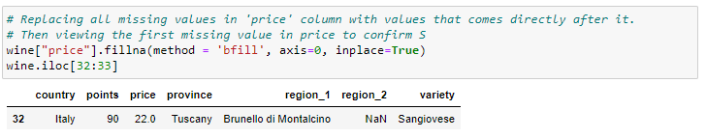
region_2 has a large number of missing values. We also have a region_1 for each wine and this has much fewer missing values. These values are missing not at random (MNAR) as some wines do not have a second region allocated to them hence set as NaN. Hence, we can merge the two columns.

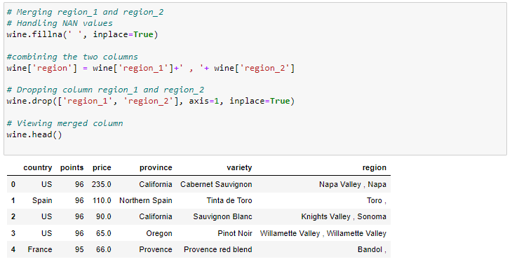

Exploration and Analysis of the data
Identifying relationships between variables / features for analysis
Univariate Analysis:
Five most expensive wines
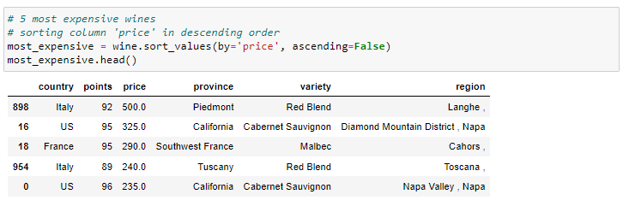

Five least expensive wines
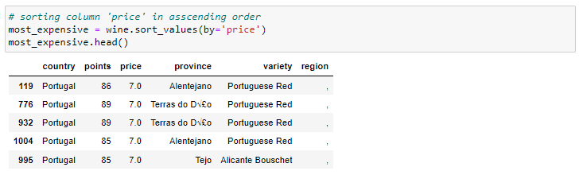

Count Plot for Wine Variety Frequency
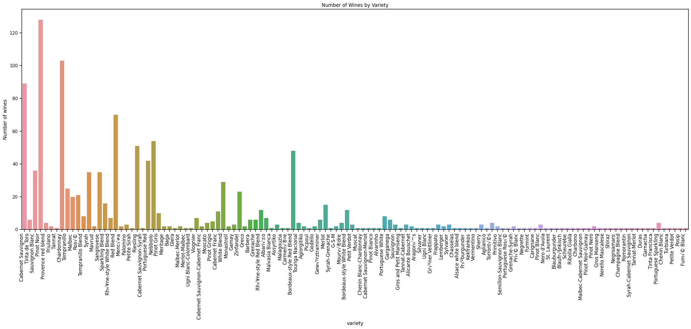

Square Plot for Province
Number of provinces: 100
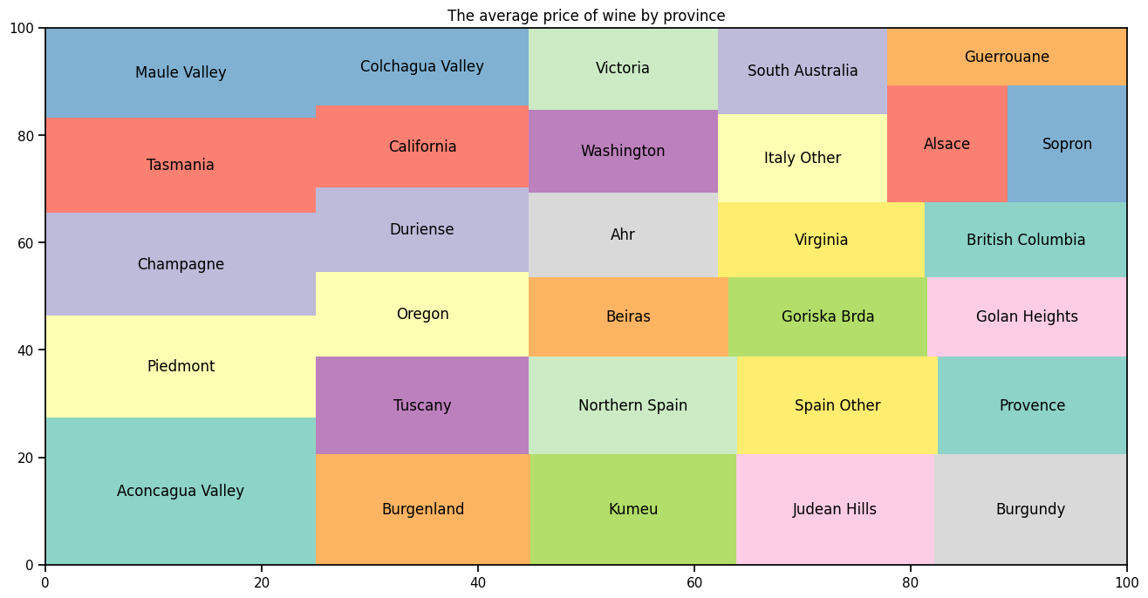

Bar Plot for Wine Distribution by Country

Numbers of countries in data: 22
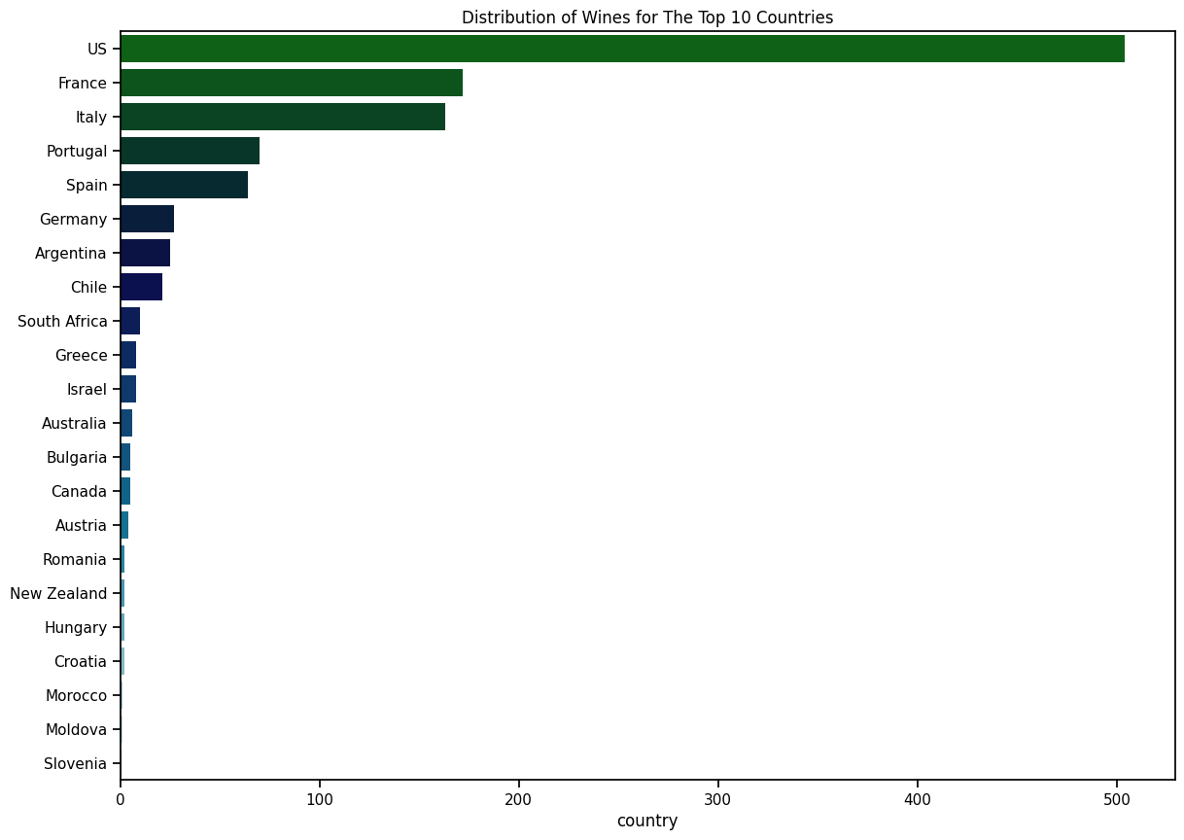

Histogram of Points Rating

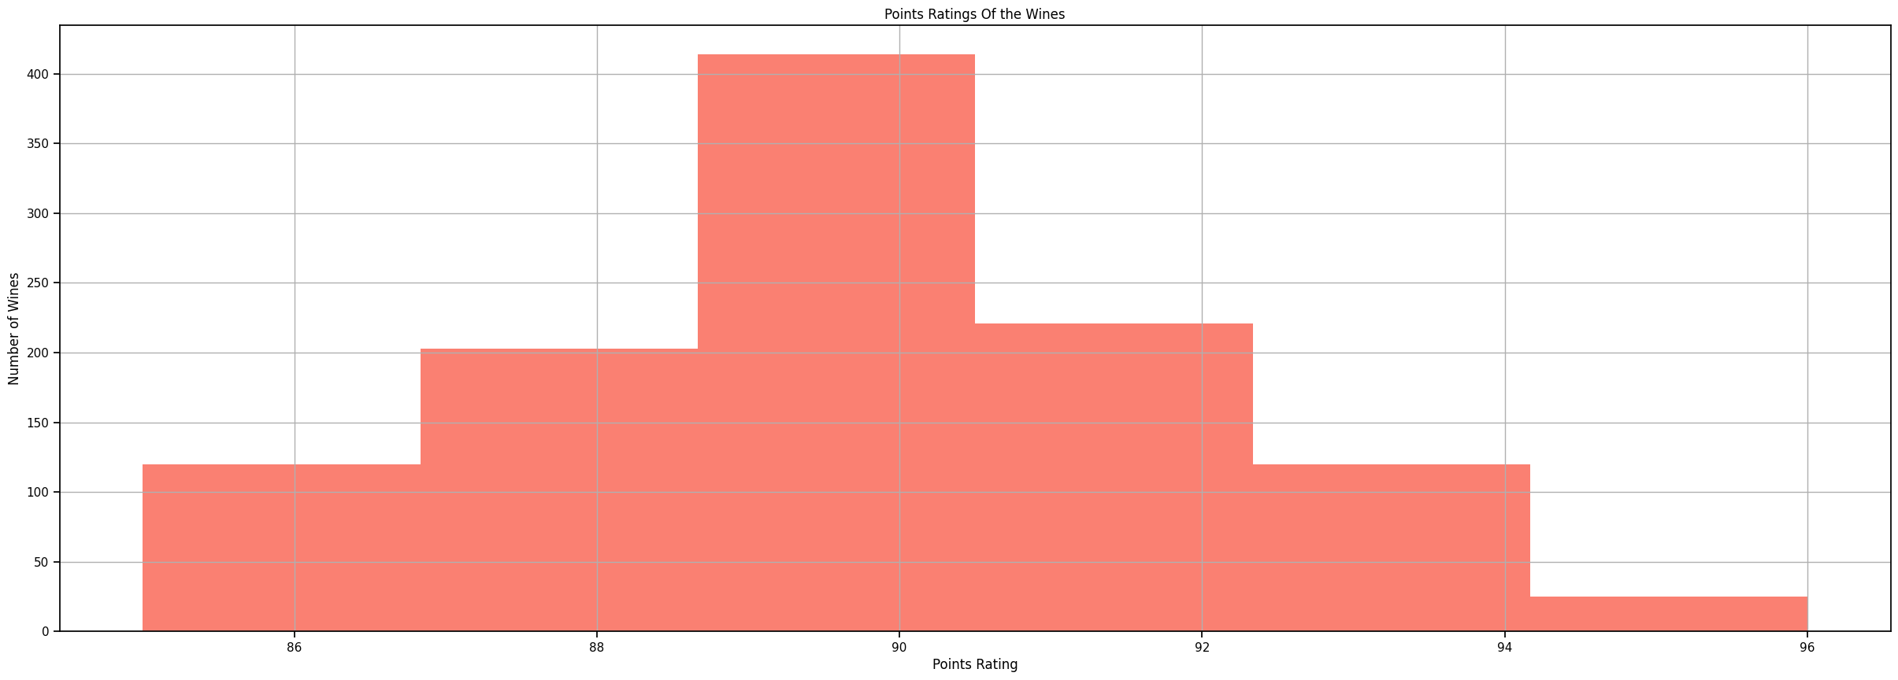

Distribution and Box Plot of Price

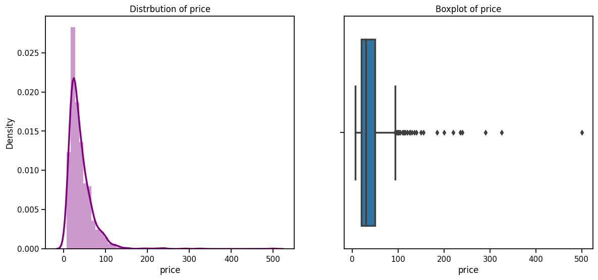

Observations

- The varieties Red Blend, Cabernet Sauvignon and Malbec appear in the top five most expensive wines. The former two twice.
- The three most popular wines are 'Cabernet Sauvignon', 'Pinot Noir' and 'Chardonnay'
- The Majority of wines are rated between 89 - 91
- The price of the wines ranges from 7 to 500.
- The mean price is 40 and the median price is 31
- There are many outliers

Correlation Analysis

Average Price by Country
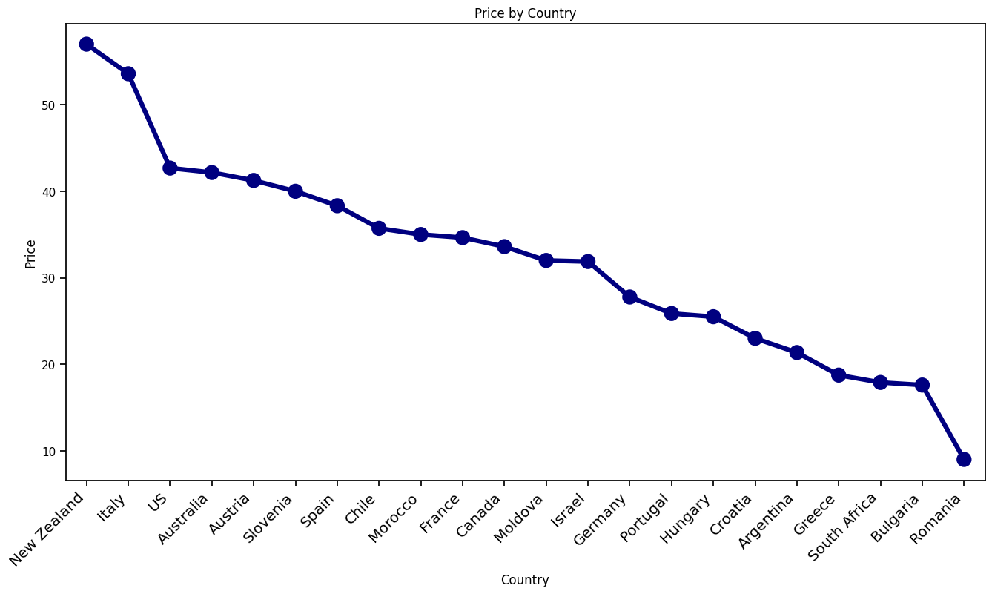
New Zealand, The US and Italy have the highest average price.
The US and Italy are also in the top three for producing the most expensive wines thus indicating a large range of values and outliers.
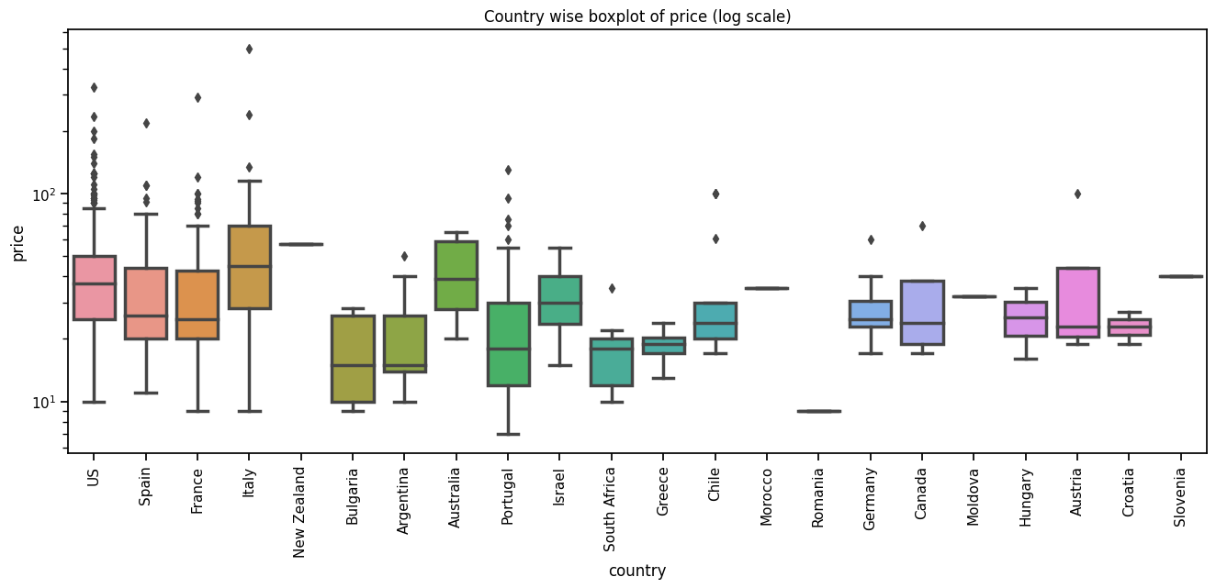

A Box Plot analysis provides a deeper understanding of the price distribution for each country. As we can see there are many outliers and the range of the median between the countries is low.

Price by Points Rating

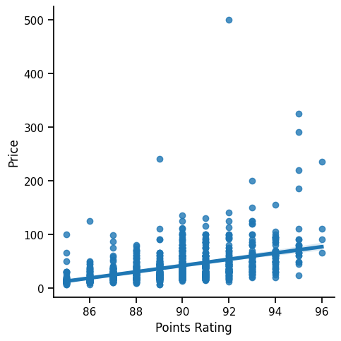
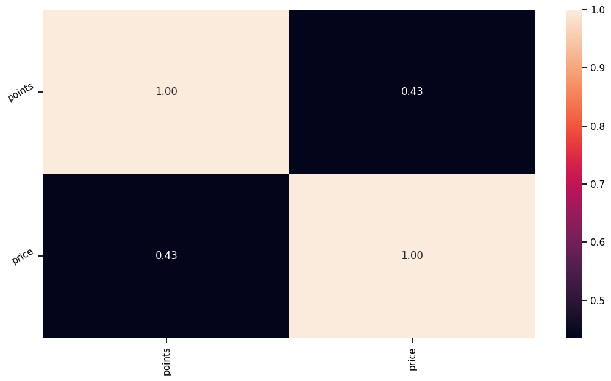

From the line plot we can see that there is a positive correlation between the points and price, however it is shallow with many outliers. The heat map shows a correlation value of 0.43 which suggests some correlation but not a significant one. We can investigate other variables to see how they relate to the price.

Square Plot Visualization of Price by Region

Number of Regions: 216
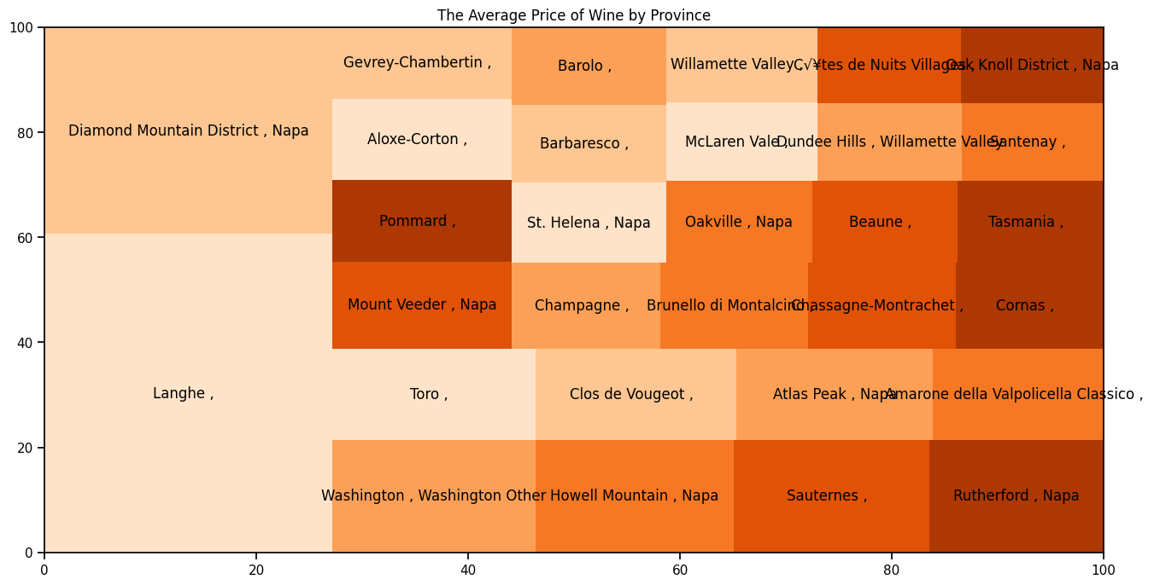
We can see that the majority of regions have been grouped together on the square plot with very few regions in different areas. We can infer that there is consistency in the price depending on the region it comes from thus the region where a wine comes from does affect the price of the wine.

Multi Plot Visualization of Price by Points
The top three most popular wines are Cabernet Sauvignon, Pinot Noir and Chardonnay. We can filter our dataset to visualize these varieties with their points rating.
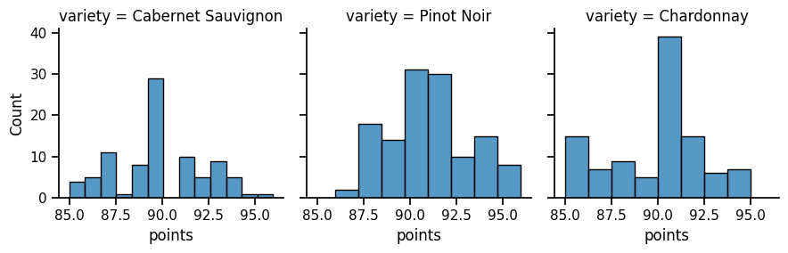

From the graphs we can see that the 'Chardonnay' variety has the highest count for 90 points rating it does not have any wines rated above 95 points.
The 'Pinot Noir' is the most consistent for points overall and has the highest count for wines that are rated over 95 points.
The 'Cabernet Sauvignon' is somewhat inconsistent in it's points however it does have a few that are also rated above 90 points.

Word Clouds to Summarize Variety and Region

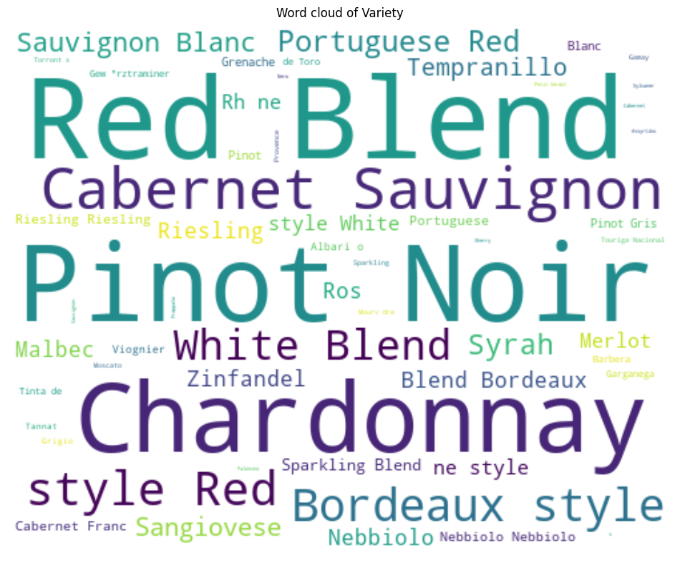
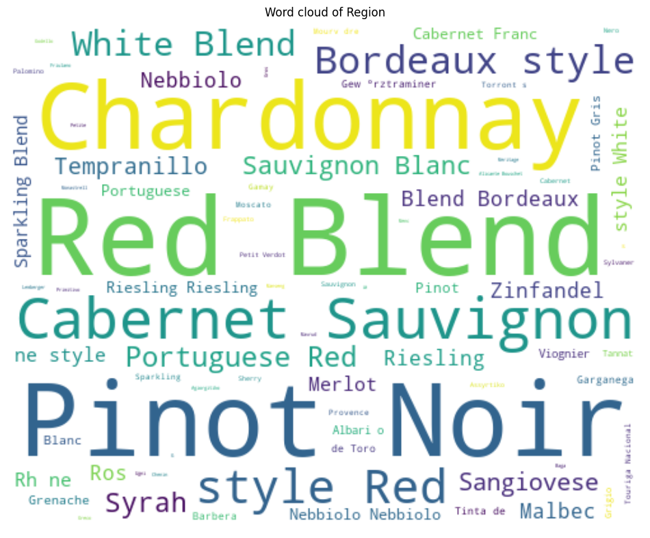

Summary

Analysis of the data set provides:

- How the data set is distributed
- Correlation and relationships between different variables and features
- Price: The factors affecting the price of a wine and how this relates to other variables
- Points: The factors affecting the points rating of a wine and how this relates to other variables
- Word Clouds to provide overview of the dataset

THIS REPORT WAS WRITTEN BY: MOONA RAB

