MY PARTITION

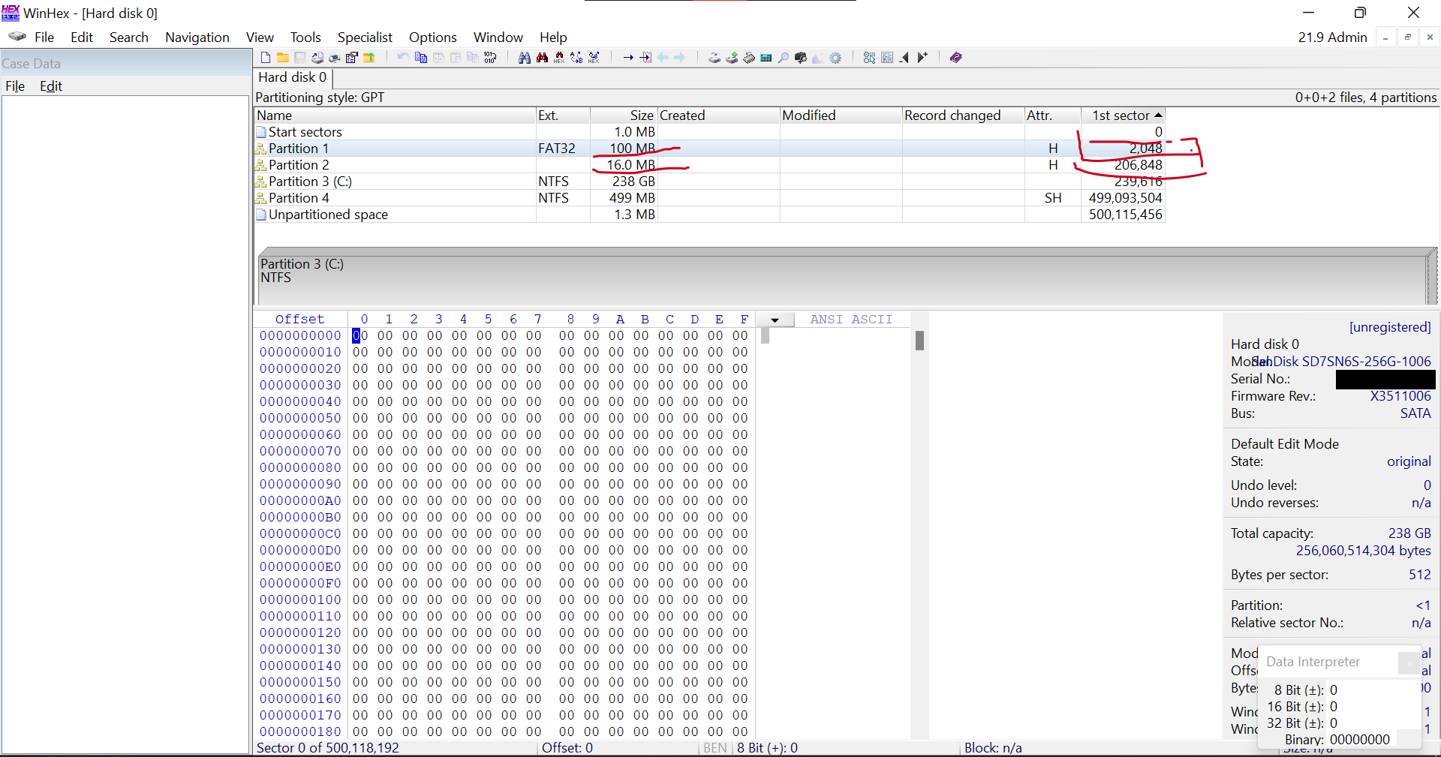
Figure 1 : My partition Table showing my partition 1 and 2

STEP 1 : My Pc Disk details
- Disk: SanDisk SD7SN6S-256G-1006 (238 GB, SATA)

- Partitioning style: GPT

- Bytes per sector: 512

STEP 2 : Methods
I will find the number of sectors in each partition by subtracting its first sector from the first sector of the next partition. Then I convert as follows:
- Sectors x 512 = bytes
- Bytes / 1024 = KB
- KB / 1024 = MB
- MB / 1024 = GB

Partition 1
- First sector of Partition 1: 2,048
- First sector of Partition 2: 206,848
- Sectors: 206,848 - 2,048 = 204,800
- Calculation in Bytes: 204,800 x 512 = 104,857,600
- Conversion to KB: 104,857,600 / 1024 = 102,400
- Conversion to MB: 102,400 / 1024 = 100
- Conversion to GB: 100 / 1024 = 0.09765625 ( is approximately 0.10 GB)
My Answer: 0.10GB

Partition 2
- First sector of Partition 2: 206,848
- First sector of Partition 3: 239,616
- Sectors: 239,616 - 206,848 = 32,768
- Calculation in Bytes: 32,768 x 512 = 16,777,216
- Conversion to KB: 16,777,216 / 1024 = 16,384
- Conversion to MB: 16,384 / 1024 = 16
- Conversion to GB: 16 / 1024 = 0.015625 ( is approximately 0.02 GB)
Answer : 0.02GB

STEP 3: Verification
My calculated sizes match the Size column in my partition table: Partition 1 is 100 MB and Partition 2 is 16 MB. My calculations are verified.

