**Pocket Bank**

Submitted by: Md Moonaz Rahman

Class roll: 19CSE023

Exam roll: CSE010/3

Submitted to: Md. Rashid Al Asif

Lecturer,

Department of Computer Science & engineering,

University of Barishal.

Submission Date: 23/06/2022

**Overview:**

* Introduction
* Importance of this project
* System design
* Implementation
* Result & discussion
* Resources

**Introduction:**

Pocket Bank is a mobile banking system.Through this user can send money to other user as well as user can withdraw money from merchandise account number .

**Background work:**

Now a days mobile banking became very popular in all over the world.There are many existing mobile banking system such as paypal, Monese, Transfast, Money gram etc. There are also some Mobile Banking System in Bangladesh,such as Bcash,Nogad,Rocket.

**Importance Of Mobile Banking:**

* Secure and fast transactions.
* 24*7 accessibility.
* Instant account opening .
* Easily withdraw money .

**System Design:**

Pocket Bank is a console base system.The system takes integer as command at first.By entering 1 user can log in or if user don’t have any account he/she can creat a new account by pressing 2.

If user gives 1 as command to log in,the system will ask user id & passward.If user enter wrong user or passward the system will show a message “invalide id or passward”.Otherwise system says “successful login”,and user can use the features such as send money ,cash out ,check balance,reset passward.By logout user can stop the system.

If user wants to create new account ,the system ask for user phone number .If the given id already have account syster show a message that already have an account.A number can’t have more than one account.

Otherwise user can creat a new account and get a message successfully created.

**Implementation:**

import moonaz.*;

import java.util.Scanner;

public class PocketBank

{

private static Scanner x;

public static void main(String[] args)

{

Scanner scn =new Scanner(System.in);

System.out.println("Welcome to PocketBank ");

System.out.println("_________________________________");

System.out.println("1.Login");

System.out.println("2.Creat a new account");

System.out.println("enter command number");

int what=scn.nextInt();

if(what==1){

scn.nextLine();

String id;

String pasward;

System.out.println("enter account number");

id=scn.nextLine();

System.out.println("enter Passward");

pasward=scn.nextLine();

access acc;

acc=new Login(id,pasward);

int y1=acc.loogin();

if(y1==1){

System.out.println("1.send money");

System.out.println("2.cashout");

System.out.println("3.Balance");

System.out.println("4.Reset passward");

System.out.println("5.Logout");

while(true){

System.out.println("enter command number");

int command=scn.nextInt();

c_outpanel C_O=new c_outpanel();

if(command==2){

C_O.withdraw(id); }

if(command==1){

C_O.send(id);}

if(command==3){

String p="info.txt";

balancecheck ac_bal=new balancecheck();

String y4=ac_bal.balance(p,id);

System.out.println("Current balance is "+y4);

}

if(command==4){

reset rsp=new reset();

rsp.resetpass (id);

}

if(command==5){

break;

} }

} }

if(what==2){

newac ac=new newac();

ac.newacc();

}}}

**Result:**

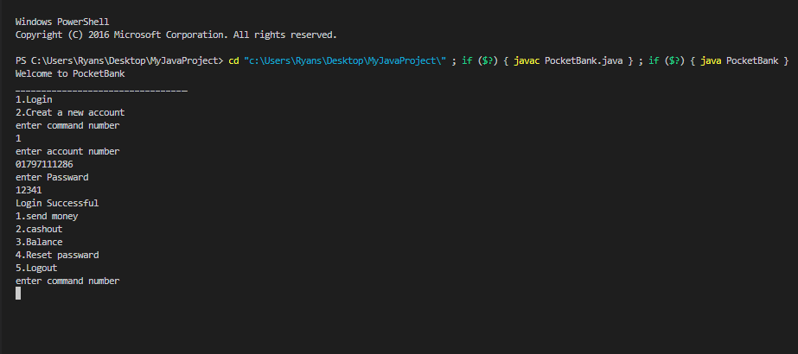

**Discussion:**

The code is executed successfully. A file is used for reading & writing data. The system store every change in data .

**Resources:**

1. Retrived june 10th,2022 from

www.google.com/javalearning/

2. Retrived june 10th,2022 from

https://github.com

3. Retrived june 10th,2022 from

https://www.w3schools.com/java/

4.Java certification training- youtube page.