# **Elicitation Output (Kano Model)**

## TT2L – Campus Ride-Sharing Platform with Parking System Integration

## **Introduction**

This document summarizes the output of the requirements elicitation process using the Kano Model. A Google Forms was created , where participants responded to questions about proposed system features. Based on their responses, requirements were categorized into three main categories: Dissatisfiers (Must-be), Satisfiers (Performance), Delighters (Exciters).

**Elicitation Method and Evidence**

The group created a Google Form consisting of questions for each feature. Below are screenshots or descriptions of the form and its responses as evidence of execution.

Here are the Google Form links : <https://docs.google.com/forms/d/e/1FAIpQLSdVG7BP3zv9ML78Zc1dUboT8MVYDur-44C-6xAZ0lTMfyAYEQ/viewform>

**Digital Id verification**

Based on survey responses, the majority of users selected “I like it that way” when it is present and “I dislike it that way” when it is absent.

→ Classified as: Dissatisfier

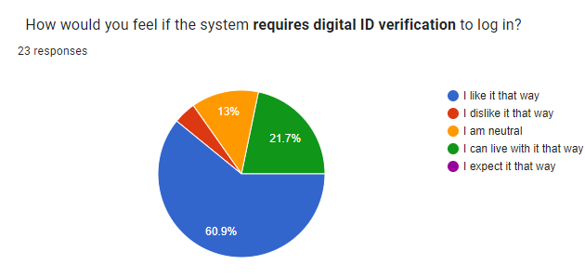

Figure 1  pie chart

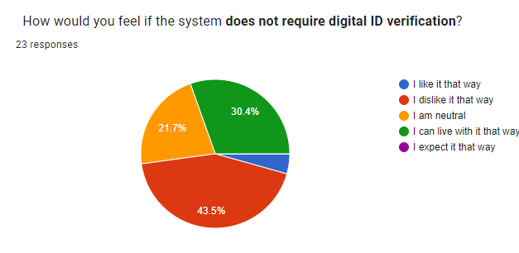

Figure 2 pie chart

**User profile management**

Based on survey responses, the majority of users selected “I like it that way” when it is present and “I dislike it that way” when it is absent.

→ Classified as: Dissatisfier

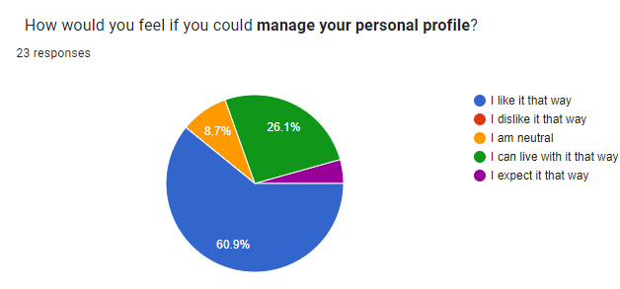

Figure 3 pie chart

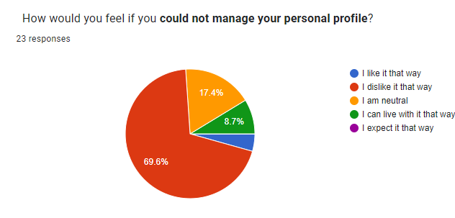

Figure 4 pie chart

**Estimated arrival time**

Based on survey responses, the majority of users selected “I like it that way” when it is present and “I dislike it that way” when it is absent.

→ Classified as: Satisfier

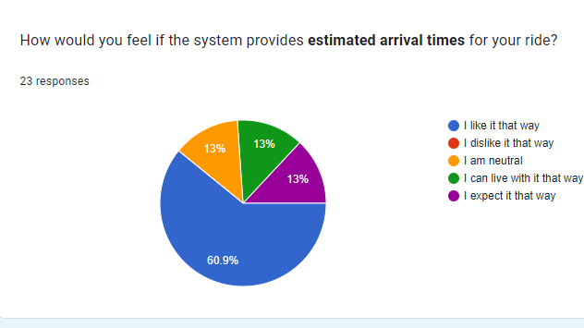

Figure 5 pie chart

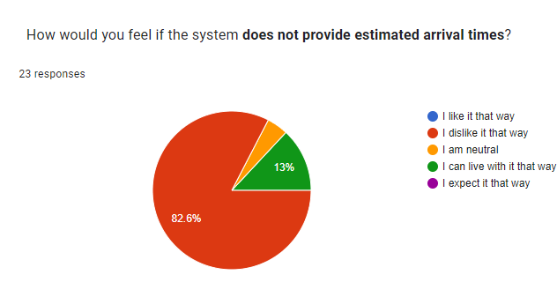

Figure 6 pie chart

**Carpool coordination scheduling**

Based on survey responses, the majority of users selected “I like it that way” when it is present and “I dislike it that way” when it is absent.

→ Classified as: Satisfier

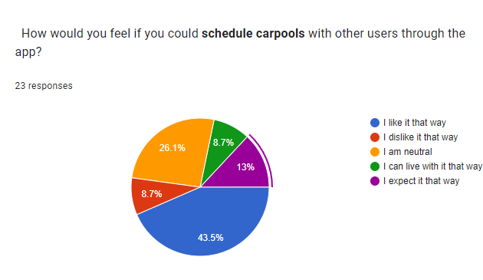

Figure 7 pie chart

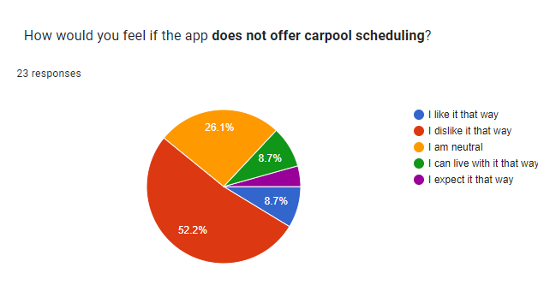

Figure 8 pie chart

**Real-time parking space availability**

Based on survey responses, the majority of users selected “I like it that way” when it is present and “I dislike it that way” when it is absent.

→ Classified as: Dissatisfier

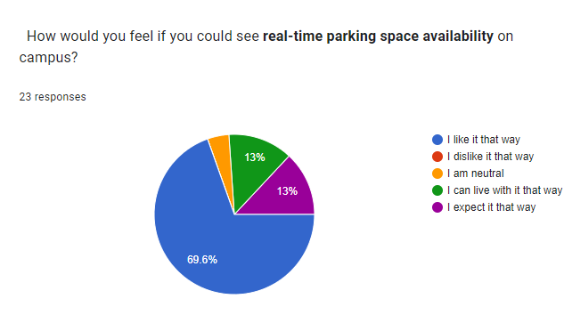

Figure 9 pie chart

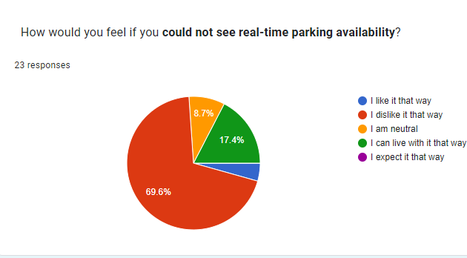

Figure 10 pie chart

**Display driver’s location**

Based on survey responses, the majority of users selected “I like it that way” when it is present and “I dislike it that way” when it is absent.

→ Classified as: Delighter

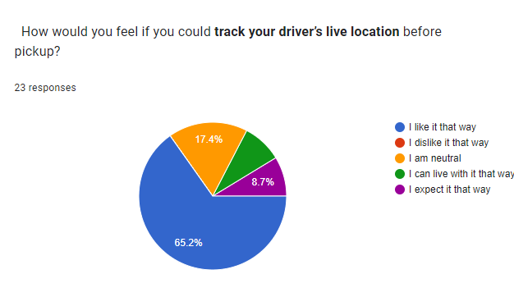

Figure 11 pie chart

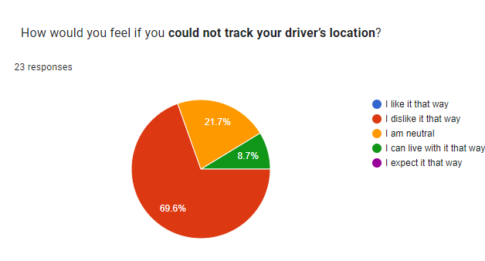

Figure 12 pie chart

**Interesting reward system for frequent carpoolers**

Based on survey responses, the majority of users selected “I like it that way” when it is present and “I dislike it that way” when it is absent.

→ Classified as: Delighter

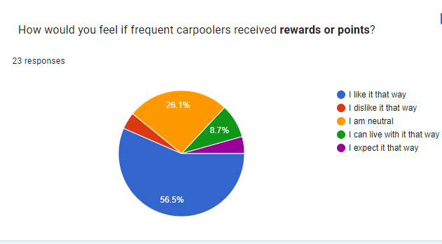

Figure 13 pie chart

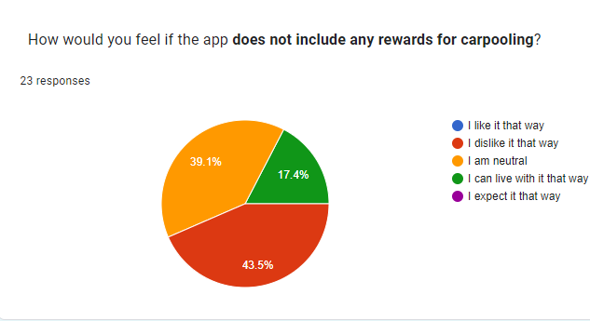

Figure 14 pie chart

**Integration with campus payment systems**

Based on survey responses, the majority of users selected “I like it that way” when it is present and “I dislike it that way” when it is absent.

→ Classified as: Delighter

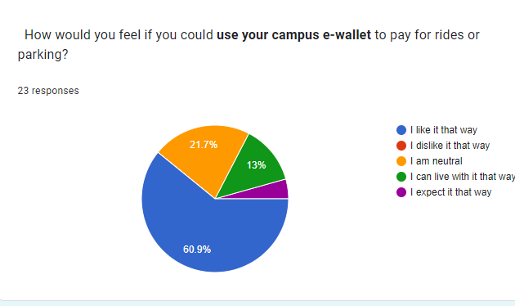Figure 15 pie chart

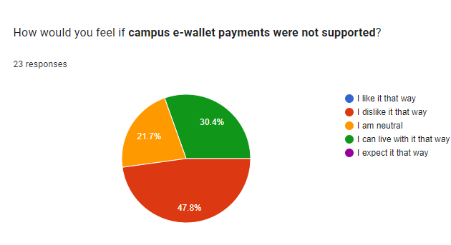Figure 16 pie chart

Elicited Requirements and Kano Classification

|  |  |  |
| --- | --- | --- |
| Requirements | Classification | Justification |
| Digital ID verification | Dissatisfier | This is a **mandatory security feature**. Users expect secure authentication when accessing campus systems. If missing, users will **lose trust**. |
| User Profile Management | Dissatisfier | Users **expect to manage their personal information** like name, contact, or parking details. If not available, they’ll feel **frustrated**. |
| Estimated arrival time | Satisfier | The more accurate the estimate arrival time, the more satisfied users will be. It's also directly tied to **usability and planning**. |
| Carpool coordination scheduling | Satisfier | This is a **core functionality**. The more effectively it works, the more **satisfied** users will be. If it’s missing or faulty, it lowers value. |
| Real-time parking space availability | Dissatisfier | Users **expect** to see this as a **standard part** of any modern parking system. If this feature is not absent, users may experience frustration and perceive the system as **outdated**. |
| Display driver’s location | Delighter | Many users **wouldn’t expect** the real-time driver location in a campus-only app, so it **exceeds expectation**. |
| Interesting reward system for frequent carpoolers | Delighter | An **unexpected bonus**. Encourages carpooling behavior. Users don’t expect it, but it will create **delight and engagement**. |
| Integration with campus payment systems | Delighter | **Innovative and smooth experience**. Simplifies user transactions. Users may not expect it, but it improves overall **app attractiveness**. |

## **Conclusion**

The Kano model categorization has helped identify which features are essential versus those that enhance user satisfaction.

* **Dissatisfiers** will be prioritized as baseline system requirements.
* **Satisfiers** will guide performance improvement.
* **Delighters** will be used to differentiate and enhance user engagement.