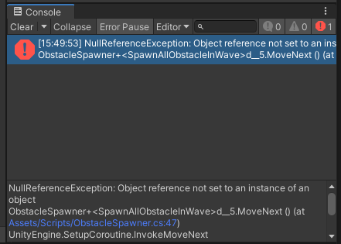

Fixed by adding obstacle pathing script to the obstacle

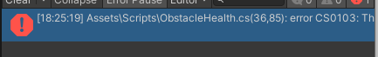  
Fixed by checking for typos