
Institute of Business Management

Final Year Project

Session 20xx-20xx
Project Title



Supervisor
Supervisor Name

Submitted by
1st Student Name (Registrtion ID)
2nd Student Name (Registrtion ID)
3rd Student Name (Registrtion ID)

College of Computer Science and Information Systems
Institute of Business Management (IoBM)
[Date (Month/Year)]

CERTIFICATE

This is to certify that the following students of Bachelor of Computer Science have successfully completed their project work titled “Peritus, AI-Based Software Risk Analysis System” in the College of Computer Science and Information Systems – IoBM (Department of Computer Science) as part of the degree requirement. The report is as per the template, formatted, and duly checked.

S.No | Student ID | Name

1

2

3

Supervisor Name:
Supervisor Signature: ___________________________
Designation:
College of Computer Science and Information Systems (CCSIS)

______________________ ___________________
FYP Coordinator Signature HOD (CS) Signature

ACKNOWLEDGEMENT

Video provides a powerful way to help you prove your point. When you click Online Video, you can paste in the embed code for the video you want to add. You can also type a keyword to search online for the video that best fits your document. To make your document look professionally produced, Word provides header, footer, cover page, and text box designs that complement each other. For example, you can add a matching cover page, header, and sidebar. Click Insert and then choose the elements you want from the different galleries. Themes and styles also help keep your document coordinated. When you click Design and choose a new Theme, the pictures, charts, and SmartArt graphics change to match your new theme. When you apply styles, your headings change to match the new theme. Save time in Word with new buttons that show up where you need them.

To change the way a picture fits in your document, click it and a button for layout options appears next to it. When you work on a table, click where you want to add a row or a column, and then click the plus sign. Reading is easier, too, in the new Reading view. You can collapse parts of the document and focus on the text you want. If you need to stop reading before you reach the end, Word remembers where you left off - even on another device. Video provides a powerful way to help you prove your point. When you click Online Video, you can paste in the embed code for the video you want to add. You can also type a keyword to search online for the video that best fits your document.

Yours Sincerely,

Student 1 (12345-6789)
Student 2 (12345-6789)
Student 3 (12345-6789)

ABSTRACT

Video provides a powerful way to help you prove your point. When you click Online Video, you can paste in the embed code for the video you want to add. You can also type a keyword to search online for the video that best fits your document. To make your document look professionally produced, Word provides header, footer, cover page, and text box designs that complement each other. For example, you can add a matching cover page, header, and sidebar. Click Insert and then choose the elements you want from the different galleries. Themes and styles also help keep your document coordinated. When you click Design and choose a new Theme, the pictures, charts, and SmartArt graphics change to match your new theme. When you apply styles, your headings change to match the new theme. Save time in Word with new buttons that show up where you need them. (at least 300 words)

Keywords – Keyword 1, Keyword 2……..Intrusion Detection System, Facial Features, Classified, Camera.

TABLE OF CONTENTS

ACKNOWLEDGEMENT 2
ABSTRACT 3
TABLE OF CONTENTS 4
LIST OF TABLES 5
LIST OF FIGURES 6
1. INTRODUCTION 8
1.1 Background of the Project 8
1.2 Problem Statement 8
1.3 Project Gaps 8
1.4 Aim / Purpose of the Project 8
1.5 Project Objectives 8
1.6 Project Scope 8
1.7 Organization of the Report 9
1.8 Chapter Summary 8
2. LITERATURE REVIEW 11
2.1 Introduction 11
2.2 Reviewed Research Articles Summary 11
2.3 Reviewed Existing Systems Summary 12
2.4 Comarison of Existing Systems with Proposed System 12
2.5 Project Gap Analysis 12
2.6 Chapter Summary 12
3. REQUIREMENT ANALYSIS 18
3.1 Introduction 18
3.2 Stakeholder Identification 18
3.3 Requirement Gathering Techniques 19
3.4 Functional Requirements 19
3.5 Non-Functional Requirements 19
3.6 Assumptions and Constraints 19
3.7 Chapter Summary 19
4. methodology 20
4.1 Introduction 20
4.2 Development Methodology 20
4.3 System Implemention Methodology 19
4.4 Chapter Summary 19

5. System Design 20
5.1 Introduction 20
5.2 System Architecture / System Diagram 19
5.3 UML Design 19
5.4 Database Design 19
5.5 Module Design 19
5.6 Chapter Summary 19
6. implementation 20
6.1 Introduction 20
6.2 Development Environment 20
6.3 Database Implementation 20
6.4 Functional Modules Implementation 19
6.5 Security Implementation 19
6.6 System Integration and Deployment 19
6.7 Chapter Summary 19
7. Testing and evaluation 20
7.1 Introduction 20
7.2 Testing Objectives 20
7.3 Testing Strategy 20
7.4 Test Cases and Test Results 19
7.5 Bug Tracking and Error Handling 19
7.6 Evaluation Criteria 19
7.7 Evaluation Results 19
7.8 Chapter Summary 19
7. conclusion 20
7.1 Introduction 20
7.2 Conclusion 20
7.3 Contribution / Novelty 19
7.4 Contribution towards Industry 19
7.5 Future Directions 19
7.6 Chapter Summary 19
References 20
appendices 20
Appendix A: Dataset 20
Appendix B: Gantt Chart 20
Appendix C: Plagiarism Report 19
Appendix E: Software Requirement Specification (SRS) 19

LIST OF TABLES

- Table 1.1: Face Scanners Deployed at ATMs in China for Security purposes 9
- Table 2.1: Multiple faces being detected 11
- Table 2.2: A person is being recognized using his Facial Features 12
- Table 4.1: Typical Iterative development process 20

LIST OF FIGURES

- Fig 2.1: Multiple faces being detected 11
- Fig 2.2: A person is being recognized using his Facial Features 12

LIST OF Abbreviations

FYP Final Year Project
CPU Central Processing Unit
USB Universal Serial Bus

Chapter 1
Introduction

1.1 Background of the Project
Video provides a powerful way to help you prove your point. When you click Online Video, you can paste in the embed code for the video you want to add. You can also type a keyword to search online for the video that best fits your document. To make your document look professionally produced, Word provides header, footer, cover page, and text box designs that complement each other. For example, you can add a matching cover page, header, and sidebar. Click Insert and then choose the elements you want from the different galleries.

Video provides a powerful way to help you prove your point. When you click Online Video, you can paste in the embed code for the video you want to add. You can also type a keyword to search online for the video that best fits your document. To make your document look professionally produced, Word provides header, footer, cover page, and text box designs that complement each other. For example, you can add a matching cover page, header, and sidebar. Click Insert and then choose the elements you want from the different galleries.



Fig 1.1: Caption

1.2 Problem Statement
Video provides a powerful way to help you prove your point. When you click Online Video, you can paste in the embed code for the video you want to add. You can also type a keyword to search online for the video that best fits your document. To make your document look professionally produced, Word provides header, footer, cover page, and text box designs that complement each other. For example, you can add a matching cover page, header, and sidebar.

1.3 Project Gaps (all gaps should be cited)
- Video provides a powerful way to help you prove your point. When you click Online Video, you can paste in the embed code for the video you want to add. You can also type a keyword to search online for the video that best fits your document.
- Video provides a powerful way to help you prove your point. When you click Online Video, you can paste in the embed code for the video you want to add. You can also type a keyword to search online for the video that best fits your document.
- Video provides a powerful way to help you prove your point. When you click Online Video, you can paste in the embed code for the video you want to add. You can also type a keyword to search online for the video that best fits your document.

1.4 Aim / Purpose of the Project
Video provides a powerful way to help you prove your point. When you click Online Video, you can paste in the embed code for the video you want to add. You can also type a keyword to search online for the video that best fits your document. To make your document look professionally produced, Word provides header, footer, cover page, and text box designs that complement each other. For example, you can add a matching cover page, header, and sidebar. Click Insert and then choose the elements you want from the different galleries.

Video provides a powerful way to help you prove your point. When you click Online Video, you can paste in the embed code for the video you want to add. You can also type a keyword to search online for the video that best fits your document. To make your document look professionally produced, Word provides header, footer, cover page, and text box designs that complement each other. For example, you can add a matching cover page, header, and sidebar. Click Insert and then choose the elements you want from the different galleries.

1.5 Project Objectives
The main objectives of this project are:
- To design and develop a web-based Library Management System.
- To automate the process of issuing and returning books.
- To provide secure user authentication and role-based access control.
- To enable efficient searching and management of library resources.
- To generate reports for library administration.
- To improve the overall efficiency of library operations.

1.6 Project Scope
Video provides a powerful way to help you prove your point. When you click Online Video, you can paste in the embed code for the video you want to add. You can also type a keyword to search online for the video that best fits your document. To make your document look professionally produced, Word provides header, footer, cover page, and text box designs that complement each other. For example, you can add a matching cover page, header, and sidebar. Click Insert and then choose the elements you want from the different galleries.

1.7 Organization of the Report (explain chapter-wise))
Chapter One: This chapter contains introduction part in which background of the study has been discussed in detail. GSD environment, its advantages, disadvantages, challenges have also been incorporated. Then moved forward and elaborated Research gaps, Problem Statement, Research questions and Research objectives have been elaborated in this chapter. At the end chapter has been summarized.

Chapter Two: In this chapter an extensive literature review / Related work has been discussed. Several recent research articles of respected authors in the field of Software Development, Global Software Development, RM in software development and global software development environment, Software RM using machine learning techniques, risk classification, risk prediction and risk assessment have been summarized to find out the research gaps. Empirical review has also been conducted in this chapter. RM and its steps, RM in GSD environment and GSD risk dimensions and factors have been described in detail. All machine learning techniques used in this study have been explained here as well. At the end chapter has been summarized.

1.6 Chapter Summary

Video provides a powerful way to help you prove your point. When you click Online Video, you can paste in the embed code for the video you want to add. You can also type a keyword to search online for the video that best fits your document. To make your document look professionally produced, Word provides header, footer, cover page, and text box designs that complement each other. For example, you can add a matching cover page, header, and sidebar. Click Insert and then choose the elements you want from the different galleries.

Chapter 2
Literature Review

2.1 Introduction
Video provides a powerful way to help you prove your point. When you click Online Video, you can paste in the embed code for the video you want to add. You can also type a keyword to search online for the video that best fits your document. To make your document look professionally produced, Word provides header, footer, cover page, and text box designs that complement each other. For example, you can add a matching cover page, header, and sidebar.

2.2 Reviewd Research Articles Summary
In the context of risk classification used in software development projects, the authors [17] proposed an SVM based method and highlighted the importance discussing the factors affecting the risks associated with the classification. Based on the CAR and AUC, the methods of SVM and K-Means were compared with the method proposed in the study. The CAR and AUC in the proposed method are found to be superior as compared to the values of SVM and K-Means. It ultimately contributes to relatively higher precision and better performance of the method proposed for the classification of risk in the software development projects.

Researchers in [18] a solution was found to determine the effort required for a software project based on an organizations historical data for projects. The solution, based on a predictive model, is a result of research which includes two methods i.e., (a) correlation matrix and (b) decision tree. Tests were run using both methodologies, which generated the same results, eventually leading the researchers to identify three parameters that were be used as input for various predictive models. Evaluation from results of these predictive models led to the concluded “Evolutionary Support Vector Machine” as the best model. Therefore, it was determined that the effort required to complete a project can be predicted based on these three parameters (a) number of entities in a project, (b) transaction of the project and (c) project duration in months.

2.3 Reviewd Existing Systems Summary

2.2.1 Existing System 1 (here name of the system required)

Video provides a powerful way to help you prove your point. When you click Online Video, you can paste in the embed code for the video you want to add. You can also type a keyword to search online for the video that best fits your document. To make your document look professionally produced, Word provides header, footer, cover page, and text box designs that complement each other. For example, you can add a matching cover page, header, and sidebar. Video provides a powerful way to help you prove your point. When you click Online Video, you can paste. Video provides a powerful way to help you prove your point. When you click Online Video, you can paste

2.2.2 Existing System 2 (here name of the system required)

Video provides a powerful way to help you prove your point. When you click Online Video, you can paste in the embed code for the video you want to add. You can also type a keyword to search online for the video that best fits your document. To make your document look professionally produced, Word provides header, footer, cover page, and text box designs that complement each other. For example, you can add a matching cover page, header, and sidebar. Video provides a powerful way to help you prove your point. When you click Online Video, you can paste.

2.2.3 Existing System 3 (here name of the system required)

Video provides a powerful way to help you prove your point. When you click Online Video, you can paste in the embed code for the video you want to add. You can also type a keyword to search online for the video that best fits your document. To make your document look professionally produced, Word provides header, footer, cover page, and text box designs that complement each other. For example, you can add a matching cover page, header, and sidebar. Video provides a powerful way to help you prove your point. When you click Online Video, you can paste

Comparison of Existing Systems with Proposed System

You are required to incorporate your comparison table at this point. Please provide at least 5–6 line explanation of the comparison table prior to its placement. The table must also be appropriately cross-referenced in the text.

Table 2.1: Comparisons of Existing systems with proposed system

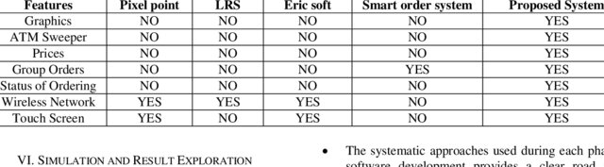

Project Gap Analysis
Video provides a powerful way to help you prove your point. When you click Online Video, you can paste in the embed code for the video you want to add. You can also type a keyword to search online for the video that best fits your document. To make your document look professionally produced, Word provides header, footer, cover page, and text box designs that complement each other. For example, you can add a matching cover page, header, and sidebar. Click Insert and then choose the elements you want from the different galleries.

2.6 Chapter Summary
Video provides a powerful way to help you prove your point. When you click Online Video, you can paste in the embed code for the video you want to add. You can also type a keyword to search online for the video that best fits your document. To make your document look professionally produced, Word provides header, footer, cover page, and text box designs that complement each other. For example, you can add a matching cover page, header, and sidebar. Click Insert and then choose the elements you want from the different galleries.

Chapter 3
Requirement Analysis

3.1 Introduction
Requirement analysis is a critical phase of software development in which the needs, expectations, limitations, and objectives of the proposed system are identified, analyzed, documented, and validated. The purpose of this section is to clearly define what the system is expected to do, who will use it, what constraints must be considered, and what quality attributes must be achieved. This chapter presents the requirement analysis for [Project/System Name]. It includes stakeholder identification, requirement gathering techniques, functional requirements, non-functional requirements, assumptions, and constraints. The requirements documented in this section will serve as the foundation for system design, development, testing, and final implementation.

3.2 Stakeholder Identification
Stakeholders are individuals, groups, or organizations that are directly or indirectly involved in the system or affected by its outcomes. Proper stakeholder identification is important because each stakeholder may have different expectations, responsibilities, and requirements from the system. The major stakeholders of [Project/System Name] are identified below:

Table 3.1 System Stakeholders
Stakeholder | Description | Role / Interest in the System
End Users | Individuals who will directly interact with the system. | Use the system to perform daily tasks efficiently.
Client / Sponsor | Person or organization requesting the development of the system. | Defines business goals, approves requirements, and evaluates final system.
System Administrator | Responsible for managing users, data, access rights, and system configuration. | Ensures smooth operation and maintenance of the system.
Development Team | Software engineers, designers, and testers involved in system development. | Design, develop, test, and deploy the system according to requirements.
Project Manager | Responsible for planning, monitoring, and controlling project activities. | Ensures that the project is completed within scope, time, and budget.
Quality Assurance Team | Responsible for testing and verifying system quality. | Ensures that the system meets functional and non-functional requirements.
External Stakeholders | Any third-party service providers, regulatory bodies, or external users. | May influence security, compliance, integration, or operational requirements.

3.3 Requirement Gathering Techniques
Requirement gathering is the process of collecting information from stakeholders to understand what the system should accomplish. Different techniques may be used depending on the nature of the project, stakeholder availability, and complexity of the system. The following requirement gathering techniques may be used for [Project/System Name]:

Interviews: Interviews are one of the most commonly used techniques for gathering requirements. In this method, the analyst communicates directly with stakeholders to understand their expectations, problems, and desired system features. Interviews may be structured, semi-structured, or unstructured. Structured interviews follow predefined questions, while semi-structured interviews allow additional discussion based on stakeholder responses. This technique is useful for obtaining detailed information and clarifying unclear requirements.

Questionnaires and Surveys: Questionnaires and surveys are useful when requirements need to be collected from a large number of users. They consist of predefined questions that stakeholders can answer in written or digital form. This technique is time-efficient and helps gather feedback from multiple users. Surveys may include multiple-choice questions, rating scales, and open-ended questions. They are especially useful for identifying common user needs, preferences, and problems.

Workshops: Workshops involve group discussions with multiple stakeholders. They are useful for brainstorming, resolving conflicts, prioritizing requirements, and achieving a shared understanding of the proposed system. During workshops, users, clients, developers, and managers can discuss the system scope, required features, business rules, and limitations. This technique improves collaboration and reduces misunderstanding among stakeholders.

Document Analysis: Document analysis involves reviewing existing documents, forms, reports, manuals, policies, and records related to the current system. This helps identify data requirements, business rules, reporting formats, and operational procedures.

Brainstorming: Brainstorming is used to generate ideas and possible solutions for the proposed system. Stakeholders and development team members discuss different features, problems, and improvements. This technique is useful during the early stages of requirement gathering when the project scope is still being explored.

3.4 Functional Requirements

Functional requirements describe the specific functions, services, and operations that the system must perform. These requirements define what the system should do in response to user actions, inputs, or business processes. The functional requirements of [Project/System Name] may include the following:

Table 3.2 Functional Requirements
Req. ID | Functional Requirement | Description | Priority
FR-01 | User Registration | The system shall allow new users to register by providing required information such as name, email, password, and contact details. | High
FR-02 | User Login | The system shall allow registered users to log in using valid credentials. | High
FR-03 | User Authentication | The system shall verify user identity before granting access to protected features. | High
FR-04 | Role-Based Access Control | The system shall provide different access rights for users, administrators, and other roles. | High
FR-05 | Profile Management | The system shall allow users to view and update their profile information. | Medium
FR-06 | Data Entry | The system shall allow authorized users to add required records into the system. | High

3.5 Non-Functional Requiremens

Non-functional requirements define the quality attributes, constraints, and performance expectations of the system. They describe how the system should perform rather than what functions it should provide. The non-functional requirements of [Project/System Name] may include the following:

Table 3.3 Non-Functional Requirements
Req. ID | Non-Functional Requirement | Description | Priority
NFR-01 | Performance | The system should respond to user requests within an acceptable time limit, such as 2–5 seconds under normal load. | High
NFR-02 | Security | The system shall protect user data through authentication, authorization, password protection, and secure data handling. | High
NFR-03 | Reliability | The system should operate correctly and consistently without frequent failures. | High
NFR-04 | Availability | The system should remain available to users during required operational hours. | High
NFR-05 | Usability | The system interface should be simple, clear, and easy to understand for users. | Medium
NFR-06 | Maintainability | The system should be designed in a way that allows easy updates, debugging, and future enhancements. | Medium
NFR-07 | Scalability | The system should support an increase in users, data, and transactions without major performance degradation. | Medium

3.6 Assumptions and Constraints

Assumptions and constraints define the conditions under which the system will be developed and operated. Assumptions are factors believed to be true during system development, while constraints are limitations that may affect design, implementation, cost, time, or technology.

Table 3.4 Assumptions
Assumption ID | Assumption
A-01 | Users will have basic knowledge of using computers, mobile devices, or web-based systems.
A-02 | The required hardware, software, and internet connectivity will be available during system operation.
A-03 | Stakeholders will provide accurate and complete information during requirement gathering.
A-04 | The system will be used only by authorized users.
A-05 | The organization will provide necessary support for system deployment and maintenance.
A-06 | Data provided during testing and implementation will be valid and reliable.
A-07 | The project scope will remain stable after requirement approval.

Table 3.5 Constraints
Constraint ID | Constraint
C-01 | The project must be completed within the given time frame.
C-02 | The system must be developed within the allocated budget.
C-03 | The system must comply with organizational policies and academic/project guidelines.
C-04 | The system must operate using the selected technology stack, programming language, database, or platform.
C-05 | The system must ensure data security and privacy.
C-06 | The availability of stakeholders for interviews, feedback, and validation may be limited.
C-07 | Hardware, software, or internet limitations may affect system performance.
C-08 | Future changes in requirements may affect project schedule and scope.

3.7 Chapter Summary
Video provides a powerful way to help you prove your point. When you click Online Video, you can paste in the embed code for the video you want to add. You can also type a keyword to search online for the video that best fits your document. To make your document look professionally produced, Word provides header, footer, cover page, and text box designs that complement each other. For example, you can add a matching cover page, header, and sidebar. Click Insert and then choose the elements you want from the different galleries.

Chapter 4
Methodology

4.1 Introduction
The methodology section explains the systematic approach followed for the planning, analysis, design, development, testing, and implementation of the proposed Student Performance Prediction System. This section provides a clear description of the development process, system design strategy, data collection approach, implementation procedure, and testing methods used to ensure that the system meets the required objectives.
The proposed system aims to predict student academic performance by analyzing relevant academic and behavioral data. The system is designed to assist administrators, teachers, and students in identifying performance trends, recognizing at-risk students, and supporting timely academic intervention. Therefore, the methodology adopted for this project focuses on accuracy, usability, reliability, and practical implementation.

This chapter describes the selected development methodology, the reason for selecting it, the major phases involved in system development, and the testing methodology used to verify and validate the system. The main objective is to develop a reliable, user-friendly, and efficient system that fulfills the needs of all stakeholders.

The methodology for this project includes the following major activities:
- Identification of project objectives and scope.
- Collection and analysis of student-related data.
- Identification of system requirements.
- Design of system architecture and user interface.
- Development of a working prototype.
- Refinement of the system based on feedback.
- Testing of system modules and complete system functionality.
- Validation of the final system through user acceptance testing.

4.2 Development Methodology
The prototype model requires the development of a working prototype before proceeding with the full-scale development of the actual software. This prototype acts as an early, simplified version of the intended system. Typically, it exhibits limited functional capabilities, reduced reliability, and less efficient performance compared to the final product. The primary purpose of a prototype is to provide a tangible representation of the system, which helps in refining requirements and understanding the overall design better. Often, clients may have only a general idea of what they expect from the software product. This lack of detailed information about the system's inputs, processing needs, and output requirements can make it challenging to define precise specifications.

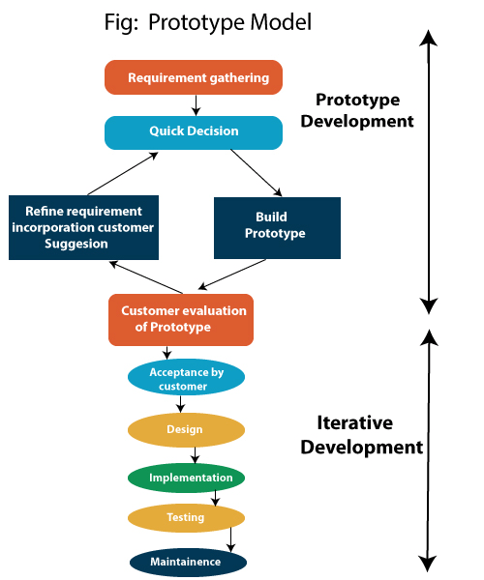

Figure 4.1: Prototype Model

4.2.1 Requirement Identification
In the first phase, the basic requirements of the system are identified by studying the problem domain and understanding the needs of stakeholders. The main stakeholders of the Student Performance Prediction System include administrators, teachers, students, and academic decision-makers. The requirements are gathered through different techniques such as interviews, observation, questionnaires, document analysis, and discussion with relevant users. The purpose of this phase is to understand what type of data is required, what prediction features should be included, and what outputs the system should generate.

4.2.2 Quick Design
After identifying the initial requirements, a quick design of the system is prepared. This design provides a basic overview of the system structure, user interface, input forms, database design, and output screens. The quick design does not include every technical detail of the final system. Instead, it focuses on the main features that need to be shown in the prototype. The purpose of this phase is to provide stakeholders with an early visual representation of the proposed system.

4.2.3 Prototype Development
In this phase, an initial working prototype of the Student Performance Prediction System is developed. The prototype includes the basic features required to demonstrate the core functionality of the system. The prototype may include limited features such as user login, student data entry, basic prediction output, and simple report generation. The objective is not to develop the complete system immediately, but to create a working model that can be reviewed by users.

4.2.4 User Evaluation and Feedback
After the prototype is developed, it is presented to the stakeholders for evaluation. Administrators, teachers, and students review the prototype and provide feedback about the system interface, features, input fields, output reports, and usability. The feedback collected during this phase is very important because it helps identify missing features, unclear requirements, design problems, and functional improvements.

4.2.5 Requirement Refinement
Based on user feedback, the system requirements are reviewed and refined. Any missing, incomplete, or unclear requirements are updated. The prototype may also be modified to reflect the changes suggested by users. This phase may be repeated multiple times until the stakeholders are satisfied with the system design and functionality. Requirement refinement ensures that the final system is aligned with user needs and project objectives.

4.2.6 Final System Development
After the requirements are finalized, the complete system is developed. In this phase, all approved features are implemented according to the refined requirements and system design. The final system development includes: Front-end development, Back-end development and Database development.

System Implementation Approach
The implementation phase involves converting the approved design into a working software system. The system is implemented according to the finalized functional and non-functional requirements. The implementation approach includes:
- Designing the database structure.
- Creating user interfaces.
- Developing system modules.
- Connecting the front-end with the database.
- Applying validation rules.
- Implementing security controls.
- Testing each module before integration.

4.4 Chapter Summary
In the methodology section, we define the systematic approach guiding the development of the Student Performance Prediction system. This includes detailing the foundational system framework, covering architecture and functionalities tailored to meet the specific needs of administrators, teachers, and students. Simultaneously, we delve into the intricacies of data collection procedures, emphasizing the careful strategies employed to ensure the accuracy and completeness of the information processed by the system. This methodological framework forms the backbone of our development process, aiming to create a user-friendly and reliable system that surpasses the expectations of our diverse user base.

Chapter 5
System Design

5.1 Introduction

The system model design incorporates key elements such as user accounts for students, teachers, and administrators. The functionalities include a seamless login/logout system, the ability to generate predictions, view grades and predictions, update data, and manage the system efficiently. Our design fosters a user-friendly experience while maintaining the robustness necessary for accurate predictions. Notably, we have opted for a flexible dataset approach, negating the use of traditional database management systems like MS Access or SQL. The database design is such that utilizes a CSV file as a dataset to fuel our machine learning algorithm. This dataset, essentially serving as our dynamic database, contains valuable information crucial for predicting student performance.

5.2 System Architecture / System Diagram

You are required to incorporate your System Architecture at this point. Please provide detailed explanation of the system diagram prior to its placement. The figure must also be appropriately cross-referenced in the text.

SYSTEM ARCHITECTURE HERE

Figure 5.1: System Diagram

5.3 UML Design

Video provides a powerful way to help you prove your point. When you click Online Video, you can paste in the embed code for the video you want to add. You can also type a keyword to search online for the video that best fits your document. To make your document look professionally produced, Word provides header, footer, cover page, and text box designs that complement each other. For example, you can add a matching cover page, header, and sidebar.

5.3.1 Use Case Diagrams

You are required to incorporate use case diagrams of main functionalities at this point. Please provide detailed explanation of the use case diagram prior to its placement. The figure must also be appropriately cross-referenced in the text.

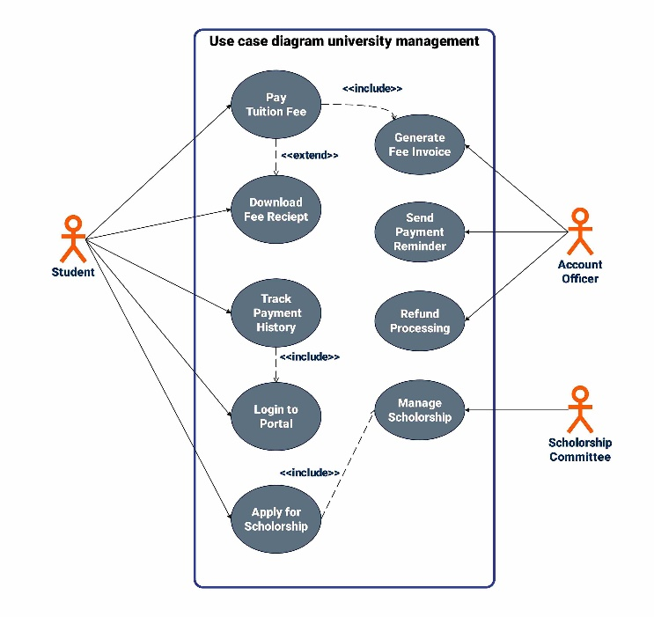
Figure 5.2: Use Case Diagram

5.3.2 Sequence Diagram

You are required to incorporate your seq. diagram of main functionalities at this point. Please provide at least 5–6 line explanation of the seq diagram prior to its placement. The figure must also be appropriately cross-referenced in the text.

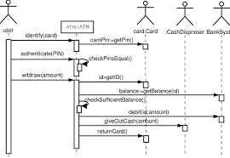
Figure 5.3: Sequence Diagram

5.3.3 Activity Diagram

You are required to incorporate your Activity diagram at this point. Please provide detailed explanation of the activity diagram prior to its placement. The figure must also be appropriately cross-referenced in the text.

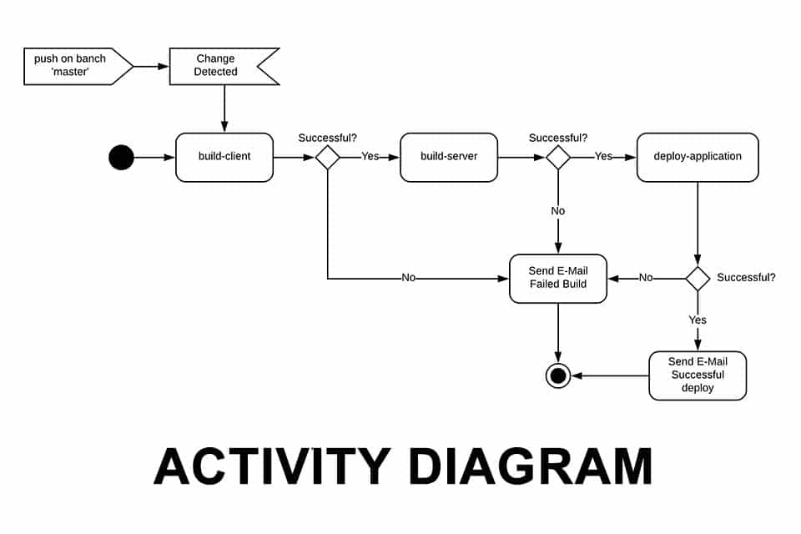
Figure 5.4: Activity Diagram

5.3.4 Class Diagram

You are required to incorporate your Class diagram at this point. Please provide detailed explanation of the Class diagram prior to its placement. The figure must also be appropriately cross-referenced in the text.

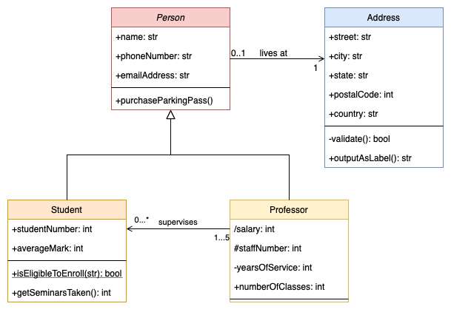
Figure 5.5: Class Diagram

5.5 Database Design

You are required to incorporate your database design at this point. Please provide detialed explanation of the database design prior to its placement. The figure must also be appropriately cross-referenced in the text.
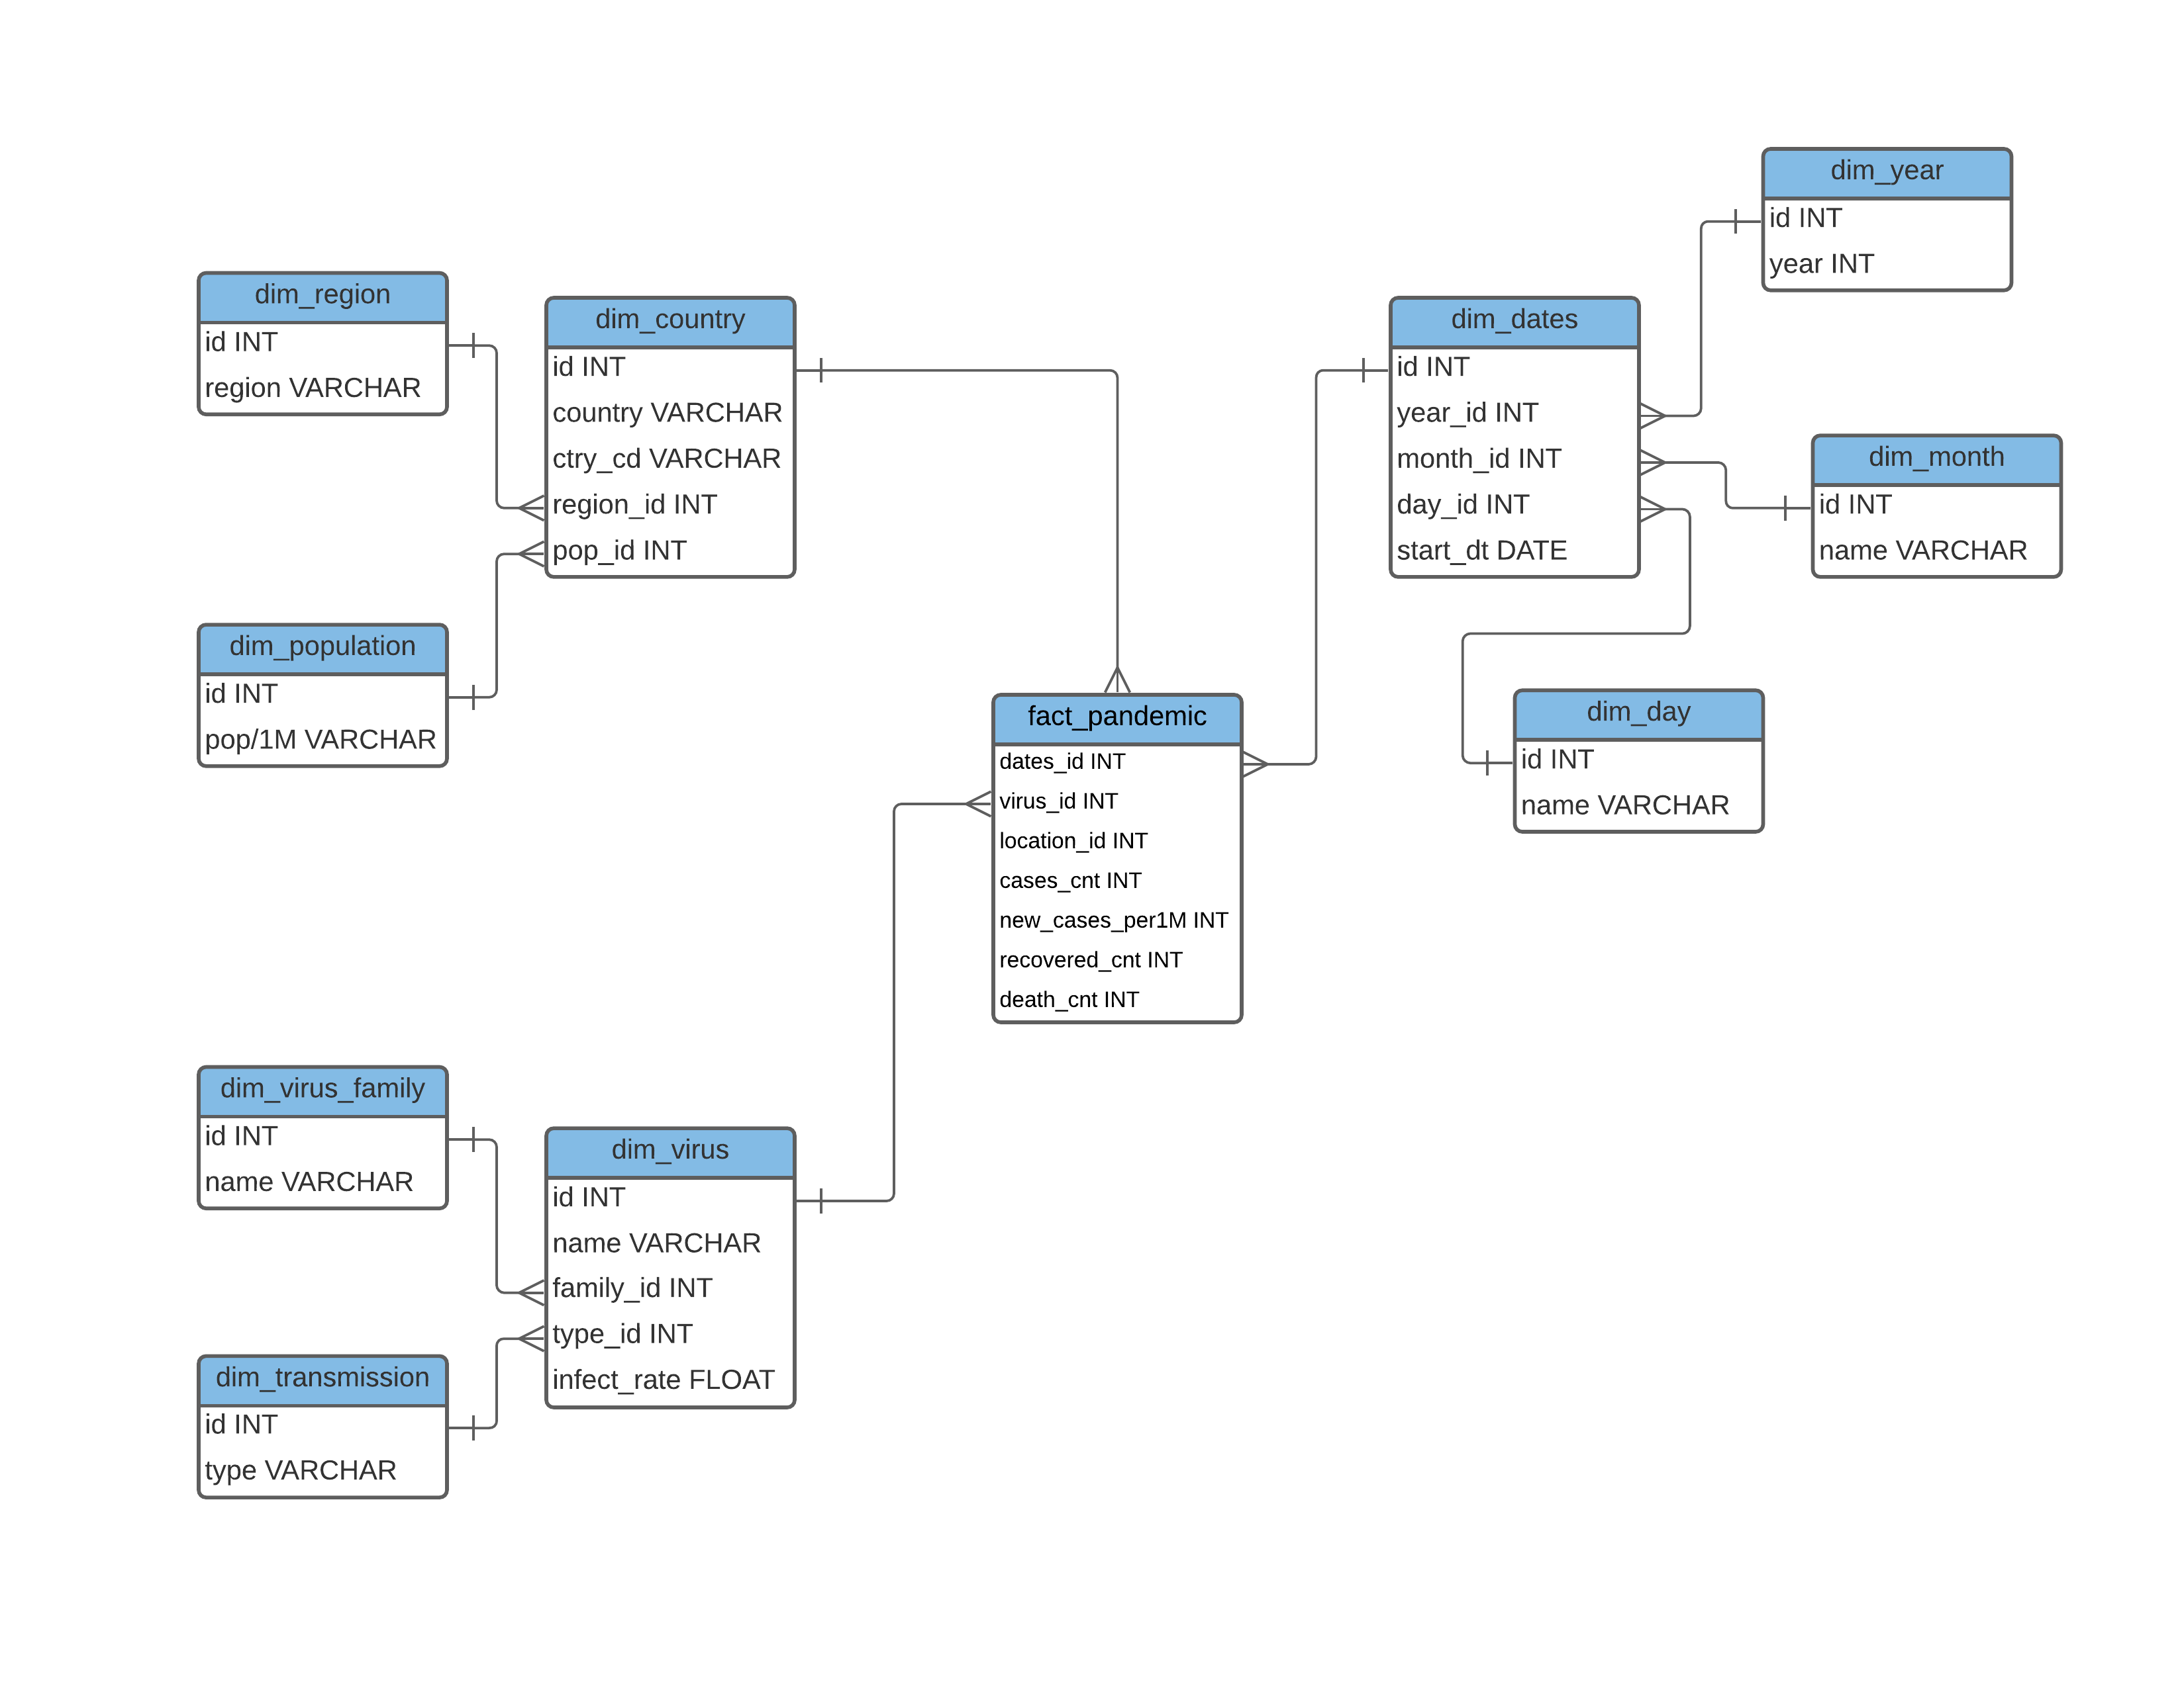
Figure 5.6: Entity Relationship Diagram

5.6 Module Design

You are required to incorporate your Module design at this point. Please provide detialed explanation of the Module design prior to its placement. The figure must also be appropriately cross-referenced in the text.

MODULE DESIGN
HERE

Figure 5.7: Module Design

5.7 Chapter Summary

Video provides a powerful way to help you prove your point. When you click Online Video, you can paste in the embed code for the video you want to add. You can also type a keyword to search online for the video that best fits your document. To make your document look professionally produced, Word provides header, footer, cover page, and text box designs that complement each other. For example, you can add a matching cover page, header, and sidebar. Click Insert and then choose the elements you want from the different galleries. Themes and styles also help keep your document coordinated. When you click Design and choose a new Theme, the pictures, charts, and SmartArt graphics change to match your new theme.

When you apply styles, your headings change to match the new theme. Save time in Word with new buttons that show up where you need them. To change the way a picture fits in your document, click it and a button for layout options appears next to it. When you work on a table, click where you want to add a row or a column, and then click the plus sign. Reading is easier, too, in the new Reading view. You can collapse parts of the document and focus on the text you want. If you need to stop reading before you reach the end, Word remembers where you left off - even on another device.

Chapter 6
System Implementation
6.1 Introduction
Implementation is the phase in which the proposed system is converted from design and planning into a working software solution. This chapter describes how the system was developed, configured, integrated, and deployed. It explains the tools, technologies, programming languages, frameworks, hardware, software, database structure, functional modules, security mechanisms, and deployment strategy used during the development of the project.

The implementation phase is very important because it ensures that the functional and non-functional requirements identified in earlier chapters are practically achieved. During this phase, the system design, database design, user interface, backend logic, and functional modules are developed and connected to form a complete operational system.

6.2 Development Environment
The development environment refers to the combination of hardware, software, programming languages, frameworks, libraries, and tools used to develop and execute the system. A suitable development environment is necessary to ensure smooth coding, testing, debugging, integration, and deployment.

6.2.1 Hardware Requirements
Hardware requirements define the minimum and recommended physical resources required to develop and run the system. These requirements may vary depending on the size, complexity, and expected usage of the system.
Table 6.1 Hardware Requirements
Hardware Component | Minimum Requirement | Recommended Requirement
Processor | Intel Core i3 or equivalent | Intel Core i5 / i7 or equivalent
RAM | 4 GB | 8 GB or above
Hard Disk / SSD | 250 GB HDD | 512 GB SSD or above
Display | Standard monitor | Full HD display
Internet Connection | Basic internet connectivity | Stable broadband connection
Server Machine | Basic server or local machine | Dedicated server or cloud-based server

6.2.2 Software Requirements
Software requirements define the applications, operating systems, platforms, and tools required for system development and execution.

Table 6.2 Software Requirements
Software Component | Description
Operating System | Windows / Linux / macOS used for development and deployment.
Code Editor / IDE | Visual Studio Code, PyCharm, Eclipse, IntelliJ IDEA, or any suitable IDE.
Database Management System | MySQL, PostgreSQL, MongoDB, SQL Server, or SQLite.
Web Browser | Google Chrome, Microsoft Edge, Mozilla Firefox, or Safari for testing.
Server Environment | XAMPP, WAMP, Node.js Server, Apache, Nginx, or cloud server.
Version Control Tool | Git / GitHub / GitLab for code management and collaboration.
Testing Tools | Postman, Selenium, JUnit, PyTest, or manual testing tools.
Design Tools | Figma, Draw.io, Lucidchart, or Microsoft Visio for diagrams and UI design.

6.2.3 Tools and Technologies
Programming languages are used to develop the logic, functionality, interface, and database connectivity of the system. The selection of programming languages depends on the nature of the project and the selected technology stack.

Table 6.3 Tools and Technologies
Tools | Purpose
HTML | Used to create the structure of web pages.
CSS | Used to design and style the user interface.
JavaScript | Used to add interactivity and client-side functionality.
Python / Java / PHP / C# / JavaScript | Used for backend development and business logic.
SQL | Used to create, manage, and query relational databases.

6.3 Database Implementation
Database implementation refers to the process of designing, creating, and managing the database used by the system. The database stores all important information required for system operations, such as user records, student records, transactions, reports, system logs, and other project-specific data. A properly implemented database ensures data accuracy, consistency, security, and availability.

6.3.1 Database Overview
The database of [Project/System Name] is designed to store, manage, retrieve, and update system data efficiently. It acts as the central storage component of the system and supports all major system operations. The database is responsible for:
- Storing user information.
- Managing login credentials and roles.
- Storing project-specific records.
- Maintaining relationships between different entities.
- Supporting data retrieval and reporting.
- Ensuring data consistency and integrity.
- Providing secure access to authorized users.

MySQL / PostgreSQL / MongoDB / SQL Server]. This database was selected because it provides reliability, scalability, query support, security features, and easy integration with the selected programming environment.

6.3.2 Database Structure
The database structure defines the tables, fields, data types, primary keys, foreign keys, and relationships used in the system. Each table stores a specific type of data.
Table 6.4 Database Structure
Table Name | Purpose
Users | Stores user login details and role information.
Students | Stores student personal and academic information.
Courses | Stores course-related information.
Marks | Stores student assessment and examination marks.
Attendance | Stores student attendance records.
Prediction Results | Stores system-generated prediction results.
Reports | Stores generated report records.
Admin Logs | Stores administrative activities and system logs.

6.3.3 Relationship Implementation
Relationship implementation explains how different database tables are connected with each other. These relationships ensure proper data organization and prevent unnecessary duplication. The major types of relationships used in the system may include:

Table 6.5 Database Relationship Structure
Relationship | Description
Users to Students | One user account may belong to one student.
Students to Marks | One student may have multiple marks records.
Courses to Marks | One course may have multiple marks records.
Students to Attendance | One student may have multiple attendance records.
Students to Prediction Results | One student may have multiple prediction records.

6.4 Functional Modules Implementation
Functional modules represent the major parts of the system. Each module performs a specific task and contributes to the overall functionality of the system. The implementation of modules should be explained with their purpose, functionality, and screenshots.

6.4.1 Module 1: [Module Name]
The purpose of this module is to [explain the main objective of the module]. This module is responsible for handling [mention the specific task, feature, or process] within the system. For example, if the module is a Login Module, its purpose is to authenticate users and provide secure access to the system based on valid credentials. This module performs the following functions:
- Allows users to access the relevant feature.
- Accepts required input from the user.
- Validates the entered information.
- Processes the request according to system logic.
- Stores or retrieves data from the database.
- Displays the required output to the user.
- Shows appropriate success or error messages.

Insert screenshot here.
Figure 6.1: Screenshot of [Module Name]

6.4.2 Module 2: [Module Name]
The purpose of this module is to [explain the main objective of the module]. This module supports the system by managing [mention feature or process]. For example, if the module is a Student Management Module, its purpose is to add, update, view, and delete student records. This module performs the following functions:
- Adds new records into the system.
- Updates existing records.
- Deletes unnecessary or incorrect records.
- Displays stored records.
- Allows searching and filtering of records.
- Ensures validation before saving data.
- Connects with the database for record management.

Insert screenshot here.
Figure 6.2: Screenshot of [Module Name]

6.4.3 Module 3: [Module Name]
The purpose of this module is to [explain the main objective of the module]. This module is designed to perform [mention the specific function] and support the main objective of the project. For example, if the module is a Report Generation Module, its purpose is to generate reports based on system data. This module performs the following functions:
- Retrieves required data from the database.
- Processes the data according to user selection.
- Generates output in the required format.
- Displays reports, summaries, charts, or results.
- Allows users to view or download information.
- Ensures that only authorized users can access reports.

Insert screenshot here.
Figure 6.3: Screenshot of [Module Name]

6.5 Security Implementation
Security implementation describes the mechanisms used to protect the system, users, database, and sensitive information from unauthorized access, misuse, data loss, or cyber threats. Security is an important part of software implementation because it ensures confidentiality, integrity, and availability of system resources.

6.5.1 User Authentication
User authentication ensures that only registered and valid users can access the system. Users are required to provide valid login credentials such as username/email and password.

6.5.2 Role-Based Access Control
Role-based access control is used to provide different permissions to different types of users. Each user can access only those features that are allowed according to their role.

6.5.3 Password Protection
Passwords should not be stored in plain text. The system should use password hashing or encryption techniques to protect user credentials.

6.5.4 Input Validation
Input validation is used to ensure that users enter correct and acceptable data. It prevents invalid, incomplete, or harmful data from being stored in the system.

6.5.5 Database Security
Database security protects stored information from unauthorized access, modification, or deletion.

6.6 System Integration and Deployment
System integration and deployment describe how different parts of the system are connected and made available for use. Integration ensures that all modules work together correctly, while deployment makes the system operational in the selected environment.

6.6.1 System Integration
System integration is the process of combining all developed modules into a complete working system. After individual modules are implemented, they are connected with each other and with the database. The integration process may include:
- Connecting frontend pages with backend logic.
- Connecting backend modules with the database.
- Integrating authentication with user roles.
- Integrating forms with data storage.
- Integrating reports with stored records.
- Ensuring smooth navigation between modules.
- Testing data flow between different components.
For example, when a user submits a form, the frontend sends the data to the backend. The backend validates the data and stores it in the database. The system then displays a success message or relevant output to the user.

6.6.2 Deployment Environment
The deployment environment refers to the platform where the final system is hosted and executed. The system may be deployed locally, on an institutional server, or on a cloud platform. Possible deployment environments include:

Table 6.5 Database Relationship Structure
Deployment Type | Description
Local Deployment | System runs on a local computer or local server.
Institutional Server | System is deployed on the organization’s internal server.
Cloud Deployment | System is hosted on cloud platforms such as AWS, Azure, Google Cloud, or Heroku.
Web Hosting Server | System is uploaded to a web hosting service and accessed through a browser.

6.6.3 Deployment Steps
The deployment process may include the following steps:
- Finalize the source code.
- Configure the database.
- Upload files to the server.
- Set up environment variables and configuration files.
- Install required dependencies and libraries.
- Connect the application with the database.
- Configure domain or local server address.
- Test the deployed system.
- Verify user login and module access.
- Monitor the system after deployment.

6.6.4 Post-Deployment Verification
After deployment, the system should be verified to ensure that it works correctly in the live environment. Post-deployment verification may include:
- Checking login functionality.
- Testing database connectivity.
- Verifying all functional modules.
- Checking report generation.
- Testing user roles and permissions.
- Verifying page loading speed.
- Checking backup configuration.
- Confirming that no errors occur during normal use.

6.7 Chapter Summary
This chapter presented the implementation details of the proposed [Project/System Name]. It explained the development environment, including hardware requirements, software requirements, programming languages, frameworks, and libraries. The chapter also discussed database implementation, including database overview, database structure, and relationship implementation. Furthermore, the chapter described the implementation of functional modules, including their purpose, functionality, implementation details, and screenshots. Security implementation was also discussed, including authentication, role-based access control, password protection, input validation, database security, session management, and backup procedures.

Chapter 7
Testing and Evaluation
7.1 Introduction
Testing and evaluation are essential phases of software development that ensure the proposed system works correctly, satisfies user requirements, and performs according to the expected standards. After implementation, the system must be tested to identify errors, verify functionality, validate outputs, and evaluate overall system performance.
This chapter presents the testing and evaluation process of [Project/System Name]. It explains the testing objectives, testing strategy, test environment, types of testing performed, test cases, evaluation criteria, and final results. The purpose of this chapter is to confirm that the developed system meets both functional and non-functional requirements identified in earlier chapters.

7.2 Testing Objectives
The main objective of testing is to ensure that the developed system is free from major errors and performs its intended functions correctly. Testing helps detect bugs, incorrect outputs, integration issues, usability problems, and performance limitations.
The specific objectives of testing are:
- To verify that each module performs its intended function.
- To ensure that all modules work together correctly.
- To validate the accuracy of system outputs.
- To check whether user inputs are properly handled.
- To ensure that unauthorized users cannot access restricted features.
- To evaluate system performance under normal operating conditions.
- To confirm that the system satisfies user expectations.
- To identify and correct errors before final deployment.

7.3 Testing Strategy
The testing strategy defines the overall approach used to verify and validate the system. In this project, testing is performed in multiple stages, starting from individual modules and ending with complete system validation. The proposed testing strategy includes:

- Unit Testing
Individual modules are tested separately to verify their correctness.
- Integration Testing
Multiple modules are combined and tested to verify proper communication and data flow.
- System Testing
The complete system is tested as a whole to ensure that all requirements are fulfilled.
- Functional Testing
System functions are tested against the functional requirements.
- Non-Functional Testing
Quality attributes such as performance, usability, reliability, and security are evaluated.
- User Acceptance Testing
Actual users test the system to confirm whether it satisfies their expectations.

7.4 Test Cases and Test Results
Test cases are prepared to document the testing process. A test case defines the test scenario, input data, expected result, actual result, and final status. The following format may be used for test case documentation:

Table 7.1 Test Cases and Results
Test Case ID | Module | Test Scenario | Input | Expected Result | Actual Result | Status
TC-01 | Login | Verify login with valid credentials | Valid username and password | User should successfully log in | [To be filled] | Pass/Fail
TC-02 | Login | Verify login with invalid credentials | Invalid username or password | Error message should be displayed | [To be filled] | Pass/Fail
TC-03 | Registration | Verify user registration | Valid user details | Account should be created successfully | [To be filled] | Pass/Fail
TC-04 | Data Entry | Add new record | Valid record details | Record should be saved in database | [To be filled] | Pass/Fail
TC-05 | Data Update | Update existing record | Modified record details | Record should be updated successfully | [To be filled] | Pass/Fail
TC-06 | Data Deletion | Delete existing record | Selected record | Record should be deleted or removed | [To be filled] | Pass/Fail
TC-07 | Search | Search record using keyword | Search keyword | Matching records should be displayed | [To be filled] | Pass/Fail
TC-08 | Report | Generate report | Selected criteria | Report should be generated correctly | [To be filled] | Pass/Fail
TC-09 | Security | Access restricted page without login | Direct page URL | User should be redirected to login page | [To be filled] | Pass/Fail
TC-10 | Logout | Verify logout functionality | Click logout button | User session should end successfully | [To be filled] | Pass/Fail

7.5 Bug Tracking and Error Handling
During testing, errors and bugs should be recorded properly so that they can be corrected before final deployment. Each bug should be assigned a severity level and status. A sample bug tracking table is shown below:

Table 7.2 Bug Tracking
Bug ID | Module | Description of Bug | Severity | Status | Action Taken
B-01 | Login | Invalid password message not displayed | Medium | Resolved/Pending | [To be filled]
B-02 | Data Entry | Empty field accepted by system | High | Resolved/Pending | [To be filled]
B-03 | Report | Report not generated for selected date | Medium | Resolved/Pending | [To be filled]
B-04 | Dashboard | Incorrect total count displayed | High | Resolved/Pending | [To be filled]

7.6 Evaluation Criteria
Evaluation is performed to determine whether the system meets the project objectives and user expectations. The developed system is evaluated on the basis of functionality, accuracy, usability, performance, security, reliability, and maintainability. The evaluation criteria are described below:

Table 7.3 Evaluation Criteria
Evaluation Criteria | Description
Functionality | Checks whether all required features are implemented correctly.
Accuracy | Verifies whether the system produces correct and reliable outputs.
Usability | Evaluates whether the system is easy to use and understand.
Performance | Measures response time and processing efficiency.
Security | Checks protection against unauthorized access and invalid input.
Reliability | Evaluates whether the system performs consistently without failure.
Maintainability | Checks whether the system can be modified, updated, or improved easily.
User Satisfaction | Measures whether users are satisfied with the system.

7.7 Evaluation Results
The evaluation results summarize the outcome of testing and user feedback. This section should describe whether the system achieved its intended objectives and whether the users found it useful. A sample evaluation result table is shown below:

Table 7.4 Evaluation Results
Evaluation Area | Result / Observation | Status
Functional Requirements | All major functional requirements were tested successfully. | Satisfactory
Non-Functional Requirements | Performance, usability, and security were evaluated. | Satisfactory
User Interface | Interface was found clear and easy to use. | Satisfactory
Database Operations | Data insertion, update, deletion, and retrieval worked correctly. | Satisfactory
Security Controls | Login, authentication, and role-based access were tested. | Satisfactory
Reports / Outputs | Reports were generated according to selected criteria. | Satisfactory
User Acceptance | Users approved the system after testing. | Satisfactory

7.8 Chapter Summary
This chapter presented the testing and evaluation process of [Project/System Name]. It described the testing objectives, test environment, testing strategy, types of testing, test case design, bug tracking, evaluation criteria, user feedback, and comparison with requirements.
The testing process included unit testing, integration testing, functional testing, non-functional testing, system testing, and user acceptance testing. These testing methods helped ensure that the system works correctly, meets user requirements, and performs reliably.
The evaluation results showed that the system is suitable for practical use after successful verification and validation. Any issues identified during testing should be corrected before final deployment.

Chapter 8
Conclusion

8.1 Introduction

Video provides a powerful way to help you prove your point. When you click Online Video, you can paste in the embed code for the video you want to add. You can also type a keyword to search online for the video that best fits your document. To make your document look professionally produced, Word provides header, footer, cover page, and text box designs that complement each other. For example, you can add a matching cover page, header, and sidebar. Click Insert and then choose the elements you want from the different galleries.

8.2 Conclusion

Video provides a powerful way to help you prove your point. When you click Online Video, you can paste in the embed code for the video you want to add. You can also type a keyword to search online for the video that best fits your document. To make your document look professionally produced, Word provides header, footer, cover page, and text box designs that complement each other. For example, you can add a matching cover page, header, and sidebar. Click Insert and then choose the elements you want from the different galleries.

8.3 Contribution / Novelty

Video provides a powerful way to help you prove your point. When you click Online Video, you can paste in the embed code for the video you want to add. You can also type a keyword to search online for the video that best fits your document. To make your document look professionally produced, Word provides header, footer, cover page, and text box designs that complement each other. For example, you can add a matching cover page, header, and sidebar. Click Insert and then choose the elements you want from the different galleries.

8.4 Contribution towards Industry

Video provides a powerful way to help you prove your point. When you click Online Video, you can paste in the embed code for the video you want to add. You can also type a keyword to search online for the video that best fits your document. To make your document look professionally produced, Word provides header, footer, cover page, and text box designs that complement each other. For example, you can add a matching cover page, header, and sidebar. Click Insert and then choose the elements you want from the different galleries.

8.5 Future Directions

Video provides a powerful way to help you prove your point. When you click Online Video, you can paste in the embed code for the video you want to add. You can also type a keyword to search online for the video that best fits your document. To make your document look professionally produced, Word provides header, footer, cover page, and text box designs that complement each other. For example, you can add a matching cover page, header, and sidebar. Click Insert and then choose the elements you want from the different galleries.

8.6 Chapter Summary

Video provides a powerful way to help you prove your point. When you click Online Video, you can paste in the embed code for the video you want to add. You can also type a keyword to search online for the video that best fits your document. To make your document look professionally produced, Word provides header, footer, cover page, and text box designs that complement each other. For example, you can add a matching cover page, header, and sidebar. Click Insert and then choose the elements you want from the different galleries.
REFERENCES

- "Face Recognition Technology on ATMs & More | Wuxi City Guide", Wuxicityguide.com, 2019. [Image]. Available: http://www.wuxicityguide.com/2019/face-recognition-technology-on-atms-more/. [Accessed: 18-May-2019].

- "Advantages and Disadvantages of Python Programming Language", Medium, 2019. [Online]. Available: https://medium.com/@mindfiresolutions.usa/advantages-and-disadvantages-of-python-programming-language-fd0b394f2121. [Accessed: 20-May-2019].

- M. Roux, "Face Recognition vs Face Detection: What's the difference?", Sightcorp, 2019. [Online]. Available: https://sightcorp.com/blog/face-recognition-vs-face-detection-whats-the-difference/. [Accessed: 25-Mar-2019].

APPENDICES

Appendix A: Dataset

Appendix B: Gantt Chart
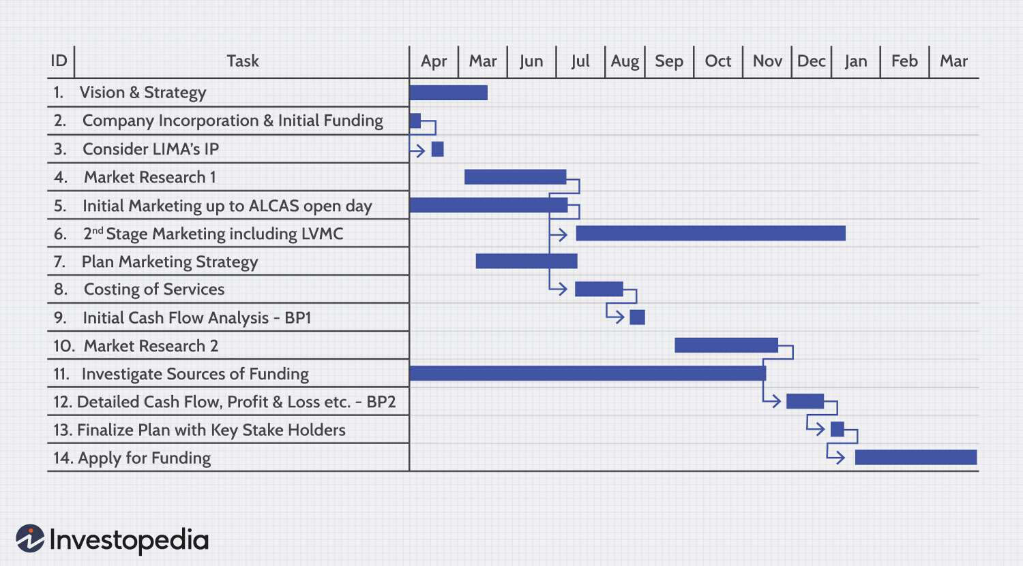

Appendix C: Turnitin Plagiarism Report

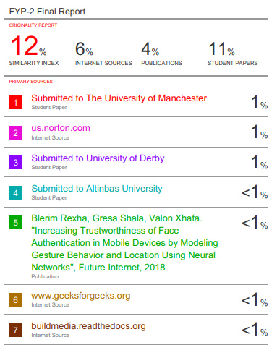

Appendix D: Software Requirement Specification

Contents
1. Introduction 3
2. General Description 3
3. Functional Requirements 4
4. Interface Requirements 5
4.1 User Interfaces 5
4.2 Hardware Interfaces 5
4.3 Communications Interfaces 5
4.4 Software Interfaces 5
5. Performance Requirements 5
6. Other non-functional attributes 6
6.1 Security 6
6.2 Binary Compatibility 6
6.3 Reliability 6
6.4 Maintainability 6
6.5 Portability 6
6.6 Extensibility 6
6.7 Reusability 6
6.8 Application Affinity/Compatibility 7
6.9 Resource Utilization 7
6.10 Serviceability 7
7. Operational Scenarios 7
8. Preliminary Use Case Models and Sequence Diagrams 8
8.1 Use Case Model 8
8.2 Sequence Diagrams 9

1. Introduction

  - Introduction
The purpose of this document is to define and describe the requirements of the project and to spell out the system’s functionality and its constraints.

  - Scope of this Document
The customer and the user for the system are the employees of the IDANRV, including Mrs. Sheila Roop, and the developers of the system is the Shock Force Software Team. Our constraints for this section includes our deadline for the document which is due 10/29/09

  - Overview
The product is an Access Database with import/export capabilities from Excel that will hold information on auctions, bid items and their bidders, including auction income, auction expenses, bid amount, bid increment, bid ID, item donor, item’s original value, payment type, bidder name, and bidder email.

  - Business Context
As it applies to this project, The Intellectual Disabilities Agency of the New River Valley is a non-profit organization that supports people struggling with intellectual disabilities through holding fundraisers and silent auctions to raise aid as well as awareness

2. General Description

2.1 Product Functions
The product should make input of data and the entire checkout process easier and streamlined for the users (employees) and time efficient for the bidder.

2.2 Similar System Information
The product is being developed with Access, so there are a large number of similar databases or systems and they are used for a wide array of different purposes. The possible strength our system has over the majority is the Excel import/export feature of the program.

2.3 User Characteristics
The users include the employees of the IDA as they input data on bids and their bidders. For this system, the user is required to know the basic usability of Excel as well as a very base level understanding of access, which hopefully will be facilitated by the software team through training.

2.4 User Problem Statement
The users system, currently, is slow and inefficient as it relates to the checkout process. Bidders must wait hours to check out the item they have won. Too many man hours have been needed to enter the wealth of information collected.

2.5 User Objectives
The user wants a database that will store information on a silent auction. The program must faciliatate the speed and ease of input. It also must store the items the IDANRV needs to store.

2.6 General Constraints
Constraints include an easy to use interface for the program through forms, a Windows platform or, at bare minimum, a Mac with Access and Excel for Mac installed. Also, it must be constructed in Access, Excel, or another related program that is easily learnable.

3. Functional Requirements
- Items provided to the IDANRV shall be stored in the Access Database.
  - Items shall be stored on the laptop machine and have complete fields.
  - Very high criticality
  - Limited network / wi-fi availability could present a technical challenge
  - The above stated factor is a risk we have encountered. Eliminate it by reducing the dependency of our program on these things.

- The items shall be accessible via queries and reports.
  - Users of the database should be able to run reports on the data that has been put into the database. They should also be able to run queries.
  - Very high criticality
  - We do not foresee any technical issues preventing the implementation of this.
  - Given the capabilities of Access, this requirement is able to be satisfied.
  - This requirement depends on requirement number one.

- The data stored should be able to be manipulated through forms.
  - Items and other data should be able to be added and updated through the use of forms.
  - Very high criticality
  - We do not foresee any technical risks involved in this requirement.
  - The only factor we can encounter here is the user of the system not being able to use it correctly. We will overcome this by training those who will be using it.
  - This requirement is dependent on requirement one.

4. Interface Requirements
4.1 User Interfaces
4.1.1 GUI
The user interface for this program is the interface provided by Microsoft Access 2007. Access includes forms and reports for the users to query and organize data to suit their needs. Forms and reports both have builders that let the user specify which fields they want to use and which constraints they want to define.
4.1.2 CLI
There is no command line interface
4.1.3 API
There is no API for the product
4.1.4 Diagnostics or ROM
There is a troubleshooting and help section provided by Microsoft

4.2 Hardware Interfaces
The program (Access) uses the hard disk. Access to the hard drive and other hardware is managed by the operating system and Access.

4.3 Communications Interfaces
If we decide to implement an Ad Hoc network for a shared database, the operating system will handle those connections.

4.4 Software Interfaces
The Access system may be used to import and export data with Microsoft Excel. This functionality is built in to the user interface.

5. Performance Requirements
The Performance Requirements section describes how well the system should perform under different conditions. These are non-functional requirements that define measurable performance criteria rather than system features.
- The system shall allow up to 300 concurrent users without noticeable degradation in performance.
- User login shall be completed within 3 seconds.
- Student record searches shall return results within 2 seconds.
- Report generation shall not exceed 10 seconds.
- The system shall process at least 100 requests per minute.
- Database backup shall be completed within 30 minutes.
- The system shall maintain 99.5% availability during working hours.
- Average CPU utilization shall remain below 70% under normal workload.
- The system shall recover from unexpected failures within 15 minutes.
- The application shall support future expansion to 10,000 registered students without significant performance degradation.

6. Other non-functional attributes
.

6.1 Security
The system shall be designed with a level of security appropriate for the sensitivity of information enclosed in the database. More interaction is needed with client about the volatility of the information. Since there is no obvious information that is of a high security level such as credit card information, the only requirements that could be implemented are encrypting the database and/or making the database password-protected, by user’s request.

6.2 Reliability
Reliability is one of the key attributes of the system. Back-ups will be made regularly so that restoration with minimal data loss is possible in the event of unforeseen events. The system will also be thoroughly tested by all team members to ensure reliability.

6.3 Maintainability
The system shall be maintained by Sheila Roop, of the IDA, or delegated to another employee.

6.5 Portability
The system shall be designed in a way that shall allow it to be run on multiple computers with Microsoft Office Professional 2007 or later installed.

6.6 Extensibility
The system shall be designed and documented in such a way that anybody with an understanding of Microsoft Access shall be able to extend the system to fit their needs with the team’s basic instructions.

6.7 Reusability
The system should be designed in a way that allows the database to be re-used regularly for the various silent auctions that the organization shall hold.

6.8 Application Compatibility
This system requires the Microsoft Office Professional 2007 suite or later, as it operates primarily through Microsoft Access, in conjunction with Microsoft Excel.

6.10 Serviceability
The maintenance of the system should be able to be sufficiently performed by any person with a basic understanding of Microsoft Access.

7. Operational Scenarios
Scenario A: Initial Item Definitions
The user shall enter the information about the items into the database for its initial construction and evolution. The fields will be completed via a form that will manipulate the data.

Scenario B: Customer Check-out
The user shall be able to enter information about the customer purchasing a particular item, and record their bid and other information. They will also enter the winning bid

Scenario C: Database Maintenance
The user may want to alter/delete information after the auction is over, In this case they will need to be able to remove the data that has been entered.

8. Preliminary Use Case Models and Sequence Diagrams
This section presents a list of the fundamental sequence diagrams and use cases that satisfy the system’s requirements. The purpose is to provide an alternative, "structural" view of the requirements stated above and how they might be satisfied in the system.
8.1 Use Case Model
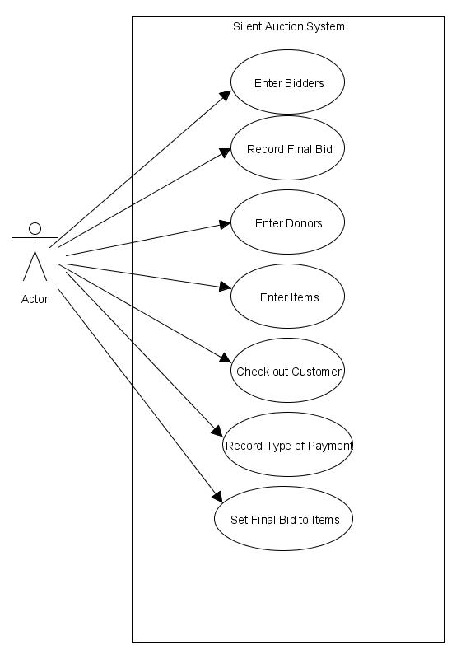

8.2 Sequence Diagrams