
BlogVault
An Online/Offline Blogging Client App Report

Name
xxx

Student ID
xxx

Course Title
BSc Computer Science

Module Name
Mobile Application Design and Development

Module Code
6CS057

Center Name
Strategy First University, Mandalay, Myanmar

Submission Date
14-08-2026

Word Count: 1356

Contents
1.Introduction 4
2. Development Overview 4
3. System Design & Diagrams 5
4. Project File Structure 7
5. Testing & Result 8
6. Development Challenges & Decisions 9
7.Conclusion 10
References 11

1.Introduction
BlogVault is an Android blogging client written in the offline-first paradigm for the Mobile Application Design and Development module. There are four main actions that can be performed on a blog post without requiring an internet connection: creating, editing, viewing and deleting posts.The application allows the user to perform these four operations without an Internet connection: create, edit, view, and delete a blog post. A post includes a title, a body of text, and possibly a photograph captured using in-app CameraX camera or selected from the gallery.
All records are stored in a local SQLite database, blogvault.db, so content remains after closing and reopening the app. The user wants to publish or send a post, BlogVault will make use of Android intents rather than a custom server. Share allows you to open the system share sheet, sending the post to either Messages, email or an app that supports it. Upload to Pinterest – opens the Pinterest app with the post image and caption via ACTION_SEND; no developer token is stored in the project. Multiple posts can be chosen, displayed as one collage image and posted to Pinterest in one click. The project thus showcases offline data management, media capture, Material Design user-interface work and integration with a public social platform.

2. Development Overview
It has been developed by using the following Android version tools: Android Studio version 2.3, Java 17, Gradle 8.7 and the Android Gradle Plugin 8.5.2. The minimum SDK version is API 24 (Android 7.0) and the target SDK version is API 34 (Android 14). Its interface is built with Material Components, ConstraintLayout, CoordinatorLayout, a teal and amber theme, a toolbar and card layouts.
Upload images using Glide 4.16. CameraX 1.3.4 is used for taking photos, so the Camera application does not open when taking photos. Local persistence is achieved using SQLiteOpenHelper in DatabaseHelper which is a singleton to support Write-Ahead Logging. MessageDao provides insert, update, delete, bulk delete, get by id and search. AppExecutors are used for database and file operations.diskIO(). The updates to the user-interface are posted only if the hosting Activity is alive, via UiSafe. Runtime camera and gallery permissions are requested from MessageEditActivity.
Files are exposed as a shared file, not as a public path. The client supports create, edit, view and delete (offline); search by title/body (background); gallery/attachments from camera; system sharing; upload to Pinterest (single post and multi select); delete (multi select). These functions correspond to the scope of a client for online/offline blogging that saves content on a local machine, and then uploads it to a social service. Pinterest should be pre-loaded on the demo device. Upon hardware failure of the emulator camera, the gallery attachment will be used.

3. System Design & Diagrams
The design has a simple layered structure of Android, which is easy to explain in a demonstration. The user interacts with five screens: MainActivity, the home screen; MessageEditActivity, Create and Edit screen; MessageDetailActivity, Post Detail screen; SearchActivity, Search screen; CameraCaptureActivity, In-app camera screen. The helpers attach themselves to RecyclerView, manipulate images, share them, and open Pinterest. The data layer maps BlogMessage objects to SQLite via MessageDao.
The use cases are presented in figure 3.1. Create and Edit can optionally add a gallery image or an in-app camera image and both have a save to SQLite option. Detail can be shared on social platforms or be uploaded to Pinterest. Multi-select delete and multi-select upload can be used to extend the home list. Figure 3.2 depicts the flow of operation for the app: open, load posts, select an action, write to database, return to list. The figure 3.3 illustrates the main classes and their dependencies including the Pinterest application as an external participant.

Use Case Diagram
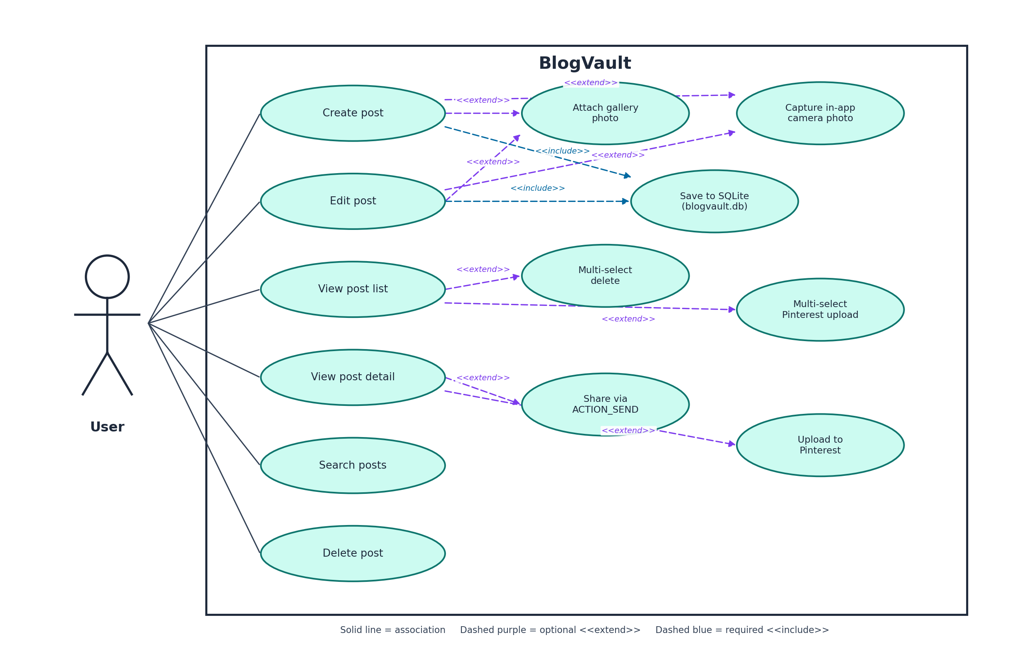
Figure 3.1 Use case diagram of BlogVault, showing CRUD, search, media, share, and Pinterest upload.
Flow Chart

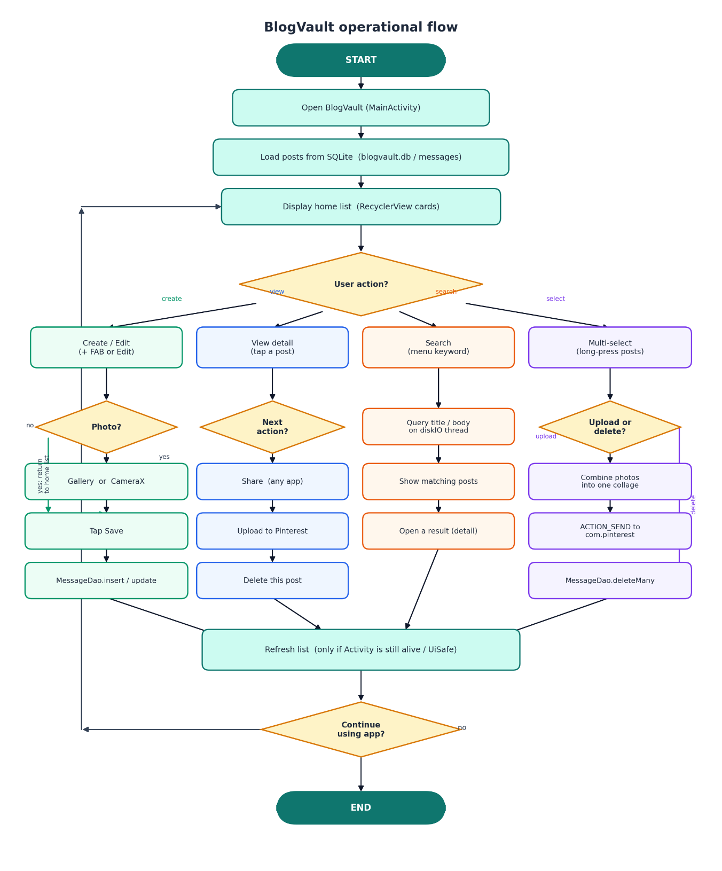
Figure 3.2 Operational flow of BlogVault from launch through save, search, share, multi-select, and Pinterest upload.
Class Diagram

Figure 3.3 Class diagram of BlogVault.

4. Project File Structure
The app's source code is located in app/src/main/java/com/blogvault/app. The package's root is called activities. MessageAdapter is included in the adapter package, which includes DiffUtil and Glide. BlogMessage is stored in the model package. DatabaseHelper and MessageDao are included in the package called "db". AppExecutors, ImageUtils, PinterestUploadHelper, ShareHelper and UiSafe are in the util package. Resources: Layouts, menus, colours, drawables are too small for res. The database file is only created at run time at /data/data/com.blogvault.app/databases/blogvault.db, and is analyzed using App Inspection, Database Inspector in Android Studio. This setup is summarised in Figure 5.1, along with the summary of the message table columns, the technology stack and the permissions that have been declared. In Figure 5.1, you can see the project packages, SQLite schema, technology stack, and runtime permissions.

Figure 4.1 Project packages

5. Testing & Result
Manual functional testing done on emulator and physical device depending on the camera behaviour or Pinterest behaviour. All marking related operations were verified against a desired outcome. The key cases that were used for the preparation of the demonstration are documented in the table below.
ID | Function | Steps | Expected | Actual | Status
T01 | Create post | Tap +, enter title/body, Save | Post appears in the home list | Saved to SQLite | Pass
T02 | Edit post | Open detail, Edit, change text, Save | Updated content shown | Updated correctly | Pass
T03 | Search | Open search, type a keyword | Only matching title/body shown | Background search works | Pass
T04 | Delete one post | Detail menu → Delete | Post removed from list and DB | Deleted | Pass
T05 | Multi-select delete | Long-press, select several, Delete | Selected posts removed | Bulk delete works | Pass
T06 | Gallery photo | Edit → Gallery → pick image → Save | Image shown and path stored | Works | Pass
T07 | In-app camera | Edit → Camera → shutter → Save | Photo stored in app files | Works on device | Pass
T08 | Share | Detail → Share | System share sheet opens | ACTION_SEND works | Pass
T09 | Pinterest upload | Detail → Upload to Pinterest | Pinterest opens with image and caption | Works if app installed | Pass
T10 | Multi-select upload | Select several → Upload to Pinterest | One collage, Pinterest opens once | Collage then ACTION_SEND | Pass
T11 | Persistence | Create posts, force-stop, reopen | Posts still listed | blogvault.db retains rows | Pass
T12 | No-photo upload | Upload a text-only post | Rendered JPEG sent to Pinterest | Text-to-image works | Pass

The results verify that BlogVault behaves exactly as expected in regards to create, edit, view, search and delete operations. Galley and in-app camera attachment are available if hardware and permissions exist. To open the system sheet, click on Share. When the Pinterest app is installed, Pinterest upload will open the app with the image and the caption. Multi select upload creates one collage and open pinterest only once. Restarting the application and verifying rows in Database Inspector was used to test for persistence. Be sure to add live screenshots of this demonstration next to this table in the final Canvas pack.

6. Development Challenges & Decisions
The final design was influenced by a number of practical considerations. Unlike the system Camera app, the camera preview on emulator hardware is not always reliable – if it ever is, and BlogVault is unable to display it in the preview window, BlogVault will use CameraX to take photos in BlogVault. In the absence of a strong emulator, Gallery is the backup. Moreover, the permissions are different based on the API level of the mobile OS: READ_MEDIA_IMAGES for API >= 13 and READ_EXTERNAL_STORAGE for API < 13, so MessageEditActivity requests the proper permission. In this project, Pinterest does not need an API token. Early cloud options, which required client IDs and/or OAuth were found to be brittle for a short viva. ACTION_SEND will open the user's own Pinterest account with the image and text.
A multi-select upload was previously unsupported due to some of the images in the set not being able to be sent as a single-stream share. The solution is to create a collage of selected images in ImageUtils, and send that single image. Any posts without an image will be converted to a JPEG by its title and text, which means Pinterest always gets a picture. Uses FileProvider instead of a raw filesystem path to prevent FileUriExposedException on modern Android. AppExecutors ensure that database operations are not performed on the main thread and UiSafe's release guards against updates after a Activity is destroyed. Multi select state is stored in the MessageAdapter as a collection of identifiers and a list refresh does not remove the selection. These decisions were made with the understanding that a reliable proof of offline storage, media, sharing and social upload were to be delivered in a limited time.
7.Conclusion
BlogVault is an offline-first Android blogging client that features SQLite persistence, in-app camera and gallery attachments, keyword search, single and group delete and Android sharing with online publishing via Pinterest upload. The architecture maintains user-interface code, helpers and data access layers separately, making the application easier to test and explain. The project can be completed for the module requirement for an online/offline blogging or social client and is ready for demonstration, documentation and submission. Later work might include categories or a flag to mark drafts vs published content, or adding optional cloud sync, but what is specified here is offline CRUD, media content sharing, content sharing for intents, and success outcomes for public-platform uploads.

References
Android Developers, ‘CameraX overview’. Available at: https://developer.android.com/camerax (Accessed: 14 August 2026).
Android Developers, ‘Sending simple data to other apps’. Available at: https://developer.android.com/training/sharing/send (Accessed: 14 August 2026).
Android Developers, ‘FileProvider’. Available at: https://developer.android.com/reference/androidx/core/content/FileProvider (Accessed: 14 August 2026).
Android Developers, ‘Intents and intent filters’. Available at: https://developer.android.com/guide/components/intents-filters (Accessed: 14 August 2026).
Material Design for Android. Available at: https://m3.material.io/develop/android (Accessed: 14 August 2026).
Bumptech, ‘Glide’. Available at: https://github.com/bumptech/glide (Accessed: 14 August 2026).
Pinterest, Pinterest Android application (opened via ACTION_SEND / com.pinterest). Available at: https://www.pinterest.com (Accessed: 14 August 2026).

