
BlogVault
An Online/Offline Blogging Client App Report

Name
xxx

Student ID
xxx

Course Title
BSc Computer Science

Module Name
Mobile Application Design and Development

Module Code
6CS057

Center Name
Strategy First University, Mandalay, Myanmar

Submission Date
14-08-2026

Word Count: 1122

Table of Contents
1.Introduction 3
2. Development Overview 3
3. System Design & Diagrams 4
4. Project File Structure 6
5. Testing & Result 7
6. Development Challenges & Decisions 13
7.Conclusion 22
8. References 23

Table of Contents
1. Introduction
2. Development Overview
3. System Design & Diagrams
Figure 4.1 Use Case Diagram
Figure 4.2 Flow Chart
Figure 4.3 Class Diagram
4. Project File Structure
Figure 5.1 Project structure, schema, stack, and permissions
5. Testing & Result
6. Development Challenges & Decisions
7. Conclusion
8. References

1.Introduction
BlogVault is an offline-first Android blogging client developed for the Mobile Application Design and Development module. The application lets a user create, edit, view, delete, and search blog posts entirely on the device, with no internet required for those core actions. A post can contain a title, body text, and an optional photograph taken with the in-app CameraX camera or chosen from the gallery. Every record is written to a local SQLite database named blogvault.db, so content is still present after the application is closed and opened again.
When the user wants to publish or send a post, BlogVault uses Android intents instead of a custom server. Share opens the system share sheet so the post can go to Messages, email, or any compatible app. Upload to Pinterest opens the official Pinterest application with the post image and caption through ACTION_SEND; no developer token is stored in the project. Several posts can be selected together, combined into one collage image, and sent to Pinterest in a single launch. The project therefore demonstrates offline data management, media capture, Material Design user-interface work, and integration with a public social platform.

2. Development Overview
The application was built in Android Studio using Java 17, Gradle 8.7, and Android Gradle Plugin 8.5.2. The minimum SDK is API 24 (Android 7.0) and the target SDK is API 34 (Android 14). The interface uses Material Components, ConstraintLayout, and CoordinatorLayout, with a teal and amber theme, card layouts, and a toolbar. Images are loaded with Glide 4.16. Photography is handled inside CameraCaptureActivity with CameraX 1.3.4, so the system Camera application does not need to open.
Local persistence is implemented with SQLiteOpenHelper in DatabaseHelper, which is a singleton and enables Write-Ahead Logging. MessageDao performs insert, update, delete, bulk delete, get-by-id, and search. Database and file work runs on AppExecutors.diskIO(). User-interface updates are posted only when the hosting Activity is still alive, using UiSafe. Runtime camera and gallery permissions are requested from MessageEditActivity. Shared files are exposed with FileProvider rather than a public path.
The client supports offline create, edit, view, and delete; search by title or body on a background thread; gallery and in-app camera attachments; system sharing; single-post and multi-select upload to Pinterest; and multi-select delete. These functions match the brief for an online/offline blogging client that stores content locally and can publish it to a social platform. Pinterest must be installed on the demonstration device. If emulator camera hardware fails, gallery attachment is used instead.

3. System Design & Diagrams
The design uses a simple layered Android structure that is straightforward to explain in a demonstration. The user works with five screens: the home list (MainActivity), create and edit (MessageEditActivity), post detail (MessageDetailActivity), search (SearchActivity), and in-app camera (CameraCaptureActivity). Helpers bind the RecyclerView, process images, share content, and launch Pinterest. The data layer maps BlogMessage objects through MessageDao onto SQLite.
Figure 4.1 shows the use cases. Create and edit can optionally attach a gallery photo or an in-app camera photo, and both include a save to SQLite. View detail can be extended by share or Pinterest upload. The home list can be extended by multi-select delete and multi-select upload. Figure 4.2 shows the operational flow from opening the app, loading posts, choosing an action, writing to the database, and returning to the list. Figure 4.3 shows the real local SQLite class model: the messages table in blogvault.db, the BlogMessage entity that maps each column, DatabaseHelper which runs CREATE TABLE, and MessageDao which performs insert, update, delete, search, and bulk delete.

Use Case Diagram
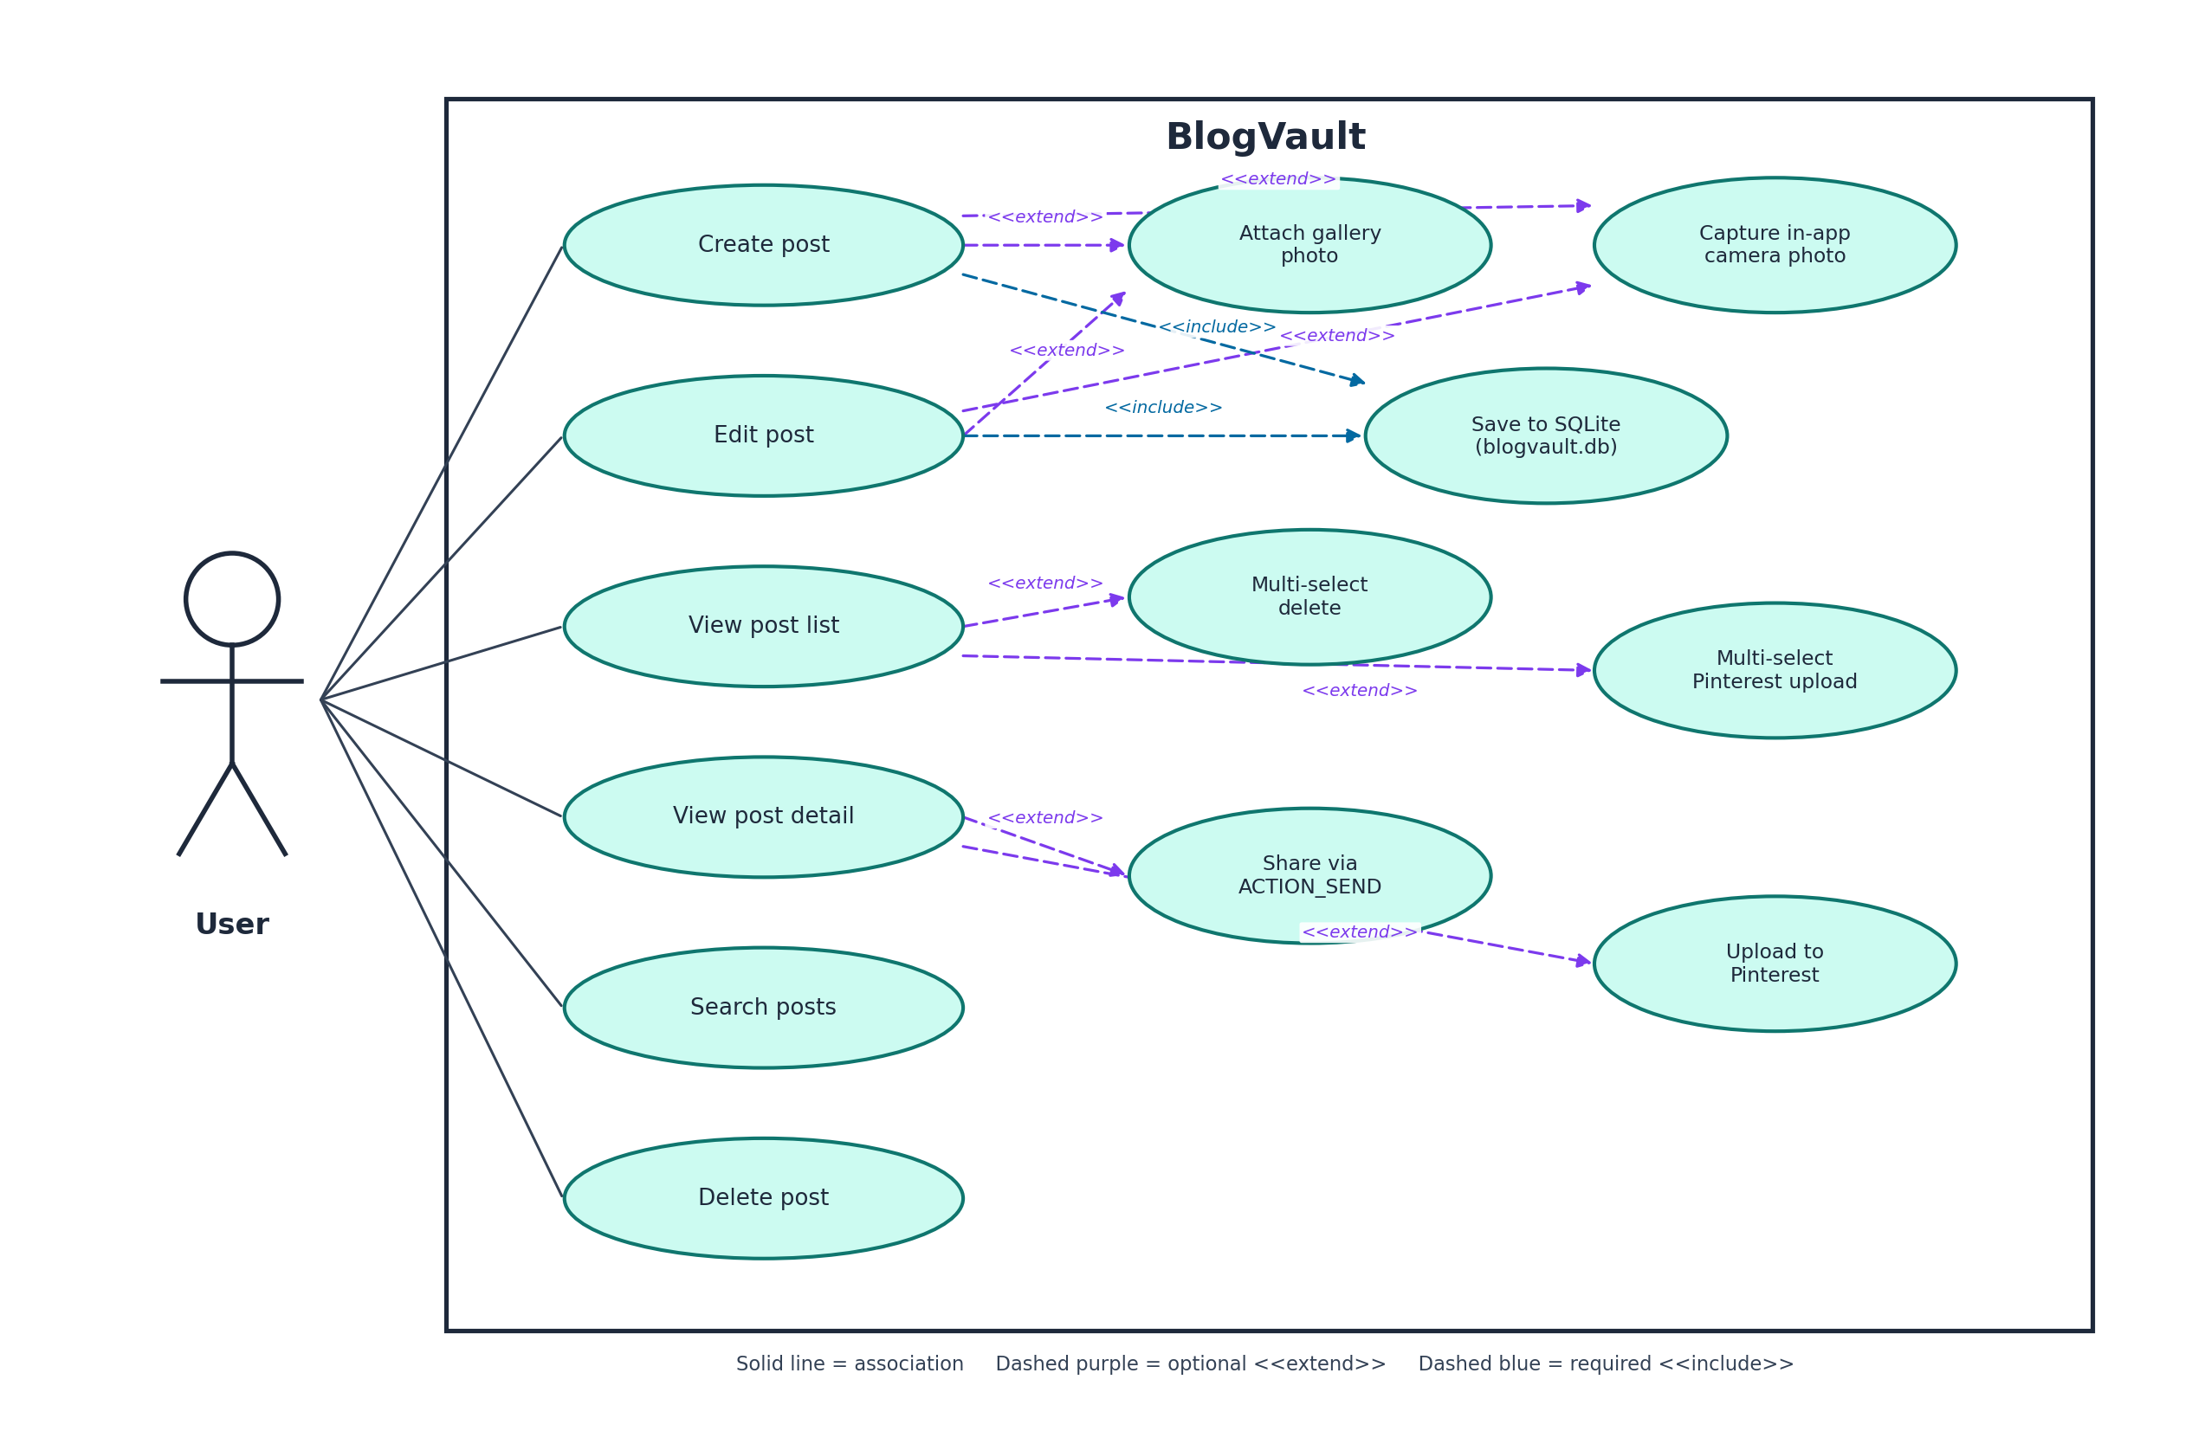
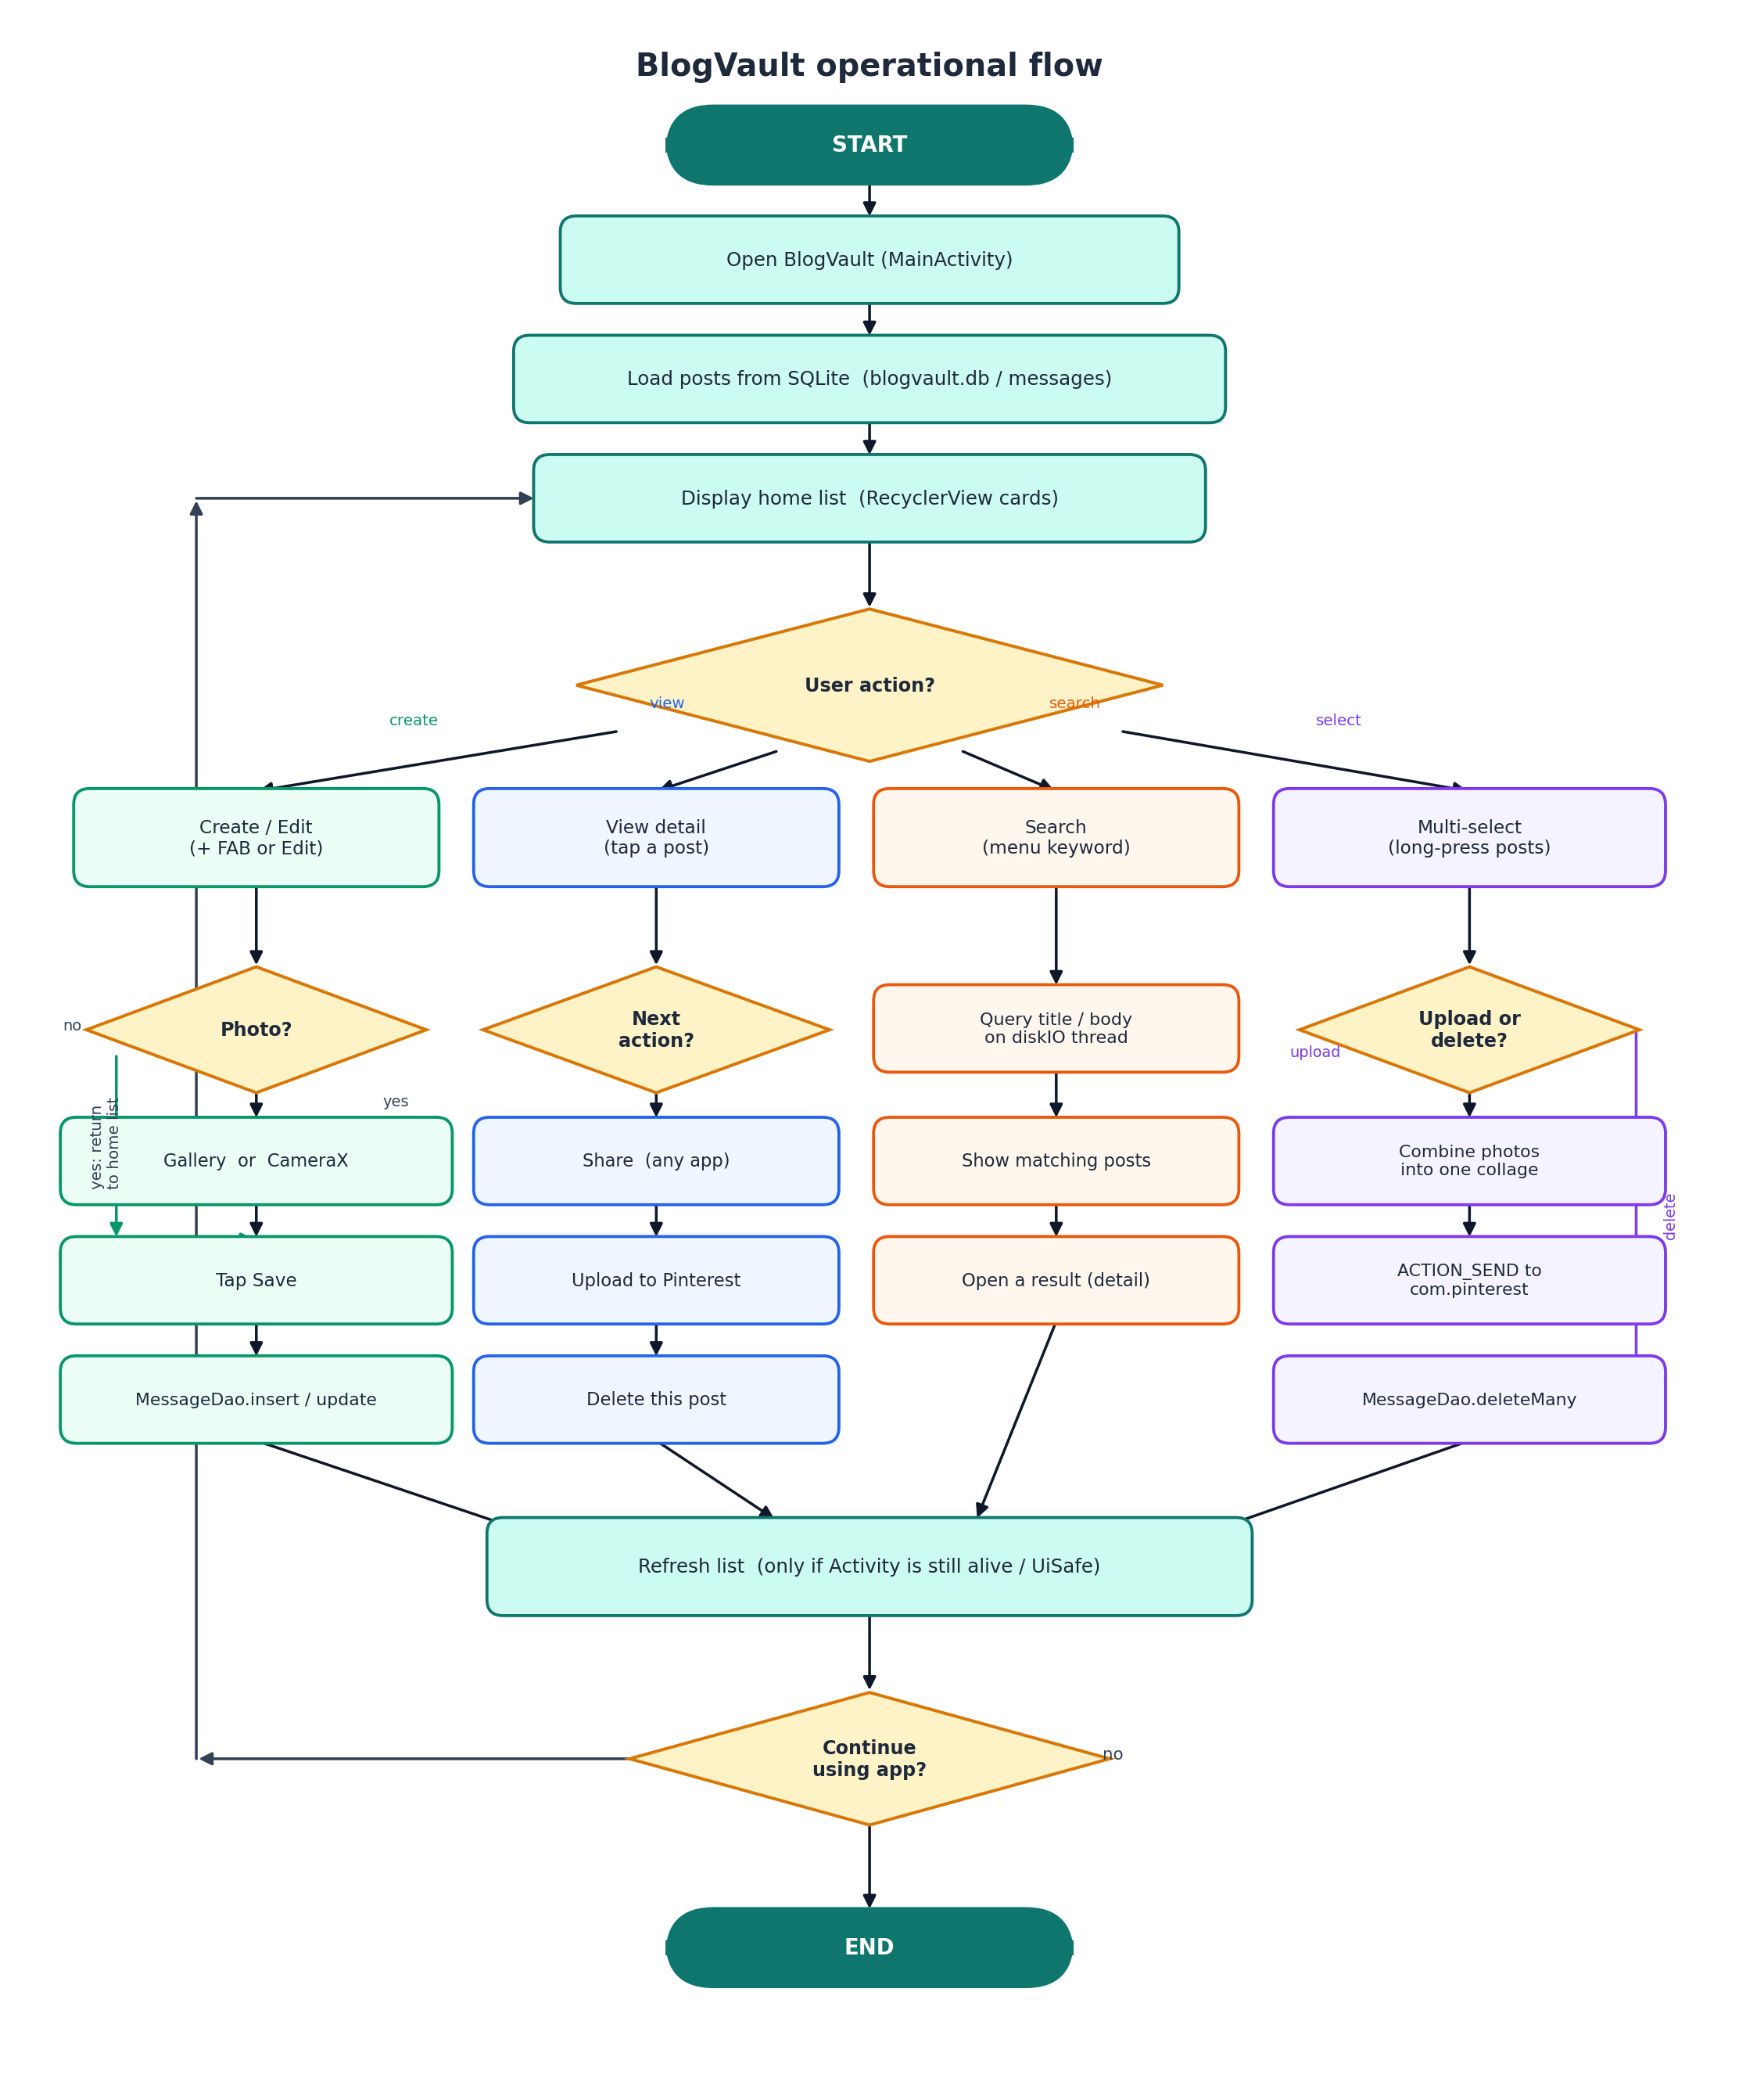
Figure 4.1 Use case diagram of BlogVault, showing CRUD, search, media, share, and Pinterest upload.

Flow Chart

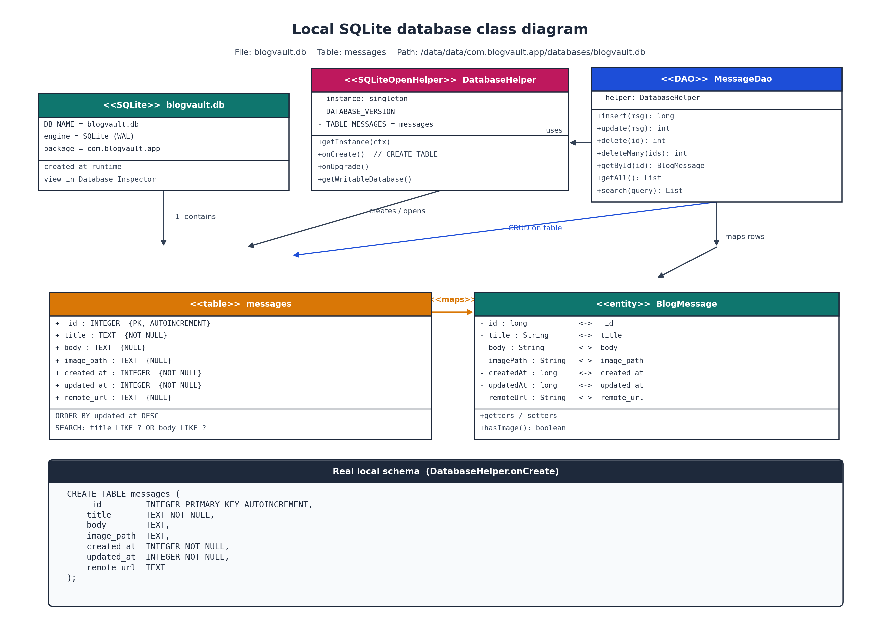
Figure 4.2 Operational flow of BlogVault from launch through save, search, share, multi-select, and Pinterest upload.

Class Diagram
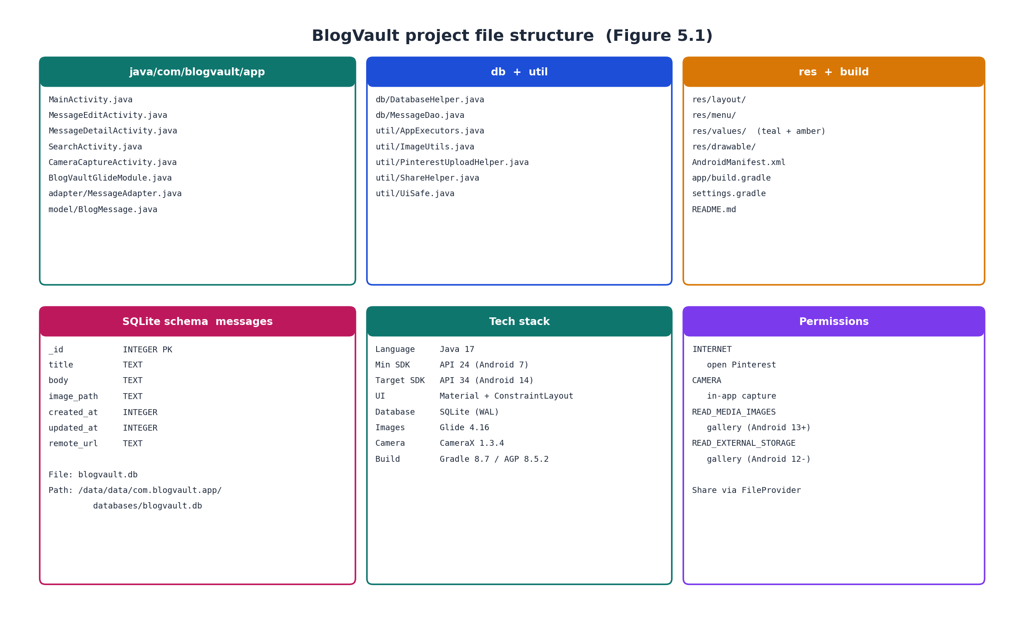
Figure 4.3 Class diagram of the local SQLite database: blogvault.db, table messages, DatabaseHelper, MessageDao, and BlogMessage.

4. Project File Structure
Source code lives under app/src/main/java/com/blogvault/app. Activities occupy the root of that package. The adapter package holds MessageAdapter, which uses DiffUtil and Glide. The model package holds BlogMessage. The db package holds DatabaseHelper and MessageDao. The util package holds AppExecutors, ImageUtils, PinterestUploadHelper, ShareHelper, and UiSafe. Layouts, menus, colours, and drawables are under res. The database file is created at runtime at /data/data/com.blogvault.app/databases/blogvault.db and is inspected in Android Studio with App Inspection, Database Inspector. Figure 5.1 summarises this layout, the messages table columns, the technology stack, and the declared permissions.
Figure 5.1 Project packages, SQLite schema, technology stack, and runtime permissions.

5. Testing & Result
Manual functional testing was carried out on an emulator and, where camera or Pinterest behaviour mattered, on a physical device. Each marking-related function was checked against the expected result. The table below records the main cases used while preparing the demonstration.
ID | Function | Steps | Expected | Actual | Status
T01 | Create post | Tap +, enter title/body, Save | Post appears in the home list | Saved to SQLite | Pass
T02 | Edit post | Open detail, Edit, change text, Save | Updated content shown | Updated correctly | Pass
T03 | Search | Open search, type a keyword | Only matching title/body shown | Background search works | Pass
T04 | Delete one post | Detail menu → Delete | Post removed from list and DB | Deleted | Pass
T05 | Multi-select delete | Long-press, select several, Delete | Selected posts removed | Bulk delete works | Pass
T06 | Gallery photo | Edit → Gallery → pick image → Save | Image shown and path stored | Works | Pass
T07 | In-app camera | Edit → Camera → shutter → Save | Photo stored in app files | Works on device | Pass
T08 | Share | Detail → Share | System share sheet opens | ACTION_SEND works | Pass
T09 | Pinterest upload | Detail → Upload to Pinterest | Pinterest opens with image and caption | Works if app installed | Pass
T10 | Multi-select upload | Select several → Upload to Pinterest | One collage, Pinterest opens once | Collage then ACTION_SEND | Pass
T11 | Persistence | Create posts, force-stop, reopen | Posts still listed | blogvault.db retains rows | Pass
T12 | No-photo upload | Upload a text-only post | Rendered JPEG sent to Pinterest | Text-to-image works | Pass
The results confirm that BlogVault meets the required offline create, edit, view, search, and delete behaviour. Gallery and in-app camera attachment work when hardware and permissions are available. Share opens the system sheet. Pinterest upload opens the Pinterest app with an image and caption when that app is installed. Multi-select upload builds one collage and launches Pinterest once. Persistence was checked by restarting the application and confirming rows in Database Inspector. Live screenshots from the demonstration should be attached beside this table in the final Canvas pack.

6. Development Challenges & Decisions

Several practical issues shaped the final design. Emulator camera hardware is unreliable and often shows a black preview, so BlogVault captures photos inside the app with CameraX instead of launching the system Camera app. Gallery remains the fallback on weak emulators. Gallery access also differs by API level: READ_MEDIA_IMAGES on Android 13 and above, and READ_EXTERNAL_STORAGE on earlier versions, so MessageEditActivity requests the correct permission.
Pinterest does not require an API token in this project. Early cloud options that need client IDs or OAuth were judged brittle for a short viva. ACTION_SEND targeted at com.pinterest opens the user's own Pinterest account with the image and text. Multi-select upload originally failed because several images could not be sent as a simple single-stream share. The fix is to combine selected photos into one collage in ImageUtils, then send that one image. Posts without a photo are rendered to a JPEG from their title and body so Pinterest always receives a picture.
Sharing uses FileProvider rather than a raw filesystem path, which avoids FileUriExposedException on modern Android. Database work is kept off the main thread through AppExecutors, and UiSafe prevents updates after an Activity is destroyed. Multi-select state is held as selected identifiers in MessageAdapter so a list refresh does not drop the selection. These decisions favoured a reliable demonstration of offline storage, media, sharing, and social upload within the time available.

7.Conclusion
BlogVault delivers an offline-first Android blogging client with SQLite persistence, in-app camera and gallery attachments, keyword search, single and group delete, Android sharing, and Pinterest upload for online publishing. The architecture keeps user-interface code, helpers, and data access in separate packages, which makes the application easier to test and explain. The project aligns with the module requirement for an online/offline blogging or social client and is ready for demonstration, documentation, and submission. Later work could add categories, a draft/published flag, or optional cloud synchronisation, but the current scope already covers the specified offline CRUD, media, intent sharing, and public-platform upload outcomes.

8. References
1. Android Developers, ‘Save data using SQLite’. Available at: https://developer.android.com/training/data-storage/sqlite (Accessed: 14 August 2026).
2. Android Developers, ‘CameraX overview’. Available at: https://developer.android.com/camerax (Accessed: 14 August 2026).
3. Android Developers, ‘Sending simple data to other apps’. Available at: https://developer.android.com/training/sharing/send (Accessed: 14 August 2026).
4. Android Developers, ‘FileProvider’. Available at: https://developer.android.com/reference/androidx/core/content/FileProvider (Accessed: 14 August 2026).
5. Android Developers, ‘Intents and intent filters’. Available at: https://developer.android.com/guide/components/intents-filters (Accessed: 14 August 2026).
6. Material Design for Android. Available at: https://m3.material.io/develop/android (Accessed: 14 August 2026).
7. Bumptech, ‘Glide’. Available at: https://github.com/bumptech/glide (Accessed: 14 August 2026).
8. Pinterest, Pinterest Android application (opened via ACTION_SEND / com.pinterest). Available at: https://www.pinterest.com (Accessed: 14 August 2026).

