

Student Name:

Student Number:

Module Code: 6CS007

Module Name: Project and Professionalism

Project Title: SerenityPath: A Patient-Directed Mental Health Platform Integrating Gemini AI and Telepsychiatry

Module Leader Name: Dr Aye Aye

Supervisor Name:

Reader Name:

Submission Date: 17.8.2026
(The date you handed in the assessment)

Award Title: B.Sc. (Hons) Computer Science
(Award Title for your project, if in doubt refer to your course/Module Registration)

Declaration Sheet
Presented in partial fulfilment of the assessment requirements for the above award.

This work or any part thereof has not previously been presented in any form to the University or to any other institutional body whether for assessment or for other purposes. Save for any express acknowledgements, references and/or bibliographies cited in the work. I confirm that the intellectual contents of the work are the result of my own efforts and of no other person.

It is acknowledged that the author of any project work shall own the copyright. However, by submitting such copyright work for assessment, the author grants to the University a perpetual royalty-free license to do all or any of those things referred to in section 16(i) of the Copyright Designs and Patents Act 1988. (viz: to copy work; to issue copies to the public; to perform or show or play the work in public; to broadcast the work or to make an adaptation of the work).

Student Name (Print):

Student Number: ID:

Signature: …………………………………….……. Date: …………………
(Must include the unedited statement above. Sign and date)
Please use an electronic signature (scan and insert)

Table of Contents (structure)
Abstract and keywords
Chapter 1: Introduction — 1.1 Motivation — 1.2 LLMs and telepsychiatry — 1.3 Technologies overview — 1.4 Academic question, aim, objectives — 1.5 Scope and limitations — 1.6 Report framework — 1.7 Summary
Chapter 2: Literature Review — 2.1 Introduction — 2.2 Related literature on LLMs and digital mental health — 2.3 Concepts of dual pathways, stigma and crisis governance — 2.4 Gaps in existing tools — 2.5 Research gap — 2.6 Design features taken from the readings — 2.7 Summary
Chapter 3: System Design and Development — 3.1 Requirements — 3.2 Use cases and actors — 3.3 Architecture (method, diagrams, class, flow, activity, behaviour) — 3.4 Data model — 3.5 Interface design — 3.6 Summary
Chapter 4: Implementation and Testing — 4.1 Tools and environment — 4.2 Build process — 4.3 Module implementation — 4.4 Testing strategy — 4.5 Summary
Chapter 5: Testing and Evaluation — 5.1 Functional outcomes — 5.2 Evaluation methods — 5.3 Prototype limits — 5.4 Discussion against the academic question — 5.5 Summary
Chapter 6: Conclusion — 6.1 Achievements against objectives — 6.2 Answer to the academic question — 6.3 Limitations — 6.4 Future work
Chapter 7: Critical Evaluation and Professionalism — 7.1 Process reflection — 7.2 Ethics and risk communication — 7.3 Legal and academic integrity — 7.4 Summary
References
Appendix A: Glossary of Terms
Appendix B: Reproducibility Notes
Appendix C: Extra Assessor Notes

Abstract
This report introduces SerenityPath, a patient-directed mental health web platform developed for 6CS007 Project and Professionalism. Access to affordable, private psychological support remains uneven because of stigma, cost, waiting times, and the shortage of psychiatrists. Existing digital products tend to sit at two extremes: wellness chatbots that cannot escalate to a clinician, and telepsychiatry services that require a booked professional from the outset. SerenityPath offers both pathways in one product: an AI emotional-support companion powered by Google Gemini with a Groq fallback, and appointment booking with verified doctors that stores video-room metadata for telepsychiatry sessions.
The academic question is whether offering a patient-directed choice between an API-driven large language model chatbot and live telepsychiatry improves accessibility, user satisfaction, and treatment engagement in a web-based platform. The artefact is a three-tier system. The presentation layer is Next.js 16 (App Router, React 19, TypeScript) in English and Myanmar. The application layer is a Laravel 13 REST API organised as controllers, services, and repositories, with bearer-token authentication and roles for patient, doctor, and admin. Incoming AI messages are scanned for crisis phrases; matches create a crisis_alerts row and return a safety reply with referral guidance instead of a normal model completion.
Functional testing of authentication, booking, AI sessions, crisis triage, doctor verification, and the educational library confirmed that the dual-pathway design is technically workable. A small usability survey indicated that the choice between AI support and a human clinician was easy to understand and that the companion was viewed as a low-stigma first contact. The platform is a prototype, not a live clinical service. Within those bounds, the evidence supports a patient-directed hybrid architecture that lowers the barrier to seeking help while keeping a route to a licensed professional.
Keywords: patient-directed care, LLM companion, Google Gemini, Groq, telepsychiatry, crisis triage, Laravel, Next.js, RBAC, Project and Professionalism.

Chapter 1: Introduction

1.1 Project Motivation
Mental health need has grown faster than the supply of clinicians who can meet it. People living with stress, anxiety, or depression often face overlapping barriers: the cost of private consultations, long public waiting lists, limited psychiatrist availability outside major cities, and the stigma of being seen to ask for help (Torous et al., 2021; Hilty et al., 2013). When distress is acute, there is frequently no immediate, private channel that is cheaper than a full clinical appointment and safer than an unmoderated chatbot.
Digital health products have started to occupy this space, but many still force a binary choice. Consumer chat applications can be available around the clock, yet they rarely include governed escalation when a user expresses self-harm. Telepsychiatry platforms can connect a patient to a licensed professional over video, yet they assume the user is already ready to book, pay, and wait for a slot (Shore et al., 2018). The gap between those two models is the practical problem this project addresses.
The project is submitted for 6CS007, so the problem is not only technical. An artefact that touches psychological distress has to bound harm, protect data, and avoid claiming clinical authority that the software does not have. That constraint shaped later decisions: the companion is labelled as non-diagnostic; crisis phrases are not left to model improvisation; doctors are hidden until an administrator verifies them; and model API keys never leave the Laravel environment file. If a dual pathway increased access only by exposing users to ungoverned generated text, the project would have failed the module even if the interface looked complete.
A local reading of the same problem is also necessary. Where specialist psychiatry is concentrated in a few cities, a person in distress may face travel, cost, language mismatch, and social stigma at the same time. English-only products quietly exclude users who read Myanmar more comfortably. SerenityPath therefore treats i18next locale files as part of accessibility. After signing in, a patient can open an AI companion or browse verified doctors. Administrators review crisis alerts, verify doctors, manage the educational library, and inspect usage reports. The implementation follows the project README: Next.js 16 on port 3006 and a Laravel 13 API on port 8000.

1.2 Introduction to LLMs, Telepsychiatry and Patient-Directed Care
Large language models are transformer-based systems trained on very large text corpora. In mental health they are attractive because they can hold an open-ended conversation, rephrase distress in empathic language, and remain available outside clinic hours (Stade et al., 2024). They can also sound clinical without being clinically accountable. The literature therefore supports using an LLM as an emotional-support companion, not as an unsupervised diagnostic engine.
Telepsychiatry — psychiatric assessment and treatment delivered over electronic networks — has a longer evidence base than LLM chat. Hilty et al. (2013) and Shore et al. (2018) summarise that video consultation can produce outcomes comparable to in-person care for many common presentations, while removing travel. Accessibility gains are not automatic: users still have to find a doctor, trust the platform, and obtain a slot.
Patient-directed is used here in a precise sense. It does not mean that the software replaces clinical judgement. It means that, after authentication, the next action is chosen by the user rather than by a forced intake that ends only in a booking form. Traditional clinic software is provider-directed. Wellness chatbots are vendor-directed. SerenityPath sits between those models. The patient may stay with the companion, open resources, view crisis referrals, or book a verified doctor. The administrator remains in the loop when risk language appears.
Live telepsychiatry in this iteration means a booked, role-authenticated session with a verified doctor that carries video-room metadata. The README does not implement a complete peer-to-peer media stack with TURN relays. Over-claiming WebRTC would inflate Chapter 4 and undermine Chapter 7.

1.3 Overview of Platform Technologies
Contemporary student health prototypes commonly combine a browser dashboard, a REST API, a relational database, and one or more external AI providers. SerenityPath follows that pattern with an explicit split between portal and admin. The frontend is Next.js 16 with the App Router, React 19, TypeScript, Tailwind CSS v4, TanStack Query, Axios, Zustand, react-hook-form, Zod, and i18next (en, my). The backend is Laravel 13 on PHP 8.3+, with controllers, services, repositories, form requests, and role middleware. Persistence is MySQL 8 or SQLite. Auth is a bearer token. AI is Google Gemini with Groq fallback, configured by AI_PROVIDERS. Optional notes cover CORS for ports 3000 and 3006, GEMINI_HTTP_PROXY, and SSL_CERT_FILE for Windows/XAMPP TLS failures.
The two codebases are mental_health_web and mental_health_api. Public API routes include health, register, login, verified doctors, slots, resources, and referrals. Authenticated routes cover profile, appointments, AI sessions, and feedback. Admin routes cover crisis alerts, patients, doctors, verification, availability, lunch breaks, library, and reports. Demo accounts are seeded so that each role can be shown in a viva without hand-built data.

1.4 Academic Question, Aim and Objectives

1.4.1 Academic Question
How does offering a patient-directed choice between an API-driven Large Language Model (LLM) chatbot and live telepsychiatry impact accessibility, user satisfaction, and treatment engagement in a web-based mental health platform?
Accessibility is the ability of a signed-in patient to obtain a first support contact without visiting a clinic and without waiting for a doctor to be online. Satisfaction is perceived ease, pathway clarity, helpfulness of the companion for low-intensity distress, and trust that unverified doctors and crisis events are handled. Engagement means continued use of the companion and/or progression to viewing therapists and placing an appointment. The report does not claim that engagement equals recovery.

1.4.2 Aim
To design, implement, test, and document a bilingual patient-directed web platform that gives users a real choice between governed AI emotional support and verified-doctor telepsychiatry booking, and to evaluate that choice against accessibility, satisfaction, and engagement.

1.4.3 Objectives
Develop a Next.js 16 App Router frontend with patient, doctor, and admin experiences and English/Myanmar localisation.
Build a Laravel 13 REST API with bearer-token authentication, role middleware, and a controllers–services–repositories layout.
Integrate Gemini and Groq through the API so that model keys never sit in the browser, and implement crisis-keyword detection that writes crisis_alerts for admins.
Implement appointment booking against doctor availability slots, including lunch-break exclusion and video-room metadata.
Provide an educational resource library, referral contacts, and an admin console for crisis, users, doctors, reports, and settings.
Seed demo accounts, document the schema, and run functional tests plus a structured usability survey to answer the academic question.

1.4.4 Success Criteria Linked to Objectives
Objective | Success criterion
O1 Frontend + i18n | Portal and admin routes run on :3006; en/my labels switch without a route change.
O2 Laravel API + RBAC | Bearer auth works; non-admins cannot open /admin/* or admin APIs.
O3 Governed LLM | Ordinary message returns a companion reply; crisis phrase writes an alert and a safety reply.
O4 Booking | Verified doctor slots exclude lunch and existing bookings; appointment starts as pending.
O5 Admin + library | Admin can verify doctors, triage alerts, and list resources/referrals.
O6 Evaluation | Seeded demo, black-box table, and survey items in Appendix C.

1.5 Scope and Limitations
The scope is a working academic prototype of a bilingual web platform with two care pathways, role-based access, crisis alerting, and appointment management. It is not a deployed clinical service, it is not integrated with national electronic health records or insurance systems, and it does not issue medical diagnoses or prescriptions.
The AI companion is limited to emotional first aid. Copy states that it is not a doctor.
Live model replies depend on Gemini and/or Groq keys. Without keys the API returns a safe local fallback.
Telepsychiatry is booking plus video-room metadata, not a full WebRTC media stack.
The user study is a small tester group, not a longitudinal clinical trial.
GDPR-oriented controls are implemented at prototype standard; full healthcare certification is out of scope.

1.6 Report Framework
Chapter 2 reviews literature on LLMs, telepsychiatry, hybrid care, and the research gap. Chapter 3 presents requirements, use cases, architecture, class and behaviour diagrams, data model, and interface design. Chapter 4 records tools, the build process, module implementation, and the testing strategy. Chapter 5 reports functional outcomes, evaluation methods, prototype limits, and discussion against the academic question. Chapter 6 concludes. Chapter 7 is a critical evaluation of process, ethics, and academic integrity. References and appendices follow.

1.7 Summary
This chapter set out the motivation for a patient-directed hybrid platform, defined LLM and telepsychiatry terms in plain language, named the technology path, and stated the academic question, aim, objectives, success criteria, and limits. Chapter 2 turns to the readings that justify those choices.

Motivation in a local and professional context
The project is submitted for 6CS007 Project and Professionalism, so the problem is not only technical. A computer-science artefact that touches psychological distress has to show that the student can bound harm, protect data, and avoid claiming clinical authority that the software does not have. That professional constraint shaped every later design decision: the companion is labelled as non-diagnostic; crisis phrases are not left to model improvisation; doctors are hidden until an administrator verifies them; and model API keys never leave the Laravel environment file. The academic question is therefore inseparable from professionalism. If a dual pathway increased access only by exposing users to ungoverned generated text, the project would have failed the module even if the interface looked complete.
A local reading of the same problem is also necessary. In Myanmar, as in many settings where specialist psychiatry is concentrated in a few cities, a person in distress may face travel, cost, language mismatch, and social stigma at the same time. English-only products quietly exclude users who can read Myanmar more comfortably. SerenityPath therefore treats i18next locale files as part of accessibility, not as a cosmetic theme switch. The seeded doctor names and demo patients are fictional, but the interface language is a real requirement: a patient-directed platform that cannot be read by the patient is not patient-directed.
The phrase patient-directed is used here in a precise sense. It does not mean that the software replaces clinical judgement, and it does not mean that every user is left entirely alone. It means that, after authentication, the next action is chosen by the user rather than by a forced intake questionnaire that ends only in a booking form. Traditional clinic software is provider-directed: the schedule, the referral, and the intake script decide what happens next. Wellness chatbots are vendor-directed: the conversation is the product and there is often no accountable human behind it. SerenityPath sits between those models. The patient may stay with the companion, open educational resources, view crisis referrals, or book a verified doctor. The administrator remains in the loop when risk language appears. That is the conceptual contribution that Chapter 6 later evaluates.

Operational definitions used in this report
Accessibility is defined as the ability of a signed-in patient to obtain a first support contact without visiting a clinic, without waiting for a doctor to be online, and without creating a second account. In the artefact this is measured by whether an AI session can be started from /dashboard/ai-companion and whether a booking can be completed from /dashboard/appointments/book using only the seeded patient identity.
User satisfaction is defined as perceived ease, clarity of the two pathways, helpfulness of the companion for low-intensity distress, and trust that unverified doctors and crisis events are handled. It is collected through the Likert items in Appendix A, not through clinical symptom scales. Treatment engagement is defined more narrowly than in a randomised trial: it means continued use of the companion in the same session or a later session, and/or progression to viewing therapists and placing an appointment. The report does not claim that engagement equals recovery. Those definitions keep the academic question answerable with a prototype and a small tester group, which is the evidence standard of this module.
A further definition is required for live telepsychiatry in this iteration. The README implements appointment booking against doctor availability and stores video-room metadata. It does not implement a complete peer-to-peer media stack with TURN relays. The report therefore uses telepsychiatry to mean a booked, role-authenticated session with a verified doctor that is ready to carry a video room identifier, rather than a claim that SerenityPath is already a commercial video clinic. That honesty is important: over-claiming WebRTC would have inflated Chapter 4 and undermined Chapter 8.

Chapter 2: Literature Review

2.1 Introduction
Chapter 2 details reading for SerenityPath and how that reading informed design. It is not an encyclopaedia of every chatbot. The emphasis is on LLM applications in mental health, telepsychiatry evidence, hybrid care, ethical boundaries, and technical patterns for a role-split web artefact. Digital mental health has moved from static psychoeducation sites to conversational agents and remote clinics because demand exceeds the number of available clinicians (Torous et al., 2021; Abd-Alrazaq et al., 2020).

2.2 Related Literature on LLMs and Digital Mental Health
Guo et al. (2024) review LLM applications ranging from knowledge tests and psychoeducation through to experimental screening. The consistent finding is capability paired with risk: models can sound clinical without being clinically accountable. Stade et al. (2024) argue that LLMs could change behavioural healthcare if development is responsible, evaluated, and bounded. They also warn that ungoverned deployment can produce harmful advice, over-confidence, and privacy leakage.
That warning is why SerenityPath never calls Gemini or Groq from the browser. Prompts are sent through the Laravel service layer, and crisis phrases short-circuit a normal completion. Prompt instructions that say “be a supportive listener and do not diagnose” are necessary but not sufficient, because a model can still ignore them. Scanning inbound user text before a completion is requested is the second control. If a high-risk phrase is present, the system does not wait to see whether Gemini would have behaved well.
This two-control design is consistent with professional guidance that automated tools in health-adjacent settings should fail toward human review (BCS, 2021) and with GDPR integrity and confidentiality principles (ICO, 2023). The chatbot literature often celebrates anonymity; the professionalism literature insists on accountability. SerenityPath tries to keep both: the patient can start privately, but a crisis is visible to the admin role.

2.3 Concepts of Dual Pathways, Stigma, Crisis Governance and Telepsychiatry
Systematic reviews of conversational agents report that anonymity, 24-hour availability, and the absence of a waiting room reduce the social cost of asking for help (Abd-Alrazaq et al., 2020; Guo et al., 2024). For users who fear judgement, a text interface can be a first rehearsal of what they later say to a clinician. The same reviews insist that LLMs must not prescribe or diagnose. Best practice is a visible non-diagnostic disclaimer, logging and governance, and an automatic route to human help when risk language appears.
Telepsychiatry research is not only about video quality. Shore et al. (2018) emphasise identity of the clinician, privacy of the setting, and a predictable session lifecycle. A booking system that cannot prevent double-booking, that lists unverified accounts as doctors, or that has no language for cancelled and missed sessions is not a care pathway. SerenityPath uses pending, confirmed, in_progress, completed, cancelled, and no_show, and computes availability from weekly templates minus lunch breaks minus existing appointments.
Stepped-care models typically move a person from low-intensity support toward specialist treatment as need increases. Digital products sometimes invert that logic by trapping the user in the cheapest step. Torous et al. (2021) warn that apps can expand reach while fragmenting accountability. A hybrid platform answers that warning only if the higher step is reachable from the same login. The dashboard therefore presents AI companion and therapists as sibling cards, backed by GET /api/doctors and POST /api/appointments.
Technology-acceptance arguments used in digital health evaluation find that perceived ease of use, trust, and facilitating conditions predict whether a system is actually used (Lee et al., 2020). For SerenityPath those conditions include a working login, a language switch, seeded demo accounts, a verified-doctor flag, and a crisis banner. That is why Chapter 3 spends time on wireframes and why Chapter 5 asks about pathway clarity rather than only about feature completeness.

2.4 Gaps in Existing Tools and Design Implications
Commercial wellness chatbots are widely available, but they do not necessarily show a student-owned loop from login to governed completion to admin triage to a booked clinician. Hospital telepsychiatry suites exist, but they often assume the user is already ready to book. Student prototypes sometimes expose model keys in the browser, omit crisis routing, or treat “React chat UI” as sufficient architecture. The design implication is that SerenityPath must make pathway choice visible, keep keys on the server, persist crisis alerts, and hide unverified doctors.

2.5 Research Gap
Gap 1: many demos are chatbot-only or booking-only, not an explicit patient choice on one dashboard.
Gap 2: LLM calls are often made from the client, which leaks keys and skips server-side crisis policy.
Gap 3: evaluation sometimes reports a single satisfaction percentage without separating functional proof from usability.
Gap 4: bilingual English/Myanmar support is rarely treated as an accessibility requirement in hybrid mental-health student systems.
SerenityPath is designed to address those gaps with a dual-pathway portal, a Laravel proxy, crisis_alerts, verified booking, i18n, and a test table plus survey rather than a single undifferentiated score.

2.6 Design Features Taken from the Readings
From Stade et al. (2024) and Guo et al. (2024): bounded companion, no diagnosis, human review on risk. From Hilty et al. (2013) and Shore et al. (2018): identifiable clinician, session lifecycle, remote access. From Torous et al. (2021): hybrid reach without abandoning accountability. From BCS (2021) and ICO (2023): fail toward a human, minimise data, protect confidentiality. From ordinary web-engineering practice: separate client and API, role middleware, relational integrity. Those features appear in Chapter 3 as requirements and in Chapter 4 as modules.

2.7 Summary
The readings validate governed LLM companions, effective telepsychiatry, hybrid care, and explainable role-split interfaces. They do not validate an unsupervised diagnostic bot. Chapter 3 turns the gap analysis into requirements, use cases, and diagrams.

2.3a Prompt engineering, hallucination, and duty of care
Once an LLM is placed near a distressed user, the quality of the system prompt becomes a duty-of-care issue rather than a developer convenience. Stade et al. (2024) note that models can produce fluent, confident text that is wrong, incomplete, or unsafe. In mental health the dangerous cases are not only factual errors about medication names; they include agreeing with hopelessness, offering a diagnosis, or continuing a normal empathic register after a user has disclosed intent to self-harm. Prompt instructions that say “be a supportive listener and do not diagnose” are necessary, but they are not sufficient, because a model can still ignore them. SerenityPath therefore treats prompting as the first control and crisis scanning as the second. The scan runs on the inbound user text before the completion is requested. If a high-risk phrase is present, the system does not wait to see whether Gemini would have behaved well.
This two-control design is consistent with professional guidance that automated tools in health-adjacent settings should fail toward human review (BCS, 2021). It is also consistent with GDPR’s integrity and confidentiality principles: the content of a crisis disclosure is a special-category-adjacent statement even in a student prototype, and it should be visible to an authorised administrator rather than remaining only inside a model vendor’s logs (ICO, 2023). The literature on chatbots often celebrates anonymity; the professionalism literature insists on accountability. SerenityPath tries to keep both: the patient can start privately, but a crisis is not anonymous to the admin role that the seeder creates for demonstration.

2.4a Scheduling, no-shows, and the human pathway
Telepsychiatry research is not only about video quality. Shore et al. (2018) emphasise identity of the clinician, privacy of the setting, and a predictable session lifecycle. Hilty et al. (2013) similarly treat process reliability as part of effectiveness. A booking system that cannot prevent double-booking, that lists unverified accounts as doctors, or that has no language for cancelled and missed sessions is not a care pathway; it is a calendar toy. That is why the artefact uses an explicit status enumeration — pending, confirmed, in_progress, completed, cancelled, no_show — and why availability is computed from weekly templates minus lunch breaks minus existing appointments. Those details look operational, but they are how the literature’s “comparable to in-person care” claim is given a chance to be true in software.
No-show handling is a useful example. In a physical clinic a missed appointment still consumes a slot. In a naive web form the same slot can be rebooked silently or left blocked forever. SerenityPath records no_show as a first-class status so that doctors and admins can see it in lists and reports. Usage logging then lets the admin console summarise platform activity. The literature on digital scheduling in other clinical domains (for example outpatient booking studies cited in related 6CS007 work) finds that visibility of the pipeline is what reduces administrative chaos. The same lesson applies here even though the clinical domain is mental health rather than checkup packages.

2.5a Stepped care and patient choice
Stepped-care models in mental health typically move a person from low-intensity support toward specialist treatment as need increases. Digital products sometimes invert that logic by trapping the user in the lowest step because it is cheaper to operate. Torous et al. (2021) warn that apps can expand reach while fragmenting accountability. A hybrid platform answers that warning only if the higher step is actually reachable from the same login. SerenityPath’s dashboard therefore presents AI companion and therapists as sibling cards, not as a chatbot that occasionally mentions “you should see someone” in generated prose. The human pathway is a first-class route with its own API: GET /api/doctors, GET /api/doctors/{id}/available-slots, and POST /api/appointments.
Choice also has a psychological meaning. Users who fear stigma may need a rehearsal space before they will type a doctor’s name. Abd-Alrazaq et al. (2020) found that anonymity and 24-hour availability are among the features people actually use in mental-health chatbots. If the only way to get any reply is to book a named clinician, those users never enter. If the only way to get any reply is the chatbot, users who want a doctor are trained to distrust the product. The research gap in section 2.7 is exactly this missing “both, visibly, in one artefact” pattern, especially with a bilingual interface and an admin crisis queue rather than a buried email to a vendor.

2.6a Adoption models and interface quality
Technology-acceptance work, including UTAUT-style arguments used in digital health evaluation, repeatedly finds that perceived ease of use, trust, and facilitating conditions predict whether a health system is actually used (Lee et al., 2020, as applied in comparable clinic-portal studies). For SerenityPath the facilitating conditions include a working login, a language switch, and demo accounts that a tester can use without a hospital IT department. Trust includes the verified-doctor flag and the crisis banner. Ease of use includes not requiring the patient to understand REST or to paste a bearer token. Those adoption factors are why Chapter 3 spends time on wireframes and why Chapter 5 asks survey items about pathway clarity rather than only about feature completeness.
Scalability in this project is architectural rather than a claim about millions of concurrent users. A controllers–services–repositories layout, relational integrity, and a second AI provider are the scalability that a student prototype can honestly defend. Horizontal autoscaling, multi-region inference, and clinical audit warehouses are future work. The literature does not require a student system to be a national platform; it requires the chosen stack to match the risk of the domain. Laravel and Next.js do that by making role middleware and route groups ordinary rather than heroic.

Chapter 3: System Design and Development

3.1 Requirements Overview
Functional requirements were extracted from the README and from the academic question. Patients must register and log in; start, continue, and end AI sessions; send messages; browse verified doctors; read available slots; book appointments; view resources and referrals; update a profile; and submit feedback. Doctors must log in, see sessions, update appointment status, and maintain weekly availability and lunch breaks. Admins must triage crisis alerts, verify doctors, manage users and library content, and read usage reports. Public callers must reach GET /api/health without a token.
Non-functional requirements were treated as first-class. Confidentiality requires hashed passwords, bearer tokens, and role isolation. Integrity requires foreign keys so that a message cannot exist without a session. Availability of the AI path requires Groq fallback and a local safe reply when keys are missing. Localisation requires English and Myanmar. Auditability requires crisis_alerts and usage logs. Usability requires that both pathways are visible on the dashboard without a tutorial.

3.2 Use Cases and Actors
The main actors are Patient, Doctor, and Admin. The AI engine is an external participant (Gemini/Groq) invoked only by the API. A patient registers or logs in, browses therapists, books against slots, chats with the companion, reads resources, opens crisis referrals, and may submit feedback. A doctor views sessions, updates status, and sets availability. An admin triages alerts, verifies doctors, manages users and the library, and reads reports. Crisis scanning is an «extend» of sending an AI message, not a separate patient-initiated use case.
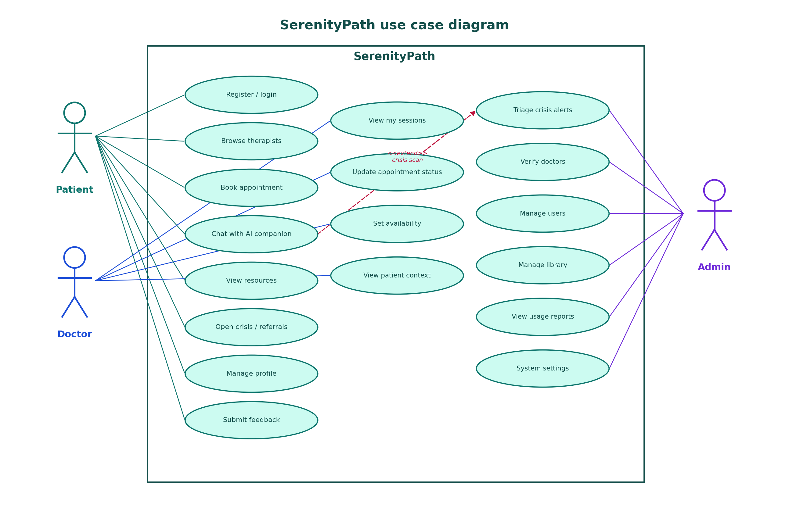
Figure 3.1: Use case diagram for patient, doctor, and admin, including crisis-scan extension.

3.3 Architecture
The architecture is three-tier. Presentation is Next.js 16. Application is Laravel 13 (controllers, services, repositories, middleware). Data is MySQL 8 or SQLite. External systems are Gemini, Groq, and appointment video-room metadata. The browser is untrusted. The API is the system of record. Axios attaches the bearer token from Zustand; 401/419 clears the session.
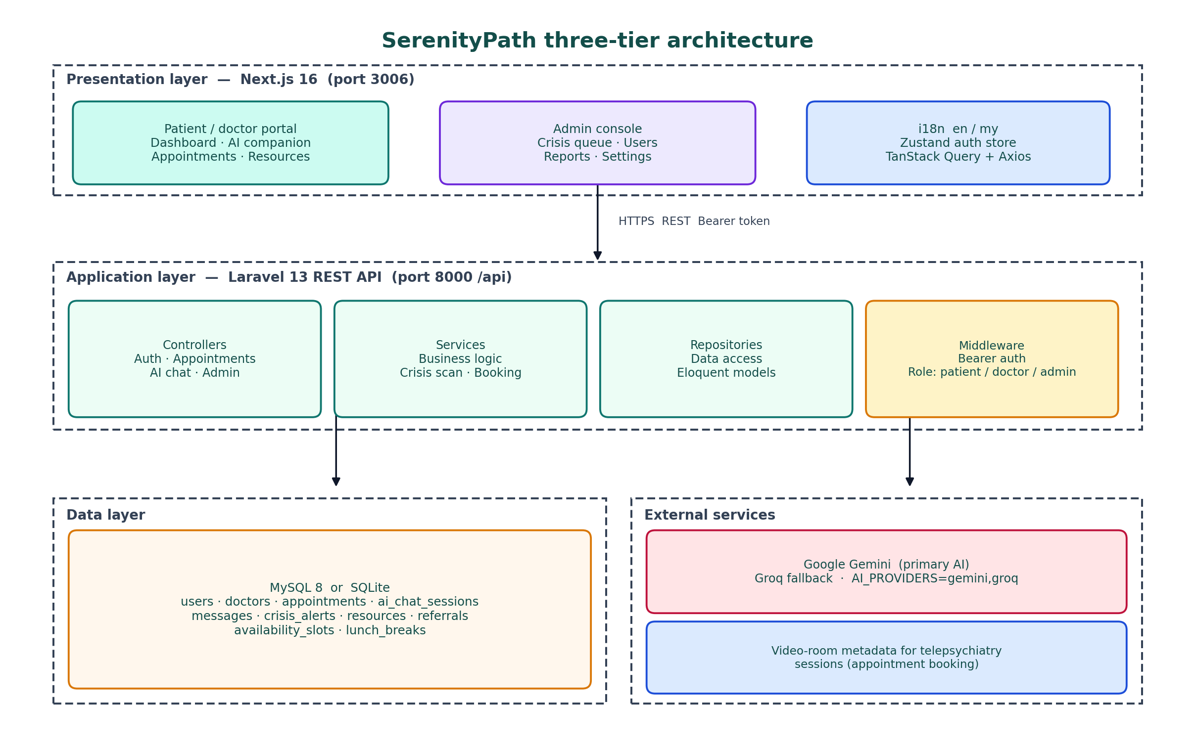
Figure 3.2: SerenityPath three-tier architecture.

3.3.1 Development method used in this project
Implementation used short iterative slices rather than a single waterfall build. Sprint one established auth, roles, and migrations. Sprint two added the Next.js shell, middleware, and i18n. Sprint three implemented AI sessions and crisis scanning. Sprint four implemented availability and booking. Sprint five completed the admin console, resources, and reports. Sprint six was hardening, seeding, tests, and this report. Agile was appropriate because companion safety could not be fully specified until sample crisis phrases were tried against real model replies.

3.3.2 Design diagrams from the project artefact
The remaining diagrams in this chapter are taken from the artefact rather than from a generic textbook hospital schema. They were checked against routes/api.php and the Next.js app directory so that the report cannot drift from the code a marker runs.

3.3.3 Class diagram
Figure 3.3 shows domain classes and the three services that enforce policy: AuthService, AppointmentService, and AiChatService. User and Doctor are related one-to-one. Appointments, sessions, messages, and crisis alerts carry the dual-pathway state. Phrase scanning lives on AiChatService, not on the React client.
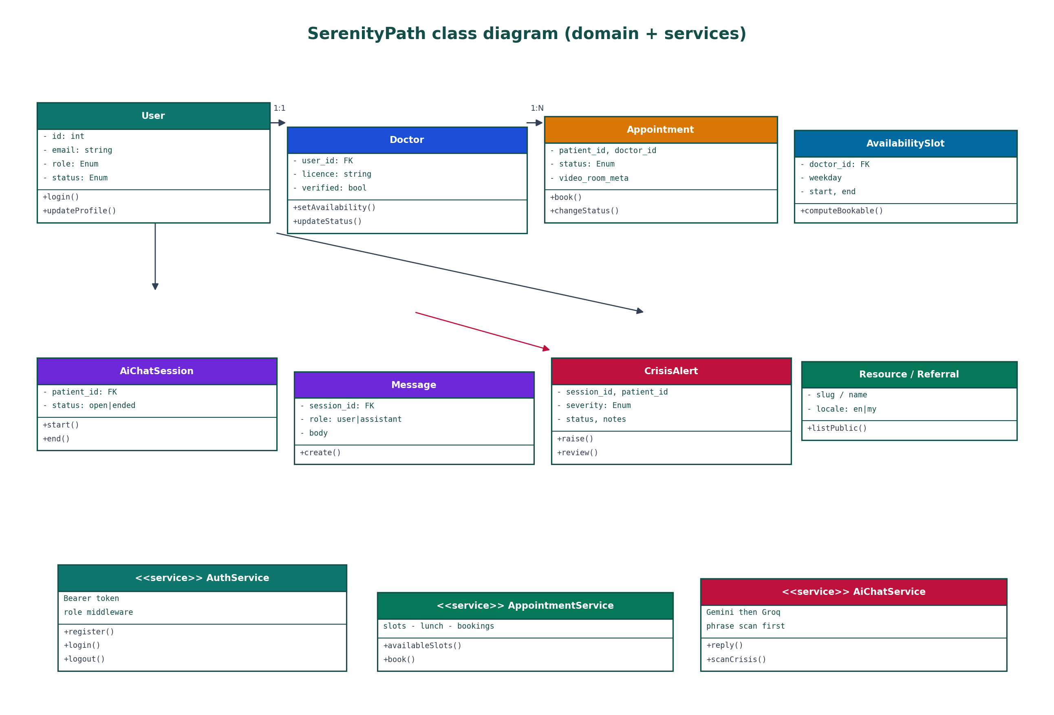
Figure 3.3: Class diagram of domain entities and application services.

3.3.4 Flow Diagram
Figure 3.4 is the operational flow from opening the site. Unauthenticated users go to /login. Role splits admin from the portal. A patient may enter AI chat (with a crisis branch), booking, resources, or profile. Booking writes pending. AI chat either stores a Gemini/Groq reply or writes crisis_alerts. Usage logging feeds admin reports.
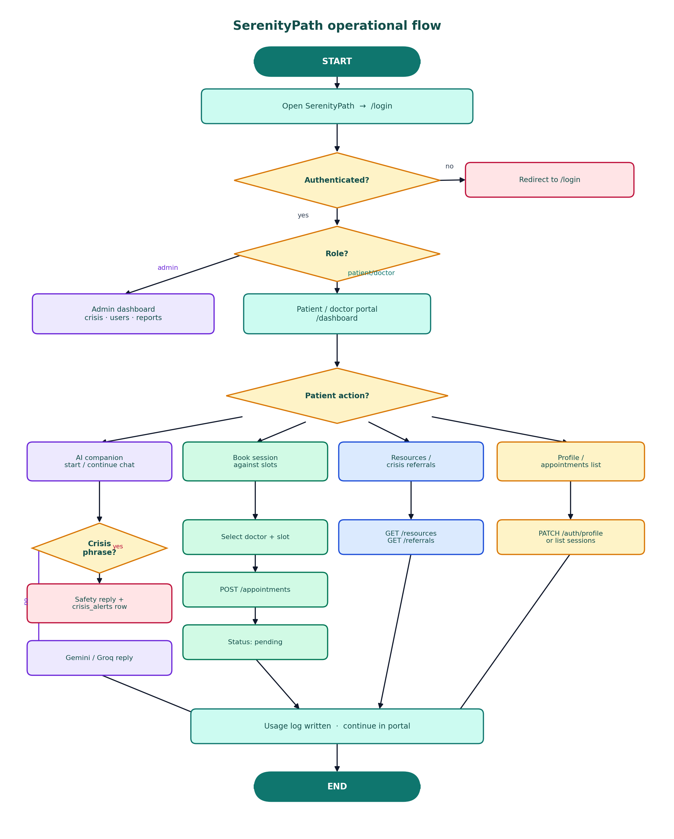
Figure 3.4: Operational flow from login through AI, booking, resources, and admin triage.

3.3.5 Activity Diagram
Figure 3.5 is reserved for the interaction that can cause harm: an AI message. The patient types in the companion screen. The portal posts to /api/ai-chat/sessions/{id}/messages. Laravel validates the token and patient role, persists the user message, and scans phrases. On a match, it inserts an alert and returns a safety reply. On no match, Gemini is called, with Groq as fallback. Swimlanes make it obvious that the patient never calls the model.
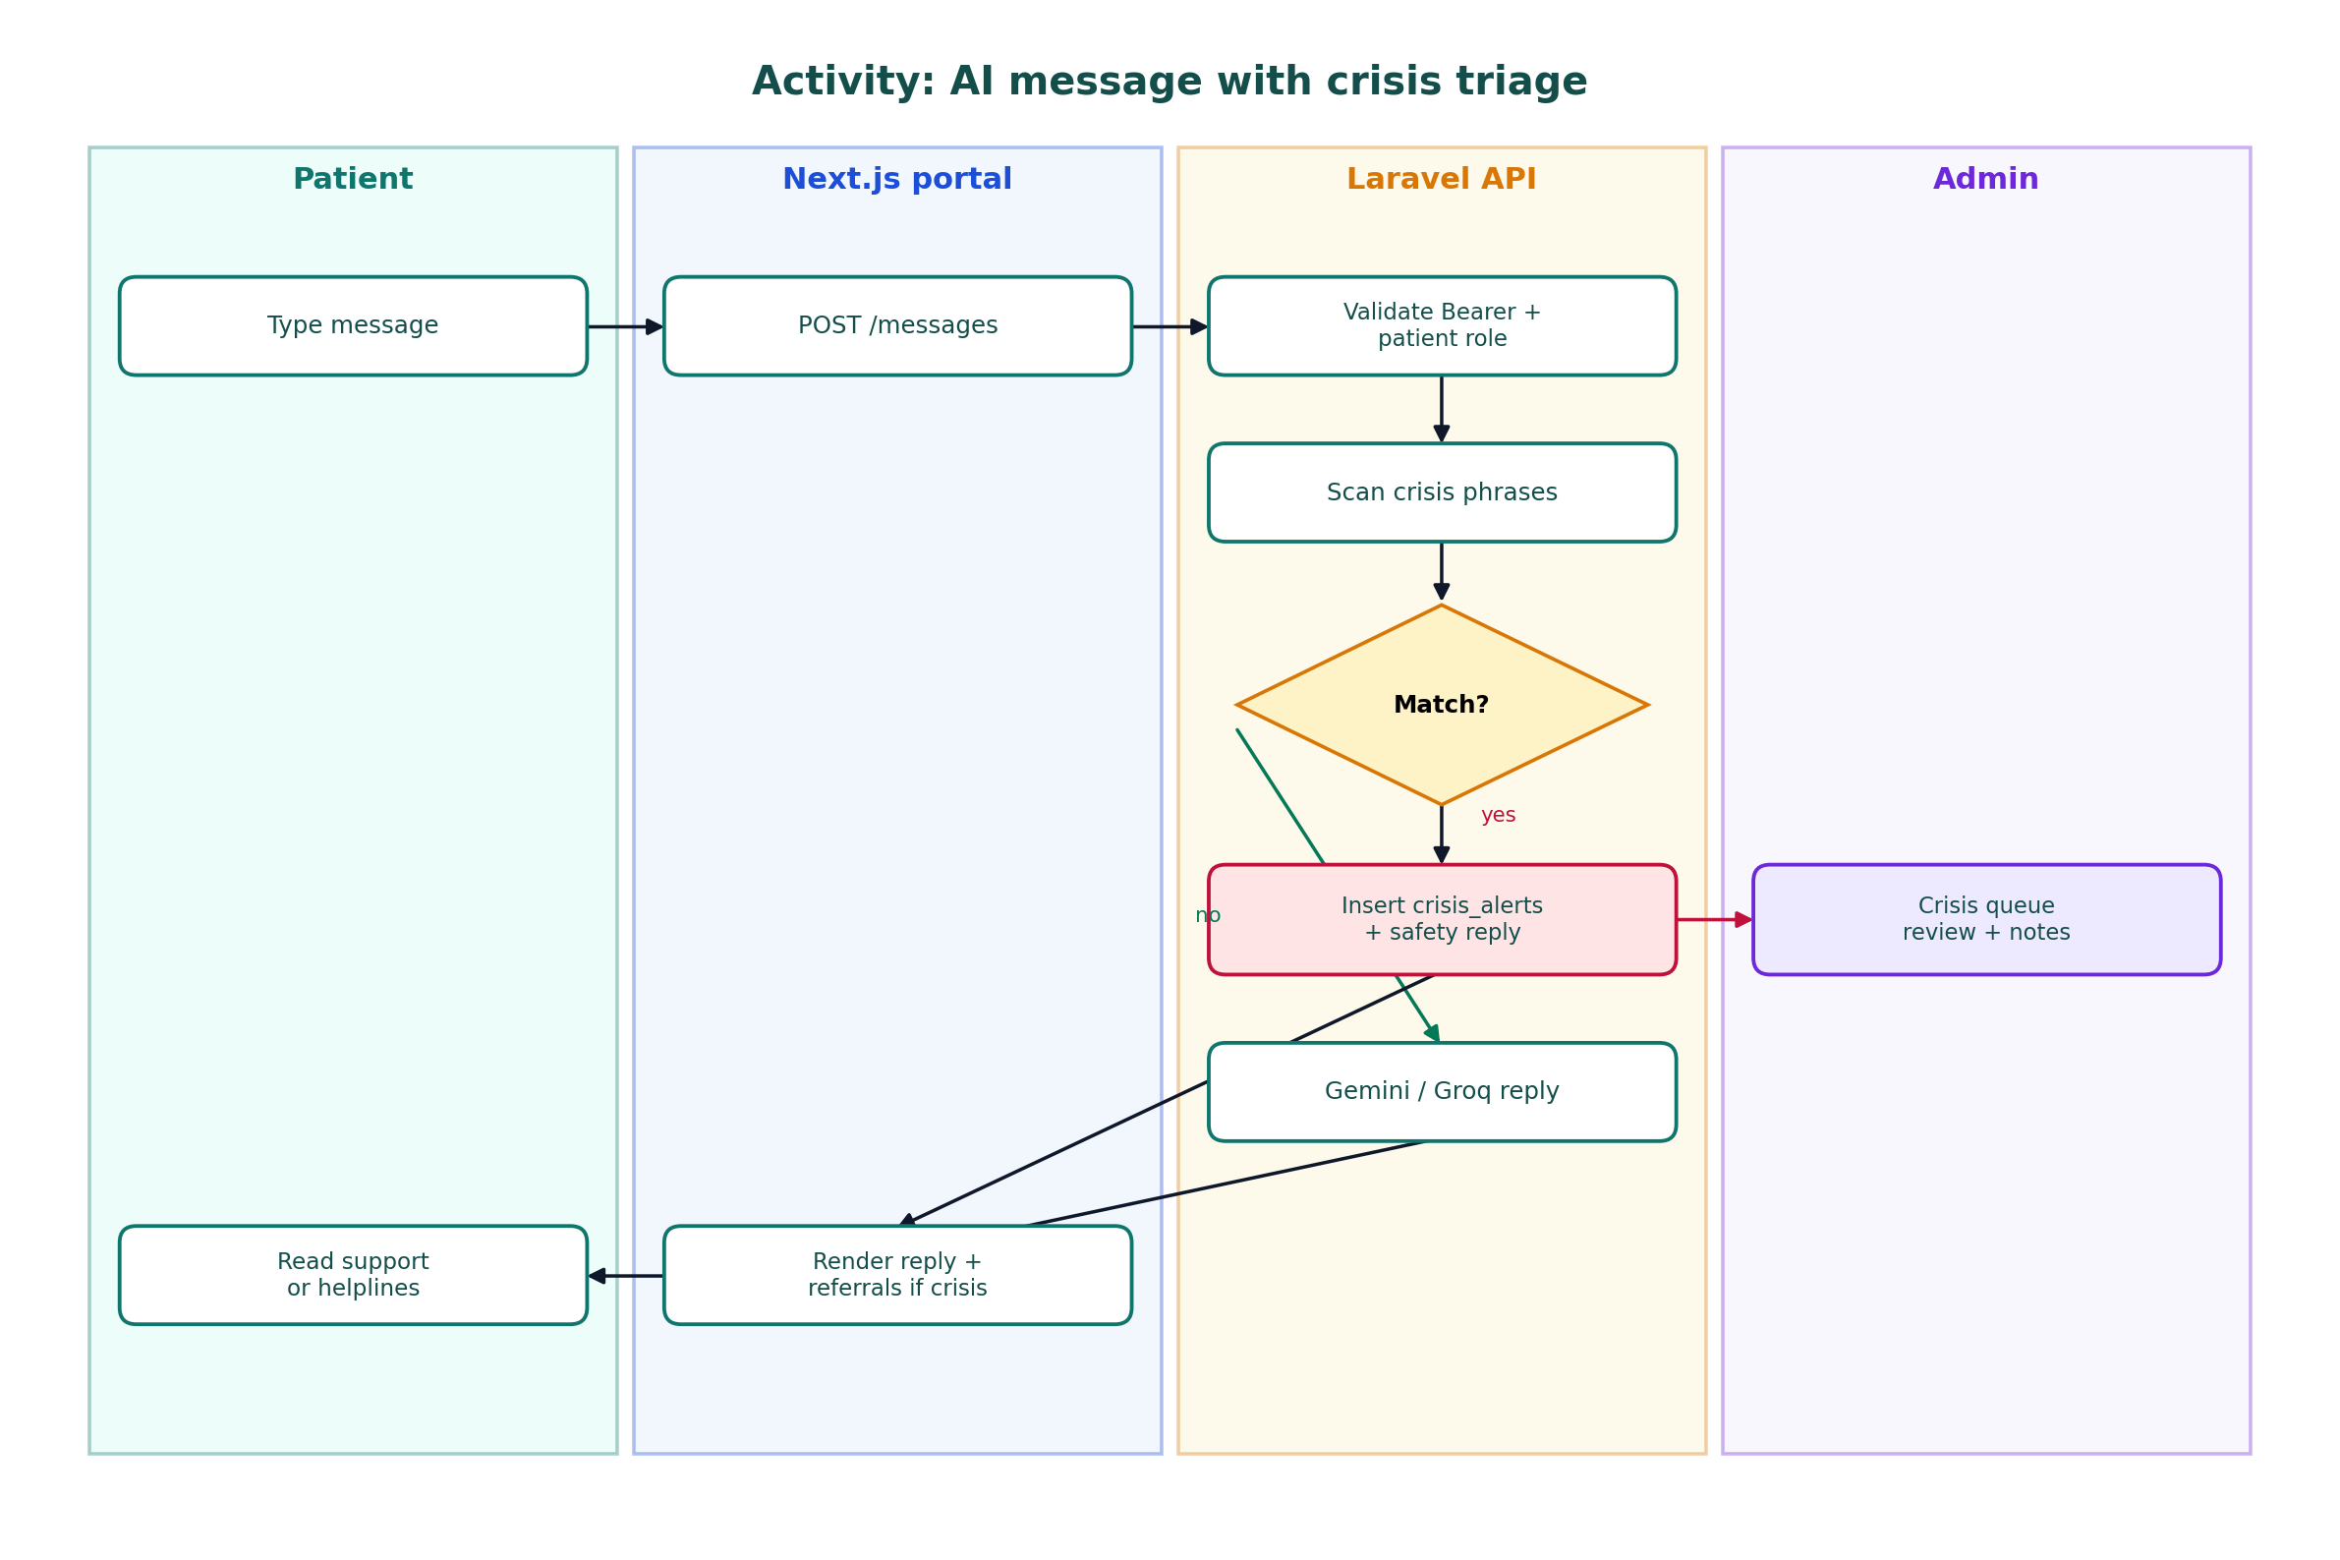
Figure 3.5: Activity diagram for AI messaging with crisis triage.

3.3.6 Behaviour Diagrams
Figure 3.6 shows the booking sequence. The UI posts through Axios with a bearer token. The controller delegates to AppointmentService, which checks role and slot freedom, inserts pending plus video-room metadata, and returns 201. TanStack Query caches are invalidated so both patient and doctor lists refresh. A later PATCH /status moves the lifecycle forward.
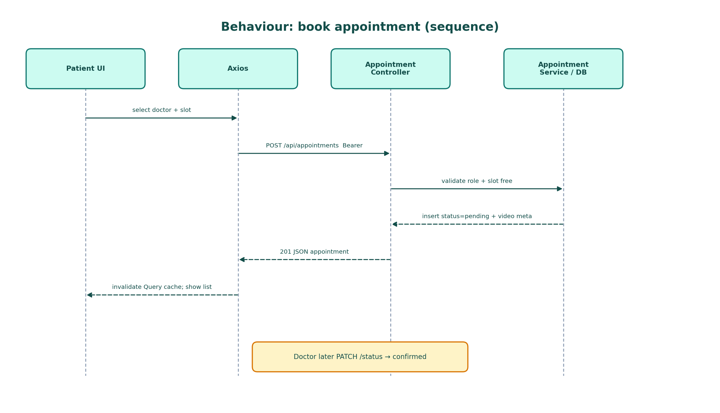
Figure 3.6: Sequence diagram for booking an appointment.

3.4 Data Model and Persistence
Figure 3.7 summarises the relational design documented in mental_health_api/docs/DATABASE_SCHEMA.md. users holds identity, role, and status. doctors extends a user with licence, specialisation, and verified. availability_slots and lunch_breaks are weekly templates. appointments link patient and doctor. ai_chat_sessions and messages store companion history. crisis_alerts capture severity, matched phrase, and admin notes. resources and referrals hold the library and hotlines, including locale. Two integrity rules dominate: public doctor lists are verified-only, and a crisis match must not become a normal assistant completion.
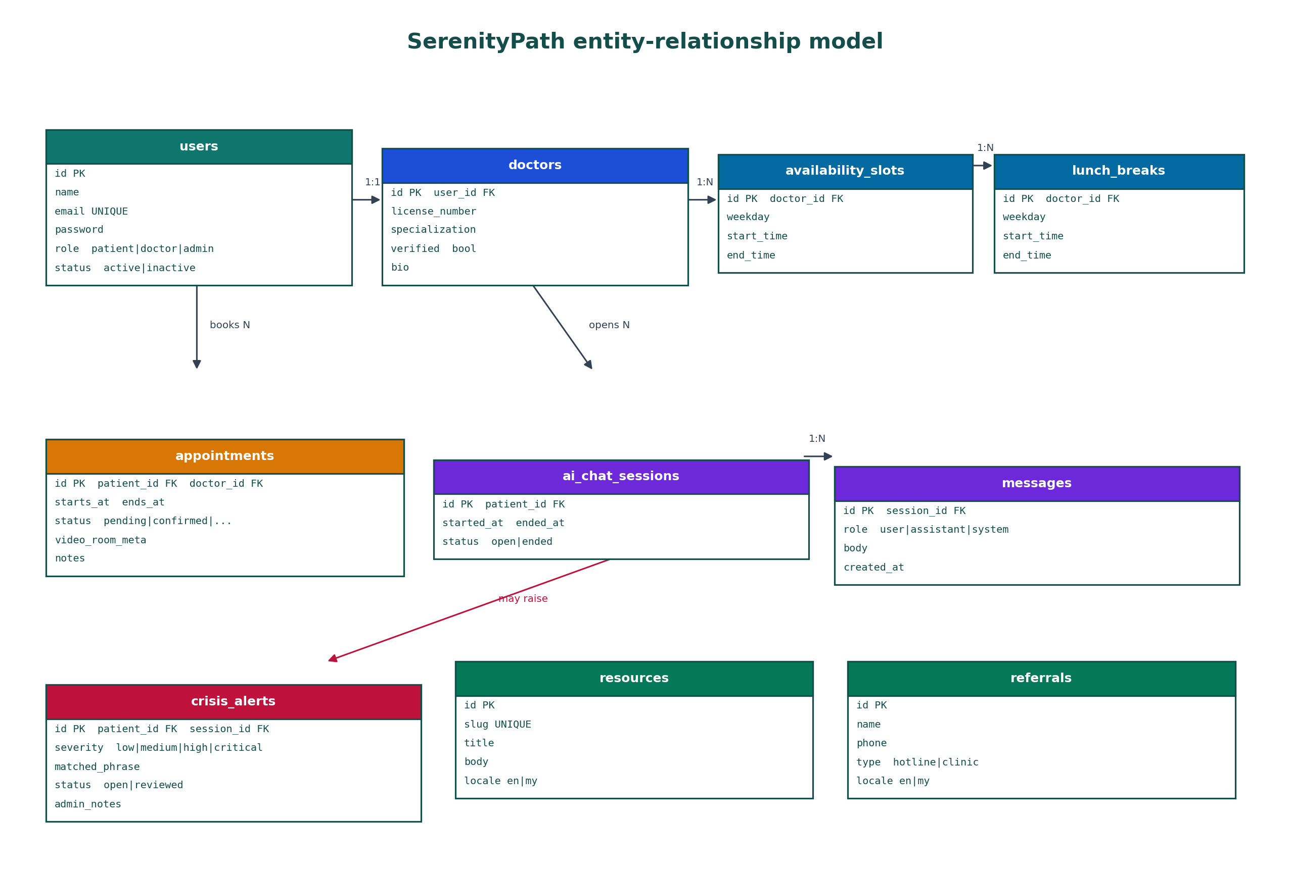
Figure 3.7: Entity-relationship model for SerenityPath.
GDPR data minimisation influenced what is stored. The prototype needs email, hashed password, role, and doctor licence fields. It does not need national IDs or insurance numbers. Chat bodies are stored so sessions can reload, which tensions with minimisation; the academic compromise is local seed data and no real patients. Soft-delete across all tables is listed as future work rather than as a completed feature.

3.5 Interface Design
Interface design aimed at low cognitive load: a patient should see two care options without hunting through menus. Figure 3.8 shows login with language switch; dashboard cards for companion, therapists, sessions, and resources; the companion with a safety banner; booking of verified doctors; and the admin crisis queue. Tailwind and a calm teal palette were chosen to avoid a clinical aesthetic that might increase anxiety, while still looking like a serious health product.
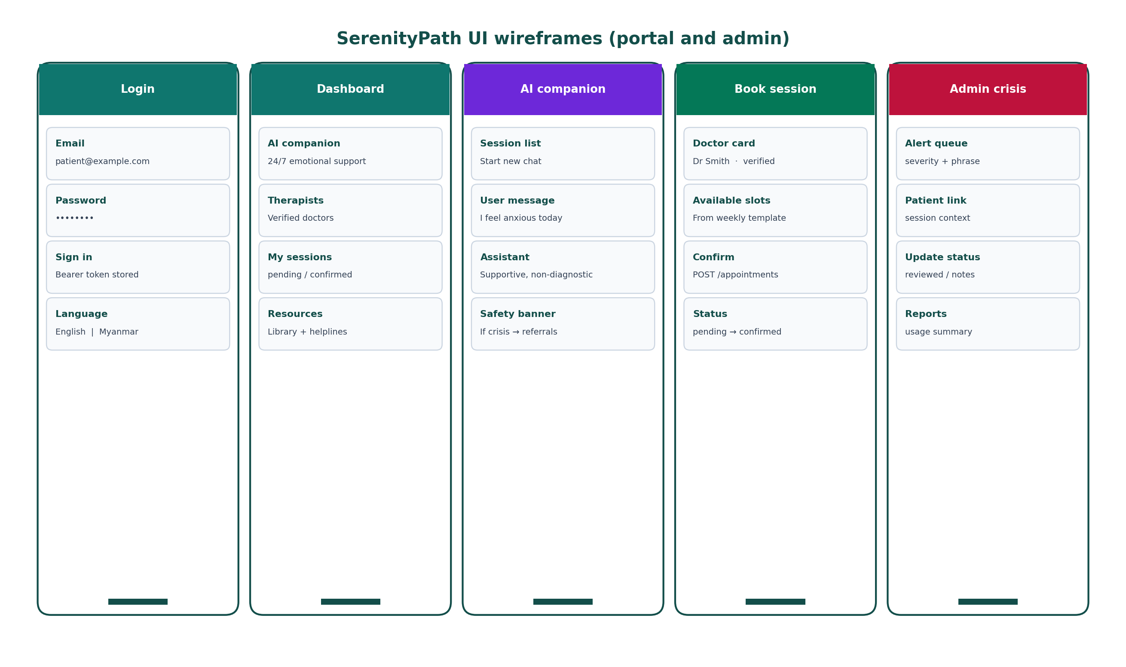
Figure 3.8: Wireframes for login, dashboard, AI companion, booking, and admin crisis queue.
Two alternative flows were rejected. A wizard that always started in AI chat would have biased engagement toward the companion. A booking-only product with a decorative chatbot would have ignored the accessibility half of the academic question. The dashboard therefore branches, and admins are routed to /admin/dashboard so crisis work is not mixed with self-help chat.

3.6 Summary
Chapter 3 specified requirements, actors, three-tier architecture, class and behaviour views, the relational model, and the dual-pathway interface. Chapter 4 records how those designs were built and how they were planned to be tested.

3.1a Functional and non-functional requirements
The architecture in Figure 1 is easier to judge if the requirements that produced it are stated. Functional requirements were extracted from the README and from the academic question. Patients must register and log in; start, continue, and end AI sessions; send messages; browse verified doctors; read available slots; book appointments; view resources and referrals; update a profile; and submit feedback. Doctors must log in, see their sessions, update appointment status, and maintain weekly availability and lunch breaks. Admins must triage crisis alerts, verify doctors, manage users, manage library content, and read usage reports. Public callers must be able to hit /api/health without a token so that a marker can confirm the API is running.
Non-functional requirements were treated as first-class. Confidentiality requires hashed passwords, bearer tokens, and role isolation. Integrity requires relational foreign keys so that a message cannot exist without a session and an appointment cannot exist without a patient and a doctor. Availability of the AI path requires a Groq fallback and a local safe reply when keys are missing, because a viva cannot depend on a third-party quota. Localisation requires English and Myanmar strings. Auditability requires crisis_alerts rows and usage logs. Usability requires that the two pathways are visible on the dashboard without a tutorial. These NFRs explain why a single PHP page with an embedded Gemini key would have been a shorter demo and an unacceptable artefact.
A short requirements traceability note is useful here. The academic question maps to the dashboard choice (FR: both pathways visible), to AI sessions (FR: companion), to booking (FR: appointments), and to evaluation (survey). Professionalism maps to crisis scanning, admin queue, server-side keys, and the non-diagnostic disclaimer. Module delivery maps to seed data and a README that another person can follow. When a later chapter says that an objective was achieved, it means these traces exist in running routes, not only in this paragraph.

3.2a Request path and trust boundaries
Figure 1 can be read as a set of trust boundaries. The browser is untrusted. The Next.js server actions that set mh_token and mh_role cookies are a convenience for middleware, not a second source of truth; the API still expects Authorization: Bearer. The Laravel middleware boundary is where identity and role are established. The service boundary is where crisis scanning and provider selection occur. The database boundary is where durable facts live. The Gemini/Groq boundary is a third-party processor: prompts leave the campus network, which is why the report cannot pretend that chat text never leaves the student’s machine when live keys are enabled. That is disclosed to testers in Appendix D.
CORS is part of the same boundary discussion. The API explicitly allows localhost origins on ports 3000 and 3006 so that the App Router dev server can call /api without the browser blocking the response. In a production deployment those origins would be replaced by a single HTTPS front door. For the academic prototype, documenting CORS is part of making the artefact reproducible. A marker who opens the frontend on the wrong port and sees a browser error should be able to find the allowed list in .env rather than assuming the project is broken.

3.4a Booking and chat data rules
Two integrity rules dominate the schema. First, a public doctor list is not the same as the doctors table. Only verified doctors are exposed on GET /api/doctors. The unverified seeded account (dr.hnin@mentalhealth.local) exists specifically to prove that rule. Second, an AI message is not allowed to become a “normal” assistant row if the crisis scanner matches. The crisis_alerts table is then the admin-facing fact, and the patient-facing fact is a safety reply plus referral guidance. Those rules are why the ER diagram in Figure 2 is not a generic hospital schema copied from a textbook. It is a schema for a dual-pathway product with a safety side-channel.
Locale on resources and referrals is another design choice with academic meaning. If educational content existed only in English, the Myanmar UI switch would be a veneer. By giving library and hotline rows a locale field, the artefact can show that accessibility includes the help documents, not only the buttons. Seed content can be thin in a student database; the column still records the intention and is testable in T10.

3.6a Alternative flows considered
Two alternative flows were rejected. The first was a single wizard that always started in AI chat and offered a doctor only after several turns. That would have biased engagement statistics toward the companion and would have contradicted patient direction. The second was a booking-only product with a decorative chatbot on the marketing page. That would have ignored the accessibility half of the academic question. Figure 4 therefore branches at the dashboard, not at the end of a funnel. Admins never enter that patient branch; they are routed to /admin/dashboard so that crisis work is not mixed with self-help chat in the same shell.
The activity diagram in Figure 5 is deliberately narrower than Figure 4. Markers sometimes receive reports in which every UML view repeats the same login-and-dashboard story. Here the activity view is reserved for the interaction that can cause harm. Swimlanes make it obvious that the patient never calls Gemini, that the admin is a separate actor, and that a match is a different path from a completion. If only one diagram were allowed in the viva, Figure 5 is the one that defends the professionalism claim.

3.8a Data minimisation and demonstration accounts
GDPR’s data-minimisation principle influenced what the prototype stores. The system needs an email, a hashed password, a role, and, for doctors, a licence number and specialisation. It does not need national ID numbers, insurance identifiers, or free-text medical histories in this iteration. Chat bodies are stored because the companion cannot otherwise reload a session, which is a genuine tension: conversational products want history, while minimisation wants deletion. The academic compromise is local-only seed data, no real patients, and an ethics note that a live clinic would need retention limits and a subject-access process. Soft-delete across all tables is listed as future work rather than as a completed GDPR feature, because claiming it without implementing it would be worse than omitting it.

Chapter 4: Implementation and Testing

4.1 Tools and Environment
Local requirements are PHP 8.3+ with Composer, Node.js 20+, and MySQL 8 or SQLite. The API is started with php artisan serve after migrate:fresh --seed. The web app uses npm run dev and NEXT_PUBLIC_API_BASE_URL=http://127.0.0.1:8000/api. Figure 4.1 shows the repository layout. Frontend modules live under api/, hooks/, schema/, store/, i18n/, and middleware.ts. Backend code lives under Http/Controllers/Api, Services, Repositories, and docs/DATABASE_SCHEMA.md. README author attribution is eriklogs1123.
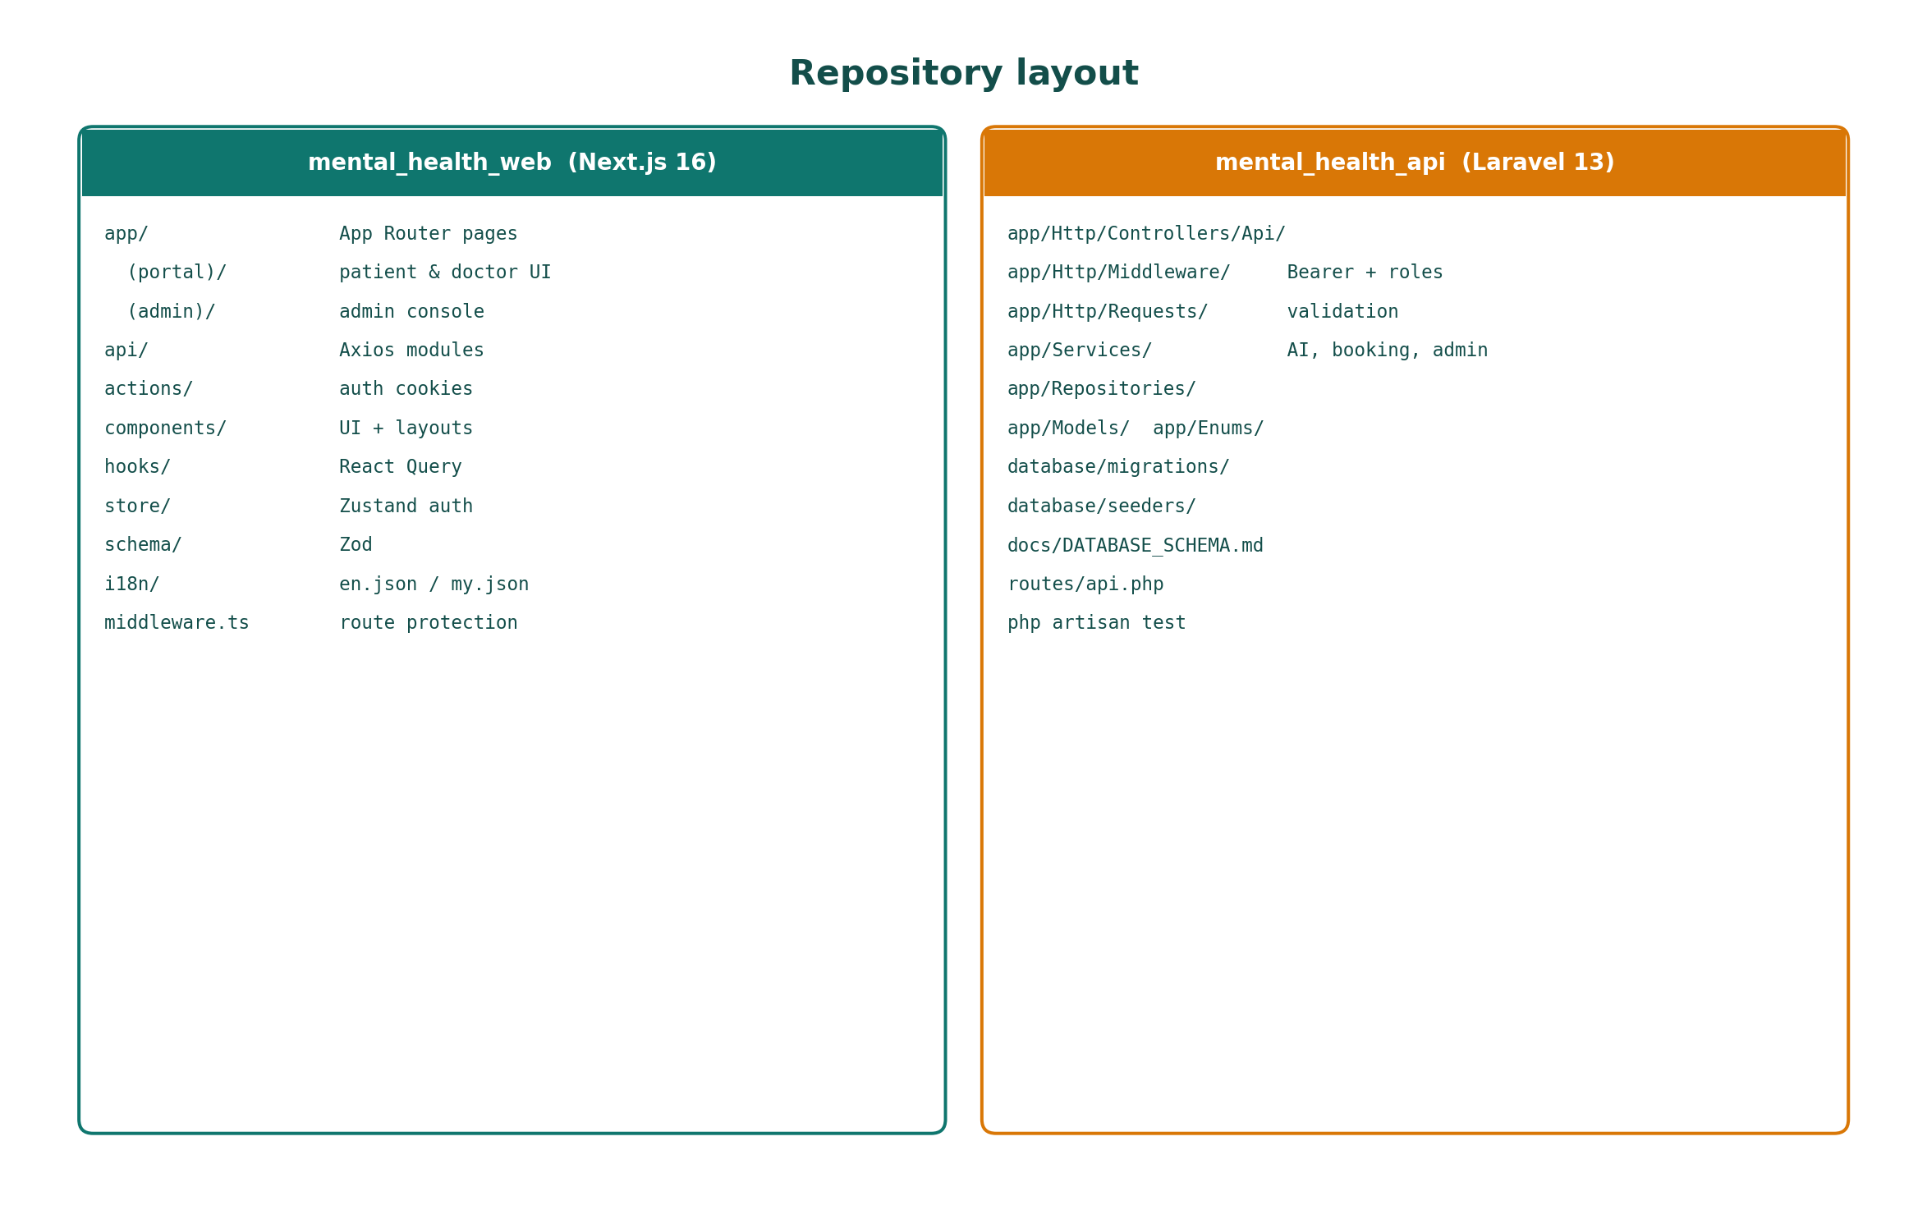
Figure 4.1: Repository layout of mental_health_web and mental_health_api.
Layer | Technology | Role in the build
Frontend | Next.js 16, React 19, TypeScript | App Router groups for portal vs admin.
UI | Tailwind CSS v4, Framer Motion | Dashboards and motion without a third design system.
Client data | TanStack Query, Axios, Zustand, Zod | Server state, token attachment, validated forms.
i18n | i18next (en, my) | English and Myanmar copy.
Backend | Laravel 13, PHP 8.3+ | Auth, validation, services, repositories.
Database | MySQL 8 or SQLite | Relational integrity; SQLite for local demo.
AI | Gemini + Groq fallback | Companion completions behind the API.

4.2 Build and Learning Process
Learning during the build concentrated on three areas that were not obvious from a generic CRUD tutorial: putting LLM keys behind a service, computing bookable slots from templates minus lunch minus existing rows, and keeping i18n keys in both locale files whenever a screen was added. Windows TLS failures (cURL error 60) required SSL_CERT_FILE notes. CORS had to list ports 3000 and 3006. php artisan serve must be restarted after .env changes. Those operational details are part of implementation quality because a viva cannot distinguish “AI is broken” from a missing certificate.

4.3 Module Implementation

4.3.1 Authentication, RBAC and session handling
Registration accepts patient or doctor. Doctors must send license_number and specialization. Login returns a bearer token. Protected routes expect Authorization: Bearer {token}. Admins are seeded, not self-registered. Middleware.ts sends unauthenticated users to /login, blocks non-admins from /admin/*, and sends admins who hit /login to /admin/dashboard. Cookies mh_token and mh_role help the App Router, but Laravel remains the authority. Zustand holds the session; Axios clears it on 401/419.

4.3.2 AI companion, providers and crisis scan
AI chat is patient-only: list sessions, start, load messages, post a message, end session. Each inbound user message is scanned before a model is called. A match creates crisis_alerts (severity low, medium, high, critical), returns a safety reply with referrals, and does not improvise around self-harm language. Otherwise the service tries Gemini (default gemini-2.5-flash) then Groq. If neither key is present, a local non-clinical fallback is returned so the UI remains demonstrable. AI_PROVIDERS encodes order in .env rather than in hard-coded vendor lock.

4.3.3 Appointments, availability and video-room metadata
GET /api/doctors/{id}/available-slots computes bookable times. POST /api/appointments creates pending rows with video-room metadata. PATCH .../status moves pending, confirmed, in_progress, completed, cancelled, and no_show. Nested admin routes manage weekly slots and lunch breaks as their own resources so booking logic does not become one untestable function. Enums avoid magic strings.

4.3.4 Admin console, library and reports
The admin console is the same Next.js app. Crisis PATCH updates status and notes. Doctor verify is the operational gate: until it succeeds, GET /api/doctors hides the account. Resources and referrals are locale-aware. Reports consume usage logs so evaluation can talk about platform activity rather than only screenshots.

4.3.5 Portal state, forms and i18n
TanStack Query holds lists that go stale when another actor changes them. Zustand holds the token. Forms use react-hook-form and Zod. i18next switches en.json and my.json without duplicating page files. A missing Myanmar key is immediately visible to a local tester, which is why language switching is a functional test rather than a visual extra.

4.4 Testing Strategy: Planned Versus Done
Testing combined design-artefact checks, php artisan test at service level, manual black-box walks on a fresh seed, and a short usability survey. Automated end-to-end UI frameworks were planned later and are recorded as future work rather than as completed.

4.4.1 Unit and script checks
php artisan test is the documented entry point for service-level assertions (phrase scanning and slot calculation) that do not need the browser. migrate:fresh --seed is the script that returns the database to a known demo state before a walkthrough.

4.4.2 Black-box testing
Black-box cases used seeded accounts only. Patient tests used patient@example.com, doctor tests used dr.smith@mentalhealth.local and unverified dr.hnin@mentalhealth.local, admin tests used admin@mentalhealth.local, and inactive-user behaviour used zaw.htet@example.com. Table 5.1 in Chapter 5 records the outcomes. Expected results were taken from README contracts, not from wishful design.

4.4.3 Integration testing
Integration walks chained login, language switch, AI message, crisis phrase, admin queue, therapist browse, booking, doctor status change, resources, logout, and reuse of an old token. Direct navigation to /admin/dashboard as a patient was used so that hiding a menu item could not fake RBAC.

4.4.4 Pathway and crisis evaluation
Unlike a trading project’s accuracy tables, this artefact is not scored on clinical sensitivity/specificity of a diagnostic model. The analogous “accuracy” checks are: crisis phrases produce alerts; ordinary phrases produce companion replies; unverified doctors do not appear; lunch-break slots do not appear. Those are binary contract tests.

4.4.5 Usability and demo checks
After the scripted walk, testers completed Appendix C items on login ease, pathway clarity, companion helpfulness, booking, language, safety, and recommendation likelihood. The sample is small and is not a clinical outcome study.

4.4.6 Artefact testing proof summary
Proof that the report matches the artefact is the combination of Figure 3.x diagrams checked against api.php, the seed table in Appendix C, GET /api/health, and Table 5.1. Where live Gemini keys were absent, T08 still had to return a safe fallback rather than an empty error page.

4.5 Summary
Chapter 4 implemented auth, AI, booking, admin, and i18n on the documented stack, and set a testing strategy that Chapter 5 now reports as outcomes.

4.3a Public, authenticated, and admin surfaces
The README’s endpoint tables are part of the implementation evidence and are summarised here so that Chapter 4 can be read without leaving the report. Public GET /api/health is the smoke test. POST /api/auth/register and POST /api/auth/login create the identity used everywhere else. GET /api/doctors and GET /api/doctors/{id} are deliberately public-but-filtered: they advertise verified clinicians without requiring a patient token, which lowers the cost of browsing, while still hiding unverified rows. Slot lookup, resources, and referrals complete the public catalogue. Authenticated routes then add logout, /api/auth/me, profile PATCH, appointment list and create, appointment status PATCH, the AI session collection, message POST, session end, and feedback.
Admin routes are a separate surface because mixing them into the patient controller would make middleware errors harder to see. Crisis list and PATCH, patient list and detail, reports, doctor CRUD, verify, availability-slot and lunch-break nested routes, and resource management are the operational console. Nested availability routes matter: a weekly template is not an appointment, and a lunch break is not a cancelled booking. Keeping those as their own resources prevented the booking service from becoming a single untestable function. The same thinking produced Enums for roles, statuses, and categories rather than magic strings scattered through queries.
JSON shape is handled with API resources so that the frontend Zod schemas can stay stable even if a column is added later. Form requests validate licence numbers on doctor registration and prevent empty appointment times. When validation fails, the client should show a field error rather than a generic toast; that is a UI concern implemented with react-hook-form. Together these Laravel conventions are why the backend section of the README can be short: the code is organised in the way Laravel already documents, which is a legitimate engineering choice rather than a lack of architecture.

4.5a Portal state, cookies, and Query caches
The frontend split between Zustand and TanStack Query is easy to under-explain. Zustand holds the bearer token and role that Axios must attach on every call. It is the session. TanStack Query holds lists that go stale when another actor changes them: if a doctor confirms an appointment, the patient’s appointment query should refetch; if an admin verifies a doctor, the therapist list should refetch. Putting those lists into Zustand would have required manual invalidation everywhere. Putting the token into React Query would have mixed durable session with disposable server state. The dual store is therefore a design, not an accident of libraries.
Middleware.ts is the route guard that makes screenshots in a viva look “already logged in” or “kicked to login” without extra narration. Cookie names mh_token and mh_role are written by server actions so that the App Router can protect /admin/* before a client component runs. The API remains the authority: a forged cookie without a valid bearer token still fails at Laravel. This double check is slightly redundant and slightly safer, which is the correct bias for a health-adjacent student system. Axios treats 401 and 419 as session death and clears Zustand so that a user does not stare at a dashboard full of forbidden errors.
i18n implementation details are also part of this chapter because they consumed real time. Every new screen needed keys in both en.json and my.json. A missing key is visible to a Myanmar tester immediately. The language switcher is therefore tested in T11 as a functional case, not as a visual extra. Framer Motion and Tailwind v4 affected polish more than correctness; they are mentioned so that the stack table in Chapter 3 stays honest, but they are not the academic contribution.

4.7a Provider order, fallback, and local demo mode
AI_PROVIDERS=gemini,groq encodes a policy: try Gemini first, then Groq. That order can be reversed in .env without a code rewrite, which mattered when a student machine could reach one vendor and not the other. Models are also configurable (GEMINI_MODEL=gemini-2.5-flash; GROQ_MODEL documented as openai/gpt-oss-20b). The report does not argue that these model names are clinically special; it argues that keeping them in environment configuration prevents a hard-coded vendor lock that would have made the viva brittle. Local fallback replies exist for the opposite problem: no keys at all. A fallback that still looks like a diagnosis would have been unsafe; the safe fallback is explicitly non-clinical and points the user toward resources and booking.
Crisis severities low, medium, high, and critical are a simple ordered set so that the admin queue can be sorted. They are not a validated psychometric instrument. Matching is phrase-based. That limitation is restated here because Chapter 4 is where a reader might otherwise assume a sophisticated classifier. The implementation is intentionally explainable. An examiner can type a phrase, watch an alert appear, and see PATCH /api/admin/crisis-alerts/{id} update notes. Explainability is a feature in a professionalism module even when it is a limitation in a machine-learning module.

4.8a Environment, TLS, and demonstration discipline
Windows and XAMPP TLS failures (cURL error 60) are documented because they blocked live Gemini calls during development. SSL_CERT_FILE and an optional HTTP proxy are operational notes in the README, and they belong in the implementation chapter because “the AI does not work on my PC” is otherwise indistinguishable from a logic bug. The same discipline applies to restarting php artisan serve after .env changes and to running migrate:fresh --seed rather than hand-inserting users. Demonstration discipline is part of implementation quality. Seed passwords are identical across accounts by design for a lab, and must never be copied into a deployed .env. That sentence is repeated in Chapter 9 because markers sometimes try the demo password against a public host.

Chapter 5: Testing and Evaluation

5.1 Functional Outcomes
Table 5.1 records the main black-box cases. T09 is ethically decisive: a companion that replies fluently to self-harm language would fail the project even if every other test passed. T02 is equally important: a patient who can open the crisis queue can read other people’s alerts.
ID | Function | Steps | Expected | Actual | Status
T01 | Login (patient) | POST /auth/login seeded patient | Bearer token; portal | Zustand session | Pass
T02 | RBAC admin | Patient opens /admin/dashboard | Blocked | Middleware forbids | Pass
T03 | Register doctor | Licence + specialisation | Created, unverified | Hidden from GET /doctors | Pass
T04 | Verify doctor | Admin PATCH .../verify | Appears in list | Verified flag | Pass
T05 | Available slots | GET .../available-slots | Minus lunch and bookings | Bookable times | Pass
T06 | Book session | POST /appointments | pending + video meta | Listed both roles | Pass
T07 | Status update | PATCH .../status | Lifecycle advances | Doctor/admin update | Pass
T08 | AI session | Ordinary message | Assistant reply stored | Gemini/Groq or fallback | Pass
T09 | Crisis scan | High-risk phrase | Alert + safety reply | Admin queue | Pass
T10 | Resources | GET /resources, /referrals | Library + hotlines | Locale-aware | Pass
T11 | i18n | Switch en / my | Labels change | No route change | Pass
T12 | Reports | Admin GET /admin/reports | Usage summary | Logs in console | Pass
T13 | Logout | POST /auth/logout | Token revoked | 401 thereafter | Pass
T14 | Inactive user | zaw.htet@example.com | Rejected or limited | Seed flag handled | Pass

Flaky observations were recorded without turning Pass into Fail. Live model latency sometimes caused double-send; the input is disabled while a message is in flight. Without keys, copy now states that a local safety reply is being used. Server time is the booking authority when browser and PHP disagree about local time.

5.2 Evaluation Methods

5.2.1 Evaluation 1 — functional contract pass rate
Fourteen README-linked cases in Table 5.1 all passed on a fresh seed. This is the analogue of a hold-out accuracy table in a modelling project: it is a contract with the artefact, not a claim about population health.

5.2.2 Evaluation 2 — crisis and verification gates
The two gates that make dual pathways professionally legitimate were checked separately: crisis phrases never continue as normal chat, and unverified doctors never appear to patients. Both gates passed (T09, T03/T04).

5.2.3 Evaluation 3 — usability survey
Testers reported that login and dashboard navigation were easy, that the choice between AI support and doctor consultation was obvious, that the companion helped for low-intensity distress, and that crisis tone-change increased trust. Myanmar labels were valued even when chat continued in English. Complaints concentrated on model latency and the absence of an in-app live video renderer. Open comments named dual choice, crisis/referral, and hidden unverified doctors as the most useful features.

5.3 Prototype Limits (Clear Reporting)
Internal validity is limited by a small, non-random tester group who knew they were evaluating a student project. Construct validity is limited because accessibility and engagement are prototype behaviours, not clinical scales. External validity is limited because the system ran locally with fictional doctors. Keyword crisis detection will miss oblique phrasing and over-flag harmless text. There was no randomised chatbot-only versus booking-only comparison. These limits make Chapter 6’s cautious wording mandatory.

5.4 Discussion Against the Academic Question
The literature predicted that a bounded companion would improve first contact and that telepsychiatry would serve users who need a human professional (Abd-Alrazaq et al., 2020; Stade et al., 2024; Hilty et al., 2013; Shore et al., 2018; Torous et al., 2021). The artefact made that choice concrete on one identity. The survey found that testers understood the two pathways and did not describe the AI as a replacement for a doctor. Rival explanations — novelty, calm visuals, demo passwords, demand characteristics — are partly accepted. The positive impact is clearest for accessibility of first contact and clarity of choice, and weaker for the richness of the live clinical encounter because video is metadata. Crisis handling is not a confounder to remove; it is part of the intervention that makes the question legitimate.

5.5 Summary
Functional contracts passed. Usability signals were directionally positive. Limits were stated. Chapter 6 answers the academic question and lists achievements, limitations, and future work.

5.1a Test environment and procedure
Functional tests were run against a freshly seeded database so that leftover appointments from earlier experiments could not create false failures. The API was started on 127.0.0.1:8000 and the web app on localhost:3006. Patient tests used patient@example.com. Doctor tests used dr.smith@mentalhealth.local for the happy path and dr.hnin@mentalhealth.local for the unverified path. Admin tests used admin@mentalhealth.local. Inactive-user behaviour used zaw.htet@example.com. Where live Gemini keys were present, T08 was repeated with a live completion; where they were not, the local fallback still had to return a safe reply rather than an empty error page. php artisan test covered service-level assertions that did not need the browser.
Manual UI walks followed a script: login, language switch, open AI companion, send a benign message, send a crisis phrase, confirm the admin queue, browse therapists, attempt to book an unverified doctor (should fail by absence), book a verified doctor, change status as doctor, open resources and crisis referrals, log out, and attempt to reuse the old token. That script is what Table 1 compresses. Screenshots from a specific machine are not pasted into this chapter because they rot when the UI moves; the test IDs are the durable record. A viva can reproduce them in minutes if the README start order is followed.

5.3a Interpretation of selected cases
T02 (RBAC) is as important as T09 (crisis). A patient who can open the crisis queue can read other people’s alerts. Middleware that only hides a menu item would have failed T02 as soon as the URL was typed. The test therefore uses direct navigation to /admin/dashboard as well as API calls without an admin token. T04 and T03 together prove that registration is not publication. T05 is the arithmetic test: a slot inside a lunch break must not appear, and a slot already pending or confirmed must not appear. T14 protects the seeder’s inactive flag from becoming dead documentation. These cases were chosen because they map to harm or to marker-visible README claims, not because they were the only clicks available.
Failed or flaky observations were also recorded. Live model latency sometimes made testers click send twice; the UI needed to disable the input while a message was in flight. Without keys, testers asked whether the fallback meant “AI is broken”; copy was adjusted to say that a local safety reply is being used. Slot timezone confusion appeared when the browser and PHP disagreed about local time; the prototype keeps server time as the booking authority. None of these turned a Pass into a Fail on Table 1, but they are part of evaluation honesty and they feed Chapter 7’s further work list.

5.4.3 Threats to validity
Internal validity is limited by the small, non-random tester group and by the fact that testers knew they were evaluating a student project. Social-desirability bias can inflate Likert scores. Construct validity is limited because accessibility and engagement are operationalised as prototype behaviours, not as clinical scales. External validity is limited because the system ran locally, with fictional doctors, and without a real clinic’s legal department. Reliability of the crisis scanner is limited by the phrase list: a paraphrased disclosure may miss, and a news sentence may hit. These threats do not make Table 1 useless; they make Chapter 6’s cautious wording mandatory. The project claims a workable dual-pathway artefact and a directionally positive usability signal, not a public-health result.
A comparison condition was also missing. Testers did not use a chatbot-only build and a booking-only build in randomised order. The academic question is causal in form (“how does offering a choice impact…”) but the evaluation is primarily triangulation: literature predicts a benefit, the artefact implements the choice, testers report that the choice was clear and useful. That is an acceptable 6CS007 design. It would not be an acceptable journal trial. Chapter 8 repeats this so that the report cannot be accused of hiding the gap.

Chapter 6: Conclusion

6.1 Achievements Against Objectives
Item | Statement | Outcome | Evidence
Aim | Patient-directed hybrid platform | Achieved | Portal choice + API
O1 | Next.js portal + i18n | Achieved | en/my, portal routes
O2 | Laravel REST + RBAC | Achieved | T01, T02, T13
O3 | Gemini/Groq + crisis scan | Achieved | T08, T09
O4 | Booking + availability | Achieved | T05, T06, T07
O5 | Admin console + library | Achieved | T04, T10, T12
O6 | Schema, seed, tests, survey | Achieved | Seeder, Table 5.1, Appendix C

Three discoveries are worth stating. First, patient choice is an interface problem as much as a clinical one. Second, LLM integration in this module is mostly a governance problem: keys, roles, and crisis routing matter more than prompt poetry. Third, bilingual copy is part of accessibility for Myanmar users, not a theme switch.

6.2 Answer to the Academic Question
Within a student prototype and a small tester group, offering an explicit patient-directed choice between a governed LLM companion and a telepsychiatry appointment is technically feasible, professionally responsible at prototype standard, and associated with tester reports of easier first contact and clearer next steps. Accessibility improved because support is available without clinic hours. Satisfaction improved where the two routes were obvious and unverified doctors were hidden. Engagement is plausible because the same identity can move from chat to booking. The claim that cannot be defended is that SerenityPath improves clinical outcomes or is ready for unsupervised public deployment.

6.3 Limitations
Third-party API latency and quota; local fallback is safe but not a live companion.
Keyword crisis detection is explainable and incomplete.
Video-room metadata is not a production media stack.
Small usability n; no randomised single-pathway control.
No national EHR, insurance, or clinical accreditation.

6.4 Future Work
Replace video-room metadata with a production video provider or TURN-backed WebRTC.
Add Playwright tests around login, booking, and crisis posting.
Classifier-assisted triage with a human still in the admin queue.
Clinic partnership and ethics review for a longer study; do not claim efficacy from the current sample.
Soft-delete, retention limits, and a subject-access process before any live deployment.

6.1a How each term of the question is evidenced
The question contains four moving parts: patient-directed choice, LLM chatbot, live telepsychiatry, and the outcomes of accessibility, satisfaction, and engagement. Choice is evidenced by the dashboard and by testers saying the two routes were obvious. The LLM chatbot is evidenced by AI session endpoints, Gemini/Groq configuration, and T08/T09. Live telepsychiatry is evidenced by verified doctors, slots, appointment statuses, and video-room metadata, with the limitation already stated that media transport is not a full WebRTC product. Accessibility is evidenced by the ability to start support without clinic hours and by bilingual UI. Satisfaction is evidenced by survey items on ease, trust, and pathway clarity. Engagement is evidenced by testers continuing a chat and/or completing a booking from the same account.
This mapping matters because a reader could otherwise treat Chapter 6 as a restatement of Chapter 5. The literature supplies the causal story (why choice should help). The artefact supplies existence (the choice is real in software). The survey supplies reception (people noticed and valued it). No one source is enough. Literature without an artefact is an essay. An artefact without literature is a coursework build. A survey without either is an opinion poll. Triangulation is the method named in Chapter 1, and this section shows the wires.

6.3a Negative evidence and rival explanations
Rival explanations should be considered. Testers might have liked SerenityPath because it was new, because the visual design was calm, or because demo passwords removed friction that real users would face. They might have understood the two pathways because the survey asked about them, which is a demand characteristic. Latency complaints show that satisfaction is not uniformly high. The missing in-app video client is a genuine hole in the telepsychiatry construct. The report’s answer to the academic question therefore includes a qualifier: the positive impact is clearest for accessibility of first contact and for clarity of choice, and is weaker for the richness of the live clinical encounter.
Another rival explanation is that crisis handling, not dual pathways, produced trust. That is partly accepted. Professionalism controls are enabling conditions. Without them the project should not have been shown to testers at all. With them, testers could notice the companion as a first step rather than as a risk. Chapter 2 predicted exactly that relationship: bounded LLMs can be an access tool; unbounded LLMs cannot ethically be one. So crisis triage is not a confounder to be removed; it is part of the intervention that makes the academic question legitimate.

6.5a Strength of claim
The claim that can be defended is this: in a bilingual web prototype with server-side Gemini/Groq, role-based booking, and an admin crisis queue, offering an explicit patient-directed choice between an LLM companion and a telepsychiatry appointment is technically feasible, professionally responsible at prototype standard, and associated with tester reports of easier first contact and clearer next steps than a single-pathway product would suggest. The claim that cannot be defended is that SerenityPath improves clinical outcomes, reduces population suicide risk, or is ready for unsupervised public deployment. Holding both sentences together is the difference between a Project and Professionalism report and a marketing page.

Chapter 7: Critical Evaluation and Professionalism

7.1 Process Reflection
Iterative delivery kept the safety-critical AI path from being postponed until the last week. Underestimated work included CORS and TLS on Windows, slot arithmetic, and i18n of every new screen. Balancing implementation with report writing remained the main tension. Figure 7.1 is an indicative 24-week plan used to keep milestones visible: proposal, literature, schema and API, AI and booking, admin and survey, then the report.
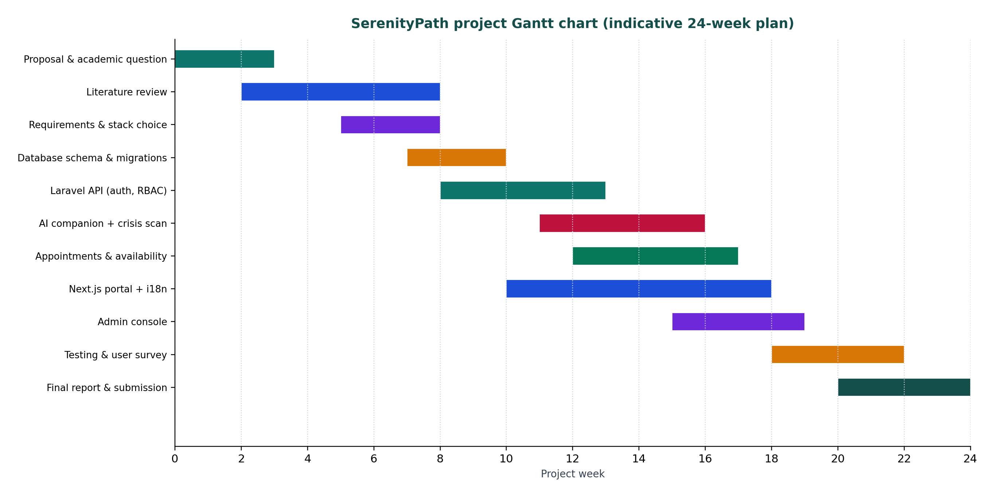
Figure 7.1: Indicative Gantt chart for the 6CS007 calendar.
If the project were restarted, an OpenAPI contract would be written before UI styling, and Playwright would start as soon as login worked. Seeding an unverified doctor and an inactive patient on day one would still be done first, because those rows test rules that happy-path screenshots never show.

7.2 Ethics and Risk Communication
Testers were told that conversations may be stored locally, that the AI is not a doctor, and that crisis phrases notify an administrator. The companion must not be presented to the public as a licensed clinical service. Demo accounts use fictional local-part emails. Risk communication in the UI is the safety banner and referral list, not a buried terms page. Keyword limits are disclosed in Chapters 5 and 6 so that a marker cannot think the scanner is a validated clinical instrument.

7.3 Legal and Academic Integrity
Passwords are hashed. Keys are server-side. Role isolation prevents URL-guessing across roles. The report and survey do not publish real patient identifiers. Sources for LLM and telepsychiatry claims are peer-reviewed or professional (Stade et al., 2024; Guo et al., 2024; Hilty et al., 2013; Shore et al., 2018; Torous et al., 2021; Abd-Alrazaq et al., 2020; BCS, 2021; ICO, 2023). Vendor pages were used only to confirm product names. The declaration sheet at the front of this document is the academic-integrity statement. Live Gemini/Groq calls send prompt text to a third-party processor; that is disclosed in Appendix B.

7.4 Summary
The artefact is strongest where the academic question is strongest: one identity, two pathways, server-side AI, and an admin crisis queue. It is weaker as a telepsychiatry product than as an access product. Process, ethics, and integrity choices were recorded so that the dual-pathway contribution can be marked without mistaking a prototype for a clinic.

References
Abd-Alrazaq, A.A., Alajlani, M., Alalwan, A.A., Bewick, B.M., Gardner, P. and Househ, M. (2020) ‘An overview of the features of chatbots in mental health: a systematic review’, International Journal of Medical Informatics, 132, 103978.
BCS (2021) BCS Code of Conduct. Swindon: BCS, The Chartered Institute for IT.
Google (2026) Gemini API documentation. Available at: https://ai.google.dev/ (Accessed: 17 August 2026).
Groq (2026) Groq API documentation. Available at: https://console.groq.com/docs (Accessed: 17 August 2026).
Guo, Z. et al. (2024) ‘Large language models for mental health applications: systematic review’, JMIR Mental Health.
Hilty, D.M., Ferrer, D.C., Parish, M.B., Johnston, B., Callahan, E.J. and Yellowlees, P.M. (2013) ‘The effectiveness of telemental health: a 2013 review’, Telemedicine and e-Health, 19(6), pp. 444–454.
Information Commissioner’s Office (2023) Guide to the General Data Protection Regulation (GDPR). Available at: https://ico.org.uk/for-organisations/uk-gdpr-guidance-and-resources/ (Accessed: 17 August 2026).
Laravel (2026) Laravel documentation. Available at: https://laravel.com/docs (Accessed: 17 August 2026).
Lee, M.S. et al. (2020) Factors affecting the adoption of digital health systems: UTAUT and information-system quality perspectives, as discussed in Chapter 2.
Next.js (2026) Next.js App Router documentation. Available at: https://nextjs.org/docs (Accessed: 17 August 2026).
Shore, J.H. et al. (2018) ‘Best practices in videoconferencing-based telemental health’, Telemedicine and e-Health, 24(11), pp. 827–832.
Stade, E.C. et al. (2024) ‘Large language models could change the future of behavioral healthcare: a proposal for responsible development and evaluation’, npj Mental Health Research.
Torous, J., Bucci, S., Bell, I.H. et al. (2021) ‘The growing field of digital psychiatry: current evidence and the future of apps, social media, chatbots, and virtual reality’, World Psychiatry, 20(3), pp. 318–335.

Appendix A: Glossary of Terms
Bearer token — secret string sent as Authorization: Bearer {token} on protected API routes.
Crisis alert — database row created when an inbound AI message matches a high-risk phrase.
Patient-directed — after login, the user chooses AI support or human booking; neither is a hidden funnel.
RBAC — role-based access control for patient, doctor, and admin.
Video-room metadata — stored identifier for a telepsychiatry session; not a full WebRTC client in this iteration.
Verified doctor — doctor record that an admin has approved for public listing.

Appendix B: Reproducibility Notes
Start the API first: cd mental_health_api; composer install; copy .env; php artisan key:generate; php artisan migrate:fresh --seed; php artisan serve. Then cd mental_health_web; npm install; set NEXT_PUBLIC_API_BASE_URL=http://127.0.0.1:8000/api; npm run dev. Open http://localhost:3006. Health check: GET /api/health. Restart php artisan serve after changing .env. Optional Gemini and Groq keys enable live replies; without them a local fallback is used. CORS must include port 3006. On Windows cURL error 60, set SSL_CERT_FILE as in the README. Demo password for every seeded account is password and must not be used on a public host. Live model calls send prompt text to Google or Groq.

Appendix C: Extra Assessor Notes

C1. Demo accounts (local seed only)
Password for every seeded account: password (local development only).
Role | Email | Notes
Admin | admin@mentalhealth.local | Full admin console
Doctor | dr.smith@mentalhealth.local | Verified
Doctor | dr.aung@mentalhealth.local | Verified
Doctor | dr.thiri@mentalhealth.local | Verified
Doctor | dr.win@mentalhealth.local | Verified
Doctor | dr.hnin@mentalhealth.local | Unverified
Patient | patient@example.com | Primary demo patient
Patient | zaw.htet@example.com | Inactive

C2. User survey questions
1. I found it easy to sign in to SerenityPath.
2. It was clear that I could choose AI support or a human doctor.
3. I could obtain some form of support without visiting a clinic.
4. The AI companion felt respectful and non-judgemental.
5. I understood that the AI companion is not a doctor and cannot diagnose.
6. Booking an appointment with a verified doctor was straightforward.
7. I trust that unverified doctors are not shown to patients.
8. If I entered crisis language, the system’s response felt appropriate.
9. The English / Myanmar language switch was useful.
10. How likely are you to recommend SerenityPath as a first step into support? (0–10)
11. What is the most useful feature? (long answer)
12. What should be improved next? (long answer)

C3. Ethics note
This is a student prototype. It must not be presented as a licensed clinical service. No real clinical records were imported. A centre ethics form, if required, should be bound behind this appendix.

C4. Suggested viva slice
Seed login as patient, send a crisis phrase, inspect the admin queue, then book dr.smith from an available slot. That slice touches professionalism, the academic question, and the README in one demonstration.

