**PRACTICE EXERCISE 1**

1. 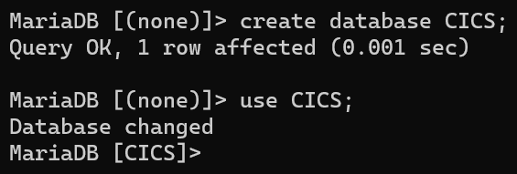Create a database named CICS.
2. Creating a table called TblStudent that has fields with data type as shown below :

- StudentID (Type=Integer, Size=10, Primary Key)

- StudentName (Type=Varchar, Size=20)

- DOB (Type=Date)

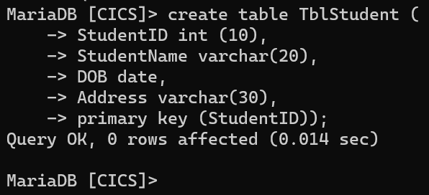- Address (Type=Varchar, Size=30)

1. Creating a table called TblTeacher that has fields with data type as shown below :

- TeacherID (Type=Integer, Size=10, Primary Key)

- TeacherName (Type=Varchar,Size=20)

- Address (Type=Varchar, Size=30)

1. Creating a table called TblSubject that has fields with data type as shown below :

- SubjectID (Type=Integer, Size=5, Primary Key)

- SubjectName (Type=Varchar, Size=30)

1. Creating a table called TblLab that has fields with data type as shown below :

- LabID (Type=Integer, Size=5, Primary Key)

- LabName (Type=Varchar, Size=20)

1. Creating a table called TblTime that has fields with data type as shown below:

- TimeID (Type=Integer, Size=5, Primary Key)

- TimeAvailable (Type=Varchar, Size=20)

1. Creating a table called TblStudy that has fields with data type as shown below:

- StudyID (Type=Varchar, Size=5, Primary Key)

- StudentID (Foreign Key Related to TblStudent)

- TeacherID (Foreign Key Related to TblTeacher)

1. Creating a table called TblStudyDetail that has fields with data type as shown below :

- StudyDetailID(Type=Integer, Size=5, Primary Key)

- StudyID (Foreign Key Related to TblStudy)

- SubjectID (Foreign Key Related to TblSubject)

- TimeID (Foreign Key Related to TblTime)

- LabID (Foreign Key Related to TblLab)

1. After creating all the tables, show the description for each table.

