Q1.

Q3.

Rest access not there

Q4.

Q5.

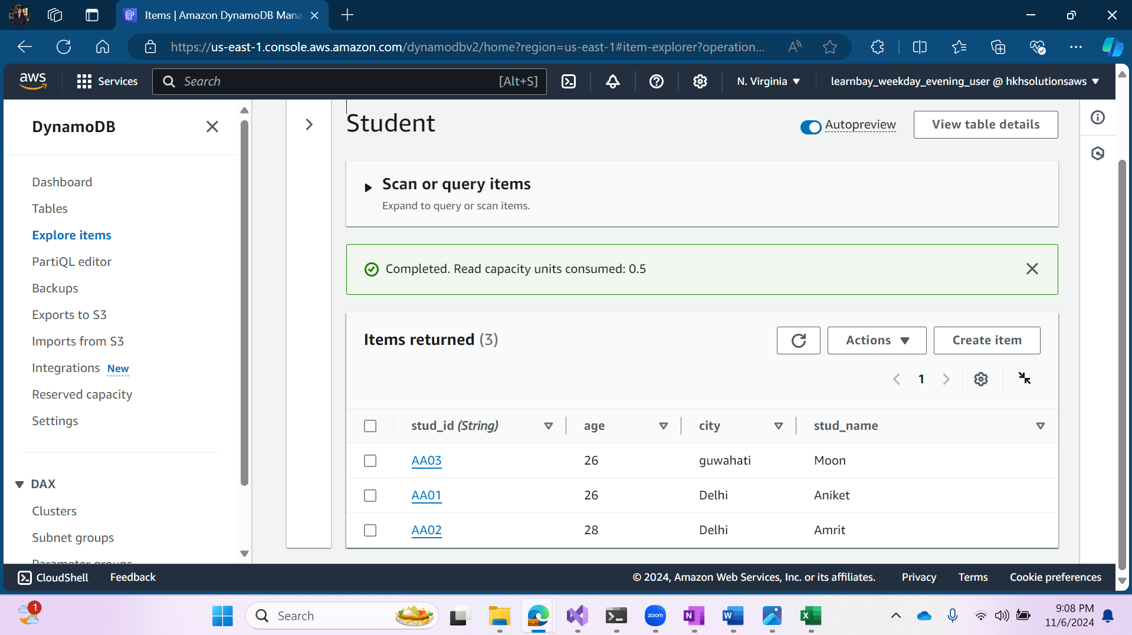

Q7.

