### **The Best Fandelier Ideas For Different Areas Of Your House**

[May 10, 2022](https://mooonilighting.blogspot.com/2022/05/the-best-fandelier-ideas-for-different.html" \o "permanent link)

When husband wants a fan but wife wants a chandelier, then you can choose this fandelier.

1 ceiling fan + 1 chandelier = the fandelier !!!

When you envision the elegant dining room of your dreams, you probably imagine a beautiful chandelier suspended above the table. You know it’s the look you want, and that your favorite gathering space won’t be complete without it. But here’s your problem: in the warmer months, you’ll need a ceiling fan, and it’s tacky to put a ceiling fan and a chandelier on the same ceiling. How do you solve this dilemma? Now a beautiful and practical ceiling fan is more and more important for our house.

[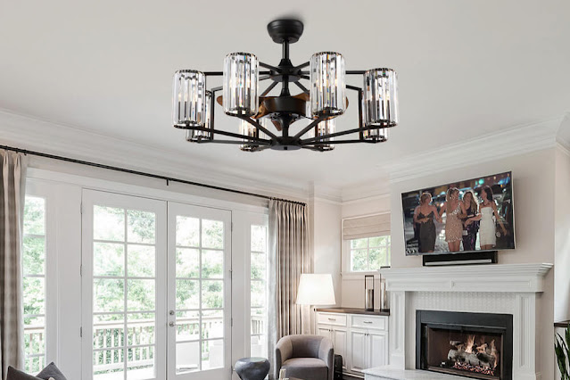](https://blogger.googleusercontent.com/img/b/R29vZ2xl/AVvXsEgUGoggljLEMbQ2Ix1oBXrXY9rksk56Rz1eVOx3B_KDIkyDMiBq7ue5zpFcZYP1JUFa1N8e6BcNyV4cOdUSF6MIr2tTbE6icFVU4dBJ0OfjLdZonZRprB-WBFSdL6qxOFBUw6yWegvQwDSo0pzXEcj2Uh4e-RgCY8DhOIfUGxXpFLrA1Qij1qmLT77Z/s1000/fandelier.jpg)

### The types of fandeliers

Retractable Fandeliers

[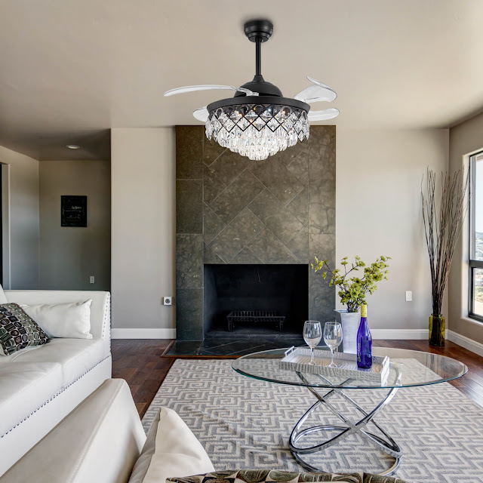](https://blogger.googleusercontent.com/img/b/R29vZ2xl/AVvXsEhg4Cr8nGBFG5VyHZj6QDPlU5xjgjB8tUWopF85gL8vgFQzYlRR9QY7V_ZKVOA0LBFm7JOpXIVERgSrkgDxk1usmIuJAL0GXhBjUvRX2QeNd6IHtScWemxptZ403mpYAwhdRiU7iewVb6JUSCsyGbYH0Rs5WiVFfMhPMCYZo95wE29OQUbxkwtSysUQ/s1500/Retractable%20Fandeliers.jpg)

Retractable ceiling fans have many pros which include functionality, energy efficiency, style, and quality. These are the reasons why they are in demand for many homes.

Flush Mount Hugger Fandelier

[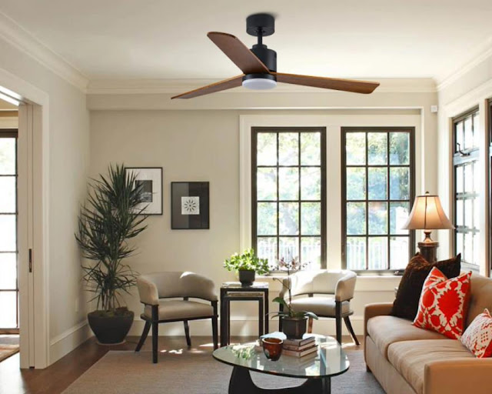](https://blogger.googleusercontent.com/img/b/R29vZ2xl/AVvXsEiQN0OV3wddfoStPzdwqfoFMRCtcx2z9Zn8Fcwhbz9o1ssWoZGLS_yI-ObGSrFTHgZ4wBATuQbeP2vR1U5XMgyImar4KSS9DIhLfur9BAEaWbyW4Q86vVLM4qQf_RpYqu-GWuXK3W49mzwrMM3d6TY7aH_zmin65UrDBZJDuAOKMdjxzVf7Qd5EMrqN/s880/Flush%20Mount%20Hugger%20Fandelier.jpg)

The fandelier blades of this fan are made of wood, and the size is relatively large, which can bring greater wind speed, especially suitable for large spaces

Small Industrial Drummed Bladeless Fandelier

[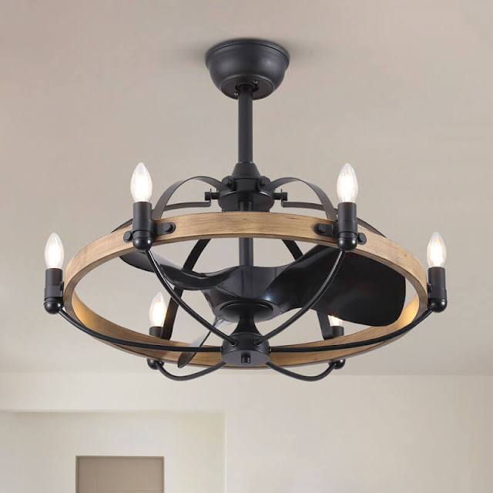](https://blogger.googleusercontent.com/img/b/R29vZ2xl/AVvXsEgA2ypAGKYrUvvZblVBDUFSmx-yF4lYThPHNUYhjVU1kqjW7oKl98E-_rqyV3G-Pa-zNb4J7IKr9jU4WRi2u8g97ykbGAECj315EQlJHxvlpW6NpHW7wyuMtBTs42Pm7CxrkbP7QQWJV2rQFHZd1KmaODz3eKPtYFluQbsbOLYm5MhGf9lk9rDkg4Di/s800/Small%20Industrial%20Drummed%20Bladeless%20Fandelier.jpg)

Small by ceiling fan standards, this design is a perfect fit for small rooms and covered porches thanks to its damp rating.

### Size Guide of the fandeliers

There are many things to consider before buying a new fandelier for your home. One of the most important considerations is the Fandelier size in the room you plan to have it installed in. You need to consider the air movement speed for the room.

Here are our measurements to find the best size for each room size

|  |  |  |
| --- | --- | --- |
| **Blade Span** | **Good for** | **Room Size** |
| 18" to 36" | Bathrooms, Breakfast Nooks, Utility Rooms | Up to 75 sq. ft |
| 42" to 48" | Bedrooms, Kitchens, Dining Rooms | Up to 175 sq. ft |
| 52" to 55" | Large Bedrooms, Family Rooms, Media Rooms | Up to 350 sq. ft |
| 56" or larger | Great Rooms, Other Large Spaces | More than 350 sq. ft |

### How to choose the Size of fandeliers for the room

1. Bedroom Fandelier

[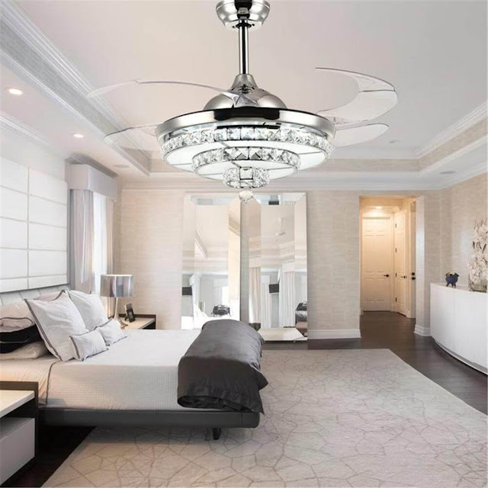](https://blogger.googleusercontent.com/img/b/R29vZ2xl/AVvXsEjDA0YvN8KEnMIZ1Dr3QLkPeE3klwMW68TOJLMPK9mjyOGHxfx9C0NIlHMDPciFJ3vkWGT7nlDCVzDfPq7s26SmZ18iga0SxK5shfPcdHCegk0n_7UloFDt2kTckOstY0p6b7dO_0KsBk1WlOtVb8jNldtUatqIK9NEC9H2Ul82dtKegrQu5I7k2mdY/s1000/bedroom%20fandelier.jpg)

The bedroom is perhaps the most important room to have a ceiling fan in—you want to be nice and cool at night. But the bedroom is also the room that most reflects your personal style and design. With a fandelier, you won’t have to compromise.

2. Kitchen Fandelier

[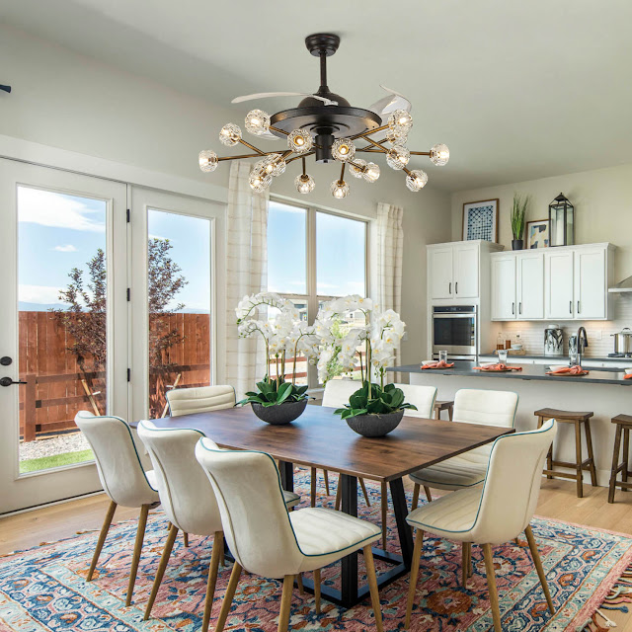](https://blogger.googleusercontent.com/img/b/R29vZ2xl/AVvXsEgzUP6XfaBvNgVEE9V2Tyl5UZlu4nMWP3XwJ8b4UUWFBALEkVYbsdwGhRDA8o-wlko4GuxE285MIrJgv9n9vSr80OrrCyTBIRe7741K_ev2sdYGQ7wJoQufVG5QCizUW8vLRvaspZ2wvNusRR32Tbgd2YWg_Lqb-hbqKFiNOnb0pYy2VS5CpZH67o4I/s1500/kitchen%20fandelier.jpg)

Cooking should be a joy, not a chore, and a beautiful and cool kitchen is the best way to achieve that. A kitchen fandelier will keep smoke and steam from engulfing the stovetop while converting an often-overlooked opportunity to make your kitchen an elegant space, not just a functional one.

3.Dining Room Fandelier

[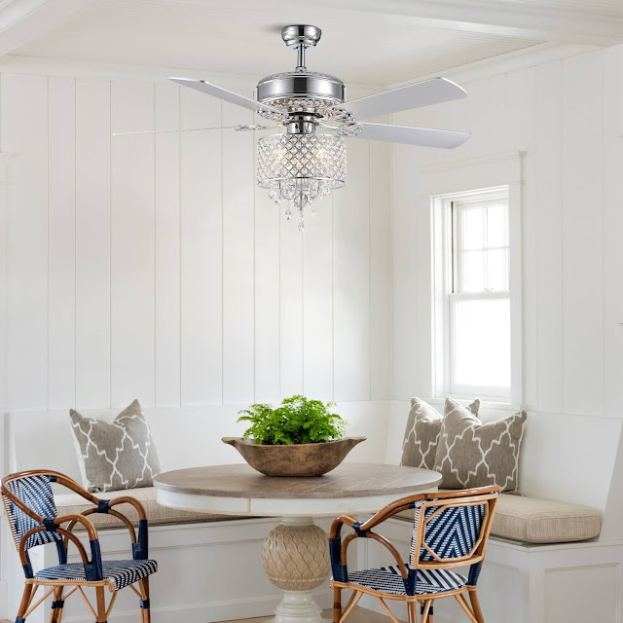](https://blogger.googleusercontent.com/img/b/R29vZ2xl/AVvXsEgyKFjTYJRcqyxAmSG7sNKsf61RuJ6E30Qi84OXrryvoHC15STqhA_kvgHwytiaMdVwJxrVQXRMjnOgAVG5wHgJ5Q0eYaq4zern20F1gILQwnJMbzGnxPN0nRMc2EVuKDM7wIQDoBipx7i2nxNIwfwIr7d3J_U9aI9rTb4Q-NA2Le5ErGhw4v70g5h4/s1500/dining%20room%20fandelier.jpg)

Have you ever felt that your body is very hot every time you eat, this is because your body emits a lot of heat when you eat. And appetite decreases when the air is hot, so having a fandelier in the restaurant is also very important.

4. Living Room Fandelier

[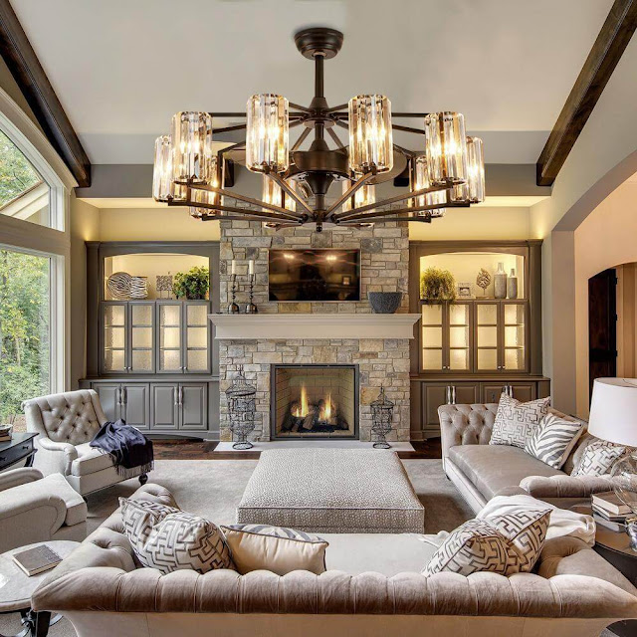](https://blogger.googleusercontent.com/img/b/R29vZ2xl/AVvXsEh1_qKOkPpI-ZeNmKsLH-CZaV20FwwMEXz5Qh8igfHl3G5Rctb8qiI2Od1QD19MKGfARExwHDNkJJTkIKuVTin5dvN4D0dpfqI2v4eH0mmpu5AiFrWhJdzHW4RSn3D5ftpjO0icBLtMDGuASxRYHsTYcSDOKu_0kn_4c1JOrF1aOh-impL_ok33tO3P/s1000/living%20room%20fandelier.jpg)

The living room should be the center of your household—the space where you hang out with family, entertain guests, and decompress in the evening. But that plushy sofa won’t get used so much if the room is too hot for comfort! Likewise, you might keep guests elsewhere in the house if there’s a naked blade spinning overhead. A fandelier will make sure your living room truly gets lived in.

5.Staircase fandelier

[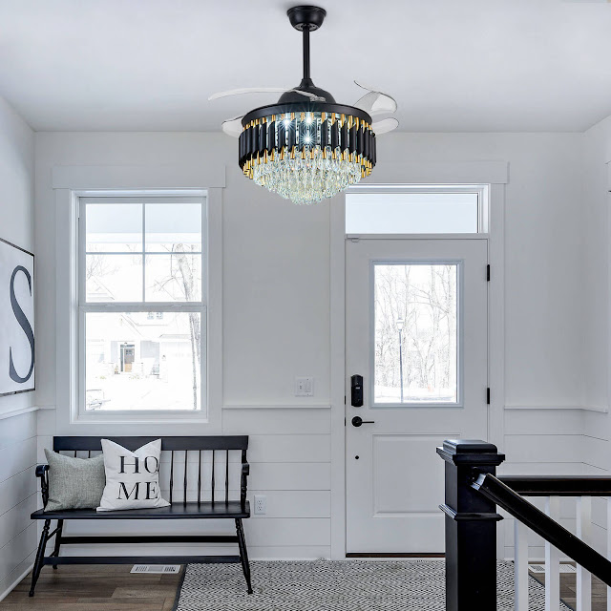](https://blogger.googleusercontent.com/img/b/R29vZ2xl/AVvXsEiegjtEMqS3xMqOpaTCWtkkSiKgUoKF-aEeMvr7KxD3kVqUbZjTtcPGz-JTrlazDR8kWAEkOB41ctys2WxTu-jKzRcUB3bbvEFf13o3zEoFzaKFVmL41oNsJiG3V_JB9tnnP5bkWLdY6HRa0nFrSy0xBbnlepGt-UfB3eLXDLkCh2HysV1r8olR1IYR/s1500/fpyer%20fandelier.jpg)

The installation of fandelier on the stairs is very beneficial to the ventilation and airflow of the house.

### Ceiling light shopping tips

Good interior design takes spaces that are overlooked or underutilized and makes them something special.

For more inspiration, check out our **Collection of Fandeliers**