Project From Moonshot to Mars
[Name of Document]

[Authors]
[Date]
[Version]



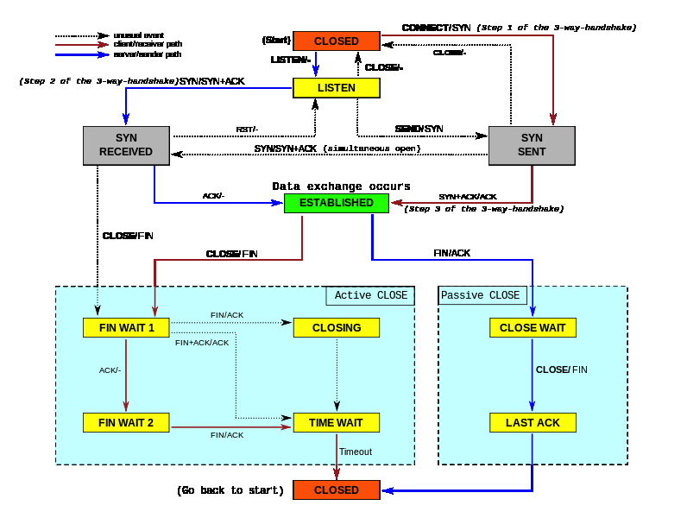

1. TCP general information
LISTEN
The servers waits for a connection request from any remote TCP and port.
SYN-SENT
The client waits for a matching connection request after having sent a connection request.
SYN-RECEIVED
The server waits for a confirming connection request acknowledgment after having both received and sent a connection request.
ESTABLISHED
Both the server and client have an open connection, data received can be delivered to the user. This is the normal state for the data transfer phase of the connection.
FIN-WAIT-1
Both the server and client are waiting for a connection termination request from the remote TCP, or an acknowledgment of the connection termination request previously sent.
FIN-WAIT-2
Both the server and the client are waiting for a connection termination request from the remote TCP.
CLOSE-WAIT
Bot the server and client are waiting for a connection termination request from the local user.
CLOSING
Both the server and client are waiting for a connection termination request acknowledgment from the remote TCP.
LAST-ACK
Both the server and client are waiting for an acknowledgment of the connection termination request previously sent to the remote TCP (which includes an acknowledgment of its connection termination request).
TIME-WAIT
The client or server is waiting for enough time to pass to be sure the remote TCP received the acknowledgment of its connection termination request. According to RFC 793 a connection can stay in TIME-WAIT for a maximum of four minutes known as a MSL maximum segment lifetime.
CLOSED
Both the server and client have no connection state at all.

1.1 Connection establishment
To establish a connection, TCP uses a three-way handshake. Before a client attempts to connect with a server, the server must first bind to and listen at a port to open it up for connections: this is called a passive open. Once the passive open is established, a client may initiate an active open. To establish a connection, the three-way (or 3-step) handshake occurs:
- SYN: The active open is performed by the client sending a SYN to the server. The client sets the segment's sequence number to a random value A.
- SYN-ACK: In response, the server replies with a SYN-ACK. The acknowledgment number is set to one more than the received sequence number (A + 1), and the sequence number that the server chooses for the packet is another random number, B.
- ACK: Finally, the client sends an ACK back to the server. The sequence number is set to the received acknowledgement value i.e. A + 1, and the acknowledgement number is set to one more than the received sequence number i.e. B + 1.
At this point, both the client and server have received an acknowledgment of the connection. The steps 1, 2 establish the connection parameter (sequence number) for one direction and it is acknowledged. The steps 2, 3 establish the connection parameter (sequence number) for the other direction and it is acknowledged. With these, a full-duplex communication is established.

1.2 Connection termination

The connection termination phase uses a four-way handshake, with each side of the connection terminating independently. When an endpoint wishes to stop its half of the connection, it transmits a FIN packet, which the other end acknowledges with an ACK. Therefore, a typical tear-down requires a pair of FIN and ACK segments from each TCP endpoint. After both FIN/ACK exchanges are concluded, the side which sent the first FIN before receiving one waits for a timeout before finally closing the connection, during which time the local port is unavailable for new connections; this prevents confusion due to delayed packets being delivered during subsequent connections.
A connection can be “half-open”, in which case one side has terminated its end, but the other has not. The side that has terminated can no longer send any data into the connection, but the other side can. The terminating side should continue reading the data until the other side terminates as well.
It is also possible to terminate the connection by a 3-way handshake, when host A sends a FIN and host B replies with a FIN & ACK (merely combines 2 steps into one) and host A replies with an ACK. This is perhaps the most common method.
It is possible for both hosts to send FINs simultaneously then both just have to ACK. This could possibly be considered a 2-way handshake since the FIN/ACK sequence is done in parallel for both directions.
Some host TCP stacks may implement a half-duplex close sequence, as Linux or HP-UX do. If such a host actively closes a connection but still has not read all the incoming data the stack already received from the link, this host sends a RST instead of a FIN (Section 4.2.2.13 in RFC1122). This allows a TCP application to be sure the remote application has read all the data the former sent—waiting the FIN from the remote side, when it actively closes the connection.
Some application protocols may violate the OSI model layers, using the TCP open/close handshaking for the application protocol open/close handshaking — these may find the RST problem on active close.

1.3 Resource usage
Most implementations allocate an entry in a table that maps a session to a running operating system process. Because TCP packets do not include a session identifier, both endpoints identify the session using the client's address and port. Whenever a packet is received, the TCP implementation must perform a lookup on this table to find the destination process.
The number of sessions in the server side is limited only by memory and can grow as new connections arrive, but the client must allocate a random port before sending the first SYN to the server. This port remains allocated during the whole conversation, and effectively limits the number of outgoing connections from each of the client's IP addresses. If an application fails to properly close unrequired connections, a client can run out of resources and become unable to establish new TCP connections, even from other applications.
Both endpoints must also allocate space for unacknowledged packets and received (but unread) data.
Some portions of this chapter can be derived from the following weblink: http://en.wikipedia.org/wiki/Transmission_Control_Protocol#cite_note-comer-2.

2. SSH
The SSH-2 protocol has an internal architecture with well-separated layers. These are:
- Transport layer:
This layer handles initial key exchange as well as server authentication, and sets up encryption, compression and integrity verification. It exposes to the upper layer an interface for sending and receiving plaintext packets with sizes of up to 32,768 bytes each (more can be allowed by the implementation). The transport layer also arranges for key re-exchange, usually after 1 GB of data has been transferred or after 1 hour has passed, whichever is sooner.
- User authentication layer:
This layer handles client authentication and provides a number of authentication methods. Authentication is client-driven: when one is prompted for a password, it may be the SSH client prompting, not the server. The server merely responds to the client's authentication requests. Widely used user authentication methods include the following:
  - Password:
A method for straightforward password authentication, including a facility allowing a password to be changed. This method is not implemented by all programs.
  - Publickey:
A method for public key-based authentication, usually supporting at least DSA or RSA keypairs, with other implementations also supporting X.509 certificates.
  - Keyboard-interacitive:
A versatile method where the server sends one or more prompts to enter information and the client displays them and sends back responses keyed-in by the user. Used to provide one-time password authentication such as S/Key or SecurID. Used by some OpenSSH configurations when PAM is the underlying host authentication provider to effectively provide password authentication, sometimes leading to inability to log in with a client that supports just the plain password authentication method.
  - GSSAPI authentication:
Methods which provide an extensible scheme to perform SSH authentication using external mechanisms such as Kerberos 5 or NTLM, providing single sign on capability to SSH sessions. These methods are usually implemented by commercial SSH implementations for use in organizations, though OpenSSH does have a working GSSAPI implementation.
- The connection layer (RFC 4254). This layer defines the concept of channels, channel requests and global requests using which SSH services are provided. A single SSH connection can host multiple channels simultaneously, each transferring data in both directions. Channel requests are used to relay out-of-band channel specific data, such as the changed size of a terminal window or the exit code of a server-side process. The SSH client requests a server-side port to be forwarded using a global request. Standard channel types include:
  - shell for terminal shells, SFTP and exec requests (including SCP transfers)
  - direct-tcpip for client-to-server forwarded connections
  - forwarded-tcpip for server-to-client forwarded connections
- The SSHFP DNS record (RFC 4255) provides the public host key fingerprints in order to aid in verifying the authenticity of the host. This open architecture provides considerable flexibility, allowing SSH to be used for a variety of purposes beyond a secure shell. The functionality of the transport layer alone is comparable to Transport Layer Security (TLS); the user authentication layer is highly extensible with custom authentication methods; and the connection layer provides the ability to multiplex many secondary sessions into a single SSH connection, a feature comparable to BEEP and not available in TLS.

2 SSH connecting to a server
In this chapter we will look deeper in setting up a SSH connection from a client to a server. Some descriptions are described from a server-side view.

The SSH-server listens on port 22 when the default port is used, when a client wants to connect to the SSH-server it will start with the TCP three-way handshake. When both parties have finished the three-way handshake the SSH connection will be set-up for the user. The server will first present the current installed SSH version to the client and vice-versa.

Next a client key exchange init packet will be send from the client to the server, inside this packet the supported algorithms are described for the client-key exchange. Using the Diffie-Hellman key exchange the shared secret will be transported from the server to the client, this is described as the client-key exchange.

The shared secret is created according to the following standard:
A random symmetric key is generated on the SSH-server, this symmetric key is encrypted with the
server's private key and send to the client. With the help of the public key the symmetric key can be derived from the packet.

From now on, the user authentication will take place. It will standard try to authenticate the user using the public/private key from the user. If this is not present, the user can authenticate itself described as “keyboard-interactive” mode.

It's now possible to securely transmit SSH packets.

SSH terminates the connection using a four-way handshake. When, for example, the client wishes to stop the connection, it transmits a FIN packet, the servers responds with an ACK when it receives the FIN packet. The server will then send a FIN packet to the client on which the client responds with an ACK. The side which sent the first FIN before receiving one, waits for a timeout before finally closing the connection, during which time the local port is unavailable for new connections. This prevents confusion due to delayed packets being delivered during subsequent connections.

2.1 Wireshark
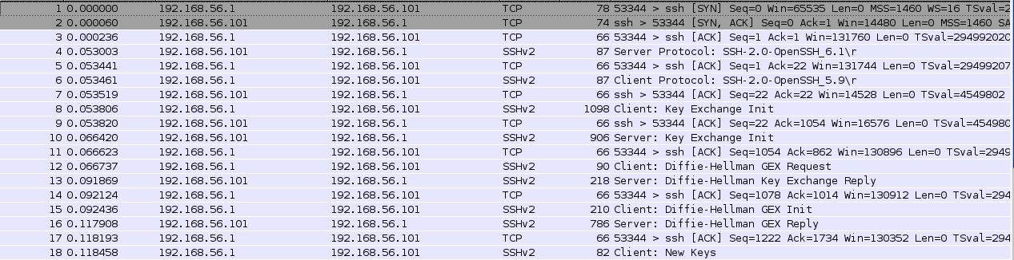
192.168.56.1 = client
192.168.56.101 = server

2.2 Debug
/etc/ssh/sshd_config line 81: Unsupported option GSSAPIAuthentication
/etc/ssh/sshd_config line 83: Unsupported option GSSAPICleanupCredentials
debug1: sshd version OpenSSH_6.1p1
debug1: read PEM private key done: type RSA
debug1: private host key: #0 type 1 RSA
debug1: read PEM private key done: type DSA
debug1: private host key: #1 type 2 DSA
debug1: rexec_argv[0]='/root/openssh-6.1p1/sshd'
debug1: rexec_argv[1]='-d'
Set /proc/self/oom_score_adj from 0 to -1000
debug1: Bind to port 22 on 0.0.0.0.
Server listening on 0.0.0.0 port 22.
debug1: Bind to port 22 on ::.
Server listening on :: port 22.
debug1: Server will not fork when running in debugging mode.
debug1: rexec start in 5 out 5 newsock 5 pipe -1 sock 8
debug1: inetd sockets after dupping: 3, 3
Connection from 192.168.56.1 port 53344
debug1: Client protocol version 2.0; client software version OpenSSH_5.9
debug1: match: OpenSSH_5.9 pat OpenSSH_5*
debug1: Enabling compatibility mode for protocol 2.0
debug1: Local version string SSH-2.0-OpenSSH_6.1
debug1: permanently_set_uid: 74/74 [preauth]
debug1: list_hostkey_types: ssh-rsa,ssh-dss [preauth]
debug1: SSH2_MSG_KEXINIT sent [preauth]
debug1: SSH2_MSG_KEXINIT received [preauth]
debug1: kex: client->server aes128-ctr hmac-md5 none [preauth]
debug1: kex: server->client aes128-ctr hmac-md5 none [preauth]
debug1: SSH2_MSG_KEX_DH_GEX_REQUEST received [preauth]
debug1: SSH2_MSG_KEX_DH_GEX_GROUP sent [preauth]
debug1: expecting SSH2_MSG_KEX_DH_GEX_INIT [preauth]
debug1: SSH2_MSG_KEX_DH_GEX_REPLY sent [preauth]
debug1: SSH2_MSG_NEWKEYS sent [preauth]
debug1: expecting SSH2_MSG_NEWKEYS [preauth]
debug1: SSH2_MSG_NEWKEYS received [preauth]
debug1: KEX done [preauth]
debug1: userauth-request for user root service ssh-connection method none [preauth]
debug1: attempt 0 failures 0 [preauth]
reprocess config line 81: Unsupported option GSSAPIAuthentication
debug1: PAM: initializing for "root"
debug1: PAM: setting PAM_RHOST to "192.168.56.1"
debug1: PAM: setting PAM_TTY to "ssh"
debug1: userauth-request for user root service ssh-connection method publickey [preauth]
debug1: attempt 1 failures 0 [preauth]
debug1: test whether pkalg/pkblob are acceptable [preauth]
debug1: temporarily_use_uid: 0/0 (e=0/0)
debug1: trying public key file /root/.ssh/authorized_keys
debug1: Could not open authorized keys '/root/.ssh/authorized_keys': No such file or directory
debug1: restore_uid: 0/0
debug1: temporarily_use_uid: 0/0 (e=0/0)
debug1: trying public key file /root/.ssh/authorized_keys2
debug1: Could not open authorized keys '/root/.ssh/authorized_keys2': No such file or directory
debug1: restore_uid: 0/0
Failed publickey for root from 192.168.56.1 port 53344 ssh2
debug1: userauth-request for user root service ssh-connection method password [preauth]
debug1: attempt 2 failures 1 [preauth]
debug1: PAM: password authentication accepted for root
debug1: do_pam_account: called
Accepted password for root from 192.168.56.1 port 53344 ssh2
debug1: monitor_read_log: child log fd closed
debug1: monitor_child_preauth: root has been authenticated by privileged process
debug1: PAM: establishing credentials
debug1: Entering interactive session for SSH2.
debug1: server_init_dispatch_20
debug1: server_input_channel_open: ctype session rchan 0 win 1048576 max 16384
debug1: input_session_request
debug1: channel 0: new [server-session]
debug1: session_new: session 0
debug1: session_open: channel 0
debug1: session_open: session 0: link with channel 0
debug1: server_input_channel_open: confirm session
debug1: server_input_global_request: rtype no-more-sessions@openssh.com want_reply 0
debug1: server_input_channel_req: channel 0 request pty-req reply 1
debug1: session_by_channel: session 0 channel 0
debug1: session_input_channel_req: session 0 req pty-req
debug1: Allocating pty.
debug1: session_pty_req: session 0 alloc /dev/pts/0
debug1: Ignoring unsupported tty mode opcode 11 (0xb)
debug1: Ignoring unsupported tty mode opcode 17 (0x11)
debug1: server_input_channel_req: channel 0 request shell reply 1
debug1: session_by_channel: session 0 channel 0
debug1: session_input_channel_req: session 0 req shell
debug1: Setting controlling tty using TIOCSCTTY.
debug1: Received SIGCHLD.
debug1: session_by_pid: pid 15710
debug1: session_exit_message: session 0 channel 0 pid 15710
debug1: session_exit_message: release channel 0
debug1: session_pty_cleanup: session 0 release /dev/pts/0
Received disconnect from 192.168.56.1: 11: disconnected by user
debug1: do_cleanup
debug1: PAM: cleanup
debug1: PAM: closing session
debug1: PAM: deleting credentials

