**This tutorial is showing the the development progress in learning Python**

The course is locating ; <https://www.udemy.com/course/complete-python-bootcamp/>

We need to install Anaconda 3. Then we will use the notebook concept and editor to learn.

* Section 1 : Python setup:

We can run Python script by typing : **Python filename.py**

This will show the result of the code.

**Or** just type **Python** which allow opening the PYTHON editor.

* Section 2: using python in VS code

How to install and using VS code (install python package)

https://code.visualstudio.com/docs/languages/python

* Section 3: **Python Object and Data Structure Basics**

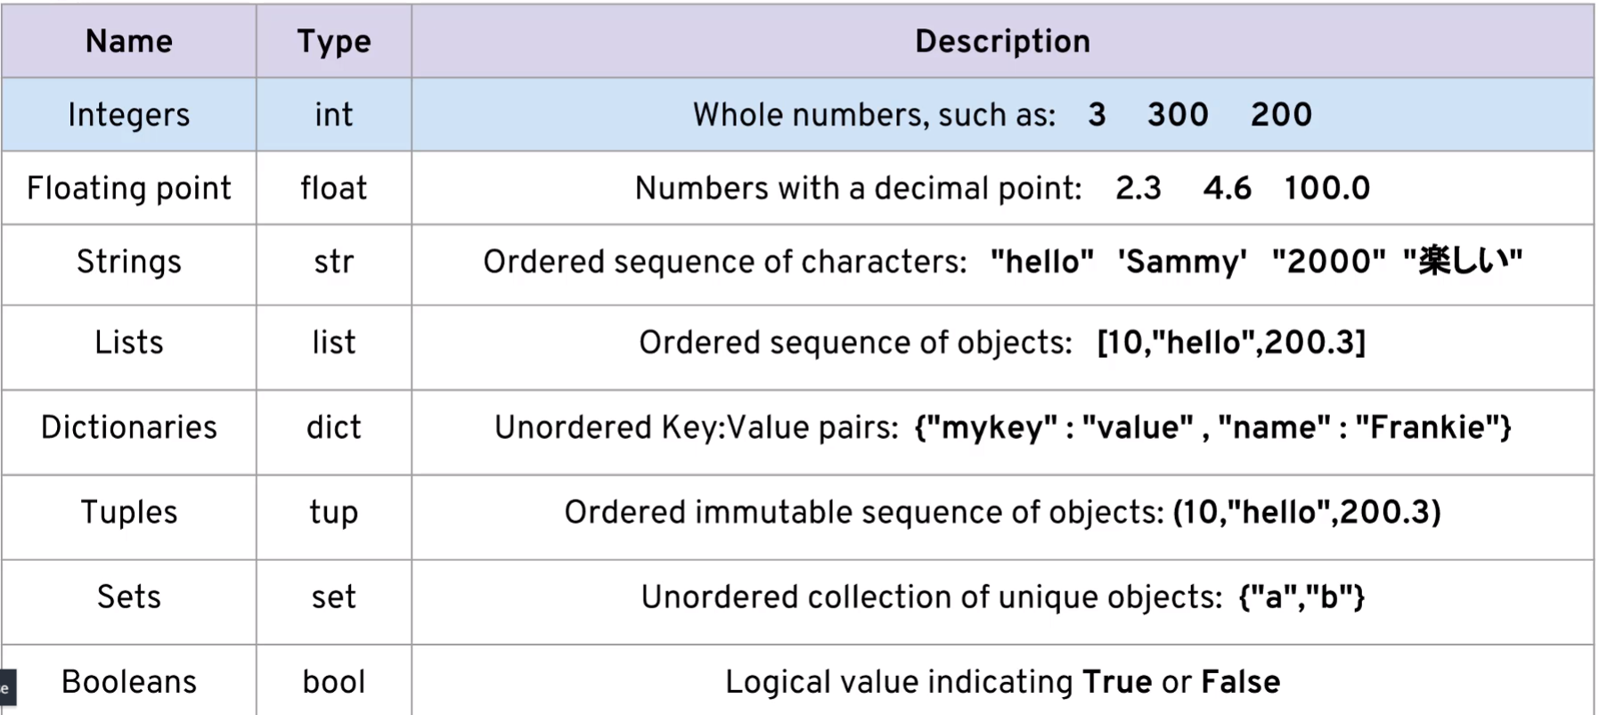

<https://docs.python.org/2/contents.html>

String : can be either “” or ‘’ , you can put them into each other if you want to use special characters

Hello :   
 Character : H e l l o

Index: 0 1 2 3 4

Reverse index:0 -4 -3 -2 -1

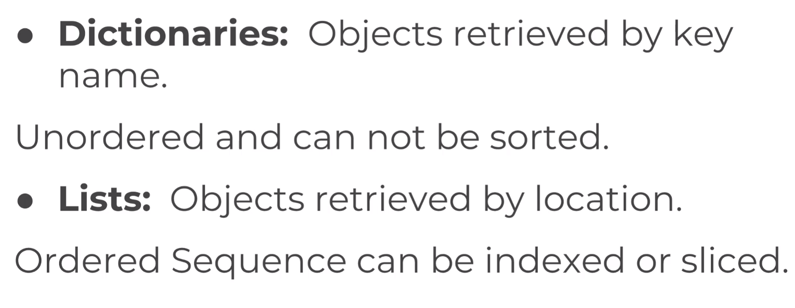

**I/O**

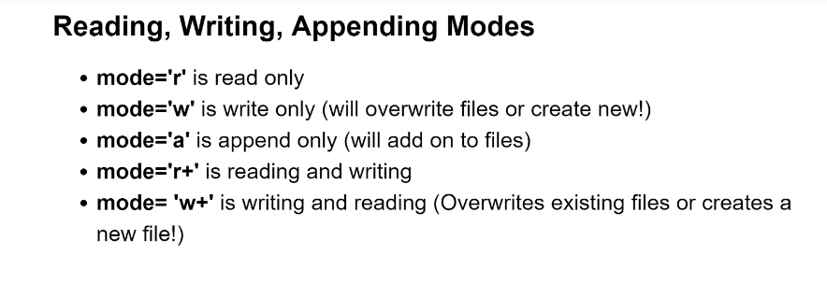

<https://realpython.com/creating-modifying-pdf/>

**Basic Practice:**

http://codingbat.com/python

**More Mathematical (and Harder) Practice:**

https://projecteuler.net/archives

**List of Practice Problems:**

http://www.codeabbey.com/index/task_list

**A SubReddit Devoted to Daily Practice Problems:**

https://www.reddit.com/r/dailyprogrammer

**A very tricky website with very few hints and touch problems (Not for beginners but still interesting)**

http://www.pythonchallenge.com/

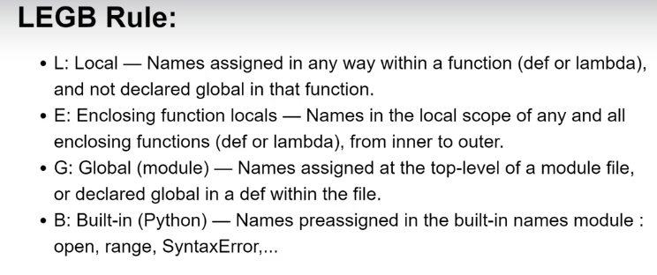

**REGULAR EXPRESSIONS PATTERNS**

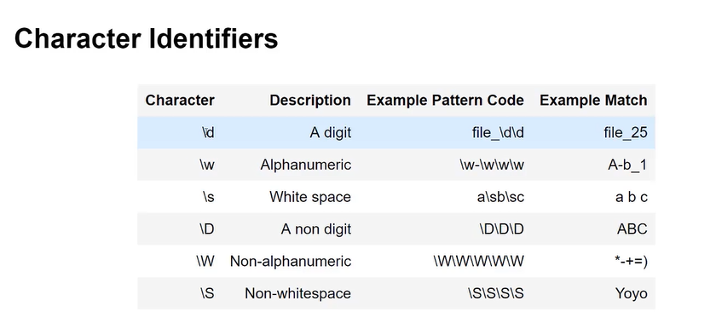

<https://realpython.com/creating-modifying-pdf/>

SMTP:Simple Mail Trasnfer Protocol

