Wang, Yue

12027710

228.371 Assignment 1

ID 00001

1.

> t.test(gas$HeatRate,mu=9750, alternative='greater')

One Sample t-test

data: gas$HeatRate

t = 3.8569, df = 31, p-value = 0.0002714

alternative hypothesis: true mean is greater than 9750

95 percent confidence interval:

10412.64 Inf

sample estimates:

mean of x

10932.44

Answer : Sample is not representative.

2.

> t.test(gas$InletTemp, gas$ExhTemp, paired=TRUE)

Paired t-test

data: gas$InletTemp and gas$ExhTemp

t = 35.3892, df = 31, p-value < 2.2e-16

alternative hypothesis: true difference in means is not equal to 0

95 percent confidence interval:

621.139 697.111

sample estimates:

mean of the differences

659.125

Answer : P value is much smaller than 0.05, and then NULL hypothesis is rejected. The default value for NULL hypothesis is zero. So the mean reduction between InletTemp and ExhTemp exists, which value is between 621.139 and 697.111.

3.

> t.test(gas$Power[gas$Engine == "Advanced"],gas$Power[gas$Engine == "Traditional"], alternative="greater")

Welch Two Sample t-test

data: gas$Power[gas$Engine == "Advanced"] and gas$Power[gas$Engine == "Traditional"]

t = 2.598, df = 21.509, p-value = 0.008297

alternative hypothesis: true difference in means is greater than 0

95 percent confidence interval:

29931.71 Inf

sample estimates:

mean of x mean of y

153469.62 65017.33

Answer:

As shown above, p-value = 0.008297, alternative hypothesis: true difference in means is greater than 0. Hence the advanced engine have more power than the other.

4

> t.test(InletTemp[Engine == 'Aeroderiv'],ExhTemp[Engine == 'Aeroderiv'],paired=TRUE)

Paired t-test

data: InletTemp[Engine == "Aeroderiv"] and ExhTemp[Engine == "Aeroderiv"]

t = 9.6462, df = 6, p-value = 7.11e-05

alternative hypothesis: true difference in means is not equal to 0

95 percent confidence interval:

438.0989 735.9011

sample estimates:

mean of the differences

587

> t.test(InletTemp[Engine == 'Advanced'],ExhTemp[Engine == 'Advanced'],paired=TRUE)

Paired t-test

data: InletTemp[Engine == "Advanced"] and ExhTemp[Engine == "Advanced"]

t = 66.5674, df = 12, p-value < 2.2e-16

alternative hypothesis: true difference in means is not equal to 0

95 percent confidence interval:

716.9696 765.4919

sample estimates:

mean of the differences

741.2308

> t.test(InletTemp[Engine == 'Traditional'],ExhTemp[Engine == 'Traditional'],paired=TRUE)

Paired t-test

data: InletTemp[Engine == "Traditional"] and ExhTemp[Engine == "Traditional"]

t = 51.2638, df = 11, p-value = 1.914e-14

alternative hypothesis: true difference in means is not equal to 0

95 percent confidence interval:

585.9634 638.5366

sample estimates:

mean of the differences

612.25

Answers: Three different types of turbines have three different estimated mean temperature reductions. The values are 587, 741.2308 and 612.25.

> anova(lm(InletTemp-ExhTemp ~ Engine))

Analysis of Variance Table

Response: InletTemp - ExhTemp

Df Sum Sq Mean Sq F value Pr(>F)

Engine 2 150419 75209 11.26 0.0002405 ***

Residuals 29 193699 6679

---

Signif. codes: 0 ‘***’ 0.001 ‘**’ 0.01 ‘*’ 0.05 ‘.’ 0.1 ‘ ’ 1

boxplot((InletTemp - ExhTemp) ~ Engine)

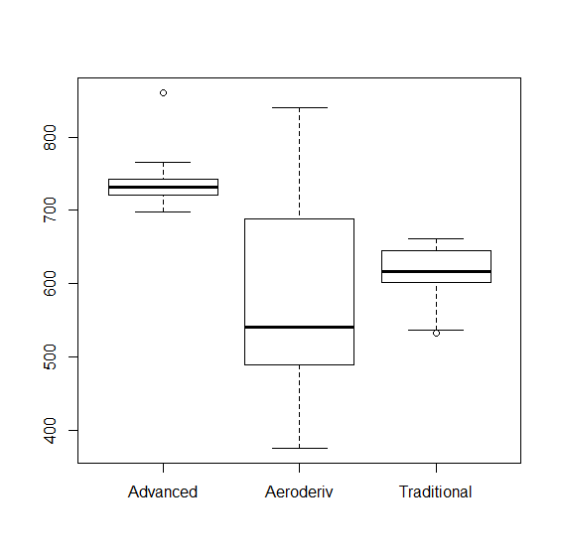

The graph shows the mean of the heat difference between inlet and outlet is different significantly.

5.

> cor.test(gas$Power, gas$Airflow)

Pearson's product-moment correlation

data: gas$Power and gas$Airflow

t = 36.0711, df = 30, p-value < 2.2e-16

alternative hypothesis: true correlation is not equal to 0

95 percent confidence interval:

0.9766740 0.9945111

sample estimates:

cor

0.9886671

Answer: P value is less than 2e-`6, Null hypothesis is rejected, hence this linear model is suitable for the relationship between Airflow and Power.

6

> qqnorm(Power)

> qqline(Power)

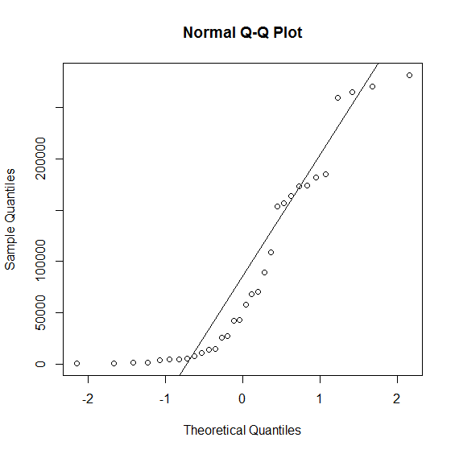

> t.test(Power)

One Sample t-test

data: Power

t = 5.3919, df = 31, p-value = 6.981e-06

alternative hypothesis: true mean is not equal to 0

95 percent confidence interval:

55776.87 123644.19

sample estimates:

mean of x

89710.53

> shapiro.test(Power)

Shapiro-Wilk normality test

data: Power

W = 0.8383, p-value = 0.0002344

Answer: As shown above the trend does not follow qqline. P value is much smaller than 0.05, so NULL hypothesis has been rejected. Null hypothesis stands for Power is normally distributed, hence this is not a normal distribution of the power of the turbines.

7

pairs(HeatRate~Engine+Shafts+RPM+CPRatio+InletTemp+ExhTemp+Airflow+Power,data=gas, main="Simple Scatterplot Matrix")

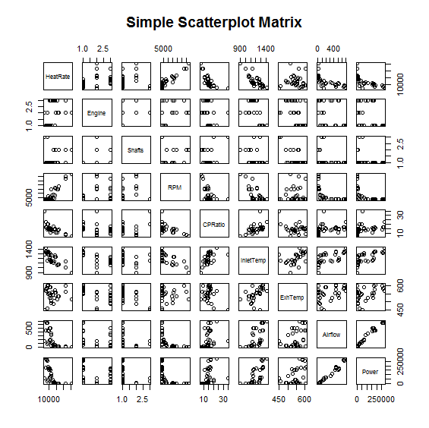

Answer: RPM and InletTemp are the numeric variables are useful as linear regression predictor.

8.

> summary(lm(HeatRate ~ RPM))

Call:

lm(formula = HeatRate ~ RPM)

Residuals:

Min 1Q Median 3Q Max

-1424.64 -404.31 -36.18 351.38 1575.73

Coefficients:

Estimate Std. Error t value Pr(>|t|)

(Intercept) 9.238e+03 1.689e+02 54.70 < 2e-16 ***

RPM 1.901e-01 1.384e-02 13.74 1.77e-14 ***

---

Signif. codes: 0 ‘***’ 0.001 ‘**’ 0.01 ‘*’ 0.05 ‘.’ 0.1 ‘ ’ 1

Residual standard error: 652.9 on 30 degrees of freedom

Multiple R-squared: 0.8628, Adjusted R-squared: 0.8583

F-statistic: 188.7 on 1 and 30 DF, p-value: 1.772e-14

Answer : p value is 1.777e-14 and Multiple R-squared: 0.8628 which is close to 1, hence these two data sets fit to a linear model.

9.

> summary(lm(HeatRate ~ InletTemp))

Call:

lm(formula = HeatRate ~ InletTemp)

Residuals:

Min 1Q Median 3Q Max

-1989.23 -847.72 -33.47 547.72 2864.75

Coefficients:

Estimate Std. Error t value Pr(>|t|)

(Intercept) 24798.940 1958.107 12.665 1.43e-13 ***

InletTemp -11.501 1.616 -7.115 6.50e-08 ***

---

Signif. codes: 0 ‘***’ 0.001 ‘**’ 0.01 ‘*’ 0.05 ‘.’ 0.1 ‘ ’ 1

Residual standard error: 1075 on 30 degrees of freedom

Multiple R-squared: 0.6279, Adjusted R-squared: 0.6155

F-statistic: 50.63 on 1 and 30 DF, p-value: 6.498e-08

Answer : Multiple R-squared: 0.6279, hence InletTemp is ok, but RPM is a better choice.

10.

> summary(lm(HeatRate~InletTemp*RPM))

Call:

lm(formula = HeatRate ~ InletTemp * RPM)

Residuals:

Min 1Q Median 3Q Max

-1510.85 -217.73 84.35 208.47 1176.65

Coefficients:

Estimate Std. Error t value Pr(>|t|)

(Intercept) 1.438e+04 1.778e+03 8.088 8.33e-09 ***

InletTemp -3.957e+00 1.421e+00 -2.785 0.0095 **

RPM 1.711e-01 1.037e-01 1.651 0.1100

InletTemp:RPM -2.007e-05 9.584e-05 -0.209 0.8356

---

Signif. codes: 0 ‘***’ 0.001 ‘**’ 0.01 ‘*’ 0.05 ‘.’ 0.1 ‘ ’ 1

Residual standard error: 563.3 on 28 degrees of freedom

Multiple R-squared: 0.9047, Adjusted R-squared: 0.8945

F-statistic: 88.62 on 3 and 28 DF, p-value: 2.103e-14

Answer : the interaction term was not required.

11.

> summary(lm(formula = HeatRate ~ Shafts + RPM + CPRatio + InletTemp + ExhTemp + Airflow + Power))

Call:

lm(formula = HeatRate ~ Shafts + RPM + CPRatio + InletTemp +

ExhTemp + Airflow + Power)

Residuals:

Min 1Q Median 3Q Max

-991.83 -215.47 -62.23 193.12 954.98

Coefficients:

Estimate Std. Error t value Pr(>|t|)

(Intercept) 1.168e+04 2.196e+03 5.318 1.86e-05 ***

Shafts 4.559e+01 2.146e+02 0.212 0.8335

RPM 1.082e-01 2.282e-02 4.741 8.02e-05 ***

CPRatio -1.619e+01 4.058e+01 -0.399 0.6935

InletTemp -6.337e+00 2.283e+00 -2.776 0.0105 *

ExhTemp 1.156e+01 5.436e+00 2.126 0.0440 *

Airflow 9.665e-01 3.260e+00 0.296 0.7694

Power -4.860e-03 8.253e-03 -0.589 0.5615

---

Signif. codes: 0 ‘***’ 0.001 ‘**’ 0.01 ‘*’ 0.05 ‘.’ 0.1 ‘ ’ 1

Residual standard error: 441.6 on 24 degrees of freedom

Multiple R-squared: 0.9498, Adjusted R-squared: 0.9351

F-statistic: 64.86 on 7 and 24 DF, p-value: 4.793e-14

12.

Answer: According to beta values, when predictor variables of Shaft, CPRatio, InletTemp, Power increase, the response variable decrease with each particular ratio.

13.

> summary(lm(HeatRate~InletTemp+RPM))

Call:

lm(formula = HeatRate ~ InletTemp + RPM)

Residuals:

Min 1Q Median 3Q Max

-1529.9 -243.1 83.9 208.5 1168.8

Coefficients:

Estimate Std. Error t value Pr(>|t|)

(Intercept) 1.457e+04 1.504e+03 9.688 1.35e-10 ***

InletTemp -4.123e+00 1.158e+00 -3.561 0.0013 **

RPM 1.497e-01 1.633e-02 9.169 4.55e-10 ***

---

Signif. codes: 0 ‘***’ 0.001 ‘**’ 0.01 ‘*’ 0.05 ‘.’ 0.1 ‘ ’ 1

Residual standard error: 553.9 on 29 degrees of freedom

Multiple R-squared: 0.9046, Adjusted R-squared: 0.898

F-statistic: 137.4 on 2 and 29 DF, p-value: 1.605e-15

> summary(lm(HeatRate~Shafts+RPM+CPRatio+InletTemp+ExhTemp+Airflow+Power))

Call:

lm(formula = HeatRate ~ Shafts + RPM + CPRatio + InletTemp +

ExhTemp + Airflow + Power)

Residuals:

Min 1Q Median 3Q Max

-991.83 -215.47 -62.23 193.12 954.98

Coefficients:

Estimate Std. Error t value Pr(>|t|)

(Intercept) 1.168e+04 2.196e+03 5.318 1.86e-05 ***

Shafts 4.559e+01 2.146e+02 0.212 0.8335

RPM 1.082e-01 2.282e-02 4.741 8.02e-05 ***

CPRatio -1.619e+01 4.058e+01 -0.399 0.6935

InletTemp -6.337e+00 2.283e+00 -2.776 0.0105 *

ExhTemp 1.156e+01 5.436e+00 2.126 0.0440 *

Airflow 9.665e-01 3.260e+00 0.296 0.7694

Power -4.860e-03 8.253e-03 -0.589 0.5615

---

Signif. codes: 0 ‘***’ 0.001 ‘**’ 0.01 ‘*’ 0.05 ‘.’ 0.1 ‘ ’ 1

Residual standard error: 441.6 on 24 degrees of freedom

Multiple R-squared: 0.9498, Adjusted R-squared: 0.9351

F-statistic: 64.86 on 7 and 24 DF, p-value: 4.793e-14

Answer: Applying least squared theory, 7-predictor has smaller Residual standard error. Hence it has better predictive than the 2-predictor model.

14.

> summary(lm(HeatRate~Shafts+RPM+CPRatio+InletTemp+ExhTemp+Airflow+Power))

Call:

lm(formula = HeatRate ~ Shafts + RPM + CPRatio + InletTemp +

ExhTemp + Airflow + Power)

Residuals:

Min 1Q Median 3Q Max

-991.83 -215.47 -62.23 193.12 954.98

Coefficients:

Estimate Std. Error t value Pr(>|t|)

(Intercept) 1.168e+04 2.196e+03 5.318 1.86e-05 ***

Shafts 4.559e+01 2.146e+02 0.212 0.8335

RPM 1.082e-01 2.282e-02 4.741 8.02e-05 ***

CPRatio -1.619e+01 4.058e+01 -0.399 0.6935

InletTemp -6.337e+00 2.283e+00 -2.776 0.0105 *

ExhTemp 1.156e+01 5.436e+00 2.126 0.0440 *

Airflow 9.665e-01 3.260e+00 0.296 0.7694

Power -4.860e-03 8.253e-03 -0.589 0.5615

---

Signif. codes: 0 ‘***’ 0.001 ‘**’ 0.01 ‘*’ 0.05 ‘.’ 0.1 ‘ ’ 1

Residual standard error: 441.6 on 24 degrees of freedom

Multiple R-squared: 0.9498, Adjusted R-squared: 0.9351

F-statistic: 64.86 on 7 and 24 DF, p-value: 4.793e-14

Answer: As shown above, it means 94.98% variation.

15.

P value is 4.793e-14, much less than 0.01, Null hypothesis is rejected. Hence this model is good to predicate HeatRate.

16.

> lm1<-lm(HeatRate~Shafts+RPM+CPRatio+InletTemp+ExhTemp+Airflow+Power)

> hatvalues(lm1)

1 2 3 4 5 6 7 8

0.4284616 0.3252555 0.1641741 0.7507745 0.5133682 0.4849646 0.2036465 0.1885726

9 10 11 12 13 14 15 16

0.1761790 0.2563977 0.2641164 0.2880030 0.3192141 0.1678053 0.1670899 0.2168007

17 18 19 20 21 22 23 24

0.2168691 0.1559862 0.3693915 0.1646246 0.1452208 0.1148014 0.4081885 0.1573087

25 26 27 28 29 30 31 32

0.1635554 0.1737555 0.1835541 0.1591480 0.2287911 0.1181886 0.2243930 0.1013998

> which((hatvalues(lm1)/mean(hatvalues(lm1))>2))

4 5

4 5

Answer: two of leverages more than twice the mean leverage. But there is no enough evidence to prove 4,5 are significantly influential.

17.

Applying stepwise algorithm:

> m1<-lm(HeatRate~Shafts+RPM+CPRatio+InletTemp+ExhTemp+Airflow+Power)

> m0<-lm(HeatRate~1, data = swiss)

> m2<-step(m0,scope=~Shafts+RPM+CPRatio+InletTemp+ExhTemp+Airflow+Power, direction="both")

Start: AIC=478.32

HeatRate ~ 1

Df Sum of Sq RSS AIC

+ RPM 1 80446795 12788995 416.75

+ InletTemp 1 58543841 34691949 448.68

+ CPRatio 1 45683457 47552333 458.77

+ Airflow 1 39749292 53486498 462.53

+ Power 1 38757766 54478024 463.12

<none> 93235790 478.32

+ Shafts 1 2105658 91130131 479.59

+ ExhTemp 1 32823 93202967 480.31

Step: AIC=416.75

HeatRate ~ RPM

Df Sum of Sq RSS AIC

+ CPRatio 1 4995085 7793910 402.90

+ InletTemp 1 3891445 8897550 407.14

+ Shafts 1 950016 11838979 416.28

+ Power 1 853856 11935139 416.54

<none> 12788995 416.75

+ Airflow 1 392791 12396204 417.75

+ ExhTemp 1 4980 12784015 418.74

- RPM 1 80446795 93235790 478.32

Step: AIC=402.9

HeatRate ~ RPM + CPRatio

Df Sum of Sq RSS AIC

+ InletTemp 1 1866842 5927068 396.14

+ Power 1 1318310 6475600 398.97

+ Airflow 1 1091714 6702196 400.07

+ ExhTemp 1 835555 6958355 401.27

<none> 7793910 402.90

+ Shafts 1 234852 7559058 403.92

- CPRatio 1 4995085 12788995 416.75

- RPM 1 39758423 47552333 458.77

Step: AIC=396.14

HeatRate ~ RPM + CPRatio + InletTemp

Df Sum of Sq RSS AIC

+ ExhTemp 1 523560 5403508 395.18

<none> 5927068 396.14

+ Power 1 319598 5607470 396.36

+ Airflow 1 308565 5618503 396.43

+ Shafts 1 33628 5893440 397.96

- InletTemp 1 1866842 7793910 402.90

- CPRatio 1 2970482 8897550 407.14

- RPM 1 19804634 25731702 441.12

Step: AIC=395.18

HeatRate ~ RPM + CPRatio + InletTemp + ExhTemp

Df Sum of Sq RSS AIC

+ Power 1 699396 4704112 392.74

+ Airflow 1 651517 4751991 393.07

- CPRatio 1 93602 5497110 393.73

<none> 5403508 395.18

- ExhTemp 1 523560 5927068 396.14

+ Shafts 1 1206 5402302 397.17

- InletTemp 1 1554848 6958355 401.27

- RPM 1 11111263 16514770 428.93

Step: AIC=392.74

HeatRate ~ RPM + CPRatio + InletTemp + ExhTemp + Power

Df Sum of Sq RSS AIC

- CPRatio 1 38144 4742256 391.00

<none> 4704112 392.74

+ Airflow 1 14173 4689939 394.65

+ Shafts 1 5840 4698272 394.70

- Power 1 699396 5403508 395.18

- ExhTemp 1 903358 5607470 396.36

- InletTemp 1 1656870 6360982 400.40

- RPM 1 6797549 11501660 419.35

Step: AIC=391

HeatRate ~ RPM + InletTemp + ExhTemp + Power

Df Sum of Sq RSS AIC

<none> 4742256 391.00

+ CPRatio 1 38144 4704112 392.74

+ Airflow 1 27094 4715162 392.82

+ Shafts 1 445 4741811 393.00

- Power 1 754854 5497110 393.73

- ExhTemp 1 4145633 8887889 409.10

- InletTemp 1 6735273 11477529 417.29

- RPM 1 7413766 12156023 419.12

Answer: My reduced model is HeaRate vs CPRatio, RPM ,InletTemp.

18.

> full_model <- lm(HeatRate~Shafts+RPM+CPRatio+InletTemp+ExhTemp+Airflow+Power)

> reduced_model <- lm(HeatRate~CPRatio+RPM+InletTemp)

> anova(full_model,reduced_model)

Analysis of Variance Table

Model 1: HeatRate ~ Shafts + RPM + CPRatio + InletTemp + ExhTemp + Airflow +

Power

Model 2: HeatRate ~ CPRatio + RPM + InletTemp

Res.Df RSS Df Sum of Sq F Pr(>F)

1 24 4681132

2 28 5927068 -4 -1245936 1.597 0.2075

Answer: reduced model is better.

19.

> par(mfrow=c(2,2))

> plot(reduced_model)

The graph generated:

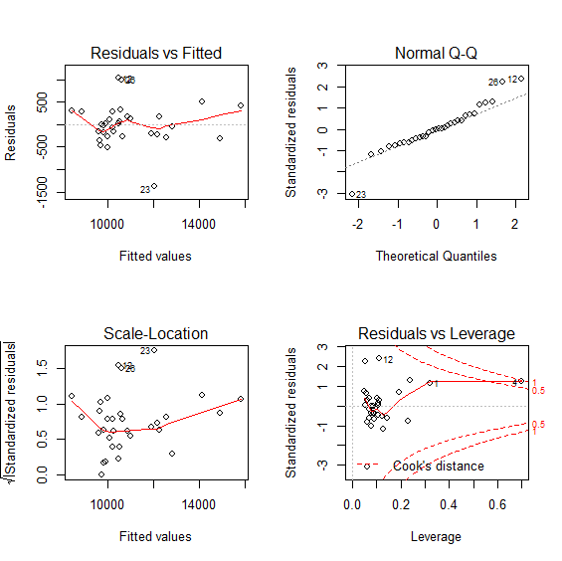

20.

> vif(reduced_model)

CPRatio RPM InletTemp

1.561515 2.076288 2.124232

> which(cooks.distance(reduced_model)>1)

named integer(0)

> vif(reduced_model)

CPRatio RPM InletTemp

1.561515 2.076288 2.124232

Answer: as shown above, cooks distance is less than 1 and vif less than 10.Hence, nothing to worry about.

21.

> poly1<-lm(HeatRate~poly(InletTemp,1,raw=T))

> poly2<-lm(HeatRate~poly(InletTemp,2,raw=T))

> poly3<-lm(HeatRate~poly(InletTemp,3,raw=T))

> anova(poly1,poly2)

Analysis of Variance Table

Model 1: HeatRate ~ poly(InletTemp, 1, raw = T)

Model 2: HeatRate ~ poly(InletTemp, 2, raw = T)

Res.Df RSS Df Sum of Sq F Pr(>F)

1 30 34691949

2 29 28960612 1 5731337 5.7391 0.02327 *

---

Signif. codes: 0 ‘***’ 0.001 ‘**’ 0.01 ‘*’ 0.05 ‘.’ 0.1 ‘ ’ 1

> anova(poly1,poly3)

Analysis of Variance Table

Model 1: HeatRate ~ poly(InletTemp, 1, raw = T)

Model 2: HeatRate ~ poly(InletTemp, 3, raw = T)

Res.Df RSS Df Sum of Sq F Pr(>F)

1 30 34691949

2 28 28358735 2 6333214 3.1265 0.05949 .

---

Signif. codes: 0 ‘***’ 0.001 ‘**’ 0.01 ‘*’ 0.05 ‘.’ 0.1 ‘ ’ 1

> anova(poly2,poly3)

Analysis of Variance Table

Model 1: HeatRate ~ poly(InletTemp, 2, raw = T)

Model 2: HeatRate ~ poly(InletTemp, 3, raw = T)

Res.Df RSS Df Sum of Sq F Pr(>F)

1 29 28960612

2 28 28358735 1 601877 0.5943 0.4472

Answer: 0.02327 is smallest one. Hence the model with degree 2 is the best model.

22.

> poly2<-lm(HeatRate~poly(CPRatio,RPM,degree=2,raw=TRUE))

> newdata<-data.frame(RPM=rep(4500,19),CPRatio=seq(7,35,1.5))

> predict1<-predict.lm(poly2,newdata)

> plot(newdata$CPRatio,predict1,type='l')

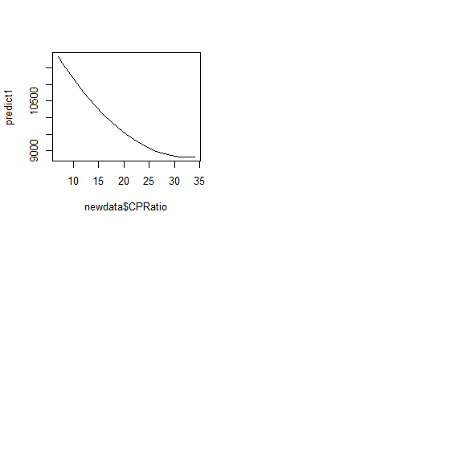

Answer: When RPM equals to 4900 rpm, and CPRatio is between 7 and 35.

23.

> plot(RPM,resid(poly2),col=Engine)

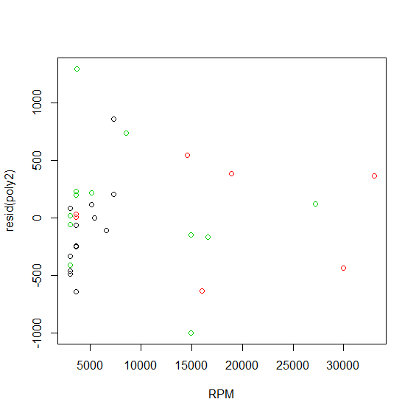

24.

> poly_with_engine<-lm(HeatRate~poly(CPRatio,RPM,degree=2,raw=TRUE)+Engine)

> summary(poly_with_engine)

Call:

lm(formula = HeatRate ~ poly(CPRatio, RPM, degree = 2, raw = TRUE) +

Engine)

Residuals:

Min 1Q Median 3Q Max

-1048.15 -256.65 3.56 181.36 1138.72

Coefficients:

Estimate Std. Error t value

(Intercept) 1.171e+04 2.242e+03 5.221

poly(CPRatio, RPM, degree = 2, raw = TRUE)1.0 -1.768e+02 1.884e+02 -0.939

poly(CPRatio, RPM, degree = 2, raw = TRUE)2.0 2.213e+00 3.517e+00 0.629

poly(CPRatio, RPM, degree = 2, raw = TRUE)0.1 1.851e-01 2.053e-01 0.901

poly(CPRatio, RPM, degree = 2, raw = TRUE)1.1 -3.942e-03 1.015e-02 -0.388

poly(CPRatio, RPM, degree = 2, raw = TRUE)0.2 -1.859e-07 3.413e-06 -0.054

EngineAeroderiv 2.862e+02 3.371e+02 0.849

EngineTraditional 3.109e+02 2.578e+02 1.206

Pr(>|t|)

(Intercept) 2.38e-05 ***

poly(CPRatio, RPM, degree = 2, raw = TRUE)1.0 0.357

poly(CPRatio, RPM, degree = 2, raw = TRUE)2.0 0.535

poly(CPRatio, RPM, degree = 2, raw = TRUE)0.1 0.376

poly(CPRatio, RPM, degree = 2, raw = TRUE)1.1 0.701

poly(CPRatio, RPM, degree = 2, raw = TRUE)0.2 0.957

EngineAeroderiv 0.404

EngineTraditional 0.240

---

Signif. codes: 0 ‘***’ 0.001 ‘**’ 0.01 ‘*’ 0.05 ‘.’ 0.1 ‘ ’ 1

Residual standard error: 511.3 on 24 degrees of freedom

Multiple R-squared: 0.9327, Adjusted R-squared: 0.9131

F-statistic: 47.51 on 7 and 24 DF, p-value: 1.548e-12

Answer: p value: 1.548e-12, hence adding Engine improved this model.

25.

> another_poly_with_engine <- lm(HeatRate~poly(CPRatio,RPM,degree=2,raw=TRUE)*Engine)

> anova(another_poly_with_engine,poly_with_engine)

Analysis of Variance Table

Model 1: HeatRate ~ poly(CPRatio, RPM, degree = 2, raw = TRUE) * Engine

Model 2: HeatRate ~ poly(CPRatio, RPM, degree = 2, raw = TRUE) + Engine

Res.Df RSS Df Sum of Sq F Pr(>F)

1 14 2218234

2 24 6275250 -10 -4057016 2.5605 0.05284 .

---

Signif. codes: 0 ‘***’ 0.001 ‘**’ 0.01 ‘*’ 0.05 ‘.’ 0.1 ‘ ’ 1