1. Introduction

An algorithm is any well-defined computational procedure that takes some value, or set of values, as input and produces some value, or set of values, as output. [clrs.ch1] To find out how data sizes, programming languages and operating systems affect performance of an algorithm, this experiment chose Quick Sort as the algorithm for testing using MiniTab 17. Data size , programming languages and Operating systems were chosen as experiment factors, running time as response.

1. Aim and objectives

Using MiniTab 17 find out to what extent data sizes, programming languages and operating systems affect performance of a specific algorithm, i. e. Quick Sort.

1. Materials and Method

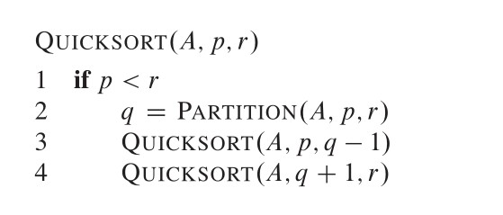

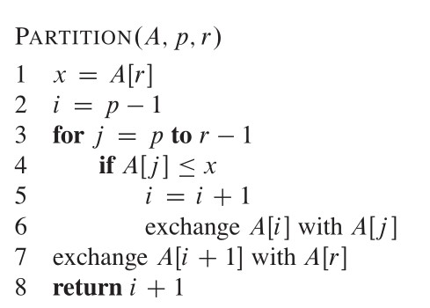

[clrs.3]

Materials and

Method

Data

|  |  |  |  |  |  |  |
| --- | --- | --- | --- | --- | --- | --- |
| StdOrder | RunOrder | Size | Languages | OS | Y1 | Y2 |
| 1 | 3 | 1.00E+08 | cpp | win | 302 | 355 |
| 2 | 2 | 1.00E+07 | cpp | win | 56 | 67 |
| 3 | 1 | 1.00E+08 | cs | win | 340 | 412 |
| 4 | 4 | 1.00E+07 | cs | win | 78 | 82 |
| 5 | 5 | 1.00E+08 | cpp | lin | 289 | 311 |
| 6 | 8 | 1.00E+07 | cpp | lin | 43 | 65 |
| 7 | 7 | 1.00E+08 | cs | lin | 387 | 416 |
| 8 | 6 | 1.00E+07 | cs | lin | 78 | 89 |

Plots:









Based on the normal probability plot of effects and the Pareto chats above, it can be seen that term A, i.e. Data Size is the only significant term.

[Engineering meaning..]



From the main effects plots , it can be found that Factor Size is the most influential factor that affects Y (because it has the highest mean change of Y, in other words the highest slope), followed by factors Languages. Factor OS has no practically important effect.

[Engineering meaning..]





**No interaction seems to be influential interactions, as no interaction plots are very un-parallel.**

[Engineering meaning..]







**Factorial Regression: Y1 versus Size, Languages, OS**

Analysis of Variance

Source DF Adj SS Adj MS F-Value P-Value

Model 4 146624 36656 82.54 0.002

Linear 3 145957 48652 109.55 0.001

Size 1 141246 141246 318.03 0.000

Languages 1 4656 4656 10.48 0.048

OS 1 55 55 0.12 0.748

2-Way Interactions 1 666 666 1.50 0.308

Languages*OS 1 666 666 1.50 0.308

Error 3 1332 444

Total 7 147956

Model Summary

S R-sq R-sq(adj) R-sq(pred)

21.0743 99.10% 97.90% 93.60%

Coded Coefficients

Term Effect Coef SE Coef T-Value P-Value VIF

Constant 196.63 7.45 26.39 0.000

Size 265.75 132.88 7.45 17.83 0.000 1.00

Languages -48.25 -24.12 7.45 -3.24 0.048 1.00

OS 5.25 2.62 7.45 0.35 0.748 1.00

Languages*OS -18.25 -9.12 7.45 -1.22 0.308 1.00

Regression Equation in Uncoded Units

Y1 = 34.2 + 0.000003 Size - 24.12 Languages + 2.62 OS - 9.12 Languages*OS

Alias Structure

Factor Name

A Size

B Languages

C OS

Aliases

I

A

B

C

BC

**Factorial Regression: Y2 versus Size, Languages, OS**

Analysis of Variance

Source DF Adj SS Adj MS F-Value P-Value

Model 4 182920 45730 58.77 0.004

Linear 3 182513 60838 78.19 0.002

Size 1 177310 177310 227.87 0.001

Languages 1 5050 5050 6.49 0.084

OS 1 153 153 0.20 0.687

2-Way Interactions 1 406 406 0.52 0.522

Languages*OS 1 406 406 0.52 0.522

Error 3 2334 778

Total 7 185254

Model Summary

S R-sq R-sq(adj) R-sq(pred)

27.8949 98.74% 97.06% 91.04%

Coded Coefficients

Term Effect Coef SE Coef T-Value P-Value VIF

Constant 224.63 9.86 22.78 0.000

Size 297.75 148.88 9.86 15.10 0.001 1.00

Languages -50.25 -25.12 9.86 -2.55 0.084 1.00

OS -8.75 -4.37 9.86 -0.44 0.687 1.00

Languages*OS -14.25 -7.12 9.86 -0.72 0.522 1.00

Regression Equation in Uncoded Units

Y2 = 42.7 + 0.000003 Size - 25.12 Languages - 4.37 OS - 7.12 Languages*OS

Alias Structure

Factor Name

A Size

B Languages

C OS

Aliases

I

A

B

C

BC