Talking to the hardware.

Writing programs that talk to the serial port in Windows is not all that hard, but it is not something that we need to be experts at – especially as we also need to link them into a Qt project.

We will use a package that has already been written.

Installing it is quite tricky, and we need to make sure that we put the extra source files in the correct folder.

Download the qextserialport.zip file from Stream.

Create a new Qt project and derive from the QDialog class.

In the same folder as your main.cpp file, unzip qextserialport.zip.

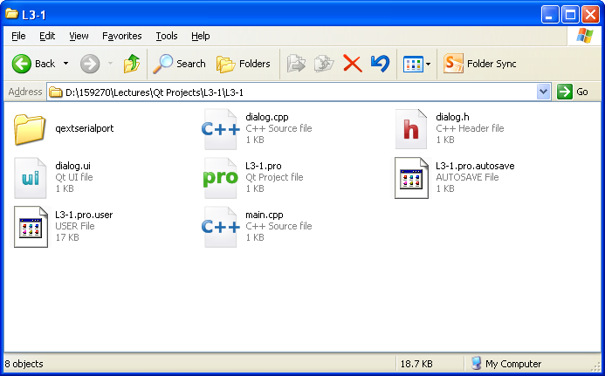

When you open up the qextserialport folder, you should see:
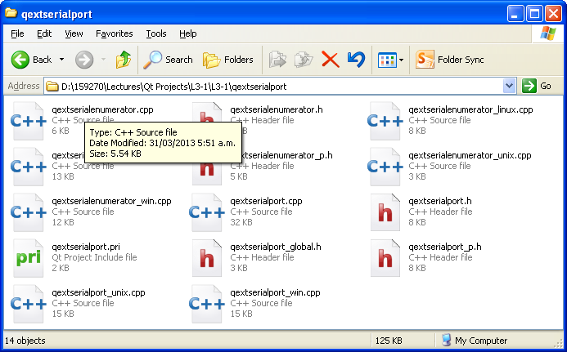

If you see another qextserialport folder, then this is not correct and you need to transfer all the files in that folder up one level and then delete the empty duplicated qextserialport folder.

Go to Qt and in Edit mode double click your .pro file:

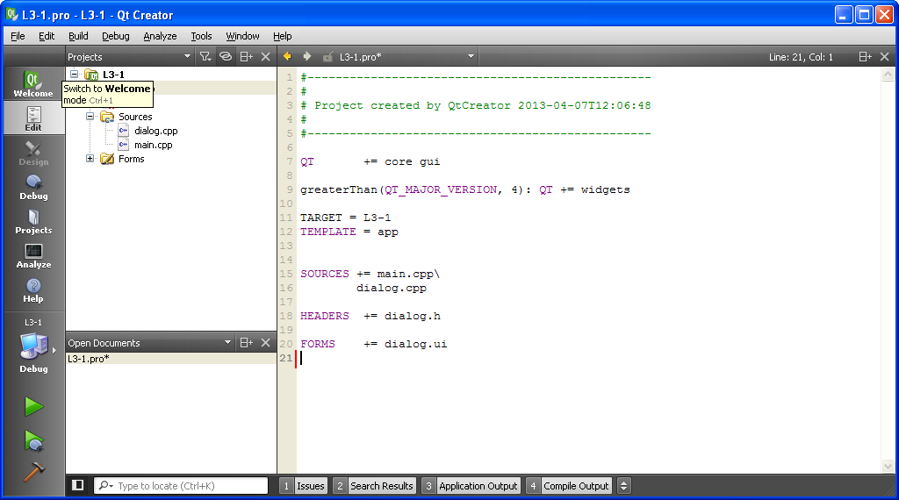

At the bottom of this file type:

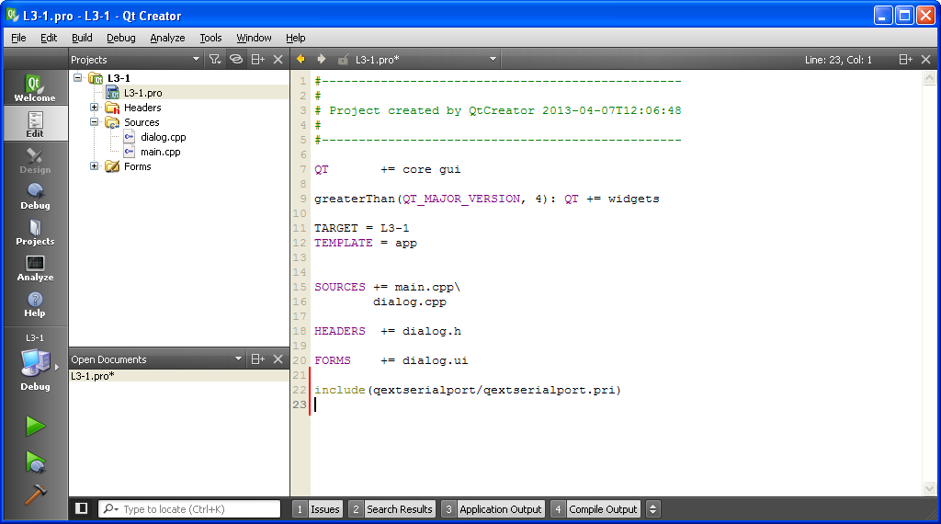

The .pri file is similar to a .pro file, and tells qmake to insert several source files into your project – we'll be having a look "under the hood" in Lecture 5.

Now when you build the project – even though you still haven't added anything to the form, the serial port source code will be visible and available:

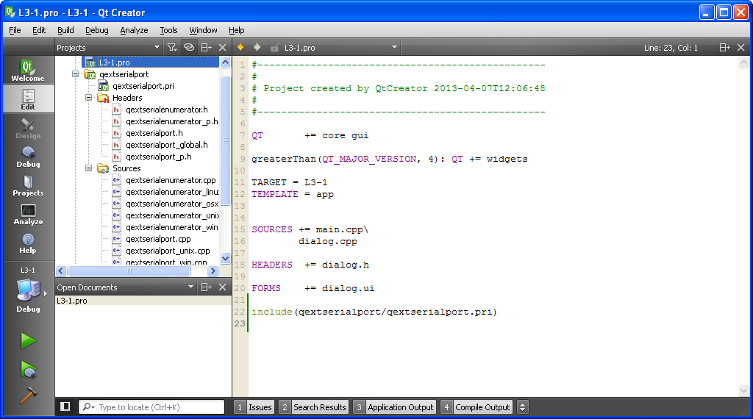

You need to do this copying and editing every time you create a project that wants to talk to the serial port.

Remembering that is a lot easier to get something simple to work first and then enhance it – our first program is going to do what we first did with the uart hardware and PuTTY.

If we connect the TXD and RXD pins of the uart/USB hardware, then any character that we send from the PC is echoed back to the PC.

We use the same COM port as PuTTY uses – either COM3 or COM4 depending on your particular hardware.

This first program won't guarantee that we will be able to talk to the Discovery board – whatever we choose for the data transfer rate will work).

Once we have this working, we can then remove the connection between TXD and RXD, connect it up to the Discovery board, and try it against the interrupt driven "echo program" we wrote (Lecture HW 9).

At this stage we will be sure that we have configured the COM port in the same way as the Discovery board.

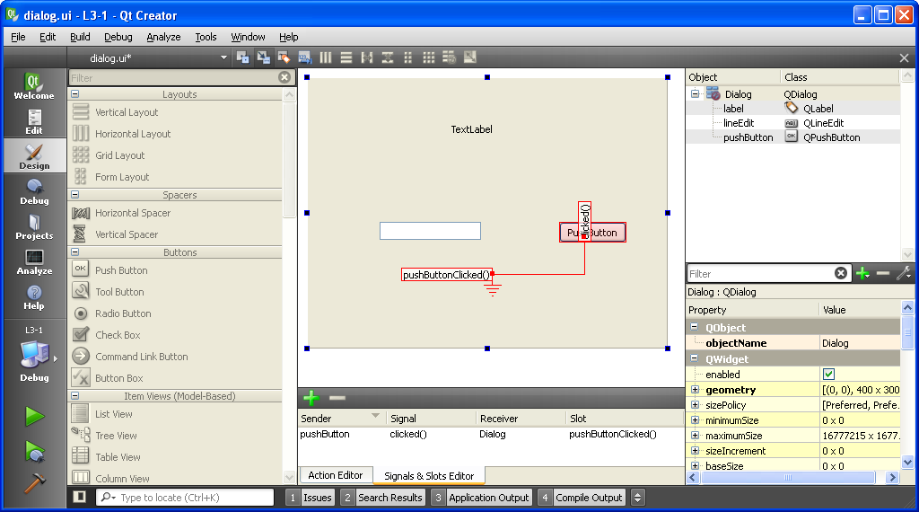

Place a button, a line edit and a label on a form.

In the signal/slots editor:

connect the clicked signal of the push button to (a new) pushButtonClicked slot of the dialog's form.

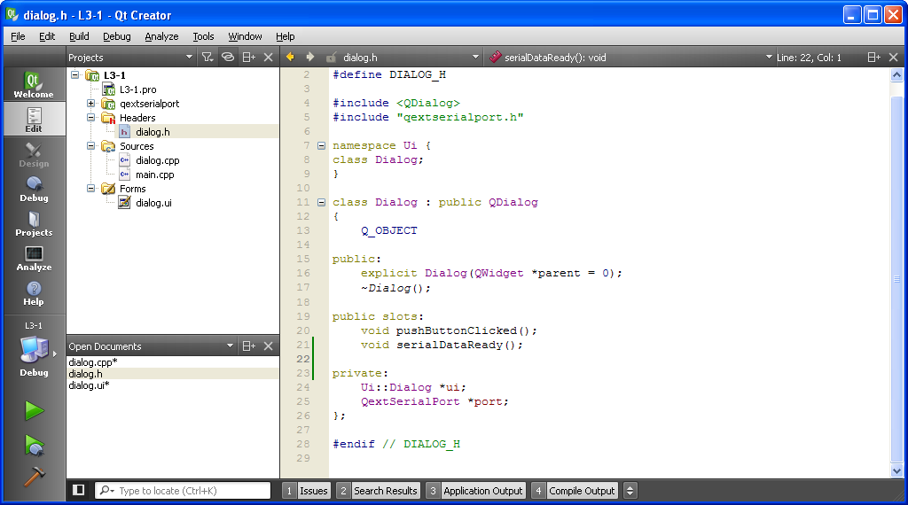

In the editor add the following to dialog.h:

#include "qextserialport.h"

Two slots:

public slots:
void pushButtonClicked();
void serialDataReady();

A pointer to a serial port:

QextSerialPort *port;
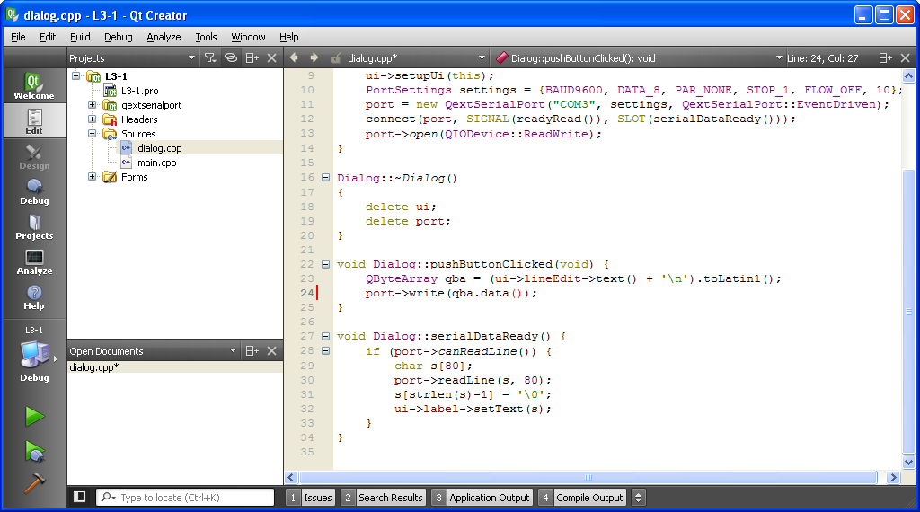

In dialog.cpp:

In the constructor configure the serial port:

Dialog::Dialog(QWidget *parent) :
QDialog(parent),
ui(new Ui::Dialog)
{
ui->setupUi(this);
PortSettings settings = {BAUD9600, DATA_8, PAR_NONE, STOP_1, FLOW_OFF, 10};
port = new QextSerialPort("COM3", settings, QextSerialPort::EventDriven);
connect(port, SIGNAL(readyRead()), SLOT(serialDataReady()));
port->open(QIODevice::ReadWrite);
}

The connect call is the interesting line – we'll come across this function again when we talk in detail about signals and slots.

In the destructor delete the port that we created in the constructor:

Dialog::~Dialog()
{
delete ui;
delete port;
}

(Otherwise we would have a memory leak, all new's have to be paired with a delete).
Add the code for the two slots:

void Dialog::pushButtonClicked(void) {
QByteArray qba = (ui->lineEdit->text() + '\n').toLatin1();
port->write(qba.data());
}

void Dialog::serialDataReady() {
if (port->canReadLine()) {
char s[80];
port->readLine(s, 80);
s[strlen(s)-1] = '\0';
ui->label->setText(s);
}
}

QStrings are Unicode. They allow for the complete alphabet of all countries – including Chinese, Arabic etc. To manage this characters are stored in 16 bits.

Converting a QString to a "normal" C string is not easy – we would lose information unless the QString only contains Latin characters (which in our case it does).

We always make sure that the data sent to, and received from the Discovery board, is a complete line including the '\n' character. Our receiving functions strip off the '\n'.

serialDataReady is called each time a byte arrives at the PC – but we will ignore them until a '\n' comes – at which time canReadLine returns true and we read the complete line in one go.

Test it with the wire connecting TXD to RXD.
Next we slightly alter our interrupt driven Discovery code (see the Lecture HW 9) to work with complete lines.

We implement similar functions to the Qt serial routines:

int canReadLine(void);

void readLine(char *s);

void writeLine(char *s);

canReadLine searches for a '\n' in the input buffer and returns true if it finds one.

readLine reads all the characters in the input buffer up to a '\n' into the string s.
It discards the '\n', and ends the string with a '\0'.

writeLine writes the chars in the string s to the uart and then also writes a '\n'.

main will also be altered to just echo a line at a time:

...
char uart_getchar(void);
int canReadLine(void);
void readLine(char *s);
void writeLine(char *s);

int main(void) {
init_uart();
while (1) {
if (canReadLine()) {
char s[80];
readLine(s);
writeLine(s);
}
}
}
int canReadLine(void) {
int i = RXQ.start;
while (i != RXQ.end) {
if (RXQ.a[i] == '\n') {
return 1;
}
i = (i + 1)%QUEUE_SIZE;
}
return 0;
}

void readLine(char *s) {
int i = 0;
s[i] = RXQ.a[RXQ.start];
RXQ.start = (RXQ.start + 1)%QUEUE_SIZE;
while (s[i] != '\n') {
i++;
s[i] = RXQ.a[RXQ.start];
RXQ.start = (RXQ.start + 1)%QUEUE_SIZE;
}
s[i] = '\0';
}

void writeLine(char *s) {
uart_putstring(s);
uart_putchar('\n');
}

Take off the short between TXD and RXD, connect up the Discovery board to the UART and test the program.

N.B.
The function readLine only works as long as canReadLine returns true – just as uart_getchar only worked as long as is_uart_data_ready returned true.

We must either: never use these functions without doing the test that they will work first.

Or: insert busy wait on the test canReadLine at the start of the function readLine. If we already know that we can read a line, then the busy wait immediately completes.

