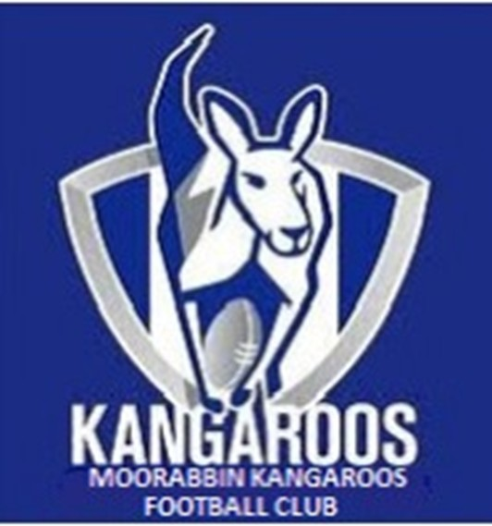 | Welcome to the  Moorabbin Kangaroos  Bar Service

Item | Price
Carlton Draught
Great Northern
Carlton Dry
Jim Beam
Johnnie Walker
Soft Drink Can
Sports Drink
Bottled Water
Chocolate Bars
Potato Chips Bag
Peanuts Bag
Killer Pythons

