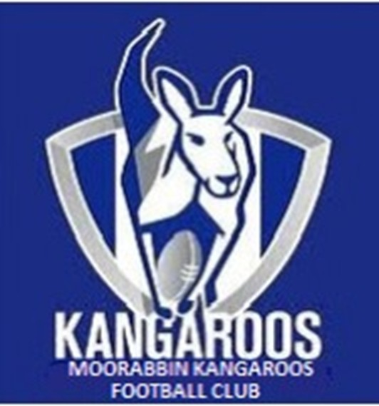 | Welcome to the  Moorabbin Kangaroos  B-B-Q Menu

Buy tickets at the canteen for B-B-Q food items

Item | Price
Hamburgers
Sausage in Bread
Bacon and Egg Rolls
Soft Drinks

