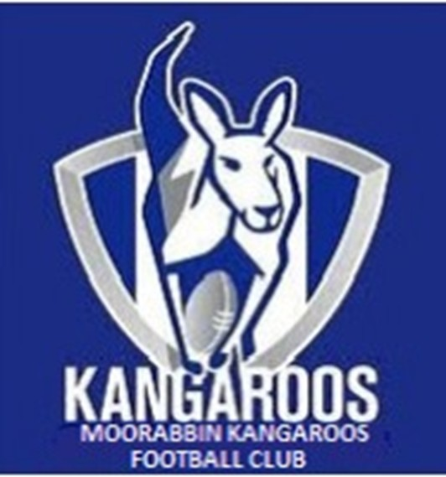 | Welcome to the  Moorabbin Kangaroos  Canteen Menu

Item | Price
Pies
Pasties
Sausage Rolls
Hot Dogs
Dim Sims
Hot Chips
Potato Cakes
Hamburgers
Sausages
Ham/Chicken Salad Rolls
Tea, Coffee
Hot Chocolate
Soft Drinks
Chocolates
Lollies
Chicken Noodles
Potato Chips
Killer Pythons

