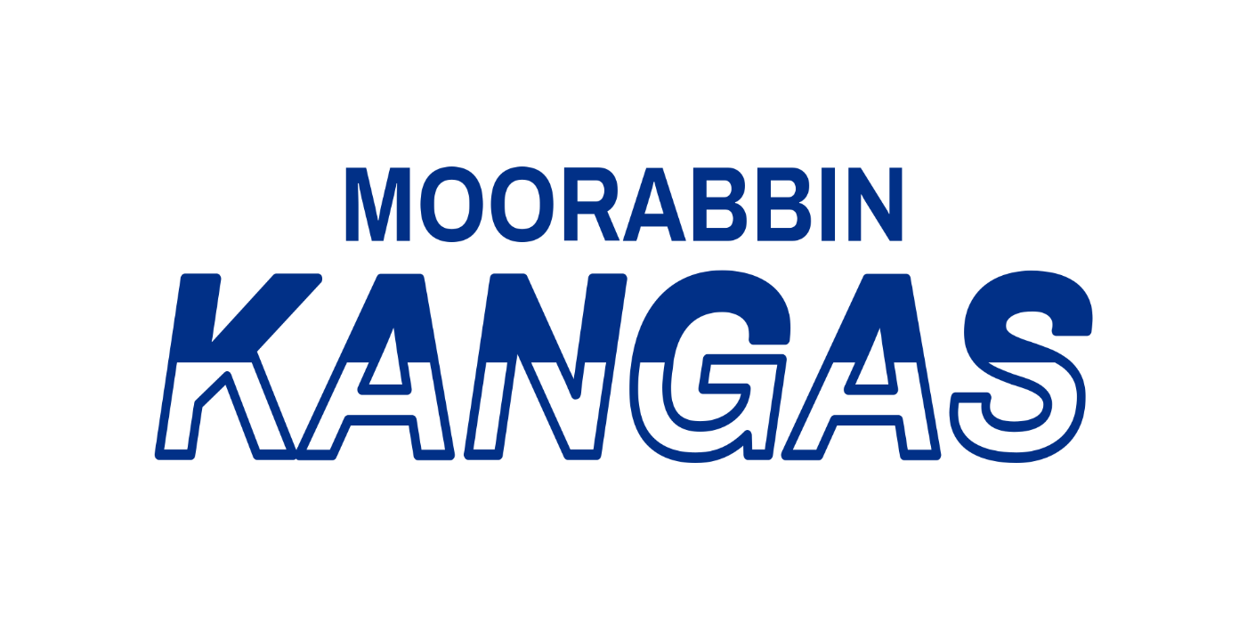Merchandise Store
Game Day Socks | $20
Game Day Shorts Away (White) | $40
Game Day Shorts Home (Blue) | $40
Baseball Cap | $20
Polo Tops | $40
Jackets | $40
Players Fees Season 2026 (Full) | $400
Players Fees Season 2026 (Concession) | $200

