LuxuryStay
Hospitality Management System
Project Documentation
Version 1.0
Prepared for: Hotel Operations Team

Executive Summary
LuxuryStay is a comprehensive hospitality management platform designed to streamline hotel operations across guest experience, reservations, staff workflows, housekeeping, maintenance, and financial oversight. The solution combines a customer-facing booking portal with backend tools for administrators and staff to manage daily operations in a secure, role-based environment.

1. Project Overview
LuxuryStay is a full-stack hotel management application developed with React on the frontend and Express/MongoDB on the backend. It is designed to support both the customer journey and the internal workflow of a modern hospitality business, including booking, operations, and reporting.
The system is structured to provide a clear separation between guest-facing features and operational modules, while preserving a consistent experience across desktop users and hotel staff.

2. Business Objectives
- Improve the guest booking experience through an intuitive room search and reservation process.
- Enable hotel staff and admins to manage check-in, check-out, bookings, and room allocation efficiently.
- Track housekeeping and maintenance issues in real time to reduce service delays.
- Support billing and invoice visibility for guests and admin personnel.
- Create a secure, role-aware system that supports different user responsibilities across departments.

3. Scope and Modules

Customer Features
- Room browsing
- Booking requests
- Profile management
- My bookings
- Service requests
- Payment status and invoice access

Operational Features
- Management dashboard
- Booking overview
- Room inventory controls
- Guest management
- Check-in and check-out workflows

Support Features
- Housekeeping task management
- Maintenance issue tracking
- Feedback and communication
- Admin settings and system control

4. User Roles and Access
Role | Access and responsibilities
Admin | Full access to rooms, users, billing, settings, reports, and system administration.
Manager | Operational oversight and monitoring of bookings, staff, and service performance.
Receptionist | Front-desk operations including bookings, guest check-in/check-out, and room-related tasks.
Housekeeping | Responsible for housekeeping schedules, room readiness, and task status updates.
Staff | General staff support and task operations across departments.
Customer | Guest profile, reservations, payments, invoice access, and guest services.

5. System Screenshots

Login Screen
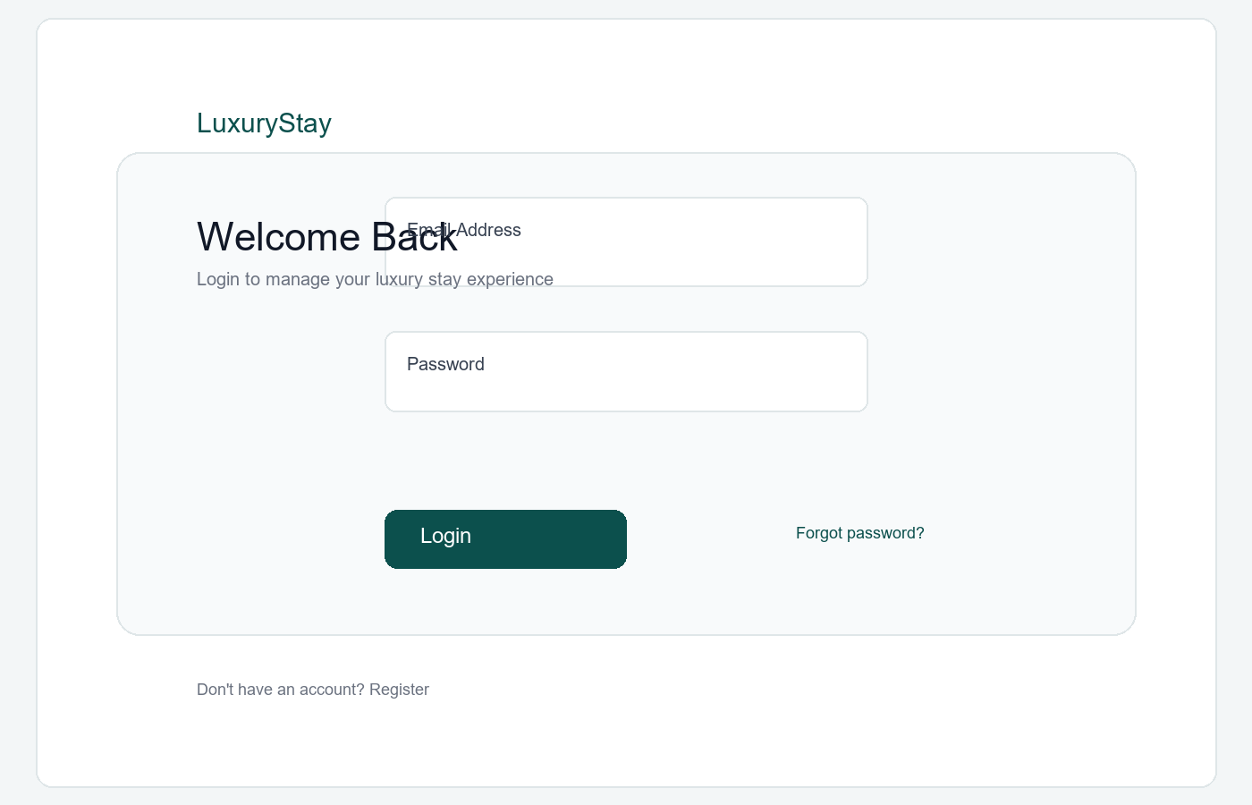

Admin Dashboard
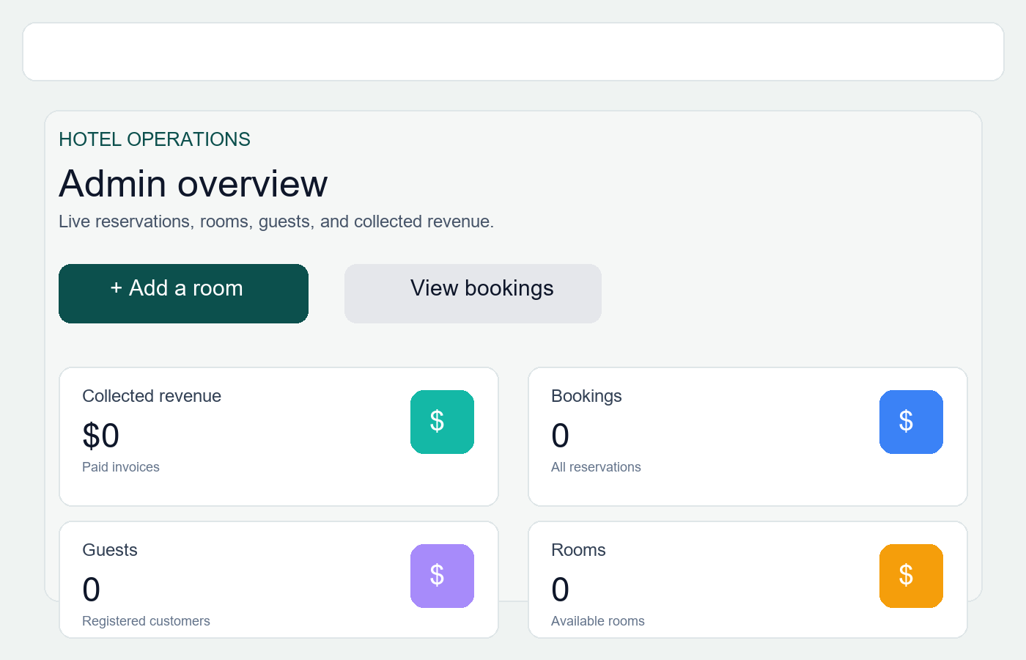

Customer Dashboard
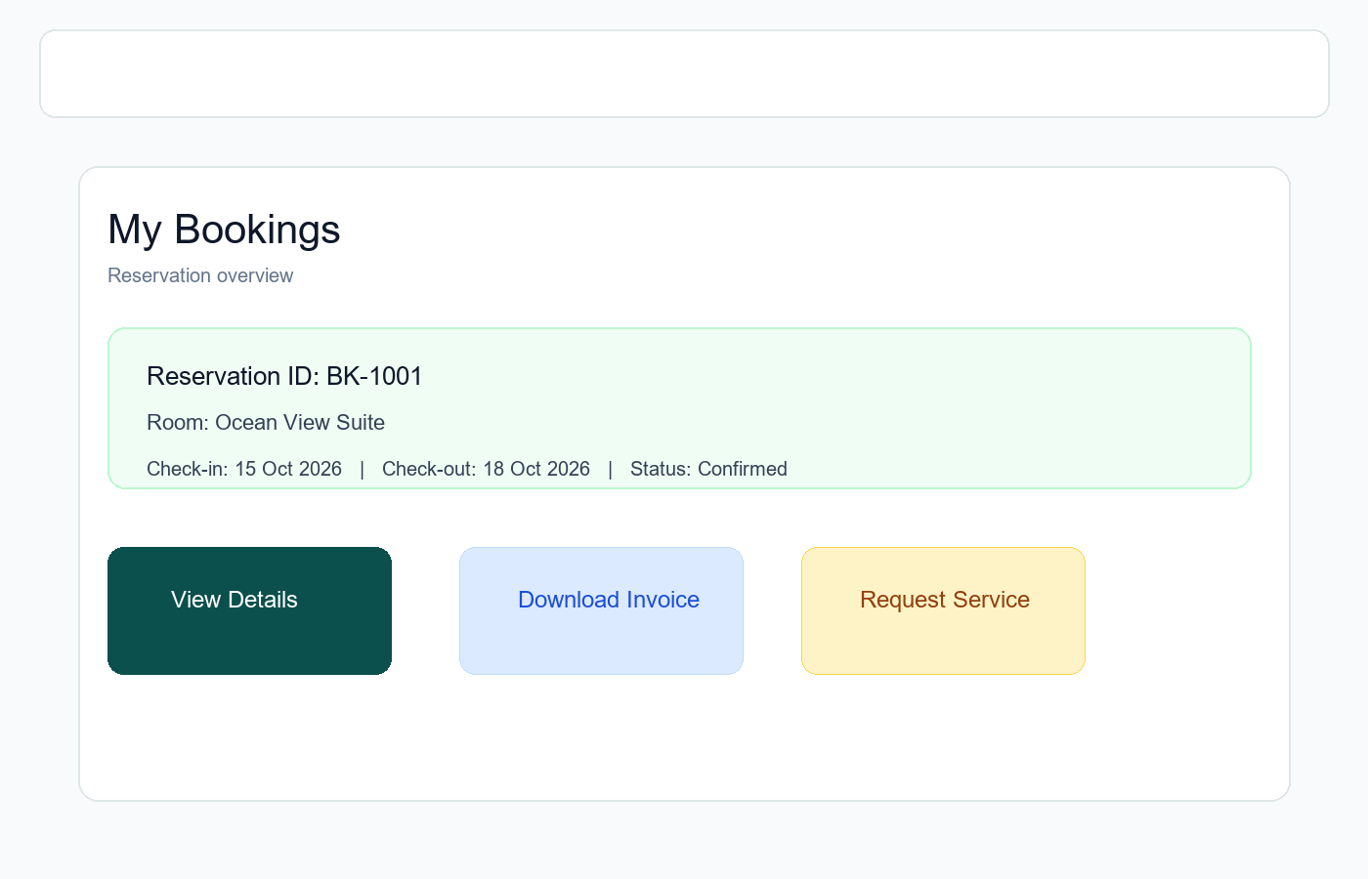

Room Management
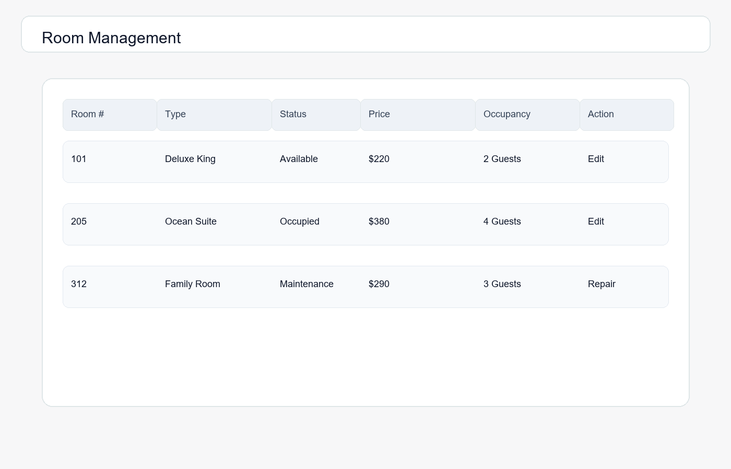

6. Setup and Configuration
- Install Node.js 20+ and MongoDB locally or via a managed service.
- Install project dependencies from the repo root and server directory.
- Create root .env.local with VITE_API_URL=http://localhost:5001/api
- Copy server/.env.example to server/.env and set MONGO_URI, JWT_SECRET, PORT, and CLIENT_URL.
- Start MongoDB and run npm run create-admin in the server directory to initialize the first admin account.
- Start the backend with npm run dev and the frontend with npm run dev.
Field | Value
Email | admin@luxurystay.local
Password | Admin@123
URL | http://localhost:5173
API | http://localhost:5001/api

7. API Overview
- Authentication: POST /api/auth/register, POST /api/auth/login, GET /api/auth/profile
- Rooms: GET /api/rooms, POST /api/rooms, PUT /api/rooms/:id, DELETE /api/rooms/:id
- Bookings: GET /api/bookings, POST /api/bookings, PUT /api/bookings/:id
- Services: GET /api/services/mine, POST /api/services, GET /api/services/:id
- Housekeeping: GET /api/housekeeping, PUT /api/housekeeping/:id
- Maintenance: GET /api/maintenance, POST /api/maintenance
- Billing: GET /api/billing, POST /api/billing
- Dashboard: GET /api/dashboard/admin, GET /api/dashboard/staff, GET /api/dashboard/customer
- Settings: GET /api/settings, PUT /api/settings

8. Security and Compliance
- Passwords are hashed using bcrypt before storage.
- Authentication is secured through JWT-based bearer tokens.
- Role-based access control restricts sensitive endpoints to authorized users.
- CORS is configured to allow only approved frontend origins.
- Sensitive values such as JWT secrets and database credentials must be managed in environment variables.
- Production deployment should use HTTPS, managed MongoDB, monitoring, and access logging.

9. Deployment and Maintenance
- Use a managed MongoDB instance in production with scheduled backups and monitoring.
- Host the frontend behind a production web server or static hosting platform.
- Run the backend in a secure Node.js environment with environment variables configured per environment.
- Implement HTTPS and a reverse proxy for production traffic.
- Track application logs and maintain periodic dependency updates.

10. Summary
LuxuryStay offers a professional and scalable solution for hotel operations management. It brings together guest-facing features, operational workflows, and staff access in one secure architecture, making it suitable for local development, testing, and future production growth.
This documentation provides a practical overview of the project structure, configuration steps, business workflows, security controls, and deployment considerations needed to operate the system successfully.

