# **COVID-19**

install.packages("covid19.analytics")

library(covid19.analytics)

ag<-covid19.data(case='aggregated')

tsc<-covid19.data(case='ts-confirmed')

report.summary(~entries-10, graphical.output = F)

tots.per.location(tsc,geo.loc = 'pakistan')

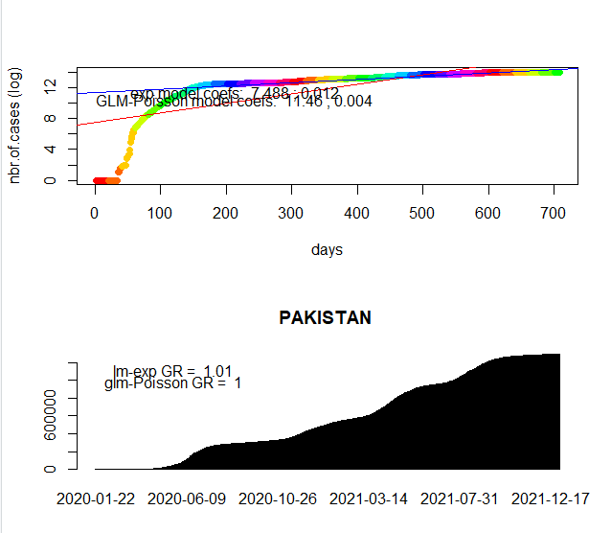

growth.rate(tsc,geo.loc = 'pakistan')

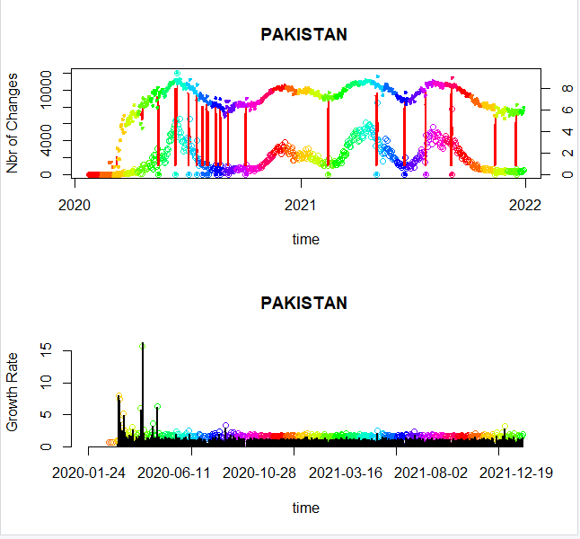

tsa<-covid19.data(case='ts-All')

totals.plt(tsc)

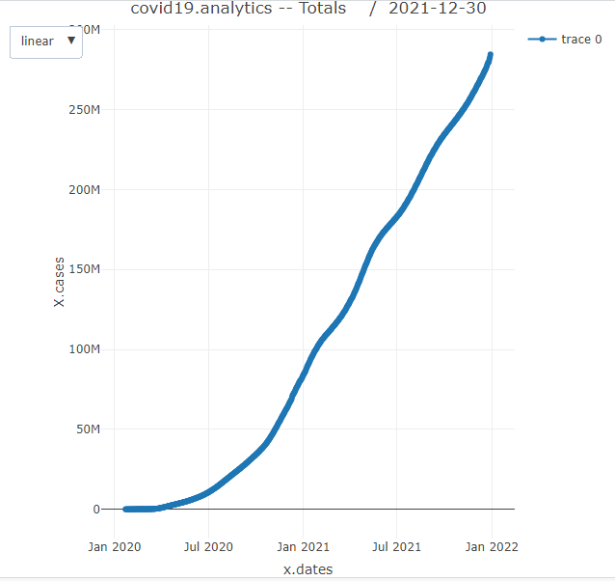

live.map(tsc)

