**Assignment 3**

**Name Moosa Hussain**

**Roll No K17394**

**Question 2 , 3 , 4**

**Question 2:(Simple Naive Bayes )**

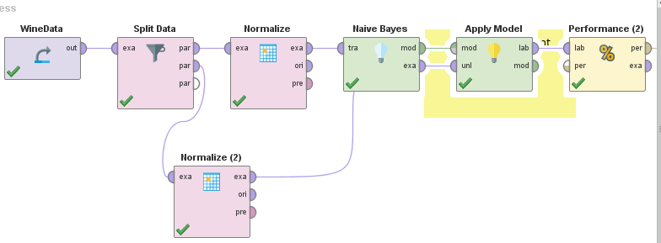

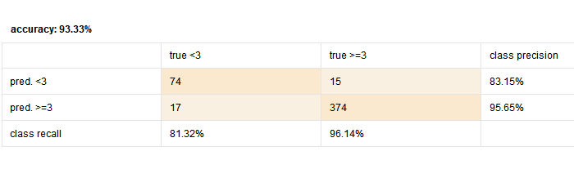

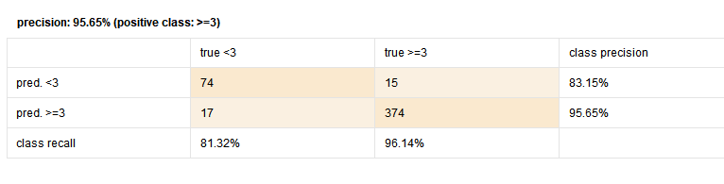

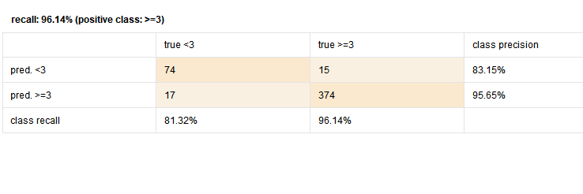

**Naive Bayes(Kernal)**

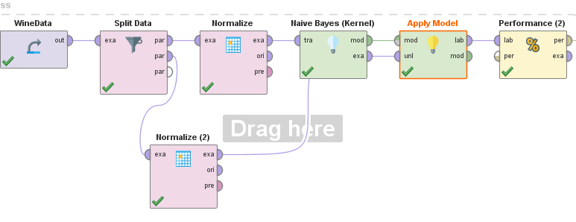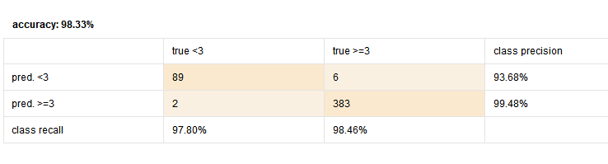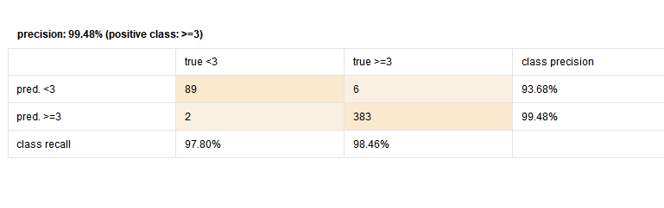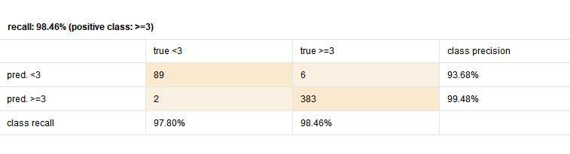

**Question 3**:

**Naive Bayes**

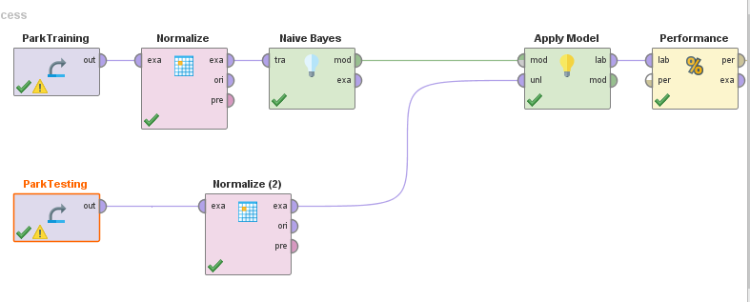

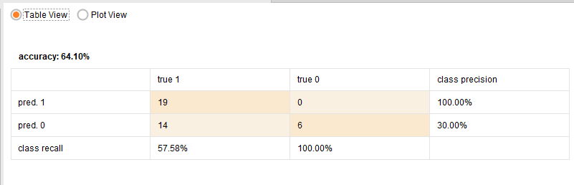

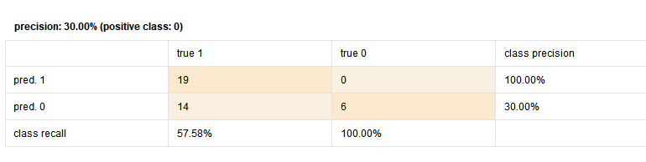

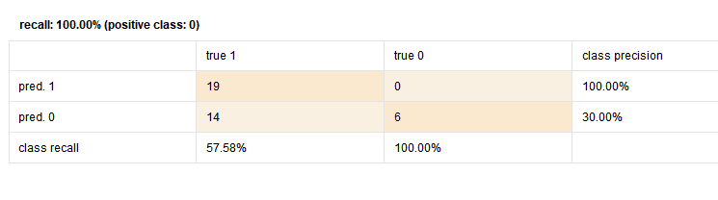

**Naive Bayes Kernal**

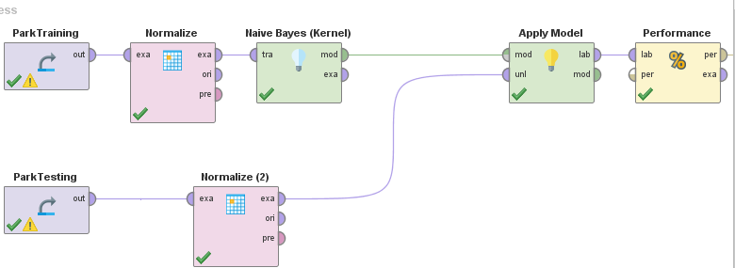

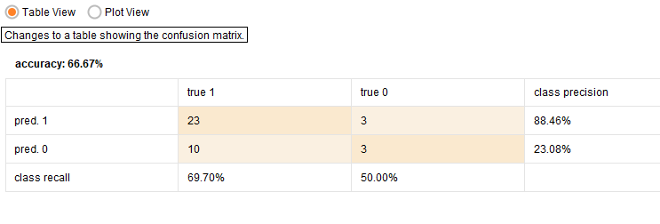

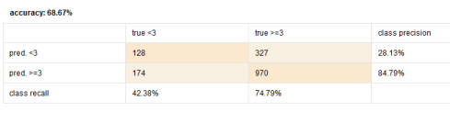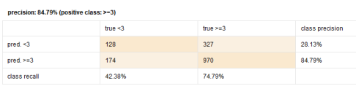

**Question 4**

