1. **Problem 1**.The behavior of polynomials fit to data tends to be erratic near the boundaries. The polynomials fit beyond the boundary knots behave even more wildly than the corresponding global polynomials in that region. Assuming the function is linear near the boundaries (where we have less information anyway) is often considered reasonable. A *natural quadratic spline* adds additional constraints, namely that the function is linear beyond the boundary knots. Let

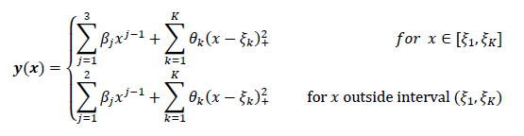

Determine a set of bases for y(x) such that $\frac{ⅆ^{2}}{∂x}y\left(x\right)$ = 0 for x outside interval $\left(ξ_{1},ξ_{K}\right)$

**Answer:**

Since we are concerned for a set of bases outside the interval $\left(ξ_{1},ξ_{K}\right)$, the second equation above is all that we are concerned with.

$$y\left(x\right)=\sum_{j=1}^{2}{β_{j}X^{j-1}}+\sum_{k=1}^{K}{θ_{k}{\left(x-ξ_{k}\right)}_{+}^{2}} (1)$$

Expanding (1)

$y\left(x\right)= β_{1}+ xβ_{2}+ \sum_{k=1}^{K}{θ_{k}x^{2}-2θ_{k}xξ_{k}+ θ_{k}ξ_{k}^{2}}$ (2)

The constraints require that f’’(x) = 0. Calculating f’(x):

$$\frac{∂}{∂x}y\left(x\right)= β_{2}+\sum_{k=1}^{k}{2θ_{k}X- 2θ_{k}ξ_{k}} (3)$$

Taking the derivative of the first derivative (3) and setting equal to 0 yields:

$$\frac{∂}{∂x}y'\left(x\right)= 2\sum_{k=1}^{k}{θ_{k}}$$

$$\sum_{k=1}^{K}{θ_{k}} =0 (4)$$

Expanding (4) and solving for $θ_{K}$

$$θ_{K }+\sum_{k=1}^{K-1}{θ_{k}} =0$$

$$θ_{K } =-\sum_{k=1}^{K-1}{θ_{k}} (5)$$

Expanding the right summation in (1) as we just did above and plugging in the value of $θ_{K }$

$$y\left(x\right)=β_{1}+ xβ_{2} +\sum_{k=1}^{K-1}{θ_{k}{\left(x-ξ_{k}\right)}_{+}^{2}}+{ θ}_{K}{\left(x-ξ_{K}\right)}_{+}^{2}$$

$$y\left(x\right)=β_{1}+ xβ_{2}+\sum_{k=1}^{K-1}{θ_{k}{\left(x-ξ_{k}\right)}_{+}^{2}}-\sum_{k=1}^{K-1}{θ_{k}}{\left(x-ξ_{K}\right)}_{+}^{2} (6)$$

Joining like terms in (6) yields:

$$y\left(x\right)=β_{1}+ xβ_{2}+\sum_{k=1}^{K-1}{θ_{k}[{\left(x-ξ_{k}\right)}_{+}^{2}}-{\left(x-ξ_{K}\right)}_{+}^{2} ] (7)$$

Finally, from (7) we arrive at our basis functions:

|  |
| --- |
| H1(X) = 1  H2(X) = X  Hk+2(X) = ${{\{\left(x-ξ_{k}\right)}_{+}^{2} - {\left(x-ξ_{K}\right)}_{+}^{2}\}}_{k=1,…..,K-1}$ |

1. **Problem 2.** Let 𝐵𝑖,𝑗(𝑥) be the 𝑖 𝑡ℎ B-spline basis function of a uniform quadratic B-spline with five knots. The B-spline curve is defined as:

$f\left(x\right)=\sum_{i=0}^{2}{B_{i,2}\left(x\right)P_{i}}$ (1)

Where

$B_{i,0}\left(x\right)= \left\{\begin{aligned}1 if { τ}_{i}≤x<τ_{i+1} \\ 0 otherwise\end{aligned}\right\}$ (2)

$B_{i,j}\left(x\right)=\frac{x-τ_{i}}{τ_{i+j}-τ_{i}}B_{i,j-1}\left(x\right)+ \frac{τ_{i+j+1}-x}{τ_{i+j+1}-τ_{i+1}}B_{i+1,j-1}\left(x\right)$ (3)

Drive an expression for 𝐵0,2 (𝑥), 𝐵1,2 (𝑥) and 𝐵2,2 (𝑥). Please note that uniform B-Spline means the knots are equidistant 𝜏𝑖+1 − 𝜏𝑖 = constant , ∀𝑖. For simplicity, let 𝜏𝑖 = 𝑖 (this is allowable given that the scaling or translating the knot vector has no effect on the shapes of the 𝐵𝑖,𝑗). The knot vector thus becomes 𝑋 = {𝜏0, 𝜏1, 𝜏2, 𝜏3, 𝜏4, 𝜏5 } = {0, 1, 2, 3, 4, 5}.

**Answer:**

i -> knot span index

j -> basis function order

b-splines, from the equations above, are recursive where higher m-order polynomial basis functions (j) are a function of the previous m-order polynomial (j-1). E.g. B0,2 – the 0th span basis function of order 2 is a function of B0,1 and B1,1 - the 0th span basis function of power 1 and the 1st span basis function of power 1 respectively. We can visualize what is meant by 0th and 1st span by creating a number line of equidistant knots in the set {0,1,2,3,4,5}

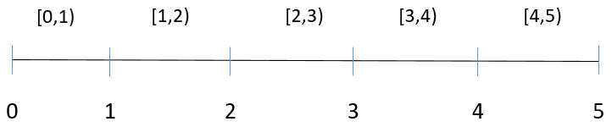

The closed to open ended interval of [0,1) is the 0th knot span, the closed to open ended interval of [1,2) is the 1st span, etc. , etc, . From equation (2) above, for the basis function of B1,0 – the 1st knot span of power 0, any value of $x ∈[1,2)$ would be constant 1. All values outside that range would be 0, as shown below

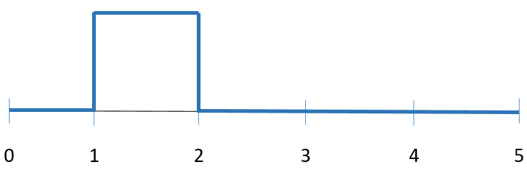

Basis functions of order m > 0 are a linear combination of basis functions of power m-1 at knot span i and i+1 as shown by equation (3). The recursiveness is easily visualized via a triangular tree.

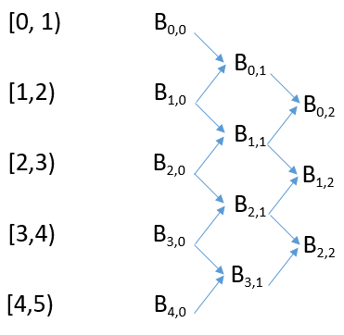

For example, basis function for the 0th span of power 2 (B0,2) is a linear combination of (B1,1) and (B0,1). The former is a linear combination of (B2,0) and (B1,0). The latter is a linear combination of (B1,0) and (B0,0). Therefore, we can construct basis functions of higher order functions by keeping track of the equations of lower order.

B0,0 – B4,0 are simply indicator functions which return 1 if x falls within in the interval, otherwise it returns 0

|  |  |
| --- | --- |
| **B0,0** |  |
| **B1,0** |  |
| **B2,0** |  |
| **B3,0** |  |
| **B4,0** |  |

B0,1 – B3,1 can be achieved by simply plug in values of i,j into equation (3) We can do this because the values of the subscript are symmetric with their actual values of the knot vector X = ( 𝜏0=0, 𝜏1=1…..). We will explicitly walk through B0,1. The rest can be inferred from the following procedure:

B0,1 (i = 0, j = 1) -> From eqn (3)

$$B_{0,1}\left(x\right)=\frac{x-0}{1-0}B_{0,0}\left(x\right)+ \frac{2-x}{2-1}B_{1,0}\left(x\right)=X*B_{0,0}\left(x\right)+\left(2-x\right)*B_{1,0}\left(x\right)$$

|  |  |
| --- | --- |
| **B0,1** |  |
| **B1,1** |  |
| **B2,1** |  |
| **B3,1** |  |

B0,2 – B2,2 can be achieved by following the same paradigm.

B0,2 (i=0, j=2) -> From eqn (3)

$$B_{0,1}\left(x\right)=\frac{x-0}{2-0}B_{0,1}\left(x\right)+ \frac{3-x}{3-1}B_{1,1}\left(x\right)=0.5X*B_{0,1}\left(x\right)+0.5\left(3-x\right)*B_{1,1}\left(x\right)$$

|  |  |
| --- | --- |
| **B0,2** |  |
| **B1,2** |  |
| **B2,2** |  |

Substituting appropriate B(x) values and with some algebra, we arrive at:

|  |  |
| --- | --- |
| **B0,2** |  |
| **B1,2** |  |
| **B2,2** |  |