**Question 1. Tensor Decomposition Reconstructions (15 points)**

**Part 1.** Kruskal tensors are a way of representing tensor decompositions as a weighted sum of outer products.

$χ=\sum_{r}{λ_{r}}U_{1r}∘U_{2r}∘...∘U_{nr}$ for each rank of the decomposition, r, and rank of the original tensor, n.

a) Given the following rank-2 CP decomposition: $λ=\left(39.28810.676\right)U_{1}=\left(\begin{matrix}0.5719 & 0.1469 \\ 0.5885 & 0.9817 \\ 0.5715 & −0.1210\end{matrix}\right)U_{2}=\left(\begin{matrix}0.5121 & −0.4042 \\ 0.6284 & 0.5877 \\ 0.5856 & 0.7009\end{matrix}\right)$

$U_{3}=\left(\begin{matrix}0.5605 & −0.3179 \\ 0.4921 & −0.3682 \\ 0.6661 & 0.8737\end{matrix}\right)U_{4}=\left(\begin{matrix}0.7502 & −0.9201 \\ 0.6612 & 0.3917\end{matrix}\right)$

Write out the calculation of the first outer product $U_{1,1}∘U_{2,1}$

***Answer:***

$U_{1,1}∘U_{2,1}$ = U1,1 * U2,1T

Where U1,1 = and U2,1T =

=

b) Either by hand or in code, calculate:

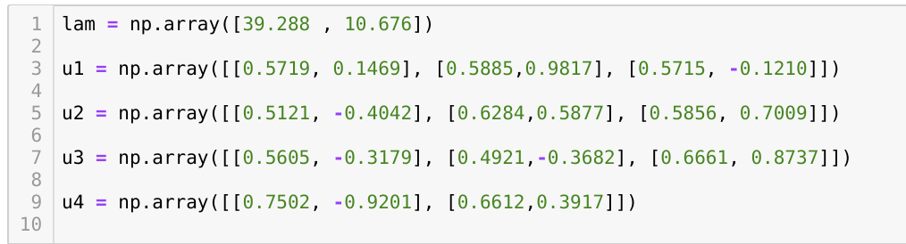

$λ_{1}U_{1,1}∘U_{2,1}∘U_{3,1}∘U_{4,1}$

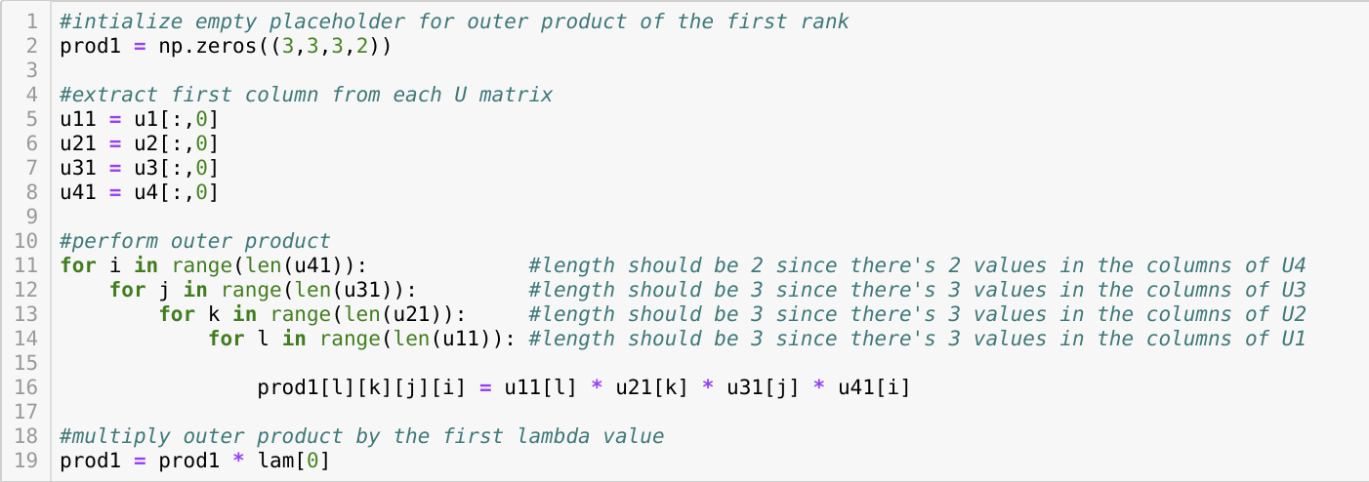NOTE: Numpy is reorganizing the final array when printing out. When manually forcing orientation, this is my result:

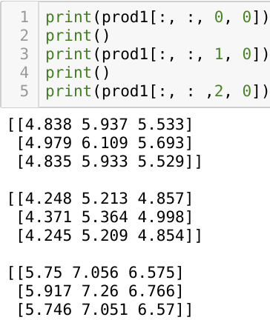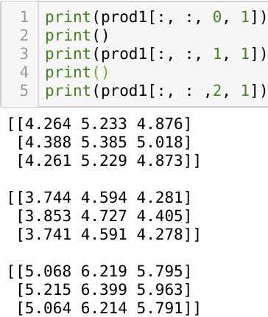

When printing out full array from numpy – this is the result

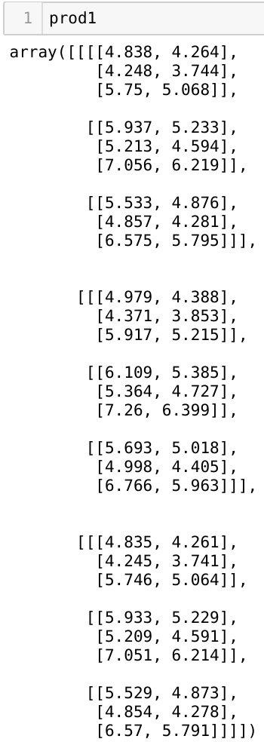

$λ_{2}U_{1,2}∘U_{2,2}∘U_{3,2}∘U_{4,2}$

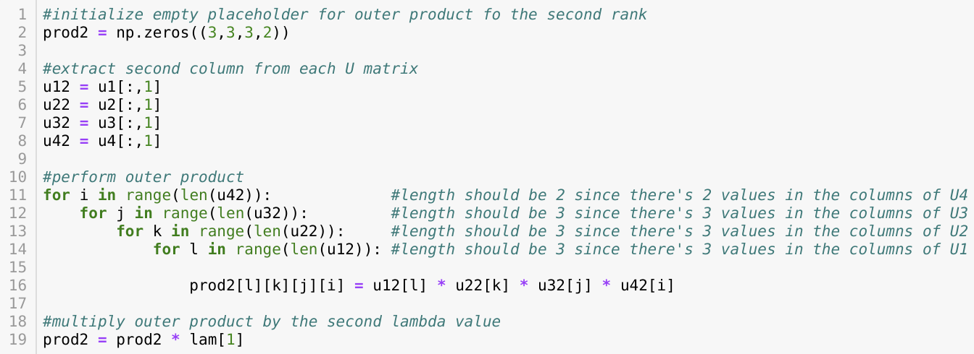

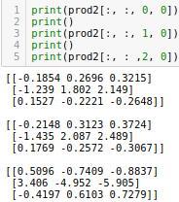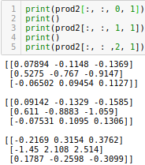

When printing out full array from numpy – this is the result

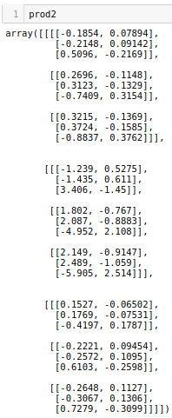

* $χ$ the full reconstruction.

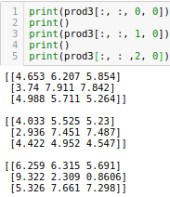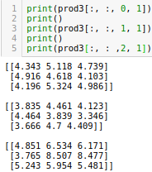

When printing out full array from numpy – this is the result

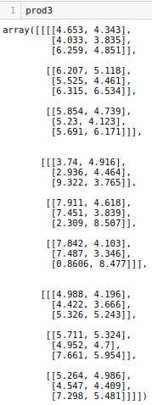

**Part 2.** A Tucker decomposition of the same original tensor is:

$G_{1,1}=\left(\begin{matrix}38.946 & 0.8653 \\ 0.9666 & −4.8832\end{matrix}\right)G_{2,1}=\left(\begin{matrix}−0.4799 & −0.0792 \\ −1.7302 & −4.3675\end{matrix}\right)$

$G_{1,2}=\left(\begin{matrix}0.7059 & −1.6496 \\ 0.7553 & −1.1648\end{matrix}\right)G_{2,2}=\left(\begin{matrix}5.7493 & −3.3204 \\ −2.0019 & 7.6587\end{matrix}\right)$

$U_{1}=\left(\begin{matrix}0.5661 & −0.1945 \\ 0.6005 & −0.5685 \\ 0.5648 & 0.7994\end{matrix}\right)U_{2}=\left(\begin{matrix}0.5031 & 0.8331 \\ 0.6345 & −0.1755 \\ 0.5867 & −0.5246\end{matrix}\right)U_{3}=\left(\begin{matrix}0.5773 & −0.3364 \\ 0.5013 & −0.5733 \\ 0.6445 & 0.7471\end{matrix}\right)$

$U_{4}=\left(\begin{matrix}0.7524 & −0.6587 \\ 0.6587 & 0.7524\end{matrix}\right)$

Compute the reconstruction of the Tucker decomposition.