

Information and Communications Technology Cluster
Economic Event-Driven Forex Trading Assistant using Machine learning

Capstone Project Final Report
(NCS)

For the project period from 01092025 to 19072026

Muhammad Mursyid Bin Hassan
2300435

Name of Industry Supervisor: Not Applicable

Name of Academic Supervisor: Li Xiaorong

Submitted as part of the requirement for ICT3902C Capstone Project

Capstone Project Final Report for the Project: Economic Event-Driven Forex Trading Assistant using Machine learning, from 01092025, to 19072026

Abstract
This project develops an Economic Event-Driven Forex Trading Assistant using Machine Learning. The dataset contains 4,727 daily EUR/USD modelling observations from October 2007 to December 2025, combining six macroeconomic event families with momentum, volatility, regime and technical variables. Six event-availability indicators distinguish missing surprises from genuine zero values, producing 48 model features.
The final evaluation follows a six-stage experimental sequence. Feature-set comparison established that a hybrid of event and market-context features outperforms either family in isolation. Event-feature refinement produced no improvement over the baseline encoding, and a training-window comparison selected a ten-year rolling window. The final configuration is a Random Forest on the hybrid feature set with a ten-year rolling window, a one-row purge gap at every fold boundary, and confidence thresholds selected on validation data only.
Across 36 non-overlapping 60-day folds covering 2,160 fully out-of-sample daily predictions, the model achieved a mean fold AUC of 0.5389 with a standard deviation of 0.0621, 26 of 36 folds above 0.50, and a pooled out-of-sample AUC of 0.5145. An exploratory fold-level test gives t = 3.754 and a one-sided p-value of 0.000316, which remains significant after Bonferroni adjustment across the 30 configurations examined.
The main performance study compares all three model families across one-day, three-day and five-day prediction horizons on 36 common folds, with the predictions integrated into a Buy-and-Hold position rather than compared against it. Predictive accuracy is lower at five days than at one day in every model family, falling from 0.5399 to 0.5139 for Logistic Regression, 0.5386 to 0.5056 for Random Forest and 0.5075 to 0.4443 for XGBoost. The decline is monotonic for Logistic Regression and XGBoost; Random Forest is flat between one and three days before falling. This is the outcome predicted by rapid absorption of announcement information and it identifies the daily sampling frequency as a binding constraint rather than an incidental design choice. The strongest trading configuration returned +18.81% against +1.47% for Buy and Hold with maximum drawdown reduced from -23.29% to -9.09%, but it beat the benchmark in only 20 of 36 folds and 93% of that advantage arose in three non-consecutive folds of the 2021 to 2022 euro decline, in two of which its own predictive accuracy was at or below random. The advantage is therefore attributed to selective exposure during a sustained trend rather than to forecasting skill. Moving the choice of model family inside the walk-forward, so that the reported figure is the performance of the selection procedure rather than of a configuration chosen with hindsight, gives a mean fold AUC of 0.5324 with a one-sided p-value of 0.000672 and a lower fold-level standard deviation than any fixed choice; that procedure selected Logistic Regression in 19 folds, Random Forest in 11 and XGBoost in 6, reversing its choice on 16 of 35 transitions.
For the single selected configuration at a one-basis-point transaction cost, the Buy-and-Hold plus overlay strategy reduced maximum drawdown from -23.29% to -18.81%, a drawdown figure and not the return quoted earlier in this abstract, while returning +1.51% against +1.80% for Buy and Hold. The clearest and most consistent benefit is therefore risk-related rather than return-related, and the delivered Streamlit system is positioned as a decision-support and risk-filtering tool rather than an autonomous trading strategy.

1. Introduction
The foreign exchange market is the largest and most liquid financial market in the world, with average daily over-the-counter turnover of approximately USD 9.5 trillion in April 2025. Unlike equity markets, forex prices are driven heavily by macroeconomic conditions: interest rate decisions, inflation reports, employment statistics and central bank policy announcements can cause sharp short-term price movements within minutes of release. For the EUR/USD pair specifically, both United States and euro area releases are relevant.
Traders attempting to capitalise on these scheduled releases face a consistent challenge. Interpreting how an economic event will move the market requires rapid synthesis of the surprise component, defined as the actual outcome minus the market consensus forecast, together with prevailing trend conditions and recent price behaviour, all under time pressure. Manual approaches are subjective, inconsistent and difficult to scale across historical data. This motivates a data-driven approach.
This project builds an Economic Event-Driven Forex Trading Assistant using Machine Learning. The system ingests historical USD and EUR macroeconomic event data, aligns it with EUR/USD daily price movements, engineers a 48-feature representation of market context, and trains supervised classification models to predict next-day directional movement. The output is a BUY, SELL or HOLD signal delivered through a live dashboard that refreshes against the ForexFactory economic calendar.
The project makes no claim to have solved forex prediction. Instead, it asks how much directional information can be extracted from public economic-surprise and market-context data at daily granularity, which feature families contribute to that information, and whether the resulting signals improve risk-adjusted investment performance relative to Buy and Hold. These questions are evaluated using a documented sequence of six experiments, 36 purged walk-forward folds covering 2,160 out-of-sample days, cost-adjusted backtesting, permutation importance and SHAP.

1.1 Objectives
The objectives of this project, consistent with the approved project proposal (Form B), are:
- To collect and process historical economic event data from ForexFactory and EUR/USD price data from yfinance.
- To develop and train supervised ML classification models that predict next-day EUR/USD price direction based on economic event surprises and market context features.
- To evaluate model performance using rigorous time-series validation methodology, including purged chronological splits and walk-forward evaluation.
- To interpret model behaviour through feature importance analysis, identifying which economic events and market features drive predictive signal.
- To deliver a live signal dashboard that generates BUY/SELL/HOLD recommendations by combining the trained model with real-time event and price data.
MetaTrader5 integration, originally listed as a stretch objective in the project proposal, was descoped in favour of the live dashboard approach. The dashboard fulfils the same decision-support objective while avoiding the operational and safety risks of automated execution on a financial platform.

1.2 Report Structure
Section 2 reviews relevant literature on event-driven forex trading, machine learning in financial forecasting and time-series validation methodology. Section 3 describes the methodology, covering dataset construction, feature engineering, training-only model selection and purged evaluation. Section 4 details the implementation, including the ForexFactory scraper, event-availability handling and the documented experimental sequence. Section 5 reports results across the experimental sequence and closes with the main performance study in Section 5.9, which compares three model families across three prediction horizons. Section 6 discusses what the results support and what they do not. Section 7 concludes with limitations and future work.

2. Literature Review

2.1 Economic Announcements and Forex Market Reactions
The relationship between scheduled macroeconomic announcements and short-term currency price movements has been studied extensively. Andersen, Bollerslev, Diebold and Vega (2003) established a foundational framework demonstrating that US macroeconomic news surprises, defined as the difference between the announced figure and the prior market consensus forecast, produce significant and rapid adjustments in exchange rates. Their evidence is measured in five-minute windows, which is materially finer than the daily horizon adopted here.
Subsequent work has refined this understanding. Evans and Lyons (2008) showed that the price impact of news surprises is mediated by order flow, meaning the same surprise can produce different magnitude responses depending on liquidity conditions and market positioning. Faust, Rogers, Wang and Wright (2007) demonstrated that exchange-rate predictability is highest in the immediate window around scheduled announcements and deteriorates rapidly at longer horizons. Both findings bound what a daily-horizon model can reasonably be expected to achieve.
For the EUR/USD pair, both USD-side events (Federal Reserve rate decisions, US CPI and Non-Farm Payrolls) and EUR-side events (ECB rate decisions and euro-area CPI releases) affect short-term volatility. Galati and Ho (2001) found that ECB communication events produce measurable short-term exchange-rate effects, motivating the inclusion of both USD and EUR event families in the hybrid feature set.

2.2 Machine Learning in Financial Forecasting
Patel, Shah, Thakkar and Kotecha (2015) evaluated multiple classification approaches and highlighted the importance of matching model complexity to the signal-to-noise ratio of the target. This is directly relevant here: XGBoost reached a training AUC of 0.8827 against a test AUC of 0.5265, a gap of 0.3562, while the selected Random Forest configuration used a maximum depth of 2 and generalised more stably.
Fischer and Krauss (2018) applied Long Short-Term Memory networks to equity prediction and noted that the advantage of more complex models diminishes as the underlying signal weakens. Their conclusion that simpler, regularised models remain competitive in low-signal environments is consistent with this project's decision to select on training evidence and fold-level stability rather than on final test performance.
Deep learning approaches such as LSTM were considered but not adopted. The final dataset contained 4,727 daily observations, which is limited for reliably training a higher-capacity sequence model, and the large train-test gaps already observed for the tree-based models indicated an existing overfitting risk. The study therefore prioritised simpler, regularised and interpretable classifiers.
Lopez de Prado (2018) identifies look-ahead bias, leakage across training and test samples, and cross-validation schemes that ignore temporal ordering as major sources of inflated financial-ML results. This project applies chronological model development, a one-row purge gap at every fold boundary, training-only hyperparameter selection, and validation-only threshold selection.

2.3 Event-Driven Trading Strategies
Event-driven strategies attempt to exploit predictable price reactions to scheduled macro releases and face several documented challenges. Market participants anticipate events in advance and partially price in consensus expectations before release, so the tradeable signal is concentrated in the surprise component rather than the announcement level. The same surprise can also produce different reactions depending on regime and positioning. Finally, transaction costs erode any small statistical edge, which is why cost sensitivity is reported explicitly in Section 5.7.
These challenges frame the research question not as whether public event data guarantees a profitable trading system, but as whether it contains modest and repeatable directional information, how stable that information is across time, and whether selective exposure can improve risk-adjusted outcomes relative to a simple Buy-and-Hold benchmark.

2.4 Research Gap
Existing literature on ML-based forex prediction often focuses on technical indicators or individual event types in isolation, over comparatively short samples. Few studies combine USD and EUR event surprises, distinguish unavailable surprise values from genuine zero surprises, normalise each event against prior releases only, and evaluate the resulting hybrid feature set across an eighteen-year sample with complete out-of-sample coverage and an explicit statistical test. This project addresses that gap using 48 features, a documented six-experiment sequence, and 36 purged walk-forward folds covering 2,160 out-of-sample days.

3. Methodology

3.1 Overview
The methodology follows a supervised binary-classification framework. EUR/USD daily closing prices are aligned with scheduled macroeconomic releases from the United States and euro area. Features capture event surprise magnitude and availability, event timing, market regime, momentum, volatility and technical indicators. Logistic Regression, Random Forest and XGBoost are tuned using training-only time-series cross-validation, compared across feature sets and training windows, and the selected configuration is then evaluated on purged non-overlapping folds covering the full out-of-sample period.
The target is the direction of the next trading day's log return, labelled UP where the return is positive and DOWN otherwise. Because the target depends on the following day's close, a one-row purge gap is applied at every boundary between training and evaluation data.
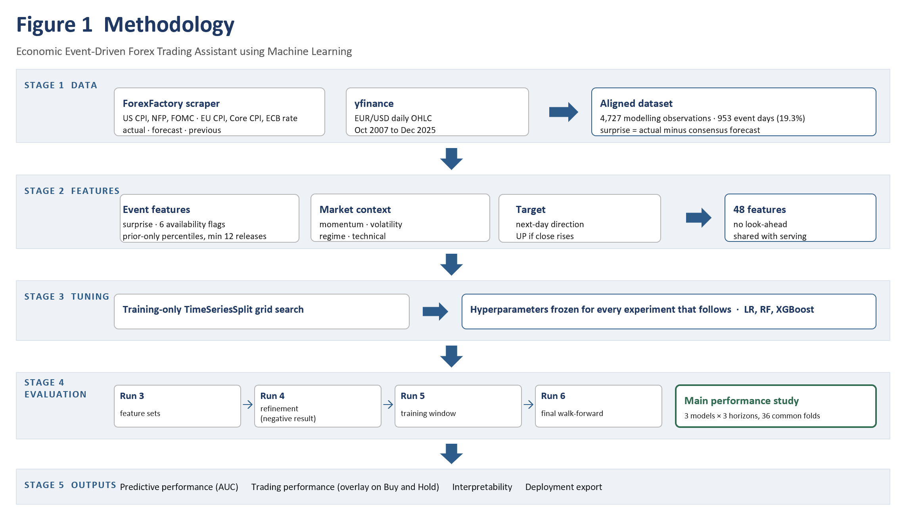
Figure 1: End-to-end methodology, from data collection and alignment through feature construction, training-only tuning, the experimental sequence and the main performance study, to the reported outputs.

3.2 Dataset Construction

3.2.1 Price Data
Daily EUR/USD OHLC data was obtained from yfinance covering October 2007 to December 2025. Closing prices are used for return and target construction, with high, low and close used for the volatility and technical indicators.

3.2.2 Economic Event Data
Six scheduled event families were scraped from the ForexFactory economic calendar: US CPI, US Non-Farm Payrolls, FOMC rate decisions, ECB rate decisions, euro-area CPI and euro-area Core CPI. For each release the actual, forecast and previous values were retained, and the surprise was computed as actual minus forecast.
Table 1 reports event coverage in the merged dataset. The availability column records releases for which both actual and forecast values were present and a genuine surprise could therefore be computed.
Table 1: Event coverage in the merged dataset
Event family | Release days | With computable surprise
US CPI | 226 | 225
US Non-Farm Payrolls | 228 | 226
FOMC rate decision | 155 | 149
ECB rate decision | 185 | 183
Euro-area CPI | 228 | 228
Euro-area Core CPI | 152 | 139
Any event | 953 (19.3%) | —

Counts in this table are releases that survive the merge onto the daily price index. The scraper audit records 226 US CPI, 228 Non-Farm Payrolls, 155 FOMC, 185 ECB rate, 228 euro-area CPI and 152 euro-area Core CPI releases; six releases across four families fall on dates with no corresponding EUR/USD trading row and are therefore not represented above. The two euro-area CPI series are unaffected.

3.2.3 Data Alignment
Events were merged onto the daily price index by date. The merged frame contains 4,927 rows and 32 raw columns. Two timing features deserve comment. The economic calendar is published in advance, so the scheduled date of the next release is known on the day a signal is formed; days_until_event therefore uses only information available at signal time and is not a look-ahead variable. Its counterpart, days_since_event, is backward-looking by construction. After feature construction and the removal of rows with incomplete rolling-window inputs, 4,727 modelling observations remain. Retaining the event date even when the surprise could not be computed is a deliberate correction: it preserves the fact that a release occurred, which the event-timing features depend on.

3.3 Feature Engineering
The 48 features fall into seven groups, summarised in Table 2. Each of the six event families contributes four features: the raw surprise, an availability indicator, a prior-only percentile rank of the surprise, and a release-day flag.
Table 2: Feature groups
Feature group | Contents | n
Event release | Surprise, availability flag, prior-only percentile rank and release-day flag for each of six event families | 24
Event timing | event_day, days_since_event, days_until_event | 3
Returns and momentum | r1d, r5d, r7d, r10d, r14d, mom5, mom7, mom10 | 8
Volatility | vol_5d, vol_14d, post_event_vol | 3
Price position and regime | price_pct_14d, above_200ma, dist_200ma, ma50_slope | 4
Time encoding | cos_dow, sin_dow | 2
Technical indicators | rsi, macd_hist, bb_pct, atr_norm | 4

3.3.1 Availability Encoding
A missing surprise and a genuine zero surprise are materially different events, and collapsing them assigns a spurious neutral reading to releases whose consensus forecast was unavailable. Each event family therefore carries an explicit availability indicator alongside its surprise value. This distinction did not exist in the earlier version of the pipeline.
The days_until_event feature represents the number of trading days until the next scheduled release, capped at 30. For regularly scheduled releases, this information is available at signal time because publication dates are announced in advance. However, the implementation derives the feature from the completed event calendar, so an unscheduled emergency meeting could introduce future-date information. This limitation is addressed in Section 7.3.

3.3.2 Prior-Only Normalisation
Raw surprise magnitudes are not comparable across event families, so each surprise is converted to a percentile rank against the historical distribution of that same family. The rank is computed using prior valid releases only and requires a minimum of 12 earlier releases before a rank is issued. Earlier releases receive a neutral value of 0.5. Computing the rank over the full sample would leak future information into historical rows and removing that leakage is one of the three corrections described in Section 4.3.

3.3.3 Target Construction
The target is constructed from the next trading day's log return, computed against the stored next-day close so that no position can be evaluated against a price already known at signal time. The final row, whose next-day return does not exist, is dropped rather than labelled. Class balance is close to even, at 49.7% UP in the training period and 49.2% UP in the evaluation period.

3.4 Model Selection and Hyperparameter Tuning
Three classifiers were considered: Logistic Regression, Random Forest and XGBoost. Hyperparameters were selected using TimeSeriesSplit cross-validation on the pre-test training sample only, with standardisation performed inside the scikit-learn Pipeline so that the scaler refits within each training fold. Table 3 reports the selected configurations and their training cross-validation AUC.
Table 3: Tuned hyperparameters and training cross-validation AUC
Model | Selected hyperparameters | Training CV AUC
Logistic Regression | C=0.1, penalty=L1, solver=saga | 0.5196
Random Forest | max_depth=2, max_features=sqrt, min_samples_leaf=5, n_estimators=100 | 0.5098
XGBoost | learning_rate=0.1, max_depth=4, n_estimators=100, reg_alpha=0, reg_lambda=1.0, subsample=0.7 | 0.5121

These parameters were then frozen. All subsequent experiments reuse them without further tuning, so that later comparisons vary only the factor under test.

3.5 Evaluation Framework
Three levels of evaluation are used, in increasing order of evidential weight.
The first is a single fixed chronological split, with 3,781 training rows from 8 October 2007 to 10 May 2022 and 946 holdout rows from 11 May 2022 to 30 December 2025. This split is used only as a bias-variance diagnostic. It is a single point estimate on one window and is not used to select the primary model.
The second is walk-forward evaluation across 65 folds, used within the experimental sequence to compare feature sets, encodings and training windows on a common basis.
The third is the final Run 6 evaluation: 36 non-overlapping 60-trading-day test folds, each preceded by a ten-year rolling training window and separated by a one-row purge gap, producing 2,160 fully out-of-sample daily predictions. Confidence thresholds are selected within each fold's validation window and never on the test window.
The mean fold AUC is treated as the primary predictive result because each fold is generated by a separately retrained model. Probabilities from different folds are not guaranteed to be calibrated on the same numerical scale, so the pooled AUC across all 2,160 predictions is reported as a secondary result.

4. Implementation

4.1 Overview
The system comprises three components: a scraping and data-preparation layer that assembles the event and price dataset, a modelling layer that performs tuning, experimentation and final evaluation, and a serving layer that exposes live signals through a Streamlit dashboard. All three share the same feature-construction code path, so the inputs built at inference time match those used in training.
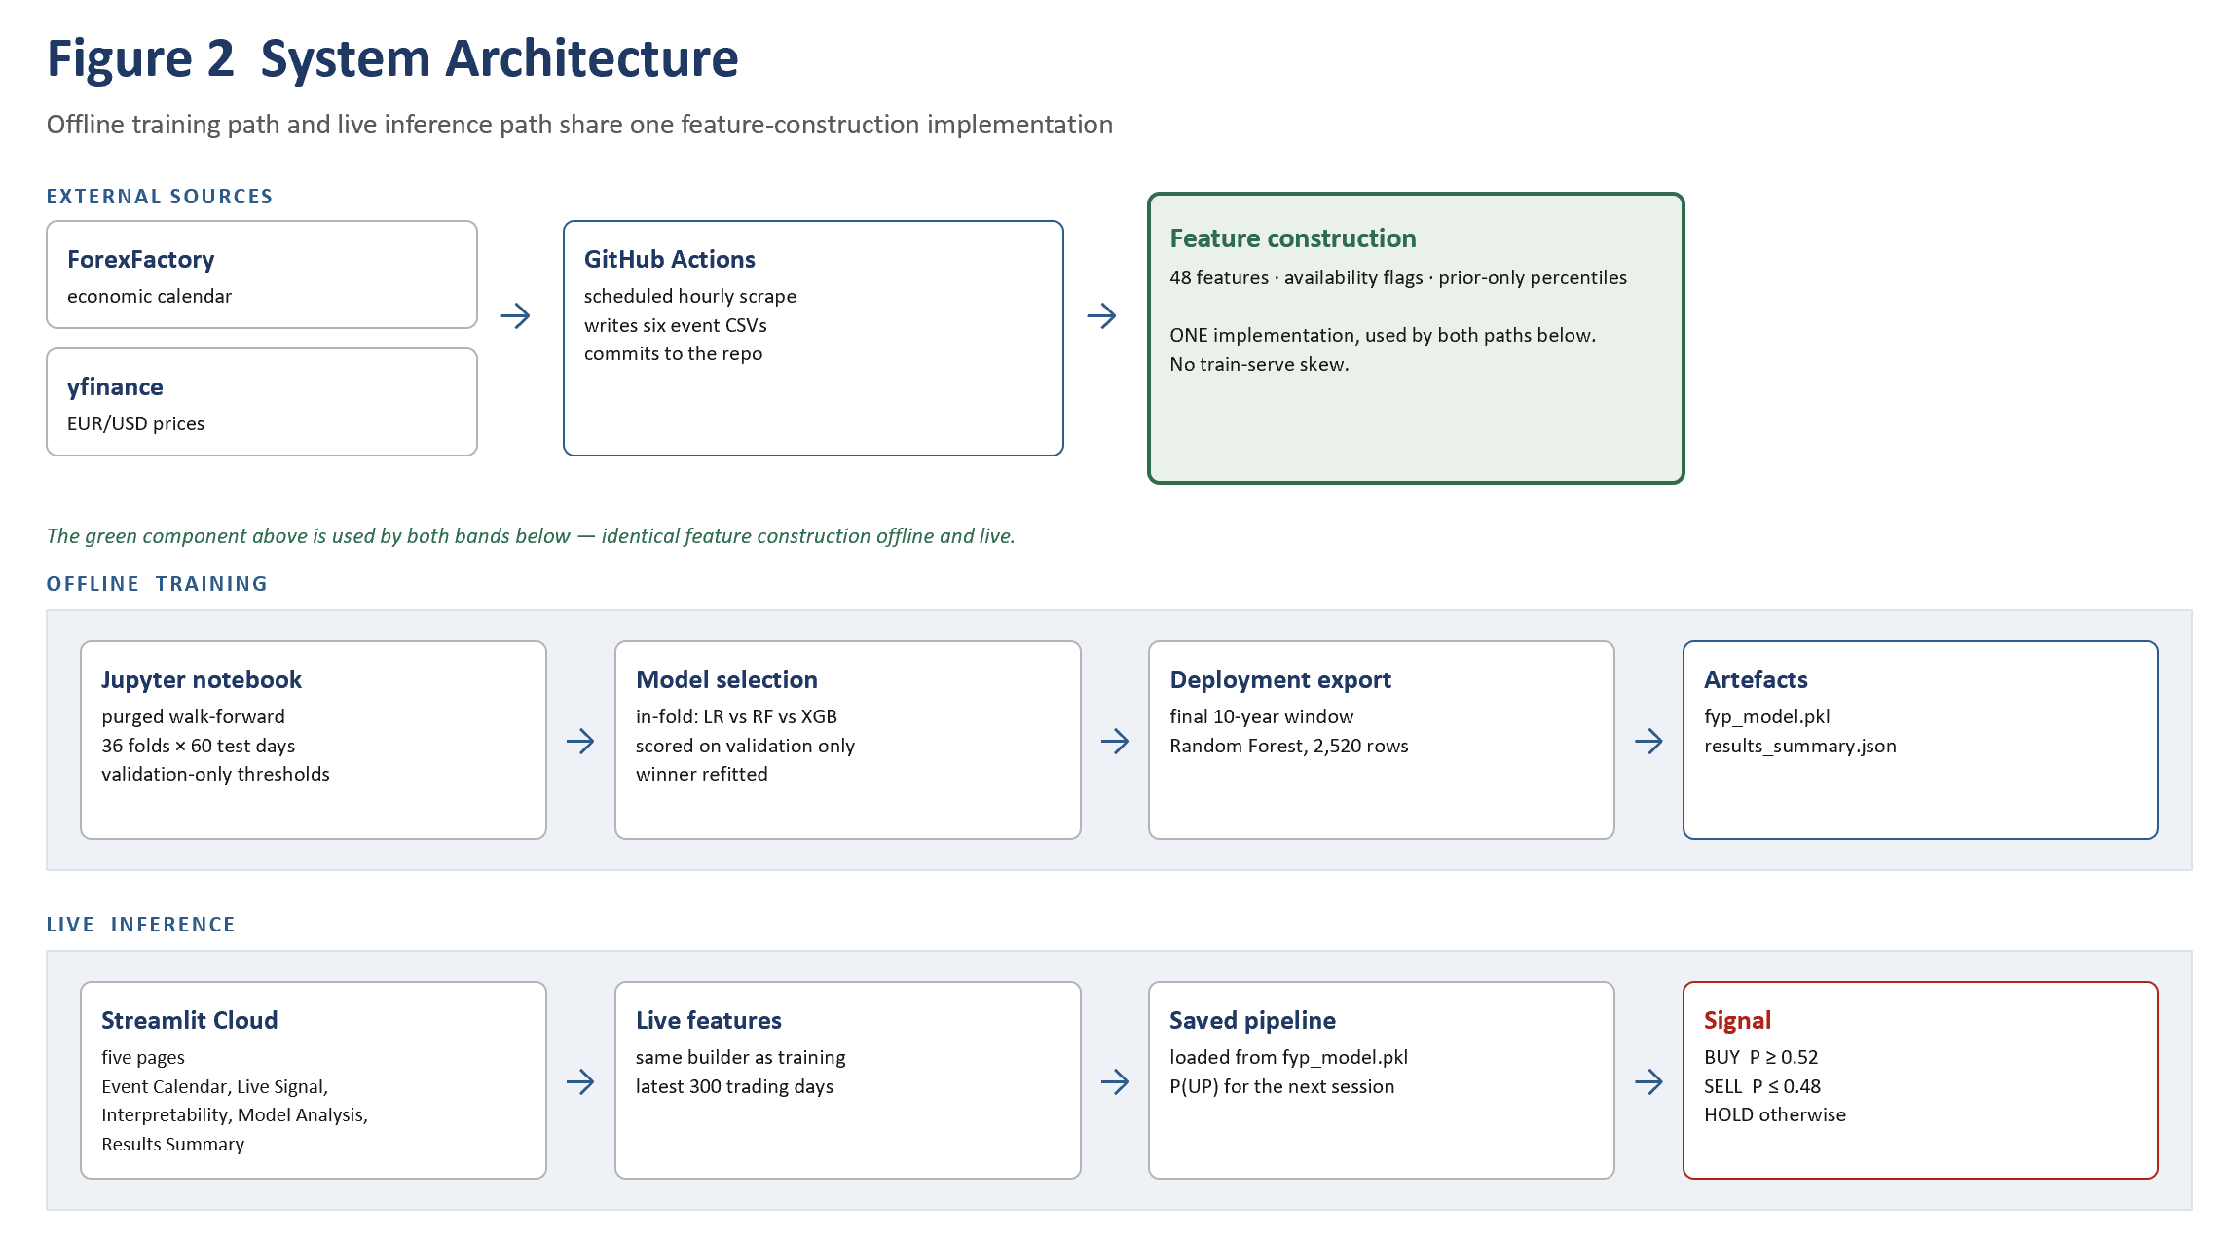
Figure 2: System architecture. The offline training path and the live inference path share a single feature-construction implementation, which is what removes train-serve skew.

4.2 ForexFactory Scraper
Economic event data was collected from the ForexFactory calendar using a parameterised scraping notebook. The scraper walks the calendar month by month across the full sample period, extracts the actual, forecast and previous values for each target release, and writes one CSV per event family. Values reported with magnitude suffixes and percentage signs are normalised to numeric form before merging.

4.3 Methodological Corrections
Three corrections distinguish this pipeline from the earlier version, and together they account for the difference between the earlier reported figures and those in Section 5.

4.3.1 Correction 1 — Event availability and percentile construction
Earlier processing could not distinguish a missing surprise from a genuine zero, and discarded event-day information when either actual or forecast was absent. The record is now retained, six availability flags are added, and surprises are ranked against prior valid releases only, with a minimum of 12 prior releases required before a rank is issued.

4.3.2 Correction 2 — Leakage-safe scaling, tuning and purging
Standardisation was moved inside the modelling Pipeline so that the scaler refits within each training fold rather than being fitted once over data that includes the evaluation period. Hyperparameters are selected on the pre-test sample only, and a one-row purge gap separates training from evaluation at every boundary because each target depends on the following day's close.

4.3.3 Correction 3 — Backtest accounting
Positions are applied to the stored next-day return, log returns compound correctly, one basis point is charged per unit of turnover, and position changes are reported rather than treating every active signal as a completed trade.

4.4 Experimental Sequence
The configuration was reached through a documented sequence of 7 runs, followed by the model and horizon comparison reported in Section 5.9 as the main performance study. Each run varies one factor and reuses the frozen hyperparameters from Section 3.4.
Table 4: Experimental sequence
Run | Factor varied | Outcome
1 | Sample extension from 2019 to 2007 | Methodological baseline; model was selected on test AUC, which was subsequently identified as a selection leak and corrected
2 | Event-data correction and availability encoding; model selection moved to training CV | Logistic Regression selected on training evidence
3 | Technical-only, event-only and hybrid feature sets across three models | Hybrid Random Forest strongest on walk-forward
4 | Event-feature refinement: signed-log, directional and rate-policy encodings | Controlled negative result; baseline encoding retained
5 | Expanding, five-year and ten-year rolling training windows | Ten-year rolling window selected
6 | Final leakage-safe evaluation with purge gap, validation-only thresholds and costs | Reported as the single-configuration evaluation in Section 5.5
7 | Three model families crossed with one-day, three-day and five-day prediction horizons, on common folds | Main performance study; accuracy lower at five days than at one day in all three families
7 | Model selection moved inside the walk-forward | Removes dependence on having inspected the grid; 0.5324 at p = 0.000672

Reporting the sequence in full, including the negative result in Run 4, is deliberate. Presenting only the final configuration would obscure the fact that several plausible refinements were tested and did not help. Runs 7 differ from the first six in purpose rather than method. Runs 1 to 6 narrow the configuration; Runs 7 evaluate it more broadly and do not feed back into the selection, which is why the multiple-comparison adjustment in Section 5.5 covers only the thirty configurations examined in Runs 3, 4 and 5.

4.5 Deployment Export
The deployment model is a Random Forest with the frozen parameters, retrained on the final ten-year window covering 22 April 2016 to 29 December 2025, comprising 2,520 rows and 48 features. Over the last 250 days of the sample its output probabilities span 0.4170 to 0.5590 with a mean of 0.4856, which is consistent with a model producing modest and generally cautious signals rather than confident directional calls. The choice of Random Forest is confirmed by the nested selection procedure of Section 5.10, which applies the same in-fold selection rule to the most recent validation window and selects Random Forest at 0.5709 against 0.5677 for Logistic Regression and 0.5140 for XGBoost. The fitted pipeline and a results summary are serialised for the dashboard.

4.6 Live Signal Dashboard
The delivered system is a Streamlit application with five pages: Event Calendar, Live Signal, Interpretability, Model Analysis and Results Summary. It scrapes the ForexFactory calendar on a schedule, reconstructs the same 48 features used in training including the availability flags, and passes them to the saved pipeline to produce a BUY, SELL or HOLD signal. Because training and inference share the feature-construction code path, there is no train-serve skew.

Figure 3: Event Calendar page. High-impact USD and euro-area releases for the current week, scraped live from the ForexFactory calendar, with forecast and previous values and a pending or released status for each.
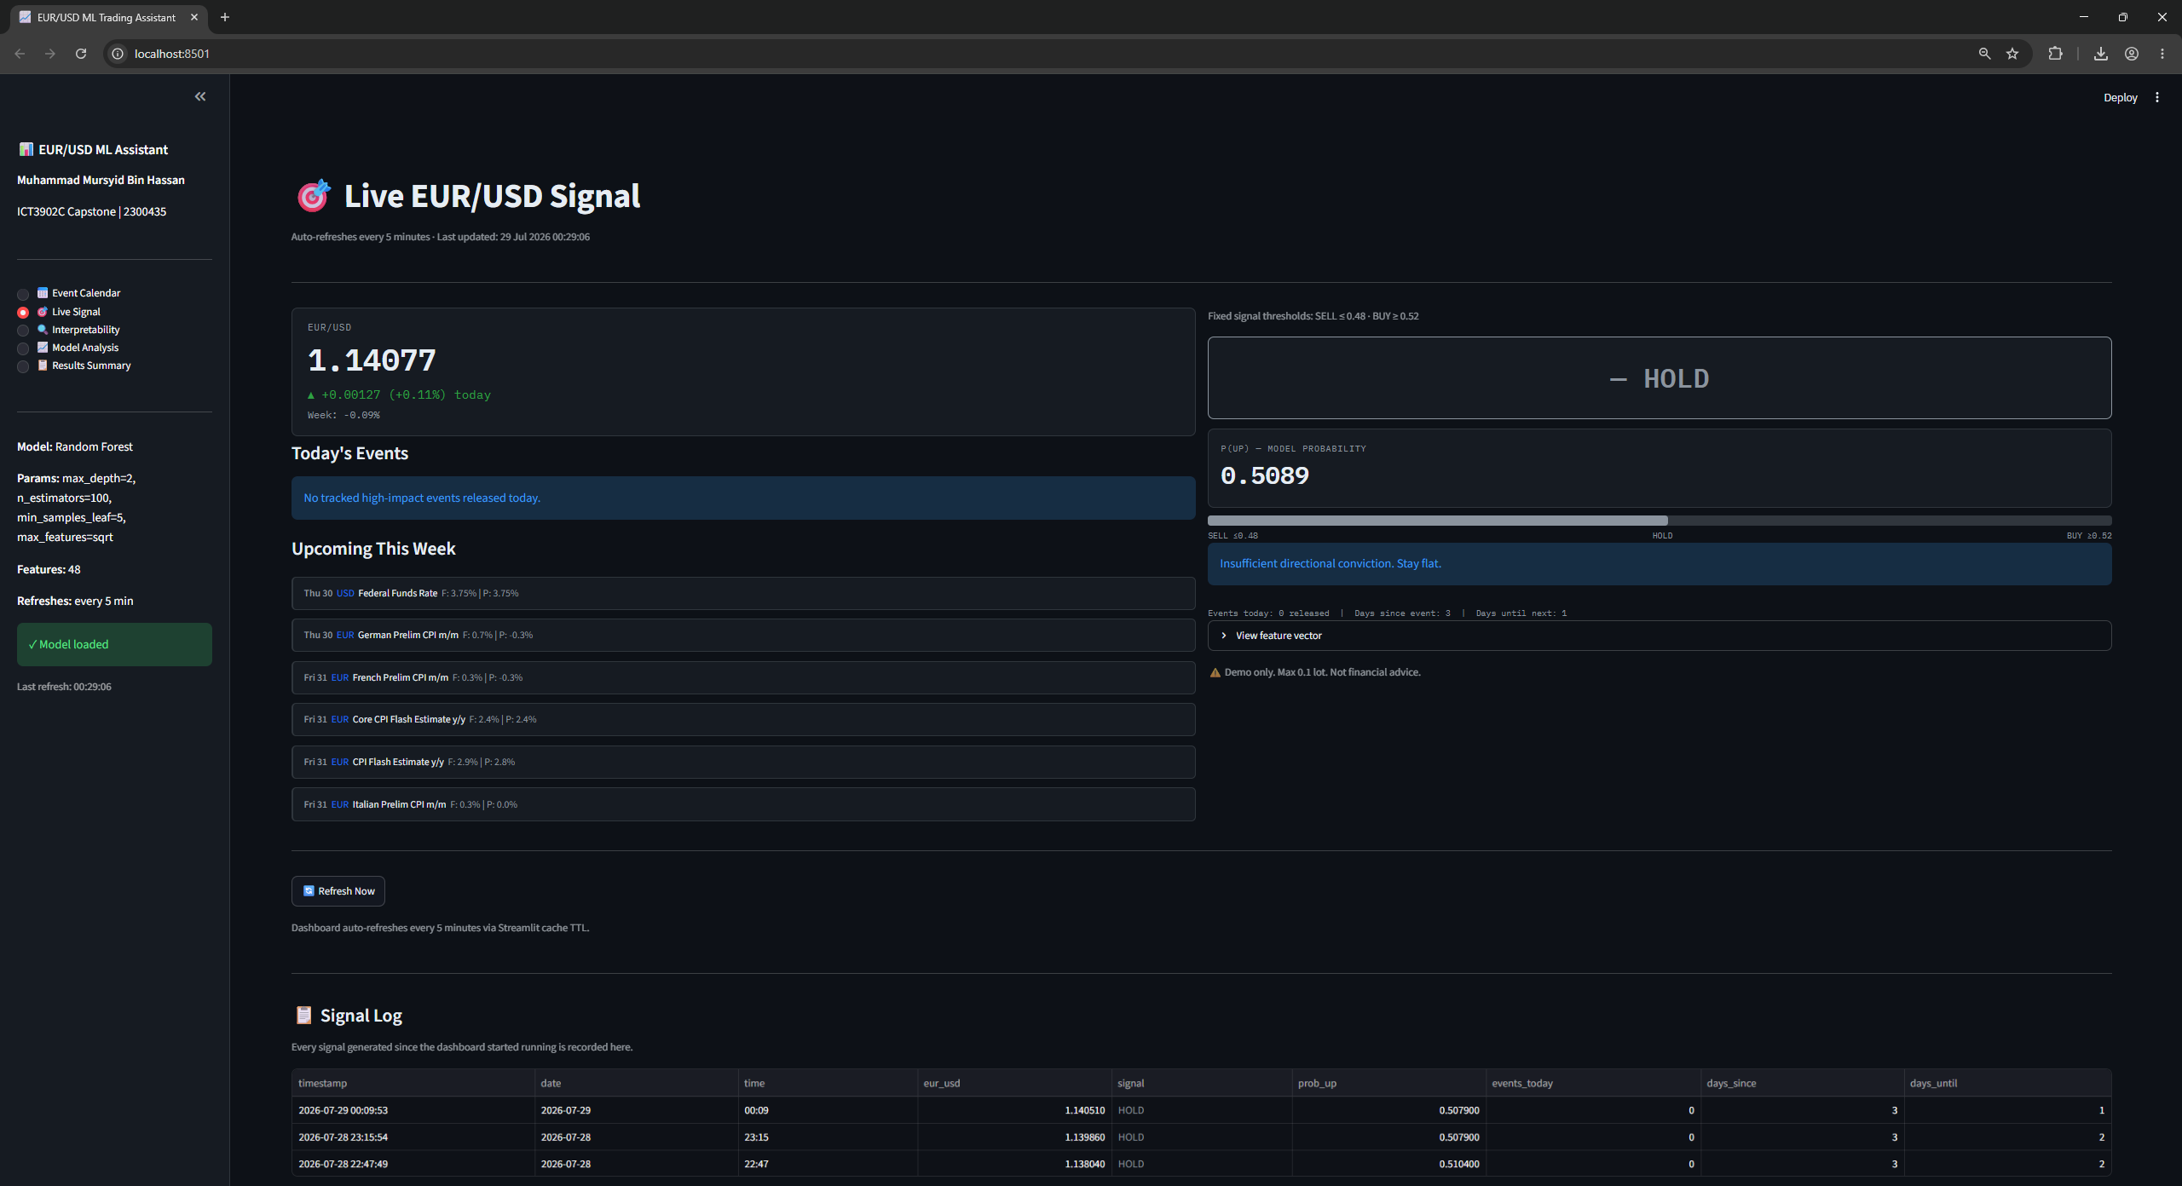
Figure 4: Live Signal page. Current EUR/USD price, the model probability of an upward move, and the resulting BUY, SELL or HOLD output against the validation-selected thresholds of 0.52 and 0.48. Every signal generated since deployment is appended to the log shown below.
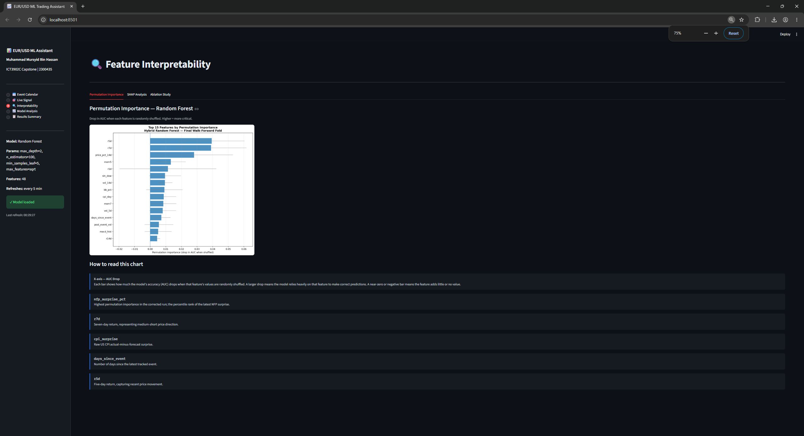
Figure 5: Interpretability page, Permutation Importance tab. Drop in AUC when each feature is randomly shuffled, for the deployed Random Forest on the final walk-forward fold.
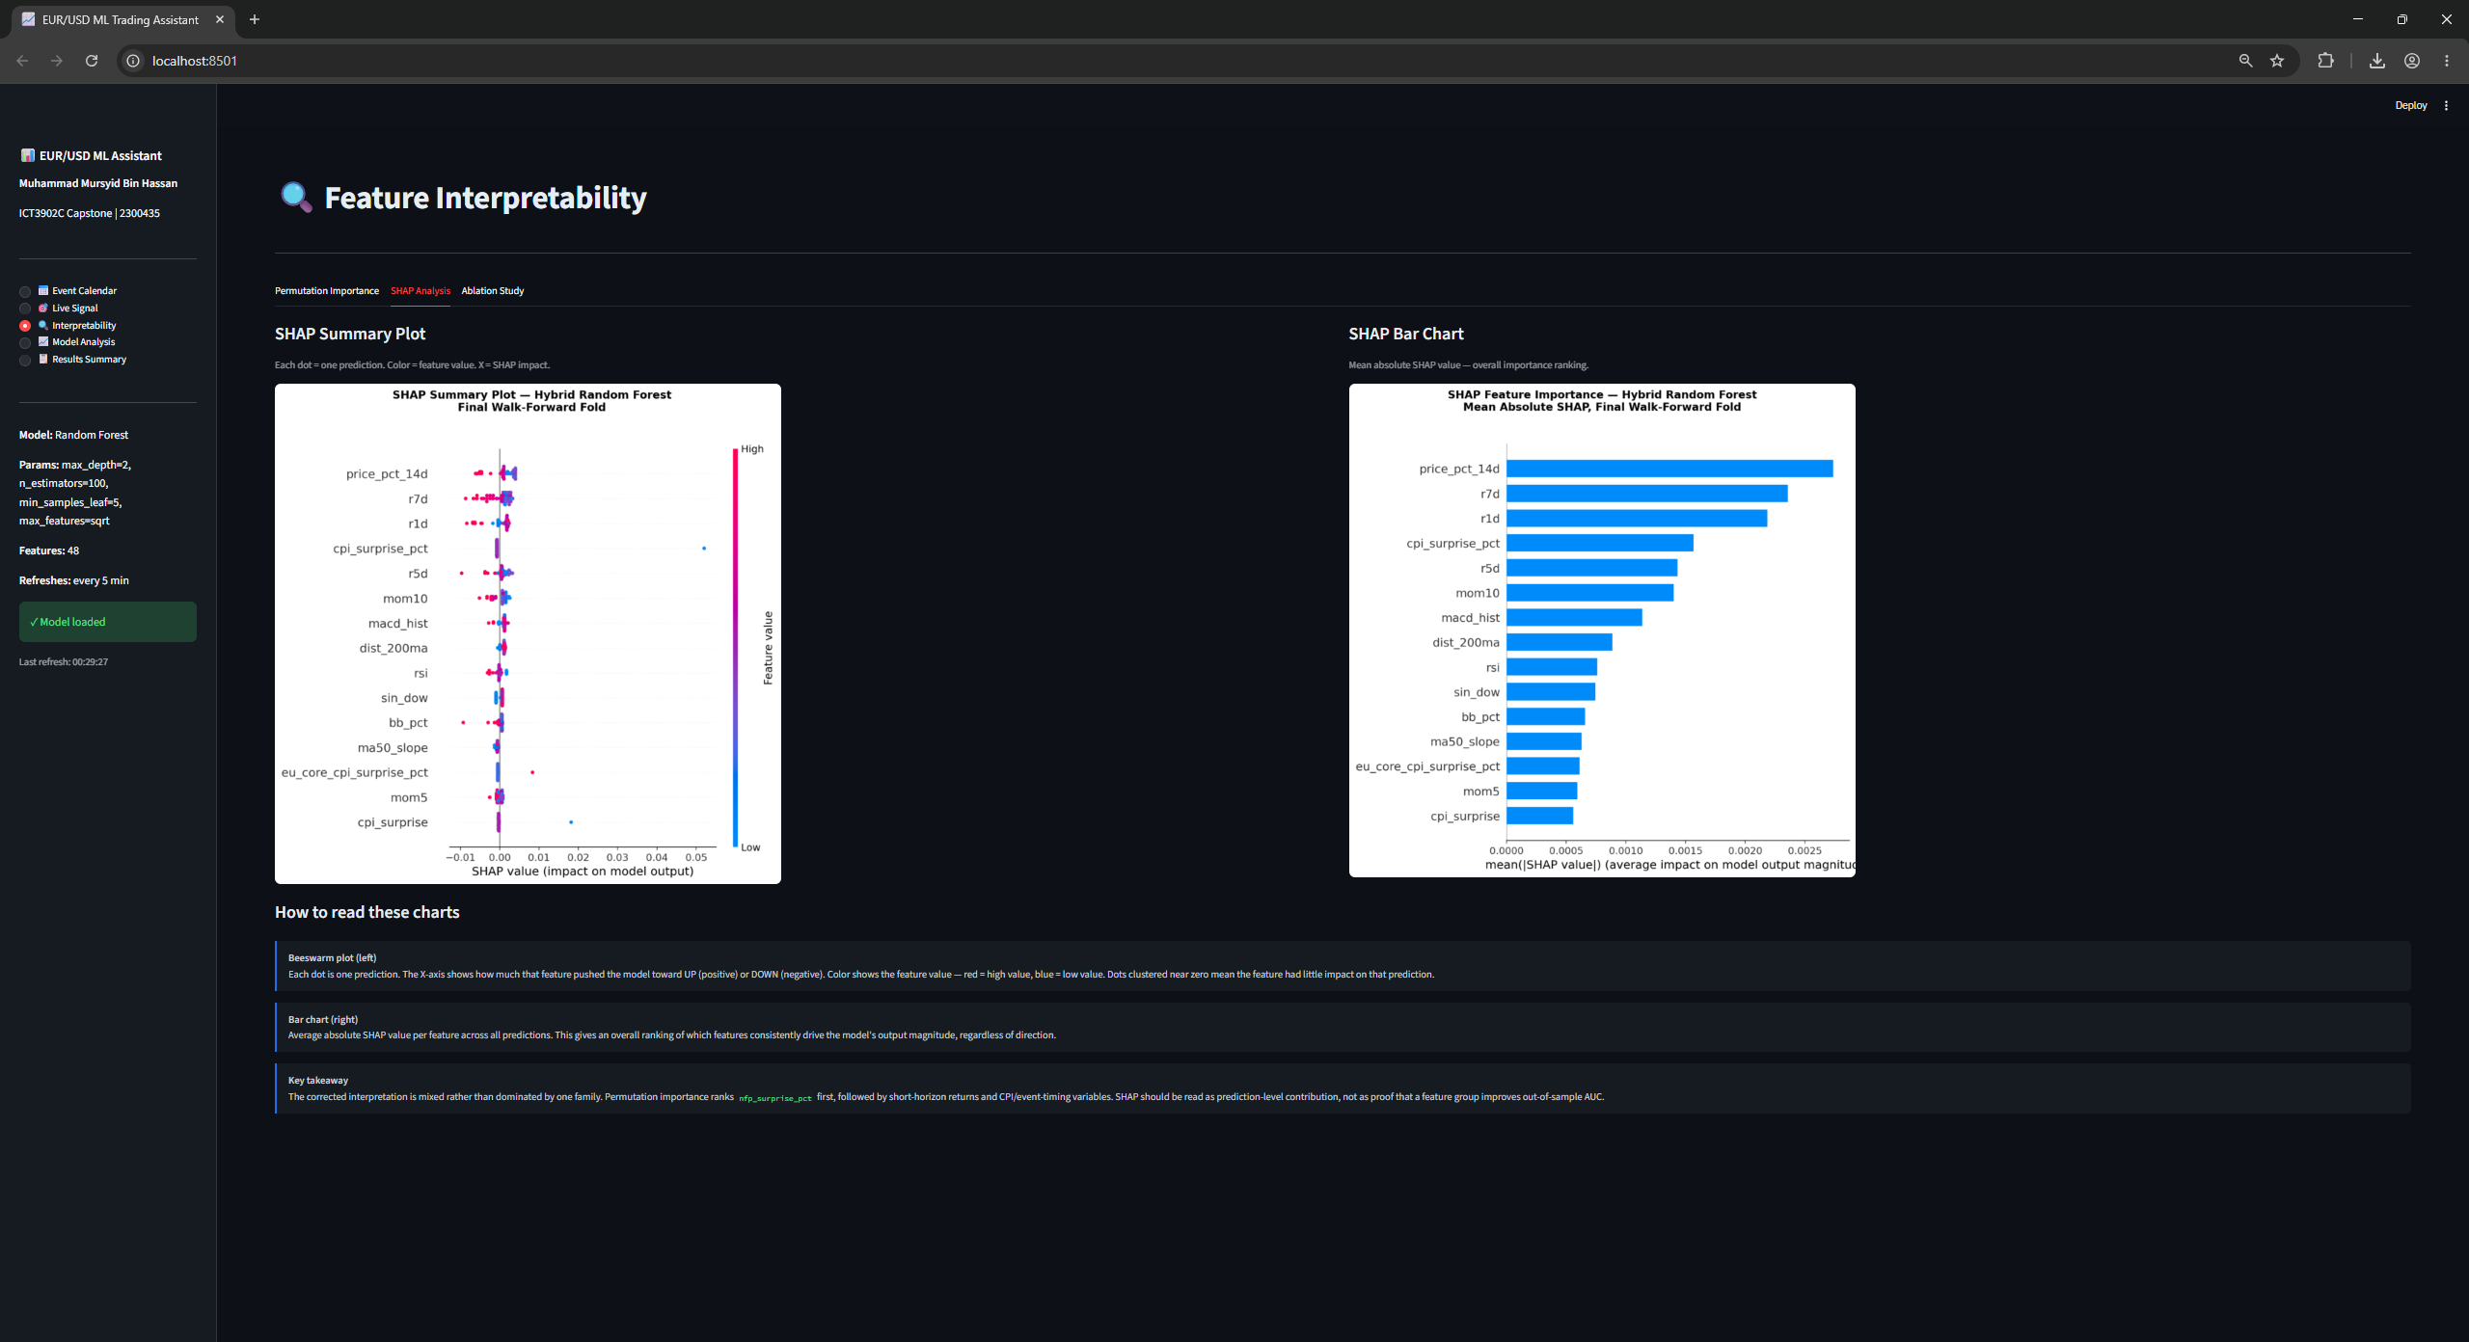
Figure 6: Interpretability page, SHAP Analysis tab. Beeswarm plot of per-prediction contributions on the left and mean absolute SHAP per feature on the right.
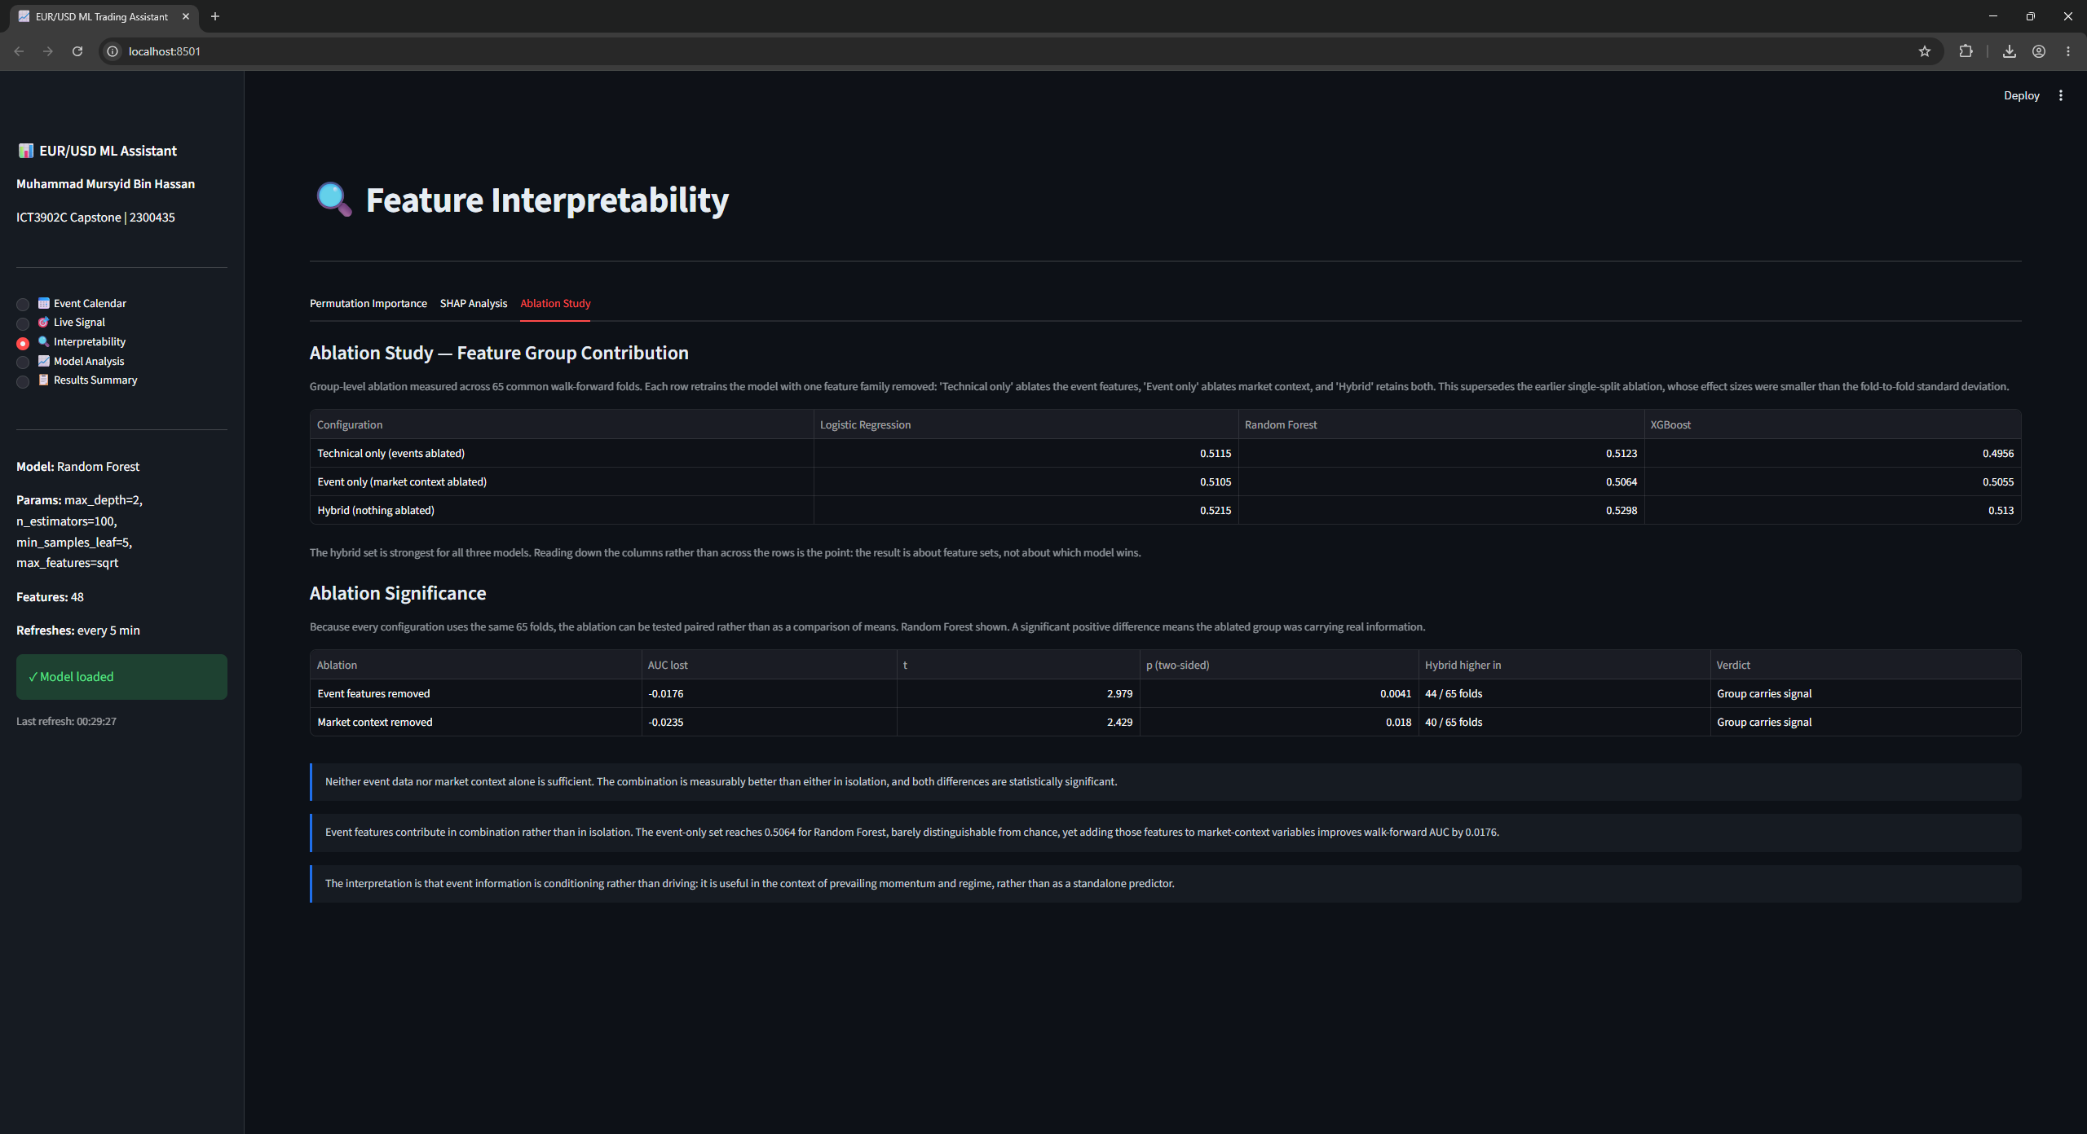
Figure 7: Interpretability page, Ablation Study tab. Group-level ablation across 65 walk-forward folds with the paired significance tests, corresponding to Table 6 and Section 5.2.
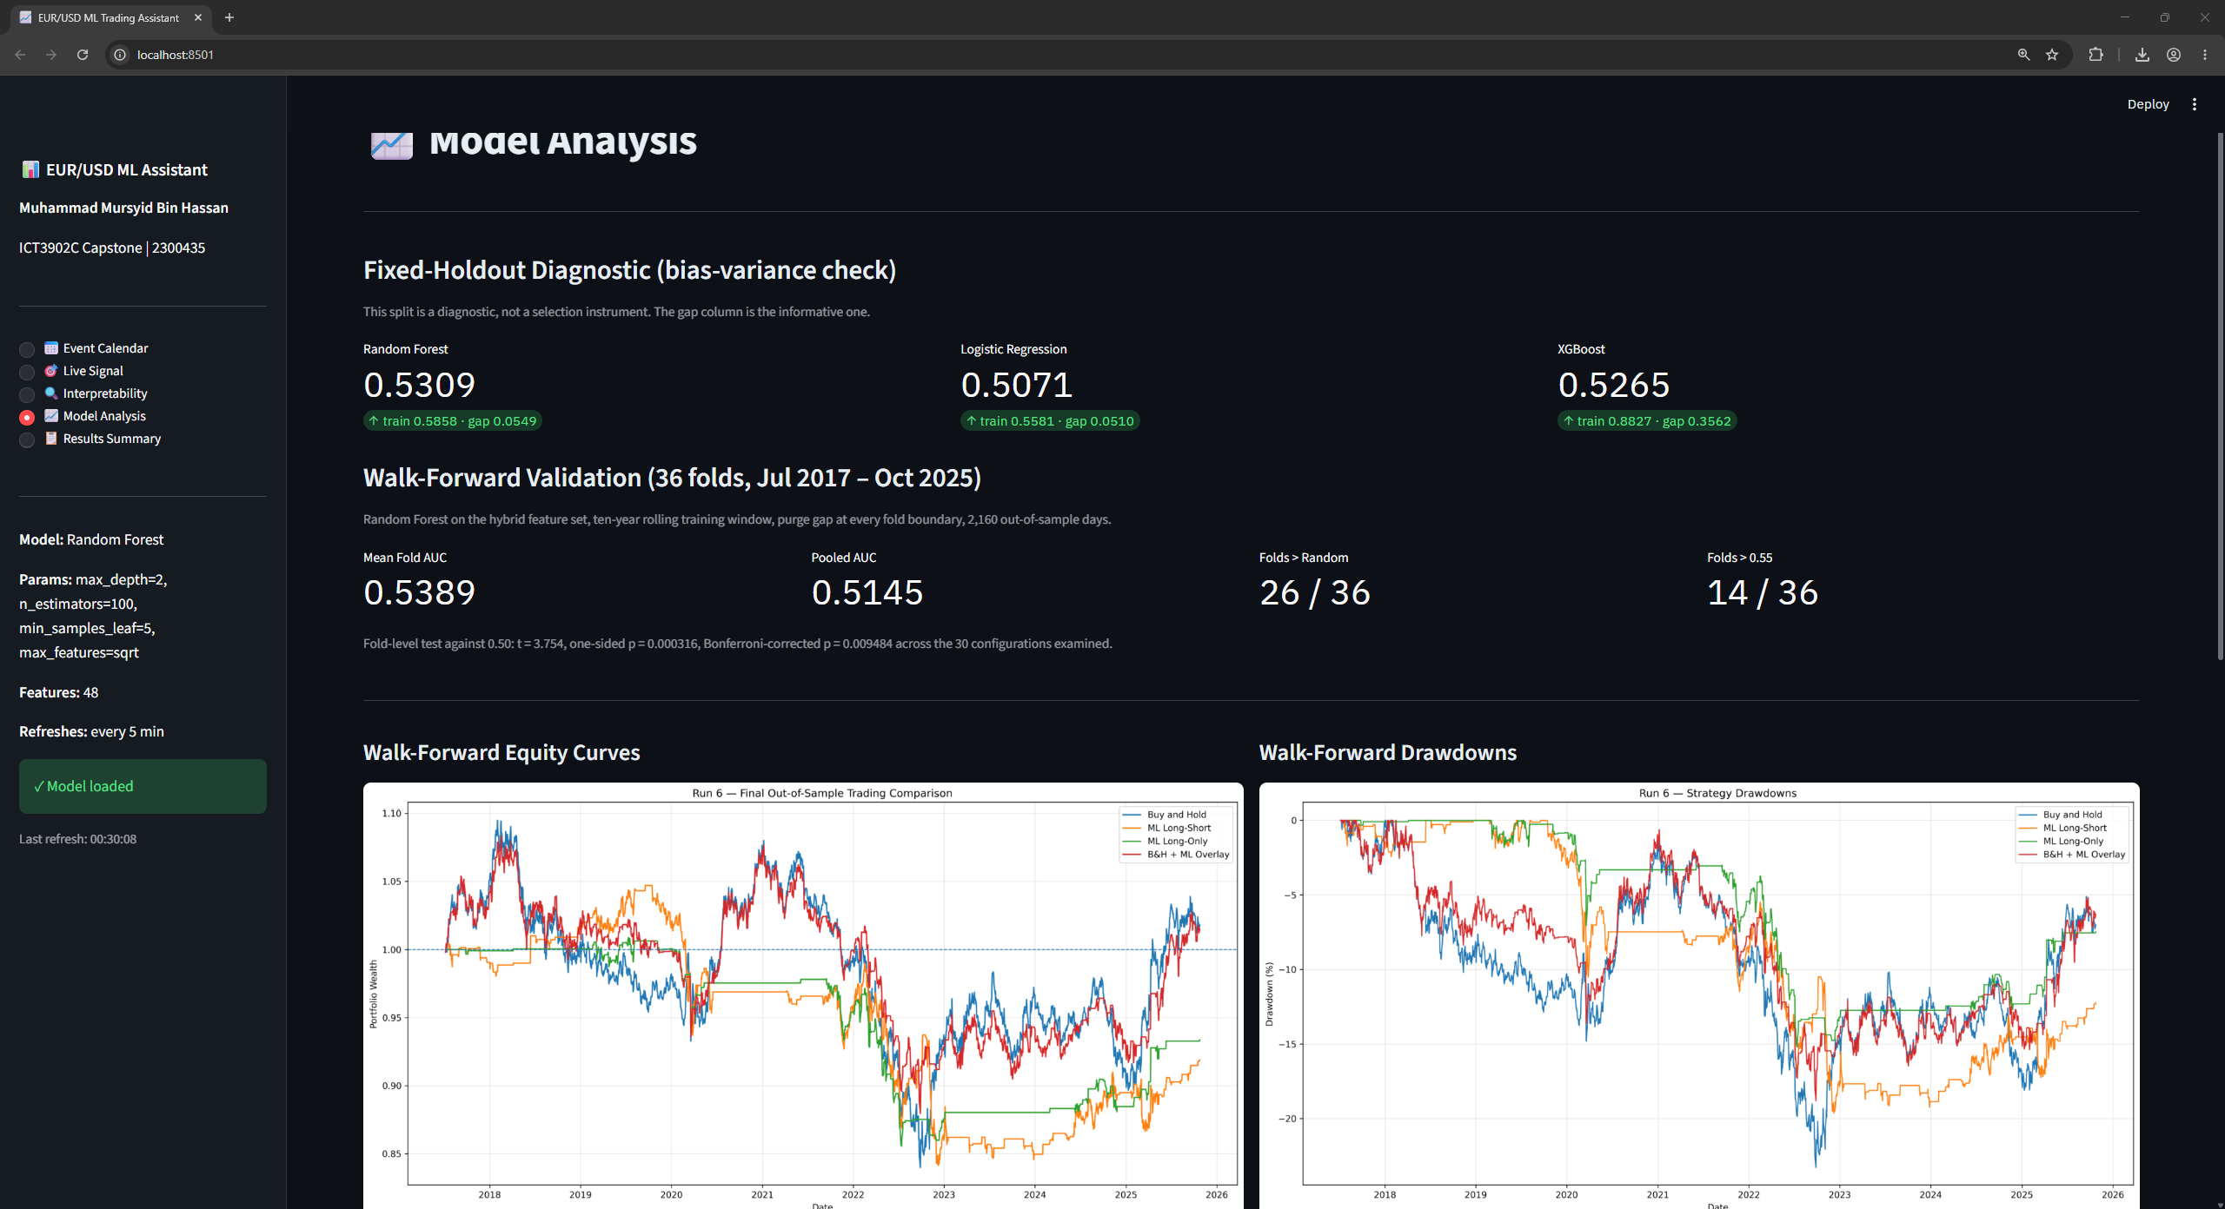
Figure 8: Model Analysis page. The fixed-holdout bias-variance diagnostic with train and test AUC for all three model families, followed by the 36-fold walk-forward summary and the equity and drawdown curves.
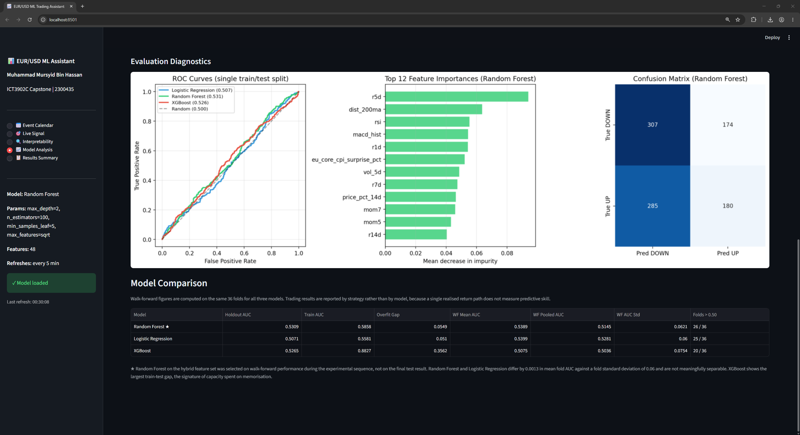
Figure 9: Model Analysis page, continued. Evaluation diagnostics and the model comparison table, showing that the three families are separated by less than the fold-to-fold standard deviation.
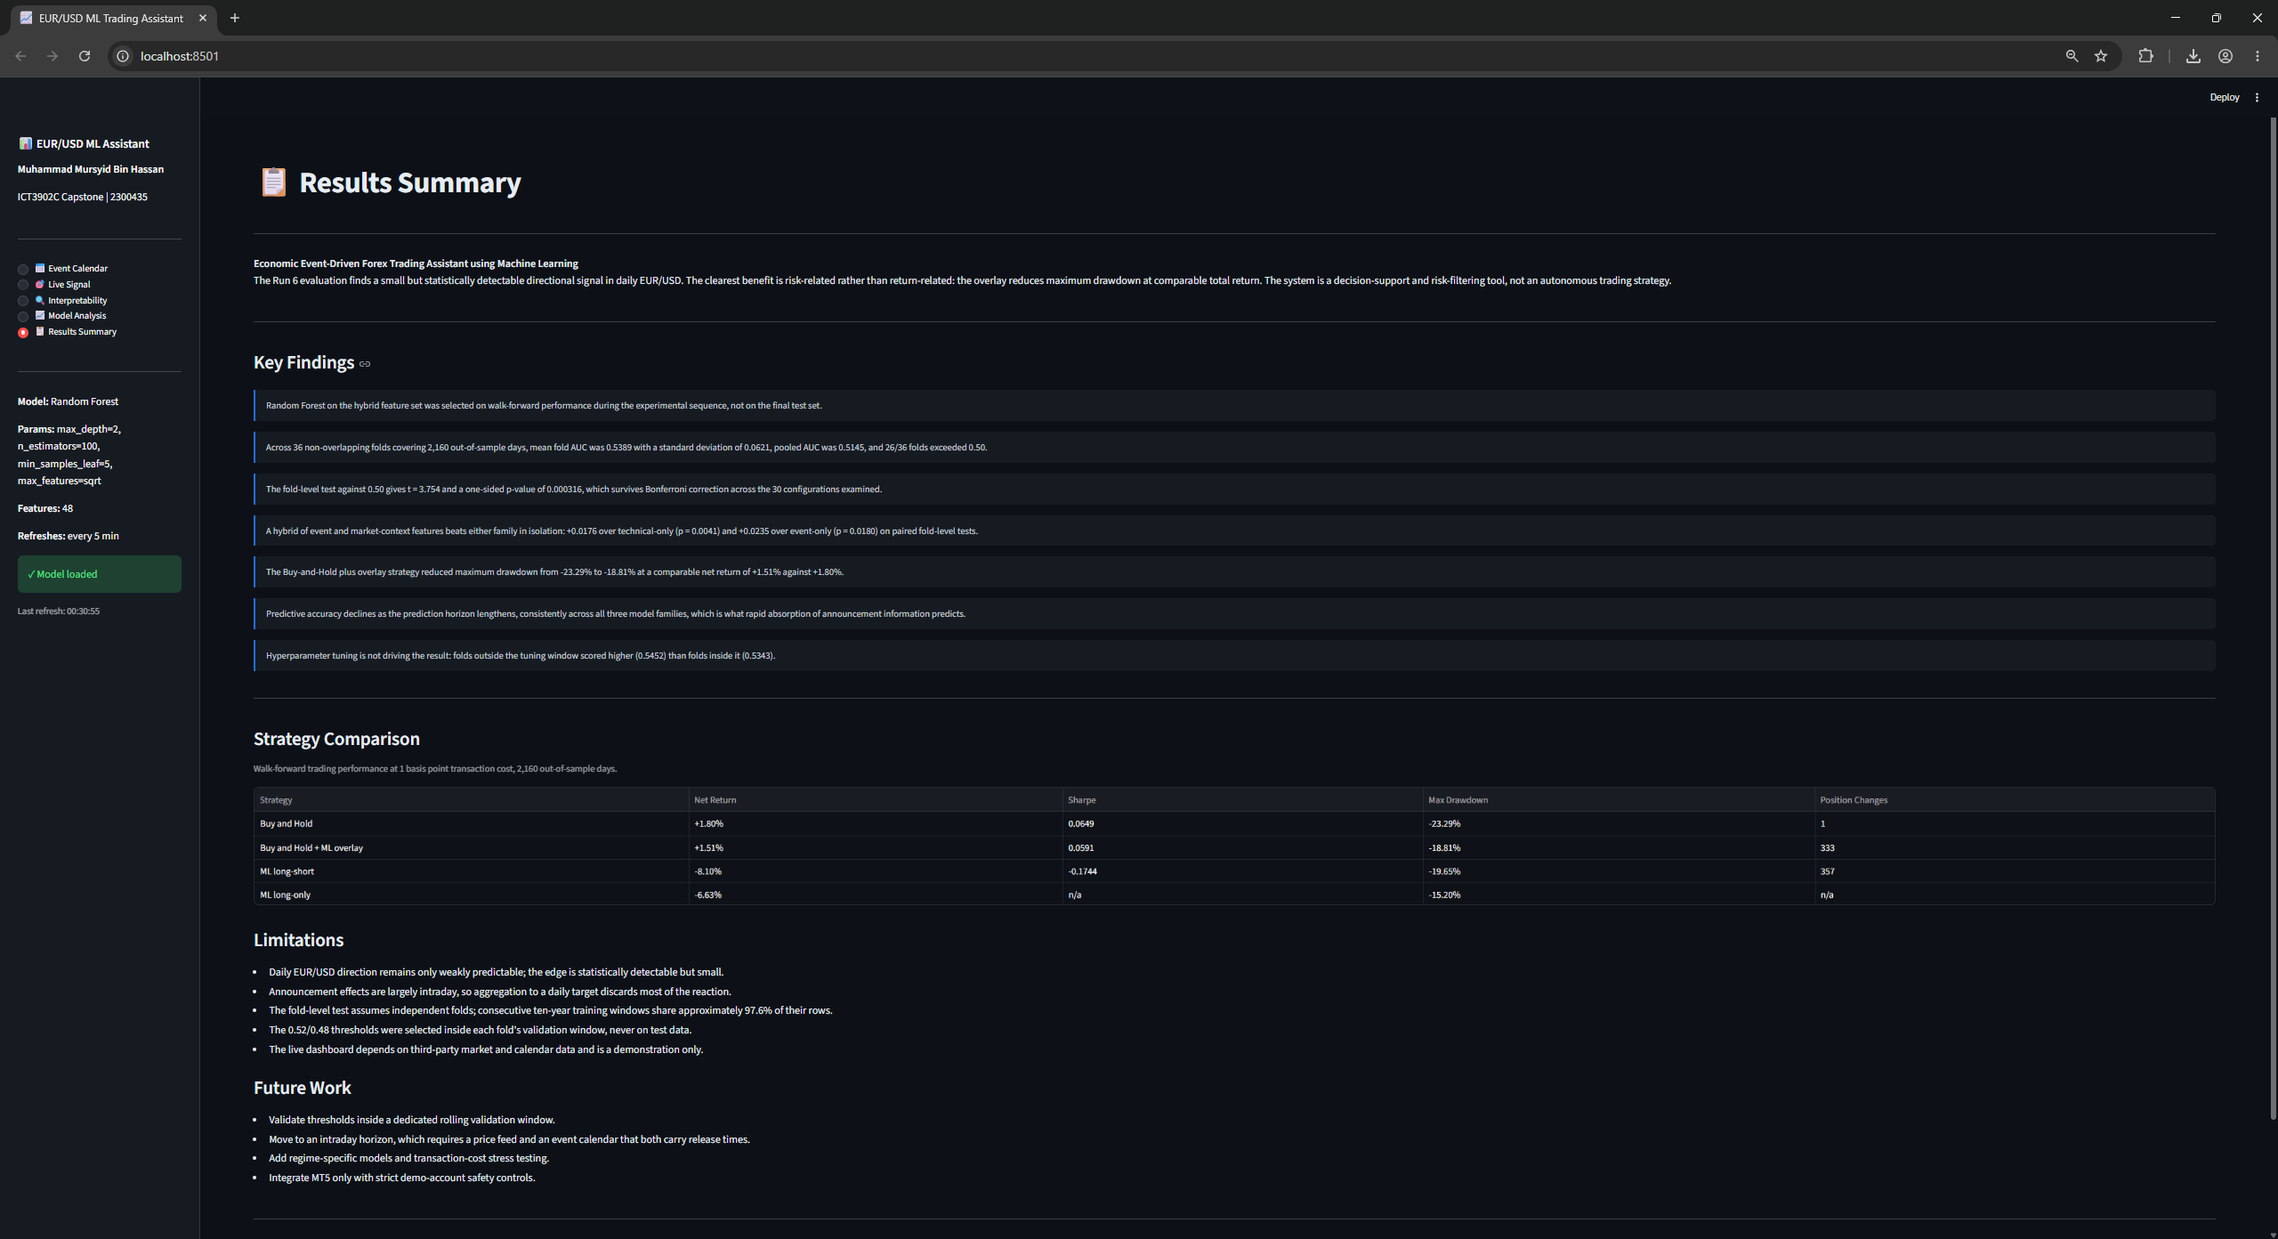
Figure 10: Results Summary page. Key findings, the strategy comparison at one basis point, the limitations and the future work items, mirroring the corresponding sections of this report.

4.7 MetaTrader5 Descoping
MetaTrader5 integration was listed as a stretch objective in the proposal and was descoped. The dashboard satisfies the same decision-support objective, and automated order execution would introduce operational and financial risk disproportionate to the evidential strength of the signal reported in Section 5. This is recorded as an engineering judgement rather than an omission.

5. Results

5.1 Fixed-Holdout Diagnostic
Table 5 reports the tuned models on the single fixed chronological split. This split is a diagnostic, not a selection instrument.
Table 5: Bias-variance diagnosis on the fixed holdout (tuned models)
Model | Train AUC | Test AUC | Gap
Logistic Regression | 0.5581 | 0.5071 | 0.0509
Random Forest | 0.5858 | 0.5309 | 0.0549
XGBoost | 0.8827 | 0.5265 | 0.3562

The gap column is the informative one. XGBoost fits the training data far better than the other two models and generalises no better, which is the signature of capacity being spent on memorisation rather than signal. Accuracy on the same split was 0.5021 for Logistic Regression, 0.5148 for Random Forest and 0.5201 for XGBoost, with corresponding AUC values of 0.5071, 0.5309 and 0.5265. These differences are small and were not used to choose the final configuration.
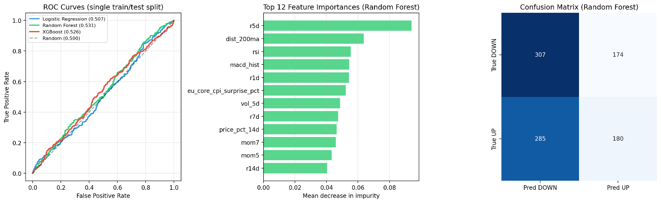
Figure 11: Single-split evaluation diagnostics. ROC curves for all three tuned models, the top twelve Random Forest feature importances by mean decrease in impurity, and the Random Forest confusion matrix at a 0.50 decision threshold.

5.2 Feature-Set Comparison (Run 3)
Table 6 reports mean walk-forward AUC across 65 folds for three feature sets and three models.
Table 6: Mean walk-forward AUC by feature set and model (65 folds)
Feature set | Logistic Regression | Random Forest | XGBoost
Technical only | 0.5115 | 0.5123 | 0.4956
Event only | 0.5105 | 0.5064 | 0.5055
Hybrid | 0.5215 | 0.5298 | 0.5130

The hybrid feature set is strongest for all three models, and the strongest single combination is Hybrid with Random Forest at 0.5298, above 0.50 in 41 of 65 folds. Because the same folds are used throughout, the comparison can be made paired rather than as a comparison of means. Against technical-only features the hybrid advantage is +0.0176 (t = 2.979, two-sided p = 0.0041, higher in 44 of 65 folds); against event-only features it is +0.0235 (t = 2.429, two-sided p = 0.0180, higher in 40 of 65 folds).
This is the central methodological finding of the experimental sequence. Neither event data nor market context alone is sufficient, and the combination is measurably better than either in isolation.

5.3 Event-Feature Refinement (Run 4)
Run 4 tested five alternative encodings of the event features against the baseline hybrid representation: signed-log transformation of surprise magnitude, a directional encoding, a directional encoding augmented with explicit rate-policy variables, and two variants with the availability flags removed. Results are shown in Table 7.
Table 7: Mean walk-forward AUC by event-feature encoding (65 folds)
Encoding | Logistic Regression | Random Forest | XGBoost
Baseline hybrid | 0.5215 | 0.5298 | 0.5130
No availability flags | 0.5218 | 0.5247 | 0.5153
Signed log | 0.5230 | 0.5266 | 0.5161
Directional | 0.5230 | 0.5266 | 0.5131
Directional + rate policy | 0.5204 | 0.5265 | 0.5146
Refined, no availability | 0.5203 | 0.5255 | 0.5163

No refinement improved on the baseline hybrid Random Forest configuration, which remained at 0.5298 with a difference of exactly zero from the Run 3 result. This is a controlled negative result and is reported as such. It also provides indirect support for the availability encoding: removing the flags reduced Random Forest performance from 0.5298 to 0.5247.

5.4 Training-Window Comparison (Run 5)
Run 5 compared an expanding training window against five-year and ten-year rolling windows, holding the model and feature set fixed. The ten-year rolling window produced a mean walk-forward AUC of 0.5387 with a standard deviation of 0.0631, above 0.50 in 26 of 36 folds and above 0.55 in 14 of 36.
On paired fold-level differences, the ten-year window exceeded the expanding window by a mean of +0.0088 (t = 1.433, two-sided p = 0.1609, higher in 20 of 36 folds with one exact tie), and the five-year window exceeded it by +0.0026 (t = 0.243, two-sided p = 0.8096). The ten-year window was therefore adopted on the basis of a consistent but not statistically significant advantage, and this is stated explicitly rather than presented as a demonstrated improvement.
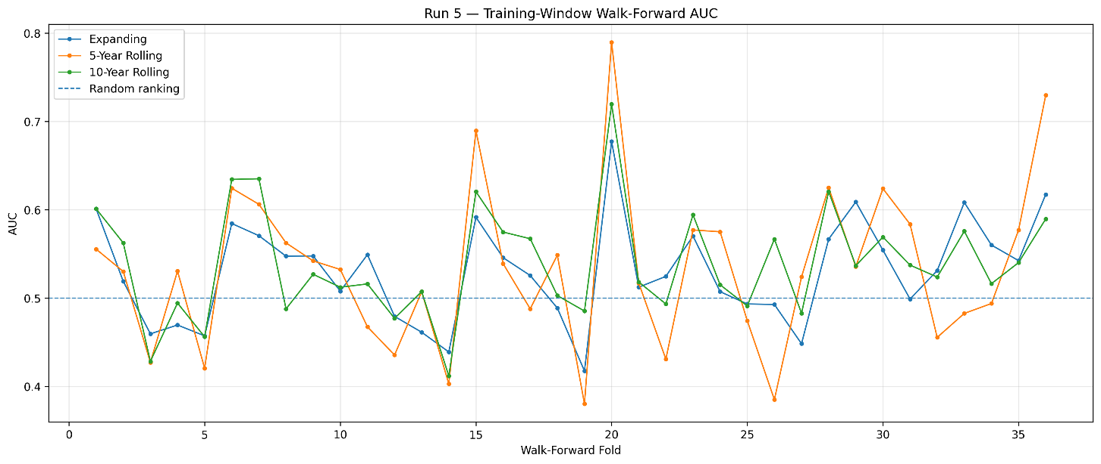
Figure 12: Walk-forward AUC per fold for the expanding, five-year rolling and ten-year rolling training windows. The three curves track each other closely, which is why the ten-year window was adopted on a consistent but not statistically significant advantage.

5.5 Single-Configuration Walk-Forward Evaluation (Run 6)
The configuration carried forward from Runs 3 to 5 is a Random Forest on the hybrid feature set with a ten-year rolling training window, a 252-day validation window used for threshold selection, a one-row purge gap and a 60-day test window per fold. This section evaluates that single configuration; Section 5.9 extends the same evaluation across three model families and three prediction horizons and is the main performance study. This produces 36 non-overlapping folds and 2,160 fully out-of-sample daily predictions. Results are shown in Table 8.
Table 8: Predictive performance of the selected configuration (36 folds, 2,160 out-of-sample days)
Metric | Result
Mean fold AUC | 0.5389
Fold AUC standard deviation | 0.0621
Folds above 0.50 | 26 / 36
Folds above 0.55 | 14 / 36
Pooled out-of-sample AUC | 0.5145

An exploratory fold-level test of the 36 fold AUCs against 0.50 gives t = 3.754 with a one-sided p-value of 0.000316. Adjusting conservatively for the 30 configurations examined across Runs 3, 4 and 5, which are the configurations that competed for selection into this evaluation, gives a Bonferroni-corrected p-value of 0.009484, so the result remains significant at conventional thresholds after correction for multiple comparisons.
The small difference between the Run 5 result of 0.5387 and the final Run 6 result of 0.5389 is attributable to the one-row purge gap introduced in Run 6.

5.6 Tuning-Contamination Check
Hyperparameters were tuned on data up to 10 May 2022, which lies inside the span covered by the earlier folds. Folds 1 to 21 therefore sit within the tuning window, while folds 22 to 36 are entirely clean. Table 9 separates them.
Table 9: Fold performance inside and outside the tuning window
Fold range | Period | n | Mean AUC | Above 0.50 | One-sided p
1-21 (inside tuning window) | 2017-07 to 2022-05 | 21 | 0.5343 | 13 / 21 | 0.0238
22-36 (clean) | 2022-06 to 2025-10 | 15 | 0.5452 | 13 / 15 | 0.0004
All folds | 2017-07 to 2025-10 | 36 | 0.5389 | 26 / 36 | 0.0003

The clean folds score higher than the contaminated ones, so hyperparameter tuning is not driving the result. The caveat is that the clean subset contains only 15 folds spanning a single market regime, so this check bounds the concern rather than eliminating it.

5.7 Trading Results for the Selected Configuration
Table 10 reports the cost-adjusted trading evaluation over the same 2,160 out-of-sample days at a one-basis-point transaction cost.
Table 10: Walk-forward trading performance at 1bp transaction cost
Strategy | Gross | Net | Sharpe | Max drawdown | Position changes
Buy and Hold | +1.81% | +1.80% | 0.0649 | -23.29% | 1
Buy and Hold + ML overlay | +4.94% | +1.51% | 0.0591 | -18.81% | 333
ML long-short | -3.07% | -8.10% | -0.1744 | -19.65% | 357
ML long-only | -4.73% | -6.63% | -0.2471 | -15.20% | 201

The clearest and most consistent difference is risk-related rather than return-related. The overlay reduced maximum drawdown from -23.29% to -18.81%, a difference of approximately 4.5 percentage points, while returning +1.51% against +1.80% for Buy and Hold. The two standalone strategies did not perform competitively after costs and are reported for completeness.
This drawdown difference is one observed outcome over a single historical market path and does not carry a confidence interval. It is therefore presented as a possible risk-filtering benefit rather than a demonstrated risk-reduction effect.
Table 11 reports sensitivity to the transaction cost assumption, which is the binding constraint on the overlay.
Table 11: Net return by transaction cost assumption
Strategy | 0 bp | 1 bp | 2 bp | 5 bp
Buy and Hold | +1.81% | +1.80% | +1.79% | +1.76%
Buy and Hold + ML overlay | +4.94% | +1.51% | -1.82% | -11.16%
ML long-short | -3.07% | -8.10% | -12.87% | -25.76%
ML long-only | -4.73% | -6.63% | -8.49% | -13.84%

The overlay is profitable in gross terms and at zero cost, matches Buy and Hold approximately at one basis point, and falls behind at two basis points and above. Turnover, not predictive accuracy, is the limiting factor.
Confidence thresholds were selected within each fold's validation window rather than fixed in advance. The selected values clustered at the lower end of the grid: 0.50 in 12 folds, 0.52 in 15 folds, 0.54 in 3, 0.56 in 1, 0.58 in 2 and 0.60 in 3. The concentration near 0.50 to 0.52 indicates the model rarely produced probabilities confident enough to justify a stricter operating point.
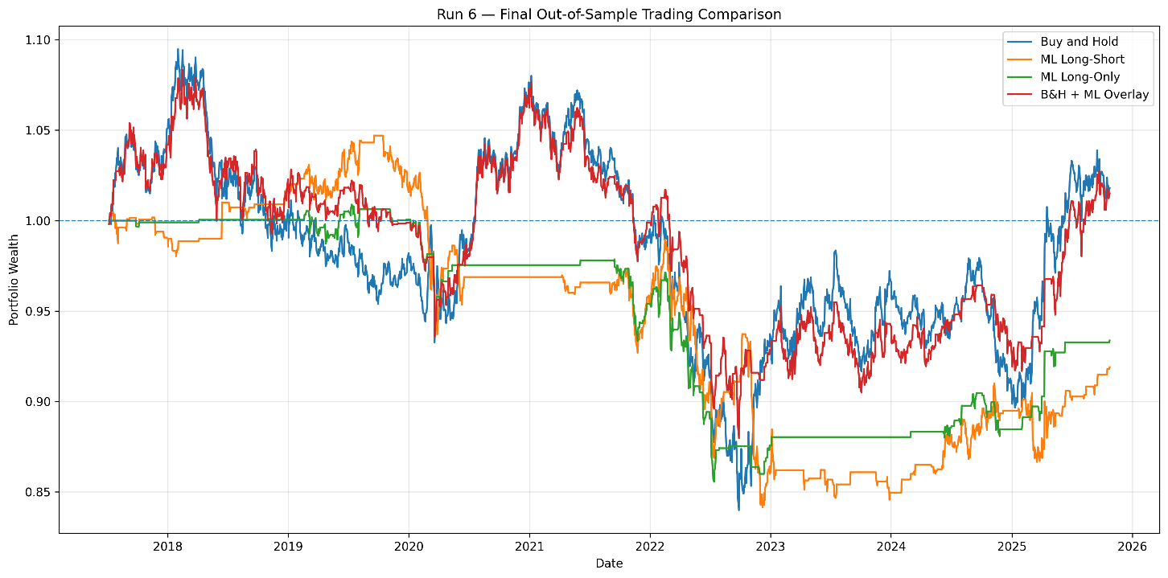
Figure 13: Walk-forward cumulative equity over the 2,160 out-of-sample days at one basis point cost. The Buy-and-Hold plus overlay curve tracks Buy and Hold closely while avoiding part of the 2022 decline.
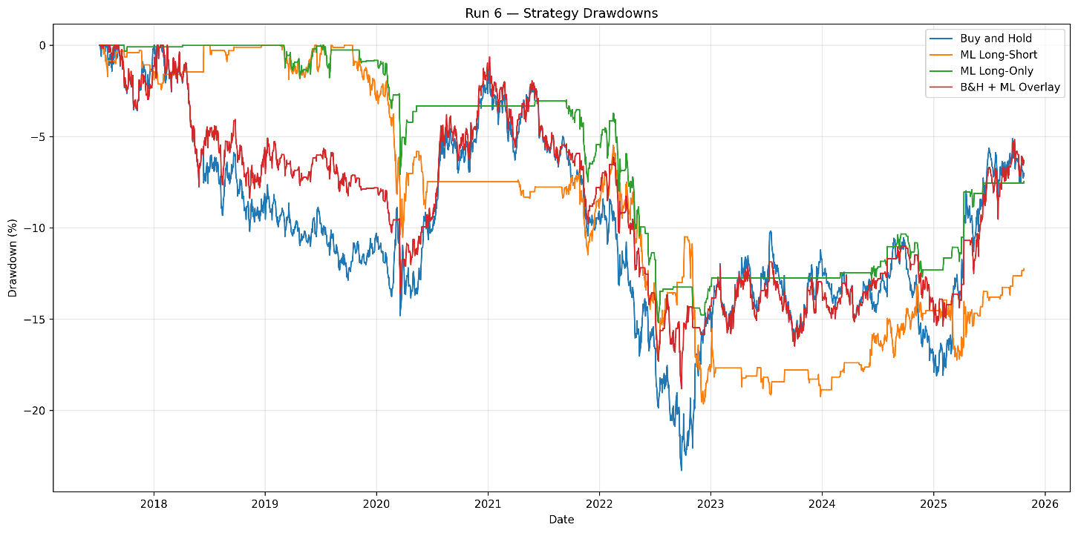
Figure 14: Walk-forward drawdowns for the same four strategies. The overlay remains above Buy and Hold through the 2022 trough, which is the source of the reduction in maximum drawdown from -23.29% to -18.81%.
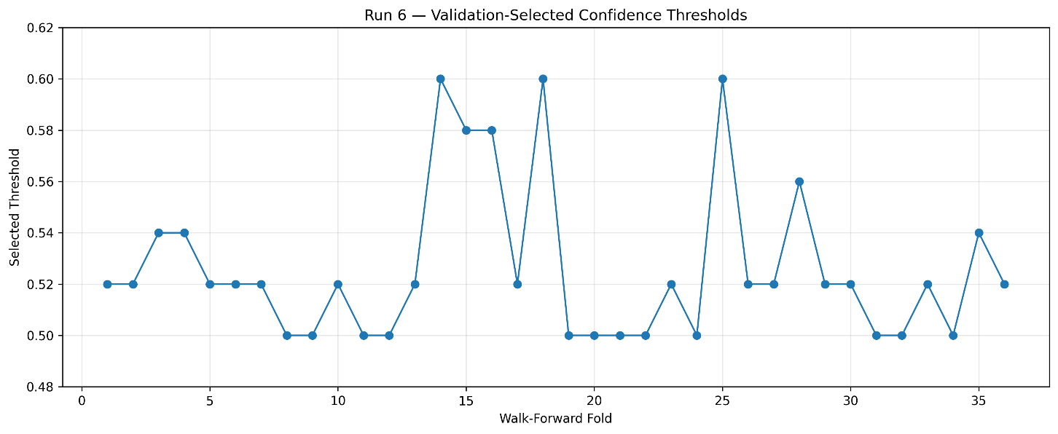
Figure 15: Confidence threshold selected on each fold’s own validation window. The concentration at 0.50 and 0.52 indicates the model rarely produced probabilities confident enough to justify a stricter operating point.

5.8 Feature Interpretability
Permutation importance was computed on the final Random Forest configuration. Table 12 reports the ten highest-ranked features.
Table 12: Permutation importance, top ten features
Feature | Mean importance | Std
price_pct_14d | 0.0305 | 0.0278
r7d | 0.0244 | 0.0213
r5d | 0.0197 | 0.0158
r1d | 0.0132 | 0.0273
vol_5d | 0.0091 | 0.0060
mom5 | 0.0090 | 0.0081
days_since_event | 0.0082 | 0.0049
macd_hist | 0.0068 | 0.0057
vol_14d | 0.0067 | 0.0055
bb_pct | 0.0062 | 0.0103

Market-context features occupy the highest individual ranks, with days_since_event the highest-ranked event feature in seventh position. This does not contradict the Run 3 finding. Run 3 measures the incremental contribution of an entire feature family, and shows that adding event features to technical features produces a significant improvement. Permutation importance measures the contribution of individual columns, and market-context variables carry more of that weight individually. Both results are true and answer different questions.
Feature-target correlations are correspondingly small: the strongest are nfp_surprise_pct at -0.0574, r5d at -0.0438 and r7d at -0.0403. No single feature carries the signal, which is consistent with a small effect distributed across a wide feature set.
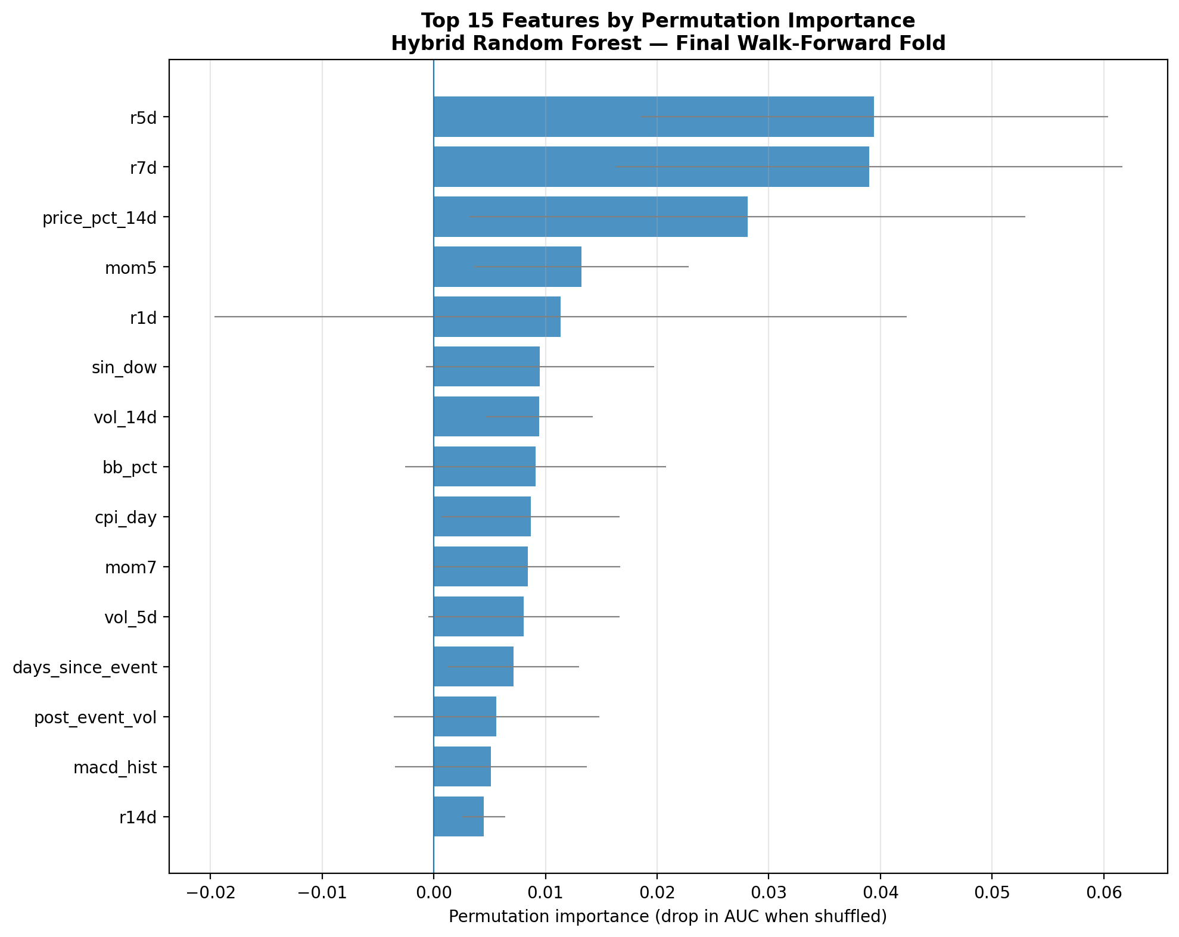
Figure 16: Top fifteen features by permutation importance for the deployed Random Forest on the final walk-forward fold. Error bars show the spread across shuffling repeats.
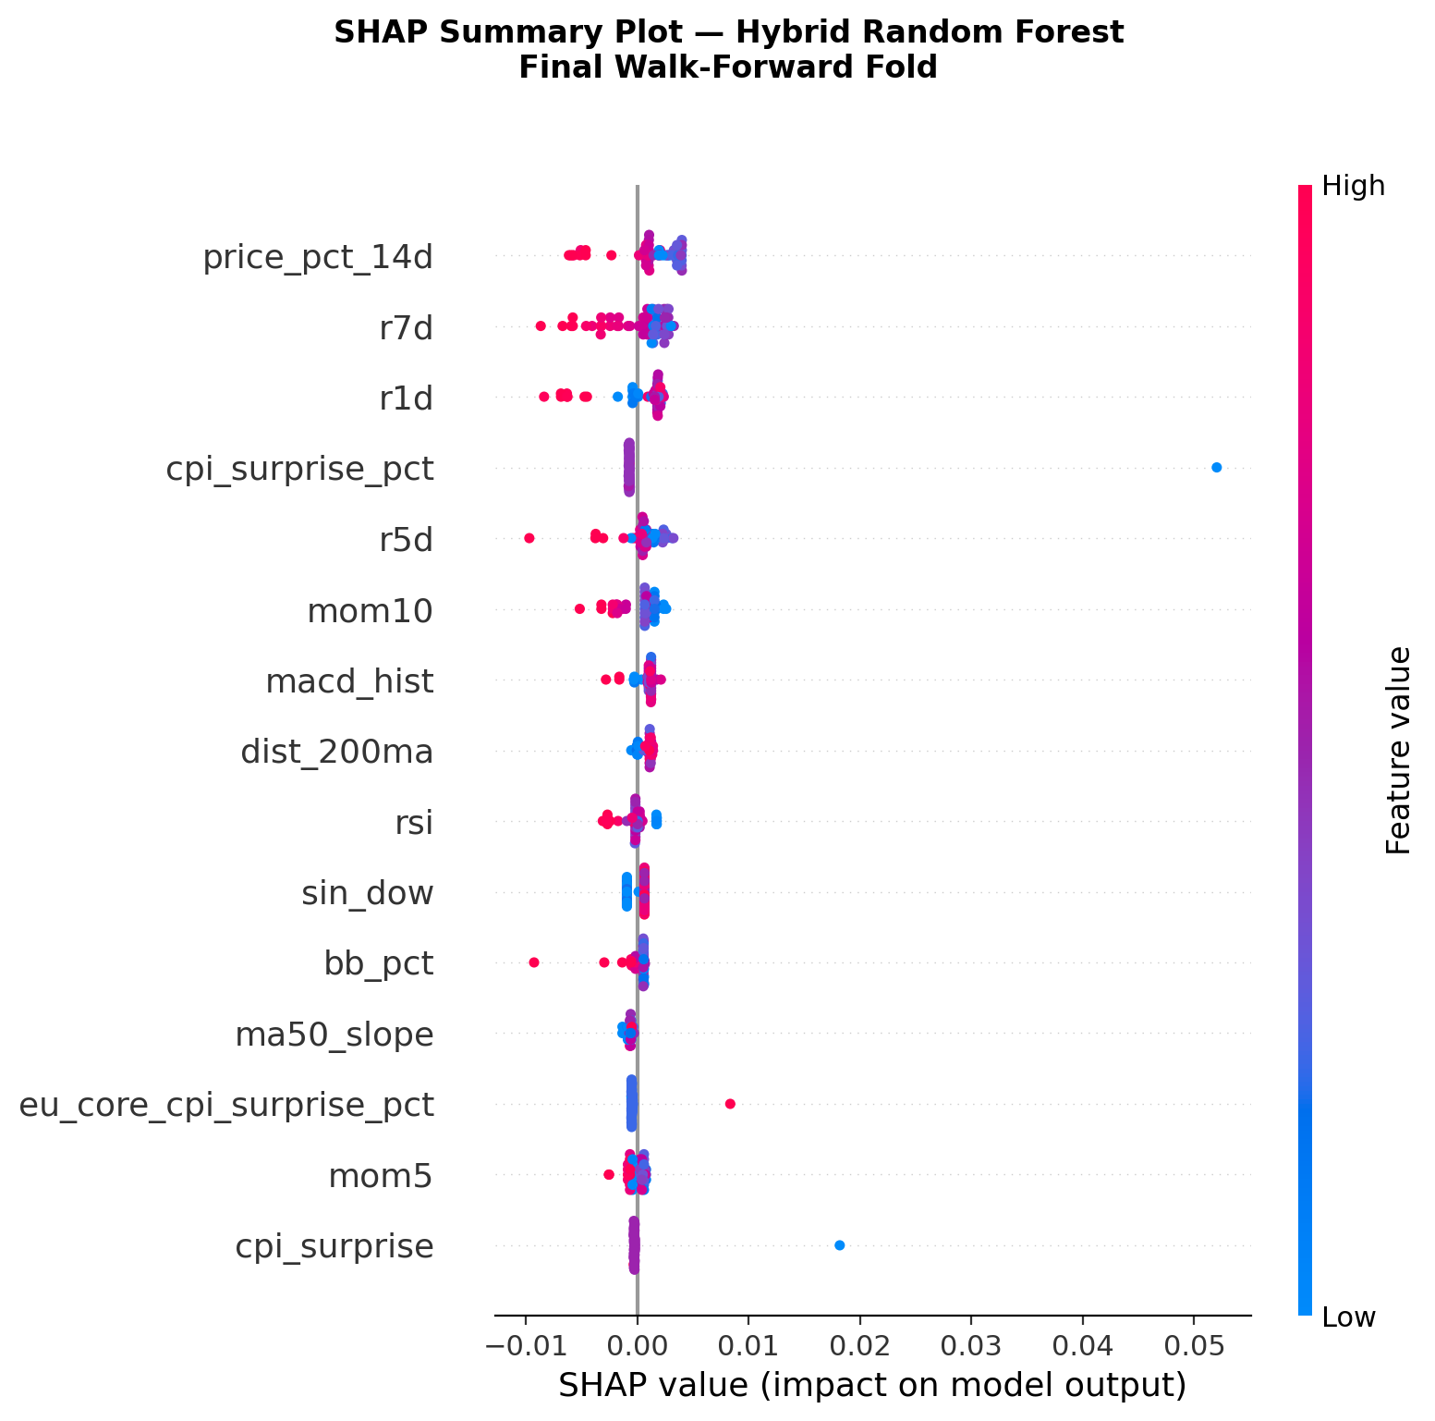
Figure 17: SHAP summary plot for the deployed Random Forest on the final walk-forward fold. Each dot is one prediction; horizontal position is the contribution to the model output and colour is the underlying feature value.
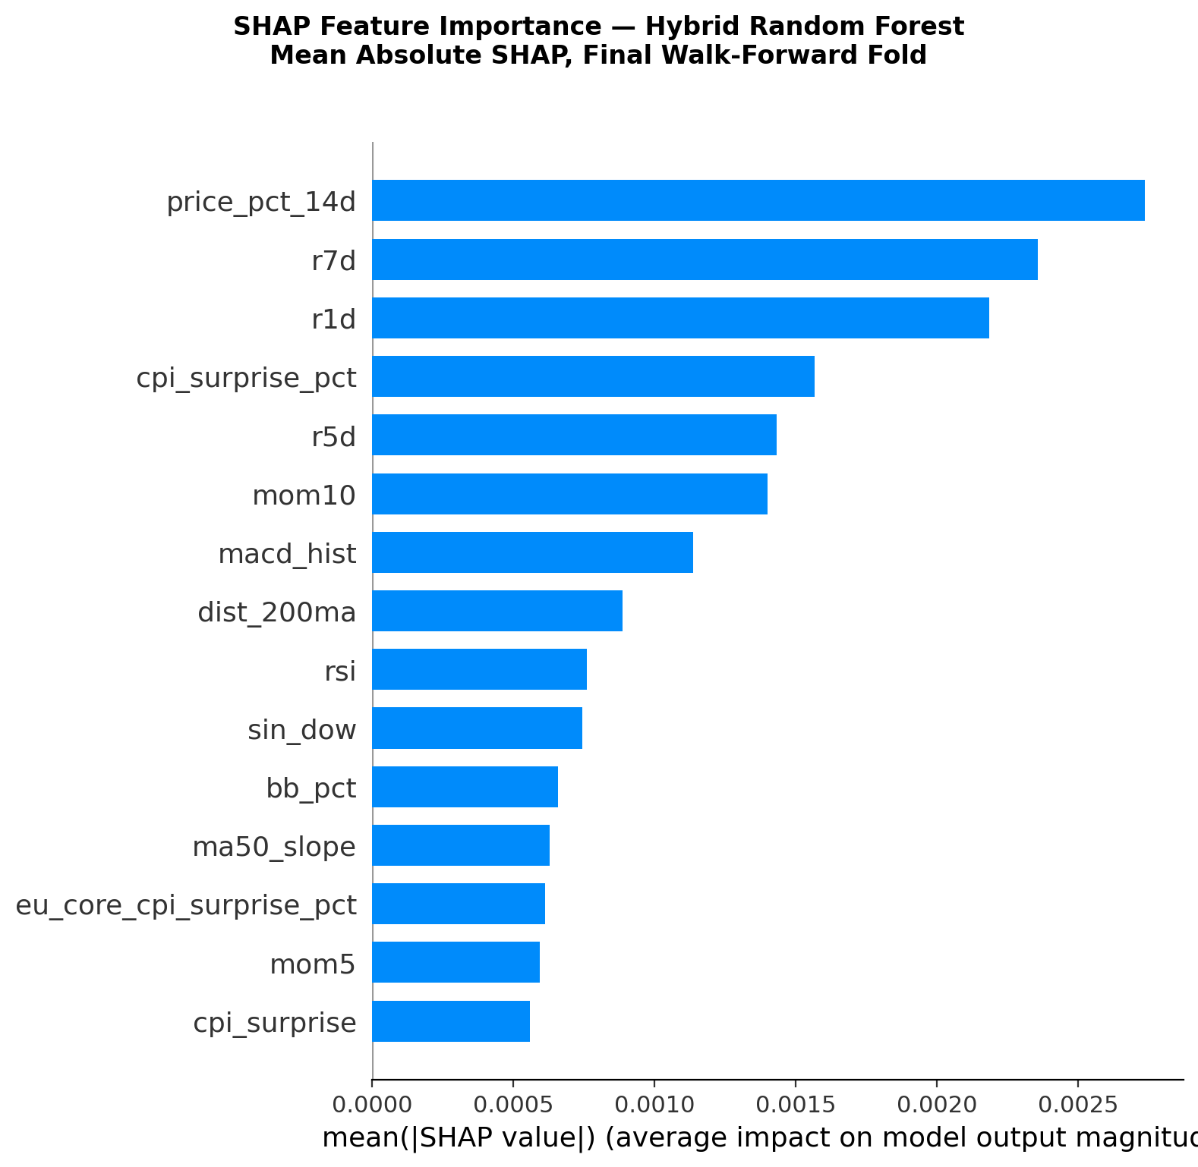

Figure 18: Mean absolute SHAP value per feature. This ranks features by average contribution magnitude, which answers a different question from the permutation importance above.

5.9 Main Performance Study: Model and Prediction Horizon Comparison
This section is the main performance study of the project. Sections 5.5 to 5.7 evaluate a single model family at a single prediction horizon, which leaves two questions open: whether the observed edge is specific to Random Forest or is a property of the feature set, and whether the one-day horizon is the appropriate choice, given that the announcement literature reviewed in Section 2.1 places the response window at minutes rather than days. Answering both requires a comparison across model families and horizons evaluated on common folds, which is what follows. The single-configuration results of Sections 5.5 to 5.7 are retained as the supporting evaluation that establishes the folds, the purge geometry and the cost treatment used here.
This section addresses both by evaluating a grid of three model families against three prediction horizons, with the predictions integrated into the Buy-and-Hold position rather than compared against it. The integration follows the overlay design described in Section 4.3.3: the position remains long by default and moves to cash only when the model produces a confident downward signal. The system never takes a short position and never leverages; its only intervention is to withdraw exposure.
Nine configurations were evaluated: Logistic Regression, Random Forest and XGBoost, each at one-day, three-day and five-day horizons. The one-hour horizon was not included. The scraper did not capture release times, and free intraday price history goes back about two years against the eighteen used here. This is recorded in Section 7.4 as the principal item of further work.
Three design decisions preserve comparability across the grid. First, the purge gap is fixed at five trading days for every configuration rather than set to the horizon of each. A gap wider than strictly required cannot introduce look-ahead bias, and fixing it means all nine configurations share identical fold boundaries and identical test days, so the only quantities that vary are the model family and the horizon. Second, hyperparameters are those frozen in Section 3.4 following training-only cross-validation; no re-tuning was performed, and each fold trains a model from scratch on its own training window. Third, the position is refreshed every h days and held in the interim, where h is the prediction horizon, so that the trading rule matches the quantity being predicted. Profit and loss is nonetheless accumulated on the daily return series, which keeps the Sharpe ratio, maximum drawdown and the Buy-and-Hold benchmark directly comparable across all three horizons.
The dataset is reduced to 4,722 observations, five fewer than the main evaluation, so that a valid five-day target exists for every retained row. The design gives 36 non-overlapping test windows of 60 trading days each, 2,160 out-of-sample days per configuration, and 19,440 daily predictions in total. Transaction costs are charged at one basis point, as in Section 5.7. The proportion of upward days is 49.6% at one day, 49.7% at three days and 49.5% at five days, so no horizon carries a directional base rate that a strategy could exploit without predictive content.
Before interpreting the grid, the Random Forest configuration at the one-day horizon was compared against the main evaluation of Section 5.5, which uses the same model and horizon but a one-row purge gap and the full row count. Table 13 reports the comparison.
Table 13: Agreement between the Section 5.5 evaluation and the sensitivity harness
Configuration | Mean fold AUC | SD | Above 0.50
Section 5.5 (purge gap 1 row) | 0.5389 | 0.0621 | 26 / 36
Section 5.9 (purge gap 5 days) | 0.5386 | 0.0641 | 26 / 36

The agreement serves two purposes. It confirms that the grid harness reproduces the established result, and it demonstrates that the headline finding is insensitive to the purge-gap choice, a methodological parameter that could otherwise be questioned. Widening the gap fivefold moves mean fold AUC by 0.0003.
Table 14 reports mean AUC across the 36 folds for each configuration, with the fold-level standard deviation, the number of folds exceeding 0.50, and the pooled out-of-sample AUC computed across all 2,160 predictions at once.
Table 14: Predictive performance across the model and horizon grid (36 folds per configuration)
Horizon | Model | Mean AUC | SD | Above 0.50 | Pooled AUC
1 day | Logistic Regression | 0.5399 | 0.0600 | 25 / 36 | 0.5281
1 day | Random Forest | 0.5386 | 0.0641 | 26 / 36 | 0.5136
1 day | XGBoost | 0.5075 | 0.0754 | 20 / 36 | 0.5036
3 days | Logistic Regression | 0.5393 | 0.1021 | 24 / 36 | 0.5077
3 days | Random Forest | 0.5395 | 0.1075 | 22 / 36 | 0.5034
3 days | XGBoost | 0.4876 | 0.0926 | 16 / 36 | 0.4860
5 days | Logistic Regression | 0.5139 | 0.1214 | 20 / 36 | 0.5158
5 days | Random Forest | 0.5056 | 0.1204 | 21 / 36 | 0.4824
5 days | XGBoost | 0.4443 | 0.1011 | 7 / 36 | 0.4537

Predictive accuracy is lower at five days than at one day in every model family, falling from 0.5399 to 0.5139 for Logistic Regression, 0.5386 to 0.5056 for Random Forest and 0.5075 to 0.4443 for XGBoost. The decline is monotonic across the three horizons for Logistic Regression and XGBoost. Random Forest is effectively flat between one and three days, rising by 0.0009, which is two orders of magnitude smaller than the fold-level standard deviation, before falling at five days. The overall direction is therefore consistent across families even though the intermediate step is not. This is the outcome the event-driven premise predicts. If macroeconomic surprises are absorbed within minutes of release, then extending the target window adds price movement unrelated to the event and dilutes whatever signal the surprise features carry. The consistency of the pattern across three structurally different learners argues that it is a property of the prediction problem rather than of any one model, and it converts the horizon mismatch noted in Section 7.3 from an assumed limitation into a measured one.
Fold-level dispersion roughly doubles between the one-day and five-day horizons, from approximately 0.06 to approximately 0.12. This is a consequence of overlapping labels: at a five-day horizon, targets on consecutive days share four of their five constituent days, so the effective number of independent observations within each fold is smaller than the nominal count. The wider dispersion should be read as reduced measurement precision rather than as increased instability in the underlying signal.
XGBoost degrades most severely and falls below random at five days, clearing 0.50 in only 7 of 36 folds. This is consistent with the bias-variance diagnostic in Table 5, where XGBoost achieved a training AUC of 0.8827 against a test AUC of 0.5265. A model that fits training noise closely has least to fall back on when the genuine signal weakens, which is precisely the condition a longer horizon creates.
On the comparison between model families, Logistic Regression and Random Forest are not meaningfully separable. At one day they differ by 0.0013 in mean fold AUC against a fold-level standard deviation of approximately 0.06; at three days the ordering reverses, with Random Forest ahead by 0.0002. No significance test was applied along the model axis, because differences of this magnitude relative to the observed dispersion do not warrant one. This is consistent with Section 5.2, where the paired tests were applied along the feature-set axis, which is the research question, and not along the model axis. The selection of Random Forest in Section 6.2 is therefore confirmed rather than contradicted: it was the strongest cell on the Run 3 walk-forward comparison, and it remains indistinguishable from the alternative here.
Table 15 reports the trading performance of each overlay configuration against the Buy-and-Hold benchmark over the same 2,160 out-of-sample days at a one-basis-point transaction cost. Cash exposure denotes the proportion of days on which the overlay withdrew from the market; the overlay holds only long or cash positions, so short exposure is zero throughout.
Table 15: Trading performance across the grid at 1bp transaction cost (2,160 out-of-sample days)
Strategy | Net return | Sharpe | Max drawdown | Trades | Cash
Buy and Hold | +1.47% | 0.060 | -23.29% | 1 | 0.00%
B&H + LR (1 day) | +18.81% | 0.379 | -9.09% | 379 | 33.75%
B&H + RF (1 day) | -3.07% | -0.030 | -22.24% | 351 | 26.67%
B&H + XGB (1 day) | -6.07% | -0.103 | -24.61% | 789 | 38.80%
B&H + LR (3 days) | +0.22% | 0.033 | -17.78% | 138 | 30.97%
B&H + RF (3 days) | -3.14% | -0.050 | -17.01% | 119 | 51.39%
B&H + XGB (3 days) | +0.97% | 0.048 | -19.88% | 281 | 38.75%
B&H + LR (5 days) | -3.08% | -0.043 | -17.98% | 77 | 43.06%
B&H + RF (5 days) | -13.17% | -0.260 | -29.55% | 71 | 35.65%
B&H + XGB (5 days) | -19.85% | -0.447 | -32.29% | 177 | 42.36%

Buy and Hold returns +1.47% here against +1.80% in Table 10. The difference arises from the five rows removed to accommodate the five-day target and the wider purge gap, which together shift each fold boundary by four trading days. The two figures describe slightly different windows and are not interchangeable.
One configuration stands apart. The overlay using Logistic Regression at one day returned +18.81% net against +1.47% for Buy and Hold, with the Sharpe ratio rising from 0.060 to 0.379 and maximum drawdown falling from -23.29% to -9.09%. Of the remaining eight configurations, six lost money and two returned approximately zero. A result of this magnitude arising in one cell of a nine-cell grid requires scrutiny before it can be interpreted.
The cumulative outperformance of that configuration, the Logistic Regression overlay at the one-day horizon, was decomposed by fold. The fold AUC values reported below belong to that configuration. The per-fold values in Appendix C belong to the Random Forest evaluation of Section 5.5 and are therefore not comparable row by row, even though both tables use the same fold numbering. The overlay outperformed Buy and Hold in 20 of 36 folds, which under a null of no advantage is not distinguishable from chance. Total outperformance was 14.96 percentage points, of which 13.96 points, or 93%, came from three folds. Table 16 sets them out.
Table 16: The three folds contributing 93% of the overlay outperformance of the Logistic Regression one-day overlay. Fold AUC here is for that configuration and therefore differs from the Random Forest per-fold values in Appendix C.
Fold | Test period | Fold AUC | Contribution | Predictive skill
19 | 7 Sep 2021 to 29 Nov 2021 | 0.4853 | +3.10 pp | Below random
21 | 22 Feb 2022 to 16 May 2022 | 0.6028 | +5.97 pp | Present
23 | 9 Aug 2022 to 31 Oct 2022 | 0.5215 | +4.89 pp | Marginal

All three fall within the sustained euro depreciation of late 2021 to late 2022, during which EUR/USD fell from approximately 1.19 through parity to approximately 0.96. The fold-level AUC values are the decisive detail. In fold 19 directional accuracy was 0.4853, below random, and in fold 23 it was 0.5215, marginally above. Only fold 21 shows accuracy that could be described as skilful. In two of the three folds responsible for the outperformance, the model’s day-to-day predictions were no better than chance, and yet the overlay profited substantially.
The mechanism is structural rather than predictive. The overlay is long by default and exits to cash on a downward signal. In a market falling persistently over an extended period, any rule that removes exposure a meaningful fraction of the time will outperform continuous exposure, irrespective of whether the specific days selected for withdrawal were the declining ones. The gain arises from the asymmetry of the strategy meeting a trending market, not from the quality of the underlying forecasts. This is the same point made in Section 5.7 in respect of the long-short and long-only variants: realised return along a single price path is not a measure of predictive skill, which is why AUC and maximum drawdown are treated as the primary performance measures throughout this report.
Table 17 reports net return for each configuration across a range of transaction cost assumptions.
Table 17: Net return by transaction cost assumption across the sensitivity grid
Strategy | 0bp | 1bp | 2bp | 5bp
Buy and Hold | +1.48% | +1.47% | +1.46% | +1.43%
B&H + LR (1 day) | +23.40% | +18.81% | +14.39% | +2.09%
B&H + LR (3 days) | +1.62% | +0.22% | -1.15% | -5.16%
B&H + LR (5 days) | -2.33% | -3.08% | -3.82% | -6.02%
B&H + RF (1 day) | +0.40% | -3.07% | -6.41% | -15.77%
B&H + RF (3 days) | -1.99% | -3.14% | -4.29% | -7.65%
B&H + RF (5 days) | -12.55% | -13.17% | -13.79% | -15.60%
B&H + XGB (1 day) | +1.65% | -6.07% | -13.19% | -31.50%
B&H + XGB (3 days) | +3.84% | +0.97% | -1.83% | -9.77%
B&H + XGB (5 days) | -18.42% | -19.85% | -21.26% | -25.33%

Only one configuration remains positive at five basis points, and every other overlay is loss-making by two. The leading configuration survives higher costs not because it trades infrequently, at 379 position changes it does not, but because the gain accumulated during the three episodes above is large relative to the cost drag. Since that gain has been shown not to derive from predictive skill, its persistence under higher costs should not be read as evidence of robustness.
This experiment produces one robust finding and one heavily qualified one. The robust finding is the decline of predictive accuracy with horizon, observed across all three model families. It supports the premise on which the project rests, identifies the daily sampling frequency as a binding constraint rather than an incidental design choice, and strengthens the case for the intraday extension proposed in Section 7.4: if accuracy improves as the horizon shortens from five days to one, the natural inference is that it would improve further at sub-daily resolution, which is where the literature locates the effect.
The qualified finding is the trading result. Taken at face value the leading configuration transforms a +1.47% return into +18.81% while more than halving maximum drawdown. On examination, 93% of that advantage is attributable to three quarters within a single sustained trend, in two of which the model exhibited no predictive skill. The honest characterisation is that the overlay confers no measurable advantage under normal conditions and derives its benefit from reducing exposure during extended adverse moves. That is the same conclusion reached in Section 6.3; the present experiment does not alter it, but supports it with stronger evidence and identifies the market conditions under which the mechanism operates.
Two limitations attach. The leading configuration is the best of nine evaluated on the same data, so its performance is upward biased by selection, and the concentration analysis above should be read as the correction to that bias rather than as an incidental caveat. At three and five days the targets of adjacent days overlap, which reduces the effective sample size within each fold and inflates fold-level dispersion. Neither limitation affects the direction of the horizon result, which is consistent across all three model families.

5.10 Nested Model Selection
The comparison presented above in Section 5.9 evaluates nine configurations on the same folds and then discusses the strongest of them. Even where no configuration is chosen based on that comparison, the reader is entitled to ask whether the reported figures carry an upward bias from having inspected all nine. This section removes the question structurally rather than answering it, by moving the choice of model family inside the walk-forward.
The procedure is as follows. Within each fold, the three model families are fitted on the inner training window and scored by AUC on the 252-day validation window that is already used for threshold selection. The highest-scoring family is then refitted on the full outer training window and used to predict the test fold. Nothing outside the training and validation data influences any decision at any point, so what is reported is the out-of-sample performance of the selection procedure itself rather than of a configuration identified with hindsight. The fold geometry, purge gap, threshold grid and cost treatment are unchanged from Section 5.9.
Table 18 places the procedure alongside the three fixed choices at the one-day horizon.
Table 18: Nested selection compared with fixed model choices (36 folds, one-day horizon)
Configuration | Mean AUC | SD | Above 0.50 | Pooled AUC | p
Fixed Logistic Regression | 0.5399 | 0.0600 | 25 / 36 | 0.5281 | —
Fixed Random Forest | 0.5386 | 0.0641 | 26 / 36 | 0.5136 | —
Fixed XGBoost | 0.5075 | 0.0754 | 20 / 36 | 0.5036 | —
Nested selection | 0.5324 | 0.0557 | 26 / 36 | 0.5201 | 0.000672

The mean falls by 0.0075 relative to the best fixed choice and by 0.0062 relative to Random Forest, which is the cost of removing hindsight and is modest against a fold-level standard deviation of 0.06. Two features of the result are more interesting than the mean. The procedure clears 0.50 in 26 of 36 folds, matching the best fixed choice, and its fold-level standard deviation of 0.0557 is lower than that of any individual model family. Allowing the selection to vary therefore produced a more consistent result across folds than committing to any one family in advance, despite the lower average. A fold-level test against 0.50 gives t = 3.485 and a one-sided p-value of 0.000672. Unlike the figures in Table 8 and Table 14, this p-value requires no adjustment for configurations examined, because no configuration competed for selection before it was produced. It is the only significance figure in the report that needs no such qualification.
Table 19 records which family the procedure selected and how often it changed.
Table 19: Model family selected by the nested procedure across 36 folds
Model family | Folds selected | Share | Fixed mean AUC
Logistic Regression | 19 / 36 | 52.8% | 0.5399
Random Forest | 11 / 36 | 30.6% | 0.5386
XGBoost | 6 / 36 | 16.7% | 0.5075

The selection changed between consecutive folds on 16 of 35 transitions. No family holds the selection for a sustained run, and the family with the highest fixed mean AUC is chosen in barely more than half of the folds. This is the strongest available evidence on the question of model equivalence raised earlier in this section, and it is evidence of a different kind. Rather than observing that the model families are separated by less than the fold-level dispersion and inferring that they are indistinguishable, the nested procedure measures that indistinguishability directly: a selection rule acting only on out-of-sample validation evidence is unable to settle on one family and reverses its choice in almost half of all transitions.
A further diagnostic reinforces the point. If the validation window carried genuine information about which family would perform better in the period that follows, then each family should perform above its own fixed-choice average in the folds where it was selected. It does not. Logistic Regression averages 0.5302 in the 19 folds where it was chosen against a fixed-choice mean of 0.5399; Random Forest averages 0.5385 in its 11 folds against 0.5386; and only XGBoost performs better when selected, at 0.5279 against 0.5075. The selection rule is therefore not adding forecasting skill so much as avoiding the worst fixed commitment, which is consistent with a setting in which the families differ by less than the measurement noise. This is why the procedure returns a lower mean than the best fixed choice while achieving a lower fold-level standard deviation than any of them.
The trading result follows the same pattern as the predictive one. With the overlay applied to the nested procedure’s predictions, net return is +15.20% against +1.47% for Buy and Hold, with a Sharpe ratio of 0.327 and maximum drawdown reduced from -23.29% to -14.05%. This sits between the fixed Logistic Regression configuration and the remainder of the grid, which is what a procedure that selects that family in roughly half of the folds should produce. The concentration analysis was not repeated for the nested procedure. An overlay profits during a sustained decline for structural reasons rather than predictive ones, so the same pattern is likely regardless of which family produced the probabilities. A fold-by-fold decomposition would confirm it.
Finally, the deployed system is made consistent with the procedure that is reported. Applying the same selection rule to the most recent validation window gives Random Forest at 0.5709, Logistic Regression at 0.5677 and XGBoost at 0.5140, so Random Forest is the family carried into deployment. This agrees with the configuration selected on walk-forward evidence in Run 3 and described in Section 4.5, but it now rests on the same rule that produces the figures in Table 18 rather than on a separate earlier decision. The validation AUCs quoted here are the basis of the selection and are optimistically biased by construction; the corresponding out-of-sample figure is the 0.5324 reported in Table 18.

6. Discussion

6.1 A Small but Statistically Detectable Signal
The central result is a mean fold AUC of 0.5389 over 36 independent test windows, with 26 of 36 folds above 0.50 and a one-sided p-value of 0.000316 that survives Bonferroni correction. This supports the conclusion that scheduled macroeconomic surprise information, combined with market context, carries a small but repeatable directional signal in daily EUR/USD.
The magnitude matters as much as the significance. An AUC of 0.5389 corresponds to a modest ranking advantage, not a reliable directional call. The appropriate reading is that a signal exists and is measurable at this horizon, not that it is large.

6.2 Why Random Forest on the Hybrid Feature Set
The selection rule was fixed before the final evaluation: hyperparameters were chosen on training-only cross-validation, and the model and feature set were chosen on walk-forward performance in Run 3, not on the final out-of-sample result. Hybrid Random Forest was strongest on that basis at 0.5298 across 65 folds, and the paired tests in Section 5.2 show that advantage over both isolated feature sets is statistically significant.
The depth-2 constraint is central to why this configuration generalises. XGBoost, with more capacity, reached a training AUC of 0.8827 against a test AUC of 0.5265. On a target this noisy, additional capacity is spent memorising the training period.

6.3 Strategy Performance Versus Buy and Hold
The clearest and most consistent difference between the overlay and Buy and Hold is risk-related rather than directional. The overlay reduced maximum drawdown from -23.29% to -18.81% over the same 2,160-day window, while total return was closely comparable at +1.51% against +1.80% after costs. The model therefore does not exceed Buy and Hold in total return, and its value lies in selective exposure rather than return enhancement.
Two qualifications are important. First, the drawdown difference is a single observed outcome and has no confidence interval attached, so it is suggestive rather than demonstrated. Second, Buy and Hold in a currency pair is not directly comparable to equity buy-and-hold: a long EUR/USD position does not represent ownership of a productive asset, and its return depends on the exchange-rate path and, in live trading, on financing and carry. Buy and Hold is therefore used here as a simple directional reference rather than a benchmark expected to generate a positive long-term return.

6.4 Contribution of Economic Event Features
Event features contribute in combination rather than in isolation. The event-only feature set produced a mean walk-forward AUC of 0.5064 for Random Forest, barely distinguishable from chance, while adding those features to market-context variables produced a significant improvement of +0.0176 over technical-only features. The interpretation is that event information is conditioning rather than driving: it is useful in the context of prevailing momentum and regime, rather than as a standalone predictor.

6.5 Interpretability Across Methods
Permutation importance, SHAP and feature-set ablation answer different questions and need not produce identical rankings. Permutation importance identifies individual columns whose shuffling most reduces holdout ranking performance. SHAP measures average contribution magnitude to individual predictions. Feature-set comparison retrains the model on an entire family. The observed pattern, in which market-context variables lead the individual rankings while the event family shows a significant group-level contribution, is consistent across all three once the difference in question is accounted for.

6.6 Threshold Selection and Post-hoc Risk
Confidence thresholds were selected inside each fold's validation window rather than chosen after observing test performance. This avoids the post-hoc optimisation that would otherwise inflate the reported trading result, at the cost of a slightly less favourable outcome than a swept threshold would produce. The clustering of selected thresholds at 0.50 to 0.52 is itself informative: the model rarely produced probabilities confident enough to support a stricter operating point.

6.7 Novelty and Practical Contribution
Five aspects distinguish this work from comparable applied studies. The sample spans eighteen years rather than the short post-2019 windows typical of similar projects. Missing surprises and genuine zero surprises are represented differently rather than collapsed. Percentile normalisation uses prior valid releases only, with a minimum release history, removing a common leakage path. Model selection is separated from outcome, so more favourable post-hoc metrics from other configurations are reported without retrofitting the choice. Finally, the negative results are reported alongside the positive ones, including a controlled refinement experiment that produced no improvement.

6.8 What the Main Performance Study Adds
Section 5.9 is the main performance study, and its findings are stated there. Three points bear on the discussion above. First, the horizon result converts the horizon mismatch listed in Section 7.3 from an assumed limitation into a measured one: accuracy is lower at five days than at one day in all three model families, which is what rapid absorption of announcement information predicts and which the single-configuration evaluation could not have shown.
Second, the model comparison confirms rather than revises the selection reasoning in Section 6.2. Random Forest and Logistic Regression are separated by 0.0013 in mean fold AUC against a fold-level standard deviation of approximately 0.06. The selection made on Run 3 walk-forward performance is therefore not contradicted by a broader evaluation, and the grid is treated throughout as an evaluation instrument rather than a selection instrument, consistent with the correction described in Section 4.3.2. Section 5.10 strengthens this further by moving the choice inside the walk-forward entirely, so that the reported figure belongs to the selection procedure rather than to any configuration chosen after the fact.
Third, the trading finding sharpens the position taken in Section 6.3. The single configuration overlay reduced drawdown at comparable return. The grid shows that the strongest return in the comparison is concentrated in three folds of one sustained trend, in two of which the model had no predictive skill. Both results point the same way: the value of the system is selective exposure, not return generation, and realised return along a single price path is not a measure of predictive skill.

7. Conclusion

7.1 Summary of Findings
This project developed an economic event-driven EUR/USD trading assistant that combines six macroeconomic event families with market-context features, evaluates three classifiers across a documented six-experiment sequence, and serves the selected model through a Streamlit dashboard.
The dataset contains 4,727 modelling observations and 48 features spanning 2007 to 2025. The main performance study compares three model families across one-day, three-day and five-day prediction horizons on 36 common purged folds covering 2,160 out-of-sample days per configuration. Predictive accuracy is lower at five days than at one day in all three families, falling from 0.5399 to 0.5139 for Logistic Regression, 0.5386 to 0.5056 for Random Forest and 0.5075 to 0.4443 for XGBoost, monotonically in two of the three. The selected configuration, a Random Forest on the hybrid feature set trained on a ten-year rolling window, achieved a mean fold AUC of 0.5389 with 26 of 36 folds above 0.50 and a pooled out-of-sample AUC of 0.5145. Moving model selection inside the walk-forward, which removes any dependence on having inspected the full grid, gives a mean fold AUC of 0.5324 over the same 36 folds with a one-sided p-value of 0.000672 and a lower fold-level standard deviation than any fixed choice. That procedure reversed its choice of model family on 16 of 35 transitions, which measures the indistinguishability of the three families rather than asserting it. The fold-level test against 0.50 gives a one-sided p-value of 0.000316, which survives Bonferroni correction across the 30 configurations examined. These results indicate a modest but repeatable directional signal, consistent with the low signal-to-noise ratio expected at a daily horizon.
In trading terms the benefit is risk-related rather than return-related. For the selected configuration the overlay reduced maximum drawdown from -23.29% to -18.81% at a comparable total return of +1.51% against +1.80% after costs. Across the wider comparison the strongest configuration returned +18.81% against +1.47% with maximum drawdown reduced to -9.09%, but it beat Buy and Hold in only 20 of 36 folds and 93% of that advantage arose in three non-consecutive folds of the 2021 to 2022 euro decline, in two of which its predictive accuracy was at or below random. The final system is therefore best interpreted as a selective decision-support and risk-filtering tool rather than a claim of consistently superior standalone returns.

7.2 Objectives Revisited
- Historical EUR/USD prices and six economic-event families were collected and processed across 2007 to 2025, with surprise availability retained explicitly.
- Three supervised classifiers were trained and compared across three feature sets and three training-window definitions.
- Evaluation used purged chronological splits, 65-fold walk-forward comparison within the experimental sequence, and a final 36-fold evaluation with complete out-of-sample coverage.
- Model behaviour was interpreted through permutation importance, SHAP and feature-set comparison, with the differences between those methods stated explicitly.
- A live Streamlit dashboard was delivered, producing BUY, SELL and HOLD signals from the same feature-construction path used in training.

7.3 Limitations
The limitations below bound what the reported result can claim.
- Horizon mismatch. Announcement effects are largely intraday. The surprise is absorbed within minutes of release while the target is the following day's close, so most of the reaction is discarded by aggregation to daily granularity.
- Event-calendar availability. The days_until_event feature is valid for regularly scheduled releases whose dates were publicly known in advance. However, deriving it from the completed historical calendar may reveal unscheduled emergency meetings before they were announced. Future work should reconstruct the feature using only the calendar information available on each historical date.
- Surprise measurement. Actual minus consensus is a weak proxy for policy surprise. The FOMC surprise series is predominantly zero, and the literature uses fed funds futures for this purpose.
- Fold independence. The fold-level test assumes independent folds. Test periods do not overlap, but consecutive ten-year training windows share approximately 97.6% of their rows. A block permutation test would be more defensible, and the reported test is therefore labelled exploratory.
- Cost sensitivity. The overlay result holds at one basis point and reverses at two basis points and above, so the conclusion is conditional on a favourable cost assumption.
- Single currency pair. Findings are specific to EUR/USD and were not tested on other pairs or regimes.
- Drawdown evidence. The observed drawdown reduction is one realisation over one historical path and carries no confidence interval.

7.4 Future Work
- Move to an intraday horizon, where the announcement effect is measurable, using a data source that supports intraday history beyond the limits of the current price feed, for which Section 5.9 provides direct empirical support.
- Replace actual-minus-consensus with a futures-implied policy surprise measure for the rate-decision families.
- Replace the fold-level t-test with a block permutation test that accounts for overlapping training windows.
- Extend the evaluation to additional currency pairs to test whether the hybrid advantage generalises.
- Retrain the deployed dashboard model on the final configuration and add an explicit cost assumption to the displayed results.

7.5 Closing Remarks
The project demonstrates that careful event-data handling and leakage-aware evaluation can identify a small, statistically detectable directional signal in daily EUR/USD, and that this signal is best used to modulate exposure rather than to generate positions outright. Its main contribution is not a claim of profitability but a transparent workflow that reports the predictive limitations and the observed risk-adjusted behaviour of the model alongside its positive results.

8. References
Andersen, T. G., Bollerslev, T., Diebold, F. X., & Vega, C. (2003). Micro effects of macro announcements: Real-time price discovery in foreign exchange. American Economic Review, 93(1), 38-62.
Evans, M. D. D., & Lyons, R. K. (2008). How is macro news transmitted to exchange rates? Journal of Financial Economics, 88(1), 26-50.
Faust, J., Rogers, J. H., Wang, S.-Y. B., & Wright, J. H. (2007). The high-frequency response of exchange rates and interest rates to macroeconomic announcements. Journal of Monetary Economics, 54(4), 1051-1068.
Fischer, T., & Krauss, C. (2018). Deep learning with long short-term memory networks for financial market predictions. European Journal of Operational Research, 270(2), 654-669.
Galati, G., & Ho, C. (2001). Macroeconomic news and the euro/dollar exchange rate. BIS Working Papers No. 105.
Kuttner, K. N. (2001). Monetary policy surprises and interest rates: Evidence from the Fed funds futures market. Journal of Monetary Economics, 47(3), 523-544.
Lopez de Prado, M. (2018). Advances in Financial Machine Learning. Hoboken, NJ: Wiley.
Meese, R. A., & Rogoff, K. (1983). Empirical exchange rate models of the seventies: Do they fit out of sample? Journal of International Economics, 14(1-2), 3-24.
Nakamura, E., & Steinsson, J. (2018). High-frequency identification of monetary non-neutrality: The information effect. Quarterly Journal of Economics, 133(3), 1283-1330.
Patel, J., Shah, S., Thakkar, P., & Kotecha, K. (2015). Predicting stock and stock price index movement using trend deterministic data preparation and machine learning techniques. Expert Systems with Applications, 42(1), 259-268.

9. Appendices

Appendix A — Full Feature List
The 48 features used in every experiment, in the order they appear in the feature matrix. The six availability flags are listed beside their corresponding surprise values because they exist specifically to distinguish a missing release from a genuine zero surprise, as described in Section 3.3.1.
# | Feature | Group | Description
1 | cpi_surprise | Event surprise | US CPI actual minus consensus forecast
2 | cpi_available | Availability | Binary flag: a valid US CPI surprise exists for this row
3 | cpi_surprise_pct | Event surprise | Percentile rank of the US CPI surprise against prior valid releases only
4 | cpi_day | Event timing | Binary flag: US CPI release day
5 | nfp_surprise | Event surprise | Non-Farm Payrolls actual minus consensus forecast
6 | nfp_available | Availability | Binary flag: a valid NFP surprise exists for this row
7 | nfp_surprise_pct | Event surprise | Percentile rank of the NFP surprise against prior valid releases only
8 | nfp_day | Event timing | Binary flag: NFP release day
9 | fomc_surprise | Event surprise | FOMC rate decision actual minus consensus forecast
10 | fomc_available | Availability | Binary flag: a valid FOMC surprise exists for this row
11 | fomc_surprise_pct | Event surprise | Percentile rank of the FOMC surprise against prior valid releases only
12 | fomc_day | Event timing | Binary flag: FOMC decision day
13 | ecb_rate_surprise | Event surprise | ECB main refinancing rate actual minus consensus forecast
14 | ecb_rate_available | Availability | Binary flag: a valid ECB rate surprise exists for this row
15 | ecb_rate_surprise_pct | Event surprise | Percentile rank of the ECB rate surprise against prior valid releases only
16 | ecb_rate_day | Event timing | Binary flag: ECB rate decision day
17 | eu_cpi_surprise | Event surprise | Euro-area CPI flash estimate actual minus consensus forecast
18 | eu_cpi_available | Availability | Binary flag: a valid euro-area CPI surprise exists for this row
19 | eu_cpi_surprise_pct | Event surprise | Percentile rank of the euro-area CPI surprise against prior valid releases only
20 | eu_cpi_day | Event timing | Binary flag: euro-area CPI release day
21 | eu_core_cpi_surprise | Event surprise | Euro-area core CPI flash estimate actual minus consensus forecast
22 | eu_core_cpi_available | Availability | Binary flag: a valid euro-area core CPI surprise exists for this row
23 | eu_core_cpi_surprise_pct | Event surprise | Percentile rank of the euro-area core CPI surprise against prior valid releases only
24 | eu_core_cpi_day | Event timing | Binary flag: euro-area core CPI release day
25 | event_day | Event timing | Binary flag: any tracked event released on this trading day
26 | days_since_event | Event timing | Trading days since the most recent tracked event
27 | days_until_event | Event timing | Trading days until the next tracked event, capped at 30
28 | r1d | Momentum | One-day lagged log return
29 | r5d | Momentum | Five-day lagged log return
30 | r7d | Momentum | Seven-day lagged log return
31 | r10d | Momentum | Ten-day lagged log return
32 | r14d | Momentum | Fourteen-day lagged log return
33 | mom5 | Momentum | Momentum: r5d minus r1d
34 | mom7 | Momentum | Momentum: r7d minus r1d
35 | mom10 | Momentum | Momentum: r10d minus r1d
36 | vol_5d | Volatility | Five-day rolling standard deviation of log returns
37 | vol_14d | Volatility | Fourteen-day rolling standard deviation of log returns
38 | price_pct_14d | Regime | Price position within the fourteen-day high-low range
39 | above_200ma | Regime | Binary flag: price above the 200-day moving average
40 | dist_200ma | Regime | Percentage distance from the 200-day moving average
41 | ma50_slope | Regime | Five-day slope of the 50-day moving average
42 | cos_dow | Calendar | Cosine encoding of day of week
43 | sin_dow | Calendar | Sine encoding of day of week
44 | rsi | Technical | Fourteen-day Relative Strength Index
45 | macd_hist | Technical | MACD histogram, 12/26/9 configuration
46 | bb_pct | Technical | Bollinger Band percentage position
47 | atr_norm | Technical | Average True Range normalised by price
48 | post_event_vol | Volatility | Three-day rolling return volatility following a tracked event

Appendix B — Final Evaluation Configuration
Parameter | Value
Model | Random Forest
Hyperparameters | max_depth=2, max_features=sqrt, min_samples_leaf=5, n_estimators=100
Features | 48 (hybrid)
Training window | 2,520 rows (ten-year rolling)
Validation window | 252 rows
Test window per fold | 60 rows
Purge gap | 1 row
Folds | 36 (non-overlapping)
Out-of-sample predictions | 2,160
Transaction cost | 1 basis point per unit of turnover

Appendix C — Per-Fold Results
Each fold reports the confidence threshold selected on its own validation window and the resulting test AUC.
Fold | Threshold | AUC | Fold | Threshold | AUC
01 | 0.52 | 0.6011 | 19 | 0.50 | 0.4785
02 | 0.52 | 0.5513 | 20 | 0.50 | 0.7119
03 | 0.54 | 0.4421 | 21 | 0.50 | 0.5311
04 | 0.54 | 0.4926 | 22 | 0.50 | 0.5100
05 | 0.52 | 0.4475 | 23 | 0.52 | 0.5752
06 | 0.52 | 0.6207 | 24 | 0.50 | 0.5256
07 | 0.52 | 0.6518 | 25 | 0.60 | 0.4804
08 | 0.50 | 0.4939 | 26 | 0.52 | 0.5498
09 | 0.50 | 0.5303 | 27 | 0.52 | 0.4772
10 | 0.52 | 0.4917 | 28 | 0.56 | 0.6290
11 | 0.50 | 0.5130 | 29 | 0.52 | 0.5606
12 | 0.50 | 0.4710 | 30 | 0.52 | 0.5691
13 | 0.52 | 0.5145 | 31 | 0.50 | 0.5177
14 | 0.60 | 0.4149 | 32 | 0.50 | 0.5495
15 | 0.58 | 0.6185 | 33 | 0.52 | 0.5657
16 | 0.58 | 0.5558 | 34 | 0.50 | 0.5309
17 | 0.52 | 0.5772 | 35 | 0.54 | 0.5435
18 | 0.60 | 0.5112 | 36 | 0.52 | 0.5940

Appendix D — Hyperparameter Search Spaces
Search spaces and selected values from the tuning described in Section 3.4. Selection used training data only, with TimeSeriesSplit cross-validation and AUC-ROC as the scoring function. The selected values were frozen at that point and reused unchanged in every subsequent experiment, so no result reported in Section 5 involves re-tuning.
Model | Parameter | Search space | Selected
Logistic Regression | C | 0.001, 0.01, 0.1, 1.0, 10 | 0.1
 | penalty | L1, L2 | L1
 | solver | saga | saga
Random Forest | n_estimators | 100, 200 | 100
 | max_depth | 2, 3, 4, 5 | 2
 | min_samples_leaf | 5, 10, 20 | 5
 | max_features | 'sqrt', 0.5 | 'sqrt'
XGBoost | n_estimators | 100, 200 | 100
 | max_depth | 2, 3, 4 | 4
 | learning_rate | 0.01, 0.05, 0.1 | 0.1
 | subsample | 0.7, 0.8 | 0.7
 | reg_alpha | 0, 0.5 | 0
 | reg_lambda | 1.0, 2.0 | 1.0

Cross-validation: TimeSeriesSplit, 5 splits. Scoring: AUC-ROC. Training cross-validation AUC at the selected values was 0.5196 for Logistic Regression, 0.5098 for Random Forest and 0.5121 for XGBoost. These training figures are the basis on which the model families were compared before any test data was examined, and they are the reason Section 5.9 is treated as an evaluation instrument rather than a selection instrument.
END OF DOCUMENT

